INDOOR AIR QUALITY ASSESSMENT

Martha’s Vineyard Regional High School
100 Edgartown Vineyard Haven Road
Oak Bluffs, Massachusetts

Prepared by:
Massachusetts Department of Public Health
Bureau of Environmental Health
Indoor Air Quality Program
January 2018

Background
Building: | Martha’s Vineyard Regional High School (MVRHS)
Address: | 100 Edgartown Vineyard Haven Road  Oak Bluffs, Massachusetts
Assessment Coordinated Through: | Michael Taus, MVRHS Facilities Manager and Meegan Lancaster, Health Agent, Oak Bluffs Board of Health
Reason for Request: | General indoor air quality (IAQ) concerns in room 209
Date of Assessment: | December 18, 2017
Massachusetts Department of Public Health/Bureau of Environmental Health (MDPH/BEH) Staff Conducting Assessment: | Cory Holmes, Environmental Analyst/Inspector, IAQ Program
Building Description: | Room 209 is a small room located on the ground floor of the MVRHS. The room contains office furniture, tile floor, painted gypsum wallboard walls and suspended ceiling tiles. It shares a common wall with a general classroom and the main hallway. The Math Office, room 519 was also assessed by request.
Windows: | Windows are openable in the space.

Methods
Please refer to the IAQ Manual and appendices for methods, sampling procedures, and interpretation of results (MDPH, 2015).

Results and Discussion
The following is a summary of indoor air testing results (Table 1).
- Carbon dioxide measurements were below the MDPH recommended level of 800 parts per million (ppm) in areas surveyed, indicating adequate exchange.
- Temperature was slightly below the MDPH recommended range of 70°F to 78°F in areas tested at the time of assessment.
- Relative humidity was below the MDPH recommended range of 40 to 60% in all areas tested, which is typical during the heating season.
- Carbon monoxide levels were non-detectable (ND) in all areas tested.
- Particulate matter (PM2.5) concentrations measured were below the National Ambient Air Quality (NAAQS) level of 35 μg/m³ in all areas tested.
- Carbon monoxide levels were non-detectable in all areas tested.
- Total Volatile Organic Compounds (TVOCs) were ND in all areas tested.

Ventilation
A heating, ventilating and air-conditioning (HVAC) system has several functions. First it provides heating and, if equipped, cooling. Second, it is a source of fresh air. Finally, an HVAC system will dilute and remove normally-occurring indoor environmental pollutants by not only introducing fresh air, but also filtering the airstream and ejecting stale air to the outdoors via exhaust ventilation. The areas tested, Rooms 209 and 519, had no means of mechanical supply ventilation but relied on baseboard radiators for heat and openable windows for introduction of outside air. However, they did both contain mechanical exhaust vents (Picture 1). The exhaust vent for room 209 was operating at the time of assessment, the one in 519 was not, which indicates it was deactivated or malfunctioning.

Microbial/Moisture Concerns
In order for building materials to support mold growth, a source of water exposure is necessary. No current leaks or related water damage were observed during this assessment.
The window in the room had a cloudy/opaque appearance (Picture 2), which is caused by condensation between window panes due to a failed seal. At the time of assessment the window was on a list for replacement.

Other Conditions
In a number of areas, items were observed on the floor, windowsills, tabletops, counters, bookcases and desks. The large number of items stored provides a source for dusts to accumulate. These items (e.g., papers, folders, boxes) make it difficult for custodial staff to clean. Items should be relocated and/or be cleaned periodically to avoid excessive dust build up. In addition, baseboard radiators were observed with accumulated dust/debris (Picture 3), which can give off odors when heated. It was reported that the room was scheduled to be painted during the Dec-Jan holiday break, which will provide an opportunity for a thorough cleaning of walls/flat surfaces.
Several ceiling-mounted vents, personal fans and flat surfaces were also observed to have accumulated dust/debris. Operation of fans and HVAC equipment can re-aerosolize accumulated dust particles providing a source of eye and respiratory irritation.
Finally, drafts were felt from open utility holes/breaches in walls (Pictures 4 and 5). These can provide pathways for dust/drafts/odors from wall cavities into occupied areas.

Conclusions and Recommendations
In view of the findings at the time of the visit, the following recommendations are made:
- Use openable windows to supplement fresh air during temperate weather. Ensure all windows are tightly closed at the end of the day.
- Check exhaust vents for draw periodically and repair any non-operating motors/vents.
- To improve air circulation, consider undercutting doors or installing passive vents in doors.
- Seal breaches in walls/around utilities to prevent drafts/dusts/odors from wall cavities into occupied areas.
- For buildings in New England, periods of low relative humidity during the winter are often unavoidable. Therefore, scrupulous cleaning practices should be adopted to minimize common indoor air contaminants whose irritant effects can be enhanced when the relative humidity is low. To control for dusts, a high efficiency particulate arrestance (HEPA) filter-equipped vacuum cleaner in conjunction with wet wiping of all surfaces is recommended. Avoid the use of feather dusters. Drinking water during the day can help ease some symptoms associated with a dry environment (throat and sinus irritation).
- Clean baseboard radiators/fins periodically.
- Consider reducing the amount of stored materials to allow for more thorough cleaning. Clean items regularly with a wet cloth or sponge to prevent excessive dust build-up.
- Clean ceiling-mounted vents/grills and personal fans periodically of accumulated dust. Use a vacuum/brush attachment as necessary.
- Refer to resource manual and other related IAQ documents located on the MDPH’s website for further building-wide evaluations and advice on maintaining public buildings. These documents are available at http://mass.gov/dph/iaq.

References
MDPH. 2015. Massachusetts Department of Public Health. Massachusetts Department of Public Health Indoor Air Quality Manual: Chapters I-III. Available at: http://www.mass.gov/eohhs/gov/departments/dph/programs/environmental-health/exposure-topics/iaq/iaq-manual/.
Picture 1
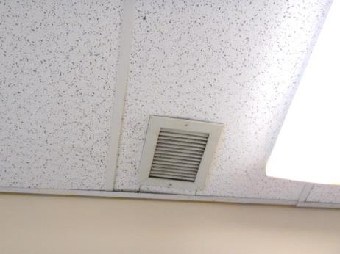
Ceiling-mounted exhaust vent in room 209
Picture 2
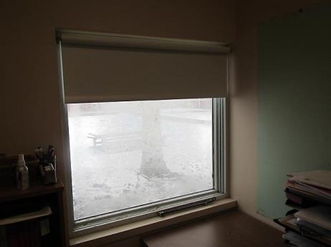
Window with failed seal in room 209
Picture 3
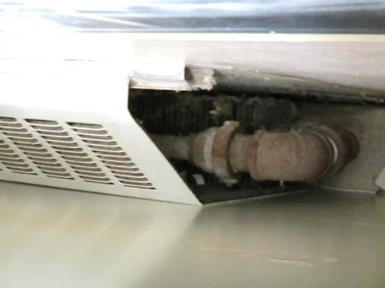
Baseboard radiator unit
Picture 4
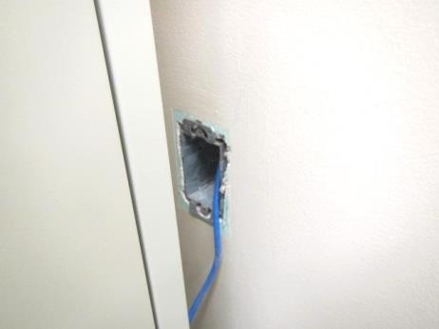
Open utility hole/electrical box
Picture 5
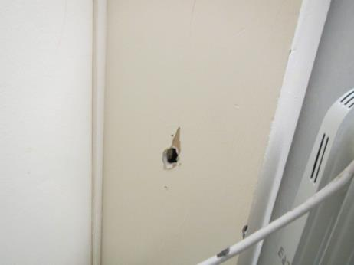
Hole in wall

Location | Carbon  Dioxide  (ppm) | Carbon Monoxide  (ppm) | Temp  (°F) | Relative  Humidity  (%) | PM2.5  (µg/m³) | TVOCs  (ppm) | Occupants  in Room | Windows  Openable | Ventilation |  | Remarks
 |  |  |  |  |  |  |  |  | Supply | Exhaust
Background (outdoors) | 405 | ND | 38 | 58 | 4 | ND
209 | 611 | ND | 68 | 24 | 3 | ND | 0 | Y | N | Y | Dusty radiator fins, dusty exhaust vent, utility holes/drafts
519 | 694 | ND | 68 | 26 | 3 | ND | 1 | Y | N | Y | Exhaust not operating, odors reported when heat operating
-

