INDOOR AIR QUALITY ASSESSMENT

J.W. Martin Elementary School
9 Landry Avenue
North Attleborough, Massachusetts

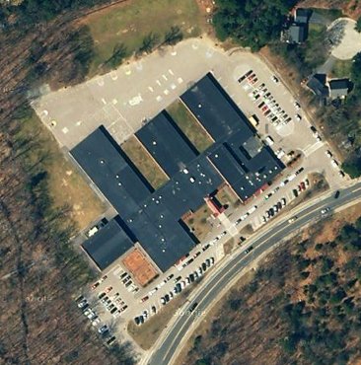

Prepared by:
Massachusetts Department of Public Health
Bureau of Environmental Health
Emergency Response/Indoor Air Quality Program
June 2007

Background/Introduction
At the request of Rick Smith, Superintendent, North Attleborough School Department (NASD), the Massachusetts Department of Public Health (MDPH), Bureau of Environmental Health (BEH), was asked to provide assistance and consultation regarding indoor air quality at the Martin Elementary School (MES), 9 Landry Avenue, North Attleborough, Massachusetts. On March 26, 2007, Cory Holmes, an Environmental Analyst in BEH’s Emergency Response/Indoor Air Quality (ER/IAQ) Program conducted an indoor air quality assessment. Head Custodian Mr. Richard (Rick) Brown accompanied Mr. Holmes for portions of the assessment.
The MES was previously evaluated by MDPH in March 2005 and January 2006 and reports were issued by CEH that described conditions observed in the building at the time (MDPH, 2006: MDPH, 2005). The current assessment was prompted by occupant complaints of eye/respiratory irritation and exacerbation of asthma. The symptoms reported by building occupants were believed to be related to the use of fans that were used to dry ceilings following a nor’easter which caused roof leaks/ice dams resulting in water damage to the dropped-ceiling tile system.
It was reported by Principal Michael Luce that school maintenance staff discovered water penetration in a number of areas in the building following heavy precipitation that occurred over the weekend of March 17-18, 2007. Once discovered, school maintenance reportedly used wet vacuums to remove standing water and placed containers below leaks. Several days later, Service Master, a flooding restoration firm, was contacted to perform remediation. According to Mr. Luce, Service Master used of dehumidifiers and portable fans to remove moisture and dry water damaged materials. Water damaged gypsum wallboard and ceiling tiles were removed so that air from the fans could be directed into the ceiling plenum (Pictures 1 through 4).
On Friday March 23, 2007 Mr. Holmes spoke with Mr. Luce about potential moisture and other environmental conditions as well as health complaints. Mr. Holmes concurred with Mr. Luce that the most likely source of irritation was the movement of particulates that accumulate in the ceiling plenum by drying fans. Mr. Luce stated that upon complaint from building occupants on Thursday March 22, 2007, all fans were deactivated to prevent further aerosolization of particulates. Mr. Luce reported that complaints had ceased after the deactivation of fans. Mr. Holmes recommended that all areas where fans had been employed should be thoroughly cleaned over the weekend using HEPA filtered vacuum cleaners and/or wet wiping techniques to remove settled particulates prior to the opening of school on Monday March 26, 2007.

Methods
Air tests for airborne particle matter with a diameter less than 2.5 micrometers were taken with the TSI, DUSTTRAK™ Aerosol Monitor Model 8520. Moisture content of carpeting and materials prone to moistening was measured with a Delmhorst, BD-2000 Model, Moisture Detector equipped with a Delmhorst Standard Probe. CEH also staff performed a visual inspection of building materials to assess water damage and/or microbial growth. Tests were conducted prior to school opening, therefore the building was unoccupied at the time of the assessment. Test results are included in Table 1.

Results and Discussion

Microbial/Moisture Concerns
In order for building materials to support mold growth, a source of moisture is necessary. Identification and elimination of water moistening building materials is necessary to control mold growth, in this case roof leaks/ice dams. Building materials with increased moisture content over normal concentrations may indicate the possible presence of mold growth. Identification of the location of materials with increased moisture levels can also provide clues concerning the source of water supporting mold growth.
In an effort to ascertain moisture content of building materials moisture readings were taken in materials that were impacted by water penetration. Building materials tested included ceiling tiles, gypsum wallboard (GW), and pipe insulation. As indicated, moisture content was measured with a Delmhorst Moisture Detector equipped with a Delmhorst Standard Probe. The Delmhorst probe is equipped with three lights that function as visual aids that indicate moisture level. Readings that activate the green light indicate a sufficiently dry or low moisture level, those that activate the yellow light indicate borderline conditions and those that activate the red light indicate elevated moisture content.
Elevated moisture readings were measured in insulation in the main hallway outside the computer lab and in the teachers workroom/copier room (Pictures 5 and 6).

Airborne Particulate Matter (PM 2.5)
Due to complaints of eye irritation CEH staff conducted air measurements for particulate matter with a diameter of 2.5 micrometers (μm) or less (PM2.5) to determine if elevated levels of particulate matter were present. ASHRAE has adopted the National Ambient Air Quality Standards (NAAQS) as one set of criteria for assessing indoor air quality and monitoring of fresh air introduced by HVAC systems (ASHRAE, 1989). The NAAQS are standards established by the US EPA to protect the public health from 6 criteria pollutants, including carbon monoxide and particulate matter (US EPA, 2006). As recommended by ASHRAE, pollutant levels of fresh air introduced to a building should not exceed the NAAQS (ASHRAE, 1989). The NAAQS were adopted by reference in the Building Officials & Code Administrators (BOCA) National Mechanical Code of 1993 (BOCA, 1993), which is now an HVAC standard included in the Massachusetts State Building Code (SBBRS, 1997).
The NAAQS originally established exposure limits for particulate matter with a diameter of 10 μm or less (PM10). According to the NAAQS, PM10 levels should not exceed 150 micrograms per cubic meter (μg/m³) in a 24-hour average. This standard was adopted by both ASHRAE and BOCA. Since the issuance of the ASHRAE standard and BOCA Code, US EPA proposed a more protective standard for fine airborne particles. This more stringent, PM2.5 standard requires outdoor air particulate levels be maintained below 35 μg/m³ over a 24-hour average. Although both the ASHRAE standard and BOCA Code adopted the PM10 standard for evaluating air quality, CEH uses the more protective proposed PM2.5 standard for evaluating airborne particulate matter concentrations in the indoor environment.
Outdoor PM2.5 concentrations were measured at 24 μg/m³ (Table 1). PM2.5 levels measured indoors ranged from 11 to 33 μg/m³. At the time of the assessment, all PM2.5 measurements were below the NAAQS of 35 μg/m³. Frequently, indoor air levels of particulates (including PM2.5) can be at higher levels than those measured outdoors. A number of mechanical devices and/or activities that occur in schools can generate particulate during normal operations. Sources of indoor airborne particulates may include but are not limited to particles generated during the operation of fan belts in the HVAC system, cooking in the cafeteria stoves and microwave ovens; use of photocopiers, fax machines and computer printing devices; operation of an ordinary vacuum cleaner and heavy foot traffic indoors.

Conclusions/Recommendations
It appears that the most likely source of eye irritation was the aerosolization of particulates in the ceiling plenum during drying operations. At the time of the assessment, no further complaints were received. Test results indicated that no elevated levels of airborne particulates (PM2.5) were measured; indicating that cleaning recommended by CEH appears to have reduced aerosolization of dust and particulates. However, due to chronic leaks through the roof it is likely that water penetration may re-occur under certain wind and weather circumstances. Evidence of past and present roof leaks were observed in the form of damaged ceiling tiles, insulation around ductwork, interior drainage systems and buckets suspended above ceiling tiles throughout the building (Pictures 7 through 12). Further, elevated moisture levels measured in insulation around ductwork in the main hallway outside the computer room and in the teacher’s workroom would necessitate its replacement.
In view of the findings at the time of the visit, the following recommendations are made:
- Continue with plans for roof and ceiling tile systems replacement. Once completed repair/replace any remaining water-stained ceiling tiles and other building materials. Examine the area above and around these areas for mold growth. Disinfect areas of water leaks with an appropriate antimicrobial.
- Replace water damaged ductwork insulation in the main hallway outside the computer room, teacher’s workroom and in any additional areas where found saturated. Examine the area above and around these areas for mold growth. Disinfect areas of water leaks with an appropriate antimicrobial.
- For information on mold consult “Mold Remediation in Schools and Commercial Buildings” published by the US Environmental Protection Agency (US EPA, 2001). This document can be downloaded from the US EPA website at: http://www.epa.gov/iaq/molds/mold_remediation.html.
- Consider adopting the US EPA document, “Tools for Schools”, to maintain a good indoor air quality environment on the building. This document can be downloaded from the Internet at: http://www.epa.gov/iaq/schools/index.html.
- Refer to resource manuals and other related indoor air quality documents for further building-wide evaluations and advice on maintaining public buildings. These materials are located on the MDPH’s website at http://mass.gov/dph/indoor_air
References
ACGIH. 1989. Guidelines for the Assessment of Bioaerosols in the Indoor Environment. American Conference of Governmental Industrial Hygienists, Cincinnati, OH.

MDPH. 2005. Indoor Air Quality Assessment. J.W. Martin Elementary School, North Attleborough, MA. Massachusetts Department of Public Health, Center for Environmental Health, Boston, MA.

MDPH. 2006. Indoor Air Quality Assessment. Classroom 5, J.W. Martin Elementary School, North Attleborough, MA. Massachusetts Department of Public Health, Center for Environmental Health, Boston, MA.

US EPA. 2001. “Mold Remediation in Schools and Commercial Buildings”. Office of Air and Radiation, Indoor Environments Division, Washington, DC. EPA 402-K-01-001. March 2001. Available at: http://www.epa.gov/iaq/molds/mold_remediation.html

Picture 1

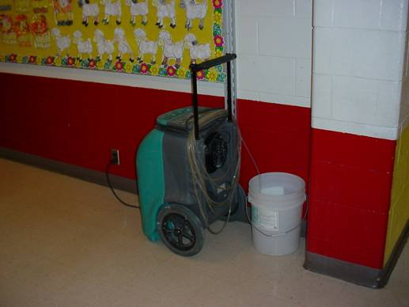

Dehumidifier in Hallway Draining into Bucket

Picture 2

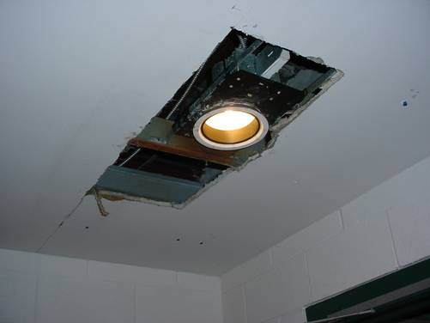

Water Damaged Gypsum Wallboard Ceiling Removed

Picture 3

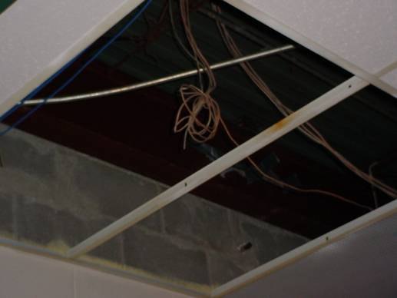

Water Damaged Ceiling Tiles Removed to Assist in Drying Plenum

Picture 4

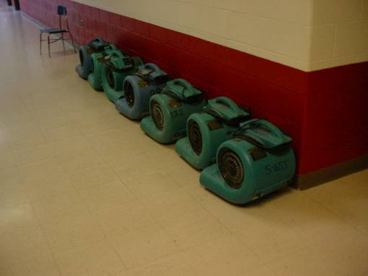

Industrial Drying Fans Stationed in Hallway
Picture 5

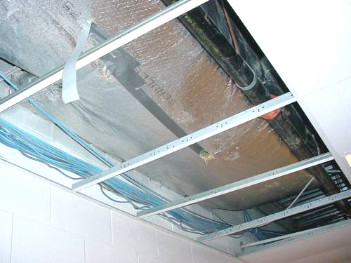

Wet Insulation in Main Hallway outside Computer Room, Note Hole in Bottom of Insulation
to Provide Drainage

Picture 6

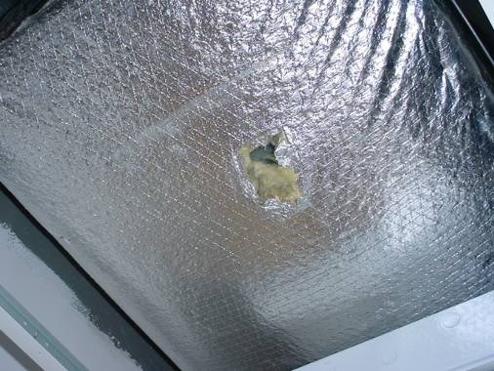

Water Damaged Insulation, Note Hole to Provide Drainage
Picture 7

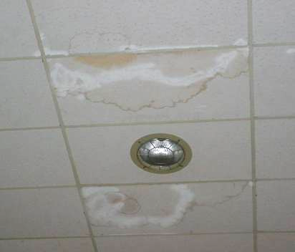

Water Damaged Ceiling Tiles in Cafeteria

Picture 8

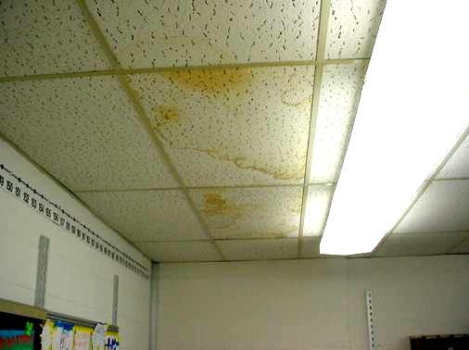

Water Damaged Ceiling Tiles in Classroom
Picture 9

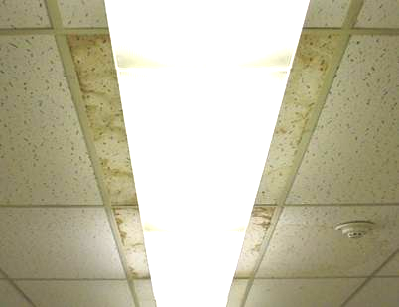

Water Damaged Ceiling Tiles in Classroom

Picture 10

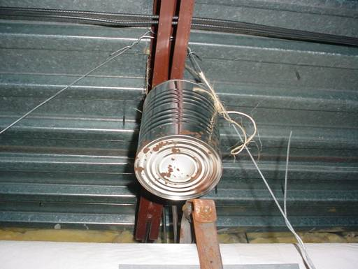

Paint Can Suspended above Ceiling Tile System to Collect Roof Leak
Picture 11

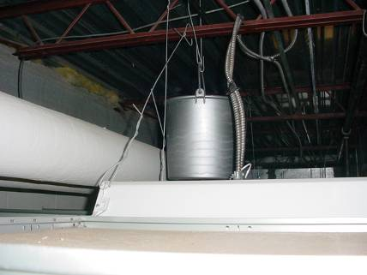

Bucket Suspended above Ceiling Tile System to Collect Roof Leak

Picture 12

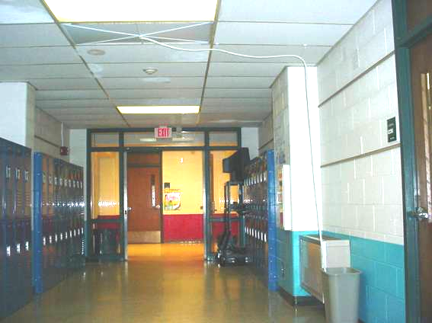

Interior Drainage System, Note Tile and Drainage Hose Empting into Trash Container on Floor

Table 1
Results of Datalogged Airborne Particulates (PM2.5)
J.W. Martin Elementary School
March 26, 2007

Location | PM2.5*  (µg/m3)
Kitchen | 30
Work Room/Teachers Lounge | 27
Food Service | 33
Reading Room | 23
Room 21 | 25
Room 25 | 19
Room 23 | 25
Room 06 | 23
Room R3 | 22
Room K5 | 22
Room K3 | 22
Hallway Stewart/Duso | 22
Duso Classroom | 23
Hallway Sullivan/Healey | 25
Hallway Charnley/Neves | 23
Doucette Classroom | 26
Hallway Doucette/Chisholm | 21
Chisholm | 18
Tannock | 19
Hallway Nurse/Leco | 20
Leco | 18
Frappier/Catullo | 23
Grade 1 Hallway | 27
Hallway Bannon/Murphy | 24
*US EPA proposed standard for fine airborne particles (PM2.5) standard requires outdoor air particulate levels be maintained below 35 μg/m³ over a 24-hour average (US EPA, 2006).

