INDOOR AIR QUALITY ASSESSMENT
ODOR INVESTIGATION

George R. Martin Elementary School
445 Cole Street
Seekonk, Massachusetts

Prepared by:
Massachusetts Department of Public Health
Bureau of Environmental Health
Indoor Air Quality Program
January 2022

Background
Building: | George R. Martin Elementary School (MES)
Address: | 445 Cole Street, Seekonk, MA
Assessment Coordinated Through: | Jim Roy, Supervisor, Buildings and  Grounds, Seekonk Public Schools (SPS)
Reason for Request: | Long-standing odor complaints in classroom B 226
Date of Assessment: | December 29, 2021
Massachusetts Department of Public Health/Bureau of Environmental Health (MDPH/BEH) Staff Conducting Assessment: | Cory Holmes, Assistant Director, Indoor  Air Quality (IAQ) Program
Building Description: | The MES is a one-story brick/concrete school that was built in 1968 with addition and renovations made over the years.
Windows: | Openable

BACKGROUND
The IAQ Program previously visited the MES in November and December of 2013 to investigate odor complaints and issued a report with recommendations, which is available at https://www.mass.gov/info-details/indoor-air-quality-reports-cities-and-towns-s#seekonk-. The unit ventilator (uninvent) in classroom B226 was fully replaced after this report was issued.

METHODS
MDPH staff conducted moisture measurements of porous building materials (i.e., gypsum wallboard and wood) as well as a visual assessment for water-damaged materials that could lead to mold growth. In addition, temperature, and relative humidity measurements, along with measurements for airborne pollutants (i.e., total volatile organic compounds, carbon monoxide and particulates) were taken to identify likely areas that could be prone to condensation in hot, humid weather. Please refer to the IAQ Manual for methods, sampling procedures, and interpretation of results (MDPH, 2015).

RESULTS AND DISCUSSION
The following is a summary of indoor air testing results (Tables 1 and 2):
- Temperature was within the MDPH recommended range of 70°F to 78°F.
- Relative Humidity was below the MDPH recommended range of 40 to 60%.
- Moisture Measurement of porous materials (i.e., gypsum wallboard and wood) prone to water damage/mold growth due to elevated relative humidity conditions were normal (i.e., dry) at the time of the assessment.
- Carbon Monoxide was not detected (ND) in the areas tested.
- Total Volatile Organic Compounds (TVOCs) were ND in the areas tested.
- Particulate Matter (PM2.5) concentrations measured were below the National Ambient Air Quality (NAAQS) level of 35 μg/m³ in the area tested.

Odor Investigation/Moisture Concerns
As mentioned previously, no elevated moisture measurements of porous materials along the exterior wall of classroom B 226 were noted nor were any signs of water infiltration, water damage and/or visual mold growth observed. When the former uninvent was removed, the interior wall cavity was examined. Mr. Roy reported that no obvious sources of mold-contaminated materials were present, however moisture infiltration through porous concrete exterior block was observed. As reported, the wet/musty odors are most prevalent after rainfall/wind-driven weather events. It is important to note that classroom B 226 is located at the southeast corner of the building where an addition forms a right angle that acts as a “pocket” to trap wind/moisture (Pictures 1 and 2). Therefore, it is most likely that the infiltration of moisture into the wall cavity through exterior concrete is the source of wet/musty odors.
As the univent draws air from the outdoors through a fresh air intake located on the exterior wall of the building (Figure 1, Pictures 2 and 3), it creates negative pressure that can also draw air from the wall cavity. If odors are being drawn from the wall cavity, they can be distributed via the univent fan and drawn across the classroom by the exhaust vent located near the hallway door (Picture 4).

Building Materials Prone to Condensation
It is important to note that Massachusetts has experienced extended periods of relative humidity during the summer of 2021. This July was the wettest ever recorded in Massachusetts, and the three-month period from June through August, known as the meteorological summer, was the fourth wettest on record, according to the National Oceanic and Atmospheric Administration’s (NOAA) Centers for Environmental Information. The three-month period also was the third warmest ever in the state and was tied for the warmest on record across the United States (HG, 2021, NOAA, 2021).
The key to managing condensation in hot, humid weather indoors is understanding dew point. When warm, moist air passes over a cooler surface, condensation can form. Condensation is the collection of moisture on a surface at or below the dew point. The dew point is the temperature that air must reach for saturation to occur. If a building material/component has a temperature below the dew point, condensation will accumulate on that material. Over time, condensation can collect and form water droplets.
A method to locate areas in a building prone to condensation would be to measure air and building material temperatures using a laser thermometer (Table 2). If a wide temperature range exists between measurements, the building materials at the colder end of the range may be prone to becoming moistened with condensation if exposed to hot, humid weather (outdoor relative humidity >70%) for extended periods of time (at least 48 hours). According to the test results at the time of assessment (Table 1), the areas examined did not appear to be prone to condensation.

CONCLUSIONS AND RECOMMENDATIONS
In view of the findings at the time of the visit, the following recommendations are made:

- Continue with plans to waterproof exterior concrete to prevent moisture infiltration.
- Consider working with a building envelope specialist to examine methods of preventing water infiltration and a heating, ventilation, and air conditioning (HVAC) engineering firm to determine if the univent cabinets can be rendered airtight as to not draw air from the wall cavities.
- Operate all supply and exhaust ventilation equipment continuously during occupied periods.
- Change filters for HVAC equipment 2-4 times a year using the best quality/highest Minimum Efficiency Reporting Value (MERV) rated filters that can be used with current equipment. Note, pleated filters of a MERV 8 or higher are adequate in filtering out pollen and mold spores (ASHRAE, 2012).
- For more information about mold, consult the US EPA’s “Mold Remediation in Schools and Commercial Buildings” (US EPA, 2008). Available at: http://www.epa.gov/mold/mold-remediation-schools-and-commercial-buildings-guide.
- The U.S. Department of Education has released new guidance encouraging the use of American Rescue Plan (ARP) funds to improve ventilation systems and make other indoor air quality improvements in schools. More information can be found at this link https://www.ed.gov/coronavirus/improving-ventilation.
- Consider forming an IAQ committee in each school building district wide. Committees should have an IAQ liaison/teacher representative, a member of maintenance/facilities and administration that conduct regular walk-throughs to identify on-going and/or potential environmental issues.
- Consider adopting the US EPA (2000) document, “Tools for Schools”, as an instrument for maintaining a good IAQ environment in the building available at: https://www.epa.gov/iaq-schools/indoor-air-quality-tools-schools-action-kit
- Refer to resource manual and other related IAQ documents located on the MDPH’s website for further building-wide evaluations and advice on maintaining public buildings. These documents are available at: http://mass.gov/dph/iaq.

REFERENCES
ASHRAE. 2012. American Society of Heating, Refrigeration and Air Conditioning Engineers (ASHRAE) Standard 52.2-2012 -- Method of Testing General Ventilation Air-Cleaning Devices for Removal Efficiency by Particle Size (ANSI Approved).
HG. 2021. Mold keeps South Hadley High School shuttered. Hampshire Gazette. https://www.gazettenet.com/South-Hadley-High-School-still-closed-amid-mold-remediation-42413519.
MDPH. 2015. Massachusetts Department of Public Health. “Indoor Air Quality Manual: Chapters I-III”. Available at: https://www.mass.gov/lists/indoor-air-quality-manual-and-appendices#indoor-air-quality-manual-
NOAA. 2021. Summer 2021 neck and neck with Dust Bowl summer for hottest on record. National Oceanic and Atmospheric Administration, 1401 Constitution Avenue NW, Room 5128, Washington, DC 20230 https://www.noaa.gov/news/summer-2021-neck-and-neck-with-dust-bowl-summer-for-hottest-on-record
US EPA. 2000. Tools for Schools. Office of Air and Radiation, Office of Radiation and Indoor Air, Indoor Environments Division (6609J). EPA 402-K-95-001, Second Edition. https://www.epa.gov/iaq-schools/indoor-air-quality-tools-schools-action-kit
US EPA. 2008. “Mold Remediation in Schools and Commercial Buildings”. Office of Air and Radiation, Indoor Environments Division, Washington, DC. EPA 402-K-01-001. September 2008. Available at: http://www.epa.gov/mold/mold-remediation-schools-and-commercial-buildings-guide.

Figure 1

Unit Ventilator (Univent)

Mixed Air

Air Diffuser

Outdoors Indoors

Fan

Heating/Cooling Coil

Air Mixing Plenum

Filter

Outdoor Return
Air Air

Air
Flow
Control
Louvers

Air Flow

= Fresh Air/Return Air

= Mixed Air

Picture 1

Classroom B226 (arrow) on southeast corner of building

Picture 2

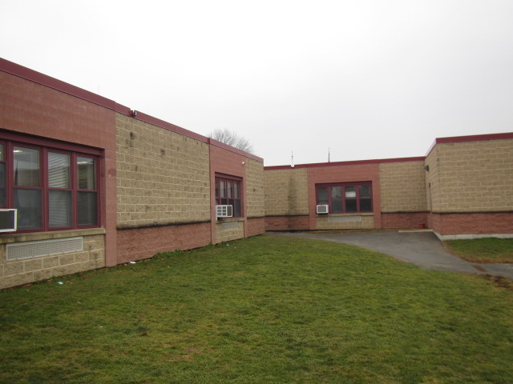

Classroom B226 (arrow) on southeast corner of building, Note univent fresh air intake beneath window

Picture 3

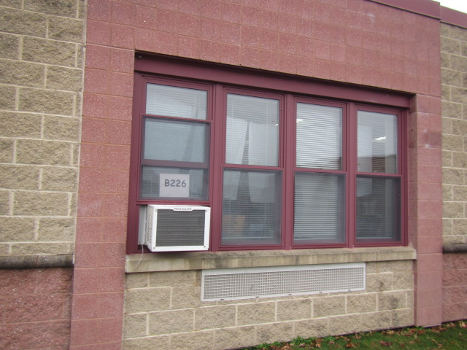

Univent fresh air intake for classroom B226

Picture 4
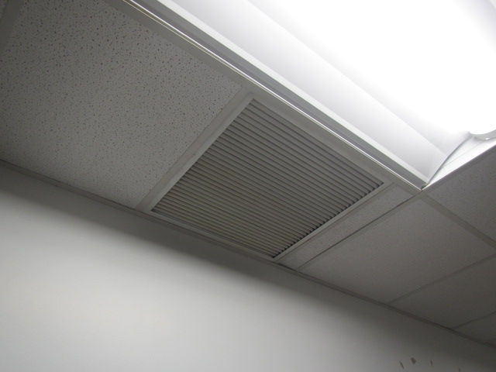

Ceiling-mounted exhaust vent in classroom B226

Location | Air Temp  (ºF) | Relative Humidity  (%) | Dew Point  (%) | Floor Temp  (ºF) | Temp at Floor/ Exterior Wall Junction  (ºF) | Water-Damaged Ceiling Tiles-stained  (#) | Water- Damaged  Bowed Ceiling Tile  (#) | Ventilation |  |  | Floor to Air Temp  Difference  (ºF) | Comments
 |  |  |  |  |  |  |  | Windows openable | Supply | Exhaust
Background (outdoors) | 54 | 44 | 31
B226 | 71 | 35 | 42 | 69 | 68 | N | N | Y | Y | Y  Off | 2 | No visible water damage or visible mold growth, slight musty odor, moisture measurements of walls and wooden shelving normal (i.e., dry), room clean and dry
B225 | 71 | 30 | 38 | 68 | 61 | N | N | Y | Y | Y | 3 | No visible water damage or visible mold growth, slight musty odor, moisture measurements of walls and wooden shelving normal (i.e., dry), room clean and dry

Location | Carbon Monoxide  (ppm) | Temp  (°F) | Relative  Humidity  (%) | PM2.5  (µg/m³) | TVOCs | Windows  Openable | Ventilation |  | Remarks
 |  |  |  |  | (ppm) |  | Supply | Exhaust
Background  (outdoors) | ND | 54 | 44 | 21 | ND
B226 | ND | 71 | 35 | 10 | ND | Y | Y | Y | DEM, exhaust vent not functioning (relay control reportedly burned out)
B225 | ND | 71 | 30 | 12 | ND | Y | Y | Y | DEM

