INDOOR AIR QUALITY ASSESSMENT

Martin Luther King Jr. Charter School of Excellence
285 Dorset Street
Springfield, Massachusetts

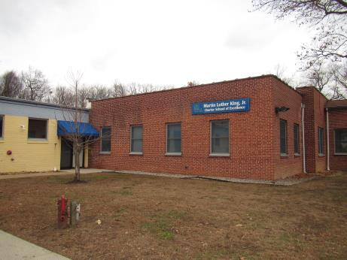

Prepared by:
Massachusetts Department of Public Health
Bureau of Environmental Health
Indoor Air Quality Program
December 2018

BACKGROUND
Building: | Martin Luther King Charter School of Excellence (MLKCS)
Address: | 285 Dorset Street, Springfield, Massachusetts
Assessment Requested by: | Natalie Bys, Director of Operations, MLKCS
Reason for Request: | General indoor air quality (IAQ) concerns, with a focus on water damage/mold.
Date of Assessment: | November 28, 2018
Massachusetts Department of Public Health/Bureau of Environmental Health (MDPH/BEH) Staff Conducting Assessment: | Ruth Alfasso, Environmental Engineer/Inspector, IAQ Program
Date of Building Construction: | Originally built in the 1950s as a warehouse, occupied areas were fully renovated in 2010 prior to the school occupying the space.
Building Description: | MLKCS is a one-story brick and concrete building originally built as a warehouse. A portion of the building remains unfinished at this time. The school is built on a concrete slab.
Windows: | Openable

METHODS
Please refer to the IAQ Manual and appendices for methods, sampling procedures, and interpretation of results (MDPH, 2015).

RESULTS and DISCUSSION
The following is a summary of indoor air testing results (Table 1).
- Carbon dioxide levels were above the MDPH recommended level of 800 parts per million (ppm) in all areas surveyed, which can indicate a lack of air exchange at the time of assessment.
- Temperature was within the MDPH recommended range of 70°F to 78°F in all occupied areas tested.
- Relative humidity was below the MDPH recommended range of 40 to 60% in areas tested the day of assessment.
- Carbon monoxide levels were non-detectable (ND) in all areas tested.
- Particulate matter (PM2.5) concentrations measured were below the National Ambient Air Quality (NAAQS) level of 35 μg/m³ in all but two areas tested.

Ventilation
A heating, ventilating and air conditioning (HVAC) system has several functions. First it provides heating and, if equipped, cooling. Second, it is a source of fresh air. Finally, an HVAC system will dilute and remove normally-occurring indoor environmental pollutants by not only introducing fresh air, but by filtering the airstream and ejecting stale air to the outdoors via exhaust ventilation. Even if an HVAC system is operating as designed, point sources of respiratory irritation may exist and cause symptoms in sensitive individuals.

Fresh air in classrooms, offices and common areas is supplied by air-handling units (AHUs) located on the roof of the building. Fresh air is provided by ceiling-mounted diffusers connected to the AHUs by ductwork (Picture 1). Exhaust ventilation is provided by ceiling-mounted exhaust grilles ducted back to AHUs. Note that in most areas, supply and exhaust vents are the same design, so it was difficult to determine which vents were which and/or if there are any areas without supply or return flow. It was reported that the HVAC system supplies both heat and cooling.

To maximize air exchange, BEH recommends that both supply and exhaust ventilation operate continuously during periods of occupancy. In order to have proper ventilation with a mechanical ventilation system, the systems must be balanced after installation to provide an adequate amount of fresh air to the interior of a room while removing stale air from the room. It is recommended that HVAC systems be re-balanced every five years to ensure adequate air systems function (SMACNA, 1994). It is not known when the HVAC system was last balanced.

Microbial/Moisture Concerns
Water-damaged ceiling tiles were observed in a number of areas (Pictures 2 and 3). These mostly stem from recent leaks, as older stained tiles in most areas are changed out promptly. Leaks in most areas are from the roof, which is known to be in need of significant repair or replacement. An area of concern above the ceiling tile system (called the ceiling plenum) in rooms 22 and 24was examined (Pictures 4 and 5). The ceiling plenum is a mostly-open space to the roof decking without insulation or other porous materials to trap water which appeared dry, free of debris, and had no moldy odors. Many water-damaged tiles and recent leaks were reported in the multi-purpose room (used as gym, Picture 3) as well as in the cafeteria. Although leaks in these areas continue to occur, the materials such as flooring in these rooms are not porous or likely to become colonized with mold.
A significant leak had occurred from the roof/exterior wall seam in rooms 42 and 43 during the past summer. After this leak was discovered, a water damage remediation company was contracted by school officials to determine what building materials were moistened and to begin remediation. School officials reported that a large section of wall board was removed and replaced in these rooms. The roof was also patched and no leaks have been reported there since the repairs were complete. No water-damaged materials or moldy odors were observed in those areas.
It is likely that the building slab floor is prone to condensation during hot, humid weather. This condition can contribute to moisture build up in the building. During hot, humid weather if the air conditioning is not operating and there is a source of outside air (e.g. open doors), moisture can condense on floors that are colder than the air. Therefore, no porous items should be on the floors, including boxes and papers.
In order for mold growth to occur, materials must be exposed to chronic moisture. Relative humidity in excess of 70 percent for extended periods of time, even in the absence of other sources of water, can provide an environment for mold and fungal growth (ASHRAE, 1989). In general, the US Environmental Protection Agency (US EPA) and the American Conference of Governmental Industrial Hygienists (ACGIH) recommends that porous materials (e.g., GW, carpeting) be dried with fans and heating within 24 to 48 hours of becoming wet (US EPA, 2008; ACGIH, 1989). If porous materials are not dried within this time frame, mold growth may occur.
The outside of the building was examined for conditions that may lead to water infiltration. Leaves and other debris were found against the sides of the building (Picture 6) which can hold moisture and eventually damage the foundation. Bricks and cement blocks were in poor condition in a few areas (Pictures 7 and 8) which can lead to increased penetration of water especially during driving rain. Falling bricks are also a safety hazard.
In several areas, downspouts end along the bottom edge of the building, which will allow water to drain at the foundation (Picture 9). Downspouts should have extensions to drain water away from the building. Nearby trees that overhang the roof can prevent drying and can be a source of leaves in gutters. Some doors to the outside lacked weather-stripping (Picture 10) which will allow unconditioned air, moisture and pests into the building.
Note that a portion of the building is not currently used for the school and is still in the original condition as a former warehouse. This area is used for storage and is heated, but is not otherwise conditioned or occupied. The door between this portion of the building and the occupied portion should be made as airtight as any door to the outside. In addition, there are broken and boarded up windows in this portion of the building (Pictures 11 and 12). These should be examined periodically to make sure any temporary repairs continue to be weather-tight.
Storage in this area should be improved to include the removal of piles of boxes and other porous materials (Picture 13) that can become harborage for pests. Items stored in this area should be periodically examined for the presence of moisture, mold, odors and debris, and cleaned as necessary before being used in the school. There are abandoned restrooms in the unoccupied portion of the building (Picture 14). Plumbing and drains in unoccupied areas should be properly shut off, sealed, or cut/capped to prevent leaks and the infiltration of sewer gas through dry drain traps.

Other Conditions
Exposure to low levels of total volatile organic compounds (TVOCs) may produce eye, nose, throat, and/or respiratory irritation in some sensitive individuals. Levels of TVOCs measured in the building were not detected (below the detection level of the instrument) at the time of the assessment. BEH/IAQ staff also examined rooms for products containing VOCs. BEH/IAQ staff noted hand sanitizers, cleaners and dry erase materials in use within the building (Picture 15; Table 1). These products have the potential to be irritants to the eyes, nose, throat, and respiratory system of sensitive individuals.
An air purifier in one of the offices listed “Plasma Wave” technology, which may mean it produces ozone. Ozone is a respiratory irritant and should be minimized in occupied spaces. Air purifiers also have filters that need to be cleaned or changed in accordance with manufacturer’s instructions.
In some classrooms, tennis balls had been sliced open and placed on table/chair footings to reduce noise (Table 1). Tennis balls are made of a number of materials that are a source of respiratory irritants. Constant wearing of tennis balls can produce fibers and lead to off-gassing of VOCs. Tennis balls are made with a natural rubber latex bladder, which becomes abraded when used as a chair leg pad. Use of tennis balls in this manner may introduce latex dust into the school environment. Some individuals are highly allergic to latex (e.g., spina bifida patients) (SBAA, 2001). It is recommended that the use of materials containing latex be limited in buildings to reduce the likelihood of symptoms in sensitive individuals (NIOSH, 1997; NIOSH, 1998).
During the assessment, two areas had measurements above the NAAQS for PM 2.5 (Table 1). The elevated PM2.5 could be attributed to the operation of the copy machine in this area, and/or a fragrance diffuser in one of the offices. The use of oil diffusers and other scented products is not recommended since these products can cause eye, nose and respiratory system irritation. Copy machines can produce odors, particulate matter and ozone, especially older units and those that are used heavily. When possible, copy machines should be located away from occupants and in areas with exhaust ventilation.
In some areas, supply and exhaust vents were dusty. Some ceiling tiles were also dusty especially near vents (Picture 16). This dust can be reaerosolized under certain conditions, and can also be a medium for mold growth. Note that the ceiling tiles shown in Picture 16 are a fibrous acoustic type which is more difficult to change or clean.
Area rugs were observed in most classrooms and carpeting was present in some rooms and offices (Picture 17; Table 1). Carpets should be cleaned annually (or semi-annually in soiled/high traffic areas) in accordance with Institute of Inspection, Cleaning and Restoration Certification (IICRC) recommendations, (IICRC, 2012). Regular cleaning with a high efficiency particulate air (HEPA) filtered vacuum in combination with an annual cleaning will help to reduce accumulation and potential aerosolization of materials from carpeting. Area carpets too worn to be effectively cleaned should be replaced. Area rugs should be rolled up and stored in a clean, dry place in rooms that are not occupied during the summer months to prevent moistening due to condensation. Upholstered items and pillows/stuffed toys in classrooms should also be cleaned regularly.
Note that the Environmental Protection Agency (EPA) conducted a National School Radon Survey in which it discovered nearly one in five schools had “…at least one frequently occupied ground contact room with short-term radon levels above 4 [picocuries per liter] pCi/L” (US EPA 1993). The BEH/IAQ Program therefore recommends that every school be tested for radon, and that this testing be conducted during the heating season while school is in session in a manner consistent with USEPA radon testing guidelines. Radon measurement specialists and other information can be found at www.nrsb.org and http://aarst-nrpp.com/wp, with additional information at: http://www.mass.gov/eohhs/gov/departments/dph/programs/environmental-health/exposure-topics/iaq/radon.

RECOMMENDATIONS
In view of the findings at the time of the visit, the following recommendations are made:
- Continue with efforts to fund roof repair/replacement.
- Operate the HVAC system to provide for continuous fresh air ventilation during occupied hours. Ensure fresh air intake louvers are functioning properly to adjust outside air intake. Make adjustments/repairs as needed.
- Ensure that supply and exhaust vents are present in each room, given the identical style of vent which makes this hard to determine visually.
- Use openable windows to supplement fresh air during temperate weather. Ensure all windows are closed tightly at the end of each day. Also ensure that windows are closed when air conditioning is operating to prevent condensation.
- Ensure all exhaust vents are operating continuously during occupied periods.
- Adopt a system to report and track maintenance issues such as broken univents, leaks and cleaning issues so that concerns can be reported by the staff that observes them, and maintenance staff can report when the issues have been resolved.
- Consider adopting a balancing schedule of every 5 years for all mechanical ventilation systems, as recommended by ventilation industrial standards (SMACNA, 1994).
- For buildings in New England, periods of low relative humidity during the winter are often unavoidable. Therefore, scrupulous cleaning practices should be adopted to minimize common indoor air contaminants whose irritant effects can be enhanced when the relative humidity is low. To control for dusts, a high efficiency particulate arrestance (HEPA) filter equipped vacuum cleaner in conjunction with wet wiping of all surfaces is recommended. Avoid the use of feather dusters. Drinking water during the day can help ease some symptoms associated with a dry environment (throat and sinus irritations).
- Replace water-damaged ceiling tiles once leaks are repaired. Inspect the area above the stained tiles for water damage or odors and remediate or clean as necessary.
- Avoid placing porous items in areas with known or suspected leaks. Avoid placing porous items on the floor in areas subject to condensation.
- Remove or remediate/clean other water-damaged materials.
- Remove plants and debris/leaves from within five feet of the edge of the building and especially around air intakes and windows. Trim trees from overhanging the roof.
- Make plans to address brick deterioration; take immediate steps to prevent falling loose bricks.
- Repair downspouts and gutters. Keep them free of debris to improve drainage.
- Ensure all doors to the exterior or between occupied and unoccupied areas are weather-tight and kept closed. Monitor for light and drafts periodically.
- Ensure the building envelope, including windows, into the unoccupied space provide an intact barrier against moisture and pests.
- Keep stored materials in the unoccupied space organized and discard unneeded items, particularly porous items. Inspect any items brought from storage into occupied areas for odors, dusts and pests and clean when necessary.
- Ensure the unused plumbing in the unoccupied area is properly decommissioned or sealed to prevent leaks and infiltration of sewer gases.
- Reduce or eliminate the use of air fresheners, scented cleaners, hand sanitizers and dry erase materials to reduce irritation.
- Use photocopiers and laminators in well-ventilated areas.
- Avoid the use of air purifiers that may produce ozone. Ensure other air purifiers are well maintained and cleaned in accordance with manufacturer’s instructions.
- Replace tennis balls on chair/table footings with latex-free glides.
- Keep cooking equipment clean and any food tightly sealed to prevent attracting pests.
- Clean classroom items regularly with a wet cloth or sponge to prevent excessive dust build-up.
- Clean supply and exhaust vents and fans regularly to remove dust build up that may lead to odors when heated. If soiled ceiling tiles around vents cannot be adequately cleaned, replace.
- Clean carpeting and rugs at least once per year according to IICRC recommendations (IICRC 2012). Area carpets too worn to be effectively cleaned should be replaced. Roll up and store are rugs in a clean, dry place during the summer
- Clean upholstered items and pillows/stuffed toys regularly.
- Ensure filters for AHUs are of a pleated variety, Minimum Efficiency Reporting Value (MERV) dust-spot efficiency 8 or higher, which are adequate in filtering out pollen and mold spores (ASHRAE, 2012). Filters should be changed 2-4 times a year. If filters have large accumulations of dust when changed, increase frequency.
- Consider adopting the US EPA (2000) document, “Tools for Schools”, as an instrument for maintaining a good IAQ environment in the building available at: http://www.epa.gov/iaq/schools/index.html.
- The school should be tested for radon by a certified radon measurement specialist during the heating season when school is in session. Radon measurement specialists and other information can be found at: www.nrsb.org, and http://aarst-nrpp.com/wp.
- Refer to resource manuals and other related IAQ documents for further building-wide evaluations and advice on maintaining public buildings. Copies of these materials are located on the MDPH’s website: http://mass.gov/dph/iaq.

REFERENCES
ACGIH. 1989. Guidelines for the Assessment of Bioaerosols in the Indoor Environment. American Conference of Governmental Industrial Hygienists, Cincinnati, OH.
ASHRAE. 2012. American Society of Heating, Refrigeration and Air Conditioning Engineers (ASHRAE) Standard 52.2-2012 -- Method of Testing General Ventilation Air-Cleaning Devices for Removal Efficiency by Particle Size (ANSI Approved). 2012.
IICRC. 2012. Institute of Inspection Cleaning and Restoration Certification. Institute of Inspection, Cleaning and Restoration Certification. Carpet Cleaning: FAQ.
MDPH. 2015. Massachusetts Department of Public Health. Indoor Air Quality Manual: Chapters I-III. Available at: http://www.mass.gov/eohhs/gov/departments/dph/programs/environmental-health/exposure-topics/iaq/iaq-manual/.
NIOSH. 1997. National Institute for Occupational Safety and Health. Alert Preventing Allergic Reactions to Natural Rubber latex in the Workplace. National Institute for Occupational Safety and Health, Atlanta, GA.
NIOSH. 1998. National Institute for Occupational Safety and Health. Latex Allergy A Prevention. National Institute for Occupational Safety and Health, Atlanta, GA.
SBAA. 2001. Latex In the Home And Community Updated Spring 2001. Spina Bifida Association of America, Washington, DC.
SMACNA. 1994. HVAC Systems Commissioning Manual. 1st ed. Sheet Metal and Air Conditioning Contractors’ National Association, Inc., Chantilly, VA.
US EPA. 1993. Radon Measurement in Schools, Revised Edition. Office of Air and Radiation, Office of Radiation and Indoor Air, Indoor Environments Division (6609J). EPA 402-R-92-014. https://www.epa.gov/sites/production/files/2014-08/documents/radon_measurement_in_schools.pdf
US EPA. 2000. Tools for Schools. Office of Air and Radiation, Office of Radiation and Indoor Air, Indoor Environments Division (6609J). EPA 402-K-95-001, Second Edition. http://www.epa.gov/iaq/schools/index.html.
US EPA. 2008. Mold Remediation in Schools and Commercial Buildings. US Environmental Protection Agency, Office of Air and Radiation, Indoor Environments Division, Washington, D.C. EPA 402-K-01-001. http://www.epa.gov/mold/mold-remediation-schools-and-commercial-buildings-guide.

Picture 1
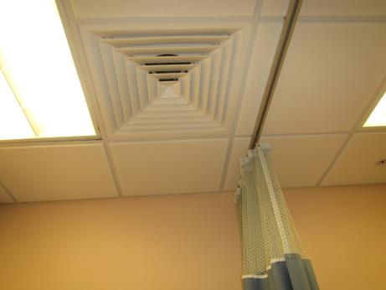
Typical supply/exhaust vent in the building
Picture 2
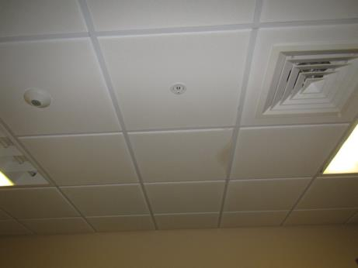
Water-damaged ceiling tile
Picture 3
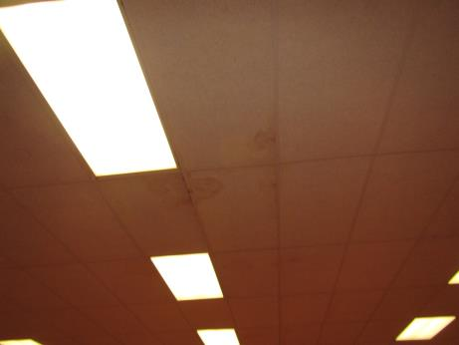
Multiple water-damaged ceiling tiles in the multi-purpose room
Picture 4
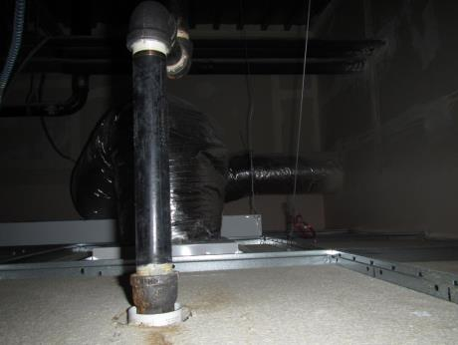
Area above ceiling tile system in room 22
Picture 5
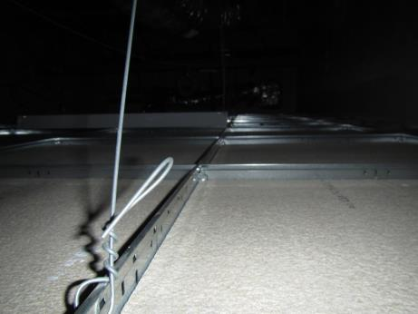
Area above ceiling tile system in room 24
Picture 6
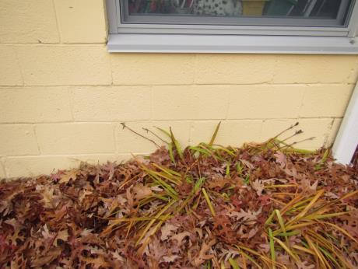
Leaves and plants against the foundation
Picture 7
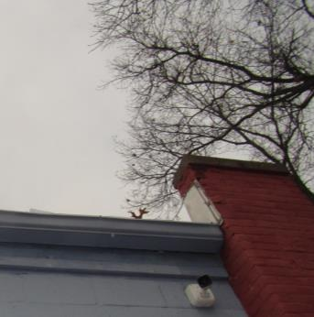
Damaged bricks
Picture 8
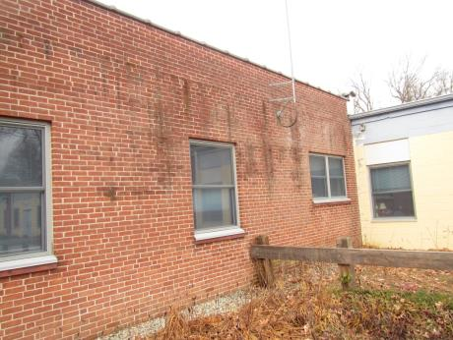
Damaged brickwork
Picture 9
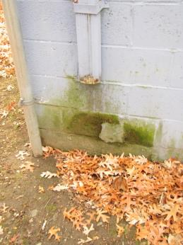
Downspout draining against the building
Picture 10
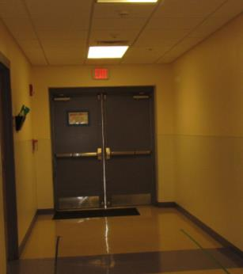
Light visible around door to the outside
Picture 11
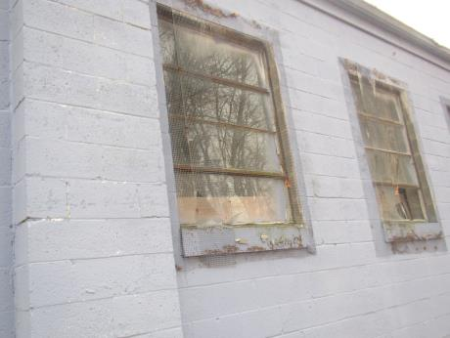
Broken windows on the outside of the unoccupied portion
Picture 12
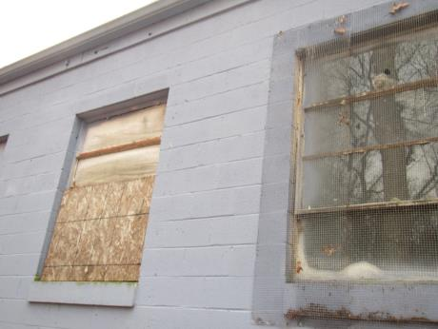
Boarded up window outside the unoccupied portion
Picture 13
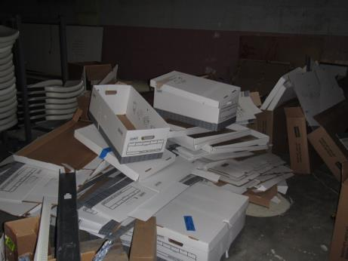
Haphazard pile of stored boxes in the unoccupied portion of the building
Picture 14
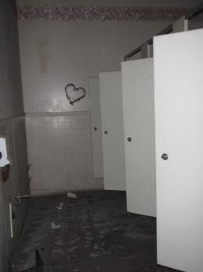
Abandoned restroom in the unoccupied portion of the building
Picture 15
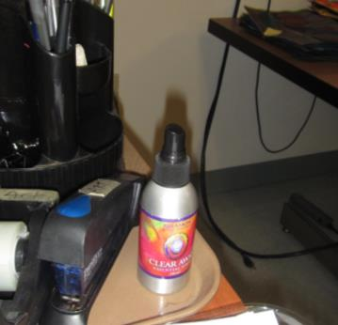
Scented product in a classroom
Picture 16
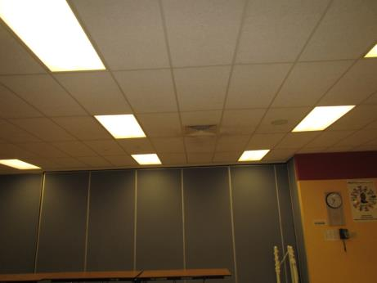
Dusty vent and ceiling tiles
Picture 17
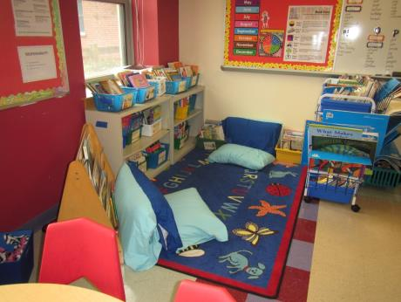
Carpet and pillows

Location | Carbon  Dioxide  (ppm) | Carbon Monoxide  (ppm) | Temp  (°F) | Relative  Humidity  (%) | PM2.5  (µg/m³) | Occupants  in Room | Windows  Openable | Ventilation |  | Remarks
 |  |  |  |  |  |  |  | Supply | Exhaust
Background/  Outdoors | 437 | ND | 55 | 28 | ND |  |  |  |  | Breezy and cloudy
21 nurse | 975 | ND | 71 | 34 | ND | 2 | Y | Y | Y | Personal fan, NC
nurse’s restroom |  |  |  |  |  |  |  |  |  | leaks in this room
20 | 815 | ND | 73 | 31 | 1 | 1 | N | Y | N | DO, carpet
23 | 938 | ND | 72 | 32 | 3 | 6 | N | Y | Y | DEM, carpet, fridge, hand sanitizer
22 | 911 | ND | 72 | 31 | 3 | 0 | N | Y | Y | WD CT, DEM
24 | 964 | ND | 73 | 30 | 5 | 4 | N | Y | Y | DEM
25 | 1018 | ND | 72 | 32 | 4 | 4 | N | Y | Y | WD CT, area rug, sink
26 | 952 | ND | 72 | 32 | 1 | 0 | N | Y | Y | NC, 2 copiers, laminator, DO
27 Kindergarten | 972 | ND | 72 | 31 | ND | 18 | Y | Y | Y | area rug, DEM, HS, has restroom inside
28 Kindergarten | 970 | ND | 73 | 29 | 2 | 23 | Y | Y | Y | has restroom inside, pillows, DEM, area rug
29 Kindergarten | 974 | ND | 73 | 29 | ND | 21 | Y | Y | Y | area rug, has restroom inside, DEM
30 1st grade | 922 | ND | 71 | 29 | ND | 15 | Y | Y | Y | area rug, door, sink
31 1sr grade | 928 | ND | 71 | 30 | ND | 19 | Y | Y | Y | sink, area rug, door, DEM
Boys restroom |  |  |  |  |  |  | N | Y | Y | dusty exhaust
32 1st grade | 941 | ND | 71 | 30 | 2 | 12 | Y | Y | Y | door, sink, area rug
33 2nd grade | 902 | ND | 71 | 30 | ND | 16 | Y | Y | Y | TBs, area rug, DEM, sink, HS
Staff restroom |  |  |  |  |  |  | N | Y | Y | scent
Girls restroom |  |  |  |  |  |  | N | Y | Y
34 2nd grade | 875 | ND | 71 | 30 | ND | 16 | Y | Y | Y | sink, area rug, DEM, food
35 | 877 | ND | 70 | 29 | ND | 18 | Y | Y | Y | sink, area rug
36 | 914 | ND | 71 | 31 | ND | 2 | Y | Y | Y | TBs, area rug, CP, DEM
37 | 1089 | ND | 72 | 31 | ND | 1 | Y | Y |  | DEM, area rug, TBs
61 media center | 919 | ND | 71 | 30 | ND | 2 | N | Y | Y | NC, DEM, HS
61A media center office | 907 | ND | 71 | 30 | ND | ND | N | Y | Y | vent split from media center
38 3rd grade | 1239 | ND | 72 | 34 | ND | 16 | Y | Y | Y | DEM, NC, sink
39 4th grade | 1094 | ND | 73 | 33 | 1 | 21 | Y | Y | Y | Area rug, sink, DEM
59 computers | 910 | ND | 72 | 28 | ND | 7 | N | Y | Y | NC, computers
54 | 931 | ND | 71 | 29 | ND | 0 | N | Y | Y | area rug, DEM, HS
55 | 944 | ND | 72 | 30 | 1 | 0 | N | Y | Y | HS
56 | 972 | ND | 71 | 30 | ND | 4 | N | Y | Y | DEM, area rug, fridge
60 art | 950 | ND | 71 | 32 | 1 | 21 | N | Y | Y | NC, art supplies, DEM
53 | 950 | ND | 72 | 31 | ND | 0 | N | Y | Y | staff lounge, vending
40 4th grade | 1209 | ND | 74 | 32 | 3 | 20 | N | Y | Y | DEM, area rug
41 4th grade | 1158 | ND | 74 | 32 | 0 | 19 | N | Y | Y | TBs, DEM, area rug
51 staff restroom |  |  |  |  |  |  | N | N | Y | cleaner odor
42 | 1050 | ND | 72 | 30 | 1 | 18 | Y | Y | Y | area rug, DEM, area of leak by windows
43 | 1051 | ND | 72 | 31 | ND | 20 | Y | Y | Y | area of leak near windows, DEM, area rug, sink
boy’s restroom |  |  |  |  |  |  | N | Y | Y | water leak in light
16A | 912 | ND | 75 | 29 | 69 | 1 | Y | Y | Y
lobby | 877 | ND | 74 | 29 | 30 | 0 | Door | Y | Y | Walk-off mat, ceramic floor tiles
reception | 857 | ND | 74 | 28 | 40 | 2 | N | Y | Y
18B | 865 | ND | 73 | 28 | 16 | 1 | Y | Y | Y
18C | 858 | ND | 73 | 28 | 16 | 0 | Y | Y | Y | AT and WD CT

