INDOOR AIR QUALITY ASSESSMENT

Martin Luther King Jr. Charter School of Excellence
285 Dorset Street
Springfield, Massachusetts

Prepared by:
Massachusetts Department of Public Health
Bureau of Climate Change and Environmental Health
Indoor Air Quality Program
October 2023

BACKGROUND
Building: | Martin Luther King Charter School of Excellence (MLKCS)
Address: | 285 Dorset Street, Springfield, Massachusetts
Assessment Requested by: | Erika Brown, Human Resources & Business Manager, MLKCS
Reason for Request: | General indoor air quality (IAQ) concerns, with a focus on water damage/mold
Date of Assessment: | April 28, 2023
Massachusetts Department of Public Health/Bureau of Climate and Environmental Health (MDPH/BCEH) Staff Conducting Assessment: | Mike Feeney, Director, IAQ Program
Date of Building Construction: | Originally built in the 1950s as a warehouse, occupied areas were fully renovated in 2010 prior to the school occupying the space.
Building Description: | MLKCS is a one-story brick and concrete building on a concrete slab.
Windows: | Openable

METHODS
Please refer to the IAQ Manual and appendices for methods, sampling procedures, and interpretation of results (MDPH, 2015).
Note that this building was previously visited by the DPH IAQ program in 2018. That report can be viewed at https://www.mass.gov/info-details/indoor-air-quality-reports-cities-and-towns-s#springfield-.

RESULTS and DISCUSSION
The following is a summary of indoor air testing results (Table 1).
- Carbon dioxide levels were above the MDPH recommended guideline of 800 parts per million (ppm) in more than half of areas surveyed, which indicates a lack of air exchange in many areas at the time of assessment.
- Temperature was within the MDPH recommended range of 70°F to 78°F in all areas tested.
- Relative humidity was within the MDPH recommended range of 40 to 60% in areas tested.
- Carbon monoxide levels were measured at 3 to 8 ppm in occupied areas. Outdoors, levels were measured at 26 ppm. Further investigation suggests that this may have been instrument error. This is discussed further below.
- Particulate matter (PM2.5) concentrations measured were below the National Ambient Air Quality (NAAQS) level of 35 μg/m³ in all areas tested.

Ventilation
A heating, ventilating, and air conditioning (HVAC) system has several functions. First it provides heating and, if equipped, cooling. Second, it is a source of fresh air. Finally, an HVAC system will dilute and remove normally occurring indoor environmental pollutants by not only introducing fresh air, but by filtering the airstream and ejecting stale air to the outdoors via exhaust ventilation. Even if an HVAC system is operating as designed, point sources of respiratory irritation may exist and cause symptoms in sensitive individuals.
Fresh air in classrooms, offices, and common areas is supplied by air-handling units (AHUs) located on the roof of the building. Fresh air is provided by ceiling-mounted diffusers connected to the AHUs by ductwork (Picture 1). Exhaust ventilation is provided by ceiling-mounted exhaust grilles ducted back to AHUs. It was reported that the HVAC system supplies both heat and cooling. Both supply and exhaust vents appear to be the same style, making it difficult to determine whether every classroom had both a supply and exhaust vent.
To maximize air exchange, the BCEH/IAQ Program recommends that both supply and exhaust ventilation operate continuously during periods of occupancy. In order to have proper ventilation with a mechanical ventilation system, the systems must be balanced after installation to provide an adequate amount of fresh air to the interior of a room while removing stale air from the room. It is recommended that HVAC systems be re-balanced every five years to ensure adequate air systems function (SMACNA, 2013). It is not known when the HVAC system was last balanced.

Microbial/Moisture Concerns
Water-damaged ceiling tiles were observed in a few classrooms (Table 1). Water-damaged ceiling tiles should be removed and replaced once the source of the leak has been mitigated. During replacement, the area above the ceiling tiles should be examined for additional water damage, and the presence of mold.
It is likely that the building slab floor is prone to condensation during hot, humid weather. This condition can contribute to moisture buildup in the building. During hot, humid weather if the air conditioning is not operating and there is a source of outside air (e.g. open doors), moisture can condense on floors that are colder than the air. Therefore, no porous items should be on the floors, including boxes and papers.
Exposure to hot, humid weather is also indicated by the presence of sagging or bowed ceiling tiles in some classrooms (Picture 2; Table 1). During periods of humid weather, the materials in ceiling tiles become slightly moistened and this weakens them, allowing them to sag in the ceiling tile grid. While this damage does not directly lead to mold growth, it is an indicator that caution should be taken with porous materials in these areas.
In order for mold growth to occur, materials must be exposed to chronic moisture. Relative humidity in excess of 70 percent for extended periods of time, even in the absence of other sources of water, can provide an environment for mold and fungal growth (ASHRAE, 2022). In general, the US Environmental Protection Agency (US EPA) and the American Conference of Governmental Industrial Hygienists (ACGIH) recommends that porous materials (e.g., gypsum wallboard, carpeting) be dried with fans and heating within 24 to 48 hours of becoming wet (US EPA, 2008; ACGIH, 1989). If porous materials are not dried within this time frame, mold growth may occur.
The outside of the building was examined for conditions that may lead to water infiltration. In several areas, downspouts end very close to the building (Picture 3), which may not drain water far enough away during very wet weather. Downspouts should have extensions to drain water away from the building. Nearby trees that overhang the roof can prevent drying and can be a source of leaves in gutters.

Other Conditions
Levels of carbon monoxide between 3 and 8 ppm were detected inside the building. These are significantly lower than the level measured outside of 26 ppm. This may indicate a source of carbon monoxide outside the building, which may include traffic/vehicle exhaust, road work, or other operations. Anomalous weather conditions, such as a temperature inversion, can also increase carbon monoxide levels outside as they may trap and collect pollutants close to the ground. However, later investigation showed that the instrument used was not reading correctly for carbon monoxide, so these readings may be attributed to instrument error. In either case, the lower levels inside the building do not indicate a source of carbon monoxide inside the building on the day of the assessment.
Exposure to low levels of total volatile organic compounds (TVOCs) may produce eye, nose, throat, and/or respiratory irritation in some sensitive individuals. Levels of TVOCs measured in the building were not detected (below the detection level of the instrument) at the time of the assessment. BCEH/IAQ staff also examined rooms for products containing VOCs. BCEH/IAQ staff noted hand sanitizers, cleaners, and dry erase materials in use within the building. These products have the potential to be irritants to the eyes, nose, throat, and respiratory system of sensitive individuals.
In some classrooms, tennis balls had been sliced open and placed on table/chair footings to reduce noise (Picture 4; Table 1). Tennis balls are made of several materials that are a source of respiratory irritants. Constant wearing of tennis balls can produce fibers and lead to off-gassing of VOCs. Tennis balls are made with a natural rubber latex bladder, which becomes abraded when used as a chair leg pad. Use of tennis balls in this manner may introduce latex dust into the school environment. Some individuals are highly allergic to latex (e.g., spina bifida patients) (SBAA, 2001). It is recommended that the use of materials containing latex be limited in buildings to reduce the likelihood of symptoms in sensitive individuals (NIOSH, 1997; NIOSH, 1998).
In some areas, supply and exhaust vents were dusty. Some ceiling tiles were also dusty especially near vents (Picture 1). This dust can be reaerosolized under certain conditions and can also be a medium for mold growth. Note that the ceiling tiles shown in Picture 1 are an acoustic type which is more difficult to change or clean.

RECOMMENDATIONS
In view of the findings at the time of the visit, the following recommendations are made:

Ventilation Recommendations
- Review the 2018 IAQ report for any recommendations that may be outstanding.
- Operate the HVAC system to provide continuous fresh air ventilation during occupied hours. Ensure fresh air intake louvers are functioning properly to adjust outside air intake. Make adjustments/repairs as needed.
- Ensure that supply and exhaust vents are present in each room, given the identical style of vent which makes this hard to determine visually.
- Ensure filters for AHUs are of a pleated variety, Minimum Efficiency Reporting Value (MERV) dust-spot efficiency 8 or higher, which are adequate in filtering out pollen and mold spores (ASHRAE, 2012). Filters should be changed 2-4 times a year. If filters have large accumulations of dust when changed, increase frequency.
- Use openable windows to supplement fresh air during temperate weather. Ensure all windows are closed tightly at the end of each day. Also ensure that windows are closed when air conditioning is operating to prevent condensation.
- Ensure all exhaust vents are operating continuously during occupied periods.
- Adopt a system to report and track maintenance issues such as leaks and cleaning issues so that concerns can be reported by the staff that observes them, and maintenance staff can report when the issues have been resolved.
- Consider adopting a balancing schedule of every 5 years for all mechanical ventilation systems, as recommended by ventilation industrial standards (SMACNA, 2013).
- For buildings in New England, periods of low relative humidity during the winter are often unavoidable. Therefore, scrupulous cleaning practices should be adopted to minimize common indoor air contaminants whose irritant effects can be enhanced when the relative humidity is low. To control for dusts, a high efficiency particulate arrestance (HEPA) filter equipped vacuum cleaner in conjunction with wet wiping of all surfaces is recommended. Avoid the use of feather dusters. Drinking water during the day can help ease some symptoms associated with a dry environment (throat and sinus irritations).

Water damage recommendations
- Replace water-damaged ceiling tiles once leaks are repaired. Inspect the area above the stained tiles for water damage or visible mold and remediate or clean as necessary.
- Avoid placing porous items in areas with known or suspected leaks. Avoid placing porous items on the floor in areas subject to condensation.
- Remove or remediate/clean other water-damaged materials.
- Remove plants and debris/leaves from within five feet of the edge of the building and especially around air intakes and windows. Trim trees from overhanging the roof.
- Extend elbows on downspouts and gutters. Keep them free of debris to improve drainage.
- Ensure all doors to the exterior or between occupied and unoccupied areas are weather-tight and kept closed. Monitor for light and drafts periodically.

Other recommendations
- Reduce or eliminate the use of air fresheners, scented cleaners, hand sanitizers and dry erase materials to reduce irritation.
- Replace tennis balls on chair/table footings with latex-free glides.
- Clean supply and exhaust vents and fans regularly to remove dust build up that may lead to odors when heated. If soiled ceiling tiles around vents cannot be adequately cleaned, replace.
- Consider adopting the US EPA (2000) document, “Tools for Schools”, as an instrument for maintaining a good IAQ environment in the building available at: http://www.epa.gov/iaq/schools/index.html.
- Refer to resource manuals and other related IAQ documents for further building-wide evaluations and advice on maintaining public buildings. Copies of these materials are located on the MDPH’s website: http://mass.gov/dph/iaq.

REFERENCES
ACGIH. 1989. Guidelines for the Assessment of Bioaerosols in the Indoor Environment. American Conference of Governmental Industrial Hygienists, Cincinnati, OH.
ASHRAE, 2022. American Society of Heating, Refrigeration and Air Conditioning Engineers (ASHRAE) Ventilation for Acceptable Indoor Air Quality. ANSI/ASHRAE Standard 62.1-2022. Atlanta, GA.
ASHRAE. 2012. American Society of Heating, Refrigeration and Air Conditioning Engineers (ASHRAE) Standard 52.2-2012 -- Method of Testing General Ventilation Air-Cleaning Devices for Removal Efficiency by Particle Size (ANSI Approved). 2012.
IICRC. 2012. Institute of Inspection Cleaning and Restoration Certification. Institute of Inspection, Cleaning and Restoration Certification. Carpet Cleaning: FAQ.
MDPH. 2015. Massachusetts Department of Public Health. Indoor Air Quality Manual: Chapters I-III. Available at: https://www.mass.gov/lists/indoor-air-quality-manual-and-appendices.
NIOSH. 1997. National Institute for Occupational Safety and Health. Alert Preventing Allergic Reactions to Natural Rubber latex in the Workplace. National Institute for Occupational Safety and Health, Atlanta, GA.
NIOSH. 1998. National Institute for Occupational Safety and Health. Latex Allergy A Prevention. National Institute for Occupational Safety and Health, Atlanta, GA.
SBAA. 2001. Latex In the Home And Community Updated Spring 2001. Spina Bifida Association of America, Washington, DC.
SMACNA. 2013. HVAC Systems Commissioning Manual. 2nd ed. Sheet Metal and Air Conditioning Contractors’ National Association, Inc., Chantilly, VA.
US EPA. 2000. Tools for Schools. Office of Air and Radiation, Office of Radiation and Indoor Air, Indoor Environments Division (6609J). EPA 402-K-95-001, Second Edition. https://www.epa.gov/iaq-schools.
US EPA. 2008. Mold Remediation in Schools and Commercial Buildings. US Environmental Protection Agency, Office of Air and Radiation, Indoor Environments Division, Washington, D.C. EPA 402-K-01-001. http://www.epa.gov/mold/mold-remediation-schools-and-commercial-buildings-guide.

Picture 1
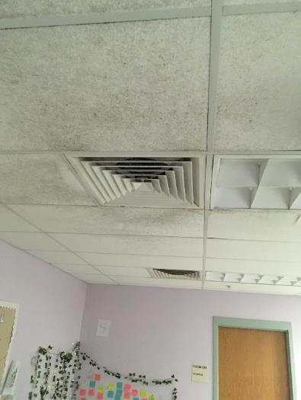
Air vents in a classroom ceiling, note that both vents are the same style, however one may be a return or exhaust vent. Also note dust on adjacent ceiling tiles.
Picture 2
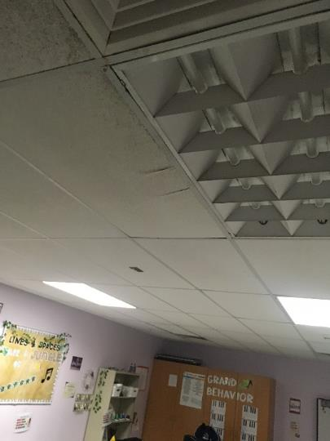
Bowed/sagging ceiling tiles
Picture 3
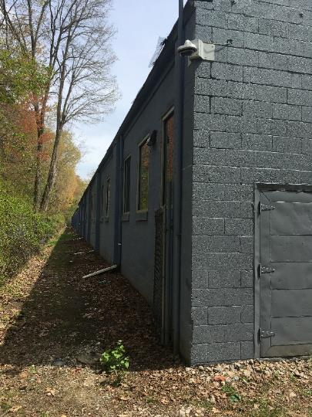
Short gutter downspouts that may drain water too close to the building
Picture 4
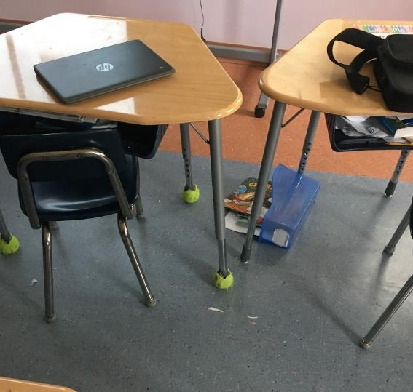
Tennis balls used on chair legs

Location | Carbon  Dioxide  (ppm) | Carbon Monoxide  (ppm) | Temp  (°F) | Relative  Humidity  (%) | PM2.5  (µg/m³) | Occupants  in Room | Windows  Openable | Ventilation |  | Remarks
 |  |  |  |  |  |  |  | Supply | Exhaust
Background (outdoors) | 393 | 26 | 70 | 39 | 5
33 | 746 | 4 | 72 | 45 | 6 | 1 | Y | Y | Y
32 | 961 | 4 | 72 | 47 | 6 | 18 | Y | Y | Y
31 | 848 | 4 | 71 | 47 | 6 | 16 | Y | Y | Y
30 | 732 | 4 | 71 | 46 |  | 19 | Y | Y | Y
29 | 908 | 3 | 72 | 48 | 6 | 17 | Y | Y | Y
27 | 938 | 3 | 72 | 47 | 7 | 24 | Y | Y | Y | Plant
26 | 955 | 3 | 71 | 47 | 5 | 0 | Y | Y | Y
60 | 1157 | 3 | 72 | 48 | 7 | 19 | N | Y | Y
12 | 1029 | 3 | 72 | 47 | 5 | 1 | N | Y | Y
13 | 1102 | 3 | 72 | 48 | 5 | 1 | N | Y | Y
8 | 488 | 3 | 72 | 46 | 4 | 0 | N | Y | Y
7 | 965 | 3 | 72 | 45 | 1 | 5 | N | Y | Y
57 | 1051 | 3 | 70 | 48 | 8 | 1 | N | Y | Y
61 | 910 | 3 | 72 | 48 | 6 | 7 | N | Y | Y | Photocopier
18 | 938 | 3 | 72 | 48 | 7 | 17 | Y | Y | Y | Bowed CT
16 | 1107 | 7 | 75 | 43 | 3 | 1 | N | Y | Y
16C | 1096 | 7 | 75 | 43 | 2 | 2 | N | Y | Y | 6 WD CT
Cafeteria | 1102 | 6 | 72 | 51 | 20 | 50+ | N | Y | Y
47 | 922 | 6 | 71 | 48 | 7 | 4 | Y open | Y | Y
46 | 901 | 6 | 70 | 49 | 4 | 0 | N | N | N
45 | 1014 | 6 | 70 | 49 | 7 | 3 | N | N | N
44 | 820 | 5 | 71 | 47 | 6 | 18 | Y | N | Y
43 | 880 | 5 | 71 | 47 | 15 | 19 | Y | Y | Y | Bowed CT
42 | 768 | 6 | 71 | 46 | 11 | 11 | Y open | Y | Y | Bowed CT
41 | 1004 | 7 | 71 | 50 | 7 | 15 | Y | Y | Y
40 | 1026 | 8 | 71 | 48 | 8 | 20 | Y | Y | Y
39 | 1029 | 7 | 71 | 49 | 7 | 18 | Y | Y | Y
38 | 799 | 5 | 72 | 45 | 5 | 1 | Y | Y | Y
37 | 754 | 4 | 70 | 45 | 6 | 1 | Y | Y | Y
35 | 738 | 4 | 71 | 47 | 8 | 0 | Y | Y | Y | Room pressurized
36 | 796 | 4 | 71 | 47 | 7 | 0 | Y | Y | Y | TBs

