INDOOR AIR QUALITY ASSESSMENT

Martinson Elementary School
257 Forest Street
Marshfield, Massachusetts

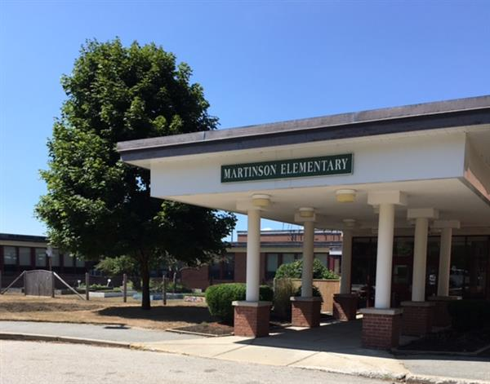

Prepared by:
Massachusetts Department of Public Health
Bureau of Environmental Health
Indoor Air Quality Program
February 2020

Background
Building: | Martinson Elementary School (MES)
Address: | 257 Forest Street, Marshfield, Massachusetts
Assessment Coordinated Through: | Fred Russell, Facilities Manager, Town of Marshfield and Robert Valery, Director of Public Health, Town of Marshfield
Reason for Request: | Odor complaints in classroom 17; indoor air quality (IAQ) Program staff were also asked to look into mold concerns in classroom 4.
Indoor Date of Assessment: | January 31, 2020
Massachusetts Department of Public Health/Bureau of Environmental Health (MDPH/BEH) Staff Conducting Assessment: | Cory Holmes, Environmental Analyst/Inspector, IAQ Program
Building Description: | The MES is a one story brick school building that formerly served as a junior high. It was built in the early 1960s and was renovated in the 1980s.
Windows: | Windows are openable in areas assessed.

Methods
Please refer to the IAQ Manual and appendices for methods, sampling procedures, and interpretation of results (MDPH, 2015).

Results and Discussion
The following is a summary of indoor air testing results (Table 1).
- Carbon dioxide measurements were below the MDPH recommended level of 800 parts per million (ppm) in all areas surveyed, indicating adequate air exchange at the time of assessment.
- Temperature was within or close to the MDPH recommended range of 70°F to 78°F in occupied areas.
- Relative humidity was below the MDPH recommended range of 40 to 60% in all areas tested the day of assessment, which is typical of conditions in New England during the heating season.
- Carbon monoxide levels were non-detectable (ND) in all indoor areas tested.
- Particulate matter (PM2.5) concentrations measured were below the National Ambient Air Quality (NAAQS) level of 35 μg/m³ in all areas tested.
- Total Volatile Organic Compounds (TVOCs) no measurable levels of TVOCs were detected.

Ventilation/Odors in Classroom 17
A heating, ventilating and air-conditioning (HVAC) system has several functions. First it provides heating and, if equipped, cooling. Second, it is a source of fresh air. Finally, an HVAC system will dilute and remove normally-occurring indoor environmental pollutants by not only introducing fresh air, but also filtering the airstream and ejecting stale air to the outdoors via exhaust ventilation. Even if an HVAC system is operating as designed, point sources of respiratory irritants may be present and produce symptoms in sensitive individuals. The following analysis examines and identifies components of the HVAC system and likely sources of respiratory irritants found in the indoor environment.
Mechanical ventilation for classroom 17, and most general classrooms in the MES, is provided by a unit ventilator (univent) located near classroom windows (Picture 1). Univents draw air from the outdoors through a fresh air intake located on the exterior wall of the building and return air through an air intake located at the base of the unit. Fresh and return air are mixed, filtered, heated or cooled and provided to rooms through an air diffuser located in the top of the unit (Figure 1).
An odor was detected upon entry into the classroom which had a mildly pungent/steam-like scent. MDPH/IAQ staff noted the odor was more prominent in the vicinity of the univent and was traced directly to a brass plumbing/heating component within the left side cabinet (Pictures 1 and 2). The source of the odor was confirmed on-site by School Custodian, Ed Norton and Marshfield Public Health Director, Bob Valery, who were assisting the investigation. Although odors were traced directly to this source, no obvious signs of leakage, staining, discoloration or other issues with the plumbing component were observed.
For comparison, univents in several other non-affected classrooms were examined. None of them were found to have to have similar odors. Therefore, it likely that the fixture in classroom 17 may be faulty and should be inspected by a licensed plumber or replaced.

Microbial/Moisture Concerns
The BEH/IAQ Program was asked to examine classroom 4 for the presence of water damage/mold growth. It was reported by Mr. Norton that over the past year, two separate flooding events had occurred in the adjacent men’s and women’s restrooms that damaged gypsum wallboard (GW) between them and classroom 4. In each case, a professional flooding/restoration firm, ServiceMaster, was contacted to conduct remediation. At the time of assessment all water-damaged/moldy GW was removed. GW in classroom 4 was replaced (Picture 3); GW in the adjacent restrooms was not (Pictures 4 and 5), which allowed MDPH IAQ staff to examine conditions within the wall cavity. No further water damage, odors or visible mold growth were observed. In addition, MDPH IAQ staff conducted moisture measurement of GW in classroom 4; no elevated moisture measurements were detected.
In general, the US Environmental Protection Agency (US EPA) and the American Conference of Governmental Industrial Hygienists (ACGIH) recommends that porous materials (e.g., GW, carpeting) be dried with fans and heating within 24 to 48 hours of becoming wet (US EPA, 2008; ACGIH, 1989). If porous materials are not dried within this time frame, mold growth may occur.

Conclusions and Recommendations
In view of the findings, the following recommendations were made at the time of the visit and are reiterated below:
- Contact the univent manufacturer, HVAC vendor or plumber to obtain replacement part for univent in classroom 17.
- In the interim:
  - Ensure fresh air intake louvers are operating as designed to dilute odors;
  - Ensure classroom exhaust vent is functioning to remove odors/provide air exchange; and
  - Slightly open windows (weather-permitting) to provide supplemental make-up air to facilitate air exchange.
- Continue with plans to replace wall materials in restrooms adjacent to classroom 4, consider using a water-resistant material such as cement board.
- For more information about mold consult the US EPA’s “Mold Remediation in Schools and Commercial Buildings” published by the US Environmental Protection Agency (US EPA, 2008) (https://www.epa.gov/mold/mold-remediation-schools-and-commercial-buildings-guide).
- Refer to resource manual and other related IAQ documents located on the MDPH’s website for further building-wide evaluations and advice on maintaining public buildings. These documents are available at http://mass/gov/dph/iaq.

References
ACGIH. 1989. Guidelines for the Assessment of Bioaerosols in the Indoor Environment. American.
MDPH. 2015. Massachusetts Department of Public Health. Massachusetts Department of Public Health Indoor Air Quality Manual: Chapters I-III. Available at: http://www.mass.gov/eohhs/gov/departments/dph/programs/environmental-health/exposure-topics/iaq/iaq-manual/.
US EPA. 2008. Mold Remediation in Schools and Commercial Buildings. US Environmental Protection Agency, Office of Air and Radiation, Indoor Environments Division, Washington, D.C. EPA 402-K-01-001. http://www.epa.gov/mold/mold-remediation-schools-and-commercial-buildings-guide.
Picture 1
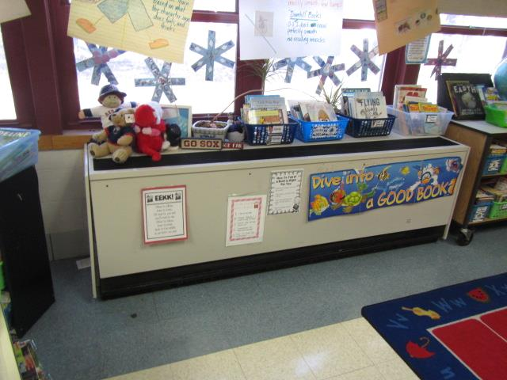
Classroom 17 univent, arrow indicates area emitting odor
Picture 2
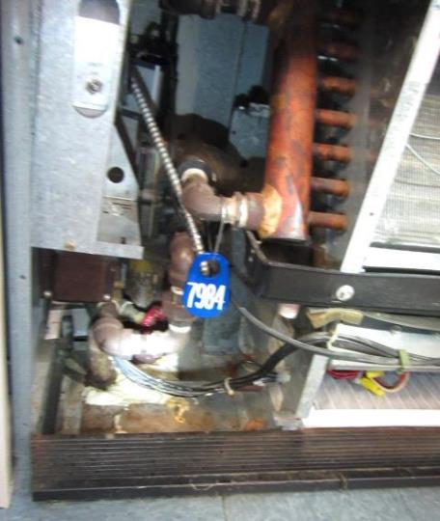
Interior of Classroom 17 univent, arrow indicates brass fitting emitting odor
Picture 3
New drywall installed in classroom 4
Picture 4
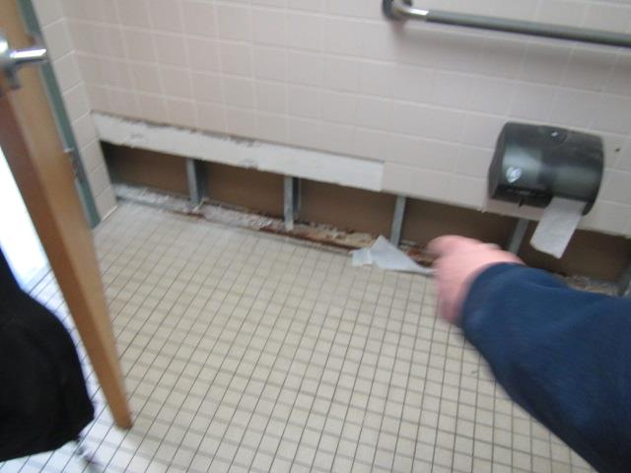
Drywall removed in restroom adjacent to classroom 4
Picture 5
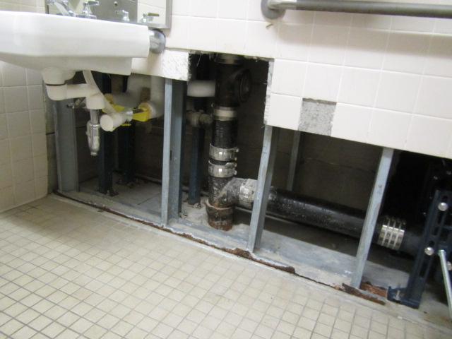
Drywall removed in restroom adjacent to classroom 4
Picture 6
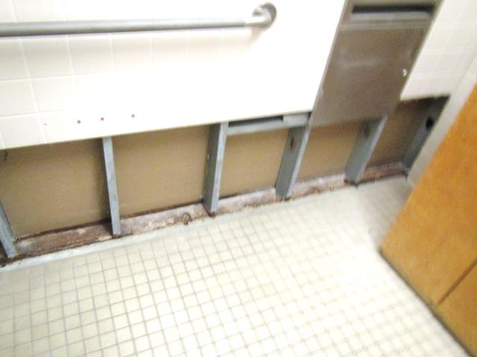
Drywall removed in restroom adjacent to classroom 4
Location | Carbon  Dioxide  (ppm) | Carbon Monoxide  (ppm) | Temp  (°F) | Relative  Humidity  (%) | PM2.5  (µg/m³) | TVOCs  (ppm) | Occupants  in Room | Windows  Openable | Ventilation |  | Remarks
 |  |  |  |  |  |  |  |  | Supply | Exhaust
Background | 376 | ND-1 | 45 | 37 | 16 | ND |  |  |  |  | Cool, clear
Classroom 17 | 623 | ND | 67 | 27 | 2 | ND | 0 | Y | Y | Y | Class just left, steam/mildly pungent odor upon entry into classroom-concentrated in univent cabinet (brass fitting)
Reading Room | 547 | ND | 68 | 23 | 8 | ND | 0 | Y | Y | Y | No similar odors in room or univent
Classroom 22 | 548 | ND | 70 | 18 | 2 | ND | 2 | Y | Y | Y | No similar odors in room or univent
Classroom 4 |  |  |  |  |  |  |  | Y | Y | Y | Water-damaged drywall replaced-moisture testing = dry (normal)
Men’s Restroom |  |  |  |  |  |  |  | N | N | y | Water-damaged drywall removed, no signs of further water damage/mold in wall cavity
Women’s Restroom |  |  |  |  |  |  |  | N | N | Y | Water-damaged drywall removed, no signs of further water damage/mold in wall cavity

