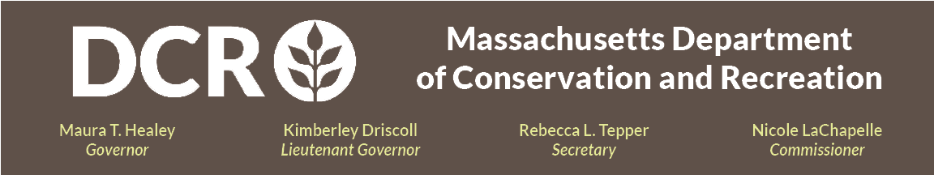

Department of Conservation and Recreation
Commonwealth of Massachusetts

Mary O'Malley State Park Pier Project Preliminary Design

Public Meeting

Wednesday, July 22nd @ 6pm – 7:30pm
Register for the meeting via the Zoom Registration Link.

The Department of Conservation and Recreation is hosting a public meeting to discuss the Mary O’Malley State Park Pier Project. This project is to design, permit and implement repairs that will stabilize the existing seawall, restore recreational use of the earth-fill and timber piers, protect areas fronted by seawall from future deterioration, and repair damage to the pavilion walk. To support this, the project team has assessed and documented current site conditions, determined design conditions for the site, and developed repair strategies. Upcoming work includes final design and permitting, and, if funding is provided, bidding and construction.

Permitting and approvals to include:
- Notice of Intent
- Chapter 91 License
- Project Notification Form to Massachusetts Historic Commission
- MEPA review: Environmental Notification Form (ENF), followed by a rollover EIR or Single Environmental Impact Report (SEIR)
- USACE Preconstruction Notification (PCN)

The public will be invited to provide comments during the meeting, after the presentation, by unmuting their microphones, or the chat functionality that will be available through the virtual participation platform. After the meeting, the presentation will be available for viewing on DCR’s Past events for DCR Public Meetings Information web page. DCR encourages the public to share additional feedback, with a deadline for receipt of comments by DCR of August 5th, 2026. Comments may be submitted via the DCR public comment portal. Please note that the content of comments you submit to DCR, along with your name, town, and zip code, will be posted on DCR's website. Additional contact information required when commenting, notably email address, will only be used for outreach on future updates on the subject project or property.

If you have agency-related questions or concerns or would like to be added to an email list to receive DCR general or project-specific announcements, please email Mass.Parks@mass.gov or call 617-626-4973.

Online or in-person live language interpretation is available upon request via DCR's Translation and Interpretation Request Form. For reasonable accommodations for people with disabilities, please email Melixza G. Esenyie, ADA and Diversity Manager at the Executive Office of Energy and Environmental Affairs, at Melixza.Esenyie2@mass.gov and include a description of the accommodation that will be needed in as much detail as possible. Last minute requests will be accepted, but it may not be possible to fulfill the request.

