INDOOR AIR QUALITY ASSESSMENT

Mashpee Middle/High School
500 Old Barnstable Road
Mashpee, Massachusetts

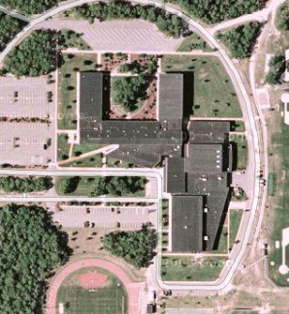

Prepared by:
Massachusetts Department of Public Health
Bureau of Environmental Health
Indoor Air Quality Program
January 2011

Background/Introduction
At the request of a parent, the Massachusetts Department of Public Health (MDPH), Bureau of Environmental Health (BEH) conducted an indoor air quality (IAQ) assessment at Mashpee Middle/High School (MMHS) located at 500 Old Barnstable Road, Mashpee, Massachusetts. On November 30, 2010, an assessment of the MMHS was made by Cory Holmes and Sharon Lee, Environmental Analysts/Inspectors within BEH’s IAQ Program. The assessment, which was coordinated through the Mashpee Health Department, was prompted by concerns of roof leaks, potential mold growth and general IAQ conditions in the building. Accompanying MDPH/IAQ staff for the assessment was Glen Harrington, Health Agent, Mashpee Board of Health and Brad Tripp, Director of Facilities for the Town of Mashpee.
The MMHS is a two-story, slab-on-grade, red brick building that was completed in 1996. The school contains general classrooms, science classrooms, computer rooms, a kitchen/cafeteria, music/band rooms, art room, shop and technology areas, library, auditorium, gymnasium, locker rooms, exercise rooms and office space. Windows are openable throughout the building.
The Town of Mashpee retained Pomroy Associates (Pomroy), a construction/engineering firm, to oversee a Capital Needs/Building Envelope Survey and address moisture intrusion issues at the MMHS. The survey prepared by Building Envelope Technologies, Inc (BET) for Pomroy was issued on August 5, 2010. The BET survey included an evaluation of all existing building envelope components including roofs, walls, windows, foundations and building/construction materials and recommended the following:
- Repair roof and address leaks, primarily near the gymnasium, weight training room, and in the B-wing (B-213);
- Re-flash the entire length of the built-in copper gutter with a semi-cured self-adhering EPDM membrane and integrated connection with the throughwall scupper drains;
- Detailed cleaning of mechanical equipment housing;
- Patch failed seams near areas of leakage near the weight training room;
- Repair damage/seam failures in the roof membrane;
- Repair exposed concrete block masonry in the cooling tower enclosure and treat with an elastomeric masonry coating;
- Repair and recoat deteriorating exterior columns;
- Repair rooftop lightning arrestor system;
- Removal and replacement of all elastomeric sealings, including materials between metal-to-metal contact (e.g., window openings, mechanical equipment); and
- Refinish steel egress doors (BET, 2010).
At the time of the MDPH/IAQ assessment, the Town of Mashpee was examining options concerning implementation of these recommendations.

Methods
Air tests for carbon monoxide, carbon dioxide, temperature and relative humidity were conducted with the TSI, Q-Trak, IAQ Monitor, Model 7565. Air tests for airborne particle matter with a diameter less than 2.5 micrometers were taken with the TSI, DUSTTRAK™ Aerosol Monitor Model 8520. MDPH staff performed a visual inspection of building materials for water damage and/or microbial growth. Moisture content of porous building materials (gypsum wallboard, carpeting) was measured with a Delmhorst, BD-2000 Model, Moisture Detector equipped with a Delmhorst Standard Probe.

Results
The school houses approximately 800 seventh through twelfth grade students and approximately 85 staff. Tests were taken during normal operations. Results appear in Table 1.

Discussion

Ventilation
It can be seen from Table 1 that carbon dioxide levels were above 800 parts per million (ppm) in 37 of 90 areas at the time of the assessment, indicating a lack of air exchange in a number of the areas surveyed. It is important to note that several classrooms had open windows and/or were empty/sparsely populated, which typically reduces carbon dioxide levels. Carbon dioxide levels would be expected to be higher with increased occupancy and/or windows closed.
Fresh air is supplied to most classrooms by unit ventilator (univent) systems (Picture 1). A univent draws air from the outdoors through a fresh air intake located on the exterior wall of the building (Picture 2). Return air from the classroom is drawn through an air intake located at the base of the unit (Figure 1). Fresh and return air are mixed, filtered, heated and provided to classrooms through an air diffuser located in the top of the unit. At the time of the IAQ assessment, univents were operating in the large majority of the areas surveyed; however, some had been deactivated. Univents in some areas had items stored on top, which can restrict airflow (Picture 3; Table 1). In order for univents to provide fresh air as designed, intakes/diffusers must remain free of obstructions. Importantly, these units must remain ‘on’ and be allowed to operate while rooms are occupied.
Exhaust ventilation for classrooms is provided by ceiling or wall-mounted vents powered by rooftop motors (Pictures 4 and 5). The exhaust system was operating at the time of assessment.
The heating, ventilating and air-conditioning (HVAC) systems for interior rooms and common areas (e.g., gymnasium, locker rooms, auditorium) is provided by air-handling units (AHUs) located in mechanical rooms, mounted from ceilings or located on the roof. Fresh air is distributed via ceiling-mounted air diffusers (Picture 6) and ducted back to AHUs via ceiling or wall-mounted return vents (Picture 7). During the assessment it was determined that the AHU in the B-112 suite of offices was not operating.
Occupants in the gym/training/locker room areas reported thermal discomfort as a result of the HVAC system being automatically deactivated by a timer. Unlike typical classrooms, the gym/training/locker room areas are used after school hours involving various activities. Due to the potential for a large number of occupants (e.g., spectators for sporting events) and water vapor/odors generated in locker rooms, the mechanical ventilation should be operating in these areas when the gym is occupied. Without fresh air supply and removal by the mechanical ventilation system, normally occurring environmental pollutants can build up and lead to indoor air/comfort complaints.
The HVAC system for the Art/Pottery/Photography classrooms is also on a timer. As a result, supply/exhaust systems to these areas are cycled off at the end of the school day. Given the products (e.g., clay, photography developing chemicals) used and the materials (e.g., dust, odors) generated in these areas, HVAC systems should be allowed to operate for an extended period following after school hours to allow for dilution and removal of pollutants.
To maximize air exchange, the MDPH recommends that both supply and exhaust ventilation operate continuously during periods of occupancy. In order to have proper ventilation with a mechanical supply and exhaust system, the systems must be balanced to provide an adequate amount of fresh air to the interior of a room while removing stale air from the room. It is recommended that HVAC systems be re-balanced every five years to ensure adequate air systems function (SMACNA, 1994). The systems were reportedly last balanced upon completion of the building in 1996.
The Massachusetts Building Code requires that each room have a minimum ventilation rate of 15 cubic feet per minute (cfm) per occupant of fresh outside air or openable windows (SBBRS, 1997; BOCA, 1993). The ventilation must be on at all times that the room is occupied. Providing adequate fresh air ventilation with open windows and maintaining the temperature in the comfort range during the cold weather season is impractical. Mechanical ventilation is usually required to provide adequate fresh air ventilation.
Carbon dioxide is not a problem in and of itself. It is used as an indicator of the adequacy of the fresh air ventilation. As carbon dioxide levels rise, it indicates that the ventilating system is malfunctioning or the design occupancy of the room is being exceeded. When this happens, a buildup of common indoor air pollutants can occur, leading to discomfort or health complaints. The Occupational Safety and Health Administration (OSHA) standard for carbon dioxide is 5,000 parts per million parts of air (ppm). Workers may be exposed to this level for 40 hours/week, based on a time-weighted average (OSHA, 1997).
The MDPH uses a guideline of 800 ppm for publicly occupied buildings. A guideline of 600 ppm or less is preferred in schools due to the fact that the majority of occupants are young and considered to be a more sensitive population in the evaluation of environmental health status. Inadequate ventilation and/or elevated temperatures are major causes of complaints such as respiratory, eye, nose and throat irritation, lethargy and headaches. For more information concerning carbon dioxide, consult Appendix A.
Indoor temperature measurements ranged from 68º F to 76º F, which were within or close to the lower end of the MDPH recommended comfort range in areas surveyed the day of the assessment (Table 1). The MDPH recommends that indoor air temperatures be maintained in a range of 70º F to 78º F in order to provide for the comfort of building occupants. In many cases concerning indoor air quality, fluctuations of temperature in occupied spaces are typically experienced, even in a building with an adequate fresh air supply.
Relative humidity in the building ranged from 26 to 64 percent. The MDPH recommends a comfort range of 40 to 60 percent for indoor air relative humidity. Relative humidity measurements were within the recommended comfort range in all areas, except for the guidance areas where relative humidity levels were 6 to 27 percent higher than other areas. The higher relative humidity levels in the guidance area are largely related to a leak that occurred in a mechanical room near the first floor guidance area and as a result had moistened carpet and other building materials; this is discussed further in the Moisture/Microbial Concerns section of this report. Relative humidity levels in the building would be expected to drop during the winter months due to heating. The sensation of dryness and irritation is common in a low relative humidity environment. Low relative humidity is a very common problem during the heating season in the northeast part of the United States.

Microbial/Moisture Concerns
In order for building materials to support mold growth, a source of water exposure is necessary. Identification and elimination of the source of water moistening building materials is necessary to control mold growth. The following conditions were identified as locations of water leaks within the MMHS.

Roof Leaks and Water-Damaged Materials
As indicated previously, the assessment was prompted by concerns of water damage/mold related to chronic roof leaks. Signs of roof leaks (e.g., water-damaged ceiling tiles and peeling paint) were observed in many areas throughout the school (Pictures 8 and 9/Table 1). Water-damaged ceiling tiles can provide a source of moisture/microbial growth and should be replaced after a water leak is discovered and repaired.
Science room B-236 was reported as an area impacted by recent roof leakage. As a temporary measure, a bucket was placed above the ceiling tile system to collect rainwater (Pictures 10 and 11). Mr. Tripp reported that the source of leakage was traced to damaged rubber membrane around the curb of a rooftop exhaust vent (Picture 12). Attempts have been made to repair the membrane in this area. Water-damaged ceiling tiles were noted throughout this room. MDPH/IAQ staff examined conditions above the ceiling tile system for water-damaged building materials that could provide a source for mold growth. No mold colonized materials were observed in this area at the time of the assessment. The ceiling plenum is an area that has a large volume for air movement, which aids in drying (Picture 13).
Water-damaged gypsum wallboard (GW) and peeling paint was observed in the first floor corridor outside of the main office. As indentified in the BET report, this damage is related to the copper gutter system installed above this area (Pictures 14 and 15).

Plumbing Leak and Water-Damaged Materials in Guidance Area
As reported by Mr. Tripp, a plumbing leak was discovered on Monday, November 29, 2010, the day prior to the MDPH assessment. The source of the leak was an HVAC unit (Picture 16) located in a mechanical room adjacent to the guidance area (specifically room B-115). As a result of the leak, which likely occurred over the previous weekend, GW and carpeting in the guidance area was moistened. At the time of the assessment, industrial fans were in use to dry carpet and GW (Picture 17).
To determine if GW and carpeting had elevated moisture content that would be conducive to mold growth, MDPH/IAQ staff conducted moisture testing of these materials. Elevated moisture measurements were detected in rooms B-115 and B-113 (Table 1), indicating that materials were wet at the time of the assessment. In addition, visible mold growth was observed behind a file cabinet and vinyl base coving along the floor in B-115 (Picture 18).
The US Environmental Protection Agency (US EPA) and the American Conference of Governmental Industrial Hygienists (ACGIH) recommend that porous materials (e.g., GW) be dried with fans and heating within 24 to 48 hours of becoming wet (US EPA, 2001; ACGIH, 1989). If not dried within this time frame, mold growth may occur. Once mold has colonized porous materials, they are difficult to clean and should be removed.
At the time of assessment, MDPH/IAQ staff recommended:
- Removal of all carpeting in B-115;
- Removal of moistened carpeting in B-113 approximately 10-feet from the shared wall between the mechanical room and guidance suite; and
- Removal of mold-colonized GW in B-115.
In addition, MDPH/IAQ staff recommended to Mr. Tripp that in order to best protect staff and students, any remediation of water-damaged/mold contaminated materials be done in a manner consistent with recommendations in “Mold Remediation in Schools and Commercial Buildings” published by the US Environmental Protection Agency (US EPA, 2001). Due to the sensitive nature of the population (i.e., school-aged children), emphasis was put on the importance of preventive measures (e.g., isolation and pressurization) during remediation to reduce/eliminate any possible migration of materials (e.g., mold, spores, construction dust) and/or exposure to occupants.

Other Potential Moisture/Microbial Sources
Plants were noted in several classrooms, in some instances on or near univent equipment (Picture 1). Plants can be a source of pollen and mold which can be respiratory irritants to some individuals. Plants should be properly maintained and equipped with drip pans. They should also be located away from univents to prevent the aerosolization of dirt, pollen and mold.
Open seams between sink countertops and backsplashes were observed in some rooms (Picture 19/Table 1). If not watertight, moisture can penetrate through seams, causing damage. Improper drainage or sink overflow can lead to water penetration into countertops, cabinet interiors and areas behind cabinets. Water penetration and chronic exposure of porous and wood-based materials can cause these materials to swell and show signs of water damage. Repeated moistening of porous materials can result in mold growth.
One room contained an aquarium with standing water that was cloudy and green with algal growth (Picture 20). Aquariums should be properly maintained to prevent bacterial/mold/algal growth and associated nuisance odors.
Lastly, water coolers were observed on carpeting in some areas. Overflow of the water bubbler or spills that often occur around the water source can also moisten carpeting. As discussed previously, moistened carpeting can be a source of mold growth.

Other IAQ Evaluations
Indoor air quality can be negatively influenced by the presence of respiratory irritants, such as products of combustion. The process of combustion produces a number of pollutants. Common combustion emissions include carbon monoxide, carbon dioxide, water vapor and smoke (fine airborne particle material). Of these materials, exposure to carbon monoxide and particulate matter with a diameter of 2.5 micrometers (μm) or less (PM2.5) can produce immediate, acute health effects upon exposure. To determine whether combustion products were present in the indoor environment, MDPH/IAQ staff obtained measurements for carbon monoxide and PM2.5.

Carbon Monoxide
Carbon monoxide is a by-product of incomplete combustion of organic matter (e.g., gasoline, wood and tobacco). Exposure to carbon monoxide can produce immediate and acute health effects. Several air quality standards have been established to address carbon monoxide and prevent symptoms from exposure to these substances. The MDPH established a corrective action level concerning carbon monoxide in ice skating rinks that use fossil-fueled ice resurfacing equipment. If an operator of an indoor ice rink measures a carbon monoxide level over 30 ppm, taken 20 minutes after resurfacing within a rink, that operator must take actions to reduce carbon monoxide levels (MDPH, 1997).
The American Society of Heating Refrigeration and Air-Conditioning Engineers (ASHRAE) has adopted the National Ambient Air Quality Standards (NAAQS) as one set of criteria for assessing indoor air quality and monitoring of fresh air introduced by HVAC systems (ASHRAE, 1989). The NAAQS are standards established by the US EPA to protect the public health from six criteria pollutants, including carbon monoxide and particulate matter (US EPA, 2006). As recommended by ASHRAE, pollutant levels of fresh air introduced to a building should not exceed the NAAQS levels (ASHRAE, 1989). The NAAQS were adopted by reference in the Building Officials & Code Administrators (BOCA) National Mechanical Code of 1993 (BOCA, 1993), which is now an HVAC standard included in the Massachusetts State Building Code (SBBRS, 1997). According to the NAAQS, carbon monoxide levels in outdoor air should not exceed 9 ppm in an eight-hour average (US EPA, 2006).
Carbon monoxide should not be present in a typical, indoor environment. If it is present, indoor carbon monoxide levels should be less than or equal to outdoor levels. On the day of the assessment, outdoor carbon monoxide concentrations were non-detect (ND) (Table 1). No measurable levels of carbon monoxide were detected inside the building (Table 1).

Particulate Matter
The US EPA has established NAAQS limits for exposure to particulate matter. Particulate matter is airborne solids that can be irritating to the eyes, nose and throat. The NAAQS originally established exposure limits to particulate matter with a diameter of 10 μm or less (PM10). According to the NAAQS, PM10 levels should not exceed 150 micrograms per cubic meter (μg/m³) in a 24-hour average (US EPA, 2006). These standards were adopted by both ASHRAE and BOCA. Since the issuance of the ASHRAE standard and BOCA Code, US EPA established a more protective standard for fine airborne particles. This more stringent PM2.5 standard requires outdoor air particle levels be maintained below 35 μg/m³ over a 24-hour average (US EPA, 2006). Although both the ASHRAE standard and BOCA Code adopted the PM10 standard for evaluating air quality, MDPH uses the more protective PM2.5 standard for evaluating airborne particulate matter concentrations in the indoor environment.
Outdoor PM2.5 concentrations were measured at 23 μg/m3 (Table 1). PM2.5 levels measured in the wood shop ranged from 30 to 37 μg/m3 (Table 1), which were slightly above the NAAQS PM2.5 level of 35 μg/m3. Elevated PM2.5 levels in the woodshop were the result of aerosolized wood dust and debris, which had accumulated on the floor, wood cutting machines, the univent and flat surfaces (Picture 2). Flexible ductwork attached to a dedicated wood dust collection system did not appear to be attached properly, allowing sawdust to escape (Picture 22). Furthermore, MDPH/IAQ observed a breach in the wood dust collection system. It is unclear whether this hole in the ductwork is intentional. Given the uniformity of the breach, it is likely that additional flexible ductwork was attached previously, but at this point had been removed. Any breaches in the dust collection ductwork can allow dust to escape the collection system (Picture 23). The shop also has general exhaust ventilation (Picture 24). MDPH/IAQ staff could not determine whether it was functioning at the time of the assessment. In addition, an air cleaner system installed in the wood shop was not operating at the time of assessment (Picture 25). The filter for this system appeared heavily occluded, which decreases its efficiency. Wood dust is a fine particulate that can be easily aerosolized and become irritating to the eyes, nose, throat and respiratory system. In addition, under certain conditions, wood dust can be a fire hazard.
PM2.5 levels measured in all other areas of the building ranged from 2 to 18 μg/m³ (Table 1), which were below the NAAQS PM2.5 level of 35 μg/m³. Frequently, indoor air levels of particulates (including PM2.5) can be at higher levels than those measured outdoors. A number of mechanical devices and/or activities that occur indoors can generate particulate during normal operations. Sources of indoor airborne particulates may include but are not limited to particles generated during the operation of fan belts in the HVAC system, use of stoves and/or microwave ovens in kitchen areas; use of photocopiers, fax machines and computer printing devices; operation of an ordinary vacuum cleaner and heavy foot traffic indoors.
Two kilns were observed in the C wing of the school. A hood style and dedicated exhaust were observed for the kilns. At the time of assessment, the flexible ductwork for the dedicated exhaust was not attached to the kiln, which was operating at the time of assessment (Picture 26). While the hood exhaust can remove latent heat and dust expelled by the kiln, a dedicated system can capture these materials more effectively, especially since the second kiln was not located directly below the hood.

Volatile Organic Compounds
Indoor air quality can also be negatively influenced by the presence of materials containing volatile organic compounds (VOCs). VOCs are carbon-containing substances that have the ability to evaporate at room temperature. Frequently, exposure to low levels of total VOCs (TVOCs) may produce eye, nose, throat and/or respiratory irritation in some sensitive individuals. For example, chemicals evaporating from a paint can stored at room temperature would most likely contain VOCs. In an effort to identify materials that can potentially increase indoor VOC concentrations, MDPH/IAQ staff examined classrooms and common areas for products containing these respiratory irritants.
The majority of classrooms contained dry erase boards and related materials. Materials such as dry erase markers and dry erase board cleaners may contain VOCs, such as methyl isobutyl ketone, n-butyl acetate and butyl-cellusolve (Sanford, 1999), which can be irritating to the eyes, nose and throat. Cleaning products and air deodorizers were also observed in a number of classrooms (Table 1). Like dry erase materials, cleaning products and air deodorizers contain VOCs and other chemicals that can be irritating to the eyes, nose and throat and should be kept out of reach of students. Furthermore, deodorizing agents do not remove materials causing odors, but rather mask odors that may be present in the area. Material Safety Data Sheets (MSDS) should be available at a central location for each product in the event of an emergency as required by Massachusetts General Laws. Consideration should be given to providing teaching staff with school issued cleaning products and supplies to ensure that MSDS information is available for all products used at the school.
Tennis balls were observed sliced open and placed on the base of the legs likely in an effort to reduce noise from sliding desks/chairs (Table 1). Tennis balls are made of a number of materials that can serve as respiratory irritants. Constant wearing of tennis balls can produce fibers and cause VOCs to off-gas. Tennis balls are made with a natural rubber latex bladder, which becomes abraded when used as a chair leg pad. Use of tennis balls in this manner may introduce latex dust into the school environment. Some individuals are highly allergic to latex (e.g., spina bifida patients) (SBAA, 2001). It is recommended that the use of materials containing latex be limited in buildings to reduce the likelihood of symptoms in sensitive individuals (NIOSH, 1997).

Other Conditions
Other conditions that can affect indoor air quality were observed during the assessment. In several classrooms, items were observed on the floor, windowsills, tabletops, counters, bookcases and desks. The large number of items stored in classrooms provides a source for dusts to accumulate. These items (e.g., papers, folders, boxes) make it difficult for custodial staff to clean. Items should be relocated and/or be cleaned periodically to avoid excessive dust build up. In addition, these materials can accumulate on flat surfaces (e.g., desktops, shelving and carpets) in occupied areas and subsequently be re-aerosolized causing further irritation.
A number of air diffusers, exhaust/return vents and personal fans were observed with accumulated dust/debris (Pictures 6 and 27). If exhaust vents are not functioning, backdrafting can occur, which can re-aerosolize accumulated dust particles. Re-activated supply vents and fans can also aerosolize dust accumulated on vents/fan blades. Several rooms had various objects hung from the ceiling tile system (Picture 28). Building occupants should refrain from hanging objects to prevent damage to the ceiling tile system. Damaged/dislodged ceiling tiles can provide a pathway for the movement of drafts, dusts and particulate matter between rooms and floors.
The majority of floor surfaces in the school are covered by wall to wall carpeting, which in most cases appears to be original to the building (~ 15 years old). Several occupants had carpet cleaning complaints. The Institute of Inspection, Cleaning and Restoration Certification (IICRC), recommends that carpeting be cleaned annually (or semi-annually in soiled high traffic areas) (IICRC, 2005). Since the average lifespan of a carpet in a school environment is approximately eleven years (Bishop, 2002), consideration should be given to planning for the installation of new flooring as funds become available.
Finally, the MMHS uses a work order format to generate maintenance requests. Due to the amount of issues raised by occupants and conditions observed by MDPH/IAQ staff during the assessment (e.g., water-damaged/missing ceiling tiles), it appears that occupants are either unaware of or are not using the system in place to report building-related issues for prompt and satisfactory response.

Conclusions/Recommendations
In view of the findings at the time of the visit, the following recommendations are provided:
- Implement recommendations included in the BET report. Major roof repairs/replacement will require capital funding and planning. In the interim, maintenance staff should continue to make minor roof repairs and monitor building materials for water damage.
- Staff should be instructed on how to use the maintenance reporting procedure and encouraged to use it for prompt remediation of building needs (e.g., active leaks, replacement of ceiling tiles).
- Operate all ventilation systems throughout the building (e.g., gym, cafeteria, classrooms) continuously during periods of occupancy to maximize air exchange.
- Remove all blockages from univents to ensure adequate airflow.
- Examine HVAC unit in B-112 for proper operation, make repairs as needed.
- Examine if fresh air supply can be increased/intake adjusted in areas that measured over 800 ppm carbon dioxide.
- Maintenance staff should work with building occupants (e.g., athletic/coaching staff) to determine proper timer operation for HVAC system. Due to occupancy of the gym/training/locker room areas outside of regular school hours, more coordination is needed in these areas to provide mechanical ventilation/comfort for occupants and air exchange/removal of locker room odors.
- Work with teachers in the art wing to ensure mechanical ventilation is operating during activities conducted after hours.
- Use openable windows in conjunction with mechanical ventilation to facilitate air exchange. Care should be taken to ensure windows are properly closed at night and weekends to avoid the freezing of pipes and potential flooding.
- Consider adopting a balancing schedule of every 5 years for all mechanical ventilation systems, as recommended by ventilation industrial standards (SMACNA, 1994).
- For buildings in New England, periods of low relative humidity during the winter are often unavoidable. Therefore, scrupulous cleaning practices should be adopted to minimize common indoor contaminants whose irritant effects can be enhanced when the relative humidity is low. To control dusts, a high efficiency particulate arrestance (HEPA) filter equipped vacuum cleaner in conjunction with wet wiping of all surfaces is recommended. Avoid the use of feather dusters. Drinking water during the day can help ease some symptoms associated with a dry environment (throat and sinus irritations).
- To mitigate future water damage/mold issues in the guidance wing associated with the adjacent mechanical room consider the following:
  - Install a sheet metal drip pan underneath/around AHU;
  - Replace water-damaged GW with green board or other water impervious material; and/or
  - Leave a small gap (~ ½ to ¾-inch) beneath wallboard to prevent wicking in the event of flooding.
- Consult “Mold Remediation in Schools and Commercial Buildings” published by the US EPA ( 2001) for additional information on mold. This document can be downloaded from the US EPA website at: http://www.epa.gov/iaq/molds/mold_remediation.html.
- Remove plants from the air stream of univents. Ensure all plants are equipped with drip pans. Examine drip pans periodically for mold growth and disinfect with an appropriate antimicrobial where necessary.
- Seal areas around sinks to prevent water damage to the interior of cabinets and adjacent wallboard.
- Clean and maintain aquariums prevent bacterial/mold/algal growth and associated odors.
- Store cleaning products properly and out of reach of students. All cleaning products used at the facility should be approved by the school department with MSDS’ available at a central location.
- Refrain from using air fresheners and deodorizers to prevent exposure to VOCs.
- Routinely clean particulate residue from dry erase boards and trays.
- Consider replacing tennis balls with latex-free tennis balls or glides.
- Relocate or consider reducing the amount of materials stored in classrooms to allow for more thorough cleaning of classrooms. Clean items regularly with a wet cloth or sponge to prevent excessive dust build-up.
- Clean accumulated dust and debris periodically from the surface of air diffusers, exhaust vents and blades of personal and ceiling fans.
- Refrain from hanging objects from ceiling tile system. Ensure missing or ajar ceiling tiles are in place.
- Clean carpeting annually or semi-annually in soiled high traffic areas as per the recommendations of the Institute of Inspection, Cleaning and Restoration Certification (IICRC). Copies of the IICRC fact sheet can be downloaded at: http://www.cleancareseminars.com/carpet_cleaning_faq4.htm (IICRC, 2005)
- Consider a long-term plan to replace all carpeting in the building as funds become available. Consider replacing carpeting with a non-porous surface such as vinyl tile.
- Consider adopting the US EPA (2000) document, “Tools for Schools”, as an instrument for maintaining a good indoor air quality environment in the building. This document is available at: http://www.epa.gov/iaq/schools/index.html.
- Refer to resource manual and other related indoor air quality documents located on the MDPH’s website for further building-wide evaluations and advice on maintaining public buildings. These documents are available at: http://mass.gov/dph/indoor_air.

References
ACGIH. 1989. Guidelines for the Assessment of Bioaerosols in the Indoor Environment. American Conference of Governmental Industrial Hygienists, Cincinnati, OH.
ASHRAE. 1989. Ventilation for Acceptable Indoor Air Quality. American Society of Heating, Refrigeration and Air Conditioning Engineers. ANSI/ASHRAE 62-1989.
BET. 2010. Building Envelope Survey, High/Middle School, Mashpee, Massachusetts. Issued: August 5, 2010. BET No. 10024. Building Envelope Technologies, Inc. 700 West Center Street, Unit 7, West Bridgewater, MA.
Bishop, J. & Institute of Inspection, Cleaning and Restoration Certification. 2002. A Life Cycle Cost Analysis for Floor Coverings in School Facilities.
BOCA. 1993. The BOCA National Mechanical Code/1993. 8th ed. Building Officials and Code Administrators International, Inc., Country Club Hill, IL.
IICRC. 2000. IICRC S001 Reference Guideline for Professional On-Location Cleaning of Textile Floor Covering Materials Institute of Inspection, Cleaning and Restoration Certification. Institute of Inspection Cleaning and Restoration, Vancouver, WA.
IICRC. 2005. Carpet Cleaning FAQ 4 Institute of Inspection, Cleaning and Restoration Certification. Institute of Inspection Cleaning and Restoration, Vancouver, WA.
MDPH. 1997. Requirements to Maintain Air Quality in Indoor Skating Rinks (State Sanitary Code, Chapter XI). 105 CMR 675.000. Massachusetts Department of Public Health, Boston, MA.
NIOSH. 1997. NIOSH Alert: Preventing Allergic Reactions to Natural Rubber Latex in the Workplace. National Institute for Occupational Safety and Health, Atlanta, GA.
OSHA. 1997. Limits for Air Contaminants. Occupational Safety and Health Administration. Code of Federal Regulations. 29 C.F.R 1910.1000 Table Z-1-A.
Sanford. 1999. Material Safety Data Sheet (MSDS No: 198-17). Expo® Dry Erase Markers Bullet, Chisel, and Ultra Fine Tip. Sanford Corporation. Bellwood, IL.
SBAA. 2001. Latex In the Home And Community Updated Spring 2001. Spina Bifida Association of America, Washington, DC.
SBBRS. 1997. Mechanical Ventilation. State Board of Building Regulations and Standards. Code of Massachusetts Regulations. 780 CMR 1209.0
SMACNA. 1994. HVAC Systems Commissioning Manual. 1st ed. Sheet Metal and Air Conditioning Contractors’ National Association, Inc., Chantilly, VA.
US EPA. 2000. Tools for Schools. Office of Air and Radiation, Office of Radiation and Indoor Air, Indoor Environments Division (6609J). EPA 402-K-95-001, Second Edition. http://www.epa.gov/iaq/schools/tools4s2.html.
US EPA. 2001. “Mold Remediation in Schools and Commercial Buildings”. Office of Air and Radiation, Indoor Environments Division, Washington, DC. EPA 402-K-01-001. March 2001. Available at: http://www.epa.gov/iaq/molds/mold_remediation.html.
US EPA. 2006. National Ambient Air Quality Standards (NAAQS). US Environmental Protection Agency, Office of Air Quality Planning and Standards, Washington, DC. http://www.epa.gov/air/criteria.html.

Picture 1

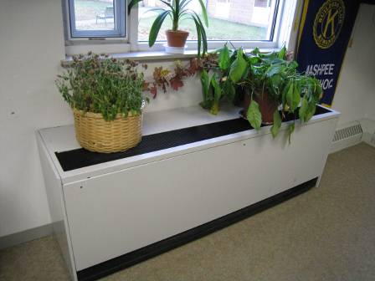

Typical Classroom Univent, Note Plants on Top/Near Air Diffuser

Picture 2

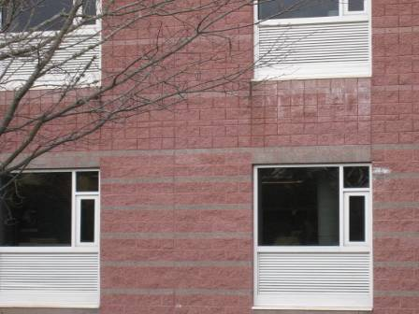

Univent Fresh Air Intakes below Windows

Picture 3



Items placed on and in front of univent, note debris in diffuser

Picture 4

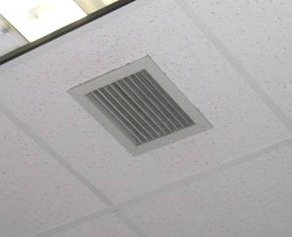

Ceiling-Mounted Exhaust Vent

Picture 5

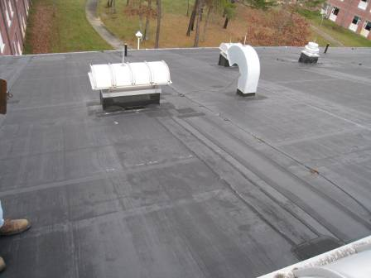

Rooftop Exhaust Motors/Vents

Picture 6

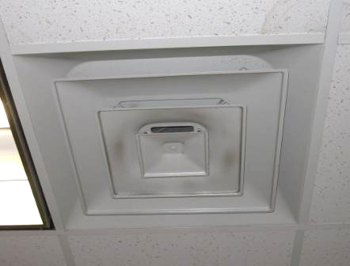

Ceiling-Mounted Supply Diffuser, Note Dust/Debris Accumulation on Louvers

Picture 7

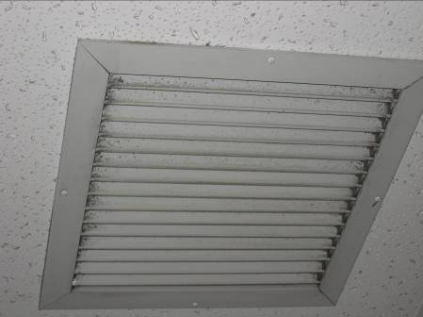

Ceiling-Mounted Return Vent

Picture 8

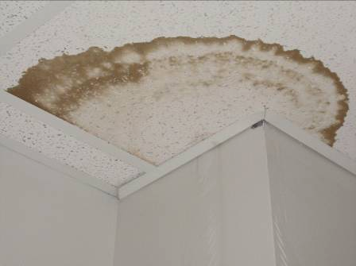

Water-Damaged Ceiling Tile and Peeling Paint on Wall

Picture 9

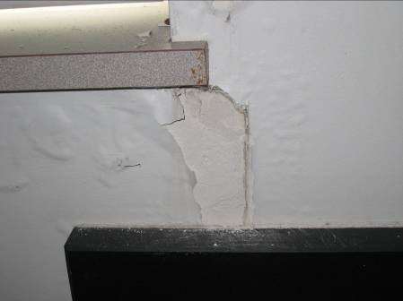

Water-Damaged Gypsum Wallboard and Peeling Paint

Picture 10

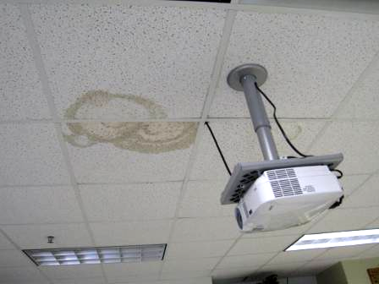

Area of Recent Leakage Reported in Classroom B-236

Picture 11

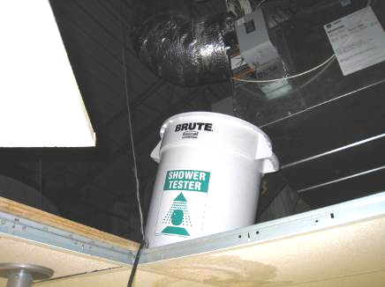

Bucket Stationed above Ceiling Tiles as a Temporary Measure to Collect Water in Classroom B-236, Note Ductwork (Source of Leak) above Bucket

Picture 12

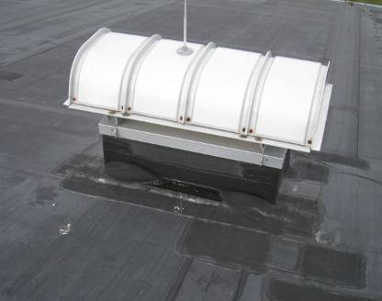

Rooftop Exhaust Motor above Classroom B-236, Note Numerous Roof Patches

Picture 13

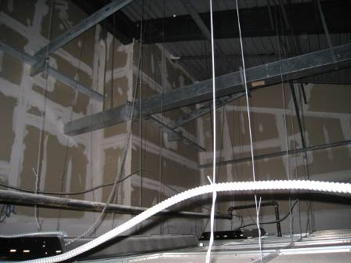

Large Volume of Air Space above Ceiling Tile System in Classroom B-236

Picture 14

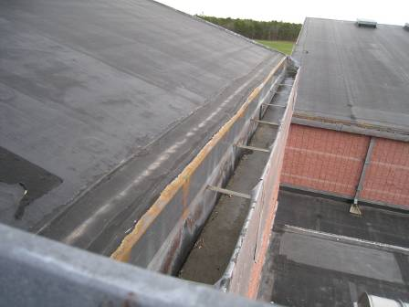

Copper Gutter along Peaked Roof Detail

Picture 15

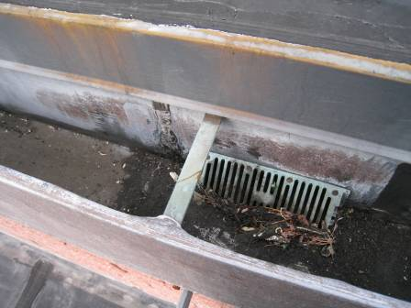

Close-Up of Copper Gutter along Peaked Roof Detail

Picture 16

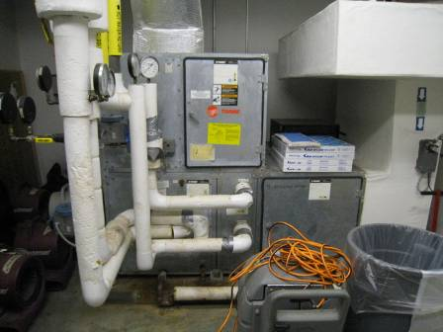

HVAC Unit in Mechanical Room adjacent to Room B-115

Picture 17

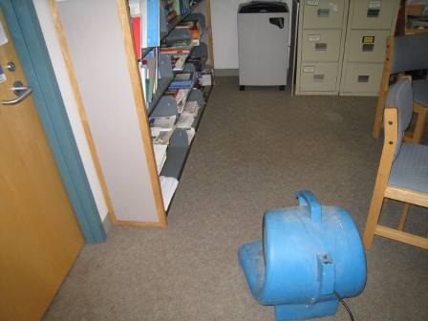

Industrial Fan Drying Moistened Carpet

Picture 18

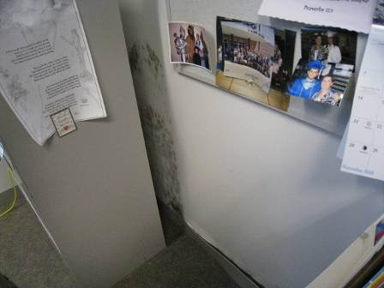

Mold Growth behind File Cabinet

Picture 19

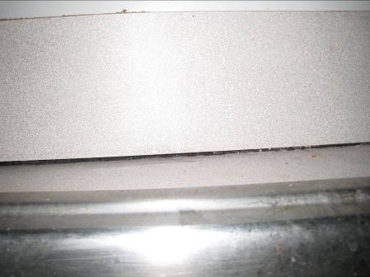

Space between Sink Backsplash and Countertop

Picture 20

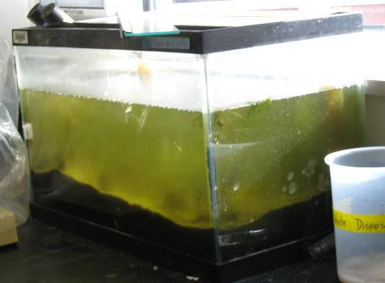

Aquarium Green with Algal Growth

Picture 21

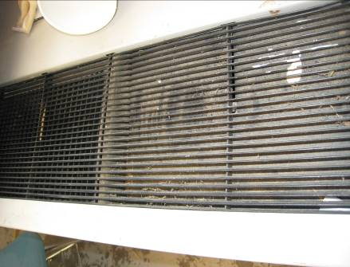

Wood Dust Collected in Univent Diffuser

Picture 22

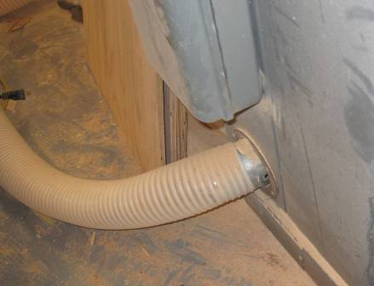
Hole in ring from detaching ductwork

Detaching Flexible Ductwork, note Wood Dust on Floor

Picture 23

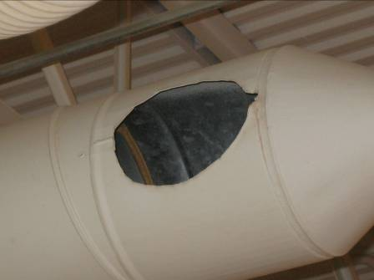

Breach in Wood Dust Collection System Ductwork

Picture 24

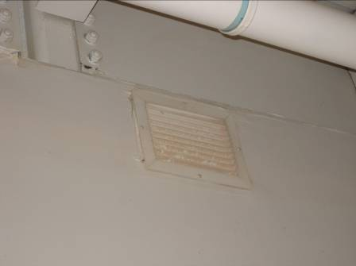

General Exhaust Vent, note Accumulation of Dust

Picture 25

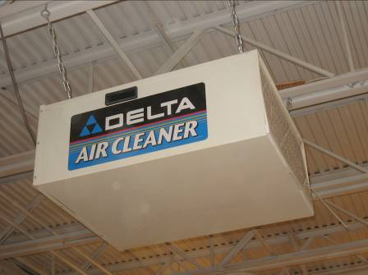

Deactivated Air Cleaner, note Dust on Filter

Picture 26

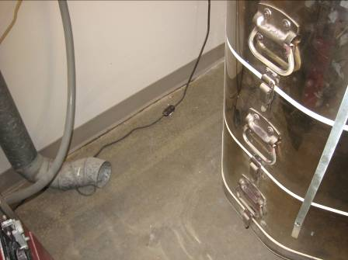

Ductwork Detached from Kiln

Picture 27

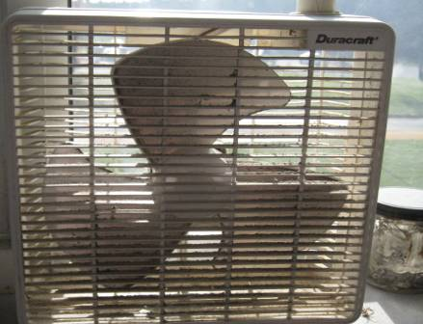

Accumulated Dust/Debris on Box Fan in Classroom

Picture 28

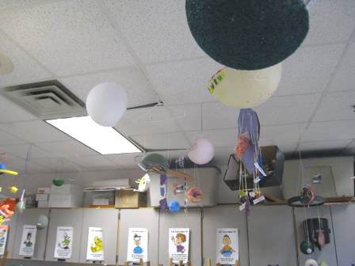

Various Objects Hanging from Suspended Ceiling Tile System
Location/ Room | Occupants  in Room | Temp  (°F) | Relative  Humidity  (%) | Carbon  Dioxide  (ppm) | Carbon Monoxide  (ppm) | PM2.5  (µg/m³) | Windows  Openable | Ventilation |  | Remarks
 |  |  |  |  |  |  |  | Supply | Exhaust | Remarks
background |  | 45 | 49 | 353 | ND | 23 |  |  |  | Cool, scattered clouds, winds SE 6-14 mph, gusts up to 22 mph
1st Floor
A 102 | 2 | 71 | 27 | 565 | ND | 3 | Y | Y | Y | Carpet complaints
A 104 | 3 | 71 | 28 | 784 | ND | 6 | Y | Y | Y | Items/plants on UV
A 106 | 0 | 71 | 27 | 701 | ND | 4 | Y | Y | Y | PC, lamination machine
A 103 | 26 | 71 | 35 | 1512 | ND | 5 | Y | Y | Y | PF
A 105 | 25 | 70 | 35 | 1500 | ND | 5 | Y | Y | Y | 1 WD CT
A 107 | 3 | 70 | 31 | 888 | ND | 4 | Y | Y | Y | Plants on UV, PF
A 108 | 1 | 70 | 29 | 730 | ND | 3 | Y | Y | Y | Space heater, AD
A 109 | 26 | 69 | 35 | 1300 | ND | 6 | Y | Y | Y | UV-off, window open, MT
A 110 | 11 | 73 | 30 | 1516 | ND | 6 | Y | Y | Y | DEM, CPs
A 112 | 1 | 69 | 29 | 1104 | ND | 4 | N | Y | Y
A 112 A | 1 | 70 | 30 | 1097 | ND | 4 | N | Y | Y
A 113 | 1 | 72 | 27 | 911 | ND | 8 | N | Y | Y | PCs, fridge, carpet
A 119 | 0 | 70 | 31 | 654 | ND | 9 | Y | Y | Y
A 120 | 5 | 73 | 32 | 815 | ND | 14 | Y | Y | N
A 120 A Wood Shop | 10 | 76 | 32 | 857 | ND | 30-37 | Y | Y | Y | Air cleaner not operating, breach in local exhaust for wood cutting equipment
A 126 | 20 | 74 | 32 | 1051 | ND | 4 | Y | Y | Y | 6 MTs, space sink/countertop
A 131 | 0 | 69 | 30 | 592 | ND | 3 | Y | Y | Y | 1 WD CT
B 102 | 0 | 69 | 30 | 537 | ND | 4 | N | Y | Y | PC, DO
B 102 A | 1 | 71 | 30 | 710 | ND | 4 | N | Y | Y | PC, DO
B 102 B | 2 | 71 | 31 | 654 | ND | 4 | Y | Y | Y | Plants
B 103 | 1 | 69 | 32 | 517 | ND | 4 | Y | Y | Y
B 104 | 21 | 71 | 33 | 900 | ND | 4 | Y | Y | Y
B 105 | 25 | 70 | 37 | 1360 | ND | 4 | Y | Y | Y
B 106 | 19 | 71 | 35 | 1095 | ND | 4 | Y | Y | Y | Musty carpet odors, CPs
B 107 | 13 | 70 | 35 | 998 | ND | 3 | Y | Y | Y
B 108 | 17 | 70 | 33 | 954 | ND | 7 | Y | Y | Y | UV off, PF
B 109 | 19 | 70 | 35 | 1132 | ND | 3 | Y | Y | Y
B 110 | 19 | 73 | 33 | 879 | ND | 8 | Y | Y | Y | Items on UV, DO
B 112 | 9 | 73 | 35 | 1327 | ND | 5 | Y | Y | Y | Dust/debris on vents, HVAC down for repairs
B 113 | 2 | 71 | 43 | 790 | ND | 3 | N | Y | Y | Exhaust fan drying carpeting, moderate moisture testing, rec moving furniture/cabinets to dry
B 114 A | 1 | 71 | 46 | 880 | ND | 3 | Y | Y | Y
B 115 | 0 | 70 | 64 | 780 | ND | 2 | Y | Y | Y | Visible mold growth on GW behind vinyl coving and file cabinet, GW and carpet elevated moisture-musty odors
B 117 Mech Room |  |  |  |  |  |  |  |  |  | Air handling unit leak, WD GW
B 118 | 9 | 73 | 30 | 640 | ND | 4 | N | Y | Y
B 119 | 21 | 72 | 34 | 1413 | ND | 5 | N | Y | Y | Space between sink and countertop, CP
B 127 | 0 | 69 | 31 | 641 | ND | 4 | Y | Y | Y | 2 MT/AT, 1 WD CT
B 132 | 1 | 72 | 27 | 737 | ND | 3 | Y | Y | Y | ~ 20 computers
C 101 | 11 | 70 | 30 | 597 | ND | 6 | N | Y | Y
C 109 | 20 | 71 | 29 | 721 | ND | 17 | Y | Y | Y | Pottery, UV obstructed
C Kiln Room | 2 | 70 | 29 | 527 | ND | 18 | N | Y | Y | Kiln vented-duct not attached, PF
C 117 Music | 10 | 71 | 27 | 821 | ND | 6 | N | Y | Y | PF, 1 WD CT, CP, accumulated items
E 107 | 2 | 69 | 31 | 502 | ND | 4 | Y | Y | Y | PF, space sink countertop
E 110 | 2 | 70 | 29 | 493 | ND | 3 | Y | Y | Y
E 115 Nurse | 1 | 74 | 26 | 561 | ND | 2 | N | Y | Y | 2 WD CT
Cafeteria | ~200 | 70 | 31 | 699 | ND | 4 | N | Y | Y
Auditorium | 0 | 70 | 26 | 450 | ND | 5 | N | Y | Y
Gymnasium | 6 | 69 | 31 | 682 | ND | 6 | N | Y | Y
Boy’s Locker Room | 2 | 68 | 31 | 431 | ND | 3 | N | Y | Y | WD CTs/MTs (mech vent on timer shuts off 2-3:00 pm) rec resetting timer to operate during occupancy
Girl’s Locker Room | 0 | 68 | 29 | 431 | ND | 4 | N | Y | Y | WD CTs, AT
Gym Instructors Office | 1 | 68 | 31 | 552 | ND | 4 | N | Y | Y | Cold complaints
Gym Hallway |  |  |  |  |  |  |  |  |  | WD CTs persistent leaks reported
Weight Room | 7 | 69 | 32 | 595 | ND | 4 | N | Y | Y
2nd Floor
A 202 | 17 | 73 | 33 | 1285 | ND | 10 | Y | Y | Y | PF
A 203 | 16 | 71 | 34 | 1370 | ND | 5 | Y | Y | Y
A 204 | 23 | 73 | 29 | 973 | ND | 7 | Y | Y | Y | Items on UV, DO
A 205 | 9 | 70 | 33 | 1222 | ND | 7 | Y | Y | Y | PF
A 206 | 21 | 73 | 33 | 1332 | ND | 10 | Y | Y | Y | Items on UV, CPs
A 207 | 26 | 72 | 34 | 1694 | ND | 6 | Y | Y | Y | PF
A 208 | 14 | 73 | 30 | 1128 | ND | 8 | Y | Y | Y | Items on UV
A 209 | 0 | 71 | 27 | 740 | ND | 3 | Y | Y | Y
A 210 | 26 | 71 | 33 | 937 | ND | 9 | Y | Y | Y | Windows open, accumulated items, PF, CTs painted, DO
A 212 | 0 | 71 | 28 | 654 | ND | 4 | N | Y | Y | 4 WD CTs, CTs painted, DO
A 213 | 0 | 70 | 28 | 673 | ND | 4 | Y | Y | Y | Items on UV, exhaust vent-dusty, DO, 4 WD CT
A 214 | 3 | 73 | 27 | 646 | ND | 3 | Y | Y | Y | 6 WD CT, DO
A 215 | 1 | 72 | 27 | 713 | ND | 3 | N | Y | Y | Exhaust vent-dusty, 5 WD CT, DO
A 230 | 23 | 74 | 30 | 924 | ND | 4 | Y | Y | Y | 4 WD CTs near exhaust vent
A 223 | 22 | 72 | 31 | 952 | ND | 7 | Y | Y | Y | 4 WD CT, WD-GW/paint-dry
A 229 | 17 | 71 | 28 | 585 | ND | 4 | Y | Y | Y | Accumulated items, 3 WD CT, aquarium-green with algal growth
A 234 | 0 | 69 | 28 | 457 | ND | 4 | Y | Y | Y | 1 WD CT, plants
A 235 | 0 | 71 | 28 | 524 | ND | 5 | N | Y | Y
A 238 | 1 | 70 | 27 | 550 | ND | 4 | N | Y | Y
B 202 | 25 | 70 | 38 | 1122 | ND | 4 | Y | Y | Y | Items on UV, PF CP
B 203 | 19 | 70 | 34 | 964 | ND | 5 | Y | Y | Y | Dusty exhaust vent, DO
B 204 | 5 | 73 | 32 | 769 | ND | 5 | Y | Y | Y | 1 AT, PF, CP
B 205 | 22 | 72 | 28 | 640 | ND | 6 | Y | Y | Y | Plants, CP, PF, DO
B 206 | 0 | 71 | 31 | 580 | ND | 4 | Y | Y | Y | PF, plants
B 207 | 13 | 72 | 31 | 854 | ND | 3 | Y | Y | Y
B 208 | 28 | 73 | 36 | 1528 | ND | 5 | Y | Y | Y | Exhaust vent dusty, 4 WD CTs, PF-dusty, CP
B 209 | 0 | 70 | 29 | 660 | ND | 4 | Y | Y | Y | 2 WD CT-dry, no visible mold, rec monitor for further leaks
B 210 | 1 | 71 | 33 | 770 | ND | 4 | Y | Y | Y | PF
B-212 | 7 | 71 | 35 | 911 | ND | 3 | Y | Y | Y | 1 WD CT
B 212 | 6 | 69 | 35 | 779 | ND | 2 | Y | Y | Y | 4 WD CTs
B 214 | 2 | 70 | 32 | 728 | ND | 2 | Y | Y | Y
B 214 A | 0 | 71 | 32 | 692 | ND | 3 | N | Y | Y | 1 WD CT
B 221 | 1 | 71 | 28 | 588 | ND | 4 | N | Y | Y | Exhaust vent dusty, PF, heat complaints (year round), DO
B 222 | 5 | 71 | 27 | 700 | ND | 4 | N | Y | Y | Exhaust vent dusty, 1 WD CT, WD paint/GW wall
B 226 Lounge | 0 | 70 | 29 | 668 | ND | 6 | N | Y | Y | 1 AT
B 229 | 13 | 70 | 27 | 603 | ND | 6 | N | Y | Y | PF, AT
Library | 8 | 70 | 27 | 432 | ND | 4 | Y | Y | Y | Plants, PC, plants on carpet
E 208 | 1 | 70 | 26 | 430 | ND | 4 | N | Y | Y | PF, spaces between sink and countertop, DO
E 213 | 0 | 69 | 29 | 552 | ND | 6 | N | Y | Y | Plant on carpet
E 214 | 3 | 70 | 29 | 508 | ND | 4 | N | Y | Y | Spaces between sink and countertop, microwave, DO

