INDOOR AIR QUALITY REASSESSMENT

Mass Commission Against Discrimination
One Ashburton Place, 6th floor
Boston, MA

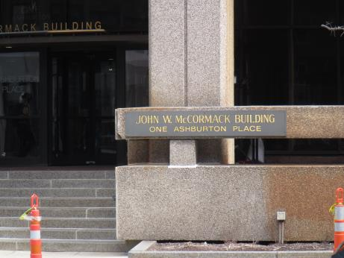

Prepared by:
Massachusetts Department of Public Health
Bureau of Environmental Health
Indoor Air Quality Program
June 2018

Background
Building: | Mass Commission Against Discrimination (MCAD)
Address: | One Ashburton Place, 6th floor
Assessment Requested by: | Michael Memmolo, Chief of Operations and Finance, MCAD
Reason for Request: | General indoor air quality (IAQ) and water damage concerns
Date of Assessment: | June 13, 2018
Massachusetts Department of Public Health/Bureau of Environmental Health (MDPH/BEH) Staff Conducting Assessment: | Ruth Alfasso, Environmental Engineer, IAQ Program
Building Description: | One Ashburton Place, also known as The McCormack Building, is a large state office building constructed in the 1970s. A small area of offices located on the east side of the building was examined during this assessment.
Windows: | Not openable

Methods
Please refer to the IAQ Manual for methods, sampling procedures, and interpretation of results (MDPH, 2015).

IAQ Testing Results
The following is a summary of indoor air testing results (Table 1).
- Carbon dioxide levels were below 800 parts per million (ppm) in all areas surveyed, indicating adequate air exchange.
- Temperature was within the recommended range of 70°F to 78°F in all areas tested.
- Relative humidity was within the recommended range of 40 to 60% in all areas tested.
- Carbon monoxide levels were non-detectable (ND) in all areas tested.
- Fine particulate matter (PM2.5) concentrations measured were below the NAAQS limit of 35 μg/m³ in all areas tested.

Other floors of this building have been assessed by this program and reports from those visits can be found at https://www.mass.gov/service-details/indoor-air-quality-reports-cities-and-towns-b.

Ventilation
A heating, ventilating, and air conditioning (HVAC) system has several functions. First it provides heating and, if equipped, cooling. Second, it is a source of fresh air. Finally, an HVAC system will dilute and remove normally-occurring indoor environmental pollutants by not only introducing fresh air, but by filtering the airstream and ejecting stale air to the outdoors via exhaust ventilation. Even if an HVAC system is operating as designed, point sources of respiratory irritation may exist and cause symptoms in sensitive individuals.
Fresh air is supplied by induction units located along the outer edges of the building (Picture 1) and supply vents located in the ceiling. Return air is drawn through vents around light fixtures using ducted returns. Some induction units had items on top of them, which can obstruct the flow of fresh air. In addition, some of the items on/near the vents of the induction units can be a source of dusts, odors and, in the case of plants, pollen, and other potential allergens. Induction unit vents should be kept free of items and kept clean.

Microbial/Moisture Concerns
The main source of concern for this area is water damage. Due to the age and condition of the building, water leaks around/near the windows have occurred in this building during wind-driven rain events. Water-damaged ceiling tiles and wall materials were observed near windows in the offices examined (Pictures 2 through 4). As shown in Picture 3, deterioration of wall plaster was significant in some of the rooms. Covering materials were added to the walls in some areas to reduce generation of dust from plaster and to make the damage less visible (Picture 5). Rust stains are also visible on some window frame materials. Note that plaster, and the metal and glass of the window frame, are not conducive to mold growth because they lack available carbon/organic material that mold needs to live. No signs of mold growth (e.g., odors, dark staining) were noted on any materials examined, including ceiling tiles. Water-damaged ceiling tiles should be replaced when discovered.
It is important that in offices where windows are known to leak, no porous materials, including papers, books, boxes or clothing, are stored in affected areas.
Plants were noted in a few areas (Table 1; Pictures 4 and 5). Plants can be a source of pollen and mold, which can be respiratory irritants to some individuals. Plants should be properly maintained and equipped with drip pans and should be located away from induction units to prevent the aerosolization of dirt, pollen, and mold.
A refrigerator and water dispenser were located on carpet (Picture 7). As shown in Picture 7, there are stains on the carpet likely from spills of items from the refrigerator. Refrigerators and water dispensing equipment should be located in a non-carpeted area or on a waterproof mat to prevent damage to carpet and subsequent odors.

Other Concerns
Exposure to low levels of total volatile organic compounds (TVOCs) may produce eye, nose, throat, and/or respiratory irritation in some sensitive individuals. In addition to testing, BEH/IAQ staff examined spaces for products containing VOCs. BEH/IAQ staff noted air fresheners, hand sanitizers, cleaning products, and dry erase materials in the office space. All of these products have the potential to be irritants to the eyes, nose, throat, and respiratory system of sensitive individuals.
Items were observed on flat surfaces, such as windowsills, tabletops, counters, bookcases, and desks. Items stored in offices provide a source for dusts to accumulate. These items (e.g. papers, folders, boxes) also make it difficult for custodial staff to clean. Items should be relocated and/or be cleaned periodically to avoid excessive dust build up.
It was reported that air purifying units are used in this office. These units have filters that need to be changed in accordance with manufacturer’s instructions. In addition, units that create ozone should not be used in occupied spaces.
The offices were mostly carpeted. Carpets should be cleaned annually (or semi-annually in soiled/high traffic areas) in accordance with Institute of Inspection, Cleaning and Restoration Certification (IICRC) recommendations, (IICRC, 2012).

Conclusions/Recommendations
Based on observations at the time of assessment, the following is recommended:
- Operate supply and exhaust ventilation continuously in all areas during occupied periods. Ensure all HVAC equipment is cleaned/maintained in accordance with manufacturer’s instructions.
- Balance the HVAC system every 5 years in accordance with Sheet Metal and Air Conditioning Contractors’ National Association (SMACNA) recommendations (SMACNA, 1994).
- Regularly clean induction unit fins and condensation pans (if any) to reduce accumulated debris.
- Remove items from the top and front of induction units to allow for air flow.
- Replace water-damaged ceiling tiles. Avoid storing porous items in areas where leaks occur. Ensure building management is aware of significant leaks or increases in leaking.
- Ensure plaster and coverings over plaster are in good condition to prevent dust generation.
- Keep plants in good condition, avoid overwatering, and remove from the airstream of heating and ventilation equipment.
- Consider the use of waterproof mats underneath refrigerators and water dispensers to protect carpet from leaks and spills.
- For buildings in New England, periods of low relative humidity during the winter are often unavoidable. Therefore, scrupulous cleaning practices should be adopted to minimize common indoor air contaminants whose irritant effects can be enhanced when the relative humidity is low. To control for dusts, a high efficiency particulate arrestance (HEPA) filter equipped vacuum cleaner in conjunction with wet wiping of all surfaces is recommended. Avoid the use of feather dusters. Drinking water during the day can help ease some symptoms associated with a dry environment (throat and sinus irritations).
- Reduce the use of scented cleaning products, sanitizers, and other items that contain VOCs.
- Reduce the amount of items stored on flat surfaces to allow regular cleaning.
- Clean supply vents, personal fans and other equipment to prevent aerosolizing dust.
- Ensure that air purifying units used in offices are maintained in accordance with manufacturer’s instructions, including filter changes. Remove any units which produce ozone.
- Clean carpeting in accordance with IICRC recommendations (IICRC, 2012). Consider the use of plastic chair mats under desks to protect carpeting.
- Refer to resource manual and other related IAQ documents located on the MDPH’s website for further building-wide evaluations and advice on maintaining public buildings. These documents are available at: http://mass.gov/dph/iaq.

References
IICRC. 2012. Institute of Inspection, Cleaning and Restoration Certification. Carpet Cleaning: FAQ.
MDPH. 2015. Massachusetts Department of Public Health. Indoor Air Quality Manual: Chapters I-III. Available at: http://www.mass.gov/eohhs/gov/departments/dph/programs/environmental-health/exposure-topics/iaq/iaq-manual/.
SMACNA. 1994. HVAC Systems Commissioning Manual. 1st ed. Sheet Metal and Air Conditioning Contractors’ National Association, Inc., Chantilly, VA.
Picture 1
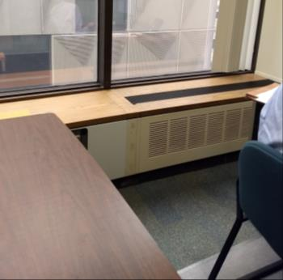
Induction unit for fresh air in offices
Picture 2
Water-damaged wall near window
Picture 3
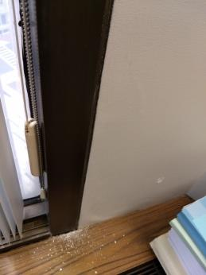
Plaster flaking off wall shown in Picture 2, from underneath top layer on wall
Picture 4
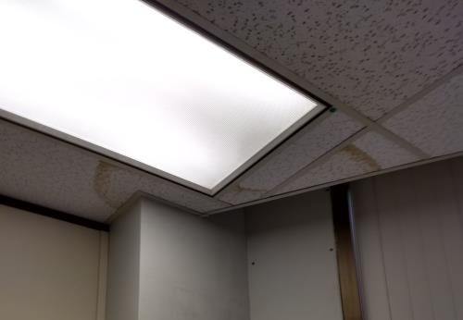
Water-damaged ceiling tile
Picture 5
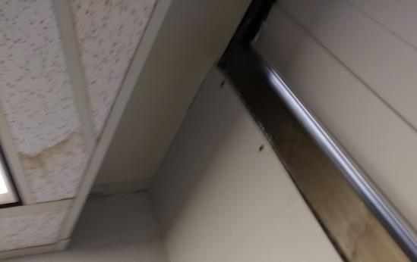
Laminate material bolted to wall to cover plaster
Picture 6
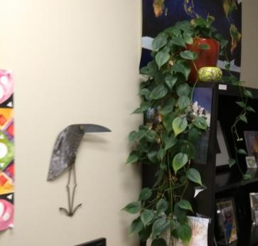
Plant in an office
Picture 7
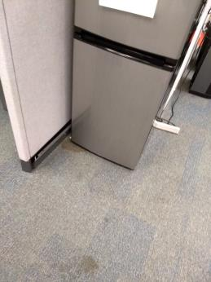
Small refrigerator with stained carpeting

Location | Carbon  Dioxide  (ppm) | Carbon Monoxide  (ppm) | Temp  (°F) | Relative  Humidity  (%) | PM2.5  (µg/m³) | Occupants  in Room | Windows  Openable | Ventilation |  | Remarks
 |  |  |  |  |  |  |  | Supply | Exhaust
612 breakroom | 737 | ND | 73 | 52 | 1 | 2 just left | N | Y | Y | PF
612 “vacant” | 741 | ND | 71 | 56 | 2 | 1 | N | Y | Y
Cassidy | 777 | ND | 72 | 54 | 1 | 0 | N | Y | Y | Items on carpet, WD wall with plaster flaking off beneath covering
Milinazzo-Gaudet | 726 | ND | 73 | 56 | 1 | 2 | N | Y | Y | WD CT, WD wall
Liebman | 653 | ND | 73 | 53 | 1 | 1 | N | Y | Y | Items stored on ventilator, plant
Sheehan | 729 | ND | 73 | 53 | 1 | 1 | N | Y | Y | WD CT and WD wall
Taveres (cubicle area) | 748 | ND | 73 | 53 | 1 | 3 | N | Y | Y | Plant, small WD CT
612-001 cubicle area | 699 | ND | 73 | 52 | 1 | 1 | N | Y | Y | Water cooler and refrigerator on carpet

