# 

**INDOOR AIR QUALITY ASSESSMENT**

**Massachusetts Commission for the Blind Office**

**5 Brussels Street, Building A**

**Worcester**



Prepared by:

Massachusetts Department of Public Health

Bureau of Climate and Environmental Health

Division of Environmental Health Regulations and Standards

March 2025

# BACKGROUND

|  |  |
| --- | --- |
| Building: | Massachusetts Commission for the Blind Office (MCB) located within the Massachusetts Department of Children and Families (DCF) Office |
| Address: | 5 Brussels Street, Building A, 1st Floor, Worcester, MA |
| Assessment Requested by: | Pedro Batista, Project Coordinator, Executive Office of Health and Human Services (EOHHS) |
| Reason for Request: | Brick dust/debris falling from the ceiling |
| Date of Assessment: | March 13, 2025 |
| Massachusetts Department of Public Health/Bureau of Climate and Environmental Health, Division of Environmental Health Regulations and Standards (MDPH/BCEH/EHRS) Staff Conducting Assessment: | Thomas Murphy, Environmental Analyst, EHRS |
| Building Description: | The MCB office is located in a large former mill complex (Whittall Mills) which was originally constructed in the late 1800s. The MCB occupies a small office space area on the first floor in Building A. Other state and private businesses are located in the building, and in the other converted mill buildings in the complex. The buildings are red brick and have typical features for mill conversions including high ceilings. Building A is partially covered with painted siding. A full gut renovation of the spaces was performed prior to MCB/DCF occupancy in 2020 including new heating, ventilation, and air conditioning systems (HVAC), interior walls and partitions, flooring, and painting. |
| Windows: | Windows are not openable on the first floor. |

**METHODS**

Please refer to the IAQ Manual for methods, sampling procedures, and interpretation of results (MDPH, 2015).

**RESULTS AND DISCUSSION**

The following is a summary of indoor air testing results (Table 1):

* ***Carbon dioxide levels*** were above MDPH guideline of 800 parts per million (ppm) in 10 out 14 areas tested, indicating a lack of adequate fresh air in the space and suggesting the HVAC system needs an adjustment.
* ***Temperature*** was just below or within the MDPH recommended range of 70°F to 78°F in most areas assessed.
* ***Relative humidity*** was below the recommended range of 40% to 60% in all areas examined, which is typical during the heating season in New England.
* ***Carbon monoxide*** levels were non-detectable (ND) in the areas assessed.
* ***Fine particulate matter (PM2.5)*** concentrations measured were non-detectable in all areas assessed which is below the National Ambient Air Quality Standard (NAAQS) level of 35 μg/m3.

## Ventilation

A heating, ventilating, and air conditioning (HVAC) system has several functions. First, it provides heating and, if equipped, cooling. Second, it is a source of fresh air. Finally, an HVAC system will dilute and remove normally occurring indoor environmental pollutants by not only introducing fresh air, but also filtering the airstream and ejecting stale air outdoors via exhaust ventilation. Even if an HVAC system is operating as designed, point sources of respiratory irritation may exist and affect symptoms in sensitive individuals. Carbon dioxide is not a problem in and of itself. It is used as an indicator of the adequacy of ventilation.

As carbon dioxide levels rise, it indicates that the ventilating system is malfunctioning, or the design occupancy of the room is being exceeded. When this happens, a buildup of common indoor air pollutants can occur, leading to discomfort or health complaints. The Occupational Safety and Health Administration (OSHA) standard for carbon dioxide is 5,000 parts per million parts of air (ppm). Workers may be exposed to this level for 40 hours/week, based on a time-weighted average (OSHA, 1997).

Fresh air is provided by rooftop air-handling units (AHUs). Fresh air is drawn into the AHUs through a bank of filters, heated or cooled, and delivered to occupied areas via ducted supply vents (Picture 1). Return air is drawn into ducted vents back to the rooftop AHUs. The return vent in the MCB was tested and found to be operating (Picture 2). A supply vent located above cubicles was tested, and the airflow was minimal from it; lack of airflow may be contributing to the elevated carbon dioxide readings.

The AHUs for this building were not assessed during this visit. The MDPH/BCEH recommends that AHU filters be changed 2-4 times a year (or per the manufacturer’s recommendations) and be at least a minimum efficiency reporting value (MERV) 8, or higher if the equipment can handle them without a degradation in airflow, as these are adequate to filter out pollen, mold, and similar particulates (ASHRAE, 2012). EOHHS staff reported the filters are at least MERV 8.

AHUs are controlled by thermostats and a centralized control system. The thermostats (Picture 3) do not indicate if the system is set to run to supply continuous fresh air during occupancy, which is recommended.

To have proper ventilation with a mechanical supply and exhaust system, the systems must be balanced to provide an adequate amount of fresh air to the interior of a room while removing stale air from the room. It is recommended that HVAC systems be re-balanced every five years to ensure adequate air systems function (SMACNA, 1994). According to EOHHS staff, the HVAC system has not yet been re-balanced.

## Brick Dust/Debris and Particulate Matter

The main concern prompting this assessment was about brick dust/debris falling from the ceiling and into the MCB office space. As is typical in old mill conversions, bricks flake over time and can produce a red dust. The MCB has a high wood beam ceiling with cracks and holes (Picture 4) installed beneath the original mill building’s brick ceiling. When the ceiling is disturbed by movements or vibrations such as walking or moving furniture on the floor above, brick dust/debris falls through the wood ceiling into the MCB. Brick dust/debris was found on surfaces in the MCB including on cubicles, windowsills, furniture, and other surfaces. (Pictures 5 and 6; Table 1). In office 1088, which reportedly had been experiencing a frequent amount of brick dust/debris falling, the ceiling had been recently plastered (Picture 7), and property management reported the dust/debris had significantly been reduced.

According to property management and EOHHS staff, the following are methods being considered to address the falling brick dust/debris in the MCB:

* Have MCB staff remove all personal items from the space and then during unoccupied hours, property management will try to disturb all the brick dust/debris above the wood ceiling and then conduct a deep cleaning to remove the fallen dust/debris. This deep cleaning should be done using methods such as wet wiping and a high-efficiency particulate arrestance (HEPA) filter-equipped vacuum cleaner to remove all the dust/debris that has fallen.
* Install a plastic material sheet on the ceiling to catch any falling dust/debris. This plastic material should be consistently monitored and repaired or replaced as necessary.
* Plaster the entire MCB ceiling similarly to office 1088.

All work done in a building that is occupied such as the MCB should follow BCEH’s recommendations [Construction and renovation generated pollutants in occupied buildings | Mass.gov](https://www.mass.gov/info-details/construction-and-renovation-generated-pollutants-in-occupied-buildings).

Particulate matter is airborne solids that can be irritating to the eyes, nose and throat. The US EPA has established national ambient air quality standard (NAAQS) limits for exposure to particulate matter. The NAAQS originally established exposure limits to particulate matter with a diameter of 10 μm or less (PM10). According to the NAAQS, PM10 levels should not exceed 150 micrograms per cubic meter (μg/m3) in a 24-hour average (US EPA, 2006). These standards were adopted by both the American Society of Heating, Refrigeration and Air Conditioning Engineers (ASHRAE) and Building Officials and Code Administrators International (BOCA).

Since the issuance of the ASHRAE standard and BOCA Code, US EPA established a more protective standard for fine airborne particles. This more stringent PM2.5 standard requires outdoor air particle levels be maintained below 35 μg/m3 over a 24-hour average (US EPA, 2006). Although both the ASHRAE standard and BOCA Code adopted the PM10 standard for evaluating air quality, MDPH uses the more protective PM2.5 standard for evaluating airborne particulate matter concentrations in the indoor environment.

While brick dust was observed on surfaces, levels of particulate matter in the 2.5 µm size range, which is the range most associated with health impacts, were non-detectable (Table 1). A non-detectable level is much lower than the EPA NAAQS level of 35 μg/m3, which is used to determine if outdoor air is in a healthy range. This indicates that while the brick dust/debris can be unsightly, it is not remaining suspended in the air where it can be inhaled. Frequent cleaning of areas impacted by brick dust/debris should be conducted using methods that will not aerosolize the dust, including wet wiping or use of a HEPA filter-equipped vacuum cleaner. Dry sweeping or similar cleaning methods should not be used.

## Microbial/Moisture Concerns

Food/liquid stains were observed in the kitchenette refrigerator (Picture 8) and the interior of the microwave was dirty (Picture 9). Food preparation equipment should be kept clean and free from spills to prevent mold growth, pests, and odors. Food was found in the MCB, including sweetener packets and trail mix stored openly in offices (Picture 10 and 11). Food should be stored in pest-proof containers that are closed every night.

The exterior of the building was examined for potential sources of water infiltration and damage. Moss growth was noted on the side of the building (Picture 12). Moss growth indicates chronic moistening and should be removed from these areas. At least one opening near the top of the building was observed (Picture 13). This opening can be an entry point for pests, water infiltration, dust/debris, hot/humid air, and should be sealed appropriately.

Efflorescence was observed on the exterior of the building envelope (Picture 14).Efflorescence results when rainwater penetrates into brick and mortar. A suspension of water and salts forms in the brick and mortar, which then travels to the wall surface. As the water evaporates, a white, powdery material is formed (efflorescence). While efflorescence is a sign of water exposure to brick, it is not mold growth.

## Other IAQ Concerns

Removal of brick dust and other dust and debris is easier when surfaces are free of items. In a few areas, items were noted on floors, desktops, and windowsills (Picture 15). Custodial staff may have difficulty vacuuming around items, and may not wish to disturb personal items or equipment, including wires from electronics. Stored items should be, to the greatest extent possible, kept off the floor and in designated storage units such as shelves, racks, and cabinets. Agency staff should coordinate with custodial staff on schedules for cleaning and dust/debris removal so that items can be moved for better cleaning.

Exposure to low levels of total volatile organic compounds (TVOCs) may produce eye, nose, throat, and/or respiratory irritation in some sensitive individuals. BCEH staff examined areas for products containing VOCs. Hand sanitizers, scented cleaning sprays, disinfectant/cleaning wipes, and dry erase materials were noted in the MCB (Picture 16; Table 1). All these products have the potential to be irritants to the eyes, nose, throat, and respiratory system of sensitive individuals. Scented products in particular can be a source of irritation, or a trigger for asthma and migraine headaches. Note that scented products only cover up odors and do not remove the source of the odor.

Almost the entire MCB is carpeted. Carpets should be vacuumed regularly with a high efficiency particulate arrestance (HEPA)-filter-equipped vacuum cleaner and cleaned annually (or semi-annually in soiled/high traffic areas) in accordance with Institute of Inspection, Cleaning and Restoration Certification (IICRC) recommendations, (IICRC, 2012). Fabric and leather-covered furniture in the office should also be consistently cleaned.

Personal fans were also noted in the MCB (Table 1). If dust is accumulated on the blades, it can be aerosolized during use. Fans should be checked and cleaned periodically to remove any dust.

# CONCLUSIONS AND RECOMMENDATIONS

In view of the findings at the time of the visit, the following recommendations are made:

## Ventilation recommendations

1. Operate the HVAC system (supply/exhaust) to provide *continuous* *fresh air* ventilation during occupied hours.
2. Air handling units should be equipped with MERV 8-rated filters (or higher), which are adequate to filter out pollen and mold spores. Filters should be changed 2-4 times a year, or as per the manufacturers’ recommendations.
3. Upgrade thermostats to indicate if the system is set to supply *continuous* *fresh air* during occupancy.
4. Balance the mechanical ventilation system every five years, as recommended by ventilation industry standards (SMACNA, 1994).

## Brick dust/debris and particulate matter recommendations

1. Implement as many methods as necessary that are being considered by property management and EOHHS staff to minimize the amount of brick dust/debris falling from the ceiling which include:

* Have MCB staff remove all personal items from the space and then property management will try to disturb all the brick dust/debris above the wood ceiling and then conduct a deep cleaning to remove the fallen dust/debris. This deep cleaning should be done using methods such as wet wiping and a high-efficiency particulate arrestance (HEPA) filter-equipped vacuum cleaner to remove all the dust/debris that has fallen.
* Install a plastic material sheet on the ceiling to catch any falling dust/debris. This plastic material should be repaired or replaced as necessary.
* Plaster the entire ceiling similar to office 1088.

1. Follow BCEH’s recommendations for conducting all work done in the MCB ([Construction and renovation generated pollutants in occupied buildings | Mass.gov](https://www.mass.gov/info-details/construction-and-renovation-generated-pollutants-in-occupied-buildings)).
2. Clean brick dust/debris frequently using methods that will not aerosolize dust/debris such as wet wiping or HEPA vacuuming.

## Microbial/Moisture recommendations

1. Routinely clean the kitchenette including food/liquid stains from the refrigerator and food residues from microwaves, toasters, coffee makers, or any other appliances used to prepare or heat food.
2. Do not store food in or on employee desks, cubicles, or other work surfaces apart from the kitchenette, and only in pest-proof air-tight containers made of hard plastic, glass, or metal.
3. Remove moss growth from the building exterior and monitor the area for drainage issues during wet weather.
4. Seal/repair the opening near the top of the building to reduce entry points for pests, water infiltration, dust/debris and hot/humid air.
5. Clean/scrape efflorescence off the exterior of the building envelope.

## Other recommendations

1. Ensure areas of the MCB can be accessed for routine cleaning of brick dust/debris by coordinating with MCB staff the removal of personal items from offices and cubicles.
2. Limit the number of cardboard boxes stored on the floor.
3. Use storage shelves, cabinets, or pest-proof totes that are configured to reduce rodent hiding spaces/harborages.
4. Use VOC-containing products in areas with good ventilation and keep tightly closed when not in use. Avoid products with strong scents and avoid mixing incompatible products.
5. Refer to “[Clean Air Is Odor Free](https://www.mass.gov/doc/clean-air-is-odor-free-removing-fragrances-to-improve-indoor-air-quality-in-schools-and-offices-0/download)” for more information on fragrances in buildings.
6. Clean carpeting in accordance with IICRC recommendations.
7. Consistently clean fabric and leather-covered furniture.
8. Periodically check personal fans for dust/debris and clean them.
9. For buildings in New England, periods of low relative humidity during the winter are often unavoidable. Therefore, scrupulous cleaning practices should be adopted to minimize common indoor air contaminants whose irritant effects can be enhanced when the relative humidity is low. To control dust, a HEPA filter equipped vacuum cleaner in conjunction with wet wiping of all surfaces is recommended. Avoid the use of feather dusters. Drinking water during the day can help ease symptoms associated with a dry environment (throat and sinus irritations).
10. Refer to resource manual and other related IAQ documents located on the MDPH’s website for further building-wide evaluations and advice on maintaining public buildings. These documents are available at: <http://mass.gov/dph/iaq>.

# REFERENCES

ASHRAE. 2012. American Society of Heating, Refrigeration and Air Conditioning Engineers (ASHRAE) Standard 52.2-2012 -- Method of Testing General Ventilation Air-Cleaning Devices for Removal Efficiency by Particle Size (ANSI Approved).

IICRC. 2012. Carpet Cleaning FAQ 4 Institute of Inspection, Cleaning and Restoration Certification. Institute of Inspection Cleaning and Restoration, Vancouver, WA.

MDPH. 2015. Massachusetts Department of Public Health. Indoor Air Quality Manual: Chapters I-III. Available at: <https://www.mass.gov/lists/indoor-air-quality-manual-and-appendices>

OSHA. 1997. Limits for Air Contaminants. Occupational Safety and Health Administration. Code of Federal Regulations. 29 C.F.R 1910.1000 Table Z-1-A.

SMACNA. 1994. HVAC Systems Commissioning Manual. 1st ed. Sheet Metal and Air Conditioning Contractors’ National Association, Inc., Chantilly, VA.

US EPA. 2006. National Ambient Air Quality Standards (NAAQS). US Environmental Protection Agency, Office of Air Quality Planning and Standards, Washington, DC.

**Picture 1**

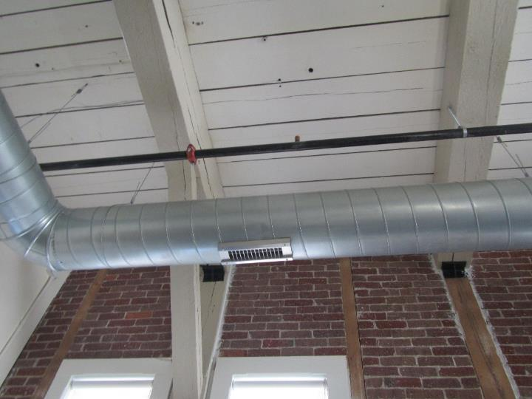

**Typical supply vent in the MCB**

**Picture 2**

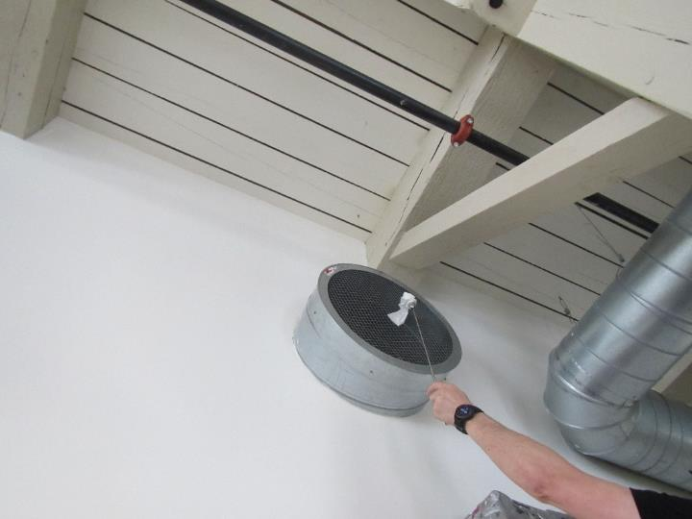

**Return vent in the MCB; note suction of the tissue paper indicating air is being pulled in**

**Picture 3**

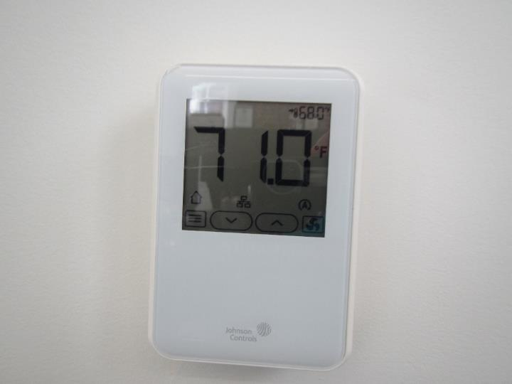

**Thermostat on wall, note no indication of HVAC fan being “on”**

**Picture 4**

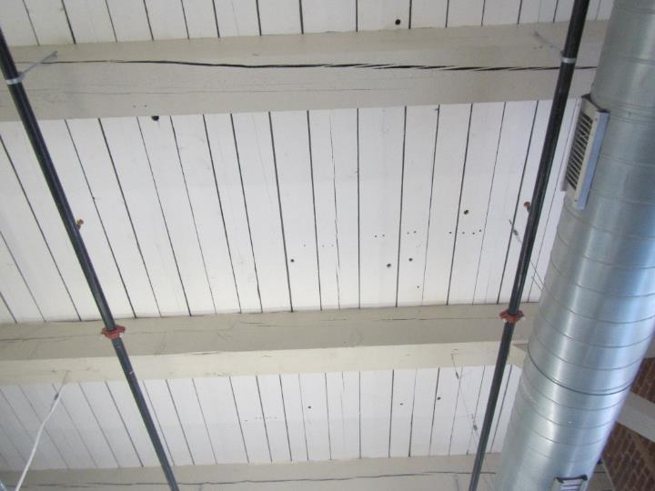

**Cracks and holes in the wood ceiling**

**Picture 5**

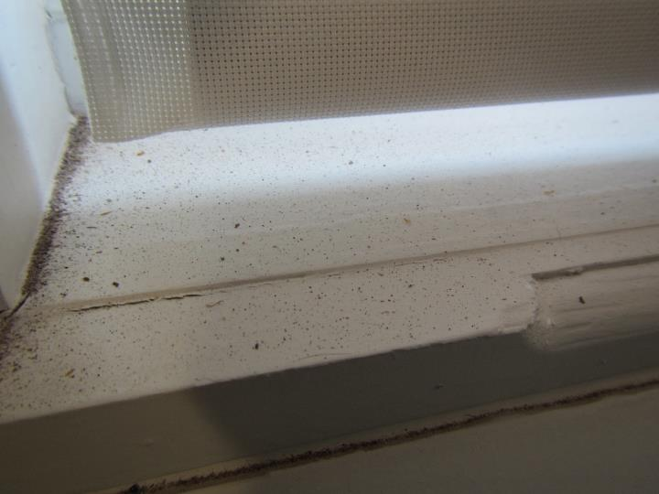

**Brick dust/debris on a windowsill**

**Picture 6**

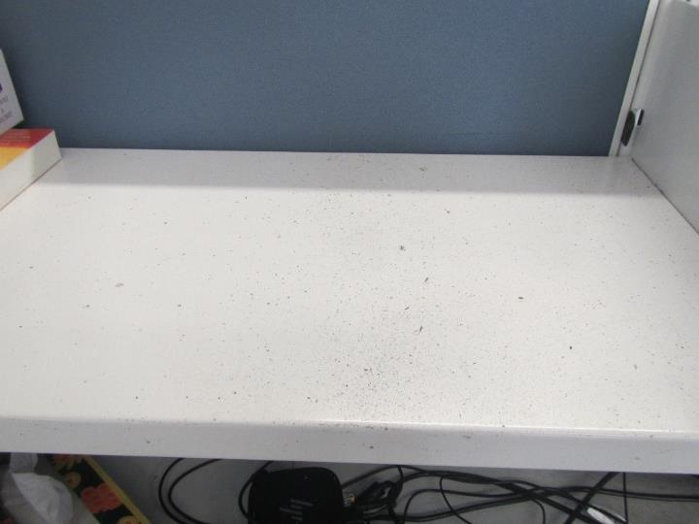

**Brick dust/debris on a cubicle desk**

**Picture 7**

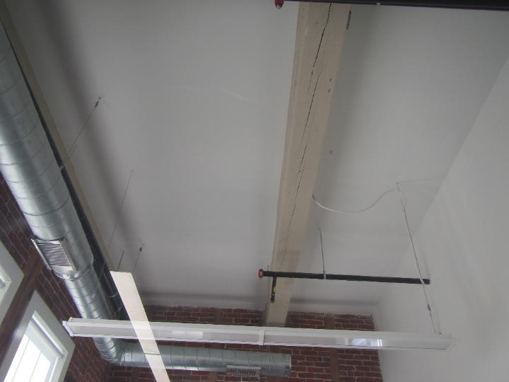

**Recently plastered ceiling in office 1088**

**Picture 8**

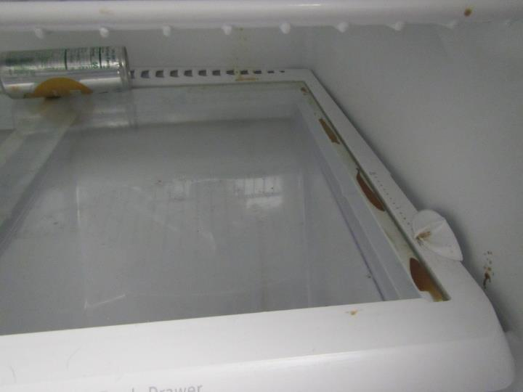

**Food/liquid stains inside refrigerator**

**Picture 9**

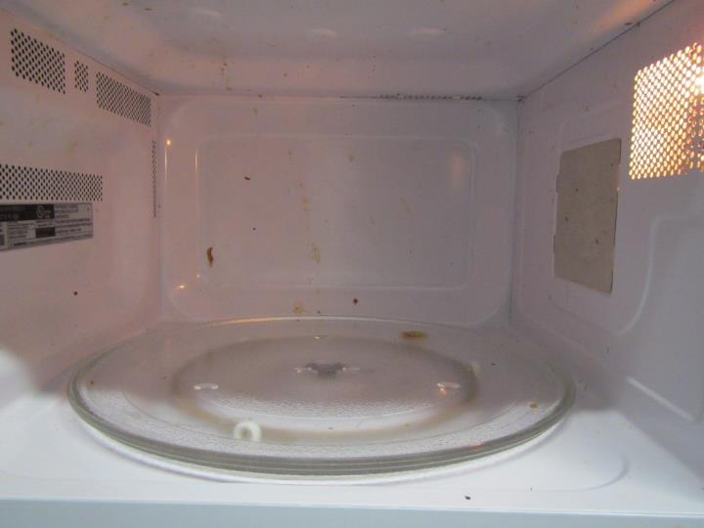

**Interior of microwave dirty**

**Picture 10**

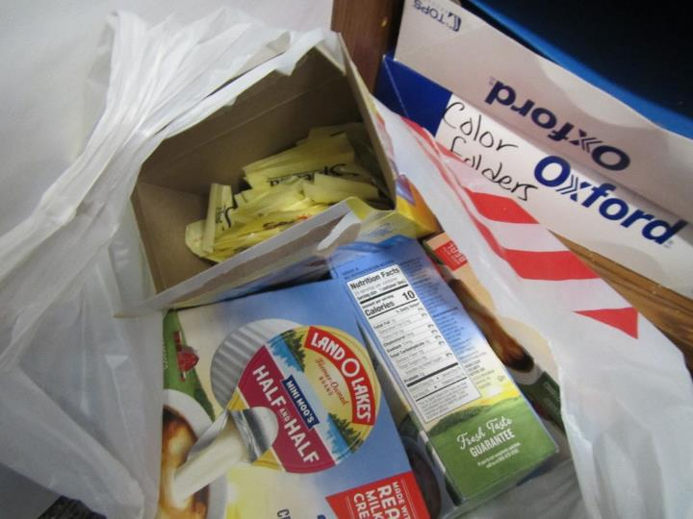

**Sweetener packets and other food items in an office**

**Picture 11**



**Trail mix on a table in an office**

**Picture 12**

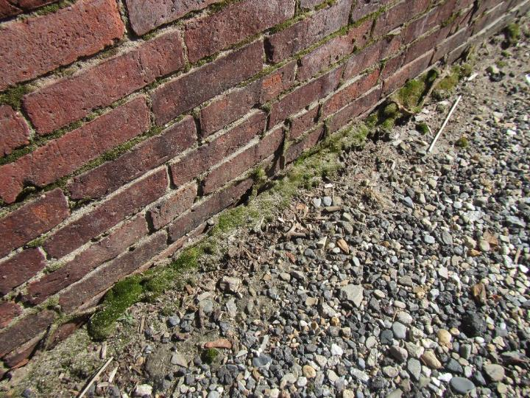

**Moss growth on the exterior of the building**

**Picture 13**

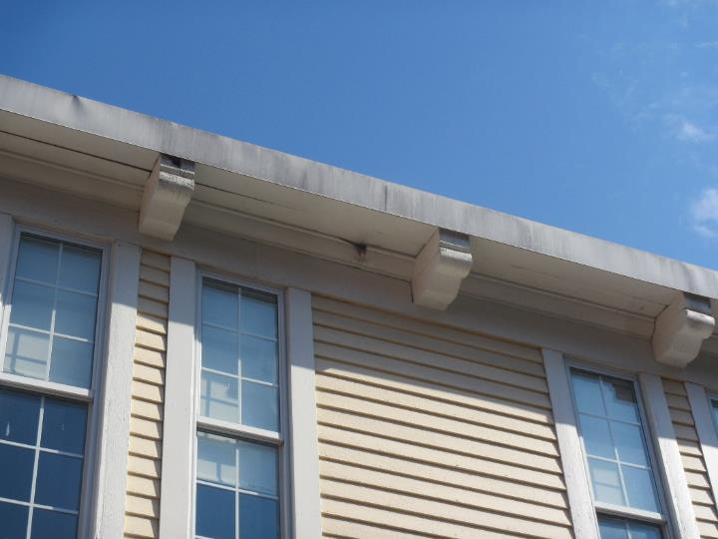

**Opening near the top of the building**

**Picture 14**

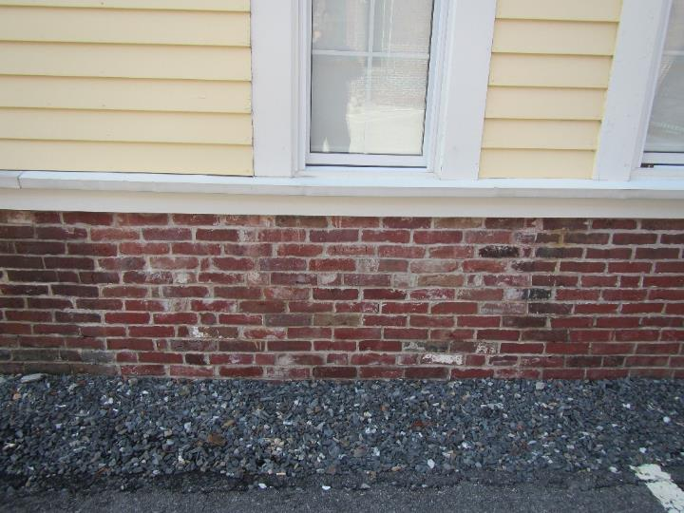

**Efflorescence on the exterior of the building**

**Picture 15**

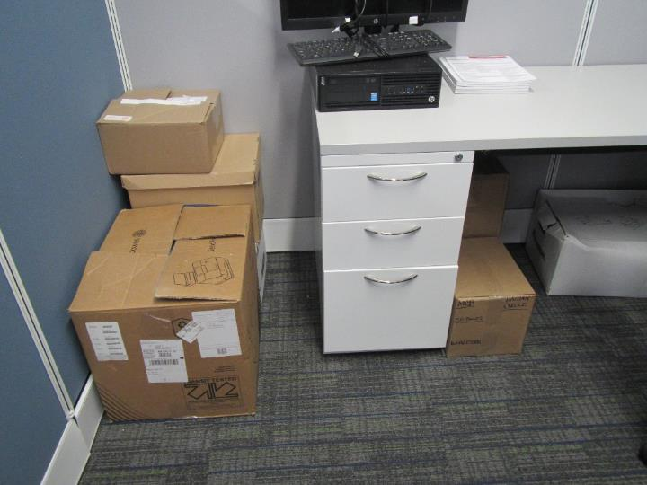

**Cardboard boxes on the floor in a cubicle**

**Picture 16**

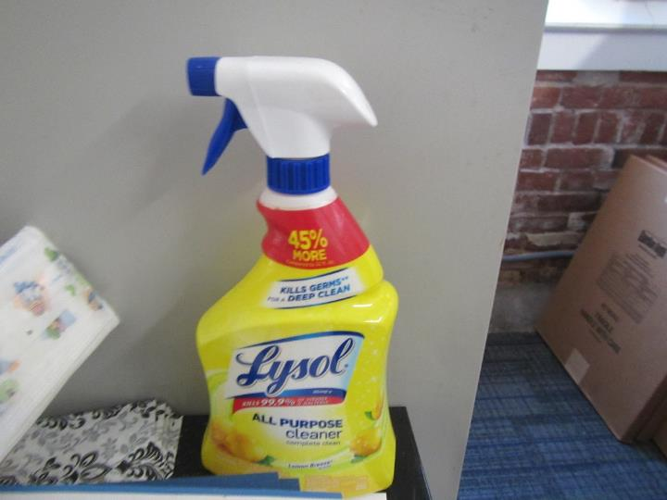

**Scented cleaning spray**

| **Location** | **Carbon**  **Dioxide**  **(ppm)** | **Carbon Monoxide**  **(ppm)** | **Temp**  **(°F)** | **Relative**  **Humidity**  **(%)** | **PM2.5**  **(µg/m3)** | **Occupants**  **in Room** | **Windows**  **Openable** | **Ventilation** | | **Remarks** |
| --- | --- | --- | --- | --- | --- | --- | --- | --- | --- | --- |
| **Supply** | **Exhaust** |
| Background (outside) | 447 | ND | 44 | 36 | 1 |  |  |  |  | Sunny |
| Office 1082 | 736 | ND | 70 | 33 | ND | 0 | N | Y | Y | Cleaning wipes, brick dust/debris on upholstered furniture |
| Office 1088 | 760 | ND | 71 | 34 | ND | 0 | N | Y | Y | Food on table, cleaning wipes |
| Cubicle 1090 | 968 | ND | 70 | 35 | ND | 1 | N | Y | Y | CS |
| Cubicle 1091 | 942 | ND | 70 | 35 | ND | 1 | N | Y | Y | Disinfectant wipes |
| Cubicle 1092 | 820 | ND | 69 | 35 | ND | 0 | N | Y | Y | Cardboard boxes on floor |
| Cubicle 1093 | 859 | ND | 69 | 35 | ND | 0 | N | Y | Y | Cardboard boxes on floor, brick dust/debris on cubicle |
| Cubicle 1094 | 867 | ND | 69 | 34 | ND | 1 | N | Y | Y | PF |
| Cubicle 1095 | 911 | ND | 69 | 35 | ND | 1 | N | Y | Y | DEM |
| Cubicle 1096 | 801 | ND | 69 | 34 | ND | 0 | N | Y | Y | Brick dust/debris on windowsill, personal fan, disinfectant wipes |
| Cubicle 1097 | 821 | ND | 69 | 35 | ND | 0 | N | Y | Y | Brick dust/debris on windowsill |
| Office 1098 | 841 | ND | 70 | 36 | ND | 0 | N | Y | Y | DEM, cardboard boxes on floor, sweetener packets |
| Office 1100 | 780 | ND | 70 | 33 | ND | 0 | N | Y | Y | PF, CS, microwave, disinfectant wipes, cardboard boxes on floor |
| Unoccupied cubicles 1101-1103 & 1106 - 1108 | 762 | ND | 70 | 34 | ND | 0 | N | Y | Y | Brick dust/debris on cubicles and furniture |
| Kitchenette | 830 | ND | 73 | 60 | ND | 1 | N | Y | Y | NC, dirty microwave, dirty refrigerator, toaster, coffee maker, water cooler |