INDOOR AIR QUALITY ASSESSMENT

Massachusetts Department of Revenue
40 Southbridge Street
Worcester, Massachusetts 01608

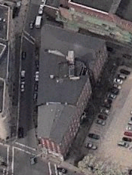

Prepared by:
Massachusetts Department of Public Health
Bureau of Environmental Health
Indoor Air Quality Program
August 2008

Background/Introduction
At the request of Richard Morrissey, Facilities Director for the Massachusetts Department of Revenue (DOR), the Massachusetts Department of Public Health (MDPH), Bureau of Environmental Health (BEH) provided assistance and consultation regarding indoor air quality concerns at the Worcester DOR facility at 40 Southbridge Street, Worcester, Massachusetts. On the morning of Thursday May 29, 2008, the DOR office was evacuated by the Worcester Fire Department (WFD) due to carbon monoxide exposure resulting in the hospitalization of 19 DOR employees.
On the afternoon of May 29, 2008, a visit to conduct an assessment was made to the DOR by Mike Feeney, Director, and Cory Holmes, Indoor Air Quality (IAQ) Inspector in BEH’s IAQ Program. On May 30, 2008, Mr. Holmes returned to the building with Lisa Hebert, IAQ Inspector within BEH’s IAQ Program to conduct follow-up testing. On June 2, 2008, Mr. Feeney returned to the building to conduct final clearance testing prior to re-occupancy by DOR staff. On June 12, 2008, Mr. Holmes and Ms. Hebert revisited the DOR building to conduct a general IAQ assessment during normal business operations. This report focuses on general indoor air quality conditions observed at the time of the June 12, 2008, assessment. Issues regarding carbon monoxide/reoccupation of DOR space are the subject of a separate report.
The DOR is located in a five-story office building located in downtown Worcester. The brick and wood framed structure was reportedly built in 1860; the DOR has occupied the building since 1995. The DOR occupies portions of the second, third, fourth, and fifth floors. A coffee shop, restaurant and private offices occupy the remainder of the building. Windows in the building are openable. The building was previously visited by BEH staff in September 2000. A report was issued detailing conditions observed at the time of that visit with recommendations for improving indoor air quality (MDPH, 2000). It is also important to note that portions of the DOR occupied space were undergoing interior renovations during the assessment.

Methods/Results
Air tests for carbon monoxide, carbon dioxide, temperature and relative humidity were conducted with the TSI, Q-Trak, IAQ Monitor, Model 8551. Air samples are listed in the Table by location that the air sample was taken or by the name of the person who occupies the area. MDPH staff also performed visual inspection of building materials for water damage and/or microbial growth.

Discussion
Ventilation
It can be seen from the Table that carbon dioxide levels were elevated above 800 ppm in thirty of fifty-two areas, which is indicative of poor air exchange in the majority of areas surveyed during the assessment. It is also important to note that the majority of areas were sparsely populated, which can greatly reduce carbon dioxide levels.
Ventilation is provided by a heating, ventilation and air conditioning (HVAC) system. The design of the HVAC system uses air handling units (AHUs) located in closets on each floor to provide heat and chilled air (Picture 1). Air is distributed from each AHU by ducted ceiling-mounted air diffusers. This system does not have ducted return vents. In this configuration, air is drawn back to the AHU closets from office space and hallways through passive vents located in closet doors (Picture 2), ceilings and/or walls. Once air is drawn through the passive vents into the AHU closet, it is pulled through a filter affixed to an opening in the AHU cabinet back into the HVAC system. With the exception of one AHU on the fifth floor, no other AHU closet has a direct supply of fresh air from the rooftop unit. Fresh air is introduced by one air handling unit (AHU) on the roof (Picture 3). Limited fresh air is delivered to the various floors occupied by DOR in the following manner:
- The fresh air supply on the fifth floor has a hole in a wall that opens into a ceiling plenum near the elevator (Picture 4). This ceiling plenum also contains an AHU that distributes conditioned air to the main workspace on the fifth floor. Two other AHUs exist on the floor, however neither of these units has a separate fresh air supply. Therefore, these two AHUs only recirculate air.
- The fresh air supply for the fourth floor is a vent that is located in the elevator hall lobby outside of the main public entrance to the DOR office (Picture 5). Due to the configuration of the ventilation system on this floor, the only area that likely receives fresh air is the elevator lobby because AHUs on this floor are located behind security doors. Fresh air from this vent cannot infiltrate into these areas and is likely drawn into the elevator shaft. Therefore, AHUs on the fourth floor only recirculate air.
- The fresh air supply on the third floor is located on a wall inside of the main DOR reception area. AHUs on this floor would then draw fresh air from this vent through the occupied space, likely to the nearest AHU. Other AHUs only recirculate air.
- Fresh air supply on the second floor is located in the DOR office lobby. Offices in this location also have AHUs that are limited to recirculating air.
Based on these observations it does not appear that fresh air is readily available for the majority of the floor spaces in DOR offices. In this configuration, normally occurring environmental pollutants would tend to build up since they are not diluted with fresh air from the mechanical ventilation system.
The exhaust system for the DOR offices appears to be provided solely by the restroom exhaust vents. A single exhaust vent terminus exists on the roof (Picture 6). This particular exhaust vent is likely connected to restrooms in the DOR space. In the experience of IAQ staff, it is a typical design to use the restroom exhaust events as the sole source of exhaust air for a building that has been renovated from one use into office space. No other exhaust ventilation system could be identified by IAQ staff. Grilles seen in the suspended ceiling are most likely return air vents for each AHU closet or are installed to provide a place for heated air to rise out of the occupied space. Also of note was that restroom doors did not appear to be undercut in order to readily allow for transfer air to be drawn from the occupied space into the rest rooms. If restroom vents are not operational during business hours and/or do not have an undercut (or passive door vent) to allow for air to be drawn from occupied spaces into the restroom, the various floors of the DOR do not have a viable means to mechanically remove air. In this condition, normally occurring pollutants can build up and lead to indoor air/comfort complaints.
Based on these observations, the DOR office space has a minimum supply of fresh air to the occupied spaces and also lacks an appropriate amount of exhaust ventilation to remove air from each floor. If any outside source of pollutants were to be drawn into the building as a steady source, the existing HVAC system would be inadequate to either dilute or remove such pollutants from the occupied space.
To maximize air exchange, the MDPH recommends that both supply and exhaust ventilation operate continuously during periods of occupancy. In order to have proper ventilation with a mechanical ventilation system, the systems must be balanced subsequent to installation to provide an adequate amount of fresh air to the interior of a room while removing stale air from the room. It is recommended that HVAC systems be re-balanced every five years to ensure adequate air systems function (SMACNA, 1994). The date of the last balancing of these systems was not available at the time of the assessment.
The Massachusetts Building Code requires that each room have a minimum ventilation rate of 20 cubic feet per minute (cfm) per occupant of fresh outside air or openable windows (SBBRS, 1997; BOCA, 1993). The ventilation must be on at all times that the room is occupied. Providing adequate fresh air ventilation with open windows and maintaining the temperature in the comfort range during the cold weather season is impractical. Mechanical ventilation is usually required to provide adequate fresh air ventilation.
Carbon dioxide is not a problem in and of itself. It is used as an indicator of the adequacy of the fresh air ventilation. As carbon dioxide levels rise, it indicates that the ventilating system is malfunctioning or the design occupancy of the room is being exceeded. When this happens, a buildup of common indoor air pollutants can occur, leading to discomfort or health complaints. The Occupational Safety and Health Administration (OSHA) standard for carbon dioxide is 5,000 parts per million parts of air (ppm). Workers may be exposed to this level for 40 hours/week, based on a time-weighted average (OSHA, 1997).
The MDPH uses a guideline of 800 ppm for publicly occupied buildings. A guideline of 600 ppm or less is preferred in schools due to the fact that the majority of occupants are young and considered to be a more sensitive population in the evaluation of environmental health status. Inadequate ventilation and/or elevated temperatures are major causes of complaints such as respiratory, eye, nose and throat irritation, lethargy and headaches. For more information concerning carbon dioxide, please see Appendix A.
Temperature readings measured during the assessment ranged from 70º F to 79 º F, which were within or slightly above the MDPH recommended comfort guidelines on the day of the assessment. The MDPH recommends that indoor air temperatures be maintained in a range of 70 º F to 78 º F in order to provide for the comfort of building occupants. In many cases concerning indoor air quality, fluctuations of temperature in occupied spaces are typically experienced, even in a building with an adequate fresh air supply. Although measurements were within (or close to) the MDPH comfort guidelines during the assessment, chronic temperature control complaints were expressed by occupants in several areas. As previously mentioned, the building was undergoing renovation during the assessment, which should include adjustment and rebalancing of the mechanical ventilation system. However, temperature control would be expected to be difficult in the building due to its configuration, building components and former function as a factory (e.g., un-insulated, brick interior walls, single-paned windows).
In addition, breaches in ductwork, around vents and directly from heat pumps were observed. In several cases, air was detected escaping from these breaches (Pictures 7 and 8). Compromised integrity of ductwork and holes in AHU closet walls (Picture 9) may reduce the efficiency of the system to heat/cool and distribute air, which may account for some of the difficulty controlling temperature.
The relative humidity measurements indoors ranged from 33 to 47 percent, which were within or close to the lower end of the MDPH comfort range in the majority of areas during the assessment. The MDPH recommends a comfort range of 40 to 60 percent for indoor air relative humidity. Relative humidity levels in the building would be expected to drop during the winter months due to heating. The sensation of dryness and irritation is common in a low relative humidity environment. Low relative humidity is a very common problem during the heating season in the northeast part of the United States.

Microbial/Moisture Concerns
Several areas had water damaged ceiling tiles (Table 1). Water damage ceiling tiles can be a source of mold growth and should be replaced after the source of water has been identified and repaired.

Other IAQ Evaluations
Carbon Monoxide
Carbon monoxide is a by-product of incomplete combustion of organic matter (e.g., gasoline, wood and tobacco). Exposure to carbon monoxide can produce immediate and acute health affects. Several air quality standards have been established to address carbon monoxide and prevent symptoms from exposure to these substances. The MDPH established a corrective action level concerning carbon monoxide in ice skating rinks that use fossil-fueled ice resurfacing equipment. If an operator of an indoor ice rink measures a carbon monoxide level over 30 ppm, taken 20 minutes after resurfacing within a rink, that operator must take actions to reduce carbon monoxide levels (MDPH, 1997).
The American Society of Heating Refrigeration and Air-Conditioning Engineers (ASHRAE) has adopted the National Ambient Air Quality Standards (NAAQS) as one set of criteria for assessing indoor air quality and monitoring of fresh air introduced by HVAC systems (ASHRAE, 1989). The NAAQS are standards established by the US EPA to protect the public health from six criteria pollutants, including carbon monoxide and particulate matter (US EPA, 2006). As recommended by ASHRAE, pollutant levels of fresh air introduced to a building should not exceed the NAAQS levels (ASHRAE, 1989). The NAAQS were adopted by reference in the Building Officials & Code Administrators (BOCA) National Mechanical Code of 1993 (BOCA, 1993), which is now an HVAC standard included in the Massachusetts State Building Code (SBBRS, 1997). According to the NAAQS, carbon monoxide levels in outdoor air should not exceed 9 ppm in an eight-hour average (US EPA, 2006).
Carbon monoxide should not be present in a typical, indoor environment. If it is present, indoor carbon monoxide levels should be less than or equal to outdoor levels. At the time of the assessment the furnaces and gas supply were deactivated and tagged by the Worcester Division of Code Enforcement (WDCE) to prevent reactivation until repairs could be conducted. Outdoor carbon monoxide concentrations were non-detect (ND) on the day of the assessment (Table 1). Carbon monoxide levels measured in the building during the assessment were also ND (Table 1).

Other Conditions
Other conditions that can affect indoor air quality were observed during the assessment. During the initial investigation of the building evacuation, IAQ staff noted that chimneys, that are original to the building, pass through the DOR offices. Each of these chimneys terminated at roof level and do not appear to be abandoned (Picture 6). In one instance, heated air was detected rising out of the chimney. Each of these chimneys had cracks, missing mortar and/or other defects which could allow for air/heat/pollutants to migrate into occupied space. Of note was a chimney clean-out that was found open in the basement area (Picture 10), immediately adjacent to the furnaces that were the source of carbon monoxide (as determined by the WFD). If these chimneys are not in use, they should be appropriately abandoned by sealing the openings on the roof and in the basement.
Areas on the third floor were found to be undergoing renovation while the building is occupied. Of note was a duct in the DOR office that was open on the renovation side of the floor (Picture 11). In addition, the door leading from the occupied space to the renovation side of the floor was not sealed (Picture 12). In this condition, pollutants generated during the renovation project can readily enter adjacent space. Exposure to these pollutants can result in irritations to the eyes, nose, and respiratory system. For that reason such pollutants should be properly contained and vented from the building during occupied hours.
In several areas, items were observed on windowsills, tabletops, counters, bookcases and desks. The large number of items stored provides a source for dusts to accumulate. These items (e.g., papers, folders, boxes) make it difficult for custodial staff to clean. Items should be relocated and/or be cleaned periodically to avoid excessive dust build up. In addition, these materials can accumulate on flat surfaces (e.g., desktops, shelving and carpets) in occupied areas and subsequently be re-aerosolized causing further irritation.
A number of personal fans, supply/exhaust/return vents and surrounding ceiling tiles were observed to have accumulated dust/debris. If exhaust/return vents are not functioning, backdrafting can occur, which can re-aerosolize accumulated dust particles. Re-activated supply vents and personal fans can also aerosolize dust accumulated on vents/fan blades. Dust can be irritating to eyes, nose and respiratory tract.
During the course of this evaluation, IAQ a staff noted water droplets impacting on ground areas behind the building. This moisture appeared to be coming from the rooftop chiller for the HVAC system (Picture 13), which appeared to be leaking water from its cabinet onto a peaked section of the roof (Picture 14) as well as on to the ground below. A chiller system that is losing water is likely affecting the efficiency of such a unit to provide adequate cooling.
Holes in damaged exterior brick were observed around the foundation of the building (Picture 15). These breaches can serve as a pathway for rodents and other pests to enter the building. It is recommended that such a means of the ingress be sealed to control pest infestation.
Finally, several fluorescent light bulbs were found leaning against the wall, unsecured in the 2nd floor heat pump room (Picture 16). Fluorescent bulbs should be stored in a secured fashion or removed/recycled if expired. Breakage of glass can cause injuries and may release mercury and/or other hazardous compounds.

Conclusions/Recommendations
The DOR office space does not appear to have a ventilation system that would be adequate for providing sufficient fresh air or exhaust ventilation. Without an adequately functioning ventilation system, the only means to provide enough fresh air and remove pollutants from the indoor environment would be to open windows. This action is not advisable during hot, humid weather since the ventilation system provides chilled air. If windows are open when the air-conditioning is operating, it would lead to condensation generation on interior building components (e.g., cool surfaces). In addition, opening windows in the winter as a means of supplementing ventilation is not feasible in Massachusetts. Therefore the only viable means to provide for the comfort of individuals in this space is to provide a properly functioning and designed ventilation system.
In order to address the conditions listed in this assessment, the following recommendations made to improve indoor air quality are divided into short-term and long-term corrective measures. The short-term recommendations can be implemented as soon as practicable. Long-term solution measures are more complex and will require planning and resources to adequately address overall indoor air quality concerns. Additional MDPH guidance regarding renovations in occupied buildings is included as Appendix B. The MDPH prepared this guidance document to prevent/reduce the migration of renovation-generated pollutants into occupied areas for buildings undergoing renovations. In view of the findings at the time of the visit, the following recommendations are made:

Short-Term Recommendations

- Due to chronic temperature control complaints it is highly recommended that a ventilation engineer be consulted to fully evaluate the HVAC system, and its components for distribution and control. In addition, have HVAC consultant determine whether the existing fresh air intake system has the capability to provide sufficient outside air.
- Operate the HVAC system continuously in the fan “on” mode during periods of occupancy to maximize air exchange.
- Use openable windows in conjunction with mechanical ventilation to supplement air exchange. Avoid opening windows during hot humid weather to avoid condensation problems. Care should also be taken to ensure windows are properly closed at night and weekends during winter months to avoid the freezing of pipes and potential flooding.
- Seal breaches/holes in heat pump rooms to prevent the draw of pollutants, odors and particulates from wall cavities or adjacent areas into the mechanical ventilation system.
- Inspect heat pumps and all HVAC system ductwork thoroughly and seal breaches throughout the DOR space. In particular, leaking air from the kitchen heat pump on the 3rd floor should be addressed.
- Consult a ventilation engineer concerning re-balancing of the ventilation systems. Ventilation industrial standards recommend that mechanical ventilation systems be balanced every five years (SMACNA, 1994).
- For buildings in New England, periods of low relative humidity during the winter are often unavoidable. Therefore, scrupulous cleaning practices should be adopted to minimize common indoor air contaminants whose irritant effects can be enhanced when the relative humidity is low. To control for dusts, a high efficiency particulate arrestance (HEPA) filter equipped vacuum cleaner in conjunction with wet wiping of all surfaces is recommended. Drinking water during the day can help ease some symptoms associated with a dry environment (e.g., throat and sinus irritations).
- Seal spaces around utility holes and breaches in walls/floors and ceilings with an appropriate fire-rated sealant.
- Seal holes/breaches in exterior brick/foundation.
- Clean personal fans, air diffusers, exhaust, return vents and adjacent ceiling tiles periodically of accumulated dust. If soiled ceiling tiles cannot be cleaned, they should be replaced.
- Repair the rooftop chiller to maximize efficiency and reduce opportunities for moisture intrusions.
- Store fluorescent bulbs in a secured fashion or remove/recycle if expired.
- Refer to resource manuals and other related indoor air quality documents located on the MDPH’s website for further building-wide evaluations and advice on maintaining public buildings. These documents are available at: http://www.state.ma.us/dph/MDPH/iaq/iaqhome.htm.

Long-Term Recommendations

- Both an adequate mechanical fresh air supply and exhaust system needs to be provided for each floor of DOR occupied space. Provide an adequate means of fresh air supply for AHU closet. Improve fresh air supply to each floor by increasing the capacity of the rooftop fresh air intake unit.
- Provide adequate exhaust ventilation for each floor.
- Repoint all existing chimney brick in occupied areas of the DOR offices. If chimneys on the roof are not in use, consider sealing all openings on the roof and clean out the doors in the basement.

References
ASHRAE. 1989. ASHRAE Standard: Ventilation for Acceptable Indoor Air Quality. Sections 5.11, 5.12. American Society of Heating, Refrigerating and Air-Conditioning Engineers, Inc. Atlanta, GA.
BOCA. 1993. The BOCA National Mechanical Code-1993. 8th ed. Building Officials & Code Administrators International, Inc., Country Club Hills, IL. M-308.1

MDPH. 1997. Requirements to Maintain Air Quality in Indoor Skating Rinks (State Sanitary Code, Chapter XI). 105 CMR 675.000. Massachusetts Department of Public Health, Boston, MA.

MDPH. 2000. Indoor Air Quality Assessment. Massachusetts Department of Revenue, Worcester, MA. Massachusetts Department of Public Health, Bureau of Environmental Health Assessment, Boston, MA. October 2000.

OSHA. 1997. Limits for Air Contaminants. Occupational Safety and Health Administration. Code of Federal Regulations. 29 C.F.R. 1910.1000 Table Z-1-A.

SBBRS. 1997. Mechanical Ventilation. State Board of Building Regulations and Standards. Code of Massachusetts Regulations. 780 CMR 1209.0

SMACNA. 1995. IAQ Guidelines for Occupied Buildings Under Construction. 1st ed. Sheet Metal and Air Conditioning Contractors’ National Association, Inc., Chantilly, VA.
US EPA. 2006. National Ambient Air Quality Standards (NAAQS). US Environmental Protection Agency, Office of Air Quality Planning and Standards, Washington, DC. http://www.epa.gov/air/criteria.html.

Picture 1

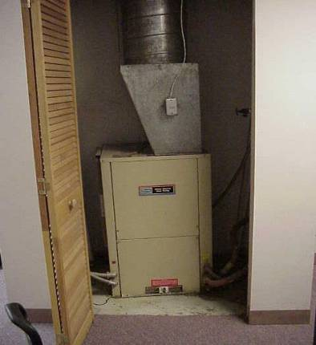

AHU Closet, Note Louvered Door, Which Serves as the Transfer Air Vent For the AHU.

Picture 2

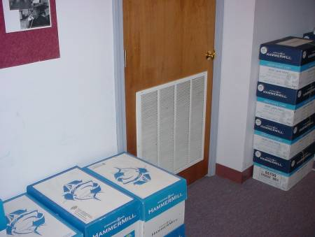

Passive Vent (Transfer Air Vent) for AHU Closet, 4th Floor Reception
Picture 3

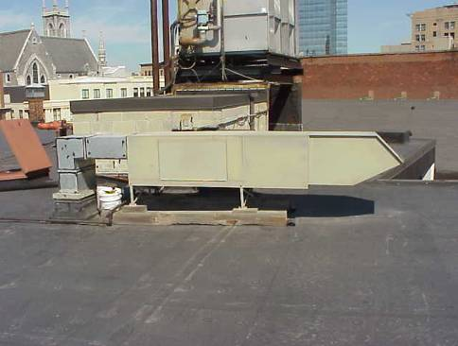
Fresh Air Intake

Rooftop Fresh Air Intake AHU, Note Chilled Water Tower in Rear

Picture 4

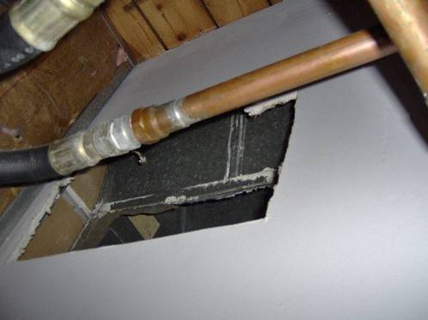

Fresh Air Supply Vent in a Plenum on 5th Floor
Picture 5

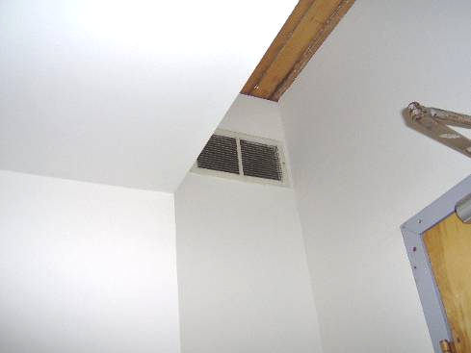

Fresh Air Supply Vent in a Plenum on the 4th Floor

Picture 6
Chimneys Sole Exhaust Vent
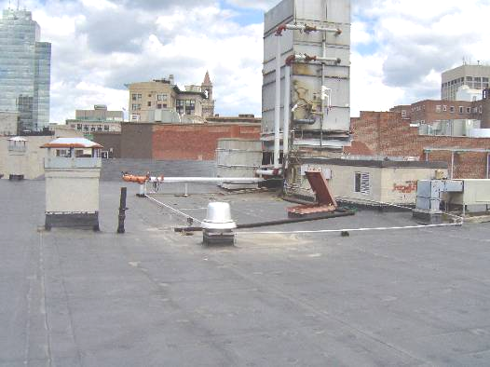

Exhaust Vent on the Roof
Picture 7

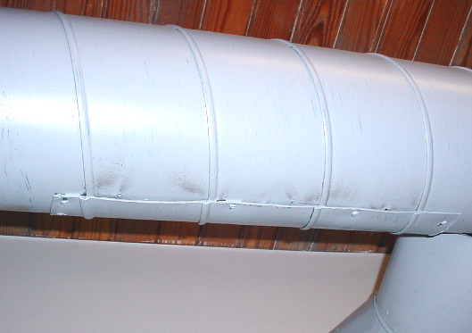

Leaking Ductwork, Note Dust “Corona” Patterns from Metal Patch

Picture 8

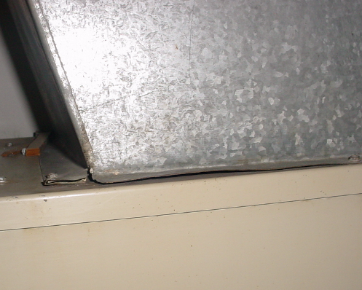

Breach between Ductwork/Heat Pump with Conditioned Air Escaping
Picture 9

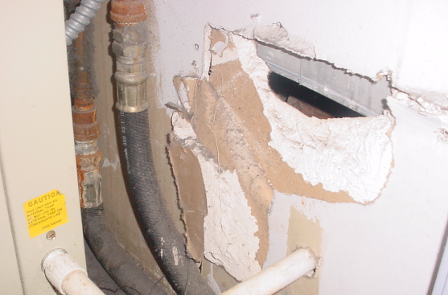

Hole in Wall of Heat Pump Closet, 4th Floor DOR Reception Area

Picture 10

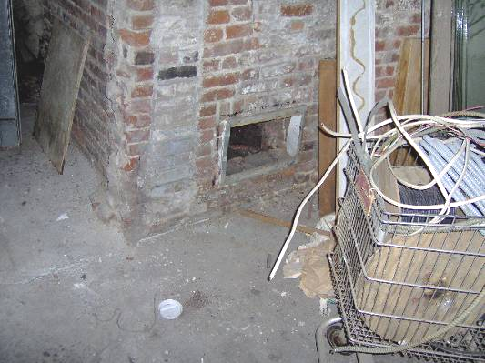

A Chimney Cleanout Door in Basement
Picture 11

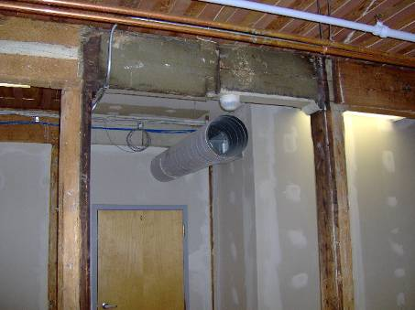

Open Duct in DOR Space, Note Lack of Covering for Vent Opening

Picture 12

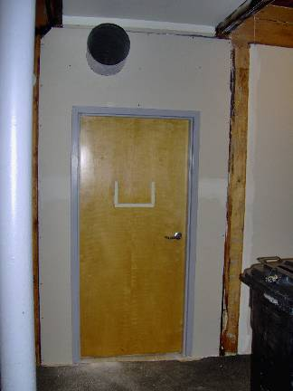

Door Leading to Renovated Area from DOR Space, Note Lack of Barriers on Door
Picture 13

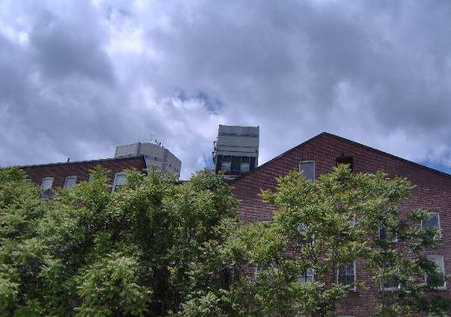

Rooftop Chiller for HVAC System

Picture 14

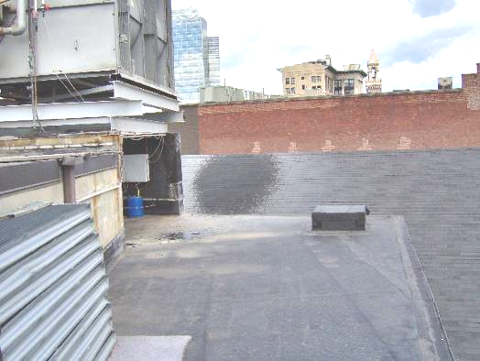

Moisture from Chiller Wetting Roof Shingles
Picture 15

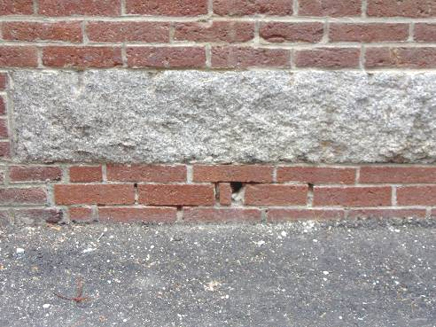

Missing/Damaged Mortar/Brick Exterior Wall/Foundation

Picture 16

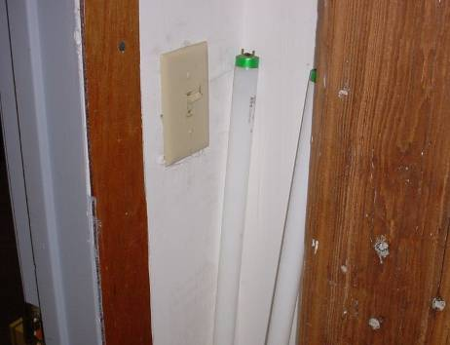

Fluorescent Light Bulbs Leaning Against Wall in 2nd Floor Heat Pump Room

Location/ Room | Occupants  in Room |  | Temp  (°F) |  | Relative  Humidity  (%) |  | Carbon  Dioxide  (ppm) |  | Carbon Monoxide  (ppm) |  | Windows  Openable |  | Ventilation |  |  |  | Remarks
 |  |  |  |  |  |  |  |  |  |  |  |  |  | Supply |  | Exhaust
background |  |  | 75 |  | 38 |  | 385 |  | ND
5th Floor
East | 0 |  | 78 |  | 39 |  | 780 |  | ND |  | Y |  | Y |  | Y
Center | 1 |  | 77 |  | 40 |  | 818 |  | ND |  | Y |  | Y |  | Y
West | 0 |  | 75 |  | 43 |  | 810 |  | ND |  | Y |  | Y |  | Y
Black Office | 0 |  | 77 |  | 40 |  | 777 |  | ND |  | Y |  | Y |  | Y |  | Damaged/frayed carpeting, dust/debris build-up around vent
Upper Copy Area | 0 |  | 75 |  | 37 |  | 763 |  | ND
Upper Back File Storage | 0 |  | 75 |  | 38 |  | 705 |  | ND
Entrance (across from shredder) | 0 |  | 77 |  | 43 |  | 790 |  | ND |  |  |  |  |  |  |  | Penetrations (utility holes) not properly sealed near exhaust
5Th Floor File Room | 1 |  | 77 |  | 43 |  | 739 |  | ND |  | Y |  | Y |  | Y |  | Heat pump AC, dust/debris accumulation on flat surfaces
Mail box area | 0 |  | 77 |  | 47 |  | 754 |  | ND |  | Y |  | Y |  | N |  | Water damage/drooping paint on metal ductwork, 1 CT
4th Floor
Swing Space 21-26 | 2 |  | 75 |  | 43 |  | 607 |  | ND |  | Y |  | Y |  | N |  | 1 CT, near entrance (cube 18), AC-window
Swing Space 14-18 | 2 |  | 75 |  | 43 |  | 605 |  | ND |  | Y |  | Y |  | N
Swing Space 12-18 | 3 |  | 76 |  | 44 |  | 580 |  | ND |  | Y |  | Y |  | N |  | PF, dust/debris on supply diffuser
Swing Space 1-5 | 0 |  | 77 |  | 40 |  | 729 |  | ND |  | Y |  | Y |  | N |  | CO monitor
Swing Space 2-6 | 0 |  | 77 |  | 40 |  | 876 |  | ND |  | Y |  | Y |  | N
Swing Space 7-11 | 1 |  | 77 |  | 40 |  | 784 |  | ND |  | Y |  | Y |  | N
Swing Space Hallway | 0 |  | 78 |  | 39 |  | 688 |  | ND |  | N |  | N |  | Y |  | Dusty vents, penetrations not sealed
Store Room | 0 |  | 79 |  | 43 |  | 674 |  | ND |  | Y |  | Y |  | N |  | No airflow, loose CT/utility hole, dust/debris on supply vent, 1 CT
File Room | 0 |  | 76 |  | 38 |  | 724 |  | ND |  | Y |  | Y |  |  |  | Breaches in ductwork, dust/debris on flat surfaces
(Temporary) Conference Room | 30 |  | 79 |  | 43 |  | 1294 |  | ND |  | Y |  | Y |  | Y |  | Larger group than normal, dust/debris on vents, utility holes, breaches in ductwork, water damage around pole-CT
Child Enforcement Lobby | 1 |  | 76 |  | 39 |  | 848 |  | ND |  | N |  | Y |  | N |  | WD around pole-CT
Pickett Office | 1 |  | 71 |  | 39 |  | 901 |  | ND |  | Y |  | Y |  | N |  | DO
Sheehan Office | 1 |  | 70 |  | 43 |  | 1080 |  | ND |  | Y |  | Y |  | N |  | Hole in wall-brick, dislodged CT
RST | 1 |  | 71 |  | 44 |  | 1174 |  | ND |  | N |  | Y |  | Y
Coraccio | 1 |  | 70 |  | 44 |  | 1108 |  | ND |  | Y |  | Y |  | N
Crocker | 1 |  | 72 |  | 44 |  | 1109 |  | ND |  | Y |  | Y |  | N
Case Initiation Team | 4 |  | 72 |  | 43 |  | 1147 |  | ND |  | Y |  | Y |  | Y |  | CO monitor
Establishment Unit | 4 |  | 73 |  | 43 |  | 1140 |  | ND |  | Y |  | Y |  | Y |  | Water cooler on carpet
Interstate | 3 |  | 73 |  | 43 |  | 1160 |  | ND |  | Y |  | Y |  | Y
Litigation Corner Office | 1 |  | 74 |  | 41 |  | 1294 |  | ND |  | Y |  | Y |  | N
Henderson | 1 |  | 74 |  | 40 |  | 1310 |  | ND |  | Y |  | Y |  | Y
Nunes | 1 |  | 74 |  | 39 |  | 1197 |  | ND |  | Y |  | Y |  | Y
Moody | 0 |  | 74 |  | 39 |  | 1252 |  | ND |  | Y |  | Y |  | Y
Computer Room | 1 |  | 76 |  | 34 |  | 803 |  | ND |  | Y |  | Y |  | Y |  | buckled section of wooden ceiling
Office near entry | 1 |  | 76 |  | 33 |  | 910 |  | ND |  | N |  | Y |  | Y
May | 1 |  | 73 |  | 36 |  | 938 |  | ND |  | Y |  | Y |  | N |  | Damaged carpet
Litigation and Establishment | 4 |  | 74 |  | 40 |  | 1180 |  | ND |  | Y
Savoy | 1 |  | 73 |  | 39 |  | 1148 |  | ND |  | Y |  | Y |  | N
Empty Office (Lounge) | 0 |  | 72 |  | 40 |  | 1149 |  | ND |  | Y |  | Y |  | N
Ruggeri | 1 |  | 74 |  | 41 |  | 1293 |  | ND |  | Y |  | Y |  | N
Front Office | 1 |  | 73 |  | 35 |  | 849 |  | ND
3rd Floor
Lobby | 4 |  | 76 |  | 40 |  | 1185 |  | ND |  | N |  | Y |  | Y
Reception | 1 |  | 74 |  | 39 |  | 1040 |  | ND |  | Y |  | Y |  | Y
Cruz | 0 |  | 74 |  | 40 |  | 995 |  | ND |  | Y |  | Y |  | Y |  | Damaged carpeting
Danilowicz | 1 |  | 74 |  | 42 |  | 876 |  | ND |  | N |  | N |  | N
Women’s Restroom |  |  |  |  |  |  |  |  |  |  |  |  |  |  | Y |  | Air freshener, buckled/loosened floor tiles below toilet, possible leaking wall seal
Break Room | 0 |  | 75 |  | 37 |  | 875 |  | ND |  | Y |  | Y |  | Y
Bureau of Desk Audit-Johnson | 3 |  | 73 |  | 43 |  | 720 |  | ND |  | Y |  | Y |  | Y |  | Dust accumulation on flat surfaces, PF
Bureau of Desk Audit-Sullivan | 6 |  | 73 |  | 45 |  | 733 |  | ND |  | Y |  | Y |  | Y
Kitchen Heat Pump Room |  |  |  |  |  |  |  |  |  |  |  |  |  |  |  |  | Breach in ductwork connected to unit-strong air leak
2nd Floor
Bureau of Local Accounts | 0 |  | 72 |  | 40 |  | 473 |  | ND |  | Y |  | Y |  | Y |  | Dust/debris on flat surfaces/air diffusers, utility holes in wall, heat pump off
Conference Room | 0 |  | 71 |  | 42 |  | 490 |  | ND |  | N |  | Y |  | Y
Lobby | 0 |  | 75 |  | 37 |  | 682 |  | ND |  | N |  | Y |  | Y |  | PF, return vent partially obstructed by counter
Bureau of Assessment | 0 |  | 73 |  | 38 |  | 539 |  | ND |  | N |  | Y |  | N
Guilfoyle Office | 0 |  | 73 |  | 38 |  | 548 |  | ND |  | Y |  | Y |  | N |  | Penetrations through floor/ceiling
Heat Pump Room |  |  |  |  |  |  |  |  |  |  |  |  |  |  |  |  | Fluorescent bulbs leaning up against wall

