Background/Introduction

INDOOR AIR QUALITY ASSESSMENT
EMERGENCY RESPONSE

Massachusetts Department of Revenue
40 Southbridge Street
Worcester, Massachusetts 01608

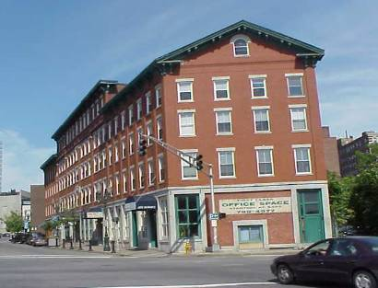

Prepared by:
Massachusetts Department of Public Health
Bureau of Environmental Health
Indoor Air Quality Program
July 2008

At the request of Richard Morrissey, Facilities Director for the Massachusetts Department of Revenue (DOR), the Massachusetts Department of Public Health (MDPH), Bureau of Environmental Health (BEH) provided immediate assistance and respond regarding an indoor air quality incident at the Worcester DOR facility, 40 Southbridge Street, Worcester, Massachusetts. On the morning of May 29, 2008, the DOR office was evacuated by the Worcester Fire Department (WFD) due to elevated carbon monoxide levels and exposure concerns resulting in the hospitalization of 19 Worcester DOR employees.
On the afternoon of May 29, 2008, Mike Feeney, Director, and Cory Holmes, an Indoor Air Quality (IAQ) Inspector in BEH’s IAQ Program arrived on scene at the DOR Worcester Office. On May 30, 2008, Mr. Holmes returned to the building with Lisa Hebert, IAQ Inspector within BEH’s IAQ Program to conduct follow-up testing. On June 2, 2008, Mr. Feeney returned to the building to conduct final clearance testing prior to re-occupancy by DOR staff. This report focuses on carbon monoxide testing. On June 12, 2008, Mr. Holmes and Ms. Hebert revisited the DOR building to conduct a general IAQ assessment; a separate report regarding general IAQ is being prepared.
The DOR is located in a five-story office building located in downtown Worcester. The brick and wood framed structure was reportedly built in 1860; the DOR has occupied space in the building (portions of the second, third, fourth and fifth floors) since 1995. The third floor was undergoing renovations at the time of the incident. A coffee shop, restaurant and private offices occupy the remainder of the building. Windows in the building are openable.
The building was previously visited by BEH staff in September 2000. A report detailing conditions observed at the time of the visit with recommendations for improving indoor air quality was issued (MDPH, 2000).

Methods/Results
Air tests for carbon monoxide were taken with the TSI, Q-Trak, IAQ Monitor. All tests were taken while the building was unoccupied and results appear in Tables 1-3. The DOR offices have a maximum population of approximately 140 on a daily basis. Air samples are listed in the Tables by location that the air sample was taken or by the name/function of the person/group who occupies the area.

Discussion
Carbon Monoxide
At approximately 10:00 a.m. on Thursday May 29, 2008, the WFD responded to a call at the DOR, where several employees had become sick. The WFD detected elevated levels of carbon monoxide [i.e., 104-800 parts per million (ppm)] in occupied areas and evacuated the building (Appendix A). The WFD reported that staff occupying the fourth floor were most affected. A number of employees were sent to area hospitals for evaluation/testing for carbon monoxide exposure and subsequently released. Two employees were transported to Massachusetts General Hospital to be treated in a hyperbaric chamber for high levels of carbon monoxide poisoning.
The source of the carbon monoxide was identified by the WFD as the furnaces located in the basement. Carbon monoxide produced by the furnaces was entrained by the mechanical ventilation system where it was distributed throughout the building, and in particular, on the fourth floor. According to the WFD, the highest concentration of carbon monoxide (800 ppm) was measured within ventilation shafts (Appendix A). The furnaces and gas supply were deactivated and tagged by the Worcester Division of Code Enforcement (WDCE) to prevent reactivation until repairs are conducted (Pictures 1 through 3). An evaluation by the WDCE building inspector found that the boilers were tied to a “restricted chimney where someone had installed a 12″ rectangular clay liner on the top. This would have caused a back pressure to occur in the chimney system” (Picture 4) (Appendix B). Therefore, no means existed for combustion products to exhaust via the chimney. As a result, combustion products released by the furnace would accumulate in the basement.
In order to explain how furnace pollutants could impact upper floors, the following concepts concerning heated air and creation of air movement must be understood:
- Heated air will create upward air movement (called the stack effect);
- Cold air moves to hot air, which creates drafts;
- As heated air rises, negative pressure is created, which draws cold air into equipment creating heat (e.g., mechanical ventilation systems);
- If a device is drawing air by its function (e.g., an AHU) at the top of an airshaft, that device can capture air and pollutants from the airshaft; and
- Combusted fossil fuels contain heat, gases and particulates that will rise in air. The higher the heated air rises, the greater airflow increases.
In this instance, interior wall cavities above the furnace were the likely pathway for combustion air to rise through the building. BEH staff identified large holes around an electrical conduit in the ceiling above the furnaces (Picture 5). Under the conditions noted, such holes would provide a means for pollutants to enter and rise through the wall spaces above the basement.
The AHU servicing the reception and north section of the fourth floor enhances the upward air movement. The return air vent is not connected to any ductwork; rather, it draws air into a filter located on the side of the AHU. Air is drawn from the occupied spaces through a fixed louver in the door of the AHU room (Picture 6). In this configuration, the AHU draws air from the occupied areas by the hallways, or in other words, the hallways are the return air duct system for this AHU. The operation of the AHU would result in a depressurization of the air within the closet. If any holes exist in the AHU closet floor, walls or ceiling, the AHU would draw air (and pollutants) from the wall cavity and distribute that air to occupied areas serviced by that AHU. It is likely that this AHU drew air and carbon monoxide from the wall cavity through a large hole in its wall (Picture 7). Once inside the AHU closet, carbon monoxide was then distributed to areas that were serviced by that AHU (e.g., the reception area and the north section of the fourth floor).
Other means for products of combustion to migrate from the basement into the occupied space include: the elevator shaft, the stairwell and abandoned chimneys that pass through the DOR space. While these are possible migration routes for carbon monoxide, BEH staff believe the most likely area where products of combustion related to the furnace appears to be the interior wall space where carbon monoxide was captured and distributed into the fourth floor.
Carbon monoxide is a by-product of incomplete combustion of organic matter (e.g., gasoline, wood and tobacco). Exposure to carbon monoxide can produce immediate and acute health affects. Several air quality standards have been established to address carbon monoxide and prevent symptoms from exposure to these substances. The MDPH established a corrective action level concerning carbon monoxide in ice skating rinks that use fossil-fueled ice resurfacing equipment. If an operator of an indoor ice rink measures a carbon monoxide level over 30 ppm, taken 20 minutes after resurfacing within a rink, that operator must take actions to reduce carbon monoxide levels (MDPH, 1997).
The American Society of Heating Refrigeration and Air-Conditioning Engineers (ASHRAE) has adopted the National Ambient Air Quality Standards (NAAQS) as one set of criteria for assessing indoor air quality and monitoring of fresh air introduced by HVAC systems (ASHRAE, 1989). The NAAQS are standards established by the US EPA to protect the public health from six criteria pollutants, including carbon monoxide and particulate matter (US EPA, 2006). As recommended by ASHRAE, pollutant levels of fresh air introduced to a building should not exceed the NAAQS levels (ASHRAE, 1989). The NAAQS were adopted by reference in the Building Officials & Code Administrators (BOCA) National Mechanical Code of 1993 (BOCA, 1993), which is now an HVAC standard included in the Massachusetts State Building Code (SBBRS, 1997). According to the NAAQS, carbon monoxide levels in outdoor air should not exceed 9 ppm in an eight-hour average (US EPA, 2006).
Carbon monoxide should not be present in a typical, indoor environment. If it is present, indoor carbon monoxide levels should be less than or equal to outdoor levels. To purge the building of carbon monoxide, windows were opened on both sides on each floor to provide cross-ventilation. Once the WFD cleared the building BEH staff conducted carbon monoxide testing and found that levels had dissipated to background levels, which ranged from non-detect (ND) to 3 ppm (Table 1). Follow-up testing for carbon monoxide on Friday May 30 and on Monday June 2, 2008, were ND or equal to background levels (Tables 2 and 3).

Conclusions/Recommendations
As indicated in the WFD incident report (Appendix A), elevated levels of carbon monoxide were measured in the building that resulted in immediate and acute health affects. As reported by the WFD, deactivation of the furnaces eliminated the direct source of carbon monoxide. Purging of the building via the opening of windows both removed and diluted carbon monoxide to background levels, which was confirmed by follow-up testing by BEH staff.
In view of the findings at the time of our inspection, the following recommendations are made:
- The furnace should remain deactivated until repairs are made and confirmed by city officials.
- Seal all potential pathways of migration for combustion pollutants in the boiler room to upper floors (e.g., conduits, utility holes, flues).
- Ensure that appropriate means to vent furnace pollutants exist.
- Seal all holes in floors, wall and ceiling of HVAC system air mixing rooms.
- Consider installing carbon monoxide detectors in occupied areas.

References
ASHRAE. 1989. ASHRAE Standard: Ventilation for Acceptable Indoor Air Quality. Sections 5.11, 5.12. American Society of Heating, Refrigerating and Air-Conditioning Engineers, Inc. Atlanta, GA.
BOCA. 1993. The BOCA National Mechanical Code-1993. 8th ed. Building Officials & Code Administrators International, Inc., Country Club Hills, IL. M-308.1

MDPH. 1997. Requirements to Maintain Air Quality in Indoor Skating Rinks (State Sanitary Code, Chapter XI). 105 CMR 675.000. Massachusetts Department of Public Health, Boston, MA.

MDPH. 2000. Indoor Air Quality Assessment. Massachusetts Department of Revenue, Worcester, MA. Massachusetts Department of Public Health, Bureau of Environmental Health Assessment, Boston, MA. October 2000.

SBBRS. 1997. Mechanical Ventilation. State Board of Building Regulations and Standards. Code of Massachusetts Regulations. 780 CMR 1209.0

US EPA. 2006. National Ambient Air Quality Standards (NAAQS). US Environmental Protection Agency, Office of Air Quality Planning and Standards, Washington, DC. http://www.epa.gov/air/criteria.html.

Picture 1

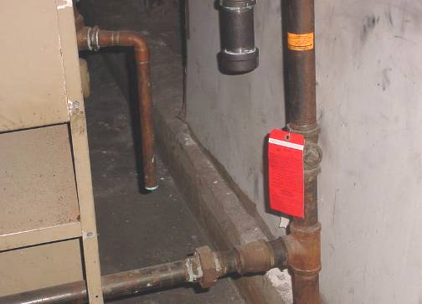

Red Tag on Faulty Furnace
Picture 2

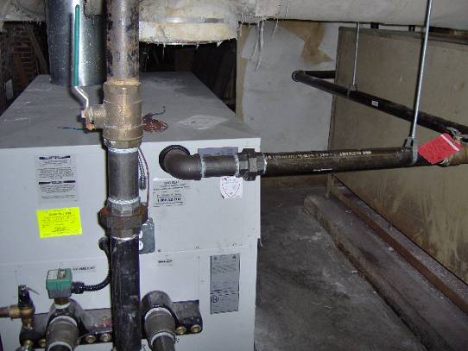

Second Tagged-Out Furnace in the Basement
Picture 3

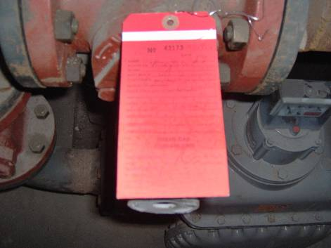

Tagged Gas Supply
Picture 4

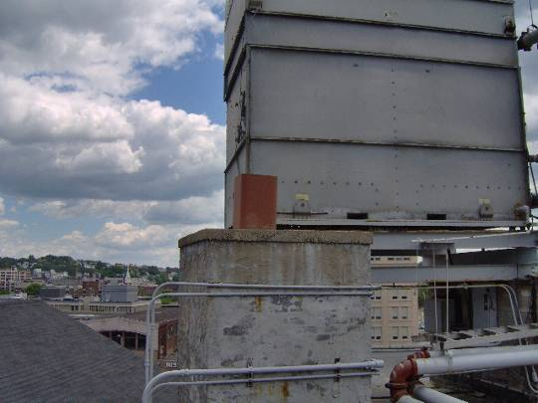

Chimney/Clay Liner on Roof (Note Size of Clay Pipe Compared to the
Size of the Original Chimney Opening)
Picture 5

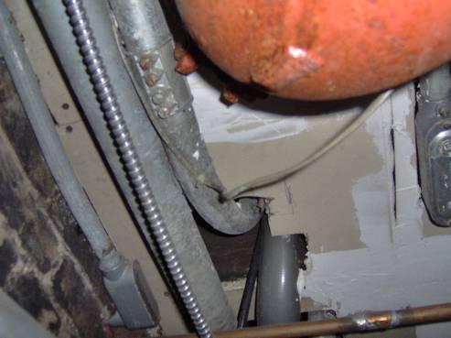

Hole for Electrical Conduit in Ceiling above the Furnaces in the Basement

Picture 6

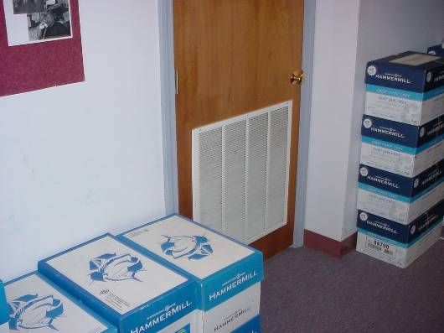

Passive Door Vent for Air Mixing Room near Fourth Floor Reception
Picture 7

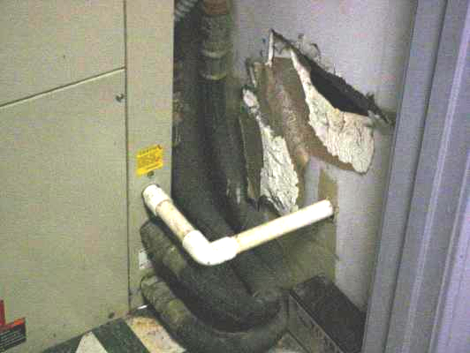

Hole in Wall of Air Mixing Room near Fourth Floor Reception That Allows for Air to be Drawn from The Wall Cavity above the Furnace Room

Location | Carbon Monoxide  (*ppm) | Comments
Background | ND - 3 | Mostly sunny, west winds 13-21 mph (gusts 29), moderate/light traffic, idling mobile news vehicles around perimeter of building
4th Floor Reception | ND
Elevator Hallway | ND
Waiting Room | ND
Conference Room | ND
Restroom Hallway | ND
File Room | ND
Swing Space | ND
Cathy May | ND
RST | 1-2
Case Create | 2
R & P | 2
Litigation | 1
Wingfield Office | 3
Corner Office | 2

* ppm = parts per million

Location | Carbon Monoxide  (*ppm) | Comments
Background | ND | Mostly sunny, southwest winds 9-14 mph (gusts 21), moderate/light traffic
1st Floor  Lobby | ND
3rd Floor
Hallway | ND
Renovation Area | ND
4th Floor
Elevator Hallway | ND
Waiting Room | ND
Conference Room | ND
Restroom Hallway | ND
Swing Space | ND
RST | ND
Case Create | ND
R & P | ND
Litigation | ND
Wingfield Office | ND
Corner Office | ND
5th Floor
East | ND
Center | ND
West | ND
Upper Level | ND
Basement Level  Boiler Room | ND | Furnace Tagged-Out by City Officials

Location | Carbon Monoxide  (*ppm) | Comments
Background | 2 | Mostly sunny, southwest winds5 mph, moderate traffic
1st Floor  Lobby | ND
3rd Floor
Hallway | ND
Renovation Area | ND
4th Floor
Elevator Hallway | ND
Waiting Room | ND
Conference Room | ND
Restroom Hallway | ND
Swing Space | ND
RST | ND
Case Create | ND
R & P | ND
Litigation | ND
Wingfield Office | ND
Corner Office | ND
5th Floor
East | ND
Center | ND
West | ND
Upper Level | ND
Basement Level  Boiler Room | ND | Furnace Tagged-Out by City Officials

