WATER DAMAGE FOLLOW-UP ASSESSMENT

Massachusetts Gaming Commission
101 Federal Street, 12th floor
Boston, Massachusetts

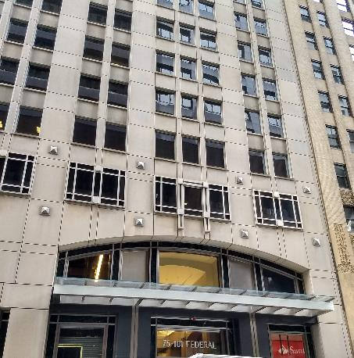

Prepared by:
Massachusetts Department of Public Health
Bureau of Environmental Health
Indoor Air Quality Program
August 2019

Background
Building: | Massachusetts Gaming Commission (GC)
Address: | 101 Federal Street, 12th floor, Boston
Assessment Requested by: | Ginny Platt, Senior Project Manager,  Division of Capital Asset Management & Maintenance (DCAMM),Office of Leasing and State Office Planning
Reason for Request: | To assess corrective actions following a flood
Date of Assessment: | August 22, 2019
Massachusetts Department of Public Health/Bureau of Environmental Health (MDPH/BEH) Staff Conducting Assessment: | Ruth Alfasso, Environmental Engineer/Inspector, indoor air quality (IAQ) Program
Building Description: | Other office tenants occupy other floors in the building.
Windows: | Not openable

Introduction
Over the weekend of July 20, 2019, a release of water from the cooling system on the 15th floor occurred. Water flowing down from the area of release moistened materials on many floors of the building. Because of the location of the GC on the 12th floor, materials in this office were significantly impacted by the flood. Facility staff began drying the affected areas when the flood was detected. The IAQ program visited the affected area on Wednesday July 24 to assess the status of the remediation efforts. Recommendations for further remediation actions were made both verbally at the time of the visit and in a report completed in August of 2019. That report is available on request.
The site was visited again on August 22, 2019 to assess conditions following remediation work.

Methods
Please refer to the IAQ Manual for methods, sampling procedures, and interpretation of results (MDPH, 2015). In addition, visual observations were made and some moisture measurements in gypsum wallboard (GW) and other materials were conducted as is discussed further below.

Results
A single set of measurements was collected in a central part of the affected area. The following is a summary of indoor air testing results.
- Carbon dioxide levels were measured at 837 parts per million (ppm), which is slightly above the MDPH guideline of 800 ppm.
- Temperature was 74°F, which is within the MDPH recommended range of 70°F to 78°F.
- Relative humidity was 48% which is within the MDPH recommended range of 40% to 60%.
- Carbon monoxide levels were non-detectable (ND) in areas tested.

Ventilation
A heating, ventilating and air conditioning (HVAC) system has several functions. First it provides heating and, if equipped, cooling. Second, it is a source of fresh air. Finally, an HVAC system will dilute and remove normally-occurring indoor environmental pollutants by not only introducing fresh air, but by filtering the airstream and ejecting stale air to the outdoors via exhaust ventilation. Even if an HVAC system is operating as designed, point sources of respiratory irritation may exist and cause symptoms in sensitive individuals.
Fresh air is provided by ceiling-mounted fresh air diffusers. A mechanical exhaust system removes stale air. Fan coil units (FCU) were installed along exterior walls within the building. The FCUs are designed to provide both heat and cooling. Depending on the setting, heated or chilled water is pumped through a finned tube (i.e., a coil) that is connected to the furnace/chiller by copper pipes that are installed in the pipe chase. Water runs through supply pipes into the coils, which heat/cool the air forced through the coils by the FCU fans. It is important to note that FCUs are designed to provide either heating or cooling, but do not have a fresh air supply. FCU units can only recirculate air.
To maximize air exchange, the MDPH recommends that both supply and exhaust ventilation operate continuously during periods of occupancy. In order to have proper ventilation with a mechanical supply and exhaust system, the systems must be balanced to provide an adequate amount of fresh air to the interior of a room while removing stale air from the room. It is recommended that HVAC systems be re-balanced every five years to ensure adequate air systems function (SMACNA, 1994). It is unknown when the last time this system was balanced.
Items were also observed on top of the FCU cabinets, including plants (Picture 1). Items should not be placed to block airflow from these cabinets. Additionally, items, particularly plants or scented items, should not be placed in the airstream of ventilation equipment, to prevent distributing dirt, pollen, and odors to other areas.

Microbial/Moisture Concerns
Areas that had been impacted by the flood were examined:
- GW had been replaced in areas where it had been moistened. All areas of GW were tested with a moisture meter and were dry;
- Carpeting was dry and free from odors;
- The covers of the FCUs that were wet at the time of the initial visit had not been replaced as recommended, however they were dry;
- There were boxes present in the same location as water-damaged boxes had been observed during the previous visit, however these did not appear water-damaged; and
- No other water-damaged material or odors were found.

Conclusions/Recommendations
Based on the observations at the time of the visit, the following recommendations are made:
- Consider adjusting the HVAC system to provide more fresh air to occupied areas. Ensure thermostats are set to “on” during occupied periods to provide continuous air circulation and filtration.
- Avoid placing any items on top or blocking of the vents. It is especially important to avoid putting plants and scented items in the airstream.
- Ensure the interior of FCUs are cleaned. If odors occur from FCUs that had been moistened, consider replacing the damaged covers to the units.
- Balance the HVAC system every 5 years in accordance with Sheet Metal and Air Conditioning Contractors’ National Association (SMACNA) recommendations (SMACNA, 1994).
- Remove any remaining water-damaged boxes, papers or other porous items.
- Refer to resource manual and other related IAQ documents located on the MDPH’s website for further building-wide evaluations and advice on maintaining public buildings. These documents are available at: http://mass.gov/dph/iaq.

References
MDPH. 2015. Massachusetts Department of Public Health. Indoor Air Quality Manual: Chapters I-III. Available at: http://www.mass.gov/eohhs/gov/departments/dph/programs/environmental-health/exposure-topics/iaq/iaq-manual/.
SMACNA. 1994. HVAC Systems Commissioning Manual. 1st ed. Sheet Metal and Air Conditioning Contractors’ National Association, Inc., Chantilly, VA.

Picture 1
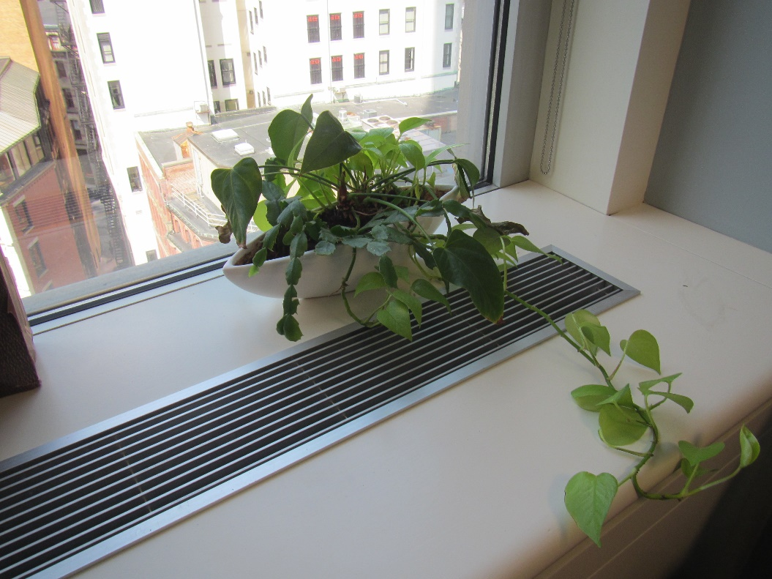
Plant on top of fan coil unit

