NORTH ATLANTIC STATES REGIONAL COUNCIL OF CARPENTERS
United Brotherhood of Carpenters and Joiners of America

750 Dorchester Ave

Boston, MA 02125-1132

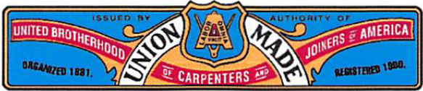Joseph Byrne
Executive Secretary – Treasurer

Telephone (617) 268-3400

April 13, 2022

Lara Szent-Gyorgyi, MPA Department of Public Health Determination of Need Program 67 Forest Street
Marlborough, MA 01752

Re: Application No. MGB-20121716-HE DPH Staff Recommendation of Approval Comment

Dear Ms. Szent-Gyorgyi:

I am writing on behalf of the North Atlantic States Regional Council of Carpenters ("NASRCC"), Ten Taxpayer Group, to reiterate our complete support for the Brigham and Woman's Faulkner Hospital's ("Faulkner") Determination of Need ("DoN") application. On behalf of our union's 30,000 members, we urge the Public Health Council to vote to approve the project.

We are proud to support this project because it will profoundly improve access to much needed health care services for our members and all the patients served by the Faulkner. This project will also create hundreds of construction and permanent jobs for Boston area workers. In addition, the project has industry leading diversity goals that will create new opportunities for workers from underrepresented communities and woman to enter the construction trades. Finally, the Faulkner will be contributing approximately $7,500,000 for community health initiatives as identified by the hospital's community advisory board and the state.

In conclusion, we urge the Public Health Council to vote to approve the Faulkner's DoN project. Sincerely,
<Signature on File>
Joseph Byrne
Executive Secretary Treasurer

