Updated: MGH Capacity through October 2021
Since MGH’s DoN Application was submitted on January 21, 2021 and the supplemental information provided in August and September, the Hospital’s operation and its patient panel continue to be impacted by the Hospital’s inpatient capacity issues detailed in the filings. The impact of inadequate inpatient capacity has been amplified over the past several months largely due to patients who are seeking care that was avoided or delayed during the height of the pandemic. Although the current patient demand is largely fueled by non-COVID cases, the COVID case volume is the equivalent of one inpatient unit (about 30 beds worth) so a significant strain on already limited bed availability. This update seeks to provide current data to demonstrate the importance of creating additional inpatient capacity at MGH through the expansion of single-bed inpatient rooms. Although the current state of increased demand is likely transient, the COVID-19 pandemic and its aftermath demonstrate the need for MGH to adequately prepare for future instances of pandemic or disaster through the Proposed Project.

The current demand experienced by MGH is mainly the result of patients now seeking care that they deferred during the pandemic either due to avoidance of healthcare facilities or cancelled services during the height of the pandemic. Deferred care results in multiple issues for patients when care is ultimately sought. For example, when the patient with unaddressed cardiac disease presents for care, they are often weaker and therefore more susceptible to other illnesses, such as pneumonia. In addition, delayed care may result in more advanced stages of disease progression, eliminating the possibility of addressing the disease through less invasive or more successful treatment that is often available in the earlier stages of disease. Accordingly, deferred care has not only resulted in a significant rise in patient demand at MGH, but also in patient acuity and therefore increased length of stay. Together with inpatient capacity constraints that the Hospital already faced including the high number of multi-bed rooms, the increasing inpatient demand the Hospital has recently experienced places further strain on hospital resources. Compounding the impact of increased demand on capacity constraints, the State is simultaneously facing staffing shortages which are adversely impacting nearly every aspect of care delivery. As demonstrated by the data below, the increased demand impacts MGH’s ED patients and inpatients, as well as patients at community hospitals requiring transfer to MGH.

Bed Blocks
On page 11 of the Application, MGH noted that an estimated 30-50 of MGH’s semi-private beds are blocked on a daily basis due to patient need. In 2019 the instances of bed closures ranged from 693-1,121 per month with associated closed bed days of 1,206-2,160. As a result of the recent capacity crisis, the upper envelope for closed beds has consistently been in the range of 60-70 blocked beds, resulting in 1,094 instances of bed closures and an associated 2,040 bed days in the month of September.
ED Boarding and Code Help
Furthermore, the lack of available inpatient beds has impacted emergency department boarding and negatively impacted throughput and operational/quality metrics.
- The DoN application notes that the number of instances of Code Help at the Hospital that were triggered in accordance with DPH requirements has trended upward from 5% in FY17, to 10% in FY18 and 20% in FY19. While the FY21 average instances of Code Help was consistent with historical trend, for the most recent months the Hospital was in this status for 30% of August, 39% of September, and 32% of October. Hospitals cannot divert ambulance traffic when on Code Help, but there are more frequent occurrences where MGH cannot accept high acuity transfers from community hospitals.
- While the aggregate percentage of all patients admitted to an inpatient bed subsequent to boarding for more than two hours rose only slightly (from 78% in FY 19 to 79% in FY21), the most recent monthly trends are 87% of admitted patients boarded in August and for both September and October, 86% of admitted patients boarded in the ED.
- The two-year trend chart below shows the average number of patients boarding in the ED per day (line) and average length of stay or hours boarding per patient (bar).
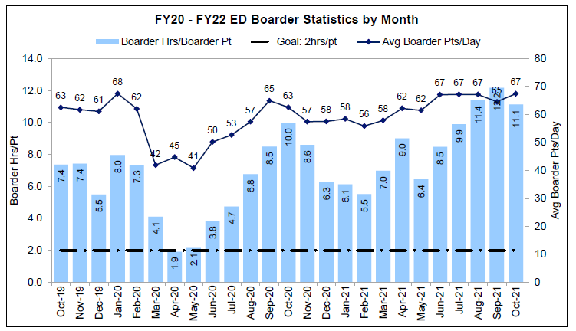
- The Application notes that in FY19, 2.5% of patients presenting to the ED left without treatment (1.3% without completing treatment and 1.2% without being seen). For the entirety of FY21 that rate increased to 3.2% (1.4% without completing treatment and 1.8% without being seen). Most recently, the rate of ED patients leaving without treatment was 4.5% in September 2021 (1.7% without completing treatment and 2.8% without being seen).
- When MGH boarders exceed 45 patients as of 7am (noting that the EDs physical capacity is 68 bays and most of these boarders are patients in excess of that physical capacity), capacity disaster is activated and patients are moved to alternative locations including hallways and conferencing spaces on inpatient units because there are no available beds to admit patients from the ED. Capacity disaster was activated 17 times in August; 20 in September; and 16 in October.

