

Housing MA

Housing MA
Final Project Report
July 16, 2014



Contents
Introductory Letter 4
Executive Summary 6
Partners 7
Developers 8
Goals 9
Implementation Plan 10
Budget 11
Challenges and Solutions 12
Outcomes 13
Contact Information 14
Housing.ma walk-through 15



Secretary Glen Shor
Massachusetts Executive Office for
Administration and Finance
Massachusetts State House, Room 373
Boston, MA 02133

Dear Secretary Shor:

Data acquisition and analysis is a common and expensive component of many federal and state housing programs. Consolidated Plans at the Federal level, and Housing Production Plans within Massachusetts both entail extensive but generic data requirements. As a result, municipalities across Massachusetts pull the same datasets and perform the same data analysis to meet the same programmatic requirements. Once met, local planners have little incentive to transfer hard-earned institutional knowledge across municipal boundaries.
Computers excel at performing the same task over-and-over. Instead of conducting the same analysis from scratch in 351 Massachusetts cities and towns, we can program a computer to perform it for all cities and towns at once. Add an intuitive web interface where planners and the public can access both the analysis and the underlying data, and the result is Housing MA, the Massachusetts Housing Data Portal, online at www.housing.ma.
This portal provides all of the data needed to conduct a housing needs assessment for a Housing Production Plan under Massachusetts General Law Chapter 40B. It offers, in one place, data from the decennial Census, American Community Survey, Comprehensive Housing Assessment Strategy, municipal assessor records, and MAPC population and housing demand projections, along with clear documentation. More than that, it provides a state-approvable housing needs assessment for each city and town, complete with dynamically generated text and graphics that planners can view online or download as a Word document. Planners who want to dive deeper into the data can export all data and metadata as Excel files.

Housing.ma does not attempt to automate the housing planning process. The goal of the site is to perform low-level and generic analysis more efficiently, so that planners can spend their time on more important matters, such as outreach to key stakeholders, listening to the needs and concerns of residents, identifying key policy recommendations, and drafting a housing plan accordingly. Over the next year, we will work to publicize the site, conduct trainings, and track its use. We thank Governor Patrick and the Community Innovative Challenge (CIC) program for supporting the development of this important tool.

Sincerely,

Marc Draisen
Executive Director
Metropolitan Area Planning Council

Executive Summary

Housing production is one of the most profound challenges facing Massachusetts, and one in which each city and town has a unique and important role to play. Creating enough homes to accommodate the next generation of workers while also addressing the complex needs of an aging and increasingly diverse population will require communities across the state to implement new plans and policies that usher in a new era of housing production.
Housing production plans (HPPs) under Massachusetts General Law Chapter 40B are a key component of the state’s affordable housing production strategy. An HPP consists of a housing needs assessment that measures the demand for and supply of affordable housing, a set of affordable housing goals that address the assessed need, and a strategy for meeting those goals. In communities that do not meet their 10% affordable housing requirement under Chapter 40B, and do not have an approved production plan, developers can apply for a comprehensive permit to build housing at densities higher than municipal zoning codes allow, provided that 25% of developed units are affordable.
Housing.ma assists communities with the needs assessment portion of a housing production plan. It provides data from the decennial Census, American Community Survey (ACS), Comprehensive Housing Assessment Strategy (CHAS), and Massachusetts assessor files, along with the latest population and housing projections from MAPC and the University of Massachusetts Donahue Institute. In addition, it provides a dynamically-generated report for each city and town that meets the requirements of a housing production plan needs assessment out-of-the-box. Planners and the general public can explore data online, or export data as Excel files. Likewise, reports are available online, or as Word documents that planners can readily incorporate into their housing production plans.
MAPC estimates, based on its own HPP work and the experience of municipalities in its region, that the data requirements associated with a needs assessment can account for 25 to 30 percent of an HPP budget. The goal of Housing.ma is to reduce those costs so that planners can spend their time and resources on community engagement and housing production strategy, work that requires extensive local knowledge, community buy-in, political acumen, and a human touch.

Partners
Housing.ma has benefited from the feedback and advice of affordable housing experts and advocates at the state, regional, and local levels. Partners include:
- Phil DeMartino, Technical Assistance Coordinator for the Department of Housing and Community Development, assists municipalities with the HPP process and reviews HPPs for compliance with 40B requirements;
- Jennifer Goldson, AICP, owner of JM Goldson community preservation + planning, has developed HPPs, Community Preservation Plans, and Affordable Housing Trust Action Plans on behalf of Bridgewater, Concord, Easton, Medway, Sharon, Stoughton, West Bridgewater, Westford, and Westport;
- Aaron Henry, Assistant Planning Directory, Town of Lexington, has helped prepare Lexington’s Comprehensive Plan, and collaborated with MAPC on Lexington’s HPP;
- Bonnie Heudorfer, planning consultant, provides master planning services, market analyses, and affordable housing plans, and is author of Taking the Initiative: A Guidebook on Creating Local Affordable Housing Strategies;
- Karen Sunnarborg, principal of Karen Sunnarborg Consulting, has 14 years experience planning and developing affordable housing in Massachusetts, including the completion of 35 affordable housing plans; and
- Ann Verrilli, Director of Research at Citzens’ Housing and Planning Association, is an expert on affordable housing production and policy trends.
All partners attended a focus-group meeting on December16, 2013, where they provided important practiced-based perspectives on the most pressing affordable housing needs facing Massachusetts communities. We also discussed common hurdles that planners face when gathering and analyzing the data required for a state-approved needs assessments, including data that would be most useful to incorporate into an online data portal. Phil DeMartino and Aaron Henry also provided valuable user feedback for a beta version of Housing.ma.
After convening the focus group and surveying existing production plans, MAPC compiled data that are necessary to meet DHCD HPP requirements, as well as data that go beyond those requirements to tell a richer story of housing need. MAPC analysts processed these data into a uniform, user-friendly database, and created a generic needs assessment analysis that provides a framework for communities to think about housing need. Finally, in-house MAPC developers produced the website itself.
Cities and towns across Massachusetts can use Housing.ma. To ensure that they do, MAPC will publicize the site through state and regional partners, co-branding with other MAPC and partner sites, and user outreach and training. Analysts within MAPC Data Services will coordinate these efforts.

Developers
Housing.ma was developed by:
- Matt Cloyd, Web Developer, MAPC
- Matt Gardner, Web Development Intern, MAPC

Goals
Reduce redundant analysis: HPP data requirements are extensive but generic. Housing.ma automates low-level data collection, visualization, and analysis, so that municipal planners and consultants can focus on higher-lever tasks.
Increase quality of analysis: The needs assessments on Housing.ma have been crafted with input from some of the leading affordable housing practitioners in Massachusetts. Data are from the latest Census, ACS, and CHAS surveys. Population and housing demand projections are from analysts at MAPC and the UMass Donahue Institute. The analysis of assessor data reflects local housing market conditions at a granularity rarely achieved in previous HPPs. By automating much of the needs assessment portion of a HPP, Housing.ma will allow planners to devote more resources to setting production goals and implementation strategies, so the quality of HPPs should increase overall.
Increase number of approved HPPs: Housing.ma provides all data needed to meet DHCD requirements for a HPP housing needs assessment. Planners can export a dynamically-generated report for their municipality and incorporate it directly into their HPP. Housing.ma thus reduces uncertainty about meeting HPP data requirements, and increases the capacity of all municipalities to generate an approvable HPP within a given budget.
Increase access to housing data: Housing.ma is available to anyone interested in affordable housing issues in Massachusetts, from planners, to engaged citizens, to students. It provides a uniform set of well-documented housing data that can serve as a platform for future analysis and dialogue. Our goal is that housing planners and advocates in Massachusetts will use Housing.ma in ways that we have not even anticipated.
Increase supply of affordable housing: The ultimate goal of Housing.ma and HPPs is the same: to increase the production of affordable housing throughout Massachusetts, especially production that can be attributed to local planning efforts. Housing.ma makes planning for affordable housing within reach of all municipalities in Massachusetts, regardless of their internal capacity to collect and analyze data.

Implementation Plan

Task | Quarter
Task | Q2 2013 | Q3 2013 | Q4 2013 | Q1 2014
Review current HPP processes
Develop database
Convene focus group
Write scripts to generate reports
Create website
Link to guidance documents
User testing
Modify database/website

Quarter 2 2013: 03.20.2013 – 06.30.2013
MAPC reviewed in-house HPPs, as well as HPPs conducted by municipalities and third-party consultants; identified bottlenecks in the HPP data collection process; began development of a database that meets HPP data requirements.
Quarter 3 2013: 07.01.2013 – 09.30.2013
MAPC identified leading housing planners at the local, regional, and state levels to serve on focus group; modified database to reflect focus-group feedback; began to write scripts to generate HPP reports.
Quarter 4 2013: 10.01.2013 – 12.31.2013
MAPC completed report generation scripts and began to design and code Housing.ma.
Quarter 1 2014: 01.01.2014 – 03.31.2013
MAPC conducted user-testing with focus group members to assess website usability, compliance with DHCD data requirements, and any remaining gaps in data; based on feedback, added data on race and ethnicity to database and automatic reports to conform to DHCD requirements.

Budget

Task | Budget
Review housing production plans (HPPs). Consult with housing experts, planners, and advocates on datasets that should be collected. | $5,000
Collect datasets. Write scripts to transform data into form suitable for HPPs. | $17,800
Create website to access and curate data. | $22,200
Conduct user testing and outreach, and modify website in light of feedback. | $5,000
Total | $50,000

The total budget for Housing.ma was $50,000. In addition to the tasks outlined above, the initial CIC contract allocated $1,100 to identify Housing Community Types through Latent Class Analysis. Each municipality would then be compared to others of the same type within the dynamically-generated reports and on the data summary pages. As described in the next section, this strategy was modified so that instead the site compares municipalities to both others of the same type as well as their ten nearest neighbors and to the county in which they are located. The final version of Housing.ma includes additional features beyond what we envisioned in the original CIC proposal. These include:
- Interactive visualizations within the reports, generated via the D3 Javascript library,
- Dynamic reports in both webpage and Word document formats, and
- A clean, simple interface that guides users to the resources they need.

Challenges and Solutions
There were two primary challenges to developing a uniform, state-wide housing needs assessment platform. First, some datasets are not readily available in a uniform format for all 351 Massachusetts municipalities. Second, analysis requires a coherent municipal classification system based on housing need. MAPC has a state-wide community typology, but housing supply and demand are functions of both community type and location – a developing suburb in the Berkshires has different needs than one in Metro Boston.
Census, ACS, and CHAS data are available for all municipalities in standard formats. These data were easy to incorporate into Housing.ma. Data on local market conditions, however, typically come from proprietary sources such as the Warren Group that can be expensive to obtain and maintain over time. To overcome this limitation, we used existing datasets, such as the Massachusetts Level 3 Parcel file, to recreate some of the proprietary data. From the Level 3 parcel file, we estimated the distribution of sales prices for both single family and condos for 91% of municipalities. The remaining municipalities do not have assessor data for last sale data and/or price, and so data for these municipalities will need to be gathered from alternative sources, such as Zillow or the Warren Group, in future iterations of Housing.ma.
Population and housing projections for Massachusetts are from MAPC and the University of Massachusetts Donahue Institute. MAPC projections cover the 164 municipalities within the Metro Boston modeling region, and Donahue projections cover the remainder of the state. These datasets had to be combined in order to cover the entire state.
Housing needs assessment analysis typically requires inter-municipal comparisons. MAPC has a coherent state-wide municipal classification scheme that it uses to compare municipalities for general planning purposes, but housing need requires a classification that also reflects local housing market conditions. Devising a housing-specific classification scheme was beyond the current project scope. We instead classified each municipality by geography. Neighboring municipalities often face similar housing market conditions, and so Housing.ma compares municipalities to their ten nearest neighbors and to the county in which they are located on both the data summary page and within the dynamically generated reports.

Outcomes
Implementation success: All outcomes depend on the development of a functioning, online data portal that provides all data needed to complete the municipal housing needs assessment section of a housing production plan. Housing.ma is live and meets the requirements outlined in our original CIC application and in this report. Its functionality extends beyond those requirements to include dynamic visualizations and reports viewable both online and as Word documents.
Outcome success: Short term outcomes include: 100 municipalities will utilize Housing.ma within one year of deployment, and 10 municipalities will use Housing.ma to complete the needs assessment portion of a housing production plan. We estimate this would recoup the initial cost to develop the site.
MAPC will have the opportunity to test the feasibility of incorporating Housing.ma into the housing production planning process with three upcoming HPPs in Ashland, Bellingham, and Quincy. We will use Housing.ma to conduct the needs assessment portion of those HPPs, and share lessons learned with municipalities and consultants engaged in production planning elsewhere.
MAPC has already begun self-funded efforts to promote the site, with presentations at the Massachusetts Housing Institute on June 11 and an upcoming meeting of housing professionals organized by the Citizens Housing and Planning Association. Subsequent outreach will be conducted through MAPC’s subregional councils and other venues as opportunities arise.
Long term outcomes include an increase in the number of approved housing production plans, and ultimately an increase in housing production, especially production that can be attributed to local planning efforts. While an increase in 40B compliance cannot be attributed to any single factor or resource, the intention of Housing.ma is to put affordable housing production planning within reach of every municipality in Massachusetts, regardless of their internal analytics capacity.

Contact Information
Tim Reardon
Assistant Director, Data Services
Metropolitan Area Planning Council
treardon@mapc.org
617.933.0718

Jessie Partridge
Research Analyst
Metropolitan Area Planning Council
jpartridge@mapc.org
617.933.0726

Housing.ma walk-through
To begin exploring Housing.ma, users enter their municipality of interest on the Home Page.
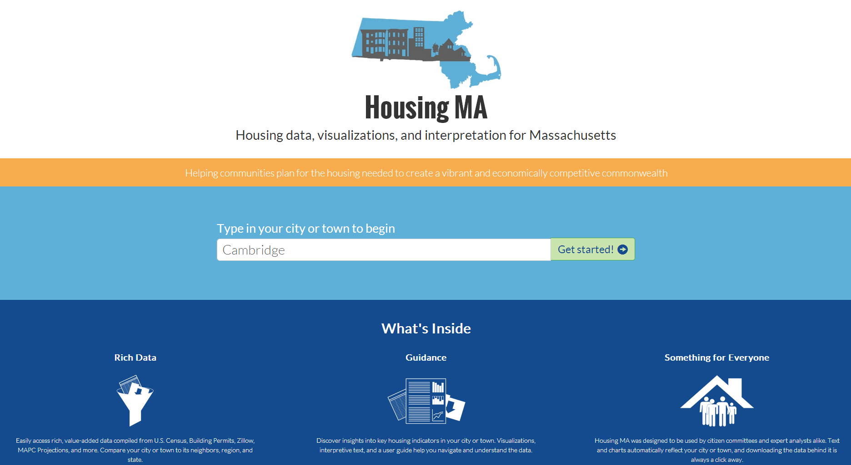

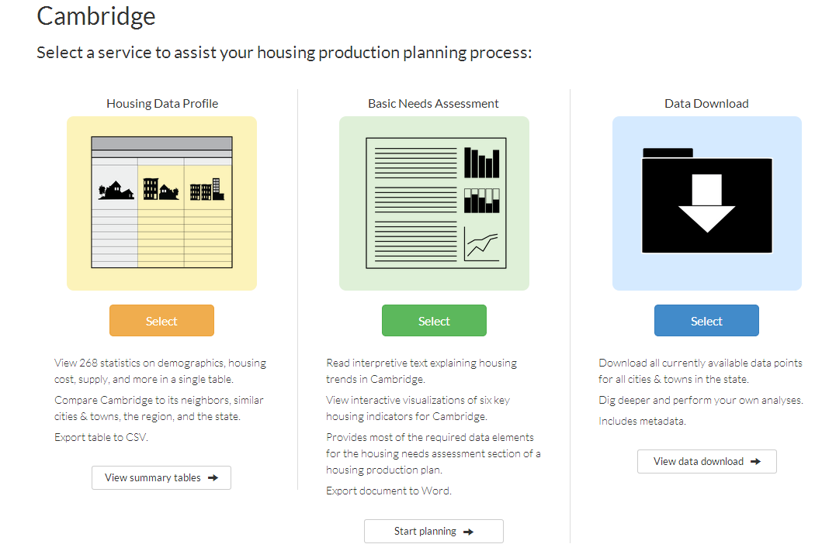
They can then view their community’s Housing Data Profile, Basic Needs Assessment, and Data Download.

The Data Profile page allows users to survey all data available on Housing.ma in one place.
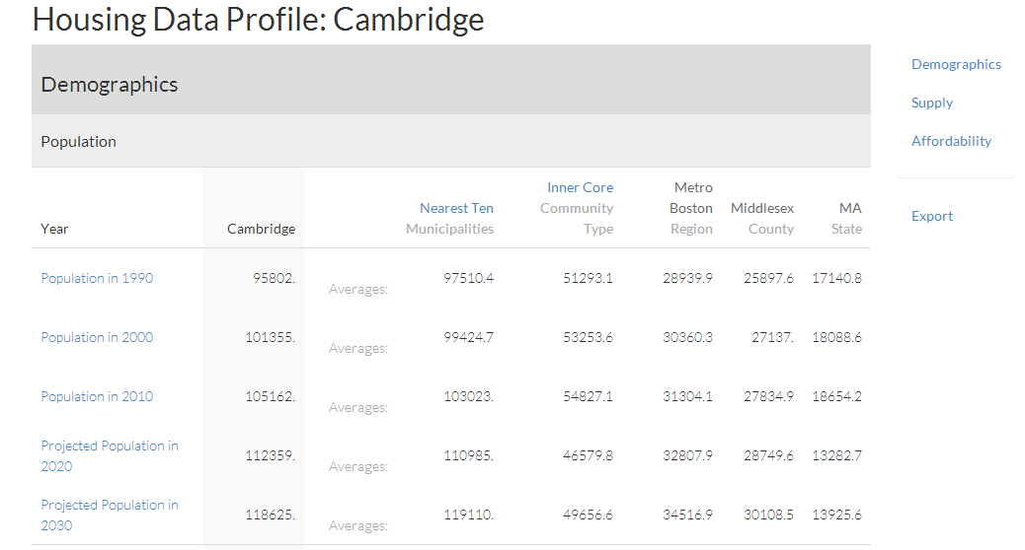
The needs assessment page provides dynamically-generated text and visualizations that users can view online or export as a Word document. Needs assessments give users a leg up in preparing the needs assessment portion of a housing production plan.
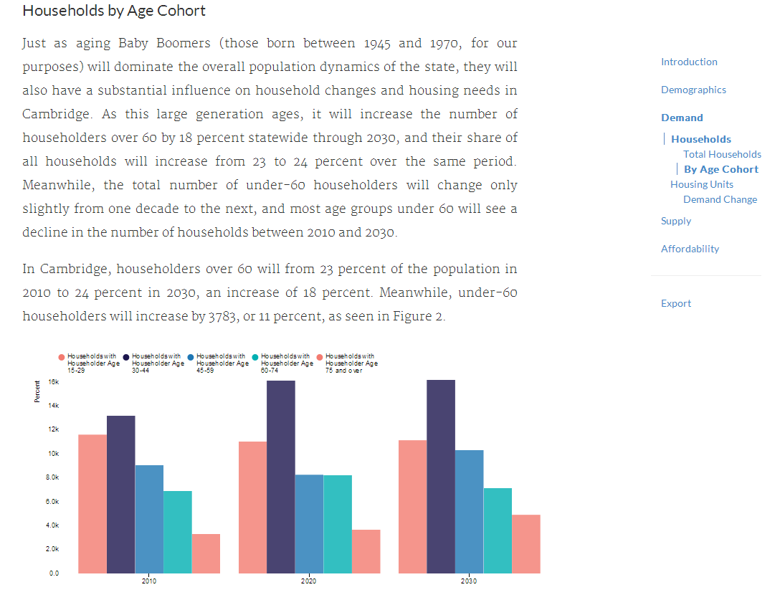
Users that want to dive deeper into the data and conduct their own analysis can download all Housing.ma data as Excel-compatible csv files.
