INDOOR AIR QUALITY ASSESSMENT

Mass Rehabilitation Commission
76 Summer Street
Fitchburg MA

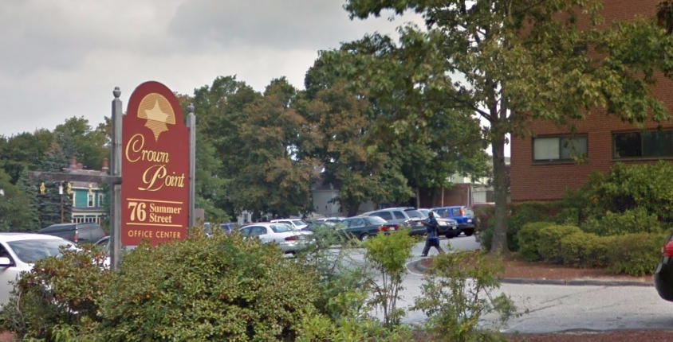

Prepared by:
Massachusetts Department of Public Health
Bureau of Environmental Health
Indoor Air Quality Program
August 2016

Background
Building: | Mass Rehabilitation Commission (MRC)
Address: | 76 Summer Street, Fitchburg, MA
Assessment Requested by: | Erin McCabe,EHS Facilities Deputy Director for Finance and Operations
Reason for Request: | Water damage and indoor air quality (IAQ) concerns
Date of Assessment: | August 19, 2016
Massachusetts Department of Public Health/Bureau of Environmental Health (MDPH/BEH) Staff Conducting Assessment: | Ruth Alfasso, Environmental Engineer/Inspector, IAQ Program
Building Description: | Three-story brick building with a flat roof. This building used to be a hospital but has been office space for several decades. MRC offices occupy part of the third floor and have had a presence here for about 20 years. The rest of the building contains other office tenants.
Building Population: | Approximately 30 employees and regular visitors
Windows: | Openable in some areas

Methods
Please refer to the IAQ Manual for methods, sampling procedures, and interpretation of results (MDPH, 2015).

IAQ Testing Results
The following is a summary of indoor air testing results (Table 1).
- Carbon dioxide levels were below 800 parts per million (ppm) in all areas assessed, indicating adequate fresh air in the space.
- Temperature was within the recommended range of 70°F to 78°F in all areas assessed.
- Relative humidity was within the recommended range of 40% to 60% in all areas assessed.
- Carbon monoxide levels were non-detectable in all indoor areas assessed.
- Fine particulate matter (PM2.5) concentrations measured were below the National Ambient Air Quality Standard (NAAQS) level of 35 μg/m³ in all areas assessed.

The assessment results indicate that the ventilation system is providing adequate fresh air for the occupancy in the building. Note that many areas had low occupancy which can reduce the creation of carbon dioxide. To maximize air exchange, the BEH recommends that mechanical ventilation systems operate continuously during periods of occupancy. Without the system operating as designed, normally occurring pollutants cannot be diluted or removed, allowing them to build up and can lead to IAQ/comfort complaints.

Ventilation
A heating, ventilating, and air conditioning (HVAC) system has several functions. First it provides heating and, if equipped, cooling. Second, it is a source of fresh air. Finally, an HVAC system will dilute and remove normally occurring indoor environmental pollutants by not only introducing fresh air, but by filtering the airstream and ejecting stale air to the outdoors via exhaust ventilation. Even if an HVAC system is operating as designed, point sources of respiratory irritation may exist and cause symptoms in sensitive individuals. The following analysis examines and identifies components of the HVAC system and likely sources of respiratory irritant/allergen exposure due to water damage, aerosolized dust, and/or chemicals found in the indoor environment.
Fresh air is provided by air handling units (AHUs) located on the roof (Pictures 1 and 2). Air from the AHUs is filtered, heated/cooled, and delivered to rooms via ducted supply vents (Picture 3). Air is returned/exhausted through vents in the ceiling. A restroom in the waiting area had a direct-vented exhaust that turned on when the light switch was operated (Picture 4).
It is recommended that HVAC systems be re-balanced every five years to ensure adequate air systems function (SMACNA, 1994). It is unknown when this system was last balanced.

Microbial/Moisture Concerns
The main purpose of this visit was to investigate water damage reported in the building. It was reported that the landlord had replaced many water-damaged ceiling tiles in the space shortly before the visit. Additional water-damaged tiles and other signs of water damage and water infiltration were observed during the visit (Pictures 4 through 8). The area above ceiling tiles was examined in several places where water infiltration was reported. Above the suspended ceiling tile system is a space in which air ducts and other services are routed. Above that is a metal decking material. Due to the volume of open space/airflow and lack of porous materials in this space, water leaks are unlikely to lead to microbial growth above the ceiling tiles. No moldy odors were observed during this examination. Some of the metal decking was found to have rust spots indicating that water infiltration has occurred chronically in those areas.
Water leaks originate with the roof which is of an unknown age. The roof was examined and areas of water pooling were observed (Picture 9) suggesting that the roof no longer slopes correctly to drains and/or that drains do not function well, creating conditions that may lead to leaking. Leaks have been observed to occur in the past on seams where portions of the roof meet. In addition, recent patches were seen on the roof (Picture 10), which reportedly covered areas where recent work on the rooftop cell tower may have led to roof membrane damage. The integrity of the roof membrane and proper drainage are vital to preventing water infiltration.
Trees/plants were observed in close proximity to the building and overhanging the roof (Picture 11). It was reported that several years earlier, the office had been subject to an infiltration of ants that had originated with a tree in contact with the building that was removed once the problem was discovered. Trees/plants in contact with the building can hold moisture against the bricks, can provide pathways for pests to enter the building, and can be a source of pollen and mold through open windows. They can also be a source of debris that can damage the roof membrane or clog roof drains. Trees and plants should be removed from within five feet of the base of the building and trimmed so that they do not overhang the roof.
Plants were observed in office areas (Picture 12). Plants can be a source of pollen and mold, which can be respiratory irritants to some individuals. Plants should be properly maintained and equipped with drip pans to prevent water damage to porous materials. Plants should also be located away from air diffusers to prevent the aerosolization of dirt, pollen, and mold. An aquarium was also observed in an office; these should be kept clean to prevent odors and microbial growth.
A ductless air conditioning unit was observed in a hallway. These units have condensation drains which may become clogged and leak if they are not maintained.
Humidifiers were observed in several places in the office (Picture 13), reportedly for the needs of an employee who has since retired. These units were empty and unplugged at the time of the visit. The use of humidifying equipment is not recommended in offices due to the potential of them becoming a source of microbial growth and aerosolized contaminants to the indoor environment due to improper use and maintenance. Low relative humidity indoors is a very common condition during the heating season in New England and can contribute to irritation of the skin and mucous membranes (nose and throat). To reduce the irritant effects of low humidity in the winter, the BEH/IAQ program recommends drinking water and providing enhanced cleaning to reduce irritating dusts.

Other IAQ Evaluations
Exposure to low levels of total volatile organic compounds (TVOCs) may produce eye, nose, throat, and/or respiratory irritation in some sensitive individuals. To determine if VOCs were present, BEH/IAQ staff examined rooms for products containing VOCs. BEH/IAQ staff noted hand sanitizers, cleaners, and dry erase materials in use within the building. All of these products have the potential to be irritants to the eyes, nose, throat, and respiratory system of sensitive individuals.
The offices were mostly carpeted. Carpets should be cleaned annually (or semi-annually in soiled/high traffic areas) in accordance with Institute of Inspection, Cleaning and Restoration Certification (IICRC) recommendations, (IICRC, 2012). However, carpeting was believed to be original to the MRC occupancy and therefore may be at least 20 years old. The service life of carpeting is approximately 10-11 years (IICRC, 2002). In many areas, carpeting was observed to be worn, wrinkled and stained (Pictures 12, 14 and 15). Carpeting of this age and condition becomes increasingly difficult to clean and maintain and may be a source of particulate matter to the indoor environment.
Dead insects were observed in windowsills in some offices (Picture 16). This suggests that there may be breaches in the building envelope, or that screens may be missing from windows that are opened. It also suggests that increased cleaning is needed. Other areas in need of enhanced or more frequent cleaning were observed including dirt on carpeting (Picture 15), and dusty supply and exhaust vents (Picture 3) which can be sources of aerosolized particulates.
In some offices, items such as paper, boxes and decorative items make it harder for custodial staff to clean. Decorative items were observed hanging from the ceiling tile system in one office. Use of ceiling tile supports for decorative items can disrupt the integrity of the tile system allowing dust and debris into occupied areas.

Conclusions/Recommendations
Based on observations at the time of assessment, the following is recommended:
- Operate supply and exhaust ventilation in all areas during occupied periods.
- Have the HVAC system balanced every 5 years in accordance with SMACNA recommendations (SMACNA, 1994).
- Have the roof repaired as needed. Consider a major roof overhaul or replacement to fix areas of poor drainage and leaks.
- Continue with replacement of water-damaged ceiling tiles. Clean water stains from non-porous surfaces as they are discovered.
- Avoid storage of porous materials in areas of known water infiltration.
- Monitor areas of previous water infiltration regularly for leaks. Ensure a system is in place for prompt reporting of water damage and other conditions to both building management and EOHHS facilities staff.
- Trim back plants from the side and overhanging the building.
- Keep indoor plants in good condition, avoid overwatering, and avoid placing them on porous items such as carpets or paper. Also, keep plants out of the air stream of supply vents.
- Keep aquariums in good condition to avoid spills and odors.
- Ensure that ductless air conditioners drain properly by inspecting hoses for clogs and leaks periodically
- Discontinue use of humidifiers in the office. For buildings in New England, periods of low relative humidity during the winter are often unavoidable. Therefore, scrupulous cleaning practices should be adopted to minimize common indoor air contaminants whose irritant effects can be enhanced when the relative humidity is low. To control for dusts, a high efficiency particulate arrestance (HEPA) filter equipped vacuum cleaner in conjunction with wet wiping of all surfaces is recommended. Avoid the use of feather dusters. Drinking water during the day can help ease some symptoms associated with a dry environment (throat and sinus irritations).
- If windows are opened for fresh air, ensure they have intact screens and are tightly closed at the end of each day to prevent pest entry. Do not open windows during hot, humid weather to avoid creating conditions where condensation may occur indoors.
- Reduce the use of cleaning products, sanitizers, and scented products.
- Change filters on AHUs on a regular schedule at least twice a year.
- Clean carpeting in accordance with IICRC recommendations (IICRC, 2012). Consider replacing carpeting that is too worn for effective cleaning with carpet squares.
- Clean windowsills and other hard-to-reach areas regularly.
- Reduce accumulated materials on flat surfaces and store in an organized manner to allow for thorough cleaning.
- Avoid hanging items to prevent disturbance of the ceiling tile system.
- Refer to resource manual and other related IAQ documents located on the MDPH’s website for further building-wide evaluations and advice on maintaining public buildings. These documents are available at: http://mass.gov/dph/iaq.

References
IICRC. 2002. Institute of Inspection, Cleaning and Restoration Certification. Carpet Cleaning: A Life-cycle Cost Analysis for Floor Coverings in School Facilities. Retrieved from http://www.carpet-rug.org/facility-specific-considerations.html.
IICRC. 2012. Institute of Inspection, Cleaning and Restoration Certification. Carpet Cleaning: FAQ. Retrieved from http://www.iicrc.org/consumers/care/carpet-cleaning/#faq.
MDPH. 2015. Massachusetts Department of Public Health. Indoor Air Quality Manual: Chapters I-III. Available at: http://www.mass.gov/eohhs/gov/departments/dph/programs/environmental-health/exposure-topics/iaq/iaq-manual/.
SMACNA. 1994. HVAC Systems Commissioning Manual. 1st ed. Sheet Metal and Air Conditioning Contractors’ National Association, Inc., Chantilly, VA.
Picture 1
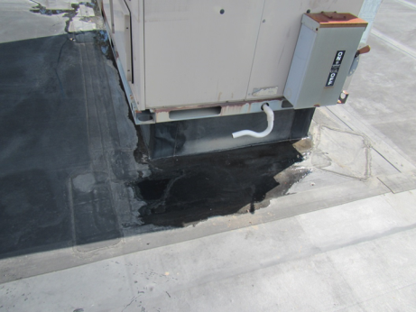
AHU on the roof
Picture 2
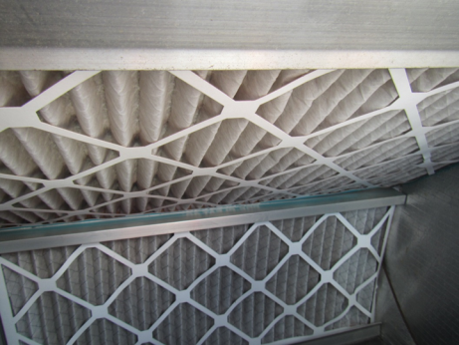
AHU filters
Picture 3
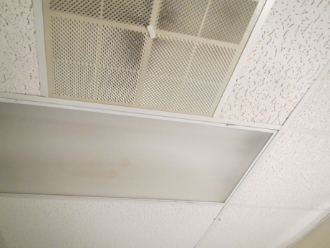
Supply vent, note dust/debris
Picture 4
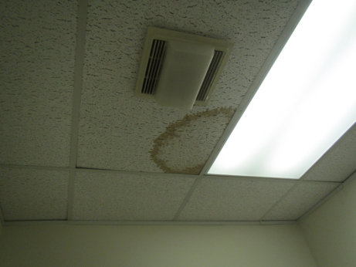
Exhaust vent in waiting room restroom, note water-damaged ceiling tile
Picture 5
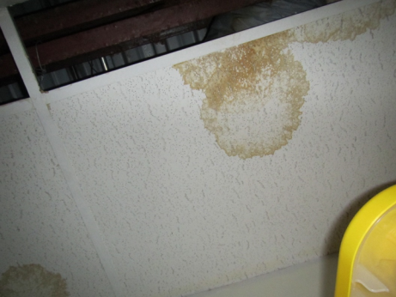
Water-damaged ceiling tiles
Picture 6
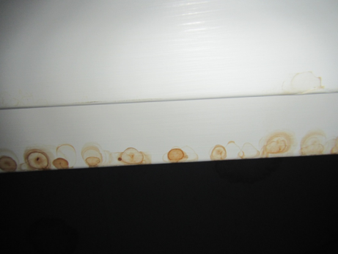
Water stains on closet molding
Picture 7
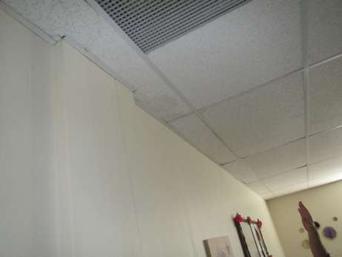
Water stains in wall in computer room
Picture 8
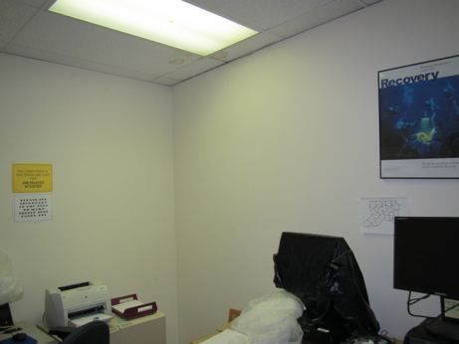
Plastic coverings on computers to protect from water damage
Picture 9
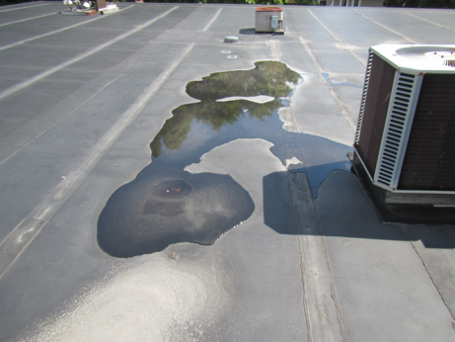
Water pooling on roof
Picture 10
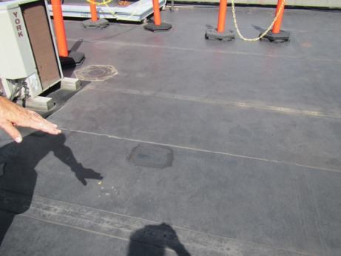
Roof patch
Picture 11
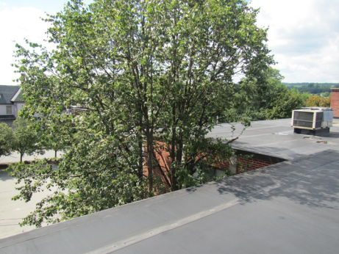
Tree in close proximity to building and overhanging roof
Picture 12
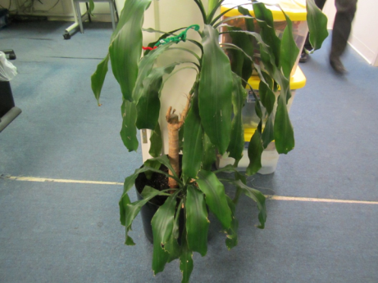
Plant in office, note worn carpeting
Picture 13
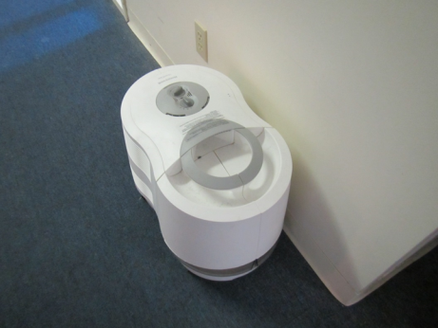
Humidifier, unplugged/unused
Picture 14
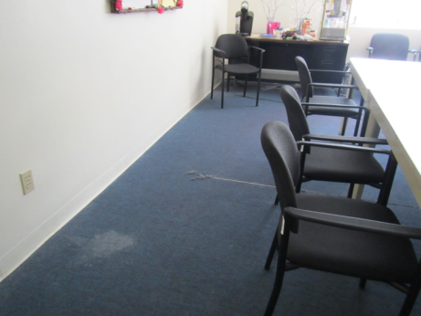
Worn and stained carpeting in a conference room
Picture 15
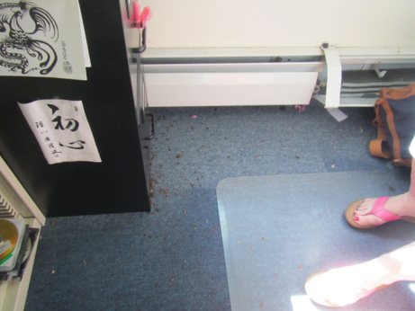
Worn and dirty carpeting
Picture 16
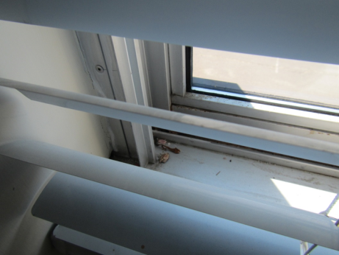
Insects in the windowsill
Location | Carbon  Dioxide  (ppm) | Carbon Monoxide  (ppm) | Temp  (°F) | Relative  Humidity  (%) | PM2.5  (µg/m³) | Occupants  in Room | Windows  Openable | Ventilation |  | Remarks
 |  |  |  |  |  |  |  | Supply | Exhaust
Background | 435 | 0.5 | 81 | 56 | 16 |  |  |  |  | Sunny
English | 617 | ND | 74 | 48 | 7 | 1 | Y | Y | N | AP – on, old carpet, HS, PF
Jones | 688 | ND | 74 | 48 | 8 | 1 | N | Y | N | PF, heater, AI, food
LoGiudici | 621 | ND | 75 | 48 | 8 | 0 | N | Y | N | Computer data equipment and regular office, items hanging from ceiling, historic WD
Allen | 620 | ND | 75 | 46 | 8 | 0 | N | Y | N | PF, worn carpeting, dust, HS
Waiting | 594 | ND | 74 | 45 | 8 | 0 | N | Y | Y
Restroom in waiting area | 711 | ND | 75 | 45 | 9 | 0 | N | N | Y | NC, WD CT and recently fixed WD CT, AF
Computer resource | 553 | ND | 74 | 44 | 8 | 0 | N | Y | N | WD CT and walls, plastic over computers to protect from water
Kitchen/Files | 561 | ND | 74 | 45 | 9 | 0 | N | Y | N | NC, fridge and microwave
Roberge | 654 | ND | 72 | 45 | 8 | 2 | Y | Y | Y | Plants, WD CT and recently replaced CT, bugs on windowsills
Conference | 614 | ND | 72 | 44 | 8 | 0 | Y | Y | Y | Old, frayed carpet, WD wall, paper storage, WD CT
Closet |  |  |  |  |  |  |  |  |  | WD CT and wall
Paper storage room |  |  |  |  |  |  |  |  |  | WD CT, NC
White | 597 | ND | 72 | 48 | 7 | 0 | N | Y | N | DO, wrinkled carpet, humidifier not used
Reception Area | 580 | ND | 72 | 47 | 7 | 1 | Y | Y | Y | WD CT and past WD CT, PC, PFs, old carpet, plants
Morrissey | 588 | ND | 73 | 48 | 8 | 1 | N | Y dusty | N | PF, area rug, HS, fabric on wall
Coble | 622 | ND | 74 | 48 | 8 | 1 | Y just open | Y | N | Food, AI, dirt on carpet, aquarium
Baile | 649 | ND | 74 | 47 | 8 | 0 | N | Y | N | Water damage in light fixture, PF
Nelson | 574 | ND | 74 | 46 | 8 | 0 | N | Y | N | WD CT, old carpet, PF
Cserny | 552 | ND | 74 | 47 | 8 | 0 | N | Y | N | PF, heater, CP, coffee
Ricardo | 553 | ND | 74 | 47 | 8 | 0 | N | Y dusty | N | PF/AP, CP
Unmarked Office | 545 | ND | 73 | 47 | 8 | 0 | N | Y dusty | N | HS, WD cabinet

