Background/Introduction

INDOOR AIR QUALITY REASSESSMENT

Commonwealth of Massachusetts
Massachusetts Rehabilitation Commission
Worcester Branch
340 Main Street
Worcester, Massachusetts

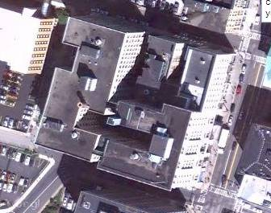

Prepared by:
Massachusetts Department of Public Health
Bureau of Environmental Health
Indoor Air Quality Program
May 2015

In response to a request from Ms. Virginia Platt, Project Manager, Office of Leasing and State Office Planning for the Massachusetts Division of Capital Asset Management and Maintenance (OLSOP/DCAMM), the Massachusetts Department of Public Health (MDPH), Bureau of Environmental Health (BEH) conducted a follow up indoor air quality (IAQ) assessment at the Massachusetts Rehabilitation Commission (MRC) located at 340 Main Street, 5th floor, Worcester, Massachusetts. The Massachusetts Department of Public Health (MDPH), Bureau of Environmental Health (BEH) conducted the assessment in response to concerns relating to high levels of airborne particulate matter that had been identified in a previous visit. On April 24, 2015, a site visit was made by Ruth Alfasso, Environmental Engineer/Inspector in BEH’s IAQ Program. The report in which the high levels of particulate matter were identified and recommendations made was released in February of 2015. Appendix A lists those recommendations and actions that were taken.

Methods
Air tests for carbon dioxide, carbon monoxide, temperature and relative humidity were taken with the TSI, Q-Trak, IAQ Monitor 7565. Air tests for airborne particle matter with a diameter less than 2.5 micrometers were taken with the TSI, DUSTTRAK™ Aerosol Monitor Model 8520. BEH/IAQ staff also performed a visual inspection of building materials for water damage and/or microbial growth.

Results
The MRC has an employee population of approximately 130 with up to 15 members of the public visiting the office daily. Test results appear in Table 1.

Discussion

Ventilation
It can be seen from Table 1 that carbon dioxide levels were below 800 parts per million (ppm) in all of the 102 areas tested, indicating adequate air exchange in all areas at the time of the assessment. Note that many areas were empty or sparsely populated, which reduces carbon dioxide levels. Levels may be higher with higher occupancy.
Mechanical ventilation is provided by a series of heating, ventilation and air conditioning (HVAC) air handling units (AHUs) located in closets throughout the floor. Fresh air is drawn through vents located above select window frames. Ductwork connects the AHUs to ceiling-mounted air supply diffusers. By design, air diffusers are equipped with fixed louvers that direct air along the ceiling to flow down the walls and create airflow. Air returns to the AHUs through the fixed louvers in the doors of the AHU closets. A few areas, such as the lounge/kitchen, training rooms and restroom, also have directly-vented exhaust to remove the pollutants generated in these areas (Picture 1).
In one area, which was largely unoccupied at the time of the visit, the thermostat was observed to be in the “automatic” setting instead of the “on” setting (Table 1). When the fan is set to on, the system provides a continuous source of air circulation and filtration. The automatic setting on the thermostat activates the HVAC system at a preset temperature. Once the preset temperature is reached, the HVAC system is deactivated. Therefore, no mechanical ventilation is provided until the thermostat re-activates the system. The MDPH typically recommends that thermostats be set to the fan on setting during occupied hours to provide continuous air circulation.
To maximize air exchange, the MDPH recommends that both supply and exhaust ventilation operate continuously during periods of occupancy. In order to have proper ventilation with a mechanical supply and exhaust system, the systems must be balanced to provide an adequate amount of fresh air to the interior of a room while removing stale air from the room. It is recommended that HVAC systems be re-balanced every five years to ensure adequate air systems function (SMACNA, 1994). The HVAC systems were reportedly balanced in 2011.
Minimum design ventilation rates are mandated by the Massachusetts State Building Code (MSBC). Until 2011, the minimum ventilation rate in Massachusetts was higher for both occupied office spaces and general classrooms, with similar requirements for other occupied spaces (BOCA, 1993). The current version of the MSBC, promulgated in 2011 by the State Board of Building Regulations and Standards (SBBRS), adopted the 2009 International Mechanical Code (IMC) to set minimum ventilation rates. Please note that the MSBC is a minimum standard that is not health-based. At lower rates of cubic feet per minute (cfm) per occupant of fresh air, carbon dioxide levels would be expected to rise significantly. A ventilation rate of 20 cfm per occupant of fresh air provides optimal air exchange resulting in carbon dioxide levels at or below 800 ppm in the indoor environment in each area measured. MDPH recommends that carbon dioxide levels be maintained at 800 ppm or below. This is because most environmental and occupational health scientists involved with research on IAQ and health effects have documented significant increases in indoor air quality complaints and/or health effects when carbon dioxide levels rise above the MDPH guidelines of 800 ppm for schools, office buildings and other occupied spaces (Sundell et al., 2011). The ventilation must be on at all times that the room is occupied. Providing adequate fresh air ventilation with open windows and maintaining the temperature in the comfort range during the cold weather season is impractical. Mechanical ventilation is usually required to provide adequate fresh air ventilation.
Carbon dioxide is not a problem in and of itself. It is used as an indicator of the adequacy of the fresh air ventilation. As carbon dioxide levels rise, it indicates that the ventilating system is malfunctioning or the design occupancy of the room is being exceeded. When this happens, a buildup of common indoor air pollutants can occur, leading to discomfort or health complaints. The Occupational Safety and Health Administration (OSHA) standard for carbon dioxide is 5,000 parts per million parts of air (ppm). Workers may be exposed to this level for 40 hours/week, based on a time-weighted average (OSHA, 1997).
The MDPH uses a guideline of 800 ppm for publicly occupied buildings. A guideline of 600 ppm or less is preferred in schools due to the fact that the majority of occupants are young and considered to be a more sensitive population in the evaluation of environmental health status. Inadequate ventilation and/or elevated temperatures are major causes of complaints such as respiratory, eye, nose and throat irritation, lethargy and headaches. For more information concerning carbon dioxide, consult Appendix B.
Indoor temperatures at the time of the assessment ranged from 71°F to 77°F (Table 1), which were within the MDPH recommended comfort range. The MDPH recommends that indoor air temperatures be maintained in a range of 70°F to 78°F in order to provide for the comfort of building occupants. In many cases concerning indoor air quality, fluctuations of temperature in occupied spaces are typically experienced, even in a building with an adequate fresh air supply.
Relative humidity measurements at the time of the assessment ranged from 17 to 25 percent (Table 1), which were below the MDPH recommended comfort range in all areas surveyed. The MDPH recommends a comfort range of 40 to 60 percent for indoor air relative humidity. Relative humidity levels in the building would be expected to drop during the winter months due to heating. The sensation of dryness and irritation is common in a low relative humidity environment. Low relative humidity is a very common problem during the heating season in the northeast part of the United States.

Microbial/Moisture Concerns
No water-damaged ceiling tiles or other building materials were observed during this visit, apart from a few water-damaged windowsill areas where plants or other water containers had been located in the past. Plants were observed in several areas, including on porous materials (Pictures 2 and 3). Plants, soil and drip pans can serve as sources of mold/bacterial growth. Plants should be properly maintained, over-watering of plants should be avoided and drip pans should be inspected periodically for mold growth. Plants should also be placed away from ventilation sources to prevent the aerosolization of related materials.
A humidifier was seen in an office (Picture 4). These appliances should be kept clean in accordance with manufacturer’s instructions, as stagnant water can be a source of odors or microbiological pollutants.
Water coolers were observed in carpeted areas (Picture 5). Spills or leaks from these appliances can moisten carpeting and lead to microbial growth. Water dispensing equipment should be located in non-carpeted areas or on a waterproof mat.

Other IAQ Evaluations
Indoor air quality can be negatively influenced by the presence of respiratory irritants, such as products of combustion. The process of combustion produces a number of pollutants. Common combustion emissions include carbon monoxide, carbon dioxide, water vapor, and smoke (fine airborne particle material). Of these materials, exposure to carbon monoxide and particulate matter with a diameter of 2.5 micrometers (μm) or less (PM2.5) can produce immediate, acute health effects upon exposure. To determine whether combustion products were present in the indoor environment, BEH/IAQ staff obtained measurements for carbon monoxide and PM2.5.

Carbon Monoxide
Carbon monoxide is a by-product of incomplete combustion of organic matter (e.g., gasoline, wood, and tobacco). Exposure to carbon monoxide can produce immediate and acute health effects. Several air quality standards have been established to address carbon monoxide and prevent symptoms from exposure to these substances. The MDPH established a corrective action level concerning carbon monoxide in ice skating rinks that use fossil-fueled ice resurfacing equipment. If an operator of an indoor ice rink measures a carbon monoxide level over 30 ppm, taken 20 minutes after resurfacing within a rink, that operator must take actions to reduce carbon monoxide levels (MDPH, 1997).
The American Society of Heating Refrigeration and Air-Conditioning Engineers (ASHRAE) has adopted the National Ambient Air Quality Standards (NAAQS) as one set of criteria for assessing indoor air quality and monitoring of fresh air introduced by HVAC systems (ASHRAE, 1989). The NAAQS are standards established by the US EPA to protect the public health from six criteria pollutants, including carbon monoxide and particulate matter (US EPA, 2006). As recommended by ASHRAE, pollutant levels of fresh air introduced to a building should not exceed the NAAQS levels (ASHRAE, 1989). The NAAQS were adopted by reference in the Building Officials & Code Administrators (BOCA) National Mechanical Code of 1993 (BOCA, 1993), which is now an HVAC standard included in the Massachusetts State Building Code (SBBRS, 2011). According to the NAAQS, carbon monoxide levels in outdoor air should not exceed 9 ppm in an eight-hour average (US EPA, 2006).
Carbon monoxide should not be present in a typical, indoor environment. If it is present, indoor carbon monoxide levels should be less than or equal to outdoor levels. Outdoor carbon monoxide concentrations were non-detect (ND) at the time of the assessment (Table 1). No measurable levels of carbon monoxide were detected inside the building during the assessment (Table 1).

Particulate Matter
The US EPA has established NAAQS limits for exposure to particulate matter. Particulate matter includes airborne solids that can be irritating to the eyes, nose, and throat. The NAAQS originally established exposure limits to PM with a diameter of 10 μm or less (PM10). In 1997, US EPA established a more protective standard for fine airborne particulate matter with a diameter of 2.5 μm or less (PM2.5). The NAAQS has subsequently been revised, and PM2.5 levels were reduced. This more stringent PM2.5 standard requires outdoor air particle levels be maintained below 35 μg/m³ over a 24-hour average (US EPA, 2006). Although both the ASHRAE standard and BOCA Code adopted the PM10 standard for evaluating air quality, MDPH uses the more protective PM2.5 standard for evaluating airborne PM concentrations in the indoor environment.
Outdoor PM2.5 concentrations the day of the assessment were measured at 10 μg/m³. PM2.5 levels measured inside the building ranged from ND to 25 μg/m³ (Table 1). Both indoor and outdoor PM2.5 levels were below the NAAQS PM2.5 level of 35 μg/m³. Frequently, indoor air levels of particulate matter (including PM2.5) can be at higher levels than those measured outdoors. A number of mechanical devices and/or activities that occur indoors can generate particulate matter during normal operations. Sources of indoor airborne particulate matter may include but are not limited to particles generated during the operation of fan belts in the HVAC system, use of stoves and/or microwave ovens in kitchen areas; use of photocopiers, fax machines and computer printing devices; operation of an ordinary vacuum cleaner and heavy foot traffic indoors.
Note that levels of PM2.5 were also measured in the lobby area, which was determined to be the likely source of PM2.5 readings above the 35 μg/m³ standard in the office on the previous visit. Levels in the lobby ranged from 104 to 169 μg/m³, which were above the standard but significantly lower than readings measured during the October 2014 visit. At that time, readings of up to 1,050 μg/m³ were made in the lobby and visible smoke was present. No smoke and very low cooking/food odors were observed in the lobby during the April 24, 2015 visit. Exhaust ventilation in the restaurant on the lobby level was reported to have been improved by the management company since the October 2014 visit. Additional work on the exhaust system for the restaurant is planned.

Other Conditions
A number of supply diffusers, return grates, exhaust vents and personal fans were observed to have accumulated dust/debris (Picture 1). If exhaust vents are not functioning, backdrafting can occur, which can re-aerosolize accumulated dust particles. Re-activated supply vents can also aerosolize dust accumulated on vents.
In one location, items were observed hanging from the ceiling tile system (Picture 6). Hanging of items from the ceiling is not recommended as disruption of the ceiling tile system can release dusts from tiles or from above the tiles into occupied areas.
In several areas, items were observed on the floor, windowsills, tabletops, counters, bookcases and desks (Picture 7). The large number of items on flat surfaces provides a source for dusts to accumulate and makes it difficult for custodial staff to clean. Items should be relocated and/or be cleaned periodically to avoid excessive dust build up.
Carpeting in the office consists mainly of carpet squares, which appeared to be in good condition. The Institute of Inspection, Cleaning and Restoration Certification (IICRC), recommends that carpeting be cleaned annually (or semi-annually in soiled high traffic areas) (IICRC, 2012).

Conclusions/Recommendations
In view of the findings at the time of the visit, the following recommendations are made:
- Consider setting thermostats to the fan “on” position to provide continuous air circulation/filtration during business hours.
- Continue with plans for additional upgrades to the lobby food establishment exhaust ventilation.
- Consider adopting a balancing schedule of every 5 years for all mechanical ventilation systems, as recommended by ventilation industrial standards (SMACNA, 1994).
- For buildings in New England, periods of low relative humidity during the winter are often unavoidable. Therefore, scrupulous cleaning practices should be adopted to minimize common indoor air contaminants whose irritant effects can be enhanced when the relative humidity is low. To control for dusts, a high efficiency particulate arrestance (HEPA) filter equipped vacuum cleaner in conjunction with wet wiping of all surfaces is recommended. Avoid the use of feather dusters. Drinking water during the day can help ease some symptoms associated with a dry environment (throat and sinus irritations).
- Ensure that plants are properly maintained, not overwatered, and not placed on porous materials.
- Properly maintain humidifiers.
- Consider placing water dispensing equipment in non-carpeted areas or on a waterproof mat.
- Clean air diffusers, exhaust and return vents periodically of accumulated dust/debris.
- Avoid hanging items from the ceiling tile system.
- Relocate or consider reducing the amount of materials stored on flat surfaces to allow for more thorough cleaning. Clean items regularly with a wet cloth or sponge to prevent excessive dust build-up.
- Clean area carpets annually or semi-annually in soiled high traffic areas as per the recommendations of the Institute of Inspection, Cleaning and Restoration Certification (IICRC, 2012). Consider a schedule for replacing any worn carpeting that is beyond its service life.
- Refer to resource manual and other related indoor air quality documents located on the MDPH’s website for further building-wide evaluations and advice on maintaining public buildings. These documents are available at http://mass.gov/dph/iaq.

References
ACGIH. 1989. Guidelines for the Assessment of Bioaerosols in the Indoor Environment. American Conference of Governmental Industrial Hygienists, Cincinnati, OH.
ASHRAE. 1989. Ventilation for Acceptable Indoor Air Quality. American Society of Heating, Refrigeration, and Air Conditioning Engineers. ANSI/ASHRAE 62-1989.
BOCA. 1993. The BOCA National Mechanical Code/1993. 8th ed. Building Officials and Code Administrators International, Inc., Country Club Hill, IL.
IICRC. 2012. Carpet Cleaning FAQ 4 Institute of Inspection, Cleaning and Restoration Certification. Institute of Inspection Cleaning and Restoration, Vancouver, WA.
MDPH. 1997. Requirements to Maintain Air Quality in Indoor Skating Rinks (State Sanitary Code, Chapter XI). 105 CMR 675.000. Massachusetts Department of Public Health, Boston, MA.
MDPH. 2015. Water Damage Investigation, Lowell DCF. Massachusetts Department of Public Health, Bureau of Environmental Health, Boston, MA. March 2015.
OSHA. 1997. Limits for Air Contaminants. Occupational Safety and Health Administration. Code of Federal Regulations. 29 C.F.R 1910.1000 Table Z-1-A
SBBRS. 2011. Mechanical Ventilation. State Board of Building Regulations and Standards. Code of Massachusetts Regulations, 8th edition. 780 CMR 1209.0
SMACNA. 1994. HVAC Systems Commissioning Manual. 1st ed. Sheet Metal and Air Conditioning Contractors’ National Association, Inc., Chantilly, VA.
Sundell. 2011. Sundell, J., H. Levin, W. W. Nazaroff, W. S. Cain, W. J. Fisk, D. T. Grimsrud, F. Gyntelberg, Y. Li, A. K. Persily, A. C. Pickering, J. M. Samet, J. D. Spengler, S. T. Taylor, and C. J. Weschler. 2011. Ventilation rates and health: multidisciplinary review of the scientific literature. Indoor Air, Volume 21: pp 191–204.
US EPA. 2006. National Ambient Air Quality Standards (NAAQS). US Environmental Protection Agency, Office of Air Quality Planning and Standards, Washington, DC. http://www.epa.gov/air/criteria.html
Picture 1

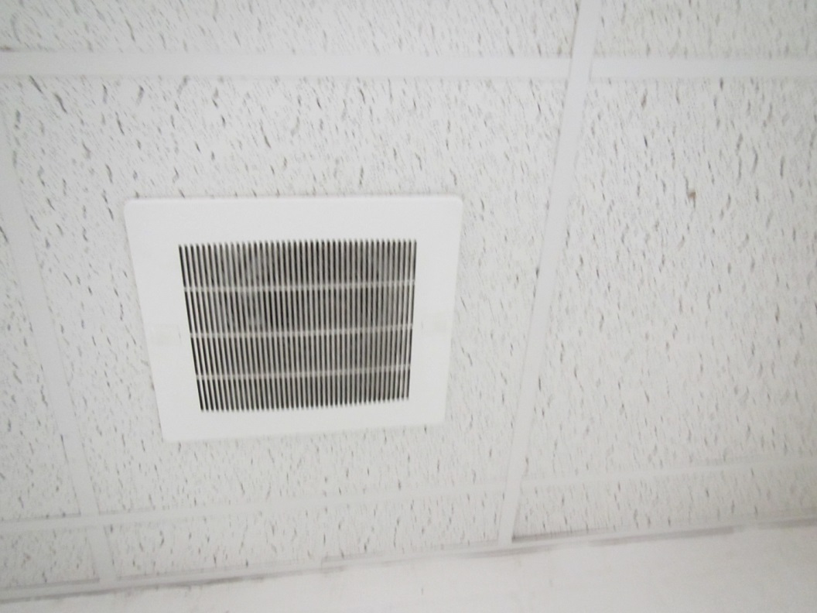

Direct vented exhaust, note dust/debris on vent

Picture 2

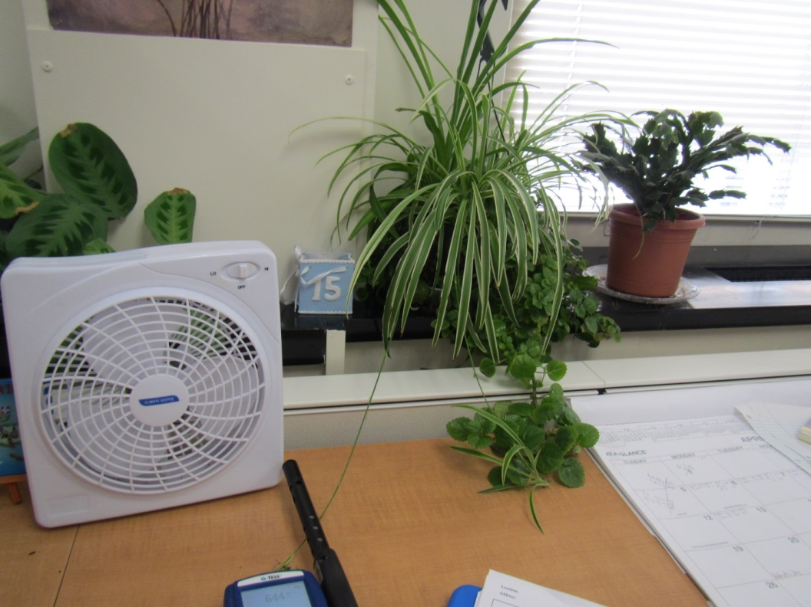

Plants in an office
Picture 3

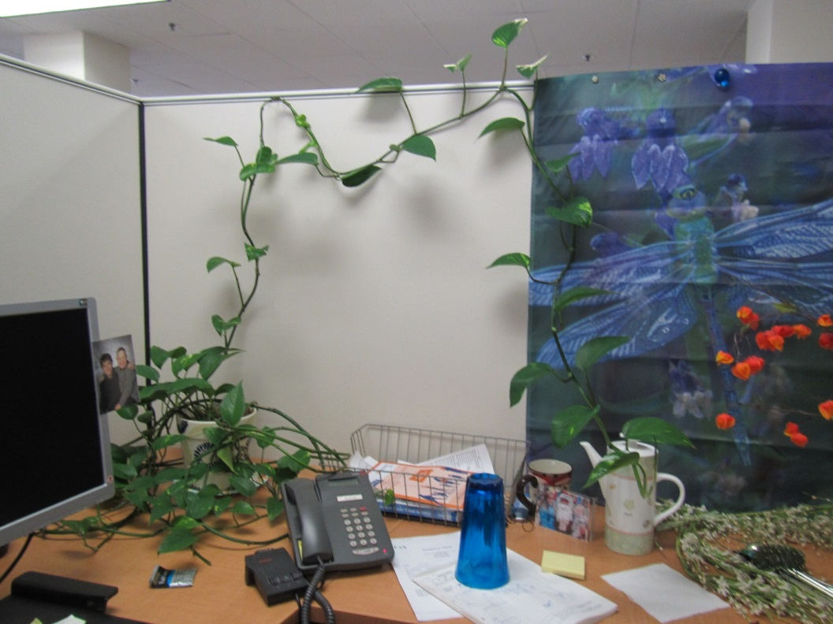

Plants draped on porous cubicle wall

Picture 4

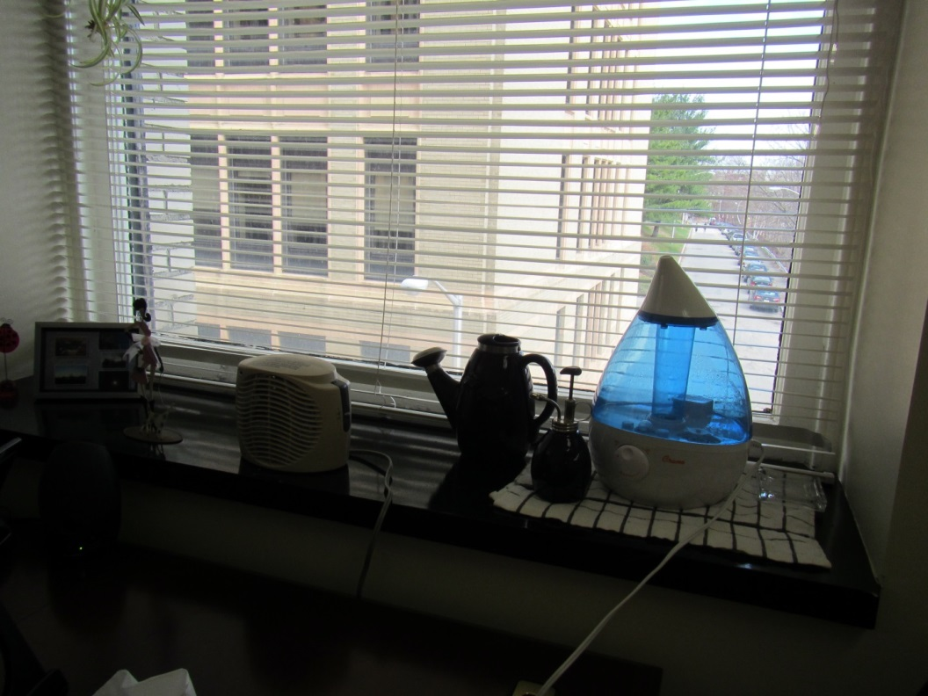

Humidifier in an office
Picture 5

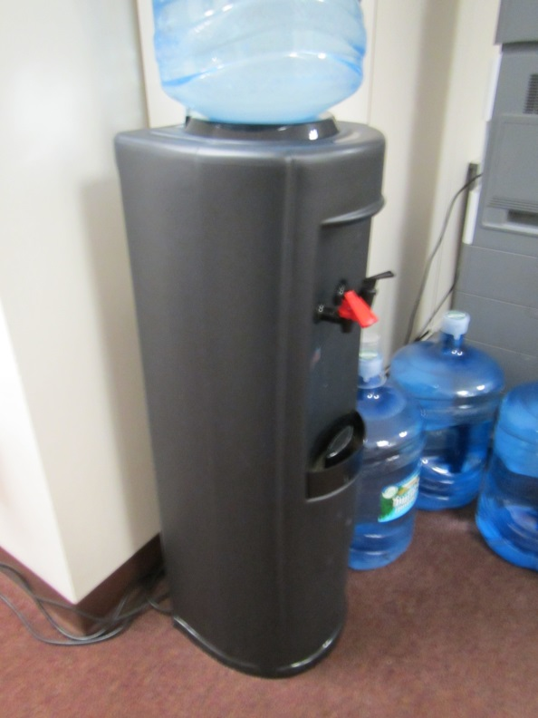

Water cooler on carpet

Picture 6

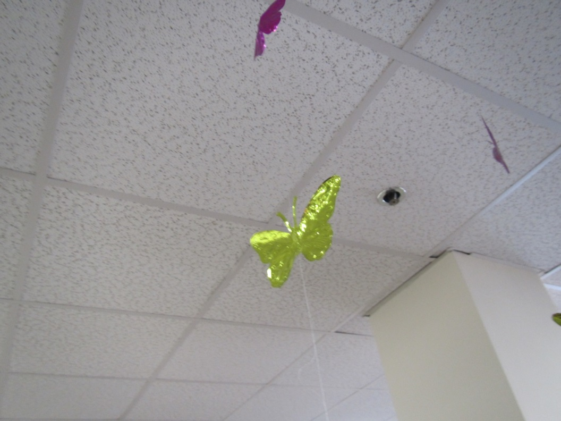

Items hanging from ceiling tiles

Picture 7

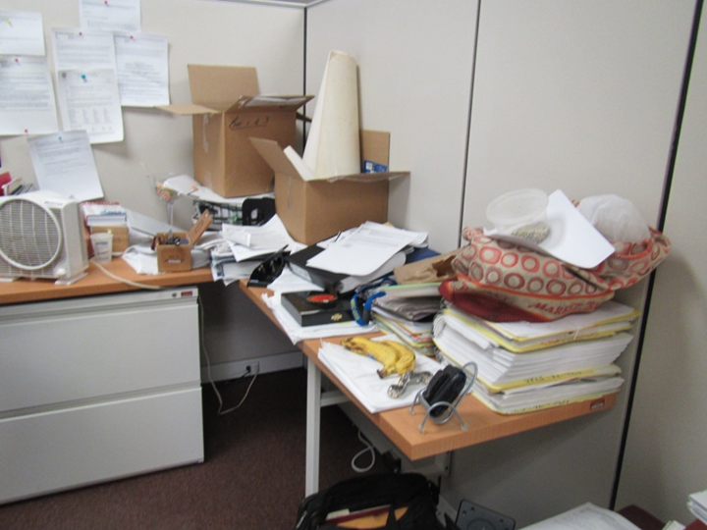

Clutter and items in an office

Location | Carbon  Dioxide  (ppm) | Carbon Monoxide  (ppm) | Temp  (°F) | Relative  Humidity  (%) | PM2.5  (µg/m³) | Occupants  in Room | Windows  Openable | Ventilation |  |  | Remarks
 |  |  |  |  |  |  |  | Intake | Exhaust
Background | 458 | ND | 62 | 14 | 10 |  |  |  |  |  | Windy, cloudy
01 conference | 585 | ND | 77 | 18 | ND | 0 | N | Y |  | Y
02 conference | 596 | ND | 77 | 19 | ND | 1 | N | Y |  | Y | Exhaust on switch
03 conference | 601 | ND | 77 | 19 | 5 | 0 | N | Y |  | Y | Exhaust on switch
04 office | 668 | ND | 77 | 19 | ND | 0 | N | Y |  | N | Plant
05 office | 585 | ND | 77 | 19 | 2 | 0 | N | Y |  | N
06 interview | 615 | ND | 77 | 19 | 1 | 0 | N | Y |  | N
08 interview | 597 | ND | 76 | 19 | 2 | 0 | N | Y |  | N
09 cube | 615 | ND | 75 | 19 | 1 | 0 | N | Y |  | N
11 office | 591 | ND | 75 | 20 | ND | 1 | N | Y |  | Y
12 office | 630 | ND | 74 | 20 | ND | 0 | N | Y |  | N
13 cube | 621 | ND | 74 | 20 | 4 | 0 | N | Y |  | N
14 cube | 634 | ND | 74 | 20 | ND | 0 | N | Y |  | N
15 cube | 622 | ND | 74 | 20 | ND | 1 | N | Y |  | N
16 cube | 657 | ND | 74 | 20 | 3 | 0 | N | Y |  | N
17 cube | 641 | ND | 74 | 21 | 1 | 1 | N | Y |  | N
18 cube | 614 | ND | 73 | 20 | ND | 0 | N | Y |  | N | plants
19 cube | 626 | ND | 72 | 21 | ND | 0 | N | Y |  | N | HS
20 cube | 624 | ND | 72 | 21 | ND | 0 | N | Y |  | N
29 cube | 616 | ND | 74 | 21 | ND | 1 | N | Y |  | N | AI
31 cube | 671 | ND | 72 | 21 | 15 | 0 | N | Y |  | N
32 cube | 624 | ND | 72 | 21 | ND | 0 | N | Y |  | N | Plant
33 cube | 652 | ND | 72 | 21 | 4 | 0 | N | Y |  | N | AI
34 cube | 651 | ND | 72 | 21 | ND | 0 | N | Y |  | N
36 office | 618 | ND | 72 | 21 | 2 | 1 | N | Y |  | N | Plant
37 office with cubes | 615 | ND | 71 | 21 | ND | 2 | N | Y |  | Y | PC, CP
38 cube | 609 | ND | 72 | 21 | ND | 1 | N | Y |  | N
39 cube | 603 | ND | 71 | 21 | ND | 1 | N | Y |  | N
40 cube | 611 | ND | 71 | 21 | ND | 0 | N | Y |  | N | PF
41 cube | 608 | ND | 72 | 21 | 3 | 1 | N | Y |  | N | Plants
42/43 cubes | 627 | ND | 72 | 21 | ND | 2 | N | Y |  | N
44 cube | 634 | ND | 71 | 21 | ND | 0 | N | Y |  | N
45 cube | 635 | ND | 72 | 22 | 1 | 1 | N | Y |  | N | AI
46 cube | 609 | ND | 72 | 21 | 2 | 1 | N | Y |  | N | Plant, papers
47 cube | 635 | ND | 72 | 21 | 7 | 0 | N | Y |  | N
48 cube | 629 | ND | 72 | 21 | ND | 1 | N | Y |  | N | Plant
49 cube | 616 | ND | 72 | 21 | ND | 0 | N | Y |  | N
50 office | 641 | ND | 72 | 21 | 20 | 1 | N | Y |  | Y | DO
51 cube | 598 | ND | 72 | 21 | 2 | 0 | N | Y |  | N | Food
52 cube | 709 | ND | 72 | 21 | 3 | 0 | N | Y |  | N | AI, HS
53 cube | 613 | ND | 72 | 20 | ND | 0 | N | Y |  | N | PF
54 office | 614 | ND | 72 | 22 | 2 | 2 | N | Y |  | N
55 office | 700 | ND | 74 | 23 | ND | 1 | N | Y |  | N
56 cube | 619 | ND | 73 | 21 | ND | 0 | N | Y |  | N | Water stain on windowsill
57 cube | 620 | ND | 73 | 21 | ND | 1 | N | Y |  | N
59 cube | 640 | ND | 72 | 21 | 1 | 0 | N | Y |  | N | Ornamental fountain, dry
60 cube | 609 | ND | 73 | 21 | 1 | 0 | N | Y |  | N
61 cube | 620 | ND | 73 | 21 | 3 | 1 | N | Y |  | N
63 training | 583 | ND | 72 | 21 | 29 | 3 | N | Y |  | Y
64 training | 592 | ND | 73 | 20 | ND | 0 | N | Y |  | Y | Switch activated exhaust
66 cubes | 617 | ND | 72 | 22 | 3 | 0 | N | Y |  | N
67 cubes | 631 | ND | 72 | 21 | 1 | 0 | N | Y |  | N | Lysol wipes
68 cubes | 620 | ND | 73 | 21 | 4 | 0 | N | Y |  | N | Items hanging from CT
69 cubes | 640 | ND | 73 | 20 | 17 | 0 | N | Y |  | N | Plants
70 cubes | 658 | ND | 73 | 20 | 2 | 1 | N | Y |  | N
71 cubes | 650 | ND | 73 | 20 | ND | 1 | N | Y |  | N
73 cube | 698 | ND | 73 | 20 | 1 | 0 | N | Y |  | N
74 cube | 637 | ND | 73 | 20 | 1 | 0 | N | Y |  | N
75 cube | 634 | ND | 73 | 20 | ND | 0 | N | Y |  | N | PF
76 cube | 647 | ND | 73 | 20 | 9 | 0 | N | Y |  | N | Plants
77 cube | 680 | ND | 73 | 20 | 7 | 1 | N | Y |  | N | PF
78 office | 666 | ND | 73 | 20 | 1 | 0 | N | Y |  | N | Plants
79 cube | 633 | ND | 73 | 20 | 1 | 0 | N | Y |  | N
80 cubes | 640 | ND | 73 | 21 | 1 | 0 | N | Y |  | N
81 cubes | 640 | ND | 72 | 21 | 5 | 1 | N | Y |  | N | PF
83 office | 681 | ND | 71 | 24 | 3 | 0 | N | Y |  | N | DO, carpet, HS
84 cube | 664 | ND | 71 | 24 | 3 | 0 | N | Y |  | N | Plants and flowers
85 cube | 732 | ND | 73 | 22 | 3 | 0 | N | Y |  | N | CP, fake plant, wave noise machine
86 cube | 739 | ND | 72 | 24 | 4 | 0 | N | Y |  | N
87 cube | 661 | ND | 73 | 22 | 25 | 0 | N | Y |  | N | Plants, PF, items
89 office | 676 | ND | 73 | 21 | 2 | 0 | N | Y |  | N | DO, plants
90 cube | 667 | ND | 74 | 22 | 5 | 0 | N | Y |  | N | Plants on heater
91 cube | 701 | ND | 74 | 21 | 7 | 0 | N | Y |  | N
92 cube | 662 | ND | 74 | 21 | 2 | 2 | N | Y |  | N | Plant
93 cube | 742 | ND | 74 | 21 | 6 | 1 | N | Y |  | N
94 cube | 680 | ND | 72 | 22 | 8 | 0 | N | Y |  | N | Plant
95 cube | 641 | ND | 73 | 22 | 2 | 1 | N | Y |  | N
96 cube | 650 | ND | 73 | 22 | 2 | 1 | N | Y |  | N
97 cube | 647 | ND | 73 | 22 | 3 | 0 | N | Y |  | N | PF, HS
98 cube | 671 | ND | 74 | 22 | 1 | 1 | N | Y |  | N | PF on, food, items
99 cube | 721 | ND | 74 | 21 | 1 | 0 | N | Y |  | N | Plant on paper plate
100 cube | 794 | ND | 74 | 21 | 11 | 0 | N | Y |  | N | PF
101 cube | 719 | ND | 74 | 21 | 9 | 0 | N | Y |  | N
102 cube | 745 | ND | 74 | 21 | 1 | 1 | N | Y |  | N | AI
103 cube | 718 | ND | 74 | 21 | 18 | 2 | N | Y |  | N
104 cube | 623 | ND | 74 | 20 | 1 | 1 | N | Y |  | N
105 cube | 699 | ND | 74 | 20 | 11 | 1 | N | Y |  | N
106 cube | 676 | ND | 74 | 20 | ND | 0 | N | Y |  | N
108 office | 661 | ND | 74 | 20 | ND | 0 | N | Y |  | N | Plants, humidifier, PF/heater
109 cube | 634 | ND | 74 | 21 | 1 | 1 | N | Y |  | N | Cleaning, concerns about dust
110 cube | 649 | ND | 74 | 20 | 4 | 0 | N | Y |  | N | PF
111 cube | 733 | ND | 74 | 20 | 2 | 0 | N | Y |  | N | PF
113 cube | 646 | ND | 74 | 20 | 1 | 1 | N | Y |  | N
114 cube | 704 | ND | 74 | 21 | 1 | 1 | N | Y |  | N | PF
115 cube | 649 | ND | 74 | 20 | 1 | 0 | N | Y |  | N
117 cube | 768 | ND | 74 | 20 | 2 | 0 | N | Y |  | N | Plant, PF
141 mailroom | 678 | ND | 74 | 21 | 6 | 1 | N | Y |  | Y | Mail machines, on
142 | 698 | ND | 74 | 21 | 13 | 0 | N | Y |  | Y | Office with cubes inside
147 office | 600 | ND | 72 | 20 | 2 | 0 | N | Y |  | N | Plants, DO, PF
150 cube area | 603 | ND | 72 | 21 | 1 | 0 | N | Y |  | Y | Fan on thermostat is “auto”
Copy area |  |  |  |  |  |  | N | Y |  | Y
Reception area | 636 | ND | 76 | 19 | ND | 1 | N | Y |  | Y
Staff lounge | 727 | ND | 70 | 25 | 4 | 1 | N | Y |  | Y | Direct vented exhaust on switch, dusty, NC, fridge, microwaves, other food prep.
Storage/files
Waiting area | 578 | ND | 77 | 17 | ND | 0 | N | Y |  | Y
Women’s restroom |  |  |  |  |  |  | Y | Y |  | Y | Exhaust on, CP
Downstairs lobby | 791 | ND | 74 | 24 | 104-169 | ` | N | Y |  | N

Actions on MDPH Recommendations at
Worcester MRC (340 Main Street, 5th floor)

The following is a status report of action(s) taken on MDPH recommendations (specific short-term recommendations only) made following the February 2015 MDPH report (in bold) based on reports from facilities staff and MDPH observations taken during the April 24, 2015 assessment.
- Have the landlord investigate the food establishments’ exhaust ventilation systems and make repairs as needed.
- Action: The landlord’s representative reports that the food establishments’ exhaust ventilation has been repaired. Levels of particulate matter in the lobby were above NAAQS standards at the time of the April 24, 2015 visit (104-169 µg/m³), but significantly lower than those measured during the previous visit and no visible haze or smoke odors were present.
- Indoor plants should be properly maintained and equipped with drip pans to prevent water damage to porous building materials and be located away from ventilation sources to prevent the aerosolization of dirt, pollen or mold. Do not place plants directly on carpeting.
- Action: Occupants of the space are regularly informed that plants should be well-maintained and not placed on porous materials. Some plants without proper drainage control, or otherwise poorly maintained were observed.
- Seal the seam around the access door in Picture 3 with an appropriate material.
- Action: The access door was found to be sealed.

