INDOOR AIR QUALITY ASSESSMENT
Massachusetts Rehabilitation Commission
100 Medway Road
Milford, Massachusetts
Prepared by:
Massachusetts Department of Public Health
Bureau of Environmental Health
Indoor Air Quality Program
May 2017
Background
Building:  Address: | Massachusetts Rehabilitation Commission (MRC)  100 Medway Road Milford, MA
Assessment Requested by: | Sharlene Sharif, Field Operations, Executive Office of Health and Human Services (EOHHS)
Reason for Request: | Water damage concerns and general indoor air quality (IAQ)
Date of Assessment: | March 30, 2017
Massachusetts Department of Public Health/Bureau of Environmental Health (MDPH/BEH) Staff Conducting Assessment: | Mike Feeney, Director, IAQ Program Jason Dustin, Environmental Analyst/Inspector, IAQ Program
Building Description: | The MRC is located on the first floor of a four-story, brick building built in 1986. The space consists of a large open office area, perimeter offices, conference rooms and kitchen. Floors are carpeted in most areas.
Windows: | There are no openable windows in the space.

Methods
Please refer to the IAQ Manual and appendices for methods, sampling procedures, and interpretation of results (MDPH, 2015).

Results and Discussion
The following is a summary of indoor air testing results (Table 1).
- Carbon dioxide measurements were below the MDPH recommended level of 800 parts per million (ppm) in all but one of the areas surveyed, indicating adequate exchange in the majority of spaces tested.
- Temperature was within the MDPH recommended range of 70°F to 78°F in areas tested at the time of assessment.
- Relative humidity was below the MDPH recommended range of 40 to 60% in all areas tested, which is typical during the winter heating season.
- Carbon monoxide levels were non-detectable (ND) in all areas tested.
- Particulate matter (PM2.5) concentrations measured were below the National Ambient Air Quality (NAAQS) level of 35 μg/m³ in all areas tested.
- Total Volatile Organic Compounds (TVOCs) were ND in all areas tested.

Ventilation
A heating, ventilating and air-conditioning (HVAC) system has several functions. First it provides heating and, if equipped, cooling. Second, it is a source of fresh air. Finally, an HVAC system will dilute and remove normally occurring indoor environmental pollutants by not only introducing fresh air, but also filtering the airstream and ejecting stale air to the outdoors via exhaust ventilation.
Mechanical ventilation is provided by an air-handling unit (AHU) on the roof of the building. Fresh air is drawn into the AHU through an intake vent and delivered to occupied areas via ceiling-mounted supply vents (Picture 1). Return air is drawn into the ceiling plenum via ceiling grates (Picture 2) and then ducted back to the AHU. According to building maintenance staff, there are several fan coil units (FCUs) mounted above the ceiling of the office space. These FCUs further condition the air supplied by the AHU and are controlled by individual thermostats. Filters are located above the ceiling on the FCUs and are reportedly changed twice per year. The MDPH typically recommends filters of a Minimum Efficiency Reporting Value (MERV) of 8, which are adequate in filtering out pollen and mold spores (ASHRAE, 2012).
Testing results suggest that sufficient fresh air is being introduced into the space for the current occupancy with the exception of the break room. Due to the small size of the room and the higher occupancy, the slight elevation in carbon dioxide indicates that this room would benefit from increased fresh air supply. Alternatively, adding/increasing local exhaust to this area would improve air exchange in addition to more effectively removing food odors and particulate matter. The HVAC systems should be operated in the fan “on” mode for continuous air circulation and filtration during occupied periods.
It is important to note that relative humidity levels in the building would be expected to be low during the winter months due to atmospheric conditions and heating. Low relative humidity can lead to common symptoms such as: dry skin, lips, and scalp; dry/scratchy throats and noses (nose bleeds); exacerbation of asthma, eczema, or allergies; dry/irritated eyes; and irritation of respiratory tract.
In order to have proper ventilation with a mechanical HVAC system, the system must be balanced to provide an adequate amount of fresh air to the interior of a room while removing stale air from the room. It is recommended that existing ventilation systems be re-balanced every five years to ensure adequate air systems function (SMACNA, 1994). It was not known when the last balancing of the HVAC system occurred.

Microbial/Moisture Concerns
In order for building materials to support mold growth, a source of water exposure is necessary.
To provide for the comfort of building occupants, temperature measurements should be within in a range of 70º F to 78º F. In many cases concerning IAQ, fluctuations of temperature in occupied spaces are typically experienced, even in a building with an adequate fresh air supply.
A lack of temperature control in the building was expressed by a number of staff. The excess heat or cold complaints can be attributed to the following conditions:
- The building uses a single AHU on the roof to provide heating/cooling for all four stories. In general, multi-story buildings have a heating, ventilating and air-condioting (HVAC) system separated into zones, at minimum one per floor. According to building management staff, the building has one zone for the entire building. This design would render the building susceptible to uneven heating and cooling during temperature extreme weather.
- The window system configuration makes the building highly susceptible to uneven heating. The window system consists of a single pane of glass installed inside a metal frame. When exposed to direct sunlight, the glass and metal become a significant source of heat (solar gain). BEH/IAQ staff measured the temperature of window glass in rooms throughout the MRC (Table 2). Window glass and frames were in direct sunlight, partial sunlight or in shade. Window frame temperatures ranged from 42ºF to 92ºF, while the outdoor temperature was 48°F (Table 2). Windows on the south exterior walls in direct sunlight had the highest temperature readings; whereas, windows on the west facing exterior walls had the lowest temperatures. The difference in temperature indicates that the window installation is not energy efficient and can serve as thermal bridges. Where a thermal bridge exists, condensation is likely to form on the warm side of the cold object which can moisten materials, such as window sills, carpeting and gypsum wallboard. This repeated exposure to moisture/condensation can lead to water damage and mold growth.
- The temperature inside was within the comfort range, as noted previously. If the floor slab near exterior walls were properly insulated, the temperature of the interior side of exterior walls would be roughly equal to the measured air temperature measured. The surface temperature of the floor slab was measure at the exterior wall junction as well as approximately five feet from the exterior wall. The temperature of the floor ranged from 48ºF to 74ºF (Table 2). Given proper insulation, all floor temperature measurements should have a temperature near the air temperature range 72ºF to 75ºF. All areas measured had a floor temperature at a minimum 9ºF below the air temtperature. These temperatures suggest the floor has minimal or non-existent insulation to prevent heat loss. In addition, this temperature likely indicates that the floor may be subject to generating condensation during hot, humid weather, which in turn can lead to chronic wetting of the carpet which can result in mold growth.
- As noted previously, the building appears to be susceptible to solar gain. It was reported by building maintenance personnel that most of these ceiling leaks are historic in nature and were related to occupants setting their thermostats below the building recommendation of 71ºF. As noted previously building maintenance personnel reported that there is one large, roof-top air conditioning unit which supplies the whole building. As a result, this AHU reportedly runs continuously during the cooling season. It was also reported that if occupants lower their thermostats below 71°F, FCUs in those zones will freeze condensation, which then creates large blocks of ice inside the FCUs. The rapid thawing of this ice creates overflows in the FCU drip pans leading to water leaks above the ceiling. Water-damaged ceiling tiles were seen in several areas (Table 1). Water-damaged ceiling tiles indicate leaks from either the roof or plumbing system and can provide a source for mold growth. These tiles should be replaced after a water leak is discovered and repaired.
Each of these conditions indicates that the exterior wall system and floor of the MRC are likely to be subject to temperature extremes in building components that is resulting in chronic moistening to carpet and gypsum wallboard.
BEH/IAQ staff examined several exterior (perimeter) offices which had visible chronic water damage to gypsum wallboard, window sills, and carpeting (Pictures 3 to 6). This water damage likely resulted from a number of contributing factors. Firstly, it was noted that the weep holes for the brick exterior appear to drain below grade in several areas (Picture 7). Weep holes allow any water that passes through the brick façade to drain down the interior drainage plane and exit through these holes between the brick and mortar (Figure 1). Next, the bark mulch around the building not only holds moisture against the building exterior but also is above the level of the window frames in several areas (Picture 8). The drainage and grading around the building should be assessed to avoid pooling water against the building. Also, the window frames/gaskets appeared to have pathways (e.g., gaps, cracks) for water infiltration. Window flashing should be inspected to prevent further water infiltration as well. Lastly, condensation may be a contributing factor. When surfaces are cooled below the dew point temperature, water droplets form and may damage porous building materials. Cooler surface temperatures such as window frames and concrete slab were measured and are shown in Table 3. Condensation is typically more of a problem when warmer humid air comes in contact with these cooler surfaces.
The US Environmental Protection Agency (US EPA) and the American Conference of Governmental Industrial Hygienists (ACGIH) recommends that porous materials (e.g., wallboard, carpeting, ceiling tiles) be dried with fans and heating within 24 to 48 hours of becoming wet (US EPA, 2008; ACGIH, 1989). If porous materials are not dried within this time frame, mold growth may occur. Once mold has colonized porous materials, they are difficult to clean and should be removed.
BEH/IAQ staff observed trees and other plantings growing against the building exterior (Picture 9). Vegetation will hold moisture against the masonry surface and may lead to damage and water infiltration.
Plants were observed in a few areas (Picture 10, Table 1). Plants can be a source of pollen and mold, which can be respiratory irritants to some individuals. Plants should be properly maintained and equipped with drip pans and should be located away from air diffusers to prevent the aerosolization of dirt, pollen, and mold.

Other Conditions
Although temperature measurements were within MDPH recommendations at the time of the assessment, occupants expressed a number of temperature/comfort complaints. Southern/Western facing offices reported overheating by solar gain. Blinds should be adjusted as needed to reduce solar heating; a tinted solar film can be applied to windows for a more permanent solution. In addition, complaints in cold weather months were reported in exterior perimeter offices likely due to the inefficiency of the large glass windows.
In a number of areas, items were observed on the floor, windowsills, tabletops, counters, bookcases and desks. The large number of items stored provides a source for dusts to accumulate. These items (e.g., papers, folders, boxes) make it difficult for custodial staff to clean. Items should be relocated and/or be cleaned periodically to avoid excessive dust build up. In addition, dust can accumulate on flat surfaces (e.g., desktops, windowsills and carpets) in occupied areas and subsequently be re-aerosolized causing further irritation.
Several supply/return vents and portable fans were observed to have accumulated dust/debris. Operation of this equipment can re-aerosolize accumulated dust particles.
Many areas contained worn and water-damaged carpeting that appeared to be past its useful life (Table1; Picture 11). The Institute of Inspection, Cleaning, and Restoration Certification (IICRC), recommends that carpeting be cleaned annually, or semi-annually in high-traffic areas (IICRC, 2012). MRC staff reported that the carpeting was cleaned prior to this assessment. Since the average lifespan of carpeting is approximately eleven years (Bishop, 2002), consideration should be given to planning the installation of new flooring (e.g., carpet tiles).

Conclusions and Recommendations
In view of the findings at the time of the visit, the following recommendations are made:
- Work with a water intrusion contractor to address water infiltration and possible condensation issues in offices where chronic water damage was observed. Inspection of the weep holes, window gaps/flashing, perimeter drainage, insulation, and mulch level should be included in the assessment.
- Remove water-damaged gypsum wallboard and carpeting in a manner consistent with US EPA “Mold Remediation in Schools and Commercial Buildings” (US EPA, 2008). This work should be performed when the building is unoccupied.
- Continue to operate HVAC system in fan “on” mode in all areas during occupied hours instead of “auto” to provide continuous circulation and filtration.
- Consult with an HVAC engineer to assess the air conditioning issues relating to ice buildup on the FCU coils to avoid future water damage in the office areas.
- Replace water-damaged ceiling tiles once the source of moisture is repaired.
- Continue to change FCU/AHU filters 2 to 4 times per year using MERV 8 filters, which are adequate to filter out pollen and mold spores (ASHRAE, 2012).
- Have the HVAC system re-balanced, as recommended (every 5 years) in accordance with SMACNA recommendations (SMACNA, 1994).
- Use blinds to reduce solar heating; consider applying a tinted film where needed for a more permanent solution.
- For buildings in New England, periods of low relative humidity during the winter are often unavoidable. Therefore, scrupulous cleaning practices should be adopted to minimize common indoor air contaminants whose irritant effects can be enhanced when the relative humidity is low. To control for dusts, a high efficiency particulate arrestance (HEPA) filter-equipped vacuum cleaner in conjunction with wet wiping of all surfaces is recommended. Avoid the use of feather dusters. Drinking water during the day can help ease some symptoms associated with a dry environment (throat and sinus irritation).
- Keep plants in good condition, avoid overwatering, and remove from the airstream of heating and ventilation equipment.
- Remove any trees/vegetation within 5’ of the building exterior to avoid damage to the brickwork and water infiltration.
- Consider reducing the amount of stored materials to allow for more thorough cleaning. Clean items regularly with a wet cloth or sponge to prevent excessive dust build-up.
- Clean personal fans, supply, exhaust, and return vents periodically of accumulated dust. If surrounding ceiling tiles cannot be cleaned, replace.
- Replace water-damaged/worn carpeting throughout the building. Consider replacing with carpet squares which provide more flexibility in terms of replacing tiles in small areas if damaged in the future.
- Consider increasing fresh air supply and/or adding or increasing local exhaust to the break room area to improve air exchange and more effectively remove food odors and particulate matter.
- Clean carpeting annually (or semi-annually in soiled high traffic areas) as per the recommendations of the Institute of Inspection, Cleaning and Restoration Certification (IICRC).
- Refer to resource manual and other related IAQ documents located on the MDPH’s website for further building-wide evaluations and advice on maintaining public buildings. These documents are available at http://mass.gov/dph/iaq.
REFERENCES
ACGIH. 1989. Guidelines for the Assessment of Bioaerosols in the Indoor Environment. American Conference of Governmental Industrial Hygienists, Cincinnati, OH.
ASHRAE. 2012. American Society of Heating, Refrigeration and Air Conditioning Engineers (ASHRAE) Standard 52.2-2012 -- Method of Testing General Ventilation Air-Cleaning Devices for Removal Efficiency by Particle Size (ANSI Approved). 2012.
Bishop. 2002. Bishop, J. & Institute of Inspection, Cleaning and Restoration Certification. A Life Cycle Cost Analysis for Floor Coverings in School Facilities.
IICRC. 2012. Institute of Inspection Cleaning and Restoration Certification. Institute of Inspection, Cleaning and Restoration Certification. Carpet Cleaning: FAQ. Retrieved from http://www.iicrc.org/consumers/care/carpet-cleaning.
MDPH. 2015. Massachusetts Department of Public Health. Massachusetts Department of Public Health Indoor Air Quality Manual: Chapters I-III. Available at: http://www.mass.gov/eohhs/gov/departments/dph/programs/environmental-health/exposure-topics/iaq/iaq-manual/.
SMACNA. 1994. HVAC Systems Commissioning Manual. 1st ed. Sheet Metal and Air Conditioning Contractors’ National Association, Inc., Chantilly, VA
US EPA. 2008. “Mold Remediation in Schools and Commercial Buildings”. Office of Air and Radiation, Indoor Environments Division, Washington, DC. EPA 402-K-01-001. September 2008. Available at: http://www.epa.gov/mold/mold-remediation-schools-and-commercial-buildings-guide.
Picture 1
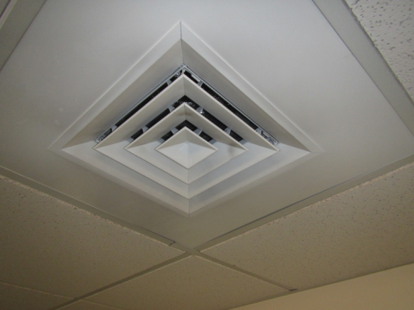
Supply air diffuser
Picture 2
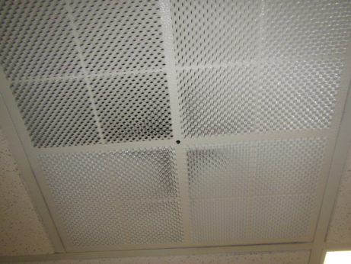
Ceiling-mounted return vent
Picture 3
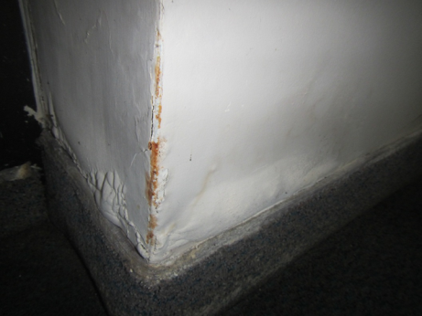
Water-damaged gypsum wallboard and carpeting
Picture 4
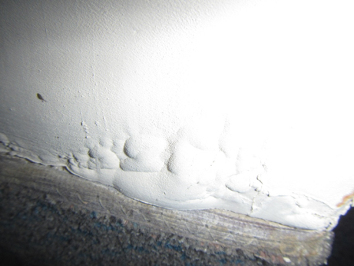
Water-damaged wall and carpeting
Picture 5
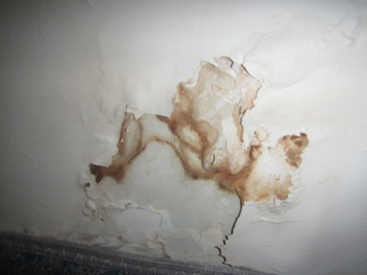
Water-damaged wall and carpeting
Picture 6
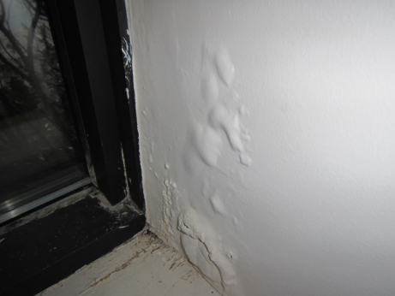
Water-damaged wall and window sill
Picture 7
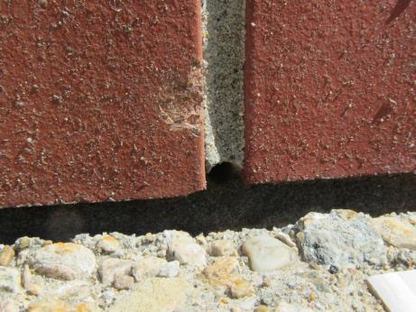
Weep hole drains against building below raised walkway
Picture 8
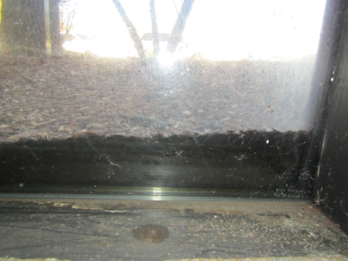
Bark mulch piled high above the level of window/frame
Picture 9
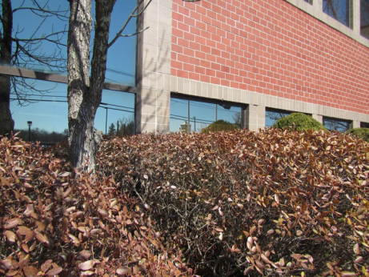
Trees and vegetation growing against building exterior
Picture 10
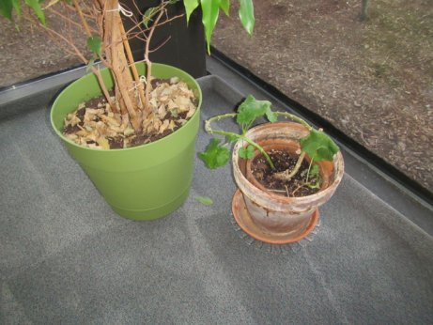
Plants on office carpeting
Picture 11
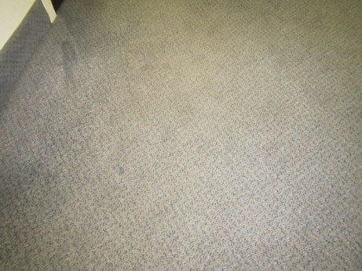
Worn carpeting
Location | Carbon  Dioxide  (ppm) | Carbon Monoxide  (ppm) | Temp  (°F) | Relative  Humidity  (%) | VOCs  (ppm) | PM2.5  (µg/m³) | Occupants  in Room | Windows  Openable | Ventilation |  |  | Remarks
 |  |  |  |  |  |  |  |  | Intake | Exhaust
Background- outside | 367 | ND | 48 | 28 | ND | 15 | - | - | - |  | -
Open main office | 765 | ND | 71 | 28 | ND | 12 | 7 | N | Y |  | Y | Dated/worn carpet, PC, HS
1-Resource room | 701 | ND | 72 | 25 | ND | 12 | 0 | N | Y |  | Y
2 | 688 | ND | 73 | 25 | ND | 12 | 2 | N | Y |  | Y | Historic fan coil leaks from freeze ups, WD, solar glare, AI
3 | 720 | ND | 75 | 24 | ND | 7 | 1 | N | Y |  | Y | Plants, solar gain
4-corner office | 776 | ND | 75 | 27 | ND | 12 | 5 | N | Y |  | Y | WD GW, WD carpeting, large plants on floor
5 | 798 | ND | 74 | 24 | ND | 10 | 0 | N | Y |  | Y | Plants on floor
6-small conference | 743 | ND | 72 | 25 | ND | 9 | 0 | N | Y |  | Y
7 | 684 | ND | 74 | 24 | ND | 10 | 2 | N | Y |  | N | WD-GW (exterior wall)
8 | 722 | ND | 72 | 24 | ND | 9 | 0 | N | Y |  | Y | HS, carpet stains, HS
9 | 725 | ND | 71 | 27 | ND | 8 | 0 | N | Y |  | Y | HS, plants, WD GW (walls & window frame), WD carpeting
10 | 787 | ND | 71 | 27 | ND | 9 | 0 | N | Y |  | Y | WD GW (exterior wall)
11 | 794 | ND | 71 | 26 | ND | 9 | 2 | N | Y |  | Y | WD carpeting, rust stains under file cabinets, HS, PF, reported water pooling from rear foyer area
12- Break room | 996 | ND | 72 | 28 | ND | 7 | 5 | N | Y |  | Y | Vinyl flooring, recycling barrels
13- Large conference | 740 | ND | 74 | 24 | ND | 8 | 0 | N | Y |  | Y | Chalk board/dust in tray

Location | Moisture against Wall (%) | Moisture 2’ from Wall (%) | Moisture 5’ from Wall (%)
1 | 18 | 3 | 3
2 | 17 | 6 | 4
3 | 21 | 7 | 5
4 | 21 | 21 | 14
5 | 13 | 9 | 5
6 | 18 | 18 | 9
7 | 23 | 19 | 19
8 | 29 | 22 | 4
9 | 17 | 5 | 3
10 | 28 | 17 | 10
11 | 17 | 5 | 3
12 | 34 | 34 | 36
13 | 20 | 8 | 0
Open main office | 18 | 6 | 4

Location | Temp (F) | Relative Humidity  (%) | Window Glass Temp  (F) | Window Frame Temp  (F) | Window Sill Temp  (F) | Floor Temp at Exterior Wall  (F) | Floor Temp 5” from Exterior Wall  (F) | Remarks
1 | 72 | 26 | 92 | 90 | 76 | 65 | 73 | In sunlight
2 | 73 | 25 | 80 | 78 | 71 | 66 | 73 | In sunlight
3 | 74 | 25 | 91 | 92 | 77 | 66 | 74 | In sunlight
4 south wall | 74 | 25 | 88 | 81 | 74 | 64 | 70 | In sunlight
4 corner | 74 | 23 | 81 | 69 | 74 | 65 | 72 | In sunlight
4 west wall | 75 | 23 | 65 | 60 | 67 | 62 | 70 | In sunlight
5 | 75 | 23 | 66 | 56 | 64 | 63 | 68 | No sunlight
6 | 74 | 23 | 62 | 54 | 65 | 61 | 70 | No sunlight
7 | 75 | 23 | 63 | 55 | 64 | 63 | 67 | No sunlight
8 wall | 74 | 23 | 66 | 54 | 52 | 60 | 65 | No sunlight
8 corner | 73 | 23 | 53 | 44 | 52 | 54 | 59 | No sunlight
8 north wall | 73 | 23 | 52 | 43 |  | 48 | 57 | No sunlight
8 north window | 73 | 26 | 48 | 43 |  | 48 | 57 | No sunlight
9 | 72 | 26 | 49 | 45 | 54 | 49 | 57 | No sunlight
10 | 72 | 26 | 50 | 43 | 50 | 52 | 58 | No sunlight
11 | 72 | 26 | 49 | 42 | 55 | 51 | 58 | No sunlight
Reception hallway wall | 72 | 26 | 51 | 60 |  | 50 | 59 | No sunlight
Interior offices | 72-73 | 26 | 63 |  |  | 62 | 64 | No sunlight

A thermal bridge is an object (usually metallic) in a wall space through which heat is transferred at a greater rate than materials surrounding it. During the heating season, the window comes in contact with heated air from the interior and chilled air from the outdoors, resulting in condensation formation if the windows temperature is below the dew point.

