INDOOR AIR QUALITY ASSESSMENT

Massachusetts Rehabilitation Commission
110 Mulberry Street
Brockton, Massachusetts

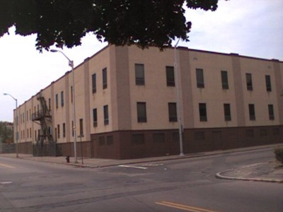

Prepared by:
Massachusetts Department of Public Health
Bureau of Environmental Health
Indoor Air Quality Program
October 2016

Executive Summary:
At the time of the assessment, the mechanical ventilation system was experiencing operation issues and a lack of maintenance of the rooftop air handling units. These issues as well as a lack of carpet cleaning have likely contributed to staff complaints/symptoms related to indoor air quality.

Background
Building: | Massachusetts Rehabilitation Commission (MRC)
Address: | 110 Mulberry Street, Brockton
Assessment Requested by: | Deborah Coleman, Facilities Director  Executive Office of Health and Human Services (EOHHS)
Reason for Request: | General indoor air quality (IAQ) assessment in response to symptoms reported by building occupants (e.g., respiratory/eye irritation, exacerbation of allergies, migraines and sinus issues.
Date of Assessment: | September 30, 2016
Massachusetts Department of Public Health/Bureau of Environmental Health (MDPH/BEH) Staff Conducting Assessment: | Mike Feeney, Director and Cory Holmes, Environmental Analyst/Inspector, IAQ Program
Date of Building Construction: | 1981, most recent renovations 2013
Building Description: | The building has two-stories with a flat rubber roof originally built as a telecom company. The current layout includes offices, open work areas (cubicles), conference and hearing rooms, storage, and kitchen/utility areas. The flooring in most areas of the building is covered with carpet tiles.
Building Population: | The MRC is located on the first floor and has approximately 10 to 15 employees with clients visiting on a daily basis.
Windows: | Windows in the building have been rendered unopenable.

Methods
Please refer to the IAQ Manual and appendices for methods, sampling procedures, and interpretation of results (MDPH, 2015).

Results and Discussion
The following is a summary of indoor air testing results (Table 1).
- Carbon dioxide measurements were below the MDPH recommended level of 800 parts per million (ppm) in all but one area surveyed.
- Temperature was within the MDPH recommended range of 70°F to 78°F at the time of assessment.
- Relative humidity was within the MDPH recommended range of 40 to 60% in all areas tested.
- Carbon monoxide levels were non-detectable in all areas tested.
- Particulate matter (PM2.5) concentrations measured were below the National Ambient Air Quality (NAAQS) level of 35 μg/m³ in all areas tested.

Ventilation
A heating, ventilating, and air conditioning (HVAC) system has several functions. First it provides heating and, if equipped, cooling. Second, it is a source of fresh air. Finally, an HVAC system will dilute and remove normally occurring indoor environmental pollutants by not only introducing fresh air, but also filtering the airstream and ejecting stale air to the outdoors via exhaust ventilation. At the time of assessment, the digital thermostat displayed an error reading (Picture 1), which appeared to deactivate the system (Picture 2). Without air circulation /filtration, this could likely contribute to thermal comfort and IAQ complaints experienced by MRC staff.
BEH/IAQ staff examined rooftop air handling units (AHUs). At the time of assessment, filters in AHUs had recently been changed. It was also reported that filters were upgraded from a low grade mesh-type filter to a more efficient pleated filter (Picture 3). The pleated filters currently installed were of a Minimum Efficiency Reporting Value (MERV) of 8, which should be adequate in filtering out pollen and mold spores.

Microbial/Moisture Concerns
No evidence of water leaks or moisture to building materials in the MRC was noted during the assessment. A water dispenser was observed on the carpet (Picture 4). Leaks or overflow can moisten the carpet and lead to microbial growth.
Upon examining rooftop AHUs, drip pans were found rusted/corroded and to have dried-up accumulation of scale/debris (Pictures 5 and 6), which may indicate they do not drain properly. Drip pans should be regularly inspected/maintained (e.g., cleaned during filter changes or prior to AC season) for cleanliness and proper operation.

Other Conditions
The MRC is covered with carpet tiles, which have reportedly not been cleaned for several years, but were in the process of being scheduled at the time of assessment. The Institute of Inspection, Cleaning, and Restoration Certification (IICRC) recommends that carpeting be cleaned annually (or semi-annually in soiled high traffic areas) (IICRC, 2012). Regular cleaning with a high efficiency particulate air (HEPA) filtered vacuum in combination with an annual cleaning will help to reduce accumulation and potential aerosolization of materials from carpeting.

Conclusions and Recommendations
In view of the findings at the time of the visit, the following recommendations are made:
- Work with building management/HVAC engineer to troubleshoot errors with digital thermostats/HVAC system. Once corrected, operate the system in fan “on” mode to provide continuous air exchange and filtration during occupied hours.
- Consider modifying HVAC system to have all MRC areas on the same thermostat.
- Continue with plans for carpet cleaning. Carpeting should be cleaned annually or semi-annually in soiled/high traffic areas as per the recommendations of the Institute of Inspection, Cleaning and Restoration Certification (IICRC, 2012).
- Clean/disinfect AHU drip pans. Drip pans should be closely inspected for proper operation/draining and repaired/replaced as needed.
- Consider adopting a balancing schedule of every 5 years for all mechanical ventilation systems, as recommended by ventilation industrial standards (SMACNA, 1994).
- For buildings in New England, periods of low relative humidity during the winter are often unavoidable. Therefore, scrupulous cleaning practices should be adopted to minimize common indoor air contaminants whose irritant effects can be enhanced when the relative humidity is low. To control for dusts, a HEPA filter equipped vacuum cleaner in conjunction with wet wiping of all surfaces is recommended. Avoid the use of feather dusters. Drinking water during the day can help ease some symptoms associated with a dry environment (throat and sinus irritation).
- Ensure that procedures are in place and encourage occupants to report HVAC/maintenance issues so that they can be logged and repaired promptly.
- Consider moving water dispensers to non-carpeted areas or install a waterproof mat underneath them.
- Continue to change HVAC filters twice a year or more frequently if needed.
- Refer to resource manual and other related indoor air quality documents located on the MDPH’s website for further building-wide evaluations and advice on maintaining public buildings. These documents are available at http://mass.gov/dph/iaq.

REFERENCES
Institute of Inspection, Cleaning and Restoration Certification (IICRC). 2012. Carpet Cleaning: FAQ. Retrieved from http://www.iicrc.org/consumers/care/carpet-cleaning.
Massachusetts Department of Public Health (MDPH). 2015. Indoor Air Quality Manual: Chapters I-III. Available at: http://www.mass.gov/eohhs/gov/departments/dph/programs/environmental-health/exposure-topics/iaq/iaq-manual/.
Sheet Metal and Air Conditioning Contractors’ National Association, Inc. (SMACNA). 1994. HVAC Systems Commissioning Manual. 1st ed. Sheet Metal and Air Conditioning Contractors’ National Association, Inc., Chantilly, VA.
Picture 1
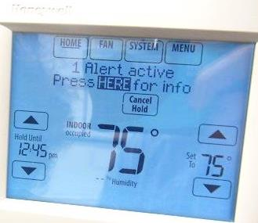
Alert message on digital thermostat
Picture 2
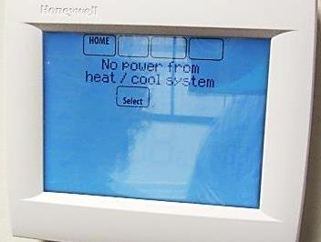
“No power” message on digital thermostat
Picture 3
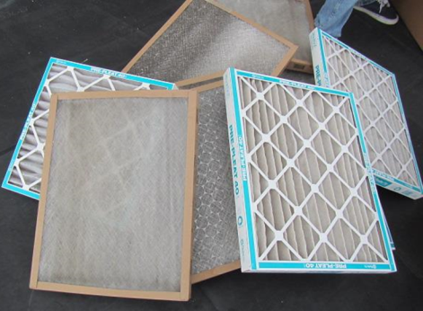
Low grade mesh filters on left, higher efficiency pleated filters on right
Picture 4
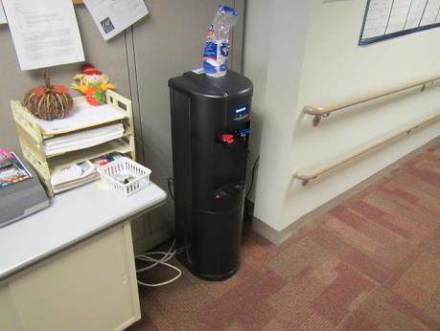
Water dispenser on carpet
Picture 5
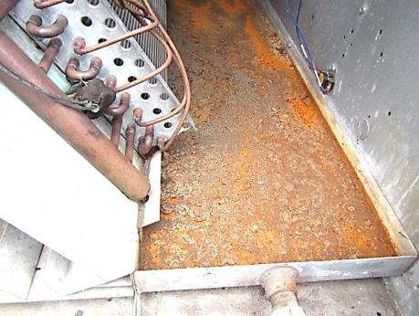
Rust/corrosion and debris in rooftop AHU drip pan
Picture 6
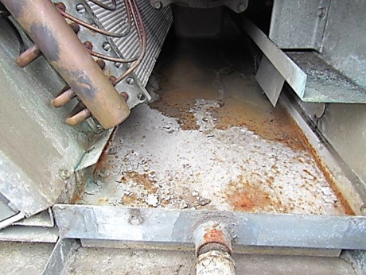
Accumulated scale and debris in rooftop AHU drip pan
Location | Carbon  Dioxide  (ppm) | Temp  (°F) | Relative  Humidity  (%) | Carbon  Monoxide  (ppm) | PM2.5  (µg/m³) | Occupants  in Room | Windows  Openable | Ventilation  Supply exhaust |  | Comments
Background | 355 | 66 | 59 | ND | 3 |  |  |  |  | Cloudy, windy
Lobby | 700 | 73 | 56 | ND | 2 | 5 | N | Y | Y
1021 | 640 | 74 | 48 | ND | ND | 0 | N | Y | N
1022 | 666 | 74 | 49 | ND | ND | 0 | N | Y | N
1024 | 665 | 74 | 49 | ND | 2 | 0 | N | Y |  | Water cooler on carpet
1026/1038 | 780 | 74 | 51 | ND | 2 | 0 | N | Y | Y
1029/1035 | 771 | 73 | 51 | ND | 2 | 2 | N | Y | N
1032/1033 | 815 | 73 | 53 | ND | 2 | 1 | N | Y | N
1040 | 683 | 73 | 50 | ND | ND | 0 | N | Y | N
1041 | 678 | 73 | 49 | ND | ND | 0 | N | Y | N
1042 | 667 | 73 | 49 | ND | ND | 0 | N | Y | Y

