INDOOR AIR QUALITY ASSESSMENT
Sewage Backup Follow-up Investigation

Massachusetts Rehabilitation Commission
1 Federal Street, Building 102-1
Springfield, Massachusetts

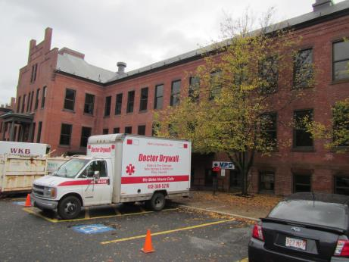

Prepared by:
Massachusetts Department of Public Health
Bureau of Environmental Health
Indoor Air Quality Program
January 2018

BACKGROUND
Building: | Massachusetts Rehabilitation Commission (MRC)
Address: | 1 Federal Street, Springfield
Assessment Contact: | Erin McCabe, Field Operations Manager, Executive Office of Health and Human Services
Reason for Request: | Follow-up assessment
Date of Assessment: | 12/21/2017
Massachusetts Department of Public Health/Bureau of Environmental Health (MDPH/BEH) Staff Conducting Assessment: | Jason Dustin, Environmental Analyst/Inspector, Indoor Air Quality (IAQ) Program
Date of Building Construction: | 1800’s
Building Description: | 3 story brick building originally constructed as part of the Springfield Armory complex
Windows: | Not openable

METHODS
Please refer to the IAQ Manual and appendices for methods, sampling procedures, and interpretation of results (MDPH, 2015).

IAQ Testing Results
The following is a summary of indoor air testing results (Table 1).
- Carbon dioxide levels were below 800 parts per million (ppm) in all but one of the areas assessed, indicating adequate air exchange throughout the majority of the space.
- Temperature was within the recommended range of 70°F to 78°F in all areas on the day of assessment.
- Relative humidity was below the recommended range of 40 to 60% in the areas tested which is typical during the heating season.
- Carbon monoxide levels were non-detectable in most areas tested.
- Fine particulate matter (PM2.5) concentrations measured were below the National Ambient Air Quality (NAAQS) limit of 35 μg/m³ in the majority of areas tested.

RESULTS and DISCUSSION

Ventilation
A heating, ventilating, and air conditioning (HVAC) system has several functions. First it provides heating and, if equipped, cooling. Second, it is a source of fresh air. Finally, an HVAC system will dilute and remove normally occurring indoor environmental pollutants by not only introducing fresh air, but by filtering the airstream and ejecting stale air to the outdoors via exhaust ventilation. Even if an HVAC system is operating as designed, point sources of respiratory irritation may exist and cause symptoms in sensitive individuals.
The MRC space has an air handling unit (AHU) to filter and heat or cool the supply air. The conditioned supply air is distributed through supply diffusers located throughout the space. Return air is drawn into the ceiling plenum and brought back to the AHU.
As shown in Table 1, room #112 was the only room assessed that had a slightly elevated carbon dioxide level. MRC staff reported that this room and an adjoining room had drop ceilings installed in the past. IAQ staff noted that little to no flow was coming from the supply vent in this room. Efforts should be made to increase supply ventilation to dilute commonly found indoor air pollutants and aid in occupant comfort.
In order to have proper ventilation with a mechanical supply and exhaust system, these systems must be balanced to provide an adequate amount of fresh air while removing stale air from a room. It is recommended that existing ventilation systems be re-balanced every five years to ensure adequate air systems function (SMACNA, 1994). It is unknown the last time these systems were balanced.

Microbial/Moisture Concerns
The primary reason for this visit was to perform IAQ testing and further assess the conditions in the MRC space following a backup of sewage in late October 2017. IAQ staff visited the space in October and investigated the water damage and remediation efforts. The initial visit was the subject of a previous report (MDPH, 2017).
During this follow-up visit, IAQ staff noted that all remaining porous building materials were discarded and replaced. These materials included new gypsum wallboard (GW), new insulation, and new carpeting (Picture 1). Remaining concrete subfloor and brick walls were sanitized and are not conducive to mold growth.
EOHHS staff reported that they do not believe the building owner has installed a backflow preventer on the building sewer line. It was further reported that there have been complications with the City of Springfield to get needed sewer line repairs made on City property. Without a properly installed backflow preventer and further repairs to the city lines, it is possible that a future sewage backup will occur.
IAQ staff noted a portable air conditioning (AC) unit ducted into a wall cavity/ceiling plenum in the IT server room (Pictures 2 and 3). This type of AC unit does not require a condensation line to remove moisture from the unit. Instead this AC unit has an exhaust air duct with a fan continuously running to evaporate condensate from the unit. These exhaust ducts are typically directed outdoors so that they are not adding warm, humid air to the occupied space. The low humidity during the heating season may reduce the risk of chronic moisture accumulation from this condition. However, during the cooling season, this condition is likely to cause chronic moisture of building materials due to condensation within the wall cavity/ceiling plenum. Chronic moisture on porous materials (e.g., gypsum wallboard) may lead to microbial colonization. The exhaust hose for this unit should be properly ducted outside according to manufacturer recommendations.
One area was noted to have a water cooler placed directly on carpeting. Spills/leaks from this unit may lead to microbial colonization and carpet degredation.
The sink in the break room was noted to be very slow-draining. This may lead to odors and microbial growth in the drain. Drain flies may feed on the accumulated organic matter. It was reported by MRC staff that the sink used to have a functioning garbage disposal unit which is now disconnected.
Indoor plants were observed in some areas. Plants can be a source of pollen and mold, which can be respiratory irritants to some individuals. Plants should be properly maintained and equipped with drip pans and should be located away from air diffusers to prevent the aerosolization of dirt, pollen and mold.

Other Concerns
IAQ staff noted several areas with air fresheners, scented cleaning products, and hand sanitizers (Table 1). These products contain volatile organic compounds (VOCs) and other fragrances which may cause irritation of the eyes, nose, and respiratory system.

CONCLUSIONS and RECOMMENDATIONS
In view of the findings at the time of the visit, the following recommendations are made:
- Continue efforts to install a sewer backflow preventer to avoid future sewage backups into the building.
- Continue to operate all supply and exhaust ventilation equipment continuously during occupied periods.
- Properly vent the portable AC unit in the IT server room to the outside according to manufacturer recommendations.
- Investigate methods to increase fresh air supply to room #112 and adjoining room.
- Consider adopting a balancing schedule of every 5 years for all mechanical ventilation systems, as recommended by ventilation industrial standards (SMACNA, 1994).
- Repair slow-draining sink in break room and use a supplemental strainer to avoid future clogs. Ensure all garbage disposal components have been removed if the unit is in non-functioning condition.
- Place a water-proof mat/tray under water cooler that is on carpeting or relocate the unit to a room with tile flooring.
- Properly maintain plants, including drip pans, to prevent water damage to porous materials. Plants should also be located away from air diffusers to prevent the aerosolization of dirt, pollen, and mold.
- Reduce or eliminate the use of products containing VOCs (e.g., air fresheners, scented cleaning products, and hand sanitizer).
- Refer to resource manual and other related indoor air quality documents located on the MDPH’s website for further building-wide evaluations and advice on maintaining public buildings. These documents are available at http://mass.gov/dph/iaq.

REFERENCES
MDPH. 2015. Massachusetts Department of Public Health. Massachusetts Department of Public Health Indoor Air Quality Manual: Chapters I-III. Available at: http://www.mass.gov/eohhs/gov/departments/dph/programs/environmental-health/exposure-topics/iaq/iaq-manual/.
MDPH. 2017. Water Damage Assessment; Sewage Backup Investigation. Springfield MRC. November 2017.
SMACNA. 1994. HVAC Systems Commissioning Manual. 1st ed. Sheet Metal and Air Conditioning Contractors’ National Association, Inc., Chantilly, VA.
Picture 1
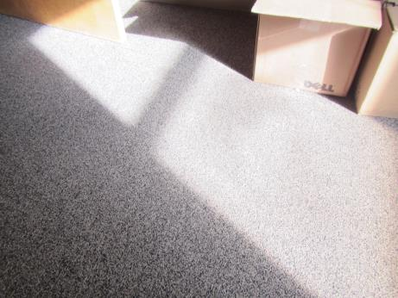
Newly-installed carpeting
Picture 2
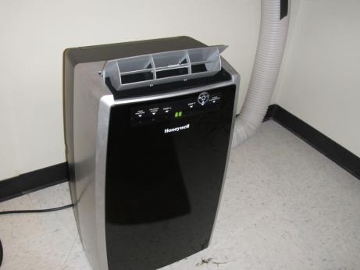
Portable AC unit in IT server room
Picture 3
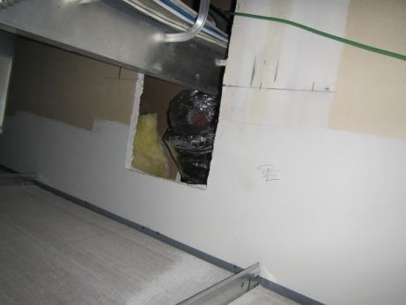
Portable AC exhaust hose terminates in wall cavity/ceiling plenum

Location | Carbon  Dioxide  (ppm) | Carbon Monoxide  (ppm) | Temp  (°F) | Relative  Humidity  (%) | PM2.5  (µg/m³) | TVOCs  (ppm) | Occupants  in Room | Windows  Openable | Ventilation |  |  | Remarks
 |  |  |  |  |  |  |  |  | Intake | Exhaust
Background | 342 | ND | 33 | 23 | 11 | ND | - | - | - |  | -
133 Storage | 431 | ND | 72 | 18 | 5 | ND | 0 | N | N |  | N
130 | 480 | ND | 72 | 19 | 4 | ND | 2 | N | Y |  | Y | New carpet, new gypsum wallboard throughout space
126 | 510 | ND | 73 | 19 | 5 | ND | 2 | N | Y |  | Y
129 | 516 | ND | 73 | 19 | 2 | ND | 2 | N | Y |  | Y | AI
124 | 523 | ND | 74 | 17 | 2 | ND | 3 | N | Y |  | Y
125 | 625 | ND | 74 | 19 | 3 | ND | 2 | N | Y |  | Y
123 | 573 | ND | 74 | 18 | 2 | ND | 3 | N | Y |  | Y | Fragrance, humidifier
121 | 674 | ND | 75 | 18 | 2 | ND | 2 | N | Y |  | Y | Personal heater
122 | 580 | ND | 75 | 18 | 2 | ND | 2 | N | Y |  | Y
Reception (inside) | 582 | ND | 74 | 17 | 2 | ND | 5 | N | Y |  | Y | HS, DEM, new carpet
Break room | 569 | ND | 74 | 21 | 7 | ND | 3 | N | Y |  | Y | Sink drain slow
105 | 617 | ND | 73 | 18 | 3 | ND | 2 | N | Y |  | Y | AF, HS, candle
104 | 671 | ND | 73 | 19 | 3 | ND | 2 | N | Y |  | Y | HS, new carpet
106 | 771 | ND | 73 | 20 | 2 | ND | 3 | N | Y |  | Y | New carpet
107 | 639 | ND | 73 | 18 | 3 | ND | 2 | N | Y |  | Y
109 | 619 | ND | 73 | 18 | 2 | ND | 3 | N | Y |  | Y
108 | 626 | ND | 72 | 19 | 3 | ND | 3 | N | Y |  | Y | AF, DEM, new carpet
110 | 578 | ND | 72 | 20 | 6 | ND | 2 | N | Y |  | Y | HS, AF, candles
111 | 620 | ND | 72 | 19 | 1 | ND | 2 | N | Y |  | Y | HS
113 | 687 | ND | 72 | 19 | 2 | ND | 3 | N | Y |  | Y
114 | 724 | ND | 74 | 22 | 5 | ND | 4 | N | Y |  | N | New carpet, CPs
115 | 605 | ND | 73 | 18 | 3 | ND | 2 | N | Y |  | Y
117 | 619 | ND | 71 | 19 | 3 | ND | 2 | N | Y |  | Y | HS, new carpet
116 | 720 | ND | 71 | 21 | 2 | ND | 3 | N | Y |  | Y | AF, HS, new carpet
118 | 653 | ND | 71 | 20 | 1 | ND | 3 | N | Y |  | Y | Plants
120 | 589 | ND | 70 | 19 | 2 | ND | 3 | N | Y |  | Y | HS, glue model project
119 | 625 | ND | 71 | 19 | 1 | ND | 2 | N | Y |  | Y | Water cooler on new carpet, books
112 | 948 | ND | 72 | 20 | 2 | ND | 3 | N | Y |  | Y | Dropped ceiling, little/no supply flow

