WATER DAMAGE ASSESSMENT
Sewage Backup Investigation

Massachusetts Rehabilitation Commission
1 Federal Street, Building 102-1
Springfield, Massachusetts

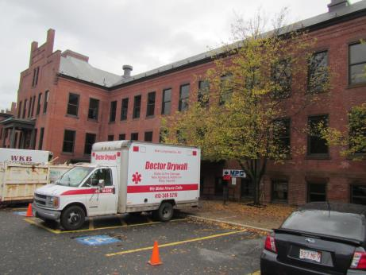

Prepared by:
Massachusetts Department of Public Health
Bureau of Environmental Health
Indoor Air Quality Program
November 2017

BACKGROUND
Building: | Massachusetts Rehabilitation Commission (MRC)
Address: | 1 Federal Street, Springfield
Assessment Contact: | Sharlene Sharif, EOHHS Project Manager
Reason for Request: | Sewage backup into facility
Date of Assessment: | 10/30/2017
Massachusetts Department of Public Health/Bureau of Environmental Health (MDPH/BEH) Staff Conducting Assessment: | Jason Dustin, Environmental Analyst/Inspector, Indoor Air Quality (IAQ) Program
Date of Building Construction: | 1800’s
Building Description: | 3 story brick building originally constructed as part of the Springfield Armory complex
Windows: | Not openable

METHODS
Please refer to the IAQ Manual and appendices for methods, sampling procedures, and interpretation of results (MDPH, 2015).

RESULTS and DISCUSSION

Water Damage Concerns
The primary reason for this visit was to assess the remediation efforts following a backup of sewage into the MRC space. According to property management, raw sewage backed up out of toilets on October 25th due to a problem in the city sewer line. According to contractors, the remediation efforts were nearly complete and they began the installation of new gypsum wallboard (GW) when a second backup occurred on October 29th. This second backup occurred following a heavy rain event and combined stormwater/sewer lines resulting in water backing up from the floor drains in the bathrooms. Even though the water may have appeared clear, the MDPH still considers this “black water” and would require the same sanitizing methods as the raw sewage that backed up out of the toilets. The remediation contractors agreed that the entire space would need to be re-sanitized and any GW water-damaged by this second flooding would need to be discarded.
Property management staff confirmed that the building does not have a backflow preventer on the building sewer line. The building’s age predates any plumbing regulations which may have required the installation of a backflow preventer. A backflow preventer would not prevent sewage backups within the internal plumbing of the facility but it would prevent sewage from city sewer lines from traveling back up into the facility should a city line become obstructed. The property manager reported that estimates were being conducted to install a backflow preventer at the facility.
According to remediation contractors (Service Master), all water-damaged porous materials/items were discarded and most GW was removed at least 12″ above the high-water marks and much higher in most cases (Picture 1). In some areas (e.g., server room) water-damaged GW remained until IT staff could properly remove the servers and other networking equipment (Pictures 2 and 3). IAQ staff also noted that the wallboard in the bathrooms was not removed at the time of this assessment (Picture 4). The contractor reported that they did not make a determination at this time as to whether the wallboard behind the tiles in the bathrooms was porous or not. It was agreed on site that if there was any chance that this wallboard backing was not able to be properly sanitized (i.e., porous) then it would be removed at least 12″ above the high water mark and replaced with new materials.
IAQ staff observed some small areas of standing water and a lingering sewer odor on the west side of the facility (Picture 5). The HVAC return vents were sealed as recommended and contractors were working to remove additional water-damaged GW during this assessment. Circulation fans, dehumidifiers, and high efficiency particulate arrestance (HEPA) scrubbers were observed running throughout the facility (Pictures 6 to 8). Other areas appeared to be dry and workers were installing new insulation and GW. The new drywall appeared to be installed leaving a 1′ gap beneath so that it will help to prevent water from being wicked up the paper of the GW following any future spills/condensation issues (Picture 9).
On the day of this assessment, IAQ staff observed city crews/contractors using a vacuum truck to remove sewage and inspect the city sewer line which was reported to be the cause of the backups (Picture 10). Later reports from property managers were that the sewer line across the street was crushed and obstructing the free flow of sewage in the line.

CONCLUSIONS and RECOMMENDATIONS
In view of the findings at the time of the visit, the following recommendations are made:
- Continue to follow EPA and industry guidelines concerning methods used to remediate buildings that are impacted by sewage (i.e., blackwater). Some of these guideline links include: https://www.epa.gov/sites/production/files/2015-09/documents/floods.pdf and ANSI/IICRC S500 - Standard and Reference Guide for Professional Water Damage Restoration.
- Continue to properly extract water, use circulation fans/dehumidifiers, and HEPA scrubbers.
- Continue to ensure proper containment strategies are being utilized while work is being performed (e.g., sealed return ducts, depressurization methods) to avoid further contamination.
- Ensure that all porous items and building materials that were water-damaged by the initial or secondary flood of “blackwater” are removed and discarded. This would include wallboard behind tiles in restrooms if it is deemed porous and not able to be properly sanitized.
- Ensure that all nonporous building materials, items, and surfaces impacted are properly disinfected prior to replacing building materials/furnishings.
- Continue to leave a 1′ gap beneath the newly installed GW to avoid it wicking water up the GW during any future spills/condensation issues.
- Consider installing a backflow preventer to avoid large-scale sewage backups due to any future problems with the city sewer lines.
- After the space is disinfected and thoroughly cleaned, change the filters in the air handling units that serve this office suite as a precautionary measure.
- Use adequate and continuous ventilation when occupants return to occupy the space.
- Copies of safety data sheets (SDS) for any disinfectant products used in the remediation should be available to occupants.
- Refer to resource manual and other related indoor air quality documents located on the MDPH’s website for further building-wide evaluations and advice on maintaining public buildings. These documents are available at http://mass.gov/dph/iaq.

REFERENCES
Massachusetts Department of Public Health (MDPH). 2015. Indoor Air Quality Manual: Chapters I-III. Available at: http://www.mass.gov/eohhs/gov/departments/dph/programs/environmental-health/exposure-topics/iaq/iaq-manual/.

Picture 1
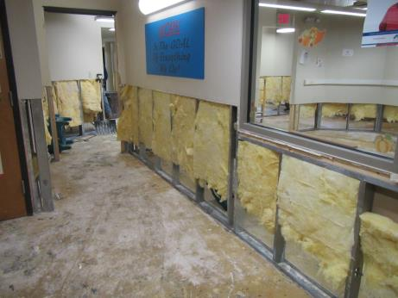
Gypsum wallboard (GW) removed well above the high-water mark
Picture 2
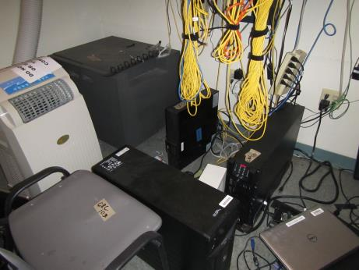
IT server room walls still intact
Picture 3
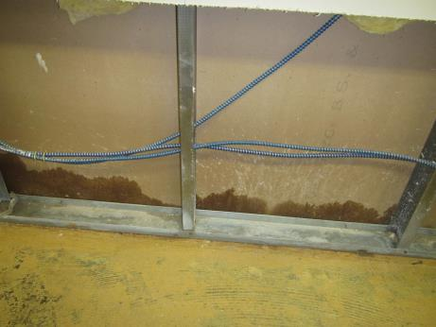
Back side of water-damaged GW for server room (to be removed)
Picture 4
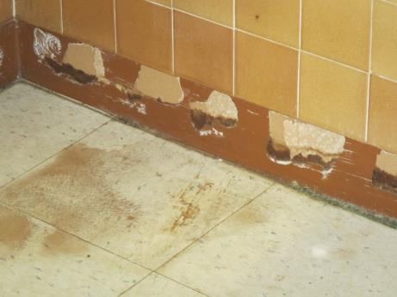
Wallboard behind tile in restrooms to be removed if determined to be porous
Picture 5
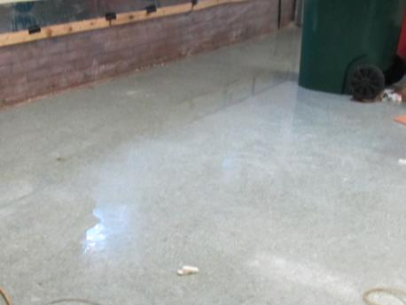
Some areas of standing water and odors noted on the west side of office suite
Picture 6
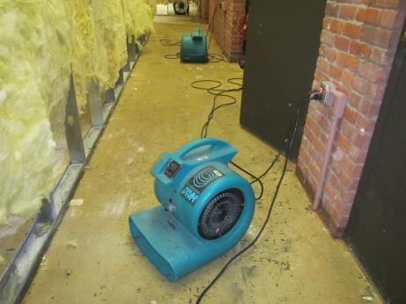
Circulation fans used to accelerate drying of the space
Picture 7
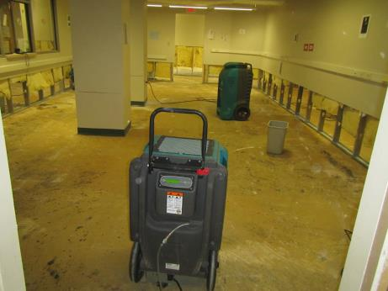
Dehumidifiers used to remove excess humidity (note all porous materials removed)
Picture 8
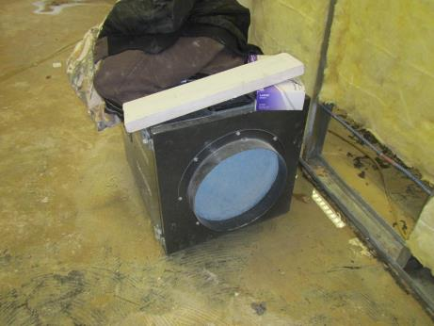
HEPA scrubber used to remove particulate matter in office suite
Picture 9
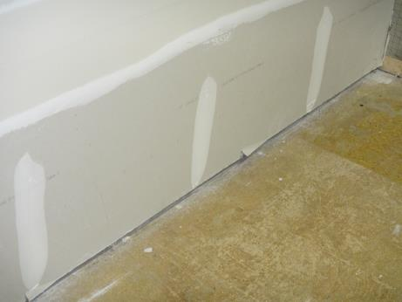
Newly installed GW showing 1″ gap beneath to prevent wicking
Picture 10
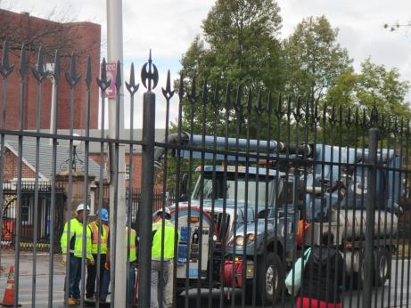
Contractors use vacuum truck to clear and inspect city sewer line

