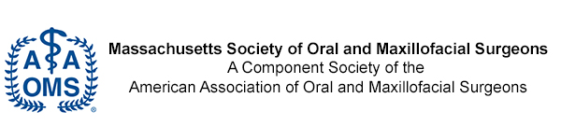

2 Willow Street Southborough, MA 01745

October 5, 2021

Massachusetts Board of Registration in Dentistry

239 Causeway Street

Suite 500

Boston, MA 02114

Dear Board of Registration in Dentistry,

I would like to take the opportunity to thank you for the time you have taken in reviewing and updating Section 234 CMR 6.0. The Massachusetts Society of Oral and Maxillofacial Surgeons (MSOMS) supports all revisions that improve the safety and quality of care in anesthesia and dentistry in Massachusetts. MSOMS has a long history of documenting safety in outpatient anesthesia. Our data has been published multiple times on the national level in medical literature demonstrating our excellent safety record. We continue to document and study the safety of our general anesthesia model annually.

The leaders of The Massachusetts Society of Oral and Maxillofacial Surgery reviewed the update to the Anesthesia section of the BORID requirements and we had 2 suggestions. The first comes in section 6.03.

“General anesthesia, deep sedation, moderate sedation or nitrous oxide-oxygen sedation shall not be administered at a dental office or facility by any licensee, M.D. or CRNA anesthesia care giver unless and until a facility permit for the type of anesthesia or sedation is obtained from the Board.”

We could not find anywhere else in the section 234 CMR 6.0 where CNAs are mentioned. Many Oral Surgeons use CNAs in their offices. I would recommend that “CNAs” is used more consistently throughout the regulations or delete it altogether for the sake of consistency.

Our second recommendation comes in Section 6.05 #3 A.

1. “ a candidate of or current board certification by the American Board of Oral and Maxillofacial Surgery (ABOMS); or “

It is possible for a person to become a ABOMS candidate without having completed the appropriate CODA anesthesia training. For safety reasons, we would recommend this qualification for anesthesia permitting be deleted.

Thank you again for all you do to keep the safety and quality of anesthesia in dentistry excellent.

Sincerely,

An-Louise Johnson DMD, MD

President of the Massachusetts Society of Oral and Maxillofacial Surgery