POST-OCCUPANCY ASSESSMENT

Massachusetts Teachers’ Retirement System
500 Rutherford Avenue
Charlestown, MA

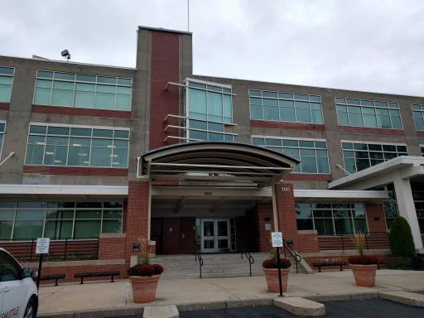

Prepared by:
Massachusetts Department of Public Health
Bureau of Environmental Health
Indoor Air Quality Program
June 2018

Background
Building: | Massachusetts Teachers’ Retirement System (MTRS)
Address: | 500 Rutherford Avenue, Charlestown, MA
Assessment Requested by: | Paul Burke, Senior Project Manager, Division of Capital Asset Management and Maintenance (DCAMM)
Reason for Request: | Concerns about construction and indoor air quality (IAQ)
Date of Assessment: | June 11, 2018
Massachusetts Department of Public Health/Bureau of Environmental Health (MDPH/BEH) Staff Conducting Assessment: | Ruth Alfasso, Environmental Engineer/Inspector, IAQ Program
Building Description: | This office suite is a part of “Hood Park” on the location of the former H.P. Hood and Sons Milk factory. It is now an office park containing other office tenants. The building also includes a fitness center and restaurant.
Building Population: | Approximately 100
Windows: | Not openable

Methods
Please refer to the IAQ Manual for methods, sampling procedures, and interpretation of results (MDPH, 2015).

IAQ Testing Results
The following is a summary of indoor air testing results (Table 1).
- Carbon dioxide levels were below 800 parts per million (ppm) in all areas assessed, indicating adequate fresh air in the space.
- Temperature was within the recommended range of 70°F to 78°F in all areas assessed.
- Relative humidity was below the recommended range of 40% to 60% in all areas assessed.
- Carbon monoxide levels were non-detectable in all indoor areas assessed.
- Fine particulate matter (PM2.5) concentrations measured were below the National Ambient Air Quality Standard (NAAQS) level of 35 micrograms per cubic meter (μg/m³) in all areas assessed.

A post-occupancy assessment of this space was conducted in November of 2016, including measurements of indoor air parameters in all areas of the space. That report can be found on the MDPH IAQ website at https://www.mass.gov/service-details/indoor-air-quality-reports-cities-and-towns-b. The current report was prompted by concerns of eye irritation and related symptoms and focused only on a subsection of the office.

Ventilation
A heating, ventilating, and air conditioning (HVAC) system has several functions. First, it provides heating and, if equipped, cooling. Second, it is a source of fresh air. Finally, an HVAC system will dilute and remove normally occurring indoor environmental pollutants by not only introducing fresh air, but also filtering the airstream and ejecting stale air to the outdoors via exhaust ventilation. Even if an HVAC system is operating as designed, point sources of respiratory irritation may exist and affect symptoms in sensitive individuals. The following analysis examines and identifies components of the HVAC system and likely sources of respiratory irritant/allergen exposure due to water damage, aerosolized dust, and/or chemicals found in the indoor environment.
Fresh air is provided by rooftop air handling units (AHU) that draw fresh air from intakes on the roof (Pictures 1 and 2). The space utilizes a ducted supply system and ceiling-mounted supply vents (Picture 3). Return vents (Picture 3) draw air back into the AHU. The HVAC system was reportedly balanced prior to the November 2016 assessment. The assessment results indicate that the ventilation system is providing adequate fresh air for the occupancy in the building.
Note that low relative humidity is a common source of eye and respiratory irritation in the indoor environment. To combat issues exacerbated by low relative humidity, it is recommended that occupants drink water to stay hydrated and that scrupulous cleaning be conducted to remove sources of dust which is more likely to become airborne when the relative humidity is low. Other sources of irritation should also be minimized. Relative humidity tends to be much lower during the heating season, but due to the actions of air conditioning, can also be low the rest of the year. Humidification is not recommended in offices due to concerns for potential water damage and stagnant water as well as difficulty with controlling humidity in such a large, open space.

Microbial/Moisture Concerns
No water-damaged materials or other signs of water infiltration were observed during this visit. Plants were observed in a few areas (Picture 4; Table 1). Plants can be a source of pollen and mold, which can be respiratory irritants to some individuals. Plants should be properly maintained and equipped with drip pans and should be located away from air diffusers to prevent the aerosolization of dirt, pollen, and mold. Water dispensers and refrigerators were observed on carpets, where leaks can damage carpet and lead to microbial growth (Picture 5).

Other IAQ Evaluations
Exposure to low levels of total volatile organic compounds (TVOCs) may produce eye, nose, throat, and/or respiratory irritation in some sensitive individuals. In addition to testing, BEH/IAQ staff examined spaces for products containing VOCs. BEH/IAQ staff noted air fresheners, hand sanitizers, cleaning products, and dry erase materials in a number of areas throughout the office space (Picture 6; Table 1). All of these products have the potential to be irritants to the eyes, nose, throat, and respiratory system of sensitive individuals.
Occupants expressed concerns that nearby construction activities, both on the Hood campus and nearby, could be contributing to irritant symptoms in the office. The location of the specific HVAC units for this building is on the east side of the roof, which is farther away from the construction than other units in this building. At the time of the visit, background air measurements taken near the air intakes did not show elevated levels of dust (Table 1). The filters on each AHU were also examined. They have the recommended Minimum Efficiency Reporting Value (MERV) rating of 8 and fit securely in the cabinets (Picture 2). It is reported that these filters are changed several times a year. Based on these conditions, and the low levels of respirable dust measured in the office, the infiltration of construction-related dust/pollutants through the HVAC system does not seem to be an issue at this time.
The offices were mostly carpeted. Carpets should be cleaned annually (or semi-annually in soiled/high traffic areas) in accordance with Institute of Inspection, Cleaning and Restoration Certification (IICRC) recommendations, (IICRC, 2012). In some areas, stored materials and accumulated items make it more difficult for custodial staff to clean. Items should be stored neatly and moved periodically to allow for wet wiping and vacuuming of surfaces.
Concerns about lighting and glare were also expressed by occupants of the area examined. Note that the skylight, originally installed shortly before the November 2016 visit, is directly above the portion of the office where occupants were concerned. It had been covered by a light-attenuating mesh on the outside to reduce light levels and associated glare. An additional umbrella shade was in use over one area to reduce lighting levels further (Picture 4). Building management reported that some of the overhead light panels have been equipped with covers that further dim and diffuse light to reduce glare, which was confirmed by DPH staff. Other areas had some lighting deactivated. There are standards for light levels in offices to provide for both ambient lighting and task lighting sufficient for the use of the space (IES, 2011). It is reported that these guidelines were used in designing the lighting for this office. However, reactions to light levels can be very individual. It appears that building management has been working cooperatively with occupants to solve light-related concerns.

Conclusions/Recommendations
Based on observations at the time of assessment, the following is recommended:
- Operate supply and exhaust ventilation continuously in all areas during occupied periods. Ensure all HVAC equipment is maintained and supply and return vents are cleaned periodically to prevent dust re-aerosolization. Ensure thermostats are programed to allow fan “on” when the building is occupied.
- Continue to use MERV 8 filters in the AHUs and change 2-4 times a year, more often if filters are found to be heavily soiled when changed due to ambient conditions.
- Keep plants in good condition, avoid overwatering, and remove from the airstream of heating and ventilation equipment. If allergic symptoms may be related to plants, consider removing them.
- Consider moving water dispensers and refrigerators to areas with non-carpeted floors or use a waterproof mat underneath.
- Reduce the use of cleaning products, sanitizers, and other items that contain VOCs.
- Clean carpeting in accordance with IICRC recommendations (IICRC, 2012).
- Reduce accumulated materials on flat surfaces and store in an organized manner to allow for thorough cleaning.
- Occupants should continue to work with building management on any light-related concerns they have for this office.
- Refer to resource manual and other related IAQ documents located on the MDPH’s website for further building-wide evaluations and advice on maintaining public buildings. These documents are available at: http://mass.gov/dph/iaq.

References
IICRC. 2012. Institute of Inspection, Cleaning and Restoration Certification. Carpet Cleaning: FAQ.
IES. 2011. The IES Lighting Handbook, Tenth Edition, Illuminating Engineering Society. 2011
MDPH. 2015. Massachusetts Department of Public Health. Indoor Air Quality Manual: Chapters I-III. Available at: http://www.mass.gov/eohhs/gov/departments/dph/programs/environmental-health/exposure-topics/iaq/iaq-manual/.
Picture 1
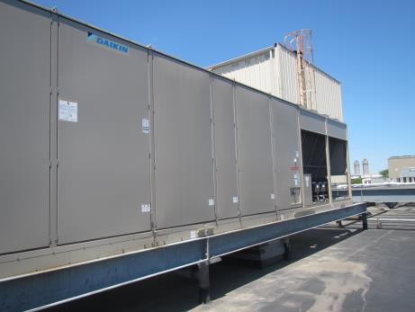
One of the two air handling units (AHU) serving the MTRS space
Picture 2
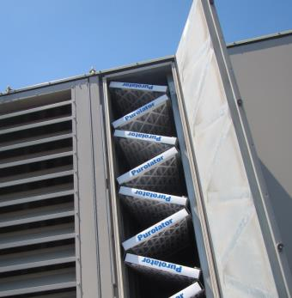
Filters in rooftop AHU
Picture 3
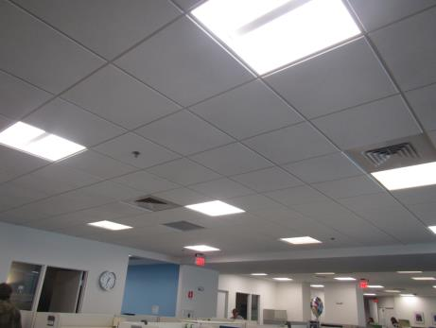
Supply (louvered) and return (plain grill) vents in the office space
Picture 4
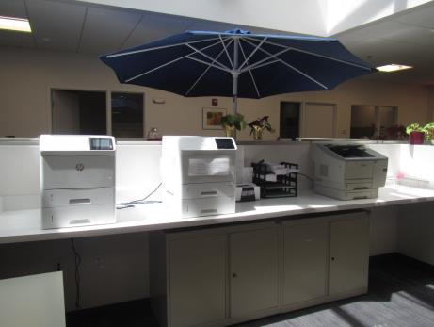
Plants in the office, also note sunshade under skylight
Picture 5
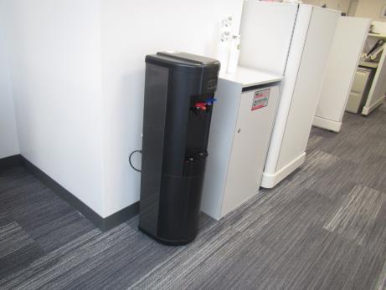
Water cooler on carpet
Picture 6
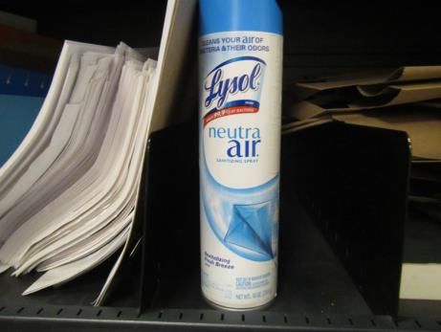
Air freshener
Location | Carbon  Dioxide  (ppm) | Carbon Monoxide  (ppm) | Temp  (°F) | Relative  Humidity  (%) | PM2.5  (µg/m³) | Occupants  in Room | Windows  Openable | Ventilation |  | Remarks
 |  |  |  |  |  |  |  | Supply | Exhaust
Background | 403 | ND | 72 | 23 | 6 |  |  |  |  | Sunny, measurement taken on rooftop near HVAC unit
Rodriguez | 600 | ND | 76 | 30 | 4 | 2 | N | Y | Y
Drayton | 521 | ND | 76 | 30 | 5 | 2 | N | Y | Y
Du | 605 | ND | 76 | 30 | 5 | 1 | N | Y | Y | Water cooler on carpet
Malone (office) | 557 | ND | 75 | 30 | 7 | 0 | N | Y | Y | DEM, refrigerator on carpet, CP
Lyon | 571 | ND | 75 | 31 | 5 | 1 | N | Y | Y | Skylight
Phuyal | 585 | ND | 75 | 32 | 5 | 1-2 | N | Y | Y | Shade for skylight, plants
Snow-Branch | 610 | ND | 75 | 33 | 5 | 1 | N | Y | Y | Plants
Fabino (office) | 554 | ND | 75 | 33 | 6 | 0 | N | Y | Y | CP
Hatch | 575 | ND | 75 | 32 | 5 | 1 | N | Y | Y
Ferris | 555 | ND | 74 | 31 | 5 | 1 | N | Y | Y | PF
Gendreau | 559 | ND | 74 | 32 | 6 | 0 | N | Y | Y | Plants, food, clutter, DEM
Lacasse | 533 | ND | 74 | 31 | 5 | 2 | N | Y | Y
Cullity | 547 | ND | 74 | 32 | 5 | 1 | N | Y | Y
Mosley (office) | 67 | ND | 73 | 32 | 5 | 1 | N | Y | Y

