Massachusetts 911   
Call Study: Assessing the Potential to Divert Behavioral Health Calls to Alternative Responses

Executive Office of Health and Human Services –   
Executive Office of Public Safety and Security

Respectfully Submitted: Massachusetts Association for Mental Health –   
Technical Assistance Collaborative

June 30, 2023

# Table of Contents

Introduction 3

Background and National Context 5

The Massachusetts Context 11

Study Methodology 17

Findings 21

Recommendations 37

Appendix A: Literature Review 43

Appendix B: Key Informants and Focus Groups 46

Appendix C: Key Informant Interview Guide 47

Appendix D: Jurisdictions that Participated in the Statewide Survey 49

Appendix E: Data Analysis Approach 51

Appendix F: PSAP CAD Review 53

# Introduction

This report represents the first of two studies required by the Massachusetts legislature focusing on the state’s crisis services system and 911 calls. In fiscal year (FY) 2021 and as part of the final FY2022 State Budget, the Massachusetts General Court directed the Executive Office of Health and Human Services (EOHHS) to collaborate with the Executive Office of Public Safety and Security (EOPSS) to [conduct a study](https://malegislature.gov/Bills/GetAmendmentContent/192/S3/420/Senate/Content) of “the disposition of 911 calls to determine how many calls and what types of calls were or could have been diverted to social service, behavioral health, community arbitration or other unarmed responders instead of law enforcement.“ The legislative directive went on to specify that the study should include analyses of computer-aided dispatch data, police incident reports, and any other information that local police departments and their respective public safety answering points (PSAPs) possess. The data were to be analyzed to document demographic, special needs, and housing status by jurisdiction of 911 calls.

In a related matter, in 2020, the State of Massachusetts passed legislation which, among other directives, tasked the Community Policing and Behavioral Health Advisory Council (“CPBHAC”) with studying and making recommendations for creating a “crisis response and continuity of care system that delivers alternative emergency services and programs across the Commonwealth.”[1] The CPBHAC was further charged in its enabling legislation with soliciting public comment regarding community policing and behavioral health.[2]

Since the directives for both studies had considerable requirements for environmental scans, key informants, and stakeholder engagement, the executives of EOHHS, EOPSS, and the Department of Mental Health (DMH) proposed and were approved to conduct joint studies using the same entities to carry out the data collection, analysis, and reporting. These state executives proposed that both studies run on the same schedule, producing interrelated reports for submission to the General Court on June 30, 2023.

On behalf of EOHHS and EOPSS, DMH contracted with the Massachusetts Association for Mental Health (MAMH) to conduct the two studies on CPBHAC’s and the Secretariat’s behalf. MAMH engaged the Technical Assistance Collaborative (TAC) and the Human Services Research Institute (HSRI) in a collaborative process to evaluate the crisis system and the 911 data, and to summarize findings and recommendations in two separate reports in compliance with the legislative mandates. Pursuant to the FY 2022 budget mandate, this first report summarizes findings from the study that analyzed the disposition of a sample of 911 data (computer-aided dispatch [CAD]) data, police incident reports, and other information available) to identify the number and types of calls that had been or could have been diverted to an alternative, non-law-enforcement response. The team was also tasked with stratifying these data “as available, based by age, race, ethnicity, gender identity, sexual orientation, individuals with autism spectrum disorder, intellectual or developmental disabilities and any person experiencing homelessness.” This report, in tandem with a companion report[3] summarizing an evaluation of the Commonwealth’s broader crisis system, is intended to identify strengths, gaps, and opportunities for growth across Massachusetts’ entire behavioral health crisis services continuum.

This page intentionally left blank.

# Background and National Context

## The National 911 Program and Public Safety Answering Points

Every year, millions of calls are made to 911 nationally and it is estimated that anywhere from five to twenty percent of these calls involve situations related to behavioral health.[4] [5] However, whether a call is classified as an emergency related to a behavioral health condition depends on a multitude of factors including the information provided by the caller, questions asked by the call taker, and ultimately how that call is triaged, referred, and communicated by the dispatcher. Currently, there are over 6,000 public safety answering points (PSAPs) across the U.S., with great variation among them in terms of approach to call triage, which plays a vital role in determining outcomes for each subject of a 911 call.[6], [7]

PSAP call takers are trained to triage and dispatch quickly, and behavioral-health-related calls to 911 often result in a law enforcement response due to a lack of alternative options or to the lack of comprehensive information at the point of initial contact. While some behavioral health crisis situations may present with a safety risk requiring law enforcement support, many of these situations can be resolved over the phone or without a police response.[8], [9], [10] A system in which law enforcement is the default responder to an individual experiencing a behavioral health crisis increases the potential of avoidable adverse outcomes for the subject, such as being arrested, involuntarily hospitalized, traumatized, or subjected to harm.[11] These adverse outcomes disproportionately impact Black, Indigenous, and people of color (BIPOC).[12] Even when an officer is equipped with the skills to de-escalate a crisis, the mere presence of an armed officer can exacerbate feelings of distress, particularly among BIPOC individuals who may have current and historical feelings of distrust toward law enforcement.[13] Individuals with a history of police engagement may be overcome with fear, anxiety, and traumatic stress, when encountering police during a behavioral health crisis. This can escalate the crisis and exacerbate risk, particularly in situations that lack the presence of appropriately trained non-law-enforcement personnel. The dispatch of first responders to calls for which they may not be necessary creates additional strain on these workers and on the broader system, which could result in a slower response to other calls for police, firefighters, and/or emergency medical technicians (EMTs).

### Federal, State, and Local Guidance and Investments to Improve Behavioral Health Crisis Response Systems

In 2020, federal guidelines released by the U.S. Substance Abuse and Mental Health Services Administration (SAMHSA) cited the following core elements of an effective behavioral health crisis response system:

Someone to talk to: Statewide or regional 24/7 clinically staffed crisis call centers that provide real-time coordination with services;

Someone to respond: Centrally deployed 24/7 mobile crisis response to homes, workplaces, or any community-based setting who provide de-escalation, assessment, and referrals; and

A place to go: Crisis stabilization units that provide short-term (up to 23 hours) stabilization services in a non-hospital setting.[14]

The National Suicide Prevention Lifeline (NSPL), established in 2005, provided a network of call centers with access via a 10-digit number, which allowed people to be routed to a local call center for support. Until the recent transition of the NSPL network to 988, there was no national centralized, easy-to-remember, three-digit crisis line dedicated to behavioral health emergencies. Some jurisdictions also had local psychiatric crisis lines but, in many locations, where these crisis lines existed, they were underfunded and were not always staffed 24/7, which limited capacity to integrate effectively with the broader behavioral health system or public safety system. Wherever gaps existed, 911 served to fill the void. This arrangement was further reinforced by after-hours messages at many behavioral health agencies directing people in crisis to call 911.

National Efforts to Improve law enforcement response to   
Behavioral Health Crisis

Police-Based Responses:

* + [Crisis Intervention Team](https://www.citinternational.org/resources/Pictures/CoreElements.pdf): A partnership between the law enforcement and behavioral health professions to promote effective responses to behavioral health emergencies, which includes a foundational training for law enforcement on recognizing, responding to, and de-escalating situations involving behavioral health conditions.
  + Co-response: Although there is great [variability](https://www.theiacp.org/sites/default/files/IDD/Review%20of%20Co-Responder%20Team%20Evaluations.pdf), this is a universal term in which a behavioral health clinician responds with a law enforcement officer to a behavioral health crisis call.

Alternative Responses: An umbrella term for the use of unarmed, professionally trained responders to behavioral health emergencies.

* + There is great variation in approach and structure, but these could include entities such as   
    mobile crisis.
  + Many communities are identifying avenues, including creating a script and embedding trained clinicians in 911 call centers, to deflect calls to these non-law- enforcement- based alternative responders.

Unprecedented federal, state, and local investments have recently been made to reform behavioral health crisis responses within both the law enforcement and behavioral health systems, including efforts to divert behavioral health calls away from 911. In July 2022, the NSPL transitioned to the 988 Suicide and Crisis Lifeline, a nationwide and easy-to-remember number providing text, chat, and call access to trained crisis counselors.[15] 988 provides a centralized access point to ensure support, de-escalation, risk assessment, and referrals. When needed, through collaborative determination with the caller, call takers can provide resources and connection to additional intervention such as deployment of a behavioral health response or 911. The 988 Suicide and Crisis Lifeline is available 24/7/365 and provides free and confidential emotional support to people experiencing distress and/or suicidal thoughts. 988 offers dedicated support to Veterans, Spanish speakers, LGBTQ+ youth and young adults, TTY services for people who are Deaf or hard of hearing, and translation services in over 200 languages. While this accessible point of entry moves our nation towards a more comprehensive system, a successful behavioral health crisis system must ensure the appropriate response no matter what number is called (911, 988, or a local crisis provider). To achieve success in this effort, collaborative planning is essential between 911, 988, and other existing call lines.

There are several strategies used across the nation to provide a behavioral-health-led response to crisis calls. Integrated crisis call centers can play a significant role in reducing unnecessary contact with law enforcement during a crisis. An integrated system that provides timely access to the right care, can reduce the number of call transfers, and creates a streamlined, trauma-informed experience for the individual in crisis. Oklahoma, Georgia, and Utah, for example, have leveraged 988 to create centralized access to statewide call centers, which have the capacity to dispatch mobile crisis units when a situation needs an in-person response.[16] Georgia’s call center can schedule follow-up appointments for the individual in crisis.[17] While all 988 call centers have protocols for transferring calls to 911 for engaging police or medical services when a caller is assessed to be at imminent risk, many states are still working to create bidirectional transfers from 911. However, Utah has created a statewide decision tree/workflow to support referrals from 911 to 988.[18], [19]

When an in-person response is needed, and where communities lack resources to support effective 24/7 mobile crisis teams, responses are most often led or co-led by law enforcement through crisis intervention team (CIT) or co-responder programs. There is great variability in how communities operationalize the practice of co-response, but the term generally refers to a combined response from a first responder (usually police) and a behavioral health professional.[20] Some co-response teams are funded and hired by law enforcement, whereas others are funded and hired by behavioral health systems. Some have clinicians who ride along with dedicated officers to respond to calls, while others have clinicians meeting the responding officer(s) on the scene.[21] Variations in delivery of co-response are often related to funding source, a municipality’s preference, or challenges with resources.[22] For example, a co-response team funded through a law enforcement entity may prefer to have the clinician ride along with the officer to ensure staff safety or to streamline resources when there is only one clinician on a shift.

CIT is a program designed to enhance collabo­ration between law enforcement and behavioral health systems. CIT combines 40 hours of behavioral health training for law enforcement with cross-system collaboration and partnership to better respond to individuals in crisis.[23] CIT training is designed to equip law enforcement personnel themselves with the tools and skills to engage an individual experiencing a behavioral health crisis, de-escalate the situation, and connect the individual to treatment rather than to the criminal justice system.[24]

Many communities use CIT-trained officers in conjunction with their co-response teams but in some communities, particularly those that lack co-response or mobile crisis capabilities, CIT teams are dispatched as primary responders to behavioral health crises. Regardless of whether CIT, co-response, or hybrid models are employed, coordination is imperative between behavioral health providers and first responders/law enforcement and 911 operators to effectively connect individuals in crisis to behavioral health care in the least restrictive setting. To ensure the best outcomes, such collaborative efforts are necessary at the individual, community, and state system levels. In May of 2023, the U.S. Departments of Justice and Health and Human Services issued guidance for state and local officials that outline effective strategies and best practices for cross-sector coordination and behavioral health system planning.[25]

FEDERAL GUIDELINES FOR   
EMERGENCY RESPONSES TO PEOPLE WITH BEHAVIORAL HEALTH OR OTHER DISABILITIES

In May 2023, the U.S. Departments of Justice and Health & Human Services issued [Guidelines for Emergency Responses to People with Behavioral Health or Other Disabilities](https://www.justice.gov/d9/2023-05/Sec.%2014%28a%29%20-%20DOJ%20and%20HHS%20Guidance%20on%20Emergency%20Responses%20to%20Individuals%20with%20Behavioral%20Health%20or%20Other%20Disabilities_FINAL.pdf), outlining best practices for state and local officials who serve people with disabilities (including behavioral health, intellectual, developmental, cognitive, hearing, and vision disabili­ties) facing a behavioral health crisis. The guidelines address the prevalent crisis response model, which in many communities continues to rely heavily on law enforcement.

Citing the legal obligations of the Americans with Disabilities Act (ADA), the guidelines encourage the establishment of community-based crisis services — including mobile crisis and crisis stabilization services — to prevent “needless institutionalization, law enforcement encounters, and incarceration of people with disabilities.” The guidance notes that the ADA applies to public entities’ emergency response and law enforcement systems, which must therefore make reasonable accommodations to serve people with disabilities including, when appropriate, sending responders trained in behavioral health service provision rather than law enforcement. In this way, people with behavioral health conditions receive the same types of accommodations currently provided to people with physical health conditions (who may now receive a health response rather than a police response).

This page intentionally left blank.

# The Massachusetts Context

### The Massachusetts State 911 Department and Regional/Municipal Public Safety Answering Points

The Massachusetts State 911 Department is an operating agency of the Executive Office of Public Safety and Security (EOPSS) that manages the statewide 911 call system for emergency services. In the current [State 911](https://www.mass.gov/orgs/state-911-department) system, there is a unique combination of police, fire, and emergency medical services (EMS) that responds to any given location in the Commonwealth. The State 911 Department provides resources to 351 Massachusetts municipalities hosting 211 PSAPs including regional PSAPs, regional secondary PSAPs, regional emergency communications centers (RECCs), and wireless centers. As in many other states, in January 2018, MassGIS in close coordination with the State 911 Department implemented the Next Generation 911 Emergency Call System (NG911). NG911 is a digital internet-protocol (IP) based system that enables a streamlined flow of information across the 911 system to provide a more efficient response to emergencies. This system utilizes computerized maps and the physical location of the caller to determine which PSAP gets the call. This technology allows for more specific location identification of the caller regardless of whether they are using a land line or a cell line. NG911 enables phone- and text-based communication and provides alternate routing links to backup call centers and other 911 systems for deployment of timely, targeted emergency response to 911 callers in need.

The implementation of NG911 involved new software and hardware, as well as the development of new trainings, policies, procedures, and standards. The State 911 Department has amended [560 CMR 2.00: Standards for 911/Next Generation 911](https://www.mass.gov/regulations/560-CMR-200-standards-for-enhanced-9-1-1), to make identification and response to callers experiencing behavioral health crises a required component of its own Basic Telecommunicator certification training, Department-approved certification courses, and the 16 hours of continuing education required annually for telecommunicators. As will be detailed later in this report, EOPSS and its State 911 Department fund annual grant solicitations to support PSAP operations, training and certification of telecommunicators, and provisioning for emergency medical dispatch (EMD). These grant programs fund staffing, training (including EMD training), systems and infrastructure, and equipment utilized within a PSAP.

For calendar year 2022, the total number of 911 calls received in the Commonwealth of Massachusetts, including text to 911, was 3,113,214. The breakdown of the received 911 calls is as follows: wireline – 663,729; wireless – 2,443,594; and text to 911 – 5,891.

### Massachusetts Behavioral Health Reform to Improve Crisis Response

Massachusetts has been working for the last several years to develop a more robust behavioral health crisis response system. Pursuant to the national initiative to establish 988, Massachusetts implemented 988, overseen by the Department of Public Health (DPH), as a first step toward reform in July 2022. DPH incorporated the five[26] legacy suicide prevention lifelines that had existed with the NSPL since 2005, providing these lines with new funds for increased staffing, training, collaboration with 911, and statewide emergency services providers (ESPs). In further reforms, Massachusetts invested significant new resources in 2022 to procure enhanced crisis systems and services to align with best practices, concurrently collaborating with public safety systems to divert individuals in crisis from law enforcement to appropriate behavioral health care.

In January 2023, Massachusetts began implementing its [Roadmap for Behavioral Health Reform](https://www.mass.gov/info-details/background-on-the-behavioral-health-roadmap), a multiyear plan to increase access to expanded and more effective ambulatory behavioral health treatment, including a 24/7 Behavioral Health Help Line, enhanced mobile crisis response, and crisis stabilization services (see companion study, *Crisis Services in Massachusetts,* for more information). The Commonwealth has a long history of providing crisis assessment, intervention, and stabilization services through its ESPs. The ESPs historically were embedded in comprehensive home- and community-based service organizations or safety net hospital ambulatory care services and offered mobile crisis intervention for both youth and adults. The Roadmap initiative recently rolled these services into 25 [Community Behavioral Health Centers](https://www.mass.gov/community-behavioral-health-centers) (CBHCs) covering defined geographic service areas across the state. The CBHCs are required to provide centralized access to crisis services regardless of insurance coverage for the first 24 hours after contact. These services include mobile crisis intervention (MCI) and assessments for both youth and adults.[27] After the first 24 hours, MassHealth-covered individuals can receive extended services including MCI, in-home care, and crisis stabilization beds, followed by continuing care in outpatient settings. The multiyear transition to centralizing crisis services through CBHCs also includes plans for police and ambulance drop-offs at designated CBHC locations to allow for diversion of individuals in crisis from emergency departments and arrest. Intentional cross-system collaboration is necessary for successful implementation of drop-offs.

The Roadmap additionally introduced the Behavioral Health Help Line (BHHL), as illustrated in Exhibit A below. The BHHL is a 24/7 call/text/chat line that connects individuals and families to real-time support, clinical assessment, and connection to evaluation and treatment for mental health and substance use. The BHHL, designed to be a telephonic “front door” to the reformed ambulatory care system, is operated by the Massachusetts Behavioral Health Partnership (MBHP). However, Executive Office of Health and Human Services (EOHHS) leaders emphasize that there is also “no wrong door” to help, as call centers such as 988 and the Substance Use Helpline also provide supports within the system. The EOHHS schematic below illustrates that the BHHL is intended to closely coordinate with existing call centers including 988 for bi-directional warm handoffs of individuals in crisis; the Substance Use Helpline for bi-directional resource and referral assistance accessing substance use services; the Mass Options hotline providing access to local aging and disability services; and Mass 211 providing information and referral to a range of community services.[28] The BHHL is also intended to provide warm handed referrals to adult and youth MCI.

Exhibit A: The Behavioral Health Help Line

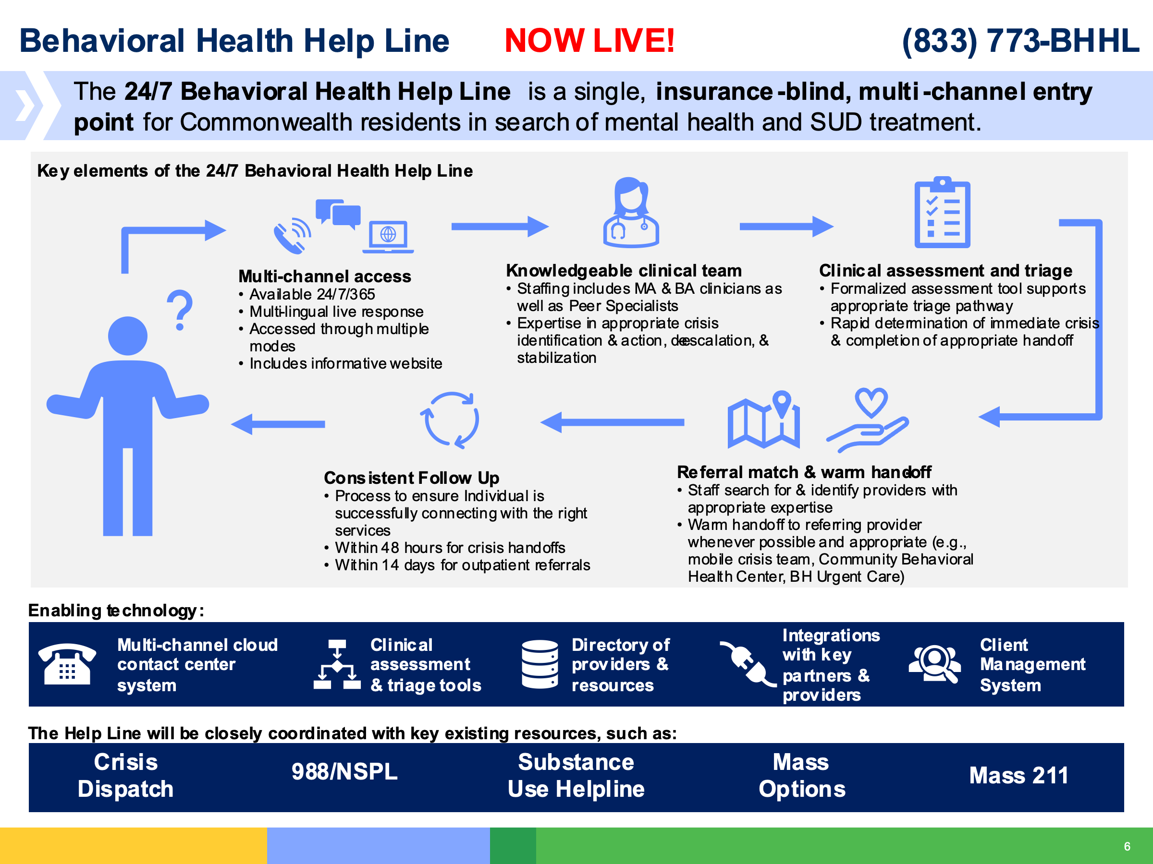



Both the CBHCs and the BHHL began their services in January 2023. Given the scale of reforms, complexity of implementation, and workforce challenges, the impact of this transition on crisis services access and delivery will take time to fully actualize over the next few years. Successful implementation of the BHHL, charged with real-time, live clinical triage and service navigation to CBHCs, requires that both the CBHCs and BHHL coordinate with related emergency and crisis services entities, including: 988 for suicide prevention and emotional support services; the Substance Use Helpline for information and referral to specialized substance use treatment, housing, harm reduction, and recovery services; and the public safety sector and law enforcement agencies for appropriate triage of behavioral health calls to the state’s PSAPs which answer 911 calls, as well as diversion or response by the law enforcement agencies.[29]

### Massachusetts Implementation of 988

As noted above, 988 plays the essential role of “someone to talk to” in a crisis continuum. In July 2022, along with the rest of the country, Massachusetts implemented the 988 Suicide and Crisis Lifeline building on the existing network of National Suicide Prevention Lifelines (NSPL). Massachusetts DPH received supplemental state budget funding and a federal SAMHSA grant, which allowed for the expansion of call center operational hours and workforce growth. DPH collaborated with the State 911 Department, the Department of Mental Health (DMH), MassHealth, and Massachusetts Behavioral Health Partnership (MBHP), among other entities, to establish key network partnerships, logistical and operational readiness, 988 website launch, and a workforce recruitment campaign. DPH developed warm transfer (when one employee handing off a call to another employee provides already shared information so that the caller does not have to repeat information) partnerships with ESPs, which preceded the implementation of the Roadmap and the BHHL, with lifelines referring callers in need to psychiatric emergency services or 911 in life-threatening emergencies. Massachusetts 988 call centers have received over 5,000 calls per month since October 2022.[30] Recent reports from Massachusetts DPH officials indicate that the Massachusetts 988 call centers receive an additional 300,000 local calls annually through an existing helpline. An estimated 98% of calls are resolved at the call center level without diversion to 911.

### The Jail/Arrest Diversion Grant Program

The Commonwealth’s Jail/Arrest Diversion Grant Program, funded through DMH, supports projects that strengthen law enforcement response to individuals experiencing crisis (see Figure 1).[31] In fiscal year 2022, DMH awarded just over nine million dollars to 105 distinct grant projects, 36 of which were new. (See Table 1).[32] Supported projects fall into four broad categories:[33]

* Development and delivery of behavioral health crisis response best practice training models for police and first responders
* Training, reimbursement, and associated costs for sending officers and first responders to behavioral health training (including 911 call takers)
* Embedding a clinical professional into the police department to provide co-response services
* Supporting innovative strategies to facilitate immediate referrals for individuals in crisis to behavioral health care providers

Figure 1: Massachusetts Jail Diversion Program (JDP) Grants, 2007 to 2023

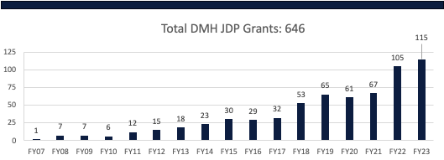

Table 1: Grantee Program Types Funded in FY 2022[34]

|  |  |  |
| --- | --- | --- |
| Program Type | # of Grants | % of Total |
| Co-Response Training & Technical Assistance Center | 2 | 1% |
| Police Drop-Off Center | 3 | 3% |
| Trainer/ Consultant | 5 | 5% |
| Crisis Intervention Team (CIT) | 8 | 8% |
| CIT Training & Technical Assistance Center | 9 | 9% |
| Component | 19 | 18% |
| Backfill /Training Reimbursement | 20 | 19% |
| Co-Response | 39 | 37% |
| **Total** | **105** | **100%** |

### Equitable Approaches to Public Safety

The Department of Public Health funds the Equitable Approaches to Public Safety (EAPS) program to support communities in identifying and implementing alternative approaches to traditional public safety responses. This approach is equity-driven and engages in community-based collaboration to identify alternatives to police-led responses, and models of implementation range from co-response to a clinical alternative response.[35] Currently the program is funding the following innovations:[36]

* The Town of Winthrop embeds trained peer recovery coaches, mental health clinicians, and resource coordination staff with law enforcement to support diversion and deflection.
* The Town of Amherst Community Responders for Equity, Safety and Service (CRESS) provides community alternative response.
* The City of New Bedford, among other initiatives, utilized the funds to expand its co-response and law enforcement assistance diversion programming.
* The City of Northampton utilizes highly skilled and trained community care responder teams to respond to identified “third tier” non-emergency and emergency response needs.
* The City of Revere created a behavioral health unit within its police department to engage in clinical support to individuals who frequently encounter law enforcement.
* The City of Lawrence’s LLEAPS N’ Bounds Initiative, which consists of an interdisciplinary response with multiple cross-sector partners and individuals with lived experience, provides resources and supports to individuals with behavioral health conditions.

### Middlesex County Initiative for Crisis Diversion

In addition to DMH investments, a few jurisdictions and cities have allocated funding to support diversion efforts, including co-response. The state legislature also created the Middlesex County Restoration Center Commission to establish a pilot crisis restoration center that would support ongoing law enforcement diversionary efforts. As planned the pilot restoration center will divert youth and adults aged 18 and above who are in a behavioral health crisis from arrest or emergency departments. The Restoration Center — for which a Request for Response was developed with input from EOHHS, DMH, and DPH and issued in June 2023 — will provide 24/7 drop-off for police, ambulances, and others, as well as walk-in, on-demand care for assessment, crisis care planning, treatment initiation, and crisis stabilization. In addition to short-term stabilization, the Center will provide 30 beds to address acute stabilization for either mental health or substance use conditions or respite care for people in need of transitional housing stabilization and support services.[37]

# Study Methodology

The systemwide assessment for this study was completed over a 10-month period from July 2022 to May 2023. While 988 was implemented in 2022, the implementation of many components of the Roadmap redesign, which began in January 2023, arose in the middle of this 911 assessment. The Massachusetts Association for Mental Health (MAMH) and the Technical Assistance Collaborative (TAC) evaluated the current state of implementation of the 911 system in relation to national best practices to inform opportunities and recommendations to enhance implementation efforts. As with any system transformation, the full implementation and impact of these changes will take years to actualize.

Acquisition and analysis of 911 call data and narratives were the core focus of this study to determine the number of calls that were or could have been diverted to an alternative, non-law-enforcement response. To provide a more comprehensive evaluation and offer informed recommendations, MAMH/TAC utilized a mixed methods approach that involved analyzing information from four primary sources over a 10-month period:

* 1. Literature Reviews: MAMH/TAC conducted a policy and practice scan of national best  
     practices and a review of Massachusetts-specific planning, policy, and budget documents to  
     inform a perspective on the Massachusetts system in a national context. This was done through interviews with state leaders, review of published reports, and acquisition of other documents detailing planned reforms. (See Appendix A for complete list).
  2. *Key Informant Interviews:* MAMH/TAC conducted key informant interviews in two waves (See Appendix B for a complete list of key informants interviewed). The first, conducted in the summer of 2022, included 23 one-hour context gathering interviews with representatives from state agencies, provider and advocacy organizations, law enforcement/PSAPs, individuals with lived and living experience, and other subject matter experts, using a semi-structured interview guide. These interviews informed development of a standard Key Informant Interview Guide (See Appendix C) used to conduct over 65 one-hour semi-structured interviews, with a range of payers, service providers, organizational leaders, law enforcement personnel, and others selected by MAMH/TAC because of their knowledge about behavioral health crisis services in Massachusetts. Informants included behavioral health providers from 988 and Community Behavioral Health Centers (CBHCs); hospital personnel; individuals with living experience; advocacy organizations representing families and service recipients; state agencies (MassHealth, DMH, DPH, EOPSS); first responders (police chiefs, Emergency Medical Services, MPTC); and national leaders in behavioral health crisis response (Utah, Oklahoma, CIT International). This phase of the study also included a comprehensive dialogue with DMH to better understand the scope, strengths, and current challenges of the Jail Diversion program, including the public facing data dashboard.
  3. *Statewide Survey of Massachusetts Public Safety Answering Points (PSAPs):* A voluntary survey of all 211 PSAPs within the state was designed and conducted with support from the State 911 Department. This survey was utilized to preliminarily explore the PSAPs’ process for coding and triaging behavioral health calls, to identify any ongoing coordination with the behavioral health system, and to supplement information gathered through data review and interviews. The survey was also used to obtain logistical information, including each PSAP’s computer-aided dispatch (CAD) vendor, incident reporting procedure, and both the PSAP’s ability and willingness to share data for the study. Responses were received from 114 PSAPs, a greater than 50% response rate, providing a sample of practices statewide. (See Appendix D for PSAP respondent information).
  4. *Review of Selected 911 Data:* The review team collaborated with the Community Policing and Behavioral Health Advisory Council (CPBHAC) on outreach to the 43 PSAPs that indicated they were or might be willing to share data for analysis. While emphasis was placed on obtaining a sample that reflected diversity in regions of the state, urban and rural communities, and variation in population demographics, the sample was ultimately gathered based on departments’ willingness to engage and their ability to share their data. Seven jurisdictions spanning the five regions of Massachusetts shared data, but three of these data sets were limited and could not be analyzed as there was no narrative or sufficient data or information to analyze. Thus, 911 data from four PSAPs was clinically reviewed for this study. The clinical review included a process to determine the most appropriate type of response such as mobile crisis or co-response. The clinical review process involved two independently licensed clinicians with extensive experience in crisis response and crisis call screening and triage reviewing the CAD narrative, as available, and the incident reports, to make a clinical determination. The clinicians utilized a crisis triage decision tool to support clinical review and utilized a sample data set to establish inter-rater reliability at 80%. The tool was created utilizing the workflow and call triage process for existing 911 call diversion programs and was informed by key informant interviews with individuals who had conducted similar CAD analysis or had established 911 call diversion programs.[38] (See supplemental materials in Appendix A). The clinical evaluation included examination of the indication of behavioral health conditions, signs and considerations for safety concerns, and on-the-scene observation and resolution of the situation. Reviewers also examined content for indication of co-response deployment and/or presence of a behavioral health professional in the response. More details regarding outreach, selection, sampling, and data analysis are described in Appendix E.

**911 Data Review Methodology[39]**

TAC clinically reviewed content from a sample of 1,079 calls across the four selected PSAPs to determine if an alternative response could have been deployed and whether, based on the content in the call narrative, it was discernible if an alternative response was actually deployed. The review team established a crisis triage decision tool, which included classification for calls needing an immediate response or where there was a direct or imminent threat to safety. As noted above, this tool was created utilizing best practices from call center screening and existing diversion programming, and   
was informed by similar analyses conducted in other jurisdictions. (See footnote 34). Call narratives and incident reports were reviewed to determine whether any of the following circumstances pertained:

* There was an indication of a mental health condition.[40]
* A co-response would have been an appropriate response.[41]
* An alternative (non-law-enforcement) clinical response (urgent or routine) would have been an appropriate response.
* A non-clinical social service response would have been appropriate.[42]
* There was any indication that a clinician was involved in the response (including co-response or mobile crisis). (See Appendix F.)

This page intentionally left blank.

# Findings

**Statewide Public Safety Answering Point Landscape**

The public safety answering point (PSAP) survey included questions designed to gain a better understanding of PSAP and law enforcement operations related to behavioral health emergencies, and to evaluate the extent of collaboration between behavioral health providers and law enforcement. A total of 114 of the 211 PSAPs in the state (54%) responded to the survey. Reflected below are key findings from the survey, coupled with themes gleaned from relevant key informant interviews and focus groups.

### PSAP Operations and Training

The majority of PSAPs surveyed reported that trained civilians operate them, with others primarily staffed by law enforcement or a combination of the two (see Figure 2). The extent to which training related to behavioral health is offered or required varied among PSAPs. It was reported that every telecommunicator in the state is required to have at least 16 hours of continuing education but there is flexibility on training content to allow the PSAP to meet its needs. Figure 3 shows the most common be­havioral-health-related trainings that telecommunicators are required to receive as reported in this survey. The desire for more training specific to behavioral health was identi­fied by several PSAP telecommunication staff during focus groups. The State 911 Department reported that it has amended regulations (560 CMR 2.00) to make identification and response to callers experiencing behavioral health crises a required component of the basic telecommunicator certification, as well as the annual required 16 hours of continuing education.

**Figure 2: PSAP operators as reported in PSAP survey for Massachusetts.**

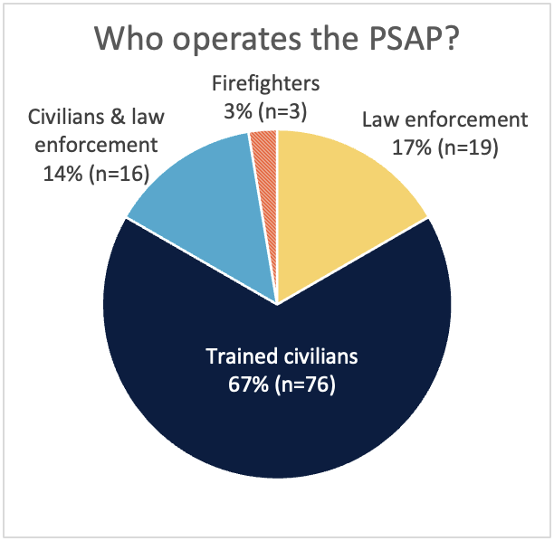

While training to identify behavioral health concerns is one component of providing appropriate response, additional factors affecting identification and diversion from 911 reported by key informants included concerns about liability, availability of behavioral health staff to respond, amenability of the caller, and understanding of the regulations regarding emergency response deployment. PSAPs that utilize an approved software platform called Emergency Medical Dispatch Protocol Reference System (EMDPRS) must complete training, which includes some basic behavioral health training, to become EMD-certified. EMDPRS is a proprietary program that systematically guides telecommunicators through questions and prompts to determine the nature and priority of the call quickly and properly, to accurately dispatch the appropriate responder. These are software systems that PSAPs can buy to support their call triage process. Recent iterations have included behavioral health dispatching questions and prompts to provide opportunities to identify and dispatch non-law-enforcement response when appropriate.[43] Personnel who work in PSAPs that utilize EMD and have behavioral health priority dispatch reported feeling more comfortable making the decision to send an alternative responder.

Additionally, the State 911 Department[44] has recently initiated action to amend regulations (560 CMR 5.00), establishing certification requirements for enhanced 911 telecommunicators, governing EMD, and establishing 911 call handling procedures to include behavioral health training. The State 911 Department is currently working with a group of subject matter experts to develop behavioral health education and trainings for implementation beginning in FY 2024. In addition, the State 911 Department provided additional funding under the FY 2024 Support Grant to those PSAPs, regional PSAPs, regional secondary PSAPs, and regional emergency communications centers (RECCs) that provide dispatch of mobile behavioral health crisis response services.

Figure 3: Required Trainings by Type as reported in PSAP survey for Massachusetts

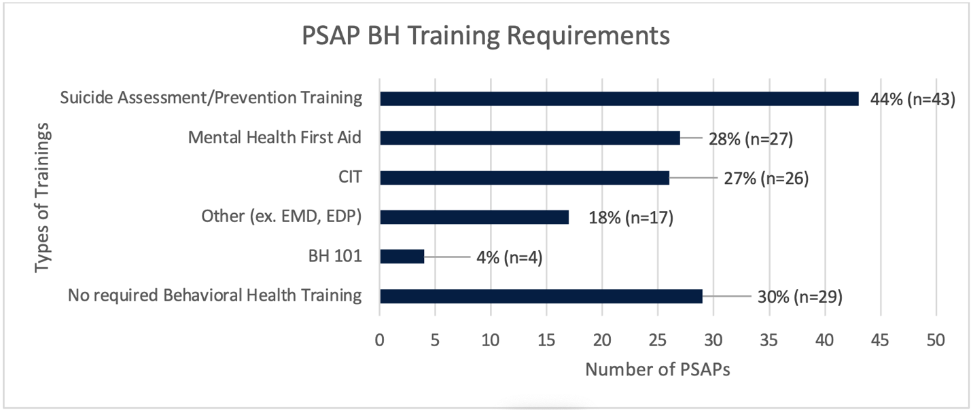

To aid in increased training and to support 911 program objectives, the State 911 Department provides Support and Incentive, Training, and EMD grants to eligible public safety departments, municipalities, and other government bodies hosting PSAPs and RECCs. These grants cover costs associated with staffing, training, systems, and equipment utilized with a PSAP/RECC and EMD costs.[45] The FY 2023 Support and Incentive grant provided approximately $62M in funding, while the FY 2024 grant will provide approximately $73M to support daily operations of PSAPs and RECCs. The FY 2023 funding for the Training Grant totaled approximately $6M while the FY 2024 Training Grant is funded at $6,219,809. The Training Grants are available to PSAPs and RECCs to fund costs associated with certification of new enhanced 911 telecommunicators to complete a 40-hour public safety telecommunicator course and two 2-day 911 equipment trainings, as well as EMD training and CPR training if the PSAP/RECC provides EMD utilizing in-house certified telecommunicators. In addition, the Training Grant provides funding for certified telecommunicators to receive 16 hours of continuing education annually.[46]

### Diversion Efforts

It is estimated that five to twenty percent of all police calls in the United States are in response to someone experiencing a mental health and/or substance use crisis.[47], [48] As noted pre­viously, many law enforcement departments have created avenues to divert such individuals from the public safety and criminal justice systems.

There are multiple points of diversion within a system. Only seven of the one hundred and fourteen PSAPs surveyed (6%) identified that they are currently engaged in diversion efforts at the point of a 911 call, which could provide opportunity to resolve some situations without an in-person response or by dispatching an al­ternative response. The State 911 Department reports that all Next Generation 911 positions located in PSAPs have a button labeled BHHL (Behavioral Health Help Line) so that 911 callers requiring behavioral health services can be connected directly to the BHHL.

However, during key informant interviews with Massachusetts law enforcement personnel, some said they felt compelled to respond to all 911 calls, that they did not feel they could do a warm handoff to 988 or a crisis line, citing safety and liability concerns.

*“I have significant concerns over the   
poten­tial liability resulting from the handoff   
of a behavioral health call to a third-party organization without a police response to determine the existence of a threat. We continue to respond to 9-1-1 hangup calls to ensure that a person is not in any danger.   
A public safety telecommunicator cannot   
‘un-hear.’”*

* *Chief Mark K. Leahy, Ret., Executive Director Massachusetts Chiefs of Police Association.*

Key informant interviews revealed how complicated it can be to create a 911 diversion program as there are questions to consider related to risk and safety. The unpredictable nature of some 911 calls was emphasized by telecommunicators and first responders. Law enforcement reported that officers often arrive at a scene and discover the reality is different from what was relayed to or from dispatch. A variety of factors can contribute to this phenomenon, including, but not limited to, third party callers not providing necessary information, the caller not being able to articulate the situation, or a telecommunicator not asking clarifying questions or misinterpreting a statement. These are factors that should be taken into consideration when screening 911 calls to determine if diversion to an alternative response is appropriate.

Nationally, it has been noted that collaboration between law enforcement and behavioral health partners is necessary to plan and assess potential challenges and safety concerns. This message was reinforced by local jurisdictions that were utilizing 911 call diversion tactics; they emphasized the need for continuous communication, level-setting, and close coordination ahead of time to discuss safety concerns and establish a mutual understanding and trust between the parties involved.

As indicated in Figure 4, a small percentage of responding PSAPs (4%) report no diversion efforts at this time and 43% of the respondents did not answer this question. Of the PSAPs that indicated at least one diversion activity, 45 (94%) reported utilizing three or more diversion approaches, which most frequently include dedicated crisis intervention teams or crisis intervention training and/or co-response with clinicians.

Figure 4: Types of Diversion Programming by PSAP as reported in PSAP survey for Massachusetts

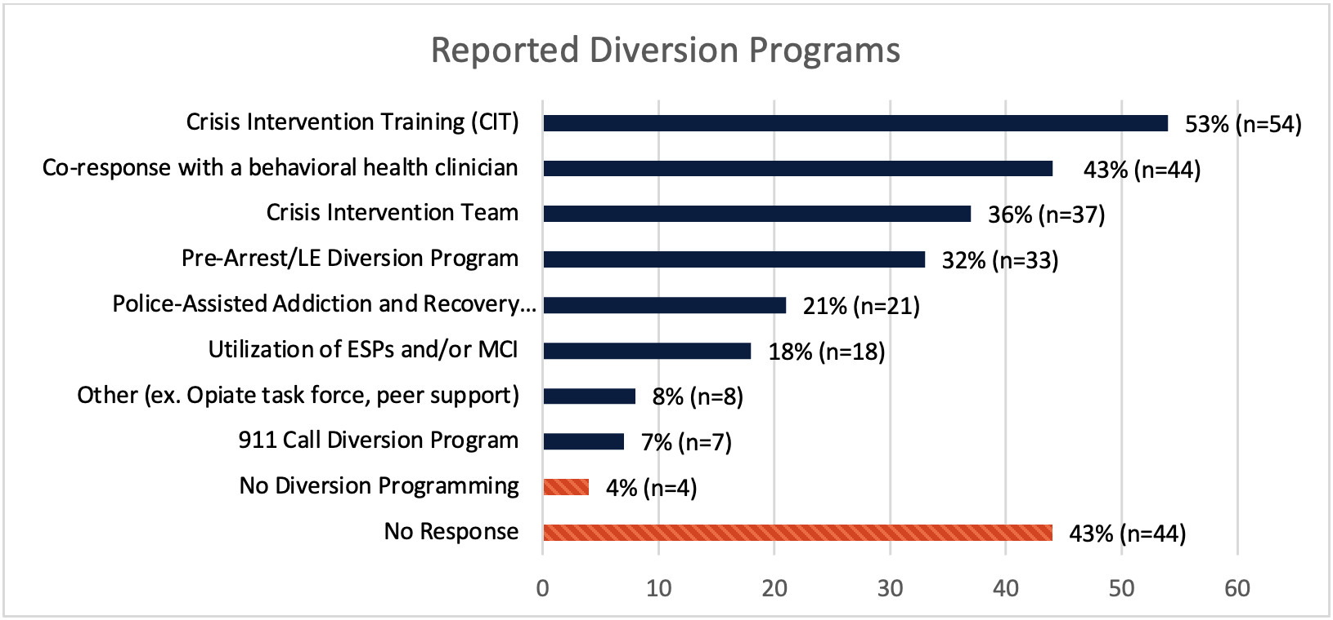

While a law-enforcement-led or co-response model may be warranted when there are identifiable safety risks, public policy, best practices, and federal guidance promote a behavioral-health-system-led response to individuals in crisis who are not posing safety risks.[49] Public safety/law enforcement coordination with mobile crisis intervention (MCI) teams within Community Behavioral Health Centers (CBHCs), formerly known as emergency service providers (ESPs), is reportedly diminishing in Massachusetts.

Some key informants reported that historically, the lack of 24/7 availability of ESP/MCI staff to respond has led many police departments to hire their own clinicians so they can directly respond to 911 calls with their own available behavioral health staff. Some departments cited that it was easier to hire directly and dispatch their own resource rather than coordinate with the local MCI/CBHC. Even in departments with embedded clinicians, there is rarely 24-hour access due to limited resources and/or predictable call volumes to justify the additional coverage. Few police departments, for example, have co-response staff on more than one shift or in sufficient supply to accompany multiple officers or teams on a single shift. Nearly every key informant (law enforcement, behavioral health provider, people with lived experience) cited the behavioral health workforce shortage as an additional barrier that is creating strain on the system’s capacity and adding to the challenge of timely access to behavioral-health-led crisis response. This issue is contributing to and exacerbating the existing challenges to integration and collaboration between the larger behavioral health system and law enforcement. Additionally, some law enforcement key informants reported that in areas where there were recent MCI/CBHC provider changes, many departments have opted to hire internally rather than coordinate with the new provider. As the CBHCs’ capabilities are implemented, it will be critical to address these concerns, to increase effective collaboration between law enforcement and the CBHCs’ enhanced crisis services.

#### CAD Codes: Behavioral Health Coding

Finally, to inform the 911 CAD analysis, our survey evaluated how PSAPs are categorizing behavioral health emergencies so that we could identify common categories and variations in approach. Figure 5 lists the CAD codes most commonly identified. Several different codes were used to signal a behavioral health emergency, including those mentioned here, and were recoded for our analytic purposes as BH/MH emergency. The numbers reflected in Figure 5 represent a rollup of the most common CAD codes utilized by surveyed PSAPs.The codes were classified as behavioral health emergency: mental health emergency, mental health situation, mental health evaluation, mental health investigation, mental health inquiry.

Given the range of calls that telecommunicators encounter and of CAD vendors utilized, this lack of uniformity is not unexpected. One PSAP informed reviewers that it utilized over 1,300 different CAD codes. The number of CAD codes utilized by PSAPs varies across the state. The high number of codes in the absence of uniform coding and standardized training increases the risk of miscommunication and supports the value of adopting a standardized process for the classification of calls.

Figure 5: Coding Behavioral Health Calls as Reported in PSAP Survey for Massachusetts

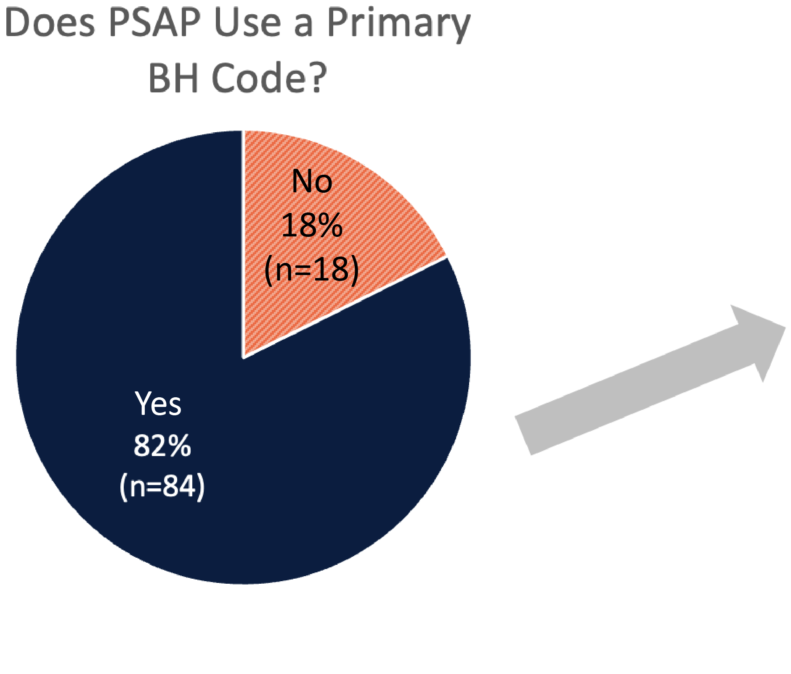

Most Common Mental Health/Substance Use CAD Codes (in order of prevalence)

1. Behavioral Health/Mental Health Emergency
2. Suicidal Intervention
3. Possible Overdose
4. Medical Emergency with Specifier
5. Emotionally Disturbed Person
6. Crisis Intervention Team (CIT)

**Clinical Review of CAD Narrative**

### Behavioral Health Response

Clinical analysis of calls sampled that included any type of behavioral health coding involved a retroactive clinical review of narrative produced by tele-communications and law enforcement incident reports. Due to the nature of the process, the reviewers elected to utilize tiers of determination (co-response, alternative response, non-clinical response). As shown in Figure 6, of all the calls reviewed (1,079), it was determined that 82.9% (894 calls) could have at least deployed a behavioral health clinician (co-response) along with law enforcement or medical personnel (co-response), and that 11.6% (125 calls) needed more information or there was insufficient data to reach a conclusion. Most of these latter instances were because there was no CAD narrative or there was such limited information that no analysis could be drawn (e.g., “no party found,” “voluntary hospital,” “person yelling at someone taking pictures of them,” “help,” etc.). Only 5.6% (60 calls) were deemed as appropriate for medical or law enforcement only to respond.[50]

The next level of analysis was to determine whether there was enough information to discern if only an alternative response (i.e., a non-law-enforcement response) could have been deployed. As shown in Figure 7, clinical reviewers determined that 35.7% (385 calls) could have resulted in deployment of an alternative response such as mobile crisis without the presence of law enforcement because there were no identified safety risks at the time of the call and based on the incident reports. For approximately one-third of all calls reviewed, more information was needed to make this determination (e.g., “suicidal person,” “brother out of control,” “aggression, unclear if weapons,” “assessment on emotionally dis­turbed person acting aggressive,” etc.) Listening to recordings of real-time calls to 911 would have allowed for additional questions which might have provided insight into safety concerns, but given the retro­spective nature of this analysis, coders qualified that additional information would be needed to support the assumption of dispatching only an alternative response. Of the calls that indicated the need for co-response involvement (894), 27% were deemed to have safety risks that would warrant the need for law enforcement; for another 30%, more information was needed to determine the appropriate response. Those calls had a level of imminent risk such as an acute situation or concern with safety that required co-response or support from law enforcement only (e.g., active attempt of suicide, person in middle of traffic).

Figure 6: Assessment of Potential to Deploy   
a Co-Response

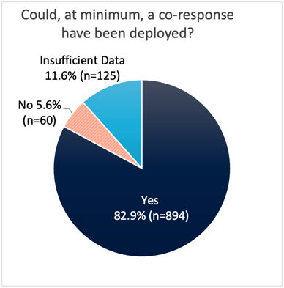

Figure 7: Assessment of Potential to Deploy a Non-Law-Enforcement Response Only

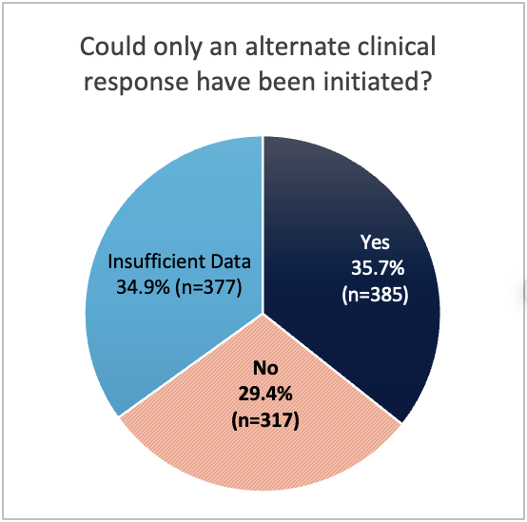

### Potential to Deploy a Social Service Only Intervention

As part of the final clinical evaluation, the reviewers determined if the calls were appropriate for neither law enforcement, first responders, nor behavioral health clinicians. Only one percent of the calls reviewed for which there was adequate information to make a determination were appropriate for a non-law-enforcement and non-clinical response. These included situations such as an individual locking themselves out and being unable to locate the property manager, or an individual needing social services support outside of the behavioral health realm. Given that the CAD codes were originally coded for behavioral health, it is not surprising that this number is significantly lower. Future studies should include a review of all calls, not just those coded behavioral health calls, as other studies have found that calls not classified as behavioral emergencies often include calls not appropriate for a law enforcement response.[51]

### Indication of Clinician Involvement in the Call

Reviewers’ assessments point to the likelihood that 82.9% of calls coded as a “behavioral health” could have utilized a clinician in some capacity; despite this, only 9.1% or 98 of the 1,079 calls reviewed indicated direct involvement by a clinician. However, it is likely that this number (9.1%) is an undercount as reviewers could only make this determination based on the content in the available narratives. Currently, there appears to be no standardized way for dispatch centers to capture the deployment of co-response by dispatchers, or at least not in a manner that is easily extracted from law enforcement reports. This information is captured by clinicians/law enforcement with DMH co-response grants and reported to DMH for police departments that received funding through DMH’s diversion grants. DMH’s Division of Forensic Services is currently revising its methods for collecting this data to support streamlined and accurate reporting. Local PSAPs and police departments with co-response programs supported by municipalities or federal grants may also capture this information; however, no centralized method currently exists for capturing and reporting data from these programs throughout the state.

### Disposition Data

The reviewers attempted to collect disposition data for all 1,079 calls analyzed to determine the resolution of the calls (see Figure 8). Based on PSAP survey and key informant interview responses, it is known that the majority of PSAPs track dispositions in the CAD system in a way that facilitates extracting and reporting the data. However, one of the PSAPs that shared data with MAMH/TAC did not include any disposition data, so it was excluded from Figure 8 below.[52] Based on calls for which this information was available, nearly two-thirds (68%) or 464 calls resulted in hospitalization. Of the calls that resulted in hospitalization, a little more than half were detained under the authority of Massachusetts General Law c.123 Section 12(a), which allows for an individual to be brought against their will to a hospital for evaluation. Calls that were coded as “Section 12” at the time of dispatch were removed from the sample (see Appendix E), as the calls were requesting transport to the hospital for evaluation for someone when a determination had already been made and law enforcement must be involved. This means that 51% of the calls that came into 911 resulted in a Section 12. Of the 385 calls that were deemed to be appropriate for an alternative clinical response, 146 resulted in hospital transport and approximately half of those were Section 12(a)s. Figure 9 reflects disposition data for calls that reviewers determined to warrant at least a co-response.

Figure 8: Disposition Data of All Calls Analyzed with Reported Dispositions[53]

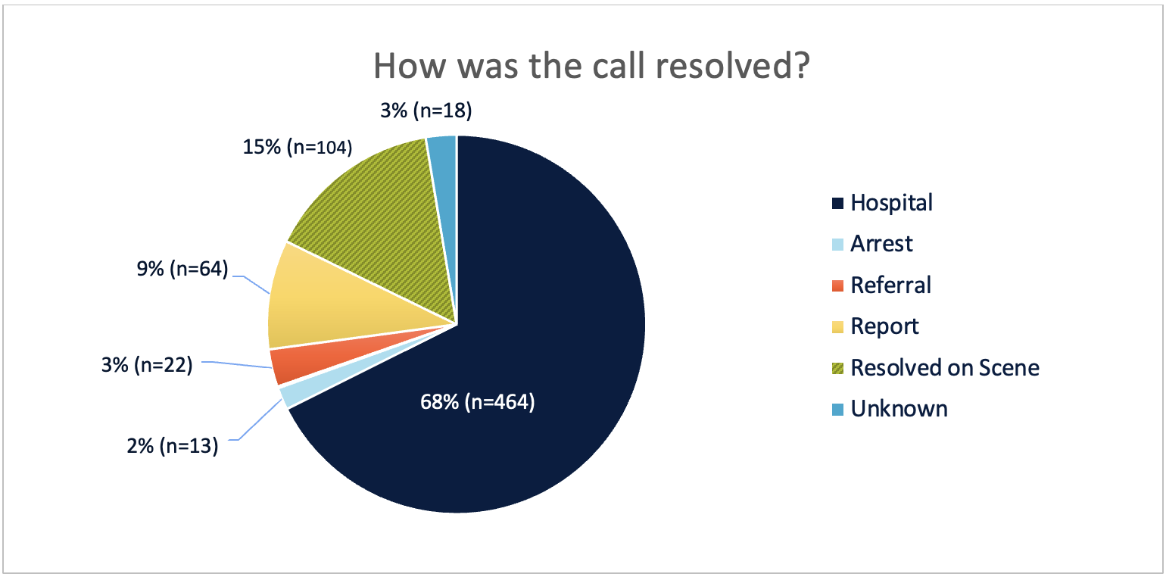

Figure 9: Disposition of Calls for which Indicated Co-response Could Have Been Deployed

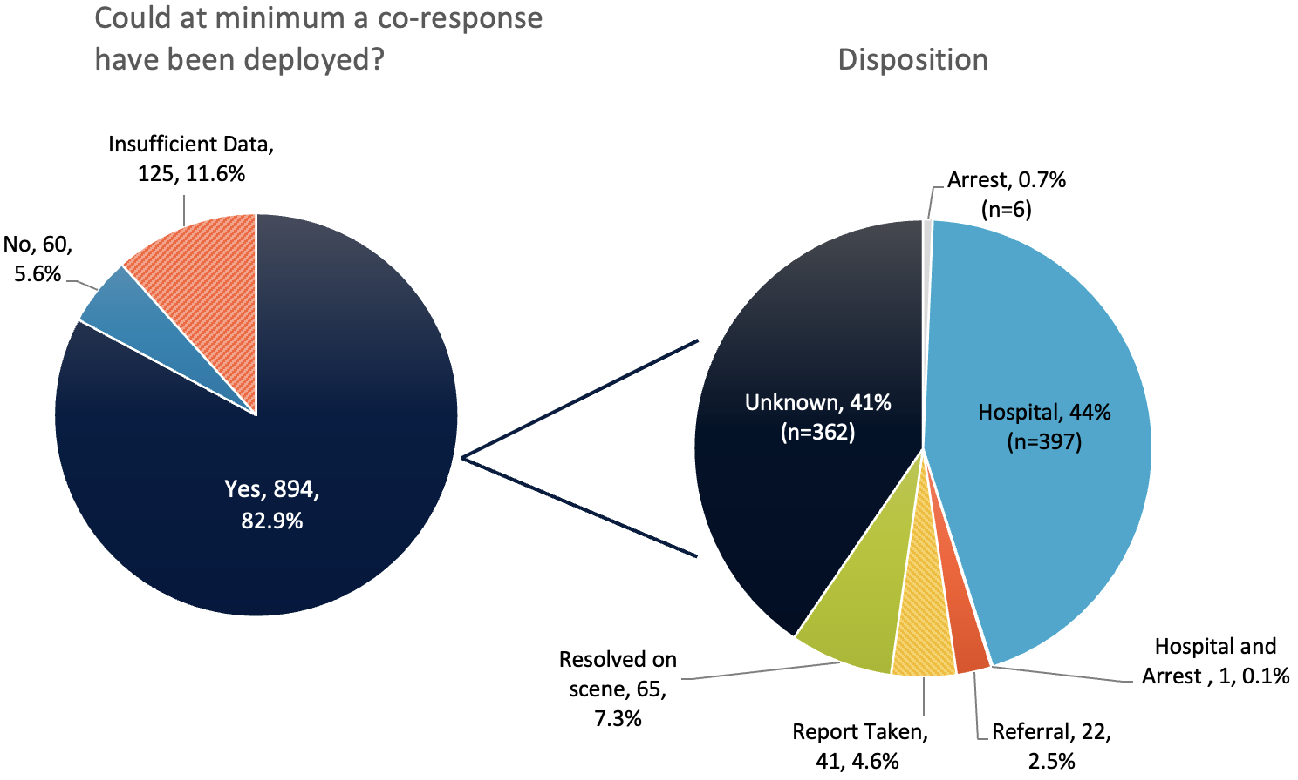

**Insufficient Data**

One limitation cited was that the quality and consistency of data that could be extrapolated from the CAD narratives and police reports varied, and at times that variation created the inability to make a clinical determination regarding safety concerns. It should be noted that there are a variety of reasons why there may have been insufficient data.

The majority of key informants who represented law enforcement and PSAP telecommunicators cited that obtaining demographic information would delay the deployment of an immediate response, which could create life-threatening consequences in some circumstances. Additionally, in all the calls, as evidenced by their classification, it was already determined that there was believed to be a behavioral health condition. All the jurisdictions whose calls were reviewed do not currently have the infrastructure to dispatch an alternative response (non-law-enforcement involved) directly from 911. Therefore, it is not currently necessary, nor are there established protocols, for telecommunicators to make the level of discernment that the reviewers made regarding co-response and alternative response as there is only co-response available. For this reason, telecommunicators are tasked with identification of behavioral health condition, and the law enforcement entity then determines to utilize co-response, if there is an available unit. Similarly, in the absence of a real-time 911 diversion option, all the information obtained by the call taker may not be fully represented in the CAD narrative. There is a likelihood that the telecommunicator transcribed only the information that they believed to be necessary for the responding officers, which may be more limited in content.

During the data review process, there were instances in the crisis triage decision tool in which a determination could not be made based on the content in the narrative/incident report. These calls were coded as “insufficient data.” Table 2 below breaks out the points at which the reviewer was unable to make a determination for each of the four review questions. For instance, there was insufficient information for 35% of all calls on the question of whether an alternative response only could have been deployed. This was most often coded as “insufficient data” because there was not information included to fully assess risk or safety concerns to make the determination that only clinicians could have responded. Other calls were coded as insufficient data when there were missing data fields (i.e., one of the data sets did not include any disposition information) or when the narrative did not provide enough details to support a clear decision. This is important to consider as two of the questions were unable to be determined in more than one-third of the total calls.

Table 2: Calls with Insufficient Information to Make a Determination

|  |  |  |
| --- | --- | --- |
| Review Question | Number of Calls | Percent of All Calls |
| At minimum, could co-response have been deployed? | 125 | 11.6% |
| Could only an alternate clinical response have been initiated? | 377 | 34.9% |
| Could only an alternate non-clinical response have been initiated? | 5 | 0.5% |
| What was the disposition? | 397 | 37% |

**Promising Collaborative Practices in Massachusetts**

Based on our review of qualitative data obtained from key informant interviews and focus groups, there were several promising practices identified that can support more effective responses during a behavioral health emergency. They are described briefly here.

### Use of Alternative Civilian Safety Programs in Massachusetts ― No Police Involvement

In May 2022, Amherst, MA implemented the Community Responders for Equity, Safety & Service (CRESS) department. This department has the same standing in town government as the police and fire departments and was established to provide community safety services as an alternative to police and fire response to situations that do not involve fire, violence, or serious crime. Staffed by a trained group of ten civilians with social service, behavioral health, and community support experience, the CRESS team collaborates closely with a range of town, county, and state services to meet the needs of Amherst residents across the lifespan.

CRESS works closely with Amherst’s police, fire, and public health departments, as well as Town Inspection Services, Zoning, the Manager’s Office, and the town’s senior center to reach individuals in all age groups who need assistance. This includes those who are housed and those who are homeless, as well as students who may not have structured after-school supports and need a reliable touch point in the form of CRESS team outreach services. In a Spring 2023 report to the Town of Amherst, CRESS described a range of individual case assistance addressing support to families, Veterans, older adults, homeless and insecurely housed persons, and youth and adults struggling with behavioral health crises. CRESS also collaborates closely with behavioral health crisis and peer respite and support services in the area. The CRESS team is explicitly dedicated to early, preventive intervention designed to assist community members to avoid crisis leading to public safety involvement. CRESS is funded in the Town of Amherst budget and supported by local tax dollars, as well as by state and federal funds to municipalities. Recent reports on staffing, costs, and services provided indicate that CRESS receives $620K from the Town of Amherst, $449K from the MA Department of Public Health (DPH) Equitable Approaches to Public Safety fund, and $150K from federal American Rescue Plan Act (ARPA) funds. Since its launch date, the CRESS team has served more than 570 individuals and families.[54]

Initiatives with a similar intent are emerging in Cambridge and Northampton. The City of Cambridge FY 2024 budget includes a substantial new investment in a Community Safety Department that is internal to the city. The Community Safety Department will have a $3.7M budget to support internal Department operations, staffed by a new Director of Community Safety, civilian crisis response specialists, an administrative coordinator, and a data analyst. The focus of the work is to provide community engagement and crisis response to vulnerable populations in Cambridge, including persons with disabilities and those with behavioral health conditions. The city budget will also support funding to the Cambridge Holistic Emergency Alternative Response Team (HEART), a community-led alternative to the city’s public safety services, including police. Funded mainly through grants and donations, HEART directs its efforts to “people in conflict or crisis” including people with behavioral health conditions.[55] Northampton secured a $450K grant from DPH in 2022 to establish the Division of Community Care (DCC) in Northampton’s Department of Health and Human Services. The DCC was designed to provide civilian responders, including peer responders, as an alternative to police for a range of community needs and crises. Northampton’s vision for the DCC team’s work is to assist people experiencing difficult and traumatic moments, regardless of the source of that difficulty, with immediate connection to a civilian response team that can meet them where they are, offering counsel, resources, and support to resolution.[56]

### Crisis Intervention Teams and Co-Responder Teams, Most Often Police-Led in Massachusetts

Crisis intervention teams and co-responder teams’ implementation in Massachusetts vary from one community to another in funding, hiring, and operationalization of co-response, with some clinicians riding along with law enforcement and others responding in their own vehicles. The majority of co-response programs are funded through DMH, but others are supported by local entities and federal grants. Within Massachusetts, co-responder teams consist of a clinician and a law enforcement officer responding together to meet the needs of an individual experiencing a crisis. Cross-training between police and clinicians creates a shared understanding of each other’s roles in responding. Co-response clinicians provide formal and informal training to their law enforcement partners, collect and input call data, and coordinate with other stakeholders, including behavioral health providers. Key informants also highlighted the positive effects that having a dedicated co-response clinician within the police department can often have on officer mental health***.*** Key informants pointed out the significance of distinguishing the nature of co-response teams as either clinician-led or officer-led, noting that more investment might be made in clinician-led collaborations. Key informants from several state agencies noted that expansion of crisis intervention training and co-response are commendable but not yet universal and will need to be complemented by additional investments in staffing, training, technology, practice, and culture change for both public safety and behavioral health systems.

### Crisis Intervention and Co-Response Training and Technical Assistance Centers

Massachusetts began its co-response efforts in 2003, and with grants made since 2007, DMH has substantially increased funding to communities to support diversion of behavioral health crisis response from law enforcement. Moreover, DMH funds crisis intervention and co-response Training and Technical Assistance Centers (TTACs) for crisis intervention team (CIT) and co-response training to promote the replication of models, such as co-response, that support diversion to community-based services. In FY 2019, the state launched a single co-response TTAC (CR-TTAC) which serves as the statewide hub for co-responder training. DMH has developed a statewide Center for Police Training in Crisis Intervention (The Center), which will serve as a clearinghouse for evidence-based behavioral health crisis intervention training.[57] Massachusetts is one of the few states that provides regional technical assistance for law enforcement on supporting diversion. Key informants stated that they were pleased with the support and coordination that TTACs are providing for local law enforcement.

### Behavioral Health Priority Dispatch-Emergency Medical Dispatch Protocol PSAP and CBHC Collaboration

WestComm Regional Dispatch utilizes an approved EMDPRS system, which includes an EMD protocol for behavioral health priority dispatch. WestComm serves the Massachusetts municipalities of Chicopee, East Longmeadow, Longmeadow, Monson, and Ware. With EMD, WestComm has established protocols for when a call can be transferred out to the behavioral health provider, which is a CBHC. Dispatch staff have the capacity to upgrade the response (to include a first responder) if they feel a given call is not appropriate to transfer out.[58] The CBHC also has a dedicated law enforcement line as well as a police radio. WestComm has made CIT training mandatory for its telecommunication personnel at time of hire. This 911 call diversion process started two years ago, and WestComm reported that no calls diverted to the CBHC required a call back to 911 for additional support. The response in the community has been positive, recognizing a more streamlined process of referring individuals who do not need a law enforcement response. There has been a steady increase in calls transferred from 911 to the behavioral health provider as personnel become more comfortable with the process.

### Community Collaboratives and Hub Models – Police-Led Intervention

The Chelsea Police Department created a [hub model](https://chelseapolice.com/community_services/hub.php) to enhance cross-system collaboration involving police, medical providers (including hospitals), and multiple social service agencies. The goal is to engage in cross-sector coordination and ensure open communication to support vulnerable individuals frequently encountering the crisis and justice systems. A key strategy that makes this model successful is weekly meetings that are convened by law enforcement and well-attended by providers, which has built a network of trust, connection, and understanding across the spectrum of care. This model has been replicated in 18 other Massachusetts communities.[59] Key informants again noted that hub models in Massachusetts are police-led initiatives, and called for more robust community behavioral health crisis services to step up in leadership roles in these collaborations.

**Promising Collaborative Practices in Other States**

As noted above, there was, for a long time, no centralized number that was accessible 24/7 specifically for behavioral health emergencies. The historical gap in behavioral health system performance in front line response to such emergencies resulted in a growing reliance on 911 and law enforcement for a quick, though not always most appropriate, response to these situations. The launch of the 988 Suicide and Crisis Lifeline in 2022 created the framework for a single point of entry for behavioral health calls; models are now unfolding throughout the country to attempt to divert 911 calls to the behavioral health system through 988. Chicago recently launched its Crisis Assistance Response and Engagement (CARE) pilot program, which deploys one of three response teams based on the needs of the caller. The three possible teams are: a multidisciplinary team that consists of a paramedic, a clinician, and a CIT officer; an alternative response team consisting of a paramedic and a clinician; or an opioid response team consisting of a paramedic and a peer recovery specialist.[60] In 2021, Austin, Texas created an option in its 911 system to allow callers to specify at the outset of the call that they need behavioral health services, and Harris County, TX has embedded clinicians into its 911 call center since 2015.[61], [62] While states are making advances to ensure 911 telecommunicators are equipped to identify and respond to behavioral health calls, a recent study found that there is still a significant need for more training for PSAP telecommunicators.[63]

While many communities have implemented alternative response programming at a local level, some states have attempted to create an infrastructure for implementation of 911 diversion at the state level. Through cross-sector collaboration, states like Virginia and Utah have worked to create statewide standards for PSAPs to utilize. In 2020, Virginia legislation required the state’s Department of Behavioral Health and Developmental Services and the Department of Criminal Justice Services work together to create minimum standards that would enforce best practices for police involvement in behavioral health crisis response. Stemming from this collaboration, Virginia became the first state to issue a [statewide matrix](https://lis.virginia.gov/cgi-bin/legp604.exe?202+sum+HB5043) for 911 diversion support. Similarly, Utah worked with its PSAP advisory board to create a statewide dispatch workflow that supports more effective triage of behavioral health calls and warm transfers to Utah's statewide crisis line, which can directly dispatch mobile crisis response.[64] Both of these initiatives are relatively new and are still being implemented, but the states are working with both behavioral health and law enforcement partners to review progress and evaluate the need for refinement of the process.

Despite growing investment in behavioral health response initiatives and recent studies of specific programs, there is a lack of clear and robust data regarding diversion practices, safety, and outcomes.[65] There is no empirical evidence on the overall or widespread impact of these programs. However, program-specific data demonstrates the benefit of deploying alternative responders. For example, a recent evaluation of New York City’s B-HEARD (Behavioral Health Emergency Assistance Response Division), a program that dispatches physical and mental health professionals to behavioral health calls, found an increase in individuals’ willingness to engage with providers, a decrease in hospital transports, and an increase in community connections.[66] In the first quarter of 2022, the Supported Team Assisted Response (STAR) program in Denver, CO responded to 2,837 crisis calls and none of the calls were sent back to 911 due to safety concerns.[67]

# Study Limitations

The primary limitations of this study are as follows:

Sample of convenience

As noted earlier in this report, the Technical Assistance Collaborative (TAC), Human Services Research Institute (HSRI), and Massachusetts Association for Mental Health (MAMH) team attempted to strategically identify and reach out to communities based on demographics, geographic region, call volume, and existence or non-existence of co-response. However, due to challenges with response to the request for 911 call data, public safety answering point (PSAP) staffing capacity, and willingness to engage in what could be a time-intensive process, the data received constitutes a sample of convenience. This methodology of self-selection creates the possibility of bias, as those who volunteer to participate in a survey or study may differ systematically from those who do not, whether that is due to shared interest, motivation, or other factors. For example, all entities that opted into participation had a co-response team that had been operational for several years. PSAPs with co-response may have been more inclined to participate as they may have specific protocols in place for the identification and triage of behavioral health calls. Additionally, there is limited representation from rural communities or smaller PSAPs. For these reasons, the results may not be extrapolated or fully representative of the entire state.

Lack of consistency in PSAP coding, categorization, and documentation of calls

As noted above, there is great variation in how PSAPs screen, identify, and categorize potential behavioral health calls. Due to discernment in screening and categorization and to variation in documentation, the narrative of the computer-aided dispatch (CAD) data varied greatly across jurisdictions. Additionally, not all communities were able or willing to share police incident data. Some PSAPs, particularly those that did not have a dedicated crime analyst position, reported that it would be extremely labor intensive to pull and, when necessary, redact incident reports. Therefore, data in three of the communities reflected only CAD narrative data, not incident reports. Of the 114 communities that completed the initial survey, 16 communities cited concerns with confidentiality in sharing 911 call narrative and/or incident reports for this study. A future review of 911 calls would benefit from the inclusion of police incident reports to determine a more comprehensive picture of calls that were or could have been diverted. This may require means outside of those that were accessible within the parameters of this study.

Focus on only behavioral health categorized calls

The current study oversampled and thus predominantly analyzed PSAP calls that had previously been coded with a behavioral health indicator (see code list in Appendix E). Given that the sample included communities that all had co-response, this selection method enhanced the likelihood that a clinician had been deployed or involved in the call. Additionally, given this narrow scope of codes, there is likely a significant underrepresentation of the magnitude of calls involving behavioral health conditions.

Limited demographic information and no ability to stratify data on demographic variations

Although the study design called for stratification of cases based on demographic characteristics, the availability of data for this purpose was limited. Because analysis based on incomplete data would likely be biased, MAMH/TAC chose not to include demographic data in the analysis. Reviewers recognize that telecommunication staff encounter situations in which mere seconds matter, and attempting to obtain demographic information could slow the process and ultimately delay, at times, life-saving interventions. This can result in exclusion of demographic information in favor of obtaining the most critical information needed to deploy a response. Situations that require an in-person response allow for the respondents to capture more robust information, including demographic information. Thus, a more accurate stratification for future research would utilize incident reports, police reports, and specific co-response data, which reviewers were not able to obtain, to stratify data and evaluate any trends and disparities in response type and outcome.

# Recommendations

Recommendations are provided with recognition that several reforms are underway in the Commonwealth of Massachusetts that touch on the delivery of 911 services. These include Executive Office of Public Safety and Security (EOPSS) initiatives through its State 911 Department to implement 560 CMR 5.00 changes establishing certification requirements for enhanced 911 telecommunicators; governing the use of emergency medical dispatch; and establishing 911 call handling procedures. The 911 Department is also engaged in public safety answering point (PSAP) consolidation and increasing PSAP capabilities through targeted development and training grants. The Commonwealth’s investment in reforms also includes implementation of 988, which allowed for expanded call center operations and workforce growth, creating additional capacity to answer more calls and establish connections for 988 callers to higher levels of care such as mobile crisis intervention. Other reform investments include the Roadmap for Behavioral Health Reform with its creation of the Behavioral Health Help Line, designation of Community Behavioral Health Centers to provide enhanced crisis services and urgent care, and expansion of the Department of Mental Health (DMH) Jail/Arrest Diversion Grant Program. Each of these reform efforts provides an affirmative change that is improving behavioral health crisis response in the Commonwealth, and which, when fully implemented and better integrated, will pay significant dividends in relieving burden on the 911 system.

Recommendation 1. Create a standardized framework and coding definitions for screening, triaging, and reporting behavioral health calls across 988, the Behavioral Health Help Line, the Substance Use Helpline, and PSAPs.

In reviewing call narratives and dispositions, and discussing processes with PSAPs, it became clear that policies and procedures for identification and response vary greatly across the state. Highlighted above, technology systems, such as approved EMDPRS, can support a more uniform call screening process and aid in emergency communication personnel feeling less stress and personal liability for discerning the appropriate response. While dispatch tools, like approved EMDPRS, that include behavioral health questions can support dispatchers in standardizing their approach, these systems, and the subsequent training for them, can be expensive ― particularly for smaller PSAPs. As the State 911 Department is funded solely by the 9-1-1 surcharge, EOPSS and the State 911 Department may need to review current grant funding levels and programs for infrastructure to implement and manage standardized technology, protocols, and training across the Commonwealth. This may further enable PSAPs to purchase approved software systems that will support call takers with analysis and triage determination, to ensure that those individuals in behavioral health crisis who do not require a police response can receive the same public health response that persons with any health condition calling in a crisis would receive.

It is advisable that EOPSS and the State 911 Department coordinate with DMH (including the Division of Forensic Services at DMH which supports Training and Technical Assistance Centers), MassHealth, and the Department of Public Health (DPH) issue a statewide protocol to support all call takers and dispatchers. This protocol would support further interoperability between 911, 988, and the new Behavioral Health Help Line (BHHL). This protocol should build on others developed by DPH for 988 and 911 interoperability and by the Executive Office of Health and Human Services (EOHHS) and DMH on BHHL, Substance Use Helpline, 988, and 911 interoperability ― to codify each entity’s responsibility in jointly dealing with parties in crisis. Joint training that uses standardized curricula is ideal, and can build partnerships and mutual trust in working relationships. The State 911 Department is currently in discussions with DMH and others to provide education for PSAPs so that they can establish policies for using the BHHL.

Recommendation 2. Require standardized behavioral health training for telecommunication operators (911, 988, BHHL, Overdose Prevention Helpline, Substance Use Helpline) and enhance training for law enforcement and behavioral health crisis staff.

The state has legislative standards mandating that an in-service training curriculum for police officers be established by the Municipal Police Training Committee (MPTC) regarding de-escalation and response to individuals with behavioral health conditions.[68] This training may include some PSAP operators who are law enforcement personnel, but will not necessarily include civilian dispatchers. In fiscal year 2022, the state trained one hundred and twenty-nine 911 dispatchers in Community Intervention Teams (CIT) through their diversion program grants, but key informants and survey respondents noted the need to standardize training available to PSAPS to ensure consistency of information.[69]

Similarly, EOHHS is set to invest in training to support implementation of the Roadmap, including enhanced crisis services and the BHHL. Behavioral health professionals will benefit from training on new crisis services protocols, police and dispatch operations, and the challenges of collaboration to deliver safe and effective crisis response across public safety and behavioral health service sectors. For example, EOHHS is making funding available to higher education institutions to train clinicians on evidence-based practices and to MassHealth-enrolled providers to train certified peer specialists, recovery coaches, and community health workers.

2a. Create a training curriculum in partnership with State 911 Department, MPTC, the Peace Officer Standards & Training Commission, DMH, DPH, MassHealth, and people with lived experience.

Though there are differences in the roles of each call center, each call center should be trained in the same core components, including de-escalation, suicide assessment, and understanding of available resources and behavioral health processes. It is useful to develop standardized partnership memoranda employing standard terms, standardized operating and clinical protocols, and referencing standardized curricula to support mutual understanding, shared responsibility, and complementary action to address the crisis intervention and crisis resolution needs at all levels of the public health and public safety systems.

Recommendation 3. Develop a governance entity that enhances cross-sector collaboration at the state and regional levels.

3a. Identify or establish one entity under the co-direction of the Secretary of Health and Human Services and the Secretary of Public Safety and Security that would be responsible for overseeing crisis response planning and implementation.

The bifurcation of crisis response and the multiple entry points have created a patchwork of overlapping programs and interventions housed under different state agencies and departments within EOHHS and EOPSS. Currently there are multiple planning commissions and task forces focusing on portions of the system (the 988 Commission, the Community Policing and Behavioral Health Planning Council, and the Behavioral Health Advisory Commission). One consistent theme in key informant interviews was the need to break down the silos between agencies, and to intentionally take steps to re-establish trust and coordination between community partners. To effect change, leadership and accountability are essential. The state should consider identifying an accountable entity or body with a defined role of coordinating efforts related to behavioral health crisis across state agencies and departments. This governance structure would provide the oversight needed for strategic planning, alignment across departments, and review of data; and would need the authority to support implementation across the various departments. The governing body would coordinate with representatives who have decision-making authority from EOPSS, PSAPs, and law enforcement, as well as EOHHS entities at DMH, DPH/988, emergency medical services (EMS), Community Behavioral Health Centers (CBHCs), MassHealth, Massachusetts Behavioral Health Partnership (MBHP), and managed care entities (MCEs). It is critical to include people living with behavioral health conditions and experienced with crisis services response in the Commonwealth as members of this body.

Reviewers from EOHHS and EOPSS stressed the importance of addressing statutory, regulatory, policy, and procedure changes to support the envisioned reforms. The singular leadership entity co-led by EOHHS and EOPSS can effectively address these key reform implementation considerations.

With clear governance, the behavioral health reform occurring within the state can meet the challenge to streamline the process for people with behavioral health care needs to get the right care at the right time from the right providers in the right place. Similarly, reforms within the 911 Department to facilitate consolidation of PSAPs and advance standardization in training, reporting, and infrastructure, can be supported by the proposed co-governance structure. Creating a single unit responsible for all aspects of behavioral health crisis response will support the Commonwealth to effectively implement its behavioral health crisis vision.

3b. Create opportunities for regional cross-sector planning and mutual understanding.

To support uniformity in process but allow for local implementation to meet the needs of the community, it is recommended that the state define and set broad expectations through collaboration on a regional level, recognizing the geographic coverage of respective CBHCs. The state has existing infrastructure that can be leveraged and enhanced to promote these collaborations. For example, DMH currently has Training and Technical Assistance Centers (TTACs) focused on providing technical support for co-response and crisis intervention teams (CIT). These TTACs are tasked with enhancing collaboration between police departments and health providers; however, the cross-system coordination can be enhanced to work more effectively with the newly re-envisioned mental health system, with hospitals, and with EMS. Therefore, a shared understanding, standardized protocols, and intentional efforts to create and sustain trust between behavioral health providers, PSAPs, and first responders are imperative to facilitate successful implementation and sustainability of the crisis system.

In developing cross sector guidance for behavioral health and public safety, consideration should be given to alignment with the National Emergency Number Association (NENA) standards currenting in revision.

**Recommendation 4.   
Improve standardized data collection and outcome metrics.**

Currently, data regarding behavioral health calls is being collected by the BHHL, 988, some PSAPS, and co-response clinicians, but these data sets are fragmented and unstandardized, making it difficult to determine and compare the volume of behavioral health emergencies coming into these various call centers. States such as [Utah](https://public.tableau.com/app/profile/crisis.network/viz/HMHIPublicDashboard/HMHI-DB-Crisis), [Arizona](https://public.tableau.com/app/profile/crisis.network/viz/CRN600-ContactCenterOverallDashboard/CRN600), and [Georgia](https://faq.988ga.org/hc/en-us/article_attachments/15733408035092/GA_DBHDD_9-8-8_Data_-_April_2023_Revised_05.17.2023.pdf) have created public-facing crisis dashboards. Analyzing data across BHHL, 988, Overdose Prevention Helpline, Substance Use Helpline, and PSAPs in a joint and systematic manner enhances the opportunity for data-informed decisions or assessment of targeted needs and to identify regional and demographic disparities in outcomes. In addition to providing opportunity to analyze this data across sectors, the creation of a public-facing dashboard can create transparency with the community.

4a. Standardize PSAP and law enforcement data collection and coding of behavioral health calls and deployments.

In most computer-aided dispatch (CAD) systems, there was no straightforward way to capture the presence of behavioral health conditions, and within some incident reports it may have been captured but was not easily extractable. This information would be used to assess the magnitude of the need more accurately for behavioral health response throughout the state. A standardized and transparent data process would increase the usability and functionality of the data available to law enforcement and government.

4b. Streamline data collection for DMH co-response grantees.

DMH has a public-facing dashboard for its jail/arrest diversion grants and is in the process of implementing a new data collection platform to improve efficiency and compatibility, and to achieve technical modernization. This is an opportune time to coordinate with the CBHCs and PSAPs on aligning metrics to obtain a more comprehensive picture of current crisis operations across these systems. This effort should also include using the data to decide what the right investments are, and to ensure equity in the disbursement of jail/arrest diversion grants. In addition, aligned efforts to implement a pilot Restoration Center in Middlesex County and its utilization should be tracked; the reporting structure should include regular updates on this and future expansions to crisis resolution services.

4c. Require call centers (988, BHHL, Substance Use Helpline, Opioid Prevention Helpline, and PSAPs) to report on key metrics and outcomes.

While 988 has national metrics, and the metrics for the BHHL are currently being finalized, some common metrics could be defined. This provides the opportunity to align key metrics to provide a comprehensive vision of need and response within the crisis system, especially if related PSAP metrics could be included. These key data points should be relayed to the centralized entity responsible for governance at the state level, and ideally in a public-facing dashboard. Such metrics could include:

* Number of calls transferred from another call center (e.g., 911 to BHHL or 988; 988 to 911 or BHHL; Substance Use Helpline or Opioid Prevention Helpline to BHHL or 911; and vice versa)
* Nature of calls received
* Disposition of calls (BHHL dispatch of mobile crisis; 911 dispatch of co-response)

**Recommendation** **5.   
Expand access to non-law-enforcement responses to 911 calls.**

Massachusetts has a long history of investing in justice diversion programs that provide an alternative response to law enforcement, and is often cited as a national leader in co-response initiatives. DMH has exponentially increased funding, and as of FY 2023, funds over 115 such programs. Given the Commonwealth’s commitment to improving access to behavioral health services, it should add enhanced alternative responses to 911 calls to allow law enforcement and alternative civilian models to focus on responding to public safety concerns. Future jail/arrest diversion grants could be aligned and integrated with the vision of the Roadmap, and DMH should consider, as per key informants from EOHHS departments, investing in civilian- and clinician-led alternative responses to behavioral health crises. This will allow for a statewide approach that braids funding and drives key statewide objectives.

# Conclusion

At this moment in Massachusetts, the phone number that someone in crisis chooses to call has a direct impact on the response and connection to care that person will receive. An ideal system needs to ensure timely connection to the appropriate response and/or care for the person in crisis regardless of which number is called. This goal requires coordination, swift decision-making, and transferring if call takers at the first number called are not able to provide an appropriate response. The Executive Office of Health and Human Services (EOHHS) and the Executive Office of Public Safety and Security (EOPSS) will play critical roles in organizing the authorities, policies, protocols, and resources across behavioral health and public safety systems required to ensure that all call takers are adequately trained, there is a common understanding of the role of each entity, and a defined process and tested technology are in place to support interoperability. If an in-person response is warranted, avenues would be explored to mitigate potential harm ― to the individual, the community, and the system ― by unnecessarily sending law enforcement. While a co-response model can produce more favorable results than a police-only response, a rapid behavioral-health-led response, like mobile crisis intervention, can be most effective for the individual experiencing a crisis in certain circumstances. Massachusetts must bolster its behavioral health response system to successfully ensure that mobile crisis intervention teams can rapidly and reliably respond to crisis calls. This would enable law enforcement to limit its response to crisis calls regarding situations where there are threats to safety or when there is a crime in progress or an investigation thereof. Massachusetts has taken intentional steps to enhance its crisis response services through the implementation of the Behavioral Health Roadmap and revisions to the training of public safety officers and crisis call takers. As these system transformations roll out over the next few years, the state must concurrently strengthen cross-sector coordination between public safety and law enforcement and behavioral health systems to define and activate roles, protocols, and processes that will strengthen the implementation process and ensure accountability for better outcomes for the individuals served and the systems that serve them. Positive transformation is possible, and it can start with the first call to 911.

# Appendix A: Literature Review

The following reports, publications, and studies were reviewed to support recommendations made in this report.

## National Best Practices

Applied Research Services (2020). [*Report of analysis of 911 calls for services inform pre-arrest diversion and other expansion efforts*.](https://static1.squarespace.com/static/5e9dddf40c5f6f43eacf969b/t/5fa5aa988c0b0b033f1e2104/1604692636402/Atlanta+Fulton+County+PAD+-+Study+of+911+Calls+for+Service+Report.pdf)

Balfour, M. E., Hahn Stephenson, A., Delany-Brumsey, A., Winsky, J., & Goldman, M. L. (2022). [Cops, clinicians, or both? Collaborative approaches to responding to behavioral health emergencies](https://doi.org/10.1176/appi.ps.202000721). *Psychiatric Services, 73*(6), 658–669.

Bazelon Center for Mental Health Law (2022). [*A new day or more of the same? Our hopes and fears for 988 (and 911)*](https://www.bazelon.org/wp-content/uploads/2022/06/A-New-Day-or-More-of-the-Same-Our-Hopes-Fears-for-988-and-911.pdf).

Center for Policing Equity (2023). [*Redesigning public safety: Mental health emergency response recommendations*](https://policingequity.org/mental-health/64-cpe-brief-mentalhealth/file).

Committee on Psychiatry & the Community for the Group for the Advancement of Psychiatry (2021). [*Roadmap to the ideal crisis system: Essential elements, measurable standards, and best practices for behavioral health crisis response*](https://www.thenationalcouncil.org/wp-content/uploads/2022/02/042721_GAP_CrisisReport.pdf). National Council for Behavioral Health.

Compton, M., & Watson, A. (n.d.). [*Research to improve law enforcement responses to persons with mental illnesses and intellectual/developmental disabilities*](https://bja.ojp.gov/sites/g/files/xyckuh186/files/media/document/Research_to_Improve_Law_Enforcement_Responses_to_Persons_with_Mental_Illnesses_and_Developmental_Disabilities.pdf). Bureau of Justice Assistance.

Council of State Governments Justice Centers (2021). [*Expanding first response: A toolkit for community responder programs*](https://csgjusticecenter.org/publications/expanding-first-response/the-toolkit/)*.*

Department of Justice & Department of Health & Human Services (2023). [*Guidance for  
emergency responses to people with behavioral health or other disabilities*](https://www.justice.gov/d9/2023-05/Sec.%2014%28a%29%20-%20DOJ%20and%20HHS%20Guidance%20on%20Emergency%20Responses%20to%20Individuals%20with%20Behavioral%20Health%20or%20Other%20Disabilities_FINAL.pdf).

Gillooly, J. W. (2020). [How 911 callers and call-takers impact police encounters with the public: The case of the Henry Louis Gates Jr. arrest](https://onlinelibrary.wiley.com/doi/10.1111/1745-9133.12508). *Criminology & Public Policy, 19*(3), 787–803.

Gulley, J., Arienti, F., Boss, R., Woodsby, A., & Wachino, V. (2022). [*Mobile crisis teams: A state planning guide for Medicaid-financed crisis response services*](https://www.tacinc.org/wp-content/uploads/2022/01/CHCF-Mobile-Crisis-Services-State-Planning-Guide-2021-01-24_Final.pdf). The Technical Assistance Collaborative and the California Health Care Foundation.

Gulley, J., Arienti, F., Martone, K, & De Voursney, D. (2021). [*Implementation of the 988 hotline: A framework for state and local systems planning*](https://www.tacinc.org/wp-content/uploads/2021/10/Pew-TAC-Implementation-of-988-Hotline_2021-10-26A.pdf). Technical Assistance Collaborative.

The International Association of Chiefs of Police and the University of Cincinnati Center for Police Research & Policy (n.d.) [*Assessing the impact of mobile crisis teams: A review of research*](https://www.theiacp.org/sites/default/files/IDD/Review%20of%20Mobile%20Crisis%20Team%20Evaluations.pdf).

League of Minnesota Cities (2022). [*Best practices in law enforcement responses to mental health crises*](https://www.lmc.org/wp-content/uploads/documents/Best-Practices-in-Law-Enforcement-Responses-to-Mental-Health-Crises.pdf). League of Minnesota Cities, Minnesota Chiefs of Police Association,

Minnesota Sheriffs Association & the Best Practices Working Group.

Neusteter, S. R., Mapolski, M., Khogali, M., & O’Toole, M. (2019). [*The 911 call processing system: A review of the literature as it relates to policing*](https://www.vera.org/downloads/publications/911-call-processing-system-review-of-policing-literature.pdf). Vera Institute of Justice.

Pinals, D. A. (2022). [*From crisis to care: Building from 988 and beyond for better mental health outcomes*](https://store.samhsa.gov/sites/default/files/pep22-01-03-001.pdf). Technical Assistance Collaborative Umbrella Paper No. 1. National Association of State Mental Health Program Directors.

Rogers, M. S., McNiel, D. E., & Binder, R. L. (2019). [Effectiveness of police crisis intervention training programs](https://pubmed.ncbi.nlm.nih.gov/31551327/). *Journal of the American Academy of Psychiatry and the Law, 47*(4): 414–421.

Shapiro, G. K., Cusi, A., Kirst, M., O'Campo, P., Nakhost, A., & Stergiopoulos, V. (2015). [Co-responding police-mental health programs: A review](https://doi.org/10.1007/s10488-014-0594-9). *Administration and Policy in Mental Health*, *42*(5), 606–620.

Substance Abuse and Mental Health Services Administration (2014). [*Crisis services: Effectiveness, cost effectiveness, and funding strategies*](https://store.samhsa.gov/product/Crisis-Services-Effectiveness-Cost-Effectiveness-and-Funding-Strategies/sma14-4848).

Substance Abuse and Mental Health Services Administration (2020). [*National guidelines for behavioral health crisis care – A best practice toolkit*](https://www.samhsa.gov/sites/default/files/national-guidelines-for-behavioral-health-crisis-care-02242020.pdf)

Substance Abuse and Mental Health Services Administration (2022). [*National guidelines for child and youth behavioral health crisis care*](https://store.samhsa.gov/sites/default/files/SAMHSA_Digital_Download/pep-22-01-02-001.pdf). SAMHSA Publication No. PEP22-01-02-001

The Front End Project (2021). [*From harm to health: Centering racial equity and lived experience in mental health crisis response*](https://fountainhouse.org/reports/from-harm-to-health). Fountain House, Haywood Burns Institute, Technical Assistance Collaborative, Center for Court Innovation, Mental Health Strategic Impact Initiative.

University of Chicago Health Lab (2022). [*Transform 911: A blueprint for change*](https://cpb-us-w2.wpmucdn.com/voices.uchicago.edu/dist/e/2911/files/2022/08/Transform911-Blueprint-for-Change.pdf).

Usher, L., Watson, A. C., Bruno, R., Andriukaitis, S., Kamin, D., Speed, C., & Taylor, S. (2019). [*Crisis Intervention Team (CIT) programs: A best practice guide for transforming community responses to mental health crises*](https://www.citinternational.org/resources/Best%20Practice%20Guide/CIT%20guide%20desktop%20printing%202019_08_16%20(1).pdf). CIT International.

Vera Institute of Justice (2021). [*Understanding police enforcement: A multicity 911 analysis summary brief*](https://www.vera.org/downloads/publications/understanding-police-enforcement-911-analysis-summary.pdf).

Vera Institute of Justice (2020). [*Behavioral health crisis alternatives: Shifting from police to community response*](https://www.vera.org/behavioral-health-crisis-alternatives).

Watson, A. C., Compton, M. T., & Draine, J. N. (2017). [The crisis intervention team (CIT) model: An evidence‐based policing practice?](https://doi.org/10.1002/bsl.2304) *Behavioral Sciences and the Law*, 35(5-6), 431–441.

Watson, A. C., & Fulambarker, A. J. (2012). [The Crisis Intervention Team Model of police response to mental health crises: A primer for mental health practitioners.](https://www.ncbi.nlm.nih.gov/pmc/articles/PMC3769782/)*Best Practices in Mental Health*, *8*(2), 71.

Watson, A. C., Compton, M. T., & Pope, L. G. (2019). [*Crisis response services for people with mental illness or intellectual developmental disabilities: A review of the literature on police-based and other first response models*](https://www.vera.org/publications/crisis-response-services-for-people-with-mental-illnesses-or-intellectual-and-developmental-disabilities)*.* Vera Institute of Justice.

Supplemental Materials reviewed:

* Review of International Association of Chiefs of Police’s Academic Training to Inform Police Responses Initiative Training curriculum, retrieved from: [CRIT Toolkit | Academic Training (informedpoliceresponses.com)](https://www.informedpoliceresponses.com/crit-toolkit)
* Review of The Academic Training to Inform Police Responses Best Practice Guide Materials, retrieved from [Products & Resources (informedpoliceresponses.com)](https://www.informedpoliceresponses.com/products)
* Council of State Governments Justice Centers (2021) materials
  + [Tips for Successfully Implementing a 911 Dispatch Diversion Program](https://csgjusticecenter.org/wp-content/uploads/2021/08/Tips-for-Successfully-Implementing-a-911-Dispatch-Diversion-Program_OCT2021508accessible.pdf)
  + [Keys to Building a Strong Call Triage Process](https://csgjusticecenter.org/wp-content/uploads/2021/12/CRP_Keys-to-Building-a-Strong-Call-Triage-Process_FINAL.pdf)
  + [Building a Comprehensive and Coordinated Crisis System](https://csgjusticecenter.org/wp-content/uploads/2021/04/Field-Notes_Comp-and-Coord-Crisis-System_508FINAL.pdf)
  + [Preparing 911 Dispatch Personnel for New First Responder Teams](https://csgjusticecenter.org/wp-content/uploads/2021/12/Field-Notes_Preparing-911-Dispatch-Personnel_508.pdf)
* Substance Abuse and Mental Health Services Administration’s [988 Suicide and Crisis Lifeline](https://www.samhsa.gov/find-help/988)
* Substance Abuse and Mental Health Services Administration’s [988 Lifeline Performance Metrics](https://www.samhsa.gov/find-help/988/performance-metrics)

**Massachusetts-Related Materials**

Gyurina, C., Victoriano, L., & Walter, J. (2021). [*Opening the door to behavioral health open access in Massachusetts*](https://www.bluecrossmafoundation.org/publication/opening-door-behavioral-health-open-access-massachusetts). Blue Cross Blue Shield of Massachusetts Foundation and Commonwealth Medicine, University of Massachusetts Chan Medical School.

Lipson, M., Boozang, P., & Rozario, N. (2022). [*Creating a robust, diverse, and resilient behavioral health workforce in Massachusetts*](https://www.bluecrossmafoundation.org/publication/creating-robust-diverse-and-resilient-behavioral-health-workforce-massachusetts). Blue Cross Blue Shield of Massachusetts Foundation and Manatt Health.

Massachusetts Behavioral Health Partnership (2022). [*2022 Community Behavioral Health Center Programs*](https://www.masspartnership.com/provider/cbhcrfp.aspx) - ESP, MCI, CCS, CBHC supplementary utilization data.

Massachusetts Behavioral Health Partnership (2022). [*Procurement for community behavioral health center programs: Request for proposals*](https://www.masspartnership.com/pdf/CBHC-RFP-2-1-22FIN.pdf).

Massachusetts Department of Mental Health (2023). [*Jail & Arrest Diversion Grant Program: FY22 annual report*](https://www.mass.gov/doc/dmh-jail-diversion-annual-report-fy2022/download).

Massachusetts Health Policy Commission. (2023). [*Health care workforce trends and challenges in the era of COVID-19: Current outlook and policy considerations for Massachusetts*](https://www.mass.gov/doc/health-care-workforce-trends-and-challenges-in-the-era-of-covid-19/download)[PowerPoint presentation].

Taylor, E., Shea-Delaney, E., Waldman, B., & Kenney Walsh, K. (2020). [*Behavioral health urgent care: A vision for Massachusetts and opportunities to improve access*](https://www.bluecrossmafoundation.org/publication/behavioral-health-urgent-care-vision-massachusetts-and-opportunities-improve-access). Blue Cross Blue Shield of Massachusetts Foundation and Bailit Health Purchasing.

# Appendix B: Key Informants and Focus Groups

Advocates

The Arc of Massachusetts

Assistant Undersecretary, Law Enforcement & Criminal Justice, EOPSS

Association For Behavioral Healthcare

Behavioral Health Network

BEST - Boston Emergency Service Team

Boston University researcher

Bournewood Hospital

Cambridge Health Alliance

Caregiver(s)

Cataldo Ambulance

Center for Crisis Response and Behavioral Health at William James

Chelsea Police Department - Hub program

Director of Children, Family and Youth Services Oklahoma MHSA

Director of Jail/Arrest Diversion Initiatives

Diverse People United

DMH - Adult Services

DMH Area Forensic Director

DMH - Behavioral Health Help Line

DMH Consumer Liaison

DMH - Child, Youth and Family Services

DMH, JDP staff

DMH - Statewide Young Adult Council

DPH - 988 Staff

DPH - BSAS Staff, Substance Use Helpline

DPH - Office of Emergency Medical Services

DPH - Statewide Recovery Support Coordinator

DPH - Suicide Prevention Program

Eliot Human Services

EOHHS staff

EOPSS staff

Executive Director of Community Intervention Teams International

Executive Office of the Trial Court staff

Fitchburg Police Department

Fostering Hope & Recovery

Framingham Police Department

Framingham Statewide Dispatcher

Gandara

H&J cofounder and principal

Hamilton Police Department

Health Lab (University of Chicago), Senior Director, 911 Portfolio

Health Management Associates

Insurance Resource Center for Autism and Behavioral Health

International Association of Chiefs of Police

Kiva Centers

Massachusetts Association of Behavioral Health Systems

Massachusetts State 911 Department

Massachusetts Behavioral Health Partnership

Massachusetts Chiefs of Police Association

Massachusetts Peace Officer Standards and Training

MassHealth - Office of Behavioral Health

Municipal Police Training Committee

National Alliance on Mental Illness - MA

National Association of Social Workers - MA

Office of Research and Development, Boston Police Department

Office of State Senator William Brownsberger

Parent Professional Advocacy League

Pittsfield Police Department

Professional Fire Fighters of Massachusetts, President Richard MacKinnon

Riverside Community Care

Samaritans of Cape Cod

Somerville Police Department, Director of Community Outreach and Harm Reduction

Utah Crisis Administrator

WestComm Regional Dispatch

# Appendix C: Key Informant Interview Guide

Script: TAC was retained by MAMH, which was contracted by the Community Policing and Behavioral Health Advisory Council (CPBHAC) to conduct two separate but parallel studies on the behavioral health crisis response system in Massachusetts. The objectives are to study and make recommendations for creating a crisis response and continuity of care system that delivers alternative emergency services and programs across the Commonwealth and to study the disposition of 911 calls to determine how many calls and what types of calls were or could have been diverted to social service, behavioral health, community arbitration or other unarmed responders instead of law enforcement. If you would like, we can send to the information with the [full language of the amendment](https://malegislature.gov/Bills/GetAmendmentContent/192/S3/420/Senate/Content).

(Explain the common definition): For the purposes of this interview, when we refer to the crisis response system, we are speaking to all facets of the response system ranging from call centers, mobile/alternative responses, crisis stabilization units, respite services, and hospital and emergency response partners. Do you have any questions?

**General Questions**

* What do you see as the strengths of the *current* crisis response system?
* What are the major challenges within the *current* crisis system (call centers, mobile response, and stabilization options, respite, etc.)
* What opportunities do you see for the Roadmap for Behavioral Health to impact the current crisis system?
* Can you discuss the current implementation of these changes to the BH system to align with the Roadmap’s vision?
  + Have you seen or experienced any success or challenges in the implementation?
* What metrics do you think will be important to measure with the new CBHCs/Crisis system?
* Can you speak to cross-sector collaboration to support effective crisis response? Are there additional opportunities for the state to support ongoing efforts?

**Behavioral Health Provider**

* What coordination is happening between law enforcement, EMS, and other community services such as housing providers? (i.e. formal agreements/MOUs, ongoing coordination meetings, ad hoc coordination)
  + Can you speak to successes and challenges?
* What is your coordination with 988 and the behavioral health help line (BBHL)?
* Describe the process for crisis response from call to provision of post-crisis care.
  + Prompts: Utilization of technology for dispatching, deployment protocols, access to crisis stabilization services, transportation for behavioral health emergencies, post-care follow up, connection to SUD services/MAT etc.
  + Does this process differ for rural response? If so, how?
* Do you have a current mechanism for feedback from individuals with lived experience?
* Can you discuss the role and utilization of peer support staff in your programs?
* Is your agency making any changes to its BH services post 1/1/23?
  + If so, what type of changes?
  + How do you see those changes enhancing the crisis system for members?

**Individuals with Lived Experience**

* Can you describe your experience with the behavioral health emergency response system?
  + Potential prompts: Sometimes police respond if someone is having a mental health or substance use crisis. If you’ve been in a situation where (**police, ESP/CBHCs, others responded)**, how was your experience?
* What supports are most helpful for your wellbeing and recovery and getting through crises?
* Are there any services or supports you would like but haven’t been able to get?
* Are you aware of upcoming changes to the system?
* In your experience, what would be one change that would enhance behavioral health emergency response in Massachusetts?

**Law Enforcement/PSAPs**

* Can you describe your experience with the behavioral health emergency response system?
* Can you talk about how you respond if someone appears to be experiencing a behavioral health crisis?
  + Potential prompts: Do you have specific behavioral health response protocols?
  + Does your agency require behavioral health training?
    - What components are included in the training? (Training on engaging individuals with developmental disabilities, autism spectrum disorder, and substance use disorder, cultural sensitivity, LGBTQA+ etc.)
* How are you currently coordinating with behavioral health services?
  + Prompt: Please talk about any coordination with 988/with the BHHL that may be happening?

**Systems/Government**

* What mechanisms are in place to support the provider network as new changes roll out?
* How are you planning to evaluate implementation of BH roadmap?
* How was the community engaged in the planning process, including individuals with lived experience?
* How do you assess the behavioral health needs in the state?

**All**

* Is there anyone else with whom it would be helpful for us to discuss this issue?
* Is there anything we did not ask that you feel would be helpful for our analysis?

# Appendix D: Jurisdictions that Participated in the Statewide Survey

* Ashland
* Auburn
* Bedford
* Belmont
* Berkshire County
* Beverly
* Boxford
* Bridgewater
* Brockton
* Brookline
* Burlington
* Canton
* Chelmsford
* Chelsea
* Clinton
* Concord
* Dedham
* Dept. of the Air Force
* Dover
* Dukes County
* Fall River
* Fitchburg
* Framingham
* Georgetown
* Grafton
* Greenfield
* Groveland
* Hadley
* Hamilton
* Haverhill
* Holden
* Kingston
* Leominster
* Lexington Police
* Lincoln Police
* Littleton
* Ludlow
* Lynn
* Malden Police
* Marblehead
* State Police
* Maynard
* Merrimac
* Metacomet
* New Braintree
* Nahant
* Nashoba Valley
* Natick
* Newton
* North Reading
* North Shore Regional
* Northampton
* Northborough
* Northbridge
* Oxford
* Palmer
* Peabody
* Quincy
* Raynham
* Reading
* Rockport
* Salem
* Saugus
* Scituate
* Shrewsbury
* Somerville
* South Hadley
* South Shore Regional
* South Worcester County
* Southampton
* Southbridge
* Spencer
* Stoughton
* Taunton
* Tewksbury
* Wakefield
* Watertown
* Wellesley
* West Newbury
* WestComm Regional
* Westfield Regional
* Westford
* Weston
* Westwood
* Weymouth
* Wilbraham
* Winchester
* Woburn
* Worcester Regional
* Yarmouth Police

This page intentionally left blank.

# Appendix E: Data Analysis Approach

### PSAP Outreach and Data Collection Process

Throughout Massachusetts, there are 211 public safety answering points (PSAPs) that answer 911 calls and dispatch appropriate responses. Many of these are dedicated to a specific city/town, while others are regionally based and comprise many towns and jurisdictions. The first phase of the data collection process was a survey of all PSAPs to familiarize those entities with the project and to better understand the pathways and resources for 911 calls. Survey questions included a range of topics, including operational inquires, computer-aided dispatch (CAD) coding, personnel training, disposition tracking, utilization of co-response, and willingness to share call-level data for analysis. Responses were received from 114 PSAPs, which provided a sample of the practices statewide.

The second phase of the data collection was to obtain PSAP 911 call data (either CAD narrative or police incident reports) for disposition analysis. Approximately 20% of respondents to the PSAP survey indicated a willingness to share CAD data. However, the majority of PSAPs that responded to the survey did not share data for reasons such as an inability to extract the data from their system, legal challenges, and an overall lack of resources to support the request. We reached out to these PSAPs, and the Massachusetts Association for Mental Health (MAMH) and Technical Assistance Collaborative (TAC) and the partnered with the Community Policing and Behavioral Health Advisory Council (CPBHAC) to gather data more effectively. We focused on attempting to gather a sample that reflected diversity in regions of the state, urban and rural communities, and variation in population demographics. However, ultimately the sample was determined based on each department’s willingness and capacity to engage in the process. The reviewing team worked with those PSAPs to identify which CAD codes would be most relevant for the purposes of this analysis (See Sidebar).

**Sample CAD Codes**

* Disturbed Person
* Emotionally Disturbed Person
* Medical Mental   
  Health Problem
* Medical Suicidal Person
* Suicidal Actual   
  Means Known
* Suicidal Actual Means Unknown
* Suicide Attempted
* Suicide Threats Only
* Well-Being Check

Seven PSAPs were able to share CAD and/or police incident reports for analysis. Those entities represent all five regions of the state (southeast, northeast, central, west, and Metro-Boston) as well as urban and rural communities. Three data sets had limited data that did not allow for the analysis proposed in this scope of work, so ultimately four data sets were analyzed. The four data sets that were clinically analyzed represent four different regions across the state with call volumes ranging from approximately 15,000- to 35,000 annually. The racial spread from the communities where the samples originated included populations with 74% White, 68% Hispanic, 21% Asian, and 9% Black[70]. Whether or not that diversity translated to the samples is unable to be determined given the lack of data. Finally, all four analyzed samples were from police departments that currently employ a co-response model.

### Data Sampling Methodology

MAMH/TAC partnered with the Human Services Research Institute (HSRI) to clean the data, determine statistical significance, and create an optimal sample of calls for clinical review. For instance, some of the data was excluded from the sample as it was not relevant to the area of inquiry. The following types of action and reason codes were removed from the sampling frame: area search negative, vehicle towed, no such person found, and perpetrator gone. Additionally, calls that were coded as Section 12[71] and Section 35[72] were removed and analyzed separately. While the content of these calls would be relevant to mental health and substance use, it would not serve to illuminate the question of diversion, as under current statute, those calls have a predetermined law enforcement response. Finally, some types of calls were oversampled to improve the likelihood that the content was relevant and substantial enough to make a determination. Such action and reason codes included “removed to hospital” and “emotionally disturbed person.” As the data allowed, the samples were stratified by day of the week (weekend vs. weekday) and time of day (night (7 p.m.-. to 7 a.m.) vs. day (7 a.m.-. to 7 p.m.) to obtain representative samples within these strata. Within each stratum, calls were randomly selected with probability of selection varying according to over/under sampling decisions.

# 

# Appendix F: PSAP CAD Review

**Question 1: Is there indication of a mental health condition?**

| Results | Number | Percentage |
| --- | --- | --- |
| Yes | 887 | 82.2% |
| No | 33 | 3.1% |
| Unable to be Determined | 159 | 14.7% |

Question 2: Did the situation involve intoxication or substance use?

| Results | Number | Percentage |
| --- | --- | --- |
| Yes | 116 | 10.8% |
| No | 87 | 8.1% |
| Unable to be Determined | 876 | 81.2% |

Question 3: Based on expert clinical review, could, at minimum, a co-response have been deployed?

| Results | Number | Percentage |
| --- | --- | --- |
| Yes | 894 | 82.9% |
| No | 60 | 5.6% |
| Unable to be Determined | 125 | 11.6% |

Question 4: Based on expert clinical review, could only an alternate clinical response (i.e. mobile crisis) have been initiated?

| Results | Number | Percentage |
| --- | --- | --- |
| Yes | 385 | 35.7% |
| No | 317 | 29.4% |
| Unable to be Determined | 377 | 34.9% |

Question 5: Based on expert clinical review, could only a non-clinical social services response have been initiated?

| Results | Number | Percentage |
| --- | --- | --- |
| Yes | 10 | 0.9% |
| No | 1006 | 93.2% |
| N/A | 5 | 0.5% |
| Unable to be Determined | 58 | 5.4% |

Question 6: What was the disposition?

| Results | Number | Percentage |
| --- | --- | --- |
| Arrest | 12 | 1.1% |
| Hospital | 479 | 44.4% |
| Hospital and Arrest | 1 | 0.1% |
| Referral | 22 | 2.0% |
| Report | 64 | 5.9% |
| Resolved on Scene | 104 | 9.6% |
| Unable to be Determined | 397 | 36.8% |

Question 7: Was a Section 12 or 35 issued?

| Results | Number | Percentage |
| --- | --- | --- |
| Yes | 252 | 23.4% |
| No | 385 | 35.7% |
| Unable to be Determined | 442 | 41.0% |

Question 8: Is there any indicator that a co-response or clinician was involved in this call?

| Results | Number | Percentage |
| --- | --- | --- |
| Yes | 98 | 9.1% |
| No | 978 | 90.6% |
| Unable to be Determined | 3 | 0.3% |

1. [Mass. Gen. Laws Ch. 253 § 117 (2020)](https://malegislature.gov/Laws/SessionLaws/Acts/2020/Chapter253)
2. [Mass. Gen. Laws Ch. 253 § 117 (2020)](https://malegislature.gov/Laws/SessionLaws/Acts/2020/Chapter253)
3. In accordance with Section 117 of Chapter 253 of the Acts of 2020 and Section 25 of Chapter 19.
4. NENA the 9-1-1 Association (n.d.). [9-1-1 statistics](https://www.nena.org/page/911Statistics). Retrieved June 9, 2023.
5. Abramson, A. (2021). [Building mental health into emergency responses](https://www.apa.org/monitor/2021/07/emergency-responses). *Monitor on Psychology, 52*(5).
6. Neusteter, S. R., O’Toole, M., Khogali, M., Rad, A., Wunschel, F., Scaffidi, S., & Henessy, P. (2020). [*Understanding police enforcement: A multicity 911 analysis*](https://www.vera.org/downloads/publications/understanding-police-enforcement-911-analysis.pdf). New York, NY: Vera Institute of Justice.
7. U.S. Federal Communications Commission (2023, June 2). [911 Master PSAP Registry](https://www.fcc.gov/general/9-1-1-master-psap-registry).
8. Jaranillia, C. (2021). 911 crisis call diversion: [*Embedding behavioral health specialists in 911 call centers*](https://houstontx.gov/arpa/public/documents/06.03.2021-911-Crisis-Call-Diversion.pdf) [PowerPoint slides]. Houston, TX: The Harris Center for Mental Health and IDD. PowerPoint Presentation. Retrieved from [PowerPoint Presentation (houstontx.gov)](https://houstontx.gov/arpa/public/documents/06.03.2021-911-Crisis-Call-Diversion.pdf)
9. Vera Institute of Justice (2022). [*911 analysis: Call data shows we can rely less on police*](https://www.vera.org/downloads/publications/911-analysis-we-can-rely-less-on-police.pdf). New York, NY: Vera Institute of Justice.
10. Texas Health & Human Services (n.d.). [Integrating 9-1-1 and behavioral health response](https://www.hhs.texas.gov/sites/default/files/documents/integrating-911-and-behavioral-health-response.pdf#:~:text=%E2%80%A2%20Integral%20Care%2C%20the%20Travis%20County%20LMHA%2C%20reports,involving%20law%20enforcement%20or%20emergency%20medical%20service%20personnel.). Retrieved June 9, 2023.
11. Saleh, A. Z., Appelbaum, P. S., Liu, X., Scott Stroup, T., & Wall, M. (2018). [Deaths of people with mental illness during interactions with law enforcement](https://doi.org/10.1016/j.ijlp.2018.03.003). *International Journal of Law and Psychiatry*, *58*, 110–116.
12. The Front End Project [Fountain House, Haywood Burns Institute, Technical Assistance Collaborative, Center for Court Innovation, Mental Health Strategic Impact Initiative]. 2021. “[From Harm to Health: Centering Racial Equity and Lived Experience in Mental Health Crisis Response](https://www.fountainhouse.org/reports/from-harm-to-health).”
13. Desilver, D., Lipka, M., & Fahmy, D. (2020, June 3). [10 things we know about race and policing in the U.S.](https://www.pewresearch.org/short-reads/2020/06/03/10-things-we-know-about-race-and-policing-in-the-u-s/) Washington, D.C.: Pew Research Center.
14. Substance Abuse and Mental Health Services Administration (2020). [*National guidelines for behavioral health crisis care best practice toolkit*](https://www.samhsa.gov/sites/default/files/national-guidelines-for-behavioral-health-crisis-care-02242020.pdf)*.* Rockville, MD: Substance Abuse and Mental Health Services Administration.
15. U.S. Substance Abuse & Mental Health Services Administration (2023, April 24). [988 Suicide & Crisis Lifeline](https://www.samhsa.gov/find-help/988).
16. Sheamekah Williams personal communication. Jan 6, 2023.
17. Gulley, J., Boss, R., Woodsby, A., Arienti, F., & Wachino, V. (2021). [*Mobile crisis teams: A state planning guide for Medicaid-financed crisis response services*](https://www.tacinc.org/resource/state-planning-guide-for-medicaid-financed-mobile-crisis-response/). Boston, MA: Technical Assistance Collaborative.
18. Hepburn, S. (2021, June 22). [How a 911-EMS crisis intervention diverts people in mental health crisis](https://talk.crisisnow.com/how-a-911-ems-crisis-intervention-diverts-people-in-mental-health-crisis/). *#CrisisTalk* (blog). Arlington, VA: National Association of Mental Health Program Directors.
19. [Comprehensive Crisis Response (oklahoma.gov)](https://oklahoma.gov/odmhsas/treatment/comprehensive-crisis-response.html)
20. Co-response models can include a combination of behavioral health clinician, a peer support staff, a law enforcement officer, fire, and emergency medical services. Co-response could include the behavioral health clinician riding alongside the officer, riding separate from the officer, or in some situations, responding virtually.
21. U.S. Department of Justice, Bureau of Justice Assistance. [Police-mental health collaboration (PMHC) toolkit](https://bja.ojp.gov/program/pmhc/learning/essential-elements-pmhc-programs/7-information-exchange-and-confidentiality) (n.d.). Retrieved September 22, 2021.
22. IACP/UC Center for Police Research & Policy, the University of Cincinnati (n.d.). [*Assessing the impact of co-responder team programs: A review of research*](https://www.theiacp.org/sites/default/files/IDD/Review%20of%20Co-Responder%20Team%20Evaluations.pdf). Retrieved June 9, 2023.
23. Usher, L., Watson, A. C., Bruno, R., Andriukaitis, S., Kamin, D., Speed, C., & Taylor, S. (2019). [*Crisis Intervention Team (CIT) programs: A best practice guide for transforming community responses to mental health crises*](https://www.citinternational.org/resources/Best%20Practice%20Guide/CIT%20guide%20desktop%20printing%202019_08_16%20(1).pdf). Memphis, TN: CIT International.
24. CIT International (n.d.). [CIT is more than just training…It’s a community program](https://citinternational.org/What-is-CIT). Salt Lake City, UT: CIT International, Inc. Retrieved June 9, 2023.
25. U.S. Department of Justice & U.S. Department of Health and Human Services (n.d.) [*Department of Justice and Department of Health & Human Services guidance for emergency responses to people with behavioral health or other disabilities*](https://www.justice.gov/d9/2023-05/Sec.%2014%28a%29%20-%20DOJ%20and%20HHS%20Guidance%20on%20Emergency%20Responses%20to%20Individuals%20with%20Behavioral%20Health%20or%20Other%20Disabilities_FINAL.pdf).
26. Operated by Samaritans of Merrimack Valley, Cape Cod & the Islands, SouthCoast, Boston and 211
27. [Community Behavioral Health Centers | Mass.gov](https://www.mass.gov/community-behavioral-health-centers)
28. Virtual Meetings with DPH Officials on 1 and 2 June 2003
29. Virtual Meeting with DPH Officials on 31 May 2023.
30. [Our Network : Lifeline (988lifeline.org)](https://988lifeline.org/our-network/)
31. Massachusetts Department of Mental Health (2022). [Jail and Arrest Diversion Grant Program FY 2021 annual report](https://www.mass.gov/doc/jdp-annual-report-fy2021/download?_ga=2.72351248.2092116300.1678757573-1260921205.1646414167).
32. Massachusetts Department of Mental Health (2023). [Jail & Arrest Diversion Grant Program FY22 annual report](https://www.mass.gov/doc/dmh-jail-diversion-annual-report-fy2022/download).
33. Massachusetts Department of Mental Health (2023). [Jail & Arrest Diversion Grant Program FY22 annual report](https://www.mass.gov/doc/dmh-jail-diversion-annual-report-fy2022/download).
34. Massachusetts Department of Mental Health (2023). [Jail & Arrest Diversion Grant Program FY22 annual report](https://www.mass.gov/doc/dmh-jail-diversion-annual-report-fy2022/download).
35. Massachusetts Bureau of Community Health & Prevention, Division of Violence & Injury Prevention (n.d.). [Equitable Approaches to Public Safety](https://www.mass.gov/equitable-approaches-to-public-safety). Retrieved June 9, 2023.
36. Massachusetts Bureau of Community Health & Prevention, Division of Violence & Injury Prevention (n.d.). [Equitable Approaches to Public Safety](https://www.mass.gov/equitable-approaches-to-public-safety). Retrieved June 9, 2023.
37. Massachusetts Association for Mental Health (n.d.). [Middlesex County Restoration Center Commission](https://www.mamh.org/advocacy/roadmap-to-reform/criminal-justice-reform/restoration-center-commission). Retrieved June 9, 2023.
38. The creation of this tool was informed by the call triage practices in existing 911 call diversion programs from Washington DC; Los Angeles, CA; Harris County, TX; Durham, NC; Chicago, IL; and Denver, CO. The creation of the diversion material was also informed by conversations with personnel in these diversion programs as well as with Jason Lerner, Senior Director of the 911 portfolio at University of Chicago Urban Labs. UChicago health lab has conducted similar CAD analyses and assisted with creation of 911 deflection programs. Specific materials as well as previous studies reviewed can be found in Appendix A, under supplemental materials.
39. For the analysis, 911 data analyzed consisted of data from four PSAPS which included CAD narrative from two PSAPs, the redacted incident forms from one PSAP, and one PSAP with limited information in the CAD narrative. Due to the difference in structure and dispatching process for Massachusetts State Police PSAPS, the analysis did not include those PSAPS. However, Massachusetts State Police were included in study interviews and survey.
40. For the purposes of this review and to align with best practices, an expansive view of mental health was considered in coding indication of mental health condition, including evidence of autism, dementia, and situations involving severe emotional distress. This inclusion criteria aligns with best practices, including [SAMHSA’s National Guidelines](https://www.samhsa.gov/sites/default/files/national-guidelines-for-behavioral-health-crisis-care-02242020.pdf)  and [the roadmap to the ideal crisis system](https://www.thenationalcouncil.org/wp-content/uploads/2022/02/042721_GAP_CrisisReport.pdf), and can support reduction in law enforcement-led responses to situations not related to health and wellness.
41. There are many implementations of co-response for the purposes of this review, it was defined as a behavioral health professional and a first responder.
42. A social services response was indicated when there were no behavioral health conditions indicated in narrative and/or incident report, no need for law enforcement, but the person needed social services supports (i.e., an older individual who needed connection to social services, an individual sleeping on public property, an individual who was panhandling with no acute concerns, etc.)
43. Though EMD is a proprietary tool, many states (noted in recommendations) are working with their behavioral health systems to create a similar, standardized process with uniform questions for telecommunicators to ask.
44. In compliance with Chapter 177 of the Acts of 2022
45. [Massachusetts Executive Office of Public Safety & Security, State 911 Department (n.d.) [Apply for the development grant](https://www.mamh.org/advocacy/roadmap-to-reform/criminal-justice-reform/restoration-center-commission). Retrieved June 9, 2023](https://www.mass.gov/how-to/apply-for-the-development-grant).
46. Massachusetts Executive Office of Public Safety & Security, State 911 Department (n.d.) [Apply for the training grant](https://www.mass.gov/how-to/apply-for-the-training-grant). Retrieved June 9, 2023.
47. Abramson, A. (2021). [Building mental health into emergency responses](https://www.apa.org/monitor/2021/07/emergency-responses). *Monitor on Psychology, 52*(5).
48. Vera Institute of Justice (April 2022). [911 analysis: Our overreliance on police by the numbers](https://www.vera.org/publications/911-analysis).
49. U.S. Department of Justice & U.S. Department of Health and Human Services (n.d.) [*Department of Justice and Department of Health & Human Services guidance for emergency responses to people with behavioral health or other disabilities*](https://www.justice.gov/d9/2023-05/Sec.%2014%28a%29%20-%20DOJ%20and%20HHS%20Guidance%20on%20Emergency%20Responses%20to%20Individuals%20with%20Behavioral%20Health%20or%20Other%20Disabilities_FINAL.pdf).
50. These calls were straight medical situations, situations in which there was active criminal behaviors/an active crime without known behavioral health conditions.
51. Vera Institute of Justice (April 2022). [*911 Analysis: How civilian crisis responders can divert behavioral health calls from police*](https://www.vera.org/downloads/publications/911-analysis-civilian-crisis-responders.pdf).
52. To provide information on disposition that is representative, MAMH/TAC removed one data set from the disposition analysis as the quantity of “unknown” skewed the results.
53. As noted in narrative, one PSAP was removed due to the fact that their data did not include any dispositions and it would skew overall data and percentages.
54. AmherstMA.gov (n.d.). [Community responders for equity, safety, & service](https://www.amherstma.gov/3655/Community-Responders-for-Equity-Safety-S). Retrieved June 9, 2023.
55. City of Cambridge (n.d.). [Budget](https://www.cambridgema.gov/departments/budget). Retrieved June 9, 2023.
56. Northampton Department of Health & Human Services (n.d.). Division of Community Care. Retrieved June 9, 2023.
57. Massachusetts Department of Mental Health (2022). [Jail and Arrest Diversion Grant Program FY 2021 annual report](https://www.mass.gov/doc/jdp-annual-report-fy2021/download?_ga=2.72351248.2092116300.1678757573-1260921205.1646414167).
58. E. Hastings. Personal Communication March 10, 2023.
59. Personal communication with Dan Cortez, Chelsea Police Department. The 19 communities using the hub model are Northern Berkshire, Boston Mass & Cass, Boston Dorchester, Boston East Boston, Boston Jamaica Plain, Boston Roxbury, Chelsea, Holyoke, Lawrence, Martha’s Vineyard, Medford-Malden, PAARI-Plymouth, PAARI-Wareham, PAARI-Brockton, PAARI-Hingham, Pittsfield, South Shore, Springfield, and Worcester.
60. City of Chicago (n.d.). [Crisis Assistance Response and Engagement (CARE) dashboard](https://www.chicago.gov/city/en/sites/public-safety-and-violence-reduction/home/CARE-Dashboard.html). Retrieved June 9, 2023.
61. Personal communication with Jennifer Battle
62. Houston Police Department, Mental Health Division (n.d.). [Crisis Call Diversion Program (CCD)](https://www.houstoncit.org/ccd/). Retrieved June 9, 2023.
63. Pew Charitable Trusts. (2021, October 26). [New research suggests 911 call centers lack resources to handle behavioral health crises](https://www.pewtrusts.org/en/research-and-analysis/issue-briefs/2021/10/new-research-suggests-911-call-centers-lack-resources-to-handle-behavioral-health-crises).
64. Personal Communication
65. Pinals, D. A. (2022). [*Lending hands: Improving partnerships and coordinated practices between  
    behavioral health, police, and other first responders*](https://www.nasmhpd.org/sites/default/files/2022-11/Lending-Hands-Improving-Partnerships-and-Coordinated-Practices-between-Behavioral-Health-Police-and-other-First-Responders_NASMHPD-10.pdf). Technical Assistance Collaborative Paper  
    No. 10. Alexandria, VA: National Association of State Mental Health Program Directors
66. City of New York (n.d.). [B-HEARD: Transforming NYC’s response to mental health emergencies, January ‒ March 2022 (FY22 Q3)](https://mentalhealth.cityofnewyork.us/wp-content/uploads/2022/06/FINAL-DATA-BRIEF-B-HEARD-FY22-Q3.pdf). Retrieved June 9, 2023.
67. Denver Department of Safety (n.d.). [Support Team Assisted Response (STAR) 2022 mid-year report](https://www.denvergov.org/files/assets/public/public-health-and-environment/documents/cbh/2022_midyear_starreport_accessible.pdf). Retrieved June 9, 2023.
68. [Mass. Gen. Laws Ch. 253 § 117 (2020)](https://malegislature.gov/Laws/SessionLaws/Acts/2020/Chapter253).
69. Massachusetts Department of Mental Health (2023). [Jail & Arrest Diversion Grant Program FY22 annual report](https://www.mass.gov/doc/dmh-jail-diversion-annual-report-fy2022/download).
70. 2020 United States Census data.
71. [Mass. Gen. Laws Ch. 123 § 12](https://malegislature.gov/Laws/GeneralLaws/Parti/Titlexvii/Chapter123/Section12)
72. [Mass. Gen. Laws Ch. 123 § 35](https://tacincma-my.sharepoint.com/personal/sburke_tacinc_org/Documents/Documents/Mass.%20Gen.%20Laws%20ch.%20123%20§12)