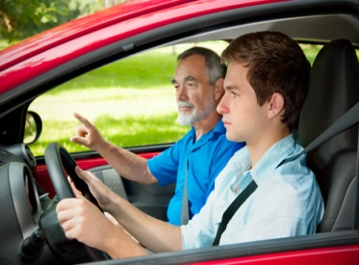
Massachusetts Adolescent Health
Motor Vehicle Injury Risk Factors

Health Survey Program, Office of Data Management and Outcomes Assessment December 2014
Massachusetts Department of Public Health | www.mass.gov/dph/hsp

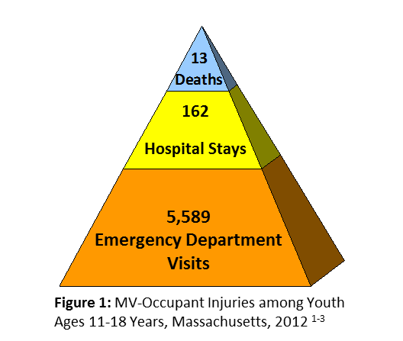
Overview

In Massachusetts (MA), a total of 5,764 youth ages 11-18 sustained injuries as a driver or passenger in a motor vehicle (MV) crash in 2012. This figure includes 13 deaths, as well as 162 hospital stays and 5,589 emergency department visits for nonfatal MV-occupant injuries (Fig. 1).¹⁻³

The majority of these deaths (92%) and nonfatal MV-occupant injuries (70%) involved youth ages 16-18, rather than those under age 16.¹⁻³ Of the 4,023 youth ages 16-18 who were injured or killed as a MV occupant in MA in 2012, only about half were identified as drivers (52%); the other youth were identified as passengers (44%) or ‘unspecified’ persons (4%).¹⁻³

Massachusetts Surveys of Youth Health Risks

Since 2007, the MA Department of Public Health (DPH) has collaborated with the MA Department of Elementary and Secondary Education (ESE) to administer two biennial surveys on the health and risk behaviors of MA youth. ESE’s Youth Risk Behavior Survey (YRBS) gathers data from high school students. DPH’s Youth Health Survey (YHS) covers topics not included on the YRBS and gathers data from both middle and high school students.

In 2013, 9,185 students in 144 public schools participated in the YHS and YRBS surveys.⁴ Presented in this bulletin are selected findings on MV risk behaviors among MA middle and high school students from both surveys.

Data limitations: YHS and YRBS data are based on self-reports from sample of middle and high school students attending MA public schools. Students in private schools or other educational setting are not represented. Data are cross-sectional, so cannot be used to determine causation. Students who have severe limitations or disabilities, or who are often absent may be under-represented in the survey.

In this bulletin:
Fatal and Nonfatal MV injuries ….…..… 1

MV Injury risk behaviors ……….………. 2-5
•Seat belt use
•Riding with a driver who had been
drinking alcohol
•Drinking and Driving
•Smoking Marijuana and Driving
•Cell phone use while driving

What’s being done? ………………….… 6
•DPH programs and strategies
•Community and state partners

Key findings from 2013:
- The percent of MA teens who reported that they always wear a seat belt when riding in a car increased from 39.4% in 2005 to 48.9% in 2013.

- The percent of MA teens who reported riding in a vehicle with a driver who had been drinking declined from 27.2% in 2005 to 18.3% in 2013.

- Emergent risk behaviors among MA high school students were: 1) driving when they had been smoking marijuana (34.8% of all drivers who ever used marijuana); 2) cell phone use while driving (32.3% texted/emailed; 39.0% talked).

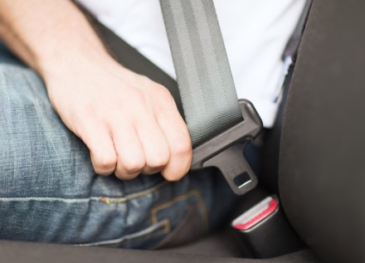
Seat Belt Use

Nationally, front seat passengers wearing their seat belts reduce their risk of death by 45% and risk of serious injury by 50%.⁵ The MA Safety Belt Law (MGL Ch 90, Sec. 13A) requires all drivers and passengers ages 12 and older to wear a seat belt in any MV, whether in the front or back seat of a car.

Survey: Middle and high school students were asked, “How often do you wear a seat belt when riding in a car driven by someone else?”

Results: Percent of students reporting always wearing a seat belt when riding in a car…
- Over time: Increased from 39.4% in 2005 to 48.9% in 2013 among high school students (Fig 2).
- By Grade: Were highest among 6th graders (67.6%) and lowest among 9-11th graders (45.8-47.2%) (Fig 3).
- By Race/Ethnicity: Were lowest among Black and Hispanic students compared to White students, in both middle and high school (Fig. 4).
- By Gender: Were not significantly different by gender (data not shown).

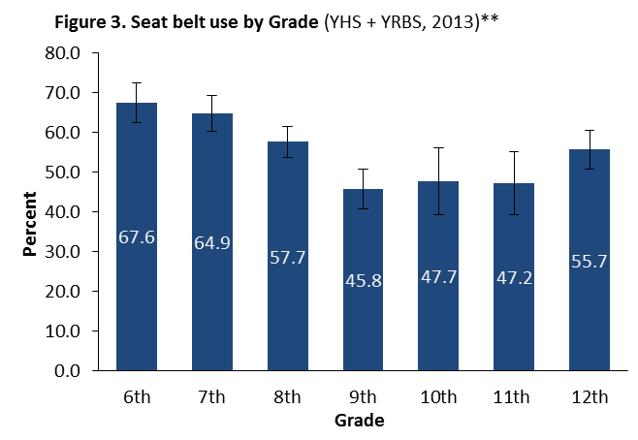
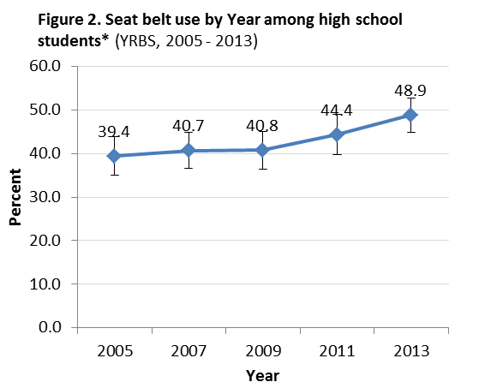
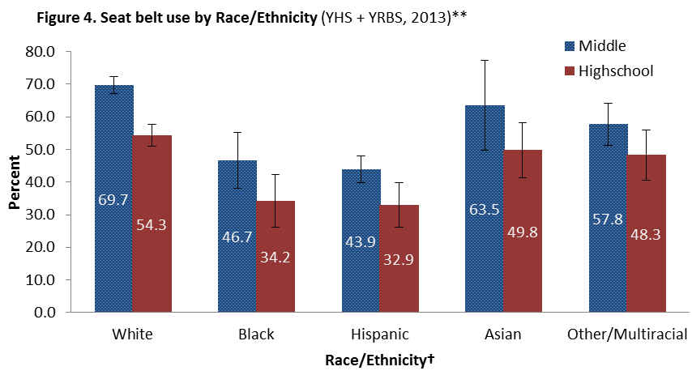

*Question not asked of middle school students until 2009. **Middle school data from YHS, high school data from YRBS. Question not asked in high school YHS. †Race categories mutually exclusive (Whites, Blacks, Asian, and Other/Multiracial are non-Hispanics). ^95% confidence intervals (CI) of percentages reported.

Riding with a driver who had been drinking alcohol
Approximately one-third of MV crash deaths in MA involve a driver who had been drinking. Although the total number of MV-occupant deaths in the state has decreased by 43% in the past decade⁶, the percentage of MV deaths from an alcohol-impaired driver has experienced little change over this time period (38% in 2001 to 36% in 2010).⁷ This percentage has remained consistently above the national average of 31% for the past decade.⁷

Survey: Middle and high school students were asked, “During the past 30 days, how many times did you ride in a car or other vehicle driven by someone who had been drinking alcohol.”

Results: Percent of students reporting riding in the past 30 days with a driver who had been drinking…
- Over time: Declined from 27.2% in 2005 to 18.3% in 2013 among high school students (Fig 5).
- By Grade: Were higher among higher grade-levels: 7.7% of 6th graders, 20.2% of 12th graders (Fig 6).
- By Race/Ethnicity and Gender: Were not significantly different by race/ethnicity nor gender (data not shown).
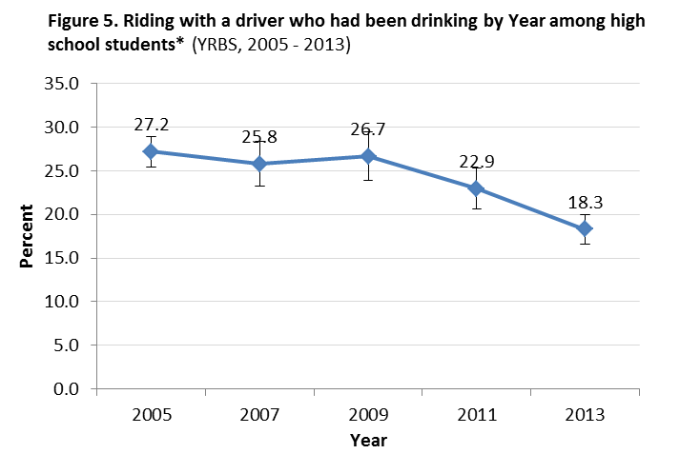

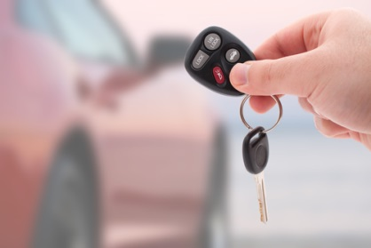

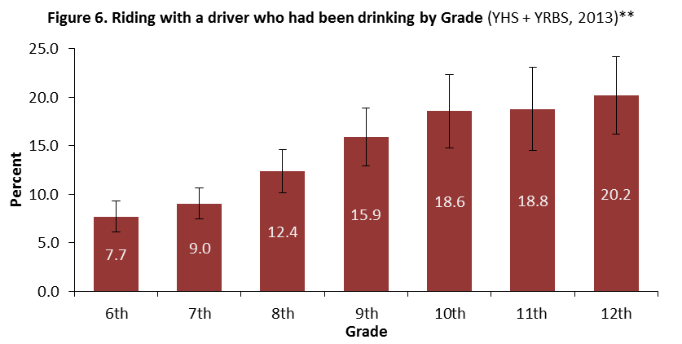

*Question not asked of middle school students until 2009. ^95% CI of percentages are reported.
**Middle school data from YHS, high school data from YRBS. Question not asked in high school YHS.

Drinking and Driving

Drinking and driving significantly increases the risk of MV injuries and deaths. Nationally in 2012, approximately 15% of 16-17 year old drivers killed in a MV-crash had a blood-alcohol concentration > 0.08.⁸ The risk of involvement in a fatal MV crash is about 8 times higher after alcohol use.⁹

Smoking Marijuana and Driving

Smoking marijuana and driving is associated with increased MV injuries and deaths: approximately 1.9 times higher risk of a MV crash⁹ and 2.1 times higher risk of involvement in a fatal MV crash. The risk of a fatal MV crash increases to 16 times after use of both alcohol and marijuana.¹⁰

Law: The MA Junior Operator's License Law imposes mandatory license suspensions for violations such as Operating Under the Influence, Operating to Endanger, and Drinking From an Open Container of an Alcoholic Beverage. Also, drivers under age 21 with a breathalyzer reading ≥ .02 or who refuse a breathalyzer test face a 180-day license suspension. Those under 18 at the time of the arrest face a full-year license suspension. These suspensions are in addition to any penalties imposed by the court. More info: www.massrmv.com/rmv/suspend/oui.htm

Survey: Beginning in 2013, high school students were asked about driving under the influence. Students who reported ever drinking alcohol were asked, “During the past 30 days, did you drive a car or other vehicle when you had been drinking alcohol?” Students who reported ever trying marijuana were asked, “In the past 30 days, did you ever drive a car or other vehicle when you had been smoking marijuana?” Results excluded non-drivers.
Table 1. High school students reporting driving in the past 30 days after drinking alcohol or smoking marijuana (YHS, 2013)*
(blank) | Recent driving after drinking alcohol (N=864) |  | Recent driving after smoking marijuana (N=646)
 | % | 95% CI | % | 95% CI
Overall | 9.1 | 7.1 - 11.2 | 34.8 | 31.0 - 38.7
Sex | (blank) | (blank) | (blank) | (blank)
Male | 10.0 | 7.3 - 12.7 | 42.4 | 36.8 - 48.0
Female | 7.5 | 4.9 - 10.0 | 24.3 | 19.1 - 29.4
Grade | (blank) | (blank) | (blank) | (blank)
9th grade | † | † | † | †
10th grade | † | † | 27.4 | 18.1 - 36.6
11th grade | 8.8 | 5.6 - 12.0 | 32.8 | 26.4 - 39.3
12th grade | 10.1 | 6.4 - 13.7 | 38.8 | 32.0 - 45.5
Race/Ethnicity** | (blank) | (blank) | (blank) | (blank)
White | 8.9 | 6.4 – 11.4 | 37.3 | 32.7 – 41.8
Black | † | † | † | †
Hispanic | 15.2 | 8.7 – 21.7 | 27.3 | 17.4 – 37.2
Other/Multiracial | † | † | † | †

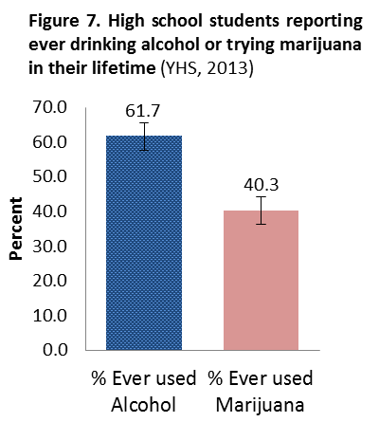

Results:
- Drinking and Driving: 61.7% of high school students reported ever drinking alcohol in their lifetime (Fig. 7).
  - Among students who reported ever drinking alcohol and who drove, 9.1% reported driving in the past 30 days when they had been drinking alcohol (Table 1). 76.1% of these students also reported driving after smoking marijuana (data not shown).§
- Smoking Marijuana and Driving: 40.3% of high school students reported ever using marijuana in their lifetime (Fig. 7).
  - Among students who reported ever using marijuana and who drove, 34.8% reported driving in the past 30 days when they had been smoking marijuana (Table 1). 29.9% of these students also reported driving after drinking alcohol (data not shown).§
- By Race/Ethnicity: No significant differences were observed.
- By Gender: More males reported driving after smoking marijuana (42.3%) than females (24.3%). Gender differences in driving after drinking alcohol were not statistically significant (Table 1).

*Includes only those who drove and reported any lifetime use of alcohol or marijuana. **Race categories are mutually exclusive. †Insufficient data. §Unknown if students engage in both risk behaviors at the same time. ^95% CI of percentages are reported.

Cell phone use while driving

In a 2012 study of MA motorists, overall cell phone use was significantly higher among teens (9.3%) than adults (7.6%). While the observed rate of talking on cell phones was similar among teen and adult drivers (6.0% vs. 6.1%, respectively), the rate of text messaging was significantly higher for teen drivers (3.3% vs. 1.5%, respectively).¹¹

Among novice 16-17 year old drivers, the risk of MV-crash or near crash was 8.3 times higher for those dialing a cell phone and 3.8 times higher for those sending or receiving texts while driving.¹² Students who texted while driving were more likely to also engage in other MV-risk behaviors, i.e. not always wearing a seatbelt, riding with someone who had been drinking, and drinking and driving, compared to those who did not text while driving.⁸

Law: In September of 2010, MA enacted the Safe Driving Law prohibiting use of mobile electronic devices by drivers under age 18. Junior Operators found talking on a cell phone or reading, writing, or sending text messages while driving face license suspension and fines. More info: www.massrmv.com/SafeDrivingLawSummary.aspx
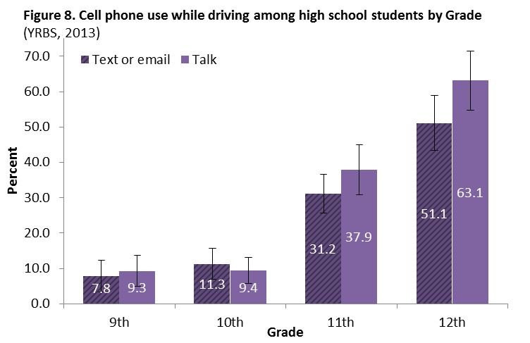
Survey: Beginning in 2013, high school students were asked: “During the past 30 days, on how many days did you text or email while driving a car or other vehicle?” and “During the past 30 days, on how many days did you talk on a cell phone while driving a car or other vehicle?” Results excluded non-drivers.

Results:
- Overall: Among high school students who drove, 32.2% reported texting or emailing and 39.0% reported talking on a cell phone while driving (data not shown).
- By Grade: 12th graders reported the highest percent of cell phone use while driving: 51.1% reported texting or emailing and 63.1% reported talking on a cell phone while driving (Fig 8).
- By Race/Ethnicity and Gender: No significant differences were observed (data not shown).

Data sources:
1. NHTSA Fatality Analysis Reporting System (FARS) Query System, Accessed 4/28/14. Drivers and passengers of cars/trucks included; motorcyclists excluded. Data collected and reported by calendar year.
2. MA Inpatient Hospital Discharge and Outpatient Observation Stay Databases, Center for Health Information and Analysis. Deaths and transfers are excluded. Includes drivers, passengers and unspecified persons; motorcyclists excluded. Data are collected and reported by fiscal year.
3. MA Emergency Department Discharge Database, Center for Health Information and Analysis. Deaths are excluded. Includes drivers, passengers and unspecified persons; motorcyclists excluded. Data are collected and reported by fiscal year.
4. Roman, A. (9/2013). 2013 Massachusetts Youth Health Survey and Youth Risk Behavior Survey Methodological Report. Center for Survey Research UMASS– Boston.
5. Dept of Transportation (US), National Highway Traffic Safety Administration (NHTSA). (2010) Traffic Safety Facts: Children. Washington (DC). DOT HS 811612. Available at: www-nrd.nhtsa.dot.gov/Pubs/811387.pdf
6. Centers for Disease Control and Prevention (CDC), National Center for Injury Prevention and Control. Web-based Injury Statistics Query and Reporting System (WISQARS), Fatal Injury Reports, Accessed 8/18/14.
7. Dept of Transportation (US), National Highway Traffic Safety Administration (NHTSA). (2012) Traffic Safety Facts: State Alcohol-Impaired Driving Estimates. Washington (DC). DOT HS 811612. Available at: www-nrd.nhtsa.dot.gov/Pubs/811612.pdf
8. Klauer, S. G., Guo, F., Simons-Morton, B. G., Ouimet, M. C., Lee, S. E., & Dingus, T. A. (2014). Distracted driving and risk of road crashes among novice and experienced drivers. New England journal of medicine, 370(1), 54-59.
9. Wolff, K., & Johnston, A. (2014). Cannabis use: a perspective in relation to the proposed UK drug‐driving legislation. Drug testing and analysis, 6(1-2), 143-154.
10. Asbridge, M., Hayden, J. A., & Cartwright, J. L. (2012). Acute cannabis consumption and motor vehicle collision risk: systematic review of observational studies and meta-analysis. Bmj, 344.
11. Wenners KE, Knodler MA, Kennedy JR, Fitzpatrick CD. (2013) A Large Scale Observational Study of Drivers’ Cell Phone Usage. Transportation Research Record 2365, 49–57.
12. Olsen, E. O. M., Shults, R. A., & Eaton, D. K. (2013). Texting while driving and other risky motor vehicle behaviors among US high school students. Pediatrics, 131(6), e1708-e1715.

What’s being done?

DPH:

- The Injury Prevention and Control Program focuses on unintentional injuries, such as those that are MV-related, and conducts research, develops policies and programs, and provides services to communities, groups, and individuals through training and health education; data collection, analysis, and reports; coalition and task force leadership; program development assistance; and public information materials. More info: www.mass.gov/dph/injury.

- The Injury Surveillance Program uses multiple data sources to track fatal and nonfatal injuries among MA residents, such as those that are MV-related. Injury surveillance is essential to monitor injury trends and to prioritize and evaluate injury prevention efforts. More info: www.mass.gov/dph/isp.

DPH Strategies:

Focus
- Seat belt use
- Graduated Driver License (GDL)/ parent class
- Ignition Interlock Science
Infrastructure
- Disseminate state data and research findings to key stakeholders
- Participate in planning and implementation of the MassDOT Strategic Highway Safety Plan
- Maintain and support Partnership for Passenger Safety and participate in Belts Ensure a Safer Tomorrow Coalition
Program
- Collaborate with the MassDOT Registry of Motor Vehicles Division to ensure that the statutorily-required parent GDL class is of high quality and takes place at the best point in the licensing process to assure retention and use of information
Policy
- Promote increased use of passenger restraints
- Promote increased use of ignition interlocks for drunk drivers
- Draft and implement a DPH Safe Driving Policy
- Participate in the planning and implementation of the MassDOT Strategic Highway Safety Plan
Data and Surveillance
- Disseminate state data and research findings (i.e. presentations, briefings, data request responses) to key stakeholders and decision makers.

Community and state partners:
- Highway Safety Division of the Executive Office of Public Safety and Security runs the federally funded Child Passenger Safety and funds police departments to perform high-visibility enforcement campaigns, e.g. “Click it or Ticket,” targeting driver seat belt use.
- MA Department of Transportation (MassDOT) coordinates stakeholder input for the MA Strategic Highway Safety Plan, which highlights areas of impaired and distracted driving, seat belts, and teen drivers.
- Partnership for Passenger Safety is a statewide coalition of traffic safety advocates, coordinating public and private resources to support safe transportation of all MV-occupants in MA.
- Prevent Injuries Now! Network is a network of community organizations and agencies working together to provide education and resources that promote injury prevention strategies.
- Northeast and Caribbean Injury Prevention Network is an association of injury control professionals from 8 states and 2 territories. This network plans community-based interventions, develop program guidelines, and conduct program evaluations.

Acknowledgements: The Massachusetts Adolescent Health Bulletin was produced by the Health Survey Program in collaboration with the Injury Surveillance and Injury Prevention and Control Programs at DPH to raise public awareness of the toll of MV-related injury in the Commonwealth and the importance of injury prevention efforts. Thank you to students and faculty of MA public schools who participated in the surveys and to ESE and the Center for Survey Research of UMass-Boston for their collaboration in making these surveys possible. Survey reports on MA youth health and risk behaviors are available at: www.mass.gov/dph/hsp.

MASSACHUSETTS DEPARTMENT OF PUBLIC HEALTH, HEALTH SURVEY PROGRAM
www.mass.gov/dph/hsp | Released December 2014

