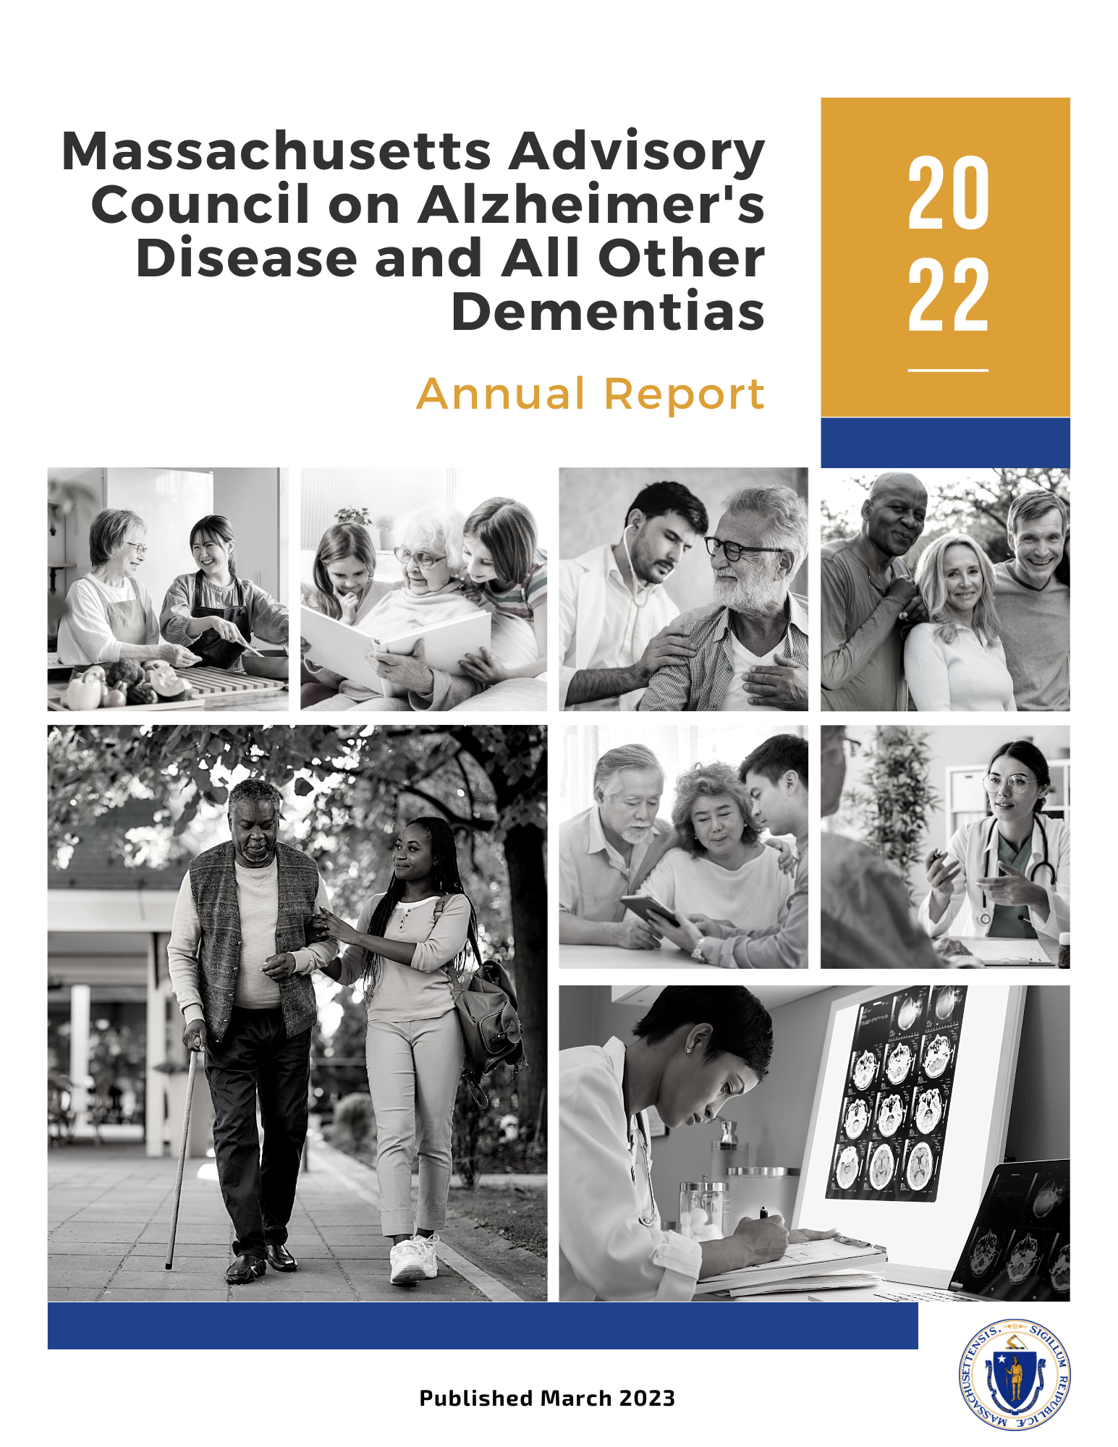

TABLE OF CONTENTS
EXECUTIVE SUMMARY…….……………………………………………………………………………..…………3
A Year in Review and the Year Ahead……………………………………………………….…………………..….3
Massachusetts State Plan on Alzheimer’s Disease and Related Dementias:
A Living Document……………………………………………………………………………………………….………..…5

INTRODUCTION……………………………………………..…………………………………..……………….……6

IMPLEMENTING EFFECTIVE AND SUSTAINABLE SOLUTIONS………………….…………….….…8

Progress, Accomplishments, and Next Steps …………………………………………………….………………8
- Caregiver Support and Public Awareness…………………………………………………………….…9
- Diagnosis and Services Navigation………………………………………………………………………..12
- Equitable Access and Care…………………………………………………………………………………….16
- Physical Infrastructure………………………………………………………………………………………….19
- Public Health Infrastructure……………………………………………………………………….…………22
- Quality of Care………………………………………………………………………………….……………..…..25
- Research……………………………………………………………………………………………….……….…….28

LOOKING TO THE FUTURE…..…………………………………………………………………………………..30

AMENDMENT TO THE MASSACHUSETTS STATE PLAN ON ALZHEIMER’S DISEASE AND RELATED DEMENTIAS, 2022……………………………………………………………………..……………..31
APPENDIX A: MEMBERS OF THE MASSACHUSETTS ADVISORY COUNCIL ON
ALZHEIMER’S DISEASE AND ALL OTHER DEMENTIAS…………………………………….…………35
APPENDIX B: IMPLEMENTATION TEAMS & WORKGROUPS……………………….…….………37
APPENDIX C: THEMES FROM FOCUS GROUP SESSIONS WITH
PEOPLE AFFECTED BY DEMENTIA………………………………………………………………………….…41

EXECUTIVE SUMMARY
A Year in Review and the Year Ahead
During calendar year 2022, the Advisory Council on Alzheimer’s Disease and All Other Dementias continued its work to implement the recommendations presented in the Massachusetts State Plan on Alzheimer’s Disease and Related Dementias, April 2021 (state plan). This year’s annual report documents the Council’s progress during 2022 and its next steps for the year ahead. The table below is a high-level summary of the report.
CAREGIVER SUPPORT AND PUBLIC AWARENESS
Began implementing new activities and initiatives to improve public awareness of supports and services available for Massachusetts residents and families affected by dementia.
- Distributed a video for caregivers of people living with dementia to cable TV stations and the aging services network; plans are underway to develop similar videos in Spanish and Portuguese.
- Made improvements to the state’s website on dementia by incorporating valuable feedback received from caregivers and people living with dementia.
- Began implementing initiatives at EOEA to identify opportunities to improve awareness of and access to services provided by Aging Services Access Points (ASAPs) and the aging services network.
- Launched efforts at EOEA aimed at enhancing outcomes among ASAP consumers, including outcomes around caregiver experience.
- Plans are underway to develop caregiver videos in Spanish and Portuguese.
DIAGNOSIS AND SERVICES NAVIGATION
Provided guidance to acute care settings on effectively recognizing and managing dementia patients; expanded the state’s capacity to provide support after a dementia diagnosis; and began assessing approaches for effective screening and diagnosis workflow.
- In collaboration with the Massachusetts Health and Hospital Association, developed a roadmap for acute care settings on implementing dementia operations plans.
- Attained $100,000 in state funding in fiscal year 2023 to expand access to dementia care coordination, which is a model for providing support to individuals diagnosed with dementia and their care partners.
- Plans are in progress to develop a guide for clinicians around initiating a conversation about a dementia diagnosis.
- Planning to examine, assess, and determine the feasibility of implementing innovative approaches to relieve primary care providers (PCP) burden around dementia screening and diagnosis workflow.
- Beginning to formulate strategies to identify, examine, and take opportunities in the home care program to advocate for appropriate screening, diagnosis, care, support, and treatment.
EQUITABLE ACCESS AND CARE
Established a common understanding of diversity, equity, and inclusion; and amended the Massachusetts State Plan on Alzheimer’s Disease and Related Dementias to close gaps in equity and inclusion for individuals affected by younger-onset dementia.
- Established a common baseline of knowledge for Council members on diversity, equity, and inclusion (DEI).
- Developed a draft DEI vision statement and pledge for the Council.
- Revised the Massachusetts State Plan on Alzheimer’s Disease and Related Dementias to include an implementation plan for addressing unmet needs and closing gaps in equality, equity, and inclusion for people and families affected by younger-onset dementia.
- Planning to deploy members of an Equity and Inclusion Team to the Council’s workgroups in 2023 to provide collaborative advice on building a foundation of DEI into their work.
PHYSICAL INFRASTRUCTURE
Made significant strides in improving stakeholder awareness and understanding of age and dementia friendly design considerations for physical infrastructure.
- Published an extensive guide entitled, Age and Dementia Friendly Design Considerations for Physical Infrastructure.
- Distributed the guide to architects, engineers, designers, builders, city/town planners, regional planners, municipal and state government officials, Council on Aging directors, and library directors.
- Succeeded in spreading awareness of age and dementia friendly design by delivering presentations and leading discussions about the guide with numerous stakeholder organizations.
- Began discussions with state officials in an effort to incorporate age and dementia friendly elements in future state procurements.
PUBLIC HEALTH INFRASTRUCTURE
Began efforts to seek resources and funding to implement activities designed to improve the state’s public health infrastructure around dementia.
- Began to assess interest and identify ideas around a five-year grant opportunity from the Centers for Disease Control and Prevention (CDC), which was subsequently announced in January 2023.
QUALITY OF CARE
Gained a better understanding of what people living with dementia and their caregivers experience when communicating with physicians.
- Convened focus groups comprised of patients diagnosed with dementia and caregivers of persons living with dementia to attain an understanding for what they experience while communicating with physicians.
- Plans are underway to examine the focus group findings and their implications; and use them to guide the work of the Council’s “Care Planning Implementation Team.”
- Planning to assess the value of creating a new tool or using existing tools to help people living with dementia and their caregivers improve their communication with health care providers in a manner that effectively expresses their preferences and goals.
- Began efforts to recruit a new leader(s) and members of the Council’s
“Interprofessional Staffing and Training Team” to develop a plan that ensures that providers across the state receive the training and support needed to build and retain interprofessional dementia care teams.
RESEARCH
Planning to engage the Council in a discussion to reevaluate its goal and/or strategies associated with dementia research.
- With both of the Council’s open researcher seats filled in late 2022, plans are in progress to engage the Council in a discussion to reevaluate and potentially reframe the goal and/or strategies of the Council’s “Research Workstream.”
Massachusetts State Plan on Alzheimer’s Disease and Related Dementias: A Living Document
The Massachusetts State Plan on Alzheimer’s Disease and Related Dementias,
April 2021 (state plan) is part of the state's continuous commitment to support people living with dementia and their families. It is a living document that the Council will update on an ongoing basis as it continues its work.

Calendar year 2022 marks the first year that the Council has voted to adopt an amendment to the state plan, which can be found later in this report in the section entitled, Amendment to the Massachusetts State Plan on Alzheimer’s Disease and Related Dementias, 2022. As the Council adopts new state plan amendments, it will document them within its annual reports and place them in a link within the Massachusetts State Plan on Alzheimer’s Disease and Related Dementias.

The Council expects to adopt state plan amendments whenever it fully and successfully executes the state plan’s strategies within any of its seven workstreams or when new challenges arise. The purpose of state plan amendments is to refresh the plan with new strategies to address the most important challenges encountered by Massachusetts residents and families living with dementia. In doing so, the Council will continue to stay abreast of those challenges; pool its expertise and resources; assess progress; and find and implement sustainable solutions.

The Council, its workgroups, and implementation teams remain keenly focused on the well-being of Massachusetts residents and families living with dementia. This is evidenced by the accomplishments and next steps included in this report. The Council looks forward to continuing to use the state plan and its amendments as its guide, attaining meaningful progress every year, and enhancing quality of life for each and every Massachusetts resident and family affected by dementia.
INTRODUCTION
As required by Massachusetts General Laws, Chapter 220 of the Acts of 2018, the Massachusetts Advisory Council on Alzheimer’s Disease and All Other Dementias (Council) has prepared this report for the Executive Office of Health and Human Services (EOHHS) and Legislature. The Council was established to write a state plan and provide EOHHS and the Legislature with advice on policies around Alzheimer’s Disease and Related Dementias (ADRD). As shown in Appendix A, the 17-member Council is comprised of a diverse group of public health professionals, clinicians, healthcare providers, researchers, legislators, dementia advocates, and caregivers.

This report is the Council’s third annual report and its second since April 2021 when it published the Massachusetts State Plan on Alzheimer’s Disease and Related Dementias (state plan). Since April 2021, the Council has been using the state plan as its roadmap to better meet the needs of the Commonwealth's 130,000 residents diagnosed with dementia, supported by 284,000 family caregivers, and an estimated 130,000 or more residents currently living with dementia without a formal diagnosis. Specifically, the state plan includes recommendations and implementation plans around seven focus areas, or “workstreams,” which appear here in alphabetical order:
- Caregiver Support and Public Awareness
- Diagnosis and Services Navigation
- Equitable Access and Care
- Physical Infrastructure
- Public Health Infrastructure
- Quality of Care
- Research

This document summarizes progress, accomplishments, and next steps for each of the state plan’s seven focus areas. As shown in Appendix B, this progress was made possible by volunteers that continue to help the Council implement the state plan’s recommendations. The Council remains grateful for their valuable expertise, insight, resources, time, and commitment to address the challenges of dementia faced by Massachusetts residents, families, and caregivers. This report embodies the state’s continued commitment to ensure that its residents affected by dementia receive the support, services, and care they need to live healthy and meaningful lives.
IMPLEMENTING EFFECTIVE AND SUSTAINABLE SOLUTIONS

Progress, Accomplishments, and Next Steps
This report is the result of an extensive review of the Council’s progress during calendar year 2022 in its continued efforts to implement the strategies included in the Massachusetts State Plan on Alzheimer’s Disease and Related Dementias, April 2021 (state plan). The following pages comprise seven sections, one for each of the Council’s focus areas, or “workstreams.” Each section includes the goals of the workstream; the state plan’s recommendations to advance those goals; and a summary of the Council’s progress during calendar year 2022. Additionally, each section concludes with a list of the next steps that the Council plans to begin in 2023 as part of its continued implementation of effective and sustainable policies and practices. In many cases, these next steps involve building the organizational and team infrastructure necessary for effective implementation.

1. Caregiver Support & Public Awareness
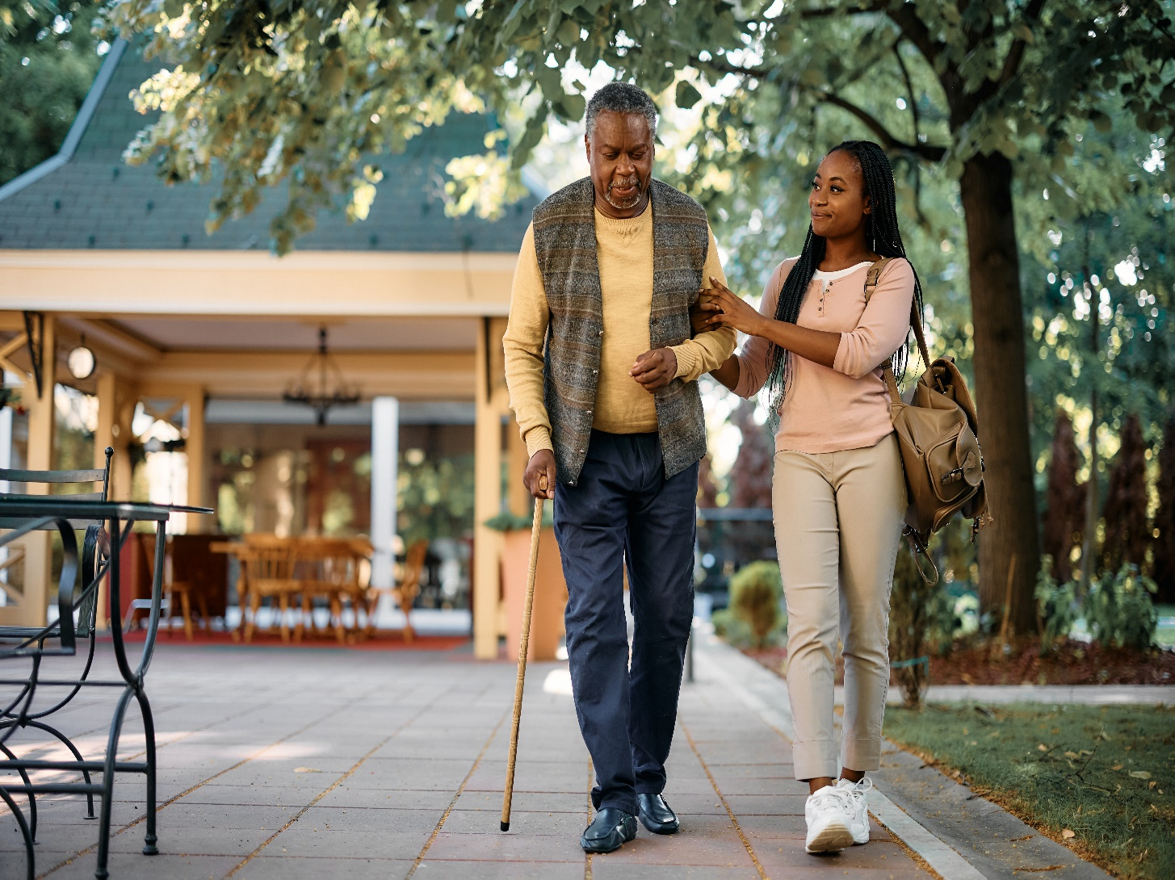
Goals
- Identify short-term approaches to improve awareness of the pathways to available supports and services for dementia caregivers and persons living with dementia

- Compare and evaluate the experiences of caregivers of people living with dementia as they navigate the Commonwealth’s system of supports and services

Recommendation #1 (Video Production)

Make and distribute three videos (English, Portuguese, Spanish)
of caregivers talking about the help they got, and how they got it
Progress and Accomplishments
- In 2022, distributed a 30-minute video that the Council created in 2021 to cable TV stations and distributed a link to it to the state’s aging services network.
- Developed a plan at the Alzheimer’s Association, MA/NH Chapter to develop similar 30-minute caregiver videos in Spanish and Portuguese.
Next Steps
- Develop and finalize caregiver videos in Spanish and Portuguese and make them available on the state’s website, cable TV stations, and the newsletters, bulletins, and websites of senior centers, aging services agencies, and other stakeholder organizations.
- Develop and implement a plan to produce similar videos in additional languages.
- Produce brief videos (“teasers”) to spread awareness and encourage viewing of the full 30-minute videos.

Recommendation #2 (Website Development)
Place on the Massachusetts Executive Office of Elder Affairs website,
an overview of statewide pathways, services, and supports
for people living with dementia and their caregivers
Progress and Accomplishments
- Conducted focus group sessions and interviews with caregivers and people living with dementia and based on their valuable feedback, made improvements to the new website.
- Through social media and newsletters, encouraged organizations throughout the Commonwealth’s aging services network to place the new website’s link in their websites, newsletters, and bulletins.
Next Steps
- Add a section on younger-onset dementia to EOEA’s website. For more information, please see the section of this report on younger-onset dementia entitled, Amendment to the Massachusetts State Plan on Alzheimer’s Disease and Related Dementias, 2022.

Recommendation #3 (Caregiver Experience)

Implement changes at the Aging Services Access Points (ASAPs) to ensure that stressed caregivers get what they need in an effective and consistent manner
Progress and Accomplishments
- The Executive Office of Elder Affairs (EOEA) began conducting an extensive review and update of its ASAP designation review process. The intent of the designation update is to evaluate, assess, and improve the quality of ASAPs’ many services and programs for aging adults and their caregivers; and to improve outcomes including caregiver experience. This review will continue throughout 2023.
- The Centers for Medicare and Medicaid approved EOEA’s proposal to use American Rescue Plan Act Home and Community Based Services (ARPA HCBS) grant funding to perform an agency branding and promotion project. This work aims to improve access to programs and services offered by EOEA and the aging services network.
Next Steps
- Beginning in 2023, as part of its update of the ASAP designation review, EOEA will survey ASAP consumers to gather valuable information about their experiences. To ensure that the survey questions are sensitive to the needs of people living with dementia and their caregivers, EOEA will seek and attain feedback about the survey questions from selected Council members.
- To further assess consumer experiences while interacting with ASAPs, beginning in 2023, EOEA will develop and implement a robust “consumer experience testing” initiative that will include caregivers of people living with dementia. Before finalizing EOEA’s “consumer experience testing” scripts and criteria for evaluating findings, EOEA will seek and attain feedback from selected members of the Council.
- Beginning in 2023, as part of EOEA’s branding and promotion project, a market research team will examine EOEA’s programs and services and how they are perceived by consumers. Specifically, the team will convene focus groups with caregivers (including people who care for individuals living with dementia) to identify areas for improvement in the caregiver experience.
- Additionally, as part of EOEA’s branding and promotion project, the market research team will interview EOEA’s key stakeholders to help attain a comprehensive understanding of the public’s knowledge, attitudes, and perceptions about EOEA and its programs. To further ensure that the perspectives of individuals living with dementia and their caregivers are included in this research, the team will include one of the co-leaders of the Council’s workstream on Caregiver Support and Public Awareness in the key stakeholder interviews and additional input will be sought in other parts of the research phase.

2. Diagnosis & Services Navigation
Goal
Increase the number of people living with dementia
who are diagnosed, informed of their diagnosis,
and able to effectively attain helpful
information, services, and care planning
Recommendation #1 (Diagnosis)
Significantly increase the numbers of undiagnosed or cognitively impaired residents who are diagnosed with dementia and informed of their diagnosis
Progress and Accomplishments
- In collaboration with the Massachusetts Health and Hospital Association (MHA), developed a user-friendly roadmap on how to develop dementia operations plans, which are essential for effective recognition and management of acute care patients with dementia or delirium.
- Included recommendations within the operations plan roadmap such as critical team members for effective plan development; pathways for plan development and implementation; and outcome measures for ongoing quality assurance and performance improvement.
- Released, presented, and discussed the above roadmap during a webinar in October 2022 where over 300 individuals participated. The program slides can be accessed here; and the webinar recording can be found here.
- Due to PCP time constraints, the Council decided on an alternative method to address issues around the state’s capacity to conduct dementia screenings. Specifically, rather than piloting a dementia screening workflow at primary care practices, the Council will assess innovative approaches that have been implemented across the country. For additional details, please see the second bullet in the “Next Steps” section below.
Next Steps
- To supplement the roadmap released in 2022 for the development of dementia operations plans, the Alzheimer’s Association will work with MHA to develop a toolkit to potentially:
  - include detailed options for screening and training;
  - share sample plans to help hospitals learn from each other; and
  - educate families/consumers on how to advocate for a loved one.
- Examine, assess, and determine the feasibility of implementing innovative approaches to relieve PCP burden around dementia screening and diagnosis workflow. For example:
  - alternate payment models;
  - better utilization of Annual Wellness Visits (Medicare Advantage);
  - Hub & Spoke models, e.g., Georgia Memory Net and Vermont’s Hub & Spoke initiative; and
  - Care Ecosystem model & utilization of community health workers, e.g., Care Ecosystem at UCSF and Initiative at Cooley Dickinson.
  - Expand participation in Project ECHO, providing training and support for primary care practices in delivering quality dementia care.
  - Given the emergence of new treatments, efforts will be explored to incorporate expanded initiatives to diagnose within treatment protocols
- In collaboration with the Massachusetts Board of Registration in Medicine (BORIM) and the Executive Office of Elder Affairs (EOEA), develop and include guidance as an addendum to BORIM’s dementia diagnosis-related guidance released in November 2021.
Specifically:
  - develop clear, concise, time-saving guidance that explains how to attain informed consent; takes the guesswork out of how to initiate diagnosis conversations; engages family care partners; and directs patients to resources and support; and
  - develop Practice Guidelines as new treatments for dementia are approved (Alzheimer’s Association); and ensure equal access to all residents who are appropriate for specific therapies.
- Examine the processes that Aging Services Access Points use to identify consumers of the state’s home care program who are demonstrating characteristics or behaviors that are consistent with undiagnosed dementia. Identify opportunities to enhance education and advocacy in a manner that supports consumer and family caregiver awareness and generates appropriate healthcare, treatment, and care.
Specifically:
  - convene a team with EOEA to identify, examine, and seize opportunities in the home care program to advocate for appropriate screening, diagnosis, care, support, and treatment.

Recommendation #2 (Services Navigation)
Ensure that after a dementia diagnosis, individuals and their families have access to comprehensive information and care planning services
Progress and Accomplishments
- As a result of Council member involvement, the legislature earmarked $100,000 for the Alzheimer's Association, MA/NH Chapter in the FY2023 elder home care program budget at the Executive Office of Elder Affairs. The purpose of the funding is to expand access to direct referral dementia care coordination (DCC), which is a positive and proven model for providing prompt support to people diagnosed with dementia and their caregivers.
Next Steps
- Due to competing priorities and a shortage of staff support, the Council’s Services Navigation Implementation Team was unable to meet throughout FY2022.
- The team plans to reconvene in FY2023 to review its plan; adjust it where necessary; and implement approaches to address the important issues around services navigation faced by people living with dementia and their caregivers.
- Specifically, the team will review and make any necessary adjustments to the following activities reported as next steps in last year’s annual report:
  - Develop a digital version of a document similar to a resource available from the National Institute on Aging that includes steps to take after a diagnosis of Alzheimer’s disease or other dementia as well as links to local resources.
  - Work with primary care providers to determine the most helpful information to include in a road map designed to direct people diagnosed with dementia and their caregivers to comprehensive, easy-to-access information and support.
  - Determine the feasibility of including in electronic medical records (EMRs) information and links to services and supports for people living with dementia and their caregivers.
  - Develop strategies and an implementation plan for primary care providers on how to interact with unaccompanied and unsupported individuals diagnosed with dementia.
- Additionally, representatives from the Council’s Diagnosis and Services Navigation Workstream will:
  - continue working to pass pending legislation that would include dementia care coordination (DCC) as a required benefit for MA Senior Care Option (SCO) members; and
  - explore strategies to expand DCC services to cover many more MA families in need of this core service including partnerships to expand access to underserved populations. Partnerships to include Senior Care Options plans (dual eligibles), community health centers, and hospitals/practices serving underrepresented populations.

3. Equitable Access & Care

Goal
Close gaps in equitable access to information,
supports, services, and care
Recommendation #1 (Equity & Inclusion Consultancy)
Form and deploy a team to advise each of the Council’s implementation teams on how to close informational gaps and address fragmentation
of care access, care planning, and dementia services

Progress and Accomplishments
- Established a common baseline of knowledge for Council members on diversity, equity, and inclusion:
  - Provided members with the opportunity to participate in a two-day workshop facilitated by the Racial Equity Institute (REI).
  - Received positive feedback from Council members about REI’s workshop; and facilitated a post-training discussion to reflect on what the participants learned.
  - Convened Council discussions on why diversity matters, the racial and ethnic makeup of Massachusetts; and the common non-English languages spoken in the Commonwealth.
  - Presented and discussed a common set of definitions of terms around diversity, equity, and inclusion (DEI);
  - Invited residents affected by dementia to speak to the Council about their challenges and cultural barriers; and engaged in discussions about how those challenges affect equitable access to quality dementia care.
- Developed a draft DEI vision statement and pledge to ensure that the Council addresses inequities as it develops policy recommendations, programs, and resources; and holds itself accountable for successes and failures.
- Developed and distributed to the Council a brief document entitled, Societal Barriers to Quality Dementia Care, Services, Support, and Risk Reduction, which provides examples of how some populations experience greater societal barriers than others.
Next Steps
- Form an Equity and Inclusion (EI) team, making it as heterogeneous as possible and convene a kick-off meeting to review, discuss, and agree upon the team’s objectives and approach.
- Ask the EI team to review and edit the Council’s draft DEI vision statement and pledge.
- Convene the EI team to learn from each other to better understand barriers that may prevent certain groups from benefiting from the Council’s work. Ask team participants to respond to the following questions:
  - What challenges have you encountered associated with dementia that are specifically due a lack of cultural understanding?
  - What benefits have you experienced when interacting with people who had a solid understanding of your cultural community?
  - What do you think are some of the reasons for the barriers and potential approaches to eliminate them, weaken them, or mitigate their impact?
- Deploy EI team members to the Council’s workgroups to help the Council achieve its goal of building a solid foundation of DEI into its work:
  - Ensure that the EI team provides workgroups with collaborative advice on refining recommended policies, implementation plans, activities, programs, or deliverables.

Recommendation #2 (Younger-Onset & Equity Analysis)
Conduct an analysis of the needs of people affected by younger-onset dementia and provide guidance for other teams on how to apply an
equity and inclusion lens by using this population as a case study
Progress and Accomplishments
- Applied an equality, equity, and inclusion lens to identify gaps in services, supports, information, and care for individuals and families affected by younger-onset dementia.
- Developed a list of “barriers to equity,” including unmet needs of individuals living with younger-onset dementia or their care partners that stem from the differing nature of their needs compared with those of older adults.
- Presented recommendations to the Council on addressing unmet needs and closing gaps in equality, equity and inclusion for people and families affected by younger-onset dementia.
- Upon the Council’s approval, revised the Massachusetts State Plan on Alzheimer’s Disease and Related Dementias to include recommendations and an implementation plan around younger-onset dementia.
Next Steps
- To view the Council’s next steps around younger-onset dementia, please refer to the section later in this report entitled, Amendment to the Massachusetts State Plan on Alzheimer’s Disease and Related Dementias, 2022.

4. Physical Infrastructure
Goal
Identify and incorporate dementia-friendly
physical infrastructure into age-friendly
physical infrastructure work

Recommendation #1 (Awareness)
Raise awareness of the importance of age- and dementia-friendly design
Progress and Accomplishments
- Developed a guide entitled, Age and Dementia Friendly Design Considerations for Physical Infrastructure. The purpose of the guide is to help readers rethink how they plan, design, build, renovate, and maintain the Commonwealth’s built environment with a special focus on the needs of Massachusetts residents as they age.
- Delivered presentations and led discussions about the guide with organizations including the Boston Society for Architecture, Massachusetts Council on Aging, Leading Age National, Massachusetts Healthy Aging Collaborative, and Mass Trails.
- Presented the guide as part of a presentation to a Boston Society for Architecture Symposium entitled, Intersections: Mobility, Equity, and the Built Environment.
- Included the guide in a presentation for a webinar hosted by the national office of AARP,
which focused on age- and dementia-friendly integration.
- Distributed the guide to architects, engineers, designers, builders, city/town planners, regional planners, municipal and state government officials, Council on Aging directors, library directors, and more:
  - Included a link to the guide in the Massachusetts Healthy Aging Collaborative’s (MHAC) newsletter and included it in MHAC’s letter to the Healey-Driscoll transition team.
  - Shared the guide with regional planning agencies in Massachusetts involved in age- and dementia-friendly efforts.
  - Distributed the guide to Council on Aging directors within more than 50 communities that received earmarked state funding in FY2023 for the construction and/or maintenance of public facilities.
Next Steps
- Work to share and discuss the Council’s recently released guide entitled, Age and Dementia Friendly Design Considerations for Physical Infrastructure with representatives and members of the Massachusetts Municipal Association and Massachusetts Health and Hospitals Association.
- Work with the American Planning Association - Massachusetts to include the guide in its spring newsletter.
- Continue to encourage age- and dementia-friendly communities and local and regional planning agencies to refer to the guide as they plan for, design, and build physical infrastructure throughout the Commonwealth. Additionally, encourage them to refer to the guide as they prepare applications for relevant funding.
- Continue to build partnerships with the design, planning, and public infrastructure procurement communities to establish a common language and understanding of age- and dementia-friendly design.
- Continue to examine state, municipal, and other built environment funding streams; and identify those that are potential candidates for the inclusion of age- and dementia-friendly design criteria.

Recommendation #2 (Public Project Scoring)
Incorporate age- and dementia-friendly scoring into
all state-funded physical infrastructure projects

Progress and Accomplishments
- Initiated discussions with the Massachusetts Division of Capital Asset Management and Maintenance to identify and pursue opportunities to incorporate age- and dementia-friendly scoring and/or characteristics into their projects.
Next Steps
- Continue to work to incorporate dementia friendly elements in future state procurements by discussing opportunities with state officials managing procurement processes and/or add the following language to state procurement documents:
- “Preference in this competition will be given to proposals that reflect the needs of older adults including those living with dementia.”
- Pursue potential opportunities to integrate age- and dementia-friendly elements in the Massachusetts Department of Transportation’s Pedestrian and Bicycle Transportation Plans and investments.
- Work with the Massachusetts Division of Capital Asset Management and Maintenance to continue to explore opportunities.

5. Public Health Infrastructure
Goal
Reduce the risk of dementia among Massachusetts
residents while enhancing the state’s public health infrastructure to address dementia

Recommendation #1 (Risk Reduction & Public Health Infrastructure)
Seek opportunities and implement strategies to reduce the
risk of dementia among our residents while enhancing the
state’s public health infrastructure to address dementia
Progress and Accomplishments
- Began to assess interest at the Massachusetts Department of Public Health (DPH) in a five-year grant opportunity from the Centers for Disease Control and Prevention (CDC), which is expected to be announced in 2023:
  - The team includes staff from DPH, the Massachusetts Executive Office of Elder Affairs, and the Alzheimer’s Association, MA/NH Chapter.
  - The grant, entitled BOLD Public Health Programs to Address Alzheimer’s Disease and Related Dementias (ADRD), is a potential funding opportunity for state and local departments of public health. It carries out actions from the Building Our Largest Dementia (BOLD) Infrastructure for Alzheimer's Act PL115-406.
  - The purpose of the grant is directly related to the goals of the Council’s Public Health Infrastructure workstream, and very much aligned with all of the Councils’ recommendations and implementation plans. Generally speaking, the grant intends to fund public health departments to:
    - increase their capacity to contribute to the field of ADRD;
    - expand and improve the response to ADRD in their jurisdictions;
    - develop a connected approach to build the dementia infrastructure, including addressing social determinants of health to facilitate health equity; and
    - improve the public health approach to ADRD using the CDC HBI.
- Due to competing and important demands on staff time at DPH, the Council did not have the opportunity to enlist a leader(s) and workgroup members to begin the 2022 activities it had planned for this recommendation.
Next Steps
- When the CDC releases the Notice of Funding Opportunity (NOFO) for the BOLD infrastructure grant, reconvene a small team to:
  - further assess DPH’s interest in the grant;
  - potentially work in collaboration with DPH to apply for the grant; and
  - more importantly, identify innovative approaches for working collaboratively with DPH to manage grant activities if funding is awarded.
- Without jeopardizing progress on DPH’s ongoing programs and initiatives, identify and implement creative approaches that help advance this workstream’s goal. In so doing, effectively tap the valuable and essential expertise at DPH in the areas of:
  - promoting risk reduction;
  - addressing Social Determinants of Health;
  - promoting health equity; and
  - developing community-clinical linkages.
- In light of all of the above, reevaluate and potentially revise the following strategies indicated in last year’s annual report:
  - Recruit individuals from the Massachusetts Department of Public Health to participate in a Risk Reduction and Public Health Infrastructure Team.
  - Review and prioritize the risk factors and risk reduction approaches listed for consideration in the Massachusetts State Plan on Alzheimer’s Disease and Related Dementias, April 2021.
  - Review potential approaches that promote effective use of community health workers for risk reduction as well as healthcare and service navigation.
  - Review the Commonwealth's public health infrastructure around dementia, beginning with a focus on dementia risk reduction.
  - Identify strategies and develop an implementation plan to address dementia risk factors while enhancing the state’s public health infrastructure to address dementia.

6. Quality of Care
Goal
Identify gaps in quality of care for people
living with dementia in Massachusetts,
as well as strategies to close those gaps

Recommendation #1 (Care Planning)

Develop a person-directed care plan framework and template
Progress and Accomplishments
- Planned focus groups for people affected by dementia and created resources, including focus group participant recruitment materials, phone screening protocols, scripts, discussion questions, and suggested follow-up questions for facilitators. Engaged stakeholders across the state to broaden recruitment efforts, ensuring diversity of participants.
- Convened four focus groups: two for people living with dementia; and two for family caregivers of people living with dementia.
- Below are some of the themes gleaned from the people living with dementia who participated in the focus group discussions. (Please see Appendix C for a complete list):
    - participants experienced delays in getting the diagnosis and difficulty with the diagnostic process;
    - there were complaints of memory problems not being taken seriously; and difficulty getting an appointment with a neurologist;
    - the diagnostic process was described as brutal, traumatic, and debilitating;
    - participants lacked awareness of what to expect;
    - care and support were not available during the process; and some were told to “go home and get your affairs in order, see you in 6 months” with no guidance offered; and;
    - the need for care and support were among the most important things participants wanted healthcare providers to know about them.
- Below are some of the themes gleaned from the family caregivers who participated in the focus group discussions. (Please see Appendix C for a complete list):
    - participants expressed a need for healthcare providers to believe them when they say there is a problem;
    - family caregivers experienced a lack of guidance; care coordination; care management; navigation; and care integration, especially between the PCP and specialists; and
    - participants expressed a need for health care providers to listen to them and acknowledge who they are in the process.
Next Steps
- Examine the focus group findings and their implications; and use them to guide the work of the Council’s Care Planning team.
- Assess the value of creating a new tool or using existing tools to help people living with dementia and their caregivers improve their communication with health care providers in a manner that effectively expresses their preferences and goals.
- Explore opportunities and approaches for distributing tools to families and providers to:
    - ensure practitioners/providers value and utilize the input and experiences of the patient/person living with dementia and their caregivers; and
    - promote the partnership between practitioners and their patient/person living with dementia and their caregivers to utilize the person-driven model of care planning.
- Initiate collaborative activities between the Council’s Care Planning team and the Council’s other workstreams to address the need for an effective reciprocal relationship between the person living with dementia and their healthcare provider:
    - Equitable Access & Care Workstream - Ensure that the Council’s Care Planning team’s outcomes meet the needs of diverse populations.
    - Caregiver Support & Public Awareness Workstream - Consider and assess the feasibility of creating a public awareness campaign that would highlight the value of an effective reciprocal relationship between the person living with dementia and their practitioner/provider.
    - Diagnosis & Services Navigation and Quality of Care Workstreams - Explore and implement solutions that ensure the value of a reciprocal relationship between the person living with dementia and their practitioner/provider is part of provider education.

Recommendation #2 (Staffing & Training)

Develop a plan that ensures that staff in primary care, long-term care and home-care settings across the state receive the training and support
needed to build and retain interprofessional dementia care teams
Progress and Accomplishments
- After the team’s leader resigned, began efforts to recruit a new leader(s) and members of the “Interprofessional Staffing and Training Team” to implement this recommendation, i.e., Recommendation #2, as indicated above.
Next Steps
- Recruit a leader or co-leaders, to lead an “Interprofessional Staffing and Training Team,” and identify and recruit a wide range of professionals and key stakeholders to join the team.
- Determine how to leverage the expertise of existing teams and/or centers of excellence to support interprofessional dementia care training and ongoing coaching.
- Examine existing interprofessional dementia care models.
- Develop a collaborative path with the Institute for Healthcare Improvement’s Age-Friendly Health System movement.
- Continue to ensure that the needs of individuals and families affected by dementia are reflected and effectively addressed by task forces operating outside of this Council as they address statewide issues around direct care worker training, support, recruitment, and retention.

7. Research
Goal
Advance dementia research in Massachusetts

Recommendation #1 (Research Diversity)

Increase diversity of dementia research and researchers
Progress and Accomplishments
- Despite considerable interest in this workstream’s recommendation, the Council was unable to identify an individual(s) with enough bandwidth in 2022 to form and lead a team to begin implementing it.
- See “Next Steps” below to learn how the Council plans to move forward.
Next Steps
- For the reasons listed below, review, reevaluate, and potentially change or rewrite this workstream’s implementation plan:
  - Both of the Council’s open “researcher” seats were filled in late 2022, and it would be in the Council’s best interest to solicit the new members’ thoughts around the issues and challenges associated with dementia research.
  - Effective and timely execution of this workstream’s plan may be infeasible due to a lack of resources and the ambitious nature of the implementation plan as written.
  - Changes in the field, such as recent developments in the landscape around dementia treatments may necessitate a reframing of this workstream’s goal and strategies.
- Engage the Council in a discussion to reevaluate and potentially reframe this workstream’s goal, and potentially change the following implementation strategies indicated in last year’s annual report:
  - Form a “Research Diversity Implementation Team” and begin developing approaches to increase diversity of dementia research at for-profit and non-profit organizations in Massachusetts.
  - Gather data on dementia research diversity in Massachusetts.
  - Seek, secure, and provide private funding for program oversight for a private non-profit organization to:
  - ensure effectiveness of implementation strategies; and
  - award a program management grant to a private non-profit organization to manage a research support grant program, deliver education programs on diversity to research organizations in Massachusetts, inform research organizations of the state’s diversity objectives, and compile data.
  - Seek and secure private funding for the program management grant.
  - Seek private funding for the research support grant program to award small grants intended as seed funding for research organizations to leverage larger grants and research projects to advance diversity in dementia research.

LOOKING TO THE FUTURE

Over the years, as the Council fully implements the state plan’s strategies within any of its seven workstreams, it will regularly amend the state plan with new recommendations and strategies, bring the appropriate stakeholders to the table, and implement solutions.

As mentioned earlier in this report, calendar year 2022 marks the first year that the Council has voted to adopt an amendment to the Massachusetts State Plan on Alzheimer’s Disease and Related Dementias, April 2022. The amendment is included in the next and final section of this annual report.

The Council will continue to use the state plan and its amendments as guide to improving the lives of people living with dementia and the people who care about them. It will continue to develop and implement fiscally responsible and sustainable policies and programs; and improve access to dementia information, services, support, care, and treatment. The Council holds fast to its commitment to ensuring that all Massachusetts residents affected by dementia receive the respect and opportunities they deserve.

Amendment to the Massachusetts State Plan on Alzheimer’s Disease and Related Dementias, 2022
(Equitable Access and Care - Younger-Onset Dementia)

The following Amendment to the Massachusetts State Plan on Alzheimer’s Disease and Related Dementias, 2022 (state plan) includes information pertaining to individuals affected by younger-onset dementia. It is in response to a desire to address unmet needs and close gaps in equality, equity, and inclusion for people living with younger-onset dementia and the people who care for them.
Specifically, the Council amended the state plan’s section entitled, Equitable Access and Care by including:
- challenges faced by individuals affected by younger-onset dementia;
- a recommendation proposed by the Council’s Younger-Onset Dementia and Equity Analysis Workgroup, as approved by the Council in November 2022; and
- an implementation plan for the above recommendation.

III. Equitable Access and Care
Challenges for Individuals Affected by Younger-Onset Dementia

- Lack of awareness of and access to the services, supports, and resources available to them.
- Unmet needs due to the differing nature of their challenges and their age compared with older adults.

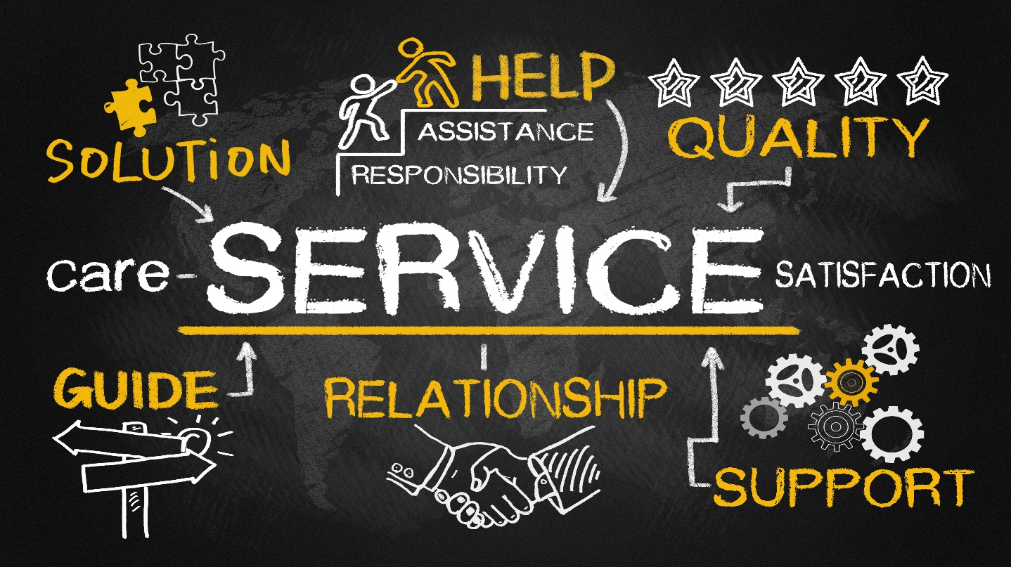

Recommendation #2 (Younger-Onset Dementia)
Improve awareness of and access to services, supports, and resources currently available to individuals affected by younger-onset dementia. Improve this awareness among the public as well as the medical community.

Implementation Strategies, Years 1-3

Beginning in Year 1 (Calendar Year 2023)
- Conduct a comprehensive analysis of services and supports available to people affected by younger-onset dementia that are provided by Aging Services Access Points, state government agencies, and the Alzheimer’s Association; and clarify age-related eligibility.
- Design and develop a younger-onset section within EOEA’s website on dementia (https://www.mass.gov/alzheimers-disease-and-related-dementias). Include all services and supports available to people affected by younger-onset dementia provided by Aging Services Access Points, state government agencies, and the Alzheimer’s Association; and clearly indicate age-related eligibility.
- Identify mental health services and supports; and financial planning and management resources provided by Aging Services Access Points, state government agencies, and the Alzheimer’s Association; and include this information in the new webpages on younger-onset dementia.
  - Identify services and supports for individuals and families to address mental health needs associated with the trauma experienced by receiving a dementia diagnosis at a younger age (including therapy, support, and support groups).
  - Identify resources available to people and their families affected by younger-onset dementia to help them make the right choices; protect their assets; help plan for their future as the condition declines; and address their financial planning and management needs associated with potential loss of income during prime earning years.
- The Younger-Onset Dementia & Equity Analysis Workgroup developed a list of examples and recommendations for the Council’s other teams to consider and address, which are associated with the following issues:
  - Diagnosis and Services Navigation Workstream - PCPs may not consider or may dismiss a young person’s experiences with dementia symptoms.
  - Care Planning Workgroup - Although activities that promote wellbeing/living a good life/social engagement are beneficial, not everyone is aware of opportunities and how critical they are to maintaining a positive quality of life.
  - Research Workstream – People living with younger-onset dementia lack opportunities to participate in clinical trials.
Beginning in Year 2 (Calendar Year 2024)
- Launch EOEA’s webpages on younger-onset dementia, disseminate link, and publicize to all.
- Develop and implement a communications plan that incorporates a variety of effective communication approaches such as informational sessions and webinars. The communications plan will enable stakeholders to gain a better understanding of the services and supports available to this population. Examples of stakeholders include Aging Services Access Points, the medical community, and individuals affected by younger-onset dementia.
- After careful examination of currently available mental health services and financial planning and management resources, services and supports, determine if they meet the needs of people affected by younger-onset dementia; and if not, recommend solutions and develop implementation plans.

Beginning in Years 3 (Calendar 2025) and Beyond
- The above strategies focus primarily on activities that begin in Years 1 and 2. However, work will continue beyond two years and recommendations will be presented to the Council during its future meetings.
- The Council will continue to determine and examine other unmet needs; identify recommendations; and develop implementation strategies to close gaps in services and supports for people affected by younger-onset dementia. Some potential examples are:
  - specialized services tailored for people affected by younger-onset dementia; and
  - services for children of a parent living with younger-onset dementia.

Responsible Organizations
Massachusetts Executive Office of Elder Affairs (EOEA)

Costs
No incremental costs
Resources
EOEA will refer to lists of state supported services for people affected by younger-onset dementia prepared by the Younger-Onset and Equity Analysis workgroup. Additionally, EOEA will gather and examine information from organizations such as other Massachusetts state agencies, the federal government, and dementia-related organizations.
Risks and Risk Response Strategies
If constraints on time and resources delay implementation of these strategies, then individuals affected by younger-onset dementia will lack knowledge of and access to the services and supports they need. In response to this risk, the workgroup will:
- prioritize and stagger the roll-out of the website’s content and carefully review current services and resources to identify any remaining gaps; and
- address any remaining gaps by recommending solutions and implementation strategies.

APPENDIX A
MEMBERS OF THE MASSACHUSETTS ADVISORY COUNCIL ON
ALZHEIMER’S DISEASE AND ALL OTHER DEMENTIAS
Council Member | Seat on Council
Secretary Elizabeth C. Chen, PhD, MBA, MPH - Secretary, Massachusetts Executive Office of Elder Affairs (EOEA) | Secretary, EOHHS  and Council Chair
Michael Belleville - Dementia Advocate (Served on this Council through December 2022) | Secretary, EOEA
James Lavery - Director, Bureau of Health Professions Licensure, Department of Public Health (DPH) | Commissioner, DPH
Andrew Budson, MD - Chief of Cognitive & Behavioral Neurology, Associate Chief of Staff for Education and Director of the Center for Translational Cognitive Neuroscience at Veterans Affairs (VA) Boston Healthcare System; Associate Director for Research at Boston University Alzheimer's Disease Center; Lecturer in Neurology at Harvard Medical School; Medical Director of the Boston Center for Memory | Secretary, Veterans’ Services
Jatin Dave, MD - Chief Medical Officer, MassHealth and Director, Office of Clinical Affairs, Commonwealth Medicine, UMass Chan Medical School | Director, Office of Medicaid
Representative Tricia Farley-Bouvier - Massachusetts House of Representatives | House Vice Chair, Elder Affairs
Senator Patricia Jehlen - Chairperson, Joint Committee on Elder Affairs &  Chairperson, Joint Committee on Labor and Workforce Development, Massachusetts Senate | Senate Vice Chair, Elder Affairs
Hector Montesino, CDP - President and CEO, Embrace Home Care and Health Services and Alzheimer’s Advocate | Alzheimer’s Patient Advocate 1
Rhiana Kohl, PhD – Caregiver and Alzheimer’s Advocate | Alzheimer’s Patient Advocate 2
Barbara Meehan - Alzheimer’s Advocate & Former Caregiver | Alzheimer’s Caregiver 1
Bernice Osborne-Pollar - Caregiver | Alzheimer’s Caregiver 2
Heather Sawitsky - General Counsel, Fox Hill Village Homeowners Corp. and White Oak Cottages | Health Care Provider 1
Linda Pellegrini, MS, GNP-BC - Geriatric Nurse Practitioner, UMass Memorial Medical Center | Health Care Provider 2
Hugo Aparicio, MD, MPH - Assistant Professor of Neurology, Boston University School of Medicine; Faculty Lead of the Research and Policy Team Program at the BU Center for Antiracist Research; Stroke Specialists in the Department of Neurology, Boston Medical Center | Alzheimer’s Researcher 1
Brent Forester, MD, MSc - Chief, Division of Geriatric Psychiatry & Director, Geriatric Psychiatry Research Program, McLean Hospital; Associate Professor of Psychiatry, Harvard Medical School; Medical Director, Dementia Care and Behavioral & Mental Health Population Health Management, Mass General Brigham | Alzheimer’s Researcher 2
Susan Antkowiak - Vice President, Programs & Services, Alzheimer’s Association, Massachusetts/New Hampshire Chapter | State Alzheimer’s Organization
James Wessler - President and CEO, Alzheimer’s Association, Massachusetts/New Hampshire Chapter and New England Regional Leader | State-based Advocacy Organization

APPENDIX B
IMPLEMENTATION TEAMS & WORKGROUPS
Workstream and Council Leads | Members of Implementation Teams and Workgroups
1. Caregiver Support & Public Awareness  Barbara Meehan, Dementia Advocate/Former Caregiver  Hector R. Montesino, President and CEO - Embrace Home Care and Health Services and Alzheimer’s Advocate | In addition to the workstream co-leads, the following people have been involved in implementing strategies in 2022 that are aligned with the goals of this workstream:  Video Production:  Jennifer Hoadley, CDP, Regional Manager Southeastern MA - Alzheimer's Association, MA/NH Chapter  Website Development:  Kathy Devine, Prescription Advantage Program Manager - EOEA  Pam MacLeod, MBA, PMP, Senior Project Director - MA Executive Office of Elder Affairs (EOEA) and University of Massachusetts Chan Medical School  Annette Peele, Director of Community Programs - EOEA  William Travascio, Special Assistant to the Secretary - EOEA  Caregiver Experience:  Amanda Barnardo, Chief of Staff & Chief Strategy Officer - EOEA  Ellie Romano, Communications and Outreach Manager - EOEA  Elise Tierney, MPH, Research Analyst - EOEA
2. Diagnosis & Services Navigation  Rep. Tricia Farley-Bouvier, Massachusetts House of Representatives  James Wessler, President and CEO, Alzheimer’s Association, MA/NH Chapter and New England Regional Leader | Diagnosis Implementation Team:  James Wessler, Council Member (Lead)  Kathryn C. Burns, MHA, Chief Executive Officer - Greater Lynn Senior Services, Inc.  Hollis D. Day, MD, MS, Chief of Geriatric Medicine - Boston Medical Center and Associate Professor of Medicine, Boston University School of Medicine  James Lavery (Council Member), Director, Bureau of Health Professions Licensure - Massachusetts Department of Public Health  Liz McCarthy, Health Systems Director - Alzheimer’s Association, New England Region  Rebecca Starr, MD, AGSF, Medical Director, Geriatrics - Cooley Dickinson HealthCare  Hagen Yang, MD, Neurologist - Atrius Health, Braintree - Harvard Vanguard  Services Navigation Implementation Team:  Rep. Tricia-Farley Bouvier, Council Member (Lead)  Ellen M. McDonough, Former Director of Clinical Services - Elder Services of Cape Cod & the Islands  Nicole McGurin, MS, CDP, Family Services Director - Alzheimer's Association, MA/NH Chapter  Molly Purdue, PhD, Executive Director - Cape Cod Alzheimer's Family Support Center  Caitlin Roy, Options Counselor - Aging Services of North Central Massachusetts  Karyn B. Wylie, Community Care Ombudsman - EOEA
3. Equitable Access & Care  Jatin Dave, MD, Chief Medical Officer, MassHealth and Director, Office of Clinical Affairs, Commonwealth Medicine, UMass Chan Medical School  Hugo Aparicio, MD, MPH, Assistant Professor of Neurology, Boston University School of Medicine; Faculty Lead of the Research and Policy Team Program at the BU Center for Antiracist Research; Stroke Specialist in the Department of Neurology, Boston Medical Center | Equity and Inclusion Team:  Jatin Dave, MD, Council Member (Lead)  Hugo Aparicio, MD, Council Member (Co-Lead beginning in 2023)  Team members to be confirmed in 2023  Younger-Onset Dementia & Equity Analysis Workgroup:  Rhiana Kohl, PhD, Council Member (Lead)  Mike Belleville, Council Member & Dementia Advocate  Kathy Devine, Prescription Advantage Program Manager - EOEA  Chelsea Gordon, Director of Public Policy & Advocacy, Alzheimer’s Association, MA/NH Chapter  Judy Johanson, Dementia Advocate - Mass. Alzheimer’s Disease Research Center, MGH  Tracy Lungelow, Caregiver  Joe Montminy, Dementia Advocate  Paul Mathew, MD, Caregiver  Barbara Meehan, Council Member & Dementia Advocate/Former Caregiver  William Travascio, Special Assistant to the Secretary - EOEA
4. Physical Infrastructure  Elizabeth C. Chen, PhD, MBA, MPH (Council Chair), Secretary - Massachusetts Executive Office of Elder Affairs (EOEA) | Age- and Dementia-Friendly Physical Infrastructure Implementation Team:  James Fuccione, MPA (Co-Lead), Senior Director - MA Healthy Aging Collaborative  Patty Sullivan (Co-Lead), Program Manager, Dementia Friendly MA - MA Councils on Aging  Pam MacLeod, MBA, PMP, Senior Project Director - EOEA and University of Massachusetts Chan Medical School  Sandra Martin, MEP, MPH, Senior Planner and Health Agent - Berkshire Public Health Alliance, Public Health Program at Berkshire Regional Planning Commission  Molly McKenna, MSW LCSW, Programs Development Manager - 2Life Communities  Maureen Mullaney, MA, Transportation and GIS Program Manager II - Franklin Regional Council of Governments  Ruth Neeman, AIA, Principal, Director of Senior Environments Studio - LWDA  Philippe Saad, AIA, LEED AP, Principal - Dimella Shaffer  Sanja Stegich, Intern  Amy Walsh, Project Manager - Institute for Healthcare Improvement
5. Public Health Infrastructure | Risk Reduction & Public Health Infrastructure:  This workstream does not yet have a leader or team; however, since late 2022, the following people have been assessing opportunities aligned with this workstream’s goal:  Pam MacLeod, MBA. PMP (Lead), Senior Project Director, EOEA and UMass Chan Medical School  Adam Frank, Council on Aging and Grants Coordinator - EOEA  Chelsea Gordon, Director of Public Policy & Advocacy - Alzheimer's Association, MA/NH Chapter  Steven Joubert, LMHC, LNHA Executive Director, Multi-Boards - Massachusetts Department of Public Health (DPH),  Bureau of Health Professions Licensure  James Lavery, Council Member, Director, Bureau of Health Professions Licensure - DPH  Nicole McGurin, MS, CDP, Programs & Services Director - Alzheimer's Association, Massachusetts/New Hampshire Chapter  Eileen Sullivan, Chief Operating Officer - DPH  Amy Sorensen-Alawad, MSPH, MPA, Grants and Development Manager - DPH  James Wessler, Chief Executive Officer - Alzheimer's Association, MA/NH Chapter, and New England Regional Leader
6. Quality of Care  Linda Pellegrini, MS, GNP-BC, Geriatric Nurse Practitioner, UMass Memorial Medical Center | Care Planning Implementation Team:  Susan Antkowiak, Council Member (Co-Lead)  Linda Pellegrini, Council Member (Co-Lead)  Mike Belleville, Council Member & Dementia Advocate  Deb Dowd-Foley, Caregiver Specialist - Elder Services of Worcester Area, Inc.  Laurie Herndon, MSN, GNP, BC, Project Director - Hinda and Arthur Marcus Institute for Aging Research, Hebrew SeniorLife  Judy Johanson, Dementia Advocate - Mass. Alzheimer’s Disease Research Center, MGH  Aaron Madow, Graduate Student (MPH candidate) - University of Massachusetts  Gad A. Marshall, MD, Medical Director of Clinical Trials at Center for Alzheimer Research and Treatment,  Brigham and Women’s Hospital (BWH); Associate Neurologist at BWH; Assistant in Neurology at Massachusetts General Hospital; Associate Professor of Neurology at Harvard Medical School
7. Research  Andrew Budson, MD,  Chief of Cognitive & Behavioral Neurology, Associate Chief of Staff for Education and Director of the Center for Translational Cognitive Neuroscience at Veterans Affairs (VA) Boston Healthcare System; Associate Director for Research at Boston University Alzheimer's Disease Center; Lecturer in Neurology at Harvard Medical School; Medical Director of the Boston Center for Memory | As of the date of this annual report, the Research Workstream does not have an implementation team or workgroup associated with it.

APPENDIX C
THEMES FROM FOCUS GROUP SESSIONS WITH
PEOPLE AFFECTED BY DEMENTIA

THEMES FROM FOCUS GROUP SESSIONS WITH PEOPLE LIVING WITH DEMENTIA

Question: What was the experience of communicating with your doctor or healthcare provider about your concerns?
- Delay in getting the diagnosis and difficulty of the diagnostic process
    - complaints of memory problems not being taken seriously
    - difficulty getting an appointment with a neurologist
    - diagnostic process was described as brutal, traumatic, debilitating
    - focus was on physical exam and medications rather than how the person was doing
    - care and support were not available during the process
    - some were told to “go home and get your affairs in order, see you in 6 months,” with no guidance offered
    - didn’t know what to expect
- Positive experiences
    - when the person had a long-standing relationship with the PCP, they felt like the PCP knew them as a person
    - referral to Dementia Care Coordination program - “the call made a huge difference”
    - health care provider offered support that was positive and affirming
    - health care provider offered positive suggestions
    - health care provider recommended exercise, intellectual stimulation, and social stimulation
Question: What are the most important things you want a doctor or healthcare provider to know about you?
- need care and support
- need better overall care management and integration
- want the provider to get to know me as a person
- want to know how to find acceptance and still live my best life
- want to know how to tell other people about my diagnosis
- want to know what I can do to delay progression and maintain some control
- “I told my doctor up front my strengths, things that were important to me like writing and meeting friends”
- want my doctor to understand my wishes and values
- want healthcare providers to know that early diagnosis is important so that you can state what you want and make decisions for yourself

THEMES FROM FOCUS GROUP SESSIONS WITH FAMILY CAREGIVERS OF INDIVIDUALS LIVING WITH DEMENTIA

Question: What was the experience of communicating with your doctor or healthcare provider about concerns regarding your loved one?
- want the provider to believe the caregiver when they say there is a problem
- there is a lack of guidance, care coordination, and navigation, especially between the PCP and specialists
- “people are rushed,” “system is flawed”
- “I feel like an orchestra conductor, but I do not know anything about music”
- “I was not prepared for how much I would have to advocate”
- want providers to not only focus on the person living with dementia, but also ask how the caregiver is managing their caregiving and stress, and if they need additional support
Question: What are the most important things you want a doctor or healthcare provider to know about your loved one?
- know “who the person is,” “they are not their illness,” “help me to help her live the life she was living”
- listen to the caregivers - acknowledge who they are in the process
- understand cultural differences in how dementia is perceived, including how open the culture is to support and resources outside of the family
- navigating the resources on your own can be daunting
- referral to a memory center was a life saver

The Council was established under Massachusetts General Laws, Chapter 6A, Section 16AA and Chapter 220 of the Acts of 2018.
The Alzheimer’s State Plan, April 2021 and Annual Reports are posted on the Council’s website: https://www.mass.gov/orgs/alzheimers-advisory-council.
Liesi, H., Rush University Institute on Healthy Aging; based on data from the Chicago Health and Aging Project: Weuve, J., Hebert, L.E., Scherr, P.A., Evans, D.A., Prevalence of Alzheimer disease in U.S. states. Epidemiology 2015;26(1): E4‐6. https://doi:10.1097/EDE.0000000000000199. PMID: 25437325. This number was similarly reflected in the Massachusetts Healthy Aging Data Report Community Profiles (2018), UMass Boston, Gerontology Institute.
Estimated by the Alzheimer’s Association using data from the 2015-2020 Behavioral Risk Factor Surveillance System survey, U.S. Census Bureau, National Alliance for Caregiving, AARP, and U.S. Department of Labor.
Boustani, M., Peterson, B., Hanson, L., Harris, R., Lohr, K. N., & U.S. Preventive Services Task Force (2003). Screening for dementia in primary care: a summary of the evidence for the U.S. Preventive Services Task Force. Annals of internal medicine, 138(11), 927–937. https://doi.org/10.7326/0003-4819-138-11-200306030-00015

