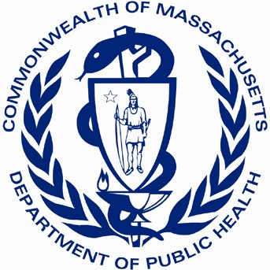
Massachusetts Ambassador Project Impact Brief
Office of Problem Gambling Services
2019

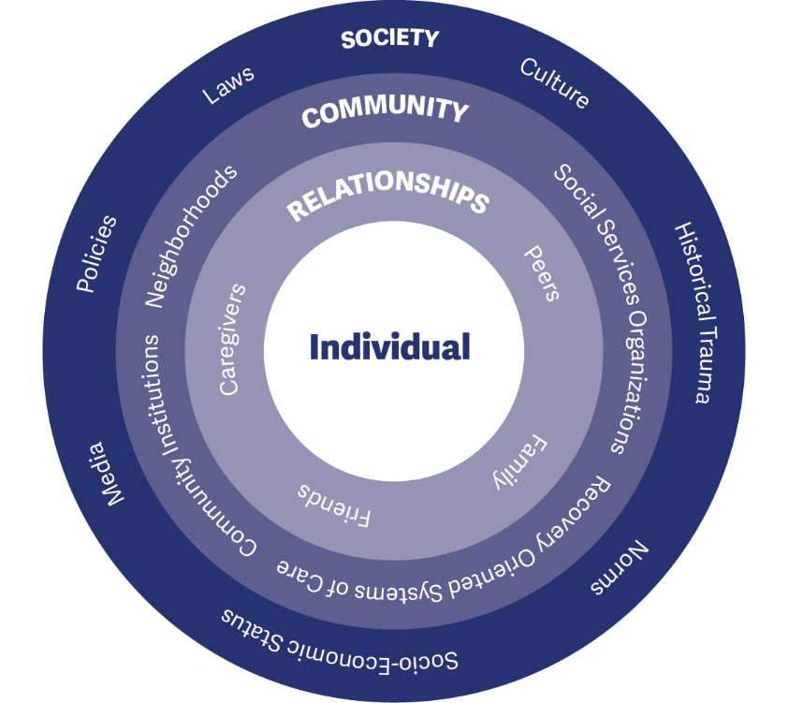
The Massachusetts Ambassador Project is an innovative approach, led by the Massachusetts Department of Public Health Office of Problem Gambling Services (OPGS), to reach a population at higher risk for problem gambling. The project is implemented within recovery-oriented organizations in Massachusetts to address the well-established relationship between problem gambling and other health and behavioral health issues such as substance misuse. This approach is:
- Peer-Based
- Community-Centered
- Participatory
- Culturally Responsive
- Grounded in Evidence-Based Principles
Each recovery-oriented organization supports up to three men of color with a history of substance misuse who are now in recovery (Ambassadors) to lead conversations about problem gambling prevention in their community. Ambassadors receive intensive training and supervision and deliver a comprehensive set of services.
The project adheres to evidence-based principles and practices from the literature on peer-based recovery support services, behavioral health education, and brief interventions with hard-to-engage populations. The conceptual framework for the project is the socio-ecological model (see Figure 1), which stresses the importance of focusing on the inter-connectedness between individuals, their social circles and neighborhoods, and aspects of the communities in which they live.
The Ambassador Project is focused on having a strong impact – ultimately preventing or reducing problem gambling in priority populations. Impact involves having both the necessary reach (such as engaging the target population in adequate numbers) and effectiveness (implementing a project that achieves the goal it set out to achieve).
By designing a peer-based and community-centered project, the Ambassador Project has had an extensive reach. At a total initial investment of $200,000 across four sites ($50,000 per site), the project achieved the following during fiscal year 2019:

553
individuals
were engaged through
one-to-one conversations and street outreach

3,067

individuals
received problem gambling prevention education through
presentations and
small group sessions
36

different organizations
across 14 communities received presentations and group sessions
768

individuals
were reached through the distribution of gambling prevention materials
Overall, Ambassadors reached 4,388 individuals throughout the year.

The Ambassador Project strives for effectiveness by grounding its work in the socio-ecological model and evidence- based literature. Together, with reach and effectiveness, the Ambassador Project is poised to have a positive impact on priority populations and become a replicable model for other states.
GOALS – PURPOSE OF THE PROJECT

Goal 1:
Prevent or reduce problem gambling among individuals, priority populations, and communities at elevated or disproportionate levels of risk for problem gambling

Goal 2:
Develop and maintain the awareness, skills, and behaviors needed to protect individuals, priority populations, and communities against developing problems with gambling
OBJECTIVES – WAYS TO ACHIEVE THE GOALS

Socio-Ecological Level: Individual Priority Group: Ambassadors
Objective 1: Train and empower Ambassadors to be catalysts of change to raise awareness, provide resources, and support attitudes and behaviors incompatible with problem gambling

Socio-Ecological Level: Interpersonal Priority Group: Peers
Objective 2: Actively engage, involve, and empower individuals, priority populations, and communities disproportionately affected by or at risk for problem gambling

Socio-Ecological Level: Organizational Priority Group: Organizations
Objective 3: Build relationships with organizations, including treatment and recovery organizations, to effect systems change by adding problem gambling prevention into services and discussions

Socio-Ecological Level: Community Priority Group: Community-Wide
Objective 4: Increase community awareness of problem gambling and educate about susceptibility to problem gambling with those at elevated levels of risk
EXTERNAL INPUTS – SUPPORT PROVIDED TO THE PROJECT

Each of the four recovery oriented-organizations received $50,000 in support during fiscal year 2019 from the Office of Problem Gambling Services. Additional non-financial support and technical assistance was provided by the OPGS Program Management Team, the MA Center of Excellence on Problem Gambling Prevention (MCOE PGP) at Education Development Center, Inc. (EDC), and the Evaluation Team at Social Science Research and Evaluation, Inc. (SSRE).

TIMELINE – TIME PERIOD COVERED
This impact brief covers the initial 12-month implementation period of the Massachusetts Ambassador Project that occurred between July 1, 2018 and June 30, 2019. The brief focuses on two Recovery-Oriented Organizations in the Plainville/Southeast Region (Region C), which were both funded for the entirety of fiscal year 2019.
Kick-Off Meeting
Mar 28, 2018
Early Implementation
Hiring, Training, Planning
Initial 12-Month Implementation Period
Fiscal Year 2019
(Jul 1, 2018 – Jun 30, 2019)

Mar Apr May Jun Jul Aug Sep Oct Nov Dec Jan Feb Mar Apr May Jun
2019
2018
FIGURE 2
PROJECT ACTIVITIES – WHAT AMBASSADORS DO

Ambassadors engaged in problem gambling prevention project activities at the individual, interpersonal, organization, and community levels during fiscal year 2019.

Socio-Ecological Level: Individual Priority Group: Ambassadors
Training: Ambassadors take a three day orientation training on problem gambling prevention, the relationship between substance use disorder and problem gambling, building health and racial equity, and engaging peers in group and individual conversations.
Supervision: Ambassadors receive weekly supervision from their Manager to discuss project activities, address challenges, build their skills, and celebrate successes.
Ongoing Professional Development: Ambassadors attend trainings and engage in peer learning communities to enhance their capacity and skills as professionals.

Socio-Ecological Level: Interpersonal Priority Group: Peers
Individual Interactions: Ambassadors engage peers individually in one-on-one discussions about problem gambling within recovery-oriented organizations, at partner organizations, through street outreach, and at community events.
Group Interactions: Ambassadors engage groups of people at recovery-oriented organizations or at partner organizations that serve populations at high risk that request peer gambling prevention groups or presentations.

Socio-Ecological Level: Organizational Priority Group: Organizations
Outreach and Engagement with Organizations: Ambassadors outreach to and engage with treatment and recovery-oriented organizations that provide Acute Treatment Services (ATS/Detox), Clinical Stabilization Services
(CSS/Inpatient Treatment), Transitional Support Services (TSS or Holding Programs), Residential Treatment (Halfway Houses), and Alcohol and Drug Free (ADF) Housing or Sober Homes. Outreach is also conducted with shelters, social service organizations, correctional facilities, and others within the Recovery-Oriented System of Care.

Socio-Ecological Level: Community Priority Group: Community-Wide
Community Events: Ambassadors engage with the broader community through distribution of program materials and resources at health fairs, faith community events, drop-in center events, and community cultural events.

PROJECT OUTPUTS AND EARLY IMPACT – PROGRESS TOWARD GOALS
Training and Professional Development
Three day orientation and skill building
Six week recovery coach academy training
Cultural competency
Motivational interviewing
Mental wellness and recovery coaching
Multiple pathways to recovery
Advanced ethics

Socio-Ecological Level: Individual Priority Group: Ambassadors
11 Ambassadors worked on the project in the first year. Ambassadors were all men of color (African American, Cape Verdean, Native American, Puerto Rican) in their 30s-60s with a GED or bachelor’s degree. Ambassadors received weekly supervision from their site Manager, participated in a six-week Recovery Coach Academy Training, and attended advanced training on a wide range of topics (see figure 3).
Ambassadors also attended problem gambling training to learn more about problem gambling mentor programs and additional resources to support their work in communities.

Socio-Ecological Level: Interpersonal Priority Group: Peers

FIGURE 3

553
individuals were engaged through one-to-one conversations and street outreach at convenience stores, libraries, parades, community events, cultural

events, after recovery support meetings, and after group sessions and presentations. On average, Ambassadors at the two project sites engaged 23 individuals through one-to-one conversations each month of the fiscal year. One of every five of these individuals (19%) was a person of color (105 individuals).

3,067

individuals received problem gambling prevention information, education, and resources through presentations and small group sessions. Ambassadors

conducted 251 sessions during the fiscal year with an average group size of 12 individuals. Ambassadors at each project site delivered an average of 10 sessions each month of the fiscal year. Almost half of the individuals who participated in a presentation or small group session (43%) was a person of color (1,326 individuals).
Treatment
16

Socio-Ecological Level: Organizational Priority Group: Organizations
Ambassadors successfully engaged with and delivered presentations and group sessions at 36 different organizations across 14 communities in the Plainville/ Southeast Region of the state during fiscal year 2019.
Partner organizations during fiscal year 2019 spanned the substance misuse treatment continuum of care (16 organizations), the recovery-oriented system of care (7), social service organizations and shelters (7), offices of community corrections and county corrections facilities (4), and faith-based settings (2).
Within the justice and corrections setting, Ambassadors run two problem gambling prevention groups per week in a county correctional facility and run a group for individuals who were recently released from incarceration.

Recovery
7

Social Services
7

Justice/Corrections
4

Faith Community
2

FIGURE 4

Socio-Ecological Level: Community Priority Group: Community-Wide

768
individuals were reached through the distribution of gambling prevention materials from the Massachusetts Health Promotion Clearinghouse at health fairs, faith

community events, drop-in center events, and community cultural events. Emphasis was placed on distributing materials that are part of the Massachusetts Department of Public Health’s “Drugs. Alcohol. Gambling. Different stories. Same problem.” campaign. Ambassadors contributed to all aspects of this campaign, including lending their images and their voices to social media videos and bus advertisements.

PROJECT OUTPUTS AND EARLY IMPACT – VOICES FROM THE FIELD

INDIVIDUAL LEVEL – Ambassador Professional Development and Reach

“There has been tremendous growth in our Ambassadors’ ability to connect and communicate with south shore agencies. They are more supportive and accepting of their role and mission.”
- Program Director

“Ambassadors’ ability to meet people where they are at in a genuine and transparent way has enhanced the impact of this work.”
- Program Director

INTERPERSONAL LEVEL – Problem Gambling Prevention Groups and Peer Discussions

“I started the group by identifying myself as an Ambassador for problem gambling prevention and asked the men to go around the room and introduce themselves and share their first experience with gambling. I went on to share my own experience with drugs, crime, and gambling and they started to make the connection.”
- Ambassador

“They like my group because I am honest with them and they can sense that… they are more engaged because they feel more familiar with me and know what to expect.”
- Ambassador

“We’re called Coaches to inspire, encourage, and uplift others. That’s what I do to the best of my ability.”
- Ambassador

“The groups are pretty powerful - what you said blew me away and made me think.”
- Small Group Participant

“Keep doing what you’re doing because it’s working.”
- Small Group Participant

LESSONS LEARNED FROM AMBASSADORS AND DIRECTORS

- The project could benefit from more branding (marketing materials) and ways in which to emphasize that Ambassadors are working professionals (e.g. badges, shirts, identification cards).
- The more that Ambassadors are able to share personal experiences, the better they seem to be received.
- Ambassadors should reflect the diversity of the community in which they work.
- There is a lack of knowledge about problem gambling within local communities (including acknowledgment of the many ways gambling occurs in everyday life). This project is about raising awareness.
- One-on-one interactions can provide an opportunity for more in-depth discussions about personal struggles and concerns about family members that may not come out of the larger group sessions and presentations.
- Individuals in early recovery from substance use disorder may have low capacity/readiness to address problem gambling behaviors. Ambassadors need to be aware of this and how to appropriately engage this population.
- Ambassadors emphasize multiple pathways to recovery (no wrong door). Extra work may be needed to promote buy-in among organizations that emphasize a single path to recovery (e.g. 12-step programs).
- More effort needs to be made to engage local social and civic organizations and to go where men gamble.

In alignment with these findings, the Ambassador Project will undertake activities to address branding needs, increase engagement of a variety of types of organizations, and hire and retain Ambassadors who reflect the community in which they work. Ambassadors will continue to support men of color with a history of substance misuse and be a valued part of the community they serve.

For further information, please visit our website at
mass.gov/problemgambling

