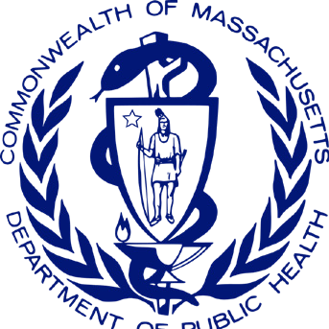
Massachusetts Ambassador Project Impact Brief Office of Problem Gambling Services
Cumulative Impact Report for July 1, 2018 – December 31, 2020

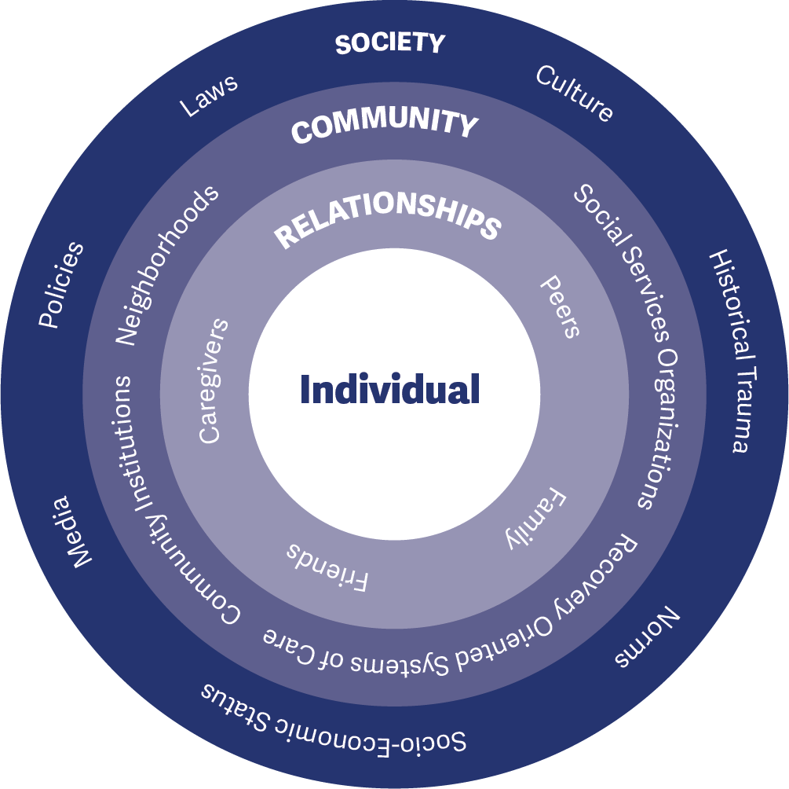
The Massachusetts Ambassador Project is an innovative approach to reach a population at higher risk for problem gambling. The project was established after a comprehensive community engagement and planning process to promote equity, engagement, and empowerment throughout problem gambling programs. The MA Ambassador Project was piloted during fiscal year 2019 and moved to full program implementation during fiscal year 2020. This work is centered on the socio-ecological model (Figure 1), which is a comprehensive approach that is rooted in the principles of public health
and incorporates the individual, family, and community to mitigate harms associated with gambling.
The project is led by the Massachusetts Department of Public Health Office of Problem Gambling Services (OPGS) and implemented within four recovery- oriented organizations in Massachusetts to address the well-established relationship between problem gambling and other health and behavioral health issues such as substance misuse. This approach is:
- Peer-Based
- Community-Centered
- Participatory
- Culturally Responsive
- Grounded in Evidence-Based Principles

Each recovery-oriented organization supports up to three men of color with a history of substance misuse who are now in recovery (Ambassadors) to lead conversations about problem gambling prevention in their community. Ambassadors receive intensive training and supervision and deliver a comprehensive set of services.
The project adheres to evidence-based principles and practices from the literature on peer-based recovery support services, behavioral health education, and brief interventions with hard-to-engage populations. The conceptual framework for the project is the socio-ecological model (see Figure 1), which stresses the importance of focusing on the inter-connectedness between individuals, their social circles and neighborhoods, and aspects of the communities in which they live.
The Ambassador Project is focused on having a strong impact – ultimately preventing or reducing problem gambling in centered populations. Impact involves having both the necessary reach (such as engaging the target population in adequate numbers) and effectiveness (implementing a project that achieves the goal it set out to achieve).
This is a cumulative brief that covers July 2018 (project development and pilot) to December 2020 (implementation and capacity building). The first iteration of this brief, detailing July 2018-June 2019, can be found here: MA Ambassador Project Impact Brief 2019. Please see the Timeline section for more details.
The Ambassador Project has had extensive reach. At an annual investment of $65,000 per organization, the project has achieved the following between July 2018 and December 2020:

882

individuals
were engaged through one-to-one conversations and street outreach

5,665

individuals
received problem gambling prevention education through presentations and small group sessions
65

different
organizations across 22 communities
received presentations
and group sessions

1,494

individuals
were reached through the distribution of gambling prevention materials at community events

Ambassadors reached 8,041 individuals between July 2018 and December 2020.

GOALS – PURPOSE OF THE PROJECT

Goal 1:
Prevent or reduce problem gambling among individuals, centered populations, and communities at elevated or disproportionate levels of risk for problem gambling

Goal 2:
Develop and maintain the awareness, skills, and behaviors needed to protect individuals, centered populations, and communities against developing problems with gambling
OBJECTIVES – WAYS TO ACHIEVE THE GOALS

Socio-Ecological Level: Individual Priority Group: Ambassadors
Objective 1: Train and empower Ambassadors to be catalysts of change to raise awareness, provide resources, and support attitudes and behaviors incompatible with problem gambling

Socio-Ecological Level: Interpersonal Priority Group: Peers
Objective 2: Actively engage, involve, and empower individuals, centered populations, and communities disproportionately affected by or at risk for problem gambling

Socio-Ecological Level: Organizational Priority Group: Organizations
Objective 3: Build relationships with organizations, including treatment and recovery organizations, to effect systems change by adding problem gambling prevention into services and discussions

Socio-Ecological Level: Community Priority Group: Community-Wide
Objective 4: Increase community awareness of problem gambling and educate about susceptibility to problem gambling with those at elevated levels of risk
EXTERNAL INPUTS – SUPPORT PROVIDED TO THE PROJECT

Fiscal Support
Office of Problem Gambling Services (OPGS): Each of the four recovery-oriented organizations receives $65,000 annually from OPGS to implement the Ambassador Project.

Management and Operations Support
Office of Problem Gambling Services (OPGS): The Program Management Team at OPGS actively monitors and supports each implementing site, including fiscal management, roles and responsibilities, scope of work, and adherence to requirements.

Training and Technical Assistance Support
MA Center of Excellence on Problem Gambling Prevention (MCOE PGP): MCOE PGP provides training and technical assistance (TA) support to each implementing site. Subject matter experts assist sites, individually and collectively, to problem-solve implementation challenges and enhance capacity.

Evaluation Support
Social Science Research and Evaluation, Inc. (SSRE): The Evaluation Team at Social Science Research and Evaluation, Inc. (SSRE) assists implementing sites with data collection, activity tracking, and monthly reporting requirements through the development and management of a series of data collection forms and databases.

TIMELINE – TIME PERIOD COVERED
This brief covers July 2018 to December 2020 (early implementation period). During this time, OPGS has supported and continues to support two recovery-oriented organizations in Region C (Southeast MA) and two organizations in Region B (Western MA). Milestones are summarized below.

Regional Planning Process, Project Development, and Start-Up (January 2017 – June 2018)
Beginning in January 2017, the first 18-months of the project involved assessing needs, resources, and concerns in each region through a structured regional planning process; development of the Ambassador Project model; identification of the initial Region C pilot sites; and hiring, training, and start-up activities.

Pilot Implementation Phase (July 2018 – June 2019)
The pilot implementation period began in July 2018 and lasted through June 2019 with two sites in Region C and two sites in Region B (added mid-cycle). This was an opportunity to test and refine the Ambassador model and to assess its fit and feasibility. During this period, Ambassadors engaged with 4,388 individuals to provide problem gambling education and support (see MA Photovoice Project Impact Brief 2019).

Formal Implementation Phase (July 2019 – June 2020)
The formal implementation phase started in July 2019 and lasted through March 2020 when it was interrupted by the COVID-19 pandemic. In adherence with state physical distancing guidelines, the project transitioned to providing only virtual online services through the end of June 2020.

Capacity Building and Professional Development Phase (July 2020 – December 2020)
Due to the pandemic, the focus was temporarily shifted from direct service work to intensive capacity-building and professional development to enhance Ambassadors’ skills and capacities. Direct service work will resume in early 2021.

Start-Up
Hiring, Training, and Planning within Two Ambassador Sites (4/1/18 – 6/30/18)
Pilot Implementation
Initial Pilot

Region B Ambassador Sites Join Region C Sites in the Pilot Implementation Period
Transition to Virtual
The Four Ambassador Sites Transition to Providing Only Virtual Services Due to the COVID-19 Pandemic
(3/10/20 – 6/30/20)
Transition to Capacity

OPGS and MCOE PGP Develop the Massachusetts Photovoice Model (8/1/17 – 12/31/17)

Region A and B Planning Processes
Begin(12/1/17)
Implementation Begins in Two Region C Ambassador Sites (7/1/18)
Region A and B Planning Reports Released (12/31/18)
(4/1/19)

Pilot Implementation Ends
(6/30/19)

Region B

Full Implementation in the Four Ambassador Sites Continues
Building Ambassadors Temporarily Shift from Providing Virtual Services to Taking Part in Intensive Capacity-Building

Region C Planning Process and Preparation of Report
Region C
Project Kick-off Meeting (3/28/18)

Two Region C
Project Kick-Off Meeting (3/22/19)

Two Region B
(1/1/20 – 3/9/20)
Formal Implementation All Four Ambassador Sites (Two in Region B and Two in Region C)
and Professional
Development with MCOE PGP to Enhance their Professional Skills and Capacities

Region C Planning Process Begins
Region C Planning Process Report Released
Sites Selected for Photo- voice Project
Sites Selected for Ambassador project
Transition into the Formal Implementation Period
(7/1/19 – 12/31/19)
and Prepare for
Implementation in 2021
(7/1/20 – 12/31/20)

J | F | M | A | M | J | J | A | S | O | N | D | J | F | M | A | M | J | J | A | S | O | N | D | J | F | M | A | M | J | J | A | S | O | N | D | J | F | M | A | M | J | J | A | S | O | N | D
2017 |  |  |  |  |  |  |  |  |  |  |  | 2018 |  |  |  |  |  |  |  |  |  |  |  | 2019 |  |  |  |  |  |  |  |  |  |  |  | 2020

FIGURE 2
PROJECT ACTIVITIES – WHAT DO AMBASSADORS DO
In adherence with the socio-ecological model (Figure 1), Ambassadors engage in problem gambling prevention project activities at the individual, interpersonal, organization, and community levels. The majority of these activities have been in place since the beginning of the project. The three activities labeled as (NEW) were introduced starting in March 2020 in response to the COVID-19 pandemic.

Socio-Ecological Level: Individual Centered Group: Ambassadors
Workplace Supervision and Support: Ambassadors receive weekly supervision and support from their Manager to discuss project activities, address challenges, build their skills, and celebrate successes.
Orientation Training: Upon hire, Ambassadors take part in a multi-day orientation training on problem gambling prevention, the relationship between substance use disorder and problem gambling, building health and racial equity, and engaging peers in group and individual conversations.
Ongoing Professional Development: Ambassadors routinely attend content-specific trainings and engage in peer learning communities such as Communities of Practice to enhance their capacity and skills as professionals.
(NEW) Professional Biography “Bio” Development: As part of the enhanced capacity-building phase during the pandemic, Ambassadors worked with their supervisors and TA providers at MCOE PGP to create professional biographies that described their experience as peer educators (including past positions held, trainings and certifications, and personal accomplishments).

Socio-Ecological Level: Interpersonal Priority Group: Caregivers
Socio-Ecological Level: Interpersonal Centered Group: Peers
Individual Interactions: Ambassadors engage peers individually in one-on-one discussions about problem gambling within recovery-oriented organizations, at partner organizations, through street outreach, and at community events.
Group Interactions: Ambassadors engage groups of people at recovery-oriented organizations or at partner organizations that serve populations at high risk that request peer gambling prevention groups or presentations.
(NEW) Virtual Interactions: During the early days of the COVID-19 pandemic, recovery-oriented organizations and Ambassadors worked to collectively build their technological infrastructure and capacity to be able to provide virtual services to individuals and organizations during the period of physical distancing restrictions.

Socio-Ecological Level: Organizational Centered Group: Organizations
Outreach and Engagement with Organizations: Ambassadors outreach to and engage with treatment and recovery-oriented organizations that provide Acute Treatment Services (ATS/Detox), Clinical Stabilization Services (CSS/Inpatient Treatment), Transitional Support Services (TSS or Holding Programs), Residential Treatment (Halfway Houses), and Alcohol and Drug Free (ADF) Housing or Sober Homes. Outreach is also conducted with shelters, social service organizations, correctional facilities, and other organizations within the Recovery-Oriented System of Care.

Socio-Ecological Level: Community Centered Group: Community-Wide
Community Events: Ambassadors engage with the broader community through distribution of program materials and resources at health fairs, faith community events, drop-in center events, and community cultural events.
(NEW) Community Messaging: During the COVID-19 pandemic, Ambassadors worked with their supervisors and TA providers at MCOE PGP to create short videos describing key parts of the MA Ambassador Project. These videos will be used in a variety of community and organizational settings to raise awareness about gambling, problem gambling, risk and protective factors, the connection between problem gambling and substance use disorders, and identifying disparities and building equity.
PROJECT OUTPUTS – PROGRESS TOWARD GOALS

Socio-Ecological Level: Individual Centered Group: Ambassadors
Through the end of December 2020, a total of 21 Ambassadors had been hired and trained as part of the project. There are currently 9 active Ambassadors across the four sites. Ambassadors are all men of color (African American, Cape Verdean, Native American, Puerto Rican) in their 30s-60s with a GED or bachelor’s degree and experience in the recovery community.
FIGURE3
Training and Professional Development
Problem gambling prevention and support
Recovery coaching
Race and health equity / cultural competency
Motivational interviewing
Mental health and wellness
Multiple pathways to recovery
Ethics and confidentiality
Ambassadors received weekly supervision from their site Manager, took part in an intensive orientation training with MCOE PGP content experts where they learned about problem gambling, and attended ongoing advanced trainings on a wide range of topics.
4

Ambassadors who were part of the project during the pandemic took part in trainings on self-care, COVID-19 impacts on recovery, and disproportionate impacts of the pandemic on communities of color. These Ambassadors also each prepared a professional biography describing their experience as peer educators.

Socio-Ecological Level: Interpersonal Centered Group: Peers
822 individuals were engaged through one-to-one conversations and street outreach at convenience stores, libraries, parades, community events, cultural events, after
recovery support meetings, and after group sessions and presentations. This includes 553 individuals reached during the 12-month pilot period (105 persons of color) and 269 individuals reached during the 8-month full implementation period that was interrupted by COVID (67 persons of color). On average, Ambassadors engaged 41 individuals through one-to-one conversations each month. Over one of every five of these individuals (21%) was a person of color (172 individuals).
5,665 individuals received problem gambling prevention information, education, and resources through presentations and small group sessions. Ambassadors
have conducted 432 sessions to date with an average group size of 13 individuals. This includes 3,067 individuals across 251 sessions during the 12-month pilot period and 2,598 individuals across 181 sessions during the 8-month full implementation period. Almost half of the individuals who participated in a presentation or small group session (44%) was a person of color (2,474 individuals).

Socio-Ecological Level: Organizational Centered Group: Organizations
65 different organizations across 22 communities were successfully engaged and hosted Ambassador presentations and group sessions. Most organizations were located within the cities of Springfield, Brockton, Fall River, Holyoke, and New Bedford. Partner organizations spanned the substance misuse treatment continuum of care (27 organizations with an emphasis on residential treatment programs and halfway houses); social service organizations such as food pantries and homeless
shelters (14 organizations); the recovery-oriented system of care (9 organizations); offices of community corrections and county corrections facilities (7 organizations); mental and physical health facilities (5 organizations); and faith-based settings (3 organizations). This includes 36 organizations that were initially engaged during the 12-month pilot period and 29 new organizations initially engaged during the 8-month full implementation period.

Socio-Ecological Level: Community Centered Group: Community-Wide
1,494 individuals were reached through the distribution of gambling prevention materials from the Massachusetts Health Promotion Clearinghouse at health fairs, faith community events, drop-in center events, recovery month events, and community cultural events. Emphasis was placed on distributing materials that are part of the Massachusetts Department of Public Health’s “Drugs. Alcohol. Gambling. Different stories. Same problem.” campaign. Ambassadors contributed to all aspects of this campaign, including lending their images and their voices to social media videos and bus advertisements.

PROJECT OUTCOMES – VOICES FROM THE FIELD

INDIVIDUAL LEVEL – Ambassador Professional Development and Reach

“Ambassadors have gained insight on how to promote themselves through their experience while still coming from a place of humility. I am really seeing their professionalism improve.”
- Program Director

“When the pandemic hit, Ambassadors were able to move quickly to providing virtual and telephone supports. They went above and beyond to help support the Recovery Center across all its operations, not just the problem gambling work. Real leaders.”
- Program Director

“I was able to use my bio as part of my resume. People I handed it to were real impressed. It helped me get another part-time job. They said they don’t ever see [bios] for people.”
- Ambassador

“We’ve really come together as a team, both within our agency and with the guys at the other sites. Despite everything going on, we were still able to be productive. We never stopped a beat.”
- Ambassador

INTERPERSONAL LEVEL – Problem Gambling Prevention Groups and Peer Discussions

“We were able to engage a lot of agencies [virtually] because of the relationships [Ambassadors] were able to develop before COVID.”
- Program Director

“This program was really starting to pick up before COVID. A lot of agencies were calling – especially knowing we had a program that focused on communities of color and gambling and having the ability to send people out to give presentations at agencies.”
- Program Director

“One of my biggest successes as an Ambassador was when one of the guys I frequently engage with called me and said he was in need of detox. I went and picked him up and brought him to detox. It started as a gambling pitch and turned into helping further.”
- Ambassador

“Despite the critical times, we were able to continue with this project and find many venues for us to work and deliver support as Gambling Ambassadors.”
- Ambassador
LESSONS LEARNED FROM AMBASSADORS AND DIRECTORS

- Although the centered population is men of color, there is also an opportunity to engage with other individuals – particularly social network members such as wives, partners, and other family members.
- The project could benefit from more branding (marketing materials) and ways to emphasize that Ambassadors are OPGS-affiliated working professionals (e.g., badges, shirts, business cards).
- Outreach to organizations should start in places where the host organization or Ambassadors have existing relationships to facilitate the linkage. These organizations can then help spread the program to other organizations through word of mouth and their professional networks.
- Communities of Practice (opportunities for Ambassadors to speak with other Ambassadors across the Commonwealth) are critical opportunities for peer sharing and learning.
- Recovery Month (September) is a good opportunity to engage other recovery-oriented organizations to include problem gambling prevention resources at their events.
- Community events are important venues through which to spread word about the project, raise awareness in the community, and share prevention resources. These brief encounters often lead to more substantive follow-up engagements with individuals in the future.
- Ambassadors should be prepared with data and resources specific to all communities of color (including Hispanic/ Latinx and Asian populations) to fully reflect the individuals with whom they interact.
- Ambassadors need to be skilled in natural engagement strategies (i.e., comfortably initiating conversations in a variety of public and private settings and environments).
- Improvements in technology infrastructure and virtual/online engagement skills gained during the COVID-19 pandemic should be incorporated into the ongoing menu of services provided by the project (e.g., continuing to offer limited online services to further enhance equity of access).

Additional lessons learned from this project can be found in the MA Ambassador Project Impact Brief 2019 and in Our Voices Matter: Using Lived Experience to Promote Equity in Problem Gambling Prevention published by Ortiz and colleagues in Current Addiction Reports. Lessons learned will be iteratively integrated into the project.
For further information, please visit our website at www.mass.gov/problemgambling

