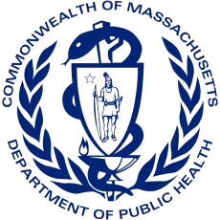
Massachusetts Ambassador Project Impact Brief Office of Problem Gambling Services
Cumulative Impact Report for January 1, 2021 – June 30, 2023

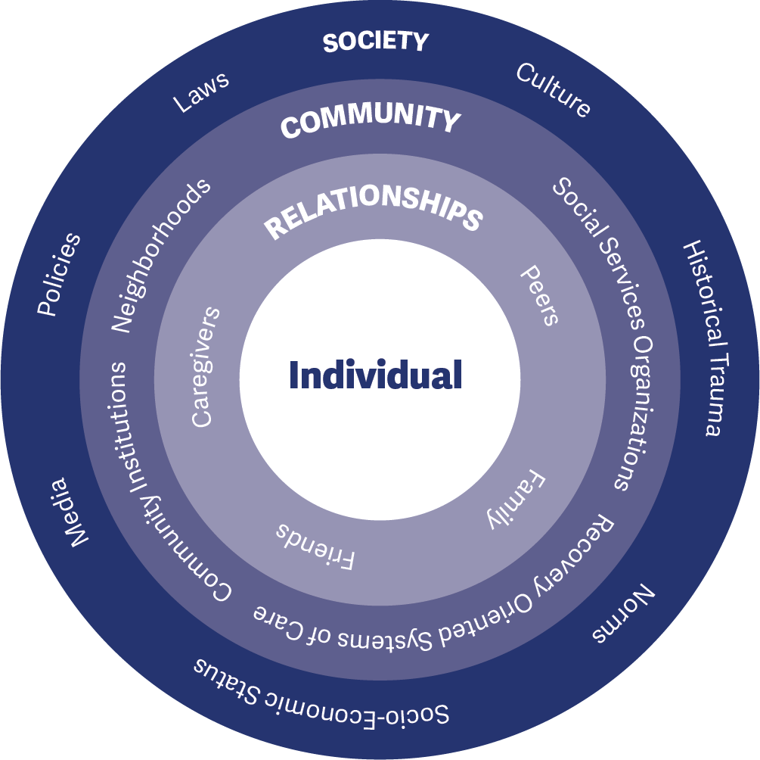
The Massachusetts Ambassador Project is an innovative, peer-to-peer approach that trains men of color with a history of substance misuse to lead conversations, small group sessions, presentations, and events about the relationship between problem gambling and substance misuse in communities disproportionately impacted by problem gambling and its associated consequences.
The project was established by the Massachusetts Department of Public Health Office of Problem Gambling Services (OPGS) as a direct result of a multi-year comprehensive planning process that engaged over 200 residents and stakeholders across the Commonwealth to discuss the issue of problem gambling and to explore ways in which it affects people, places, and spaces. The planning process and project design were both guided by a universal shared commitment to respect for persons, authentic engagement, the promotion of racial and health equity, and community empowerment.
Historically, efforts to mitigate gambling-related harm have centered on the promotion of individual responsibility and have ignored the broader life and community contexts in which these behaviors, harms, and consequences occur. The MA Ambassador Project is centered on the socio-ecological model (Figure 1) – a comprehensive approach rooted in public health principles that incorporates the individual, family, and community. This approach stresses the importance of focusing on the interconnectedness between individuals, their social circles and neighborhoods, and aspects of the communities in which they live.
Since July 2018, the Ambassador Project has been implemented within five recovery-oriented organizations in Massachusetts. Each recovery-oriented organization supports up to three men of color with a history of substance misuse who are now in recovery (Ambassadors). Ambassadors receive intensive training on problem gambling prevention; the relationship between problem gambling and other behavioral health issues such as substance misuse; health equity; group facilitation; and community engagement, capacity-building, and empowerment. Under the supervision of management staff within their host recovery-oriented organization, Ambassadors conduct community-based outreach and education with peers who are at elevated levels of risk for problem gambling. Outreach is conducted both individually and through partnership with community-based agencies and organizations. The project adheres to evidence-based principles and practices from the literature on peer-based recovery support services, behavioral health education, and brief interventions with underserved populations.
This approach is:
- Peer-Based
- Community-Centered
- Participatory
- Culturally Responsive
- Grounded in Evidence-Based Principles
The Ambassador Project is focused on having a strong impact – ultimately preventing or reducing problem gambling in centered populations. Impact involves having both the necessary reach (visibility and comprehensive coverage) and effectiveness (achievement of desired goals and objectives). This brief focuses on the period between January 1, 2021, and June 30, 2023. Impact briefs on earlier periods are referenced in the Timeline section.
The Ambassador Project has had extensive reach. At an average annual investment of $95,000 per organization, the project achieved the following between January 2021 and June 2023:

2,949

individuals
received prevention education through one-on-one discussions and small group work
173

different organizations
were engaged in discussions about problem gambling within their setting
3,140

individuals
received prevention education through community events and presentations

2,009

individuals
were reached through the distribution of gambling prevention materials

Ambassadors reached 8,098 individuals between January 2021 and June 2023.

GOALS – PURPOSE OF THE PROJECT

Goal 1:
Prevent or reduce problem gambling among individuals, centered populations, and communities at elevated or disproportionate levels of risk for problem gambling.

Goal 2:
Develop and maintain the awareness, skills, and behaviors needed to protect individuals, centered populations, and communities against developing problems with gambling.
OBJECTIVES – WAYS TO ACHIEVE GOALS

Socio-Ecological Level: Individual Priority Group: Ambassadors
Objective 1: Train and empower Ambassadors to be catalysts of change to raise awareness, provide resources, and support attitudes and behaviors incompatible with problem gambling.

Socio-Ecological Level: Interpersonal Priority Group: Peers
Objective 2: Actively engage, involve, and empower individuals, centered populations, and communities disproportionately affected by or at risk for problem gambling.

Socio-Ecological Level: Organizational Priority Group: Organizations
Objective 3: Build relationships with organizations, including treatment and recovery organizations, to promote systems change by adding problem gambling prevention into services and discussions.

Socio-Ecological Level: Community Priority Group: Community-Wide
Objective 4: Increase community awareness of problem gambling and educate about susceptibility to problem gambling with those at elevated levels of risk.
EXTERNAL INPUTS – SUPPORT PROVIDED TO THE PROJECT

Fiscal Support
Office of Problem Gambling Services (OPGS): Each of the host recovery-oriented organizations receives an average of $95,000 annually from OPGS to implement the Ambassador Project.

Management and Operations Support
Office of Problem Gambling Services (OPGS): The Program Management Team at OPGS actively monitors and supports each recovery-oriented organization, including fiscal management, roles and responsibilities, scope of work, and adherence to project requirements.

Training and Technical Assistance Support
Massachusetts Center of Excellence on Problem Gambling Prevention (MCOE PGP): MCOE PGP provides training and technical assistance (TA) support to each implementing site. Subject matter experts assist sites, individually and collectively, to problem-solve implementation challenges and enhance capacity.

Evaluation Support
Social Science Research and Evaluation, Inc. (SSRE): The Evaluation Team at SSRE assists implementing sites with data collection, activity tracking, and monthly reporting requirements through the development and management of a series of data collection forms and databases.

TIMELINE – TIME PERIOD COVERED
This impact brief covers January 2021 to June 2023 (Phase 2 implementation period). During this time, OPGS supported two recovery-oriented organizations in Region B (Western MA) and two organizations in Region C (Southeast MA).
Milestones and key dates are summarized below.

Regional Planning Process, Project Development, and Start-Up (January 2017 – June 2018)
Beginning in January 2017, the first 18-months of the project involved assessing needs, resources, and concerns in each OPGS region through a structured planning process; development of the Ambassador Project model; identification of the initial Region C pilot sites; and hiring, training, and start-up activities.
Region C Planning Process (January – June 2017) (see Region C Report)
OPGS and MCOE PGP develop the Massachusetts Ambassador model (August – December 2017)
Region A and B planning process (December 2017 – December 2018) (see Region A Report and Region B Report)
Two Region C sites selected for the Ambassador Project and begin start-up activities (January – June 2018)

Pilot Implementation Phase (July 2018 – June 2019)
The pilot implementation period began in July 2018 and lasted through June 2019 with two sites in Region C and two sites in Region B (added mid-cycle). This was an opportunity to assess and refine the Ambassador model and assess fit and feasibility.
Initial pilot implementation begins in two Region C Ambassador sites (July 2018 – June 2019)
Two Region B Ambassadors sites added to the initial pilot implementation (April 2019 – June 2019)
MA Ambassadors Project Impact Brief released (see MA Ambassadors Project Impact Brief 2019)

Phase 1 Implementation (July 2019 – December 2020)
The Phase 1 implementation period started in July 2019 and lasted through March 2020 when it was interrupted by the COVID-19 pandemic. In adherence with state physical distancing guidelines, the project transitioned to providing only virtual online services. Due to the pandemic, the focus was temporarily shifted from direct service work to intensive capacity-building and professional development to enhance Ambassadors’ skills and capacities.
Phase 1 implementation period in two Region B and two Region C sites (July 2019 – March 2020)
COVID-19 pandemic state of emergency declared – sites shift to virtual only services (March 2020 – June 2020)
Sites pause direct service operations and shift to intensive professional development (July 2020 – December 2020)
MA Ambassadors Project Impact Brief released (see MA Ambassadors Project Impact Brief 2020).

Phase 2 Implementation (January 2021 – June 2023)
The Phase 2 implementation period started in January 2021 following a competitive Request for Response (RFR) issued by OPGS that sought to identify four implementation sites in the Commonwealth. This phase of the project, expected to continue through June 2028, supports full implementation of the MA Ambassador project.
OPGS awards funding to two Region B and two Region C sites (see OPGS MA Ambassador Project RFR)
Phase 2 implementation begins in Regions B and C with virtual services (January 2021 – April 2021)
In-person activities resume as COVID-19 infection rates decline (May 2021 – October 2021)
COVID-19 pandemic Omicron variant temporarily disrupts in-person services (November 2021 – February 2022)
Continued full Phase 2 in-person implementation (March 2022 – June 2023)
Sports betting (online and in-person) is legalized in Massachusetts (January 31, 2023)

In adherence with the socio-ecological model (Figure 1), Ambassadors engage in problem gambling prevention activities at the individual, interpersonal, organizational, and community levels.
PROJECT ACTIVITIES – AMBASSADOR ACTIVITIES

Socio-Ecological Level: Individual
Centered Group: Ambassadors
Workplace Supervision and Support: Ambassadors receive weekly supervision and support from their manager to discuss project activities, address challenges, build their skills, and celebrate successes.
Orientation Training: Upon hire, Ambassadors take part in a three-day training on problem gambling prevention, the relationship between substance use disorder and problem gambling, building health and racial equity, and engaging peers in group and individual conversations.
Ongoing Professional Development: Ambassadors routinely attend and participate in additional content-specific professional development training opportunities (e.g., Massachusetts Recovery Coach training) and conferences.
Technical Assistance and Peer Support: The Massachusetts Center of Excellence on Problem Gambling Prevention provides capacity building, training, and program development services to Ambassadors (including hosting monthly Communities of Practice for Ambassadors to interact and share with Ambassadors at other sites).
Socio-Ecological Level: Interpersonal
Centered Group: Peers
Individual Interaction and Education: Ambassadors engage peers individually in one-on-one discussions about problem gambling to enhance knowledge and awareness, modify attitudes and beliefs, and provide support and resources. These interactions occur in a variety of settings such as recovery-oriented organizations, partner organizations, through street outreach, and at community events.
Small Group Education: Ambassadors engage groups of individuals in structured small group settings within recovery-oriented organizations or at partner organizations that serve populations at elevated levels of risk for problem gambling and its associated consequences. These sessions provide opportunities for Ambassadors to educate group members and for peer-to-peer education and support between group members.

Socio-Ecological Level: Organizational
Centered Group: Organizations
Outreach and Engagement with Organizations: Ambassadors outreach to and engage with treatment and recovery-oriented organizations that provide Acute Treatment Services (ATS/Detox), Clinical Stabilization Services (CSS/Inpatient Treatment), Transitional Support Services (TSS or Holding Programs), Residential Treatment (Halfway Houses), and Alcohol and Drug Free (ADF) Housing or Sober Homes. Outreach to organizations is also conducted with shelters, social service organizational, correctional facilities, and other organizations within the Recovery-Oriented System of Care.
Systems Change: Ambassadors seek to promote organization-level systems change by raising awareness among partnering organizations of the importance of incorporating, institutionalizing, and sustaining problem gambling prevention discussions within substance misuse treatment and recovery organizations.

Socio-Ecological Level: Community
Centered Group: Community-Wide
Community Events and Presentations: Ambassadors engage with the broader community through events and presentations to large groups of individuals. These include speaking engagements and active participation at health fairs, faith community events, drop-in center events, and community cultural events.
Community Messaging and Materials Distribution: Ambassadors distribute problem gambling prevention materials and resources throughout the community including brochures and pamphlets from the Massachusetts Health Promotion Clearinghouse (see MA Clearinghouse), the Let’s Get Real about Gambling campaign (see Let’s Get Real About Gambling Campaign), and the Protect Yourself and Your Loved Ones from Problem Gambling brochure (see Protect Yourself and Your Loved Ones brochure).

PROJECT OUTPUTS – PROGRESS TOWARD GOALS

Socio-Ecological Level: Individual
Centered Group: Ambassadors
Between January 2021 and June 2023, a total of 15 Ambassadors were hired and trained as part of the project. Across the four project sites, there were between 1 and 3 active Ambassadors per site each month during this period. Ambassadors are all men of color (African American, Cape Verdean, Native American, Puerto Rican) in their 30s-60s with a high school equivalent or bachelor’s degree and experience in the recovery community (see sample job description).
Ambassadors received weekly supervision from their site manager both individually and with other Ambassadors in the organization. Topics discussed during supervision included: project operations (Ambassador roles and responsibilities, teamwork, professionalism); project logistics (planning, scheduling, coordination of services); technology (overcoming technical issues, computer skills, comfort on phone calls); implementation skills (community engagement, leading groups, group activities, presentation skills); quality improvement (continuous feedback); work-life balance (self-care and personal recovery); and professional development (long-term planning and career goals). Ambassadors also participated in Communities of Practice with staff from MCOE PGP and Ambassadors from other sites to role-play and practice their outreach, engagement, education, and presentation skills. Additional professional development included participation in advanced trainings on topics such as: problem gambling prevention (online gambling and sports betting, using social media to increase reach, financial education); groupwork and peer support (confidentiality and boundaries, recovery language, motivational interviewing); culture and society (cultural humility), workplace safety (crisis management, overdose prevention and naloxone training) and mental health and well-being.
4

Socio-Ecological Level: Interpersonal
Centered Group: Peers
1,211 individuals were engaged through one-to-one conversations after group sessions at recovery centers and related settings and through street outreach at convenience stores, bodegas, barbershops, gas stations, bus stations, and local hang out spots. Topics discussed included the co-occurrence of problem gambling and substance use disorder, problem gambling awareness, resources, and the relationship between gambling and culture. On average, Ambassadors engaged 12 individuals through one-on-one conversations each month. Two-thirds of the individuals reached through one-on-one conversations (66%) were people of color (794 individuals).
1,738 individuals received problem gambling prevention information, education, and resources through small group sessions. Ambassadors conducted 265 sessions with an average group size of 7 individuals. Topics covered included risk factors, similarities between problem gambling and substance use disorder, first experiences gambling, what gambling is and is not, and resources for gambling addiction. Half of the individuals who participated in small group sessions (52%) were people of color (900 individuals).

Socio-Ecological Level: Organizational
Centered Group: Organizations
173 different organizations were successfully engaged in discussions about the importance of incorporating problem gambling prevention discussions as part of their services – many of which hosted Ambassador presentations and group sessions. Partner organizations spanned the recovery-oriented system of care (77 organizations); substance misuse treatment continuum of care (32 organizations with an emphasis on residential treatment programs and halfway houses); social service organizations such as food pantries and shelters for the unhoused (30 organizations); faith-based settings (23 organizations); and offices of community corrections and county corrections facilities (11 organizations).

Socio-Ecological Level: Community
Centered Group: Community-Wide
3,140 individuals were reached through 70 community events (2,020 people – 1,115 people of color) and 62 presentations (1,120 people – 555 people of color). Community events tended to coincide with holidays (Martin Luther King, Jr. Day, Thanksgiving community dinner, St. Patrick’s Day parade) and with other occasions focused on related health and behavioral health areas (e.g., recovery month, overdose awareness month, suicide prevention month). Half of the individuals reached through community events and group presentations (53%) were people of color (1,670 individuals).
2,009 individuals received problem gambling prevention materials via tabling and direct handouts from Ambassadors. Materials were largely drawn from the Massachusetts Health Promotion Clearinghouse and included the “Let’s Get Real About Gambling” brochure, “Worried About Your Gambling” wallet cards, “Protect Yourself and Your Loved Ones from Problem Gambling” brochures and flyers, and Massachusetts Problem Gambling Helpline stickers. Over half of the individuals who received problem gambling prevention materials (62%) were people of color (1,236 individuals).
PROJECT OUTCOMES – VOICES FROM THE FIELD

Socio-Ecological Level: Individual
Professional Development and Skill Building: Supervisors and Ambassadors commented extensively on the amount and quality of technical assistance, professional development, and training they received through the project.

“The amount of professional development they have received is incredible. I am seeing their professionalism and confidence improve and am always bragging about how prepared and ready they are.” (Supervisor)

“Watching them during the community of practice calls this year, I have learned a lot and watched them grow. It’s great seeing the results in the end of all their hard work.” (Supervisor)

“We got equipped and built up to be more versatile. Learning proper etiquette, how to conduct yourself, and stuff like that. They taught us how to conduct ourselves and start discussions with people about gambling.” (Ambassador)

“Tremendously informative. The TA people have a way of presenting the information in a way that you can grasp it and retain it, and most of all, use it and apply it.” (Ambassador)

Socio-Ecological Level: Interpersonal
Outreach and Education with Peers: Ambassadors and supervisors consistently reflected on the role that peer work plays in breaking down barriers to engagement, especially with individuals who are not initially receptive to problem gambling prevention messaging.

“The Ambassadors continue to be surprised by the number of people that come to them and express their thanks for opening their eyes to gambling. Peer work is such a natural way of reaching people where they are at.” (Supervisor)

“Peer work can be challenging at times due to resistance and how some folks believe gambling isn’t an addiction. The Ambassadors begin talking to them and sharing their information. After a while, peers start asking lots of questions. It’s very gratifying.” (Supervisor)

“I have a biweekly group at a pre-release facility, and I was extremely nervous to speak to incarcerated men. They were extremely engaged and receptive to the message and I was very surprised with their honesty.” (Ambassador)

“Many of the discussions are about the casino and it being risky for those who are in recovery because of free drinks, the thrill of winning, the chase to get even when you are down. Also talk a lot about sports betting during play-off season and how much they spend on scratch tickets.” (Ambassador)

“People at the [recovery] center have really engaged with the gambling group and are now looking forward to it each week and have started bringing others or encouraging them to attend.” (Ambassador)

“People seem to be receptive to what we bring to them about gambling when they become aware that I am just a peer trying to share information.” (Ambassador)

Socio-Ecological Level: Organizational
Outreach to Organizations and Systems Change: Ambassadors and supervisors indicate that they have felt welcomed by most agencies and organizations they approach and that the services provided are valued by these sites.

“We were able to go into many treatment facilities and recovery centers. The Ambassadors were well received and welcomed. The organizations are so happy that they are asking us to write MOUs [memoranda of agreement] between our agencies” (Supervisor)

“We bring our lived experience when we go to other organizations to do groups and provide education, prevention, and resources. The organizations appreciate when we bring this awareness to their clientele.” (Ambassador)

Socio-Ecological Level: Community
Raising Awareness in the Community About Problem Gambling: Supervisors note that Ambassadors have become established and well-known members of their local communities and have helped raise awareness of problem gambling.

“We celebrated Recovery Month Day in the community where over 45 agencies were present to support the community. Over 200 people stopped by the event and interacted with Ambassadors at their table.” (Supervisor)

“Ambassadors have shared hundreds of the Let’s Get Real About Gambling brochures throughout the community. Sharing this information is an effective way to reach more individuals and get more information out there regarding problem gambling.” (Supervisor)

LESSONS LEARNED FROM AMBASSADORS AND SUPERVISORS
Recruitment, Hiring, and Retention
- Ambassador positions should be full-time (with benefits) to promote recruitment and retention and provide sufficient time for preparation, travel, coordination, and professional development.
- Organizations with an Ambassador project should establish peer hiring committees and involve existing Ambassadors in the interview process when hiring new staff for the project.
- Ambassadors should reflect the diversity of the community in which they work.
- Agencies should reduce administrative hurdles to hiring, especially related to individuals with past legal history.
- Ambassadors should be bilingual or have access to bilingual peers to facilitate outreach and engagement with language diverse populations.
Training, Professional Development, Support, and Resources
- Communities of Practice (opportunities for Ambassadors to share with other Ambassadors across sites) are critical opportunities for peer sharing and learning.
- Ambassadors need more information and resources related to online sports betting – including counter-advertising messages to protect against the industry’s use of celebrities of color in their advertisements.
- Agency budgets for Ambassadors should include mileage reimbursement for travel, especially in areas where treatment and recovery organization partners are not in close geographic proximity to the host organization.
- There should be an established and ongoing process for onboarding and training new Ambassadors to minimize delays following turnover or transitions in staffing.
- Branding materials, promotional materials, and print resources should be readily available to Ambassadors to facilitate outreach and engagement – these materials should be available in multiple languages.
Peer Work
- Ambassadors should be skilled in natural engagement strategies (i.e., comfortably initiating conversations in a variety of public and private settings and environments).
- Community outreach should prioritize places and spaces where men of color gamble and socialize (e.g., cultural clubs, barber shops, community cultural events).
- Outreach and education should be inclusive of messaging and resources for social network members and those who may be concerned about others (e.g., family members, friends, co-workers).
- One-on-one interactions can provide an opportunity for more in-depth discussions about personal struggles and concerns about family members that people may not feel comfortable expressing during educational group sessions.
Work with Organizations
- Despite improvements in technology during the COVID-19 pandemic, many organizations within the treatment and recovery-oriented system of care lack the infrastructure and capacity to host virtual groups and presentations.
- Events and occasions focused on health and behavioral health areas related to problem gambling (e.g., recovery month, overdose awareness month, suicide prevention month) are opportunities to partner with other organizations in the community.
Community Work
- Community events are important venues through which to raise awareness among residents and share problem gambling prevention resources.
- The Ambassador Project should be promoted within the community and visible to the community in ways that identify Ambassadors as credible knowledge and resource experts.

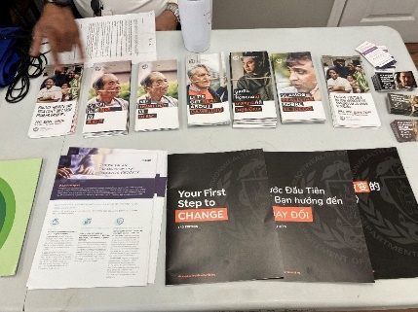
Additional information about the Massachusetts Ambassador project can be found at the Office of Problem Gambling Services website (www.mass.gov/opgs),
the Massachusetts Center of Excellence on Problem Gambling Prevention website (www.mcoepgp.org), and in Our Voices Matter: Using Lived Experience to Promote Equity in Problem Gambling Prevention (see Ortiz, et. al., 2021).
The Office of Problem Gambling Services provides a range of programs and services across the continuum of care. If you or a loved one need immediate assistance regarding problem gambling, please call the Massachusetts Problem Gambling Helpline at 1-800-327-5050, visit www.gamblinghelplinema.org, or text: “GAMB” to 800327.

