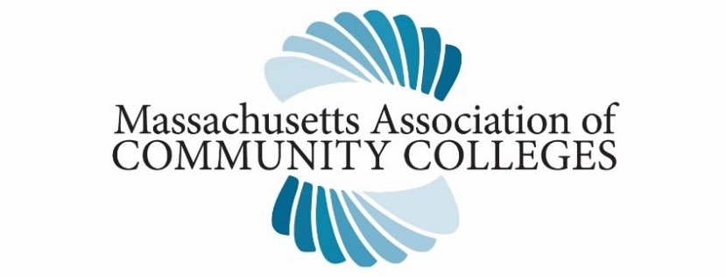
October 29, 2020

Massachusetts Board of Registration in Nursing
239 Causeway St., Suite 500
Boston, MA 02114

Dear Board Members,
I write this letter on behalf of the presidents of the 15 community colleges in Massachusetts to request removing the proposed regulation revision for 244 CMR 6.04 2 (b)4. c. (iii) (a)-Faculty Qualifications. This change, being considered at the October 29th hearing, would significantly limit the option to utilize BSN prepared part-time faculty. We request that the language on page seven that would require a graduate degree be removed from the proposed regulations. Although our understanding is that current part-time faculty under this waiver are grandfathered in, the proposed change will eliminate the option to hire new experienced BSN prepared faculty for clinical and laboratory teaching. Programs will lose the ability to share faculty who teach in specialized areas such as pediatrics, maternity, and mental health. Currently, the BSN clinical faculty are drawn from the majority of BSN prepared nurses in Massachusetts who work primarily in inpatient academic and community hospitals.
Removal of this proposed change is necessary for our programs to continue to educate professional nurses and meet workforce needs locally and throughout the state. Without any action, many Massachusetts nursing programs, including our community college programs, will likely face decreasing enrollments of students due to the lack of available faculty for clinical and lab experiences. For our vulnerable programs that are geographically isolated, this presents a dire situation due to the lack of master’s-prepared educators. Currently, nursing programs are already facing a significant nursing faculty shortage. This is well documented in research and publications, specifically done by the Massachusetts Action Coalition (see footnote). Barriers to nurses becoming nurse faculty include pay inequities with practice, need for advanced education, and scholarship requirements. The burden of eliminating the use of BSN-prepared faculty in the clinical areas may result in some programs being forced to close.

Our community college programs currently enroll more than 1,700 students in every region of the Commonwealth, and we graduated more than 2,200 over the last three years. According to the Massachusetts & Rhode Island League of Nurses, Massachusetts programs currently employ over 110 BSN prepared nurses as clinical and laboratory faculty based on a 2020 spring semester survey of the Associate Degree and Diploma Programs in Massachusetts. Even before the challenges of COVID-19, we live in a healthcare environment where the need for nurses continues to grow. Now, it is even more important to avoid creating additional barriers. We appreciate your consideration of this evidenced-based testimony so that our programs can continue to provide high-quality and affordable education to the next generation of nurses.

Sincerely,

Tom Sannicandro, Ph.D.
Director
Massachusetts Association of Community Colleges

Bittner, N & Bechtel, C (2017). Identifying and Describing Faculty Workload Issues: A Looming Faculty Shortage. Nursing Education Perspectives. July/August 2017 - Volume 38 - Issue 4 - p 171–176 Bittner, N., Bechtel, C. Frontiero, L., Kowal, N., & Silveira, C. (2015) Nursing Faculty Workload Survey 2015: Summary Report. Robert Wood Johnson APIN Grant; Massachusetts Action Coalition, December 2015. Manning, K., Bittner, N. Seymour-Route, P. & Bechtel, C. (2014) Nursing Faculty Workforce Challenges in Massachusetts. Massachusetts Action Coalition White Paper, December 2014. C: James Peyser, Massachusetts Secretary of Education Marylou Sudders, Massachusetts Secretary of Health & Human Services Rosalin Acosta, Massachusetts Secretary of Labor & Workforce Development Dr. Carlos Santiago, Commissioner of the Massachusetts Department of Higher Education

