INDOOR AIR QUALITY ASSESSMENT

Massachusetts Board of Bar Overseers
New Suffolk County Court High-rise
3 Pemberton Square
Boston, Massachusetts

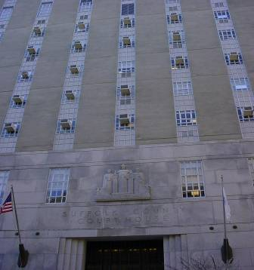

Prepared by:
Massachusetts Department of Public Health
Bureau of Environmental Health
Emergency Response/Indoor Air Quality Program
June 2007

Background/Introduction
In response to a request from Steve Carroll, Director of Court Facilities, Massachusetts Administrative Office of the Trial Court (DCAM), the Massachusetts Department of Public Health (MDPH), Bureau of Environmental Health (BEH) conducted an indoor air quality assessment at the offices of the Massachusetts Board of Bar Overseers (MBBO), which are located on the seventh floor of the Suffolk County Court High-rise (SCC), 3 Pemberton Square, Boston, Massachusetts. Concerns about indoor air quality and waterproofing materials that were previously applied to the building prompted the request.
On March 9, 2007, Michael Feeney, Director of BEH’s Emergency Response/Indoor Air Quality (ER/IAQ) Program, made a visit to this building. The MBBO is located in an office suite located on the eastern wall of the SCC. Windows are openable in the building.

Methods
Air tests for carbon dioxide, temperature and relative humidity were taken with the TSI, Q-Trak, IAQ Monitor. Screening for total volatile organic compounds (TVOCs) was conducted using a Thermo Environmental Instruments Inc., Model 580 Series Photo Ionization Detector (PID). MDPH staff also performed a visual inspection of building materials for water damage and/or microbial growth.

Results
The MBBO has an employee population of eight. Tests were taken under normal operating conditions and results appear in Table 1.

Discussion
Ventilation
It can be seen from Table 1 that carbon dioxide levels were below 800 parts per million (ppm) in all areas surveyed, which generally indicates adequate fresh air supply in a building. Fresh air in rooms is supplied by a unit ventilator (univent) system. Univents draw air from outdoors through a fresh air intake located on the exterior walls of the building (Picture 1) and return air through an air intake located at the base of each unit (Figure 1). Fresh and return air are mixed, filtered, heated and provided to rooms through an air diffuser located in the top of the unit. Window-mounted air conditioners provide cooling during hot weather. No functioning exhaust system exists in these offices in an effort to create pressurization within the building. Pressurization of the building is designed to prevent the draw of air/odors from external sources (e.g., wall cavities, exterior) into occupied areas.
The Massachusetts Building Code requires a minimum ventilation rate of 20 cubic feet per minute (cfm) per occupant of fresh outside air or have openable windows in each room (SBBRS, 1997; BOCA, 1993). The ventilation must be on at all times that the room is occupied. Providing adequate fresh air ventilation with open windows and maintaining the temperature in the comfort range during the cold weather season is impractical. Mechanical ventilation is usually required to provide adequate fresh air ventilation.
Carbon dioxide is not a problem in and of itself. It is used as an indicator of the adequacy of the fresh air ventilation. As carbon dioxide levels rise, it indicates that the ventilating system is malfunctioning or the design occupancy of the room is being exceeded. When this happens a buildup of common indoor air pollutants can occur, leading to discomfort or health complaints. The Occupational Safety and Health Administration (OSHA) standard for carbon dioxide is 5,000 parts per million parts of air (ppm). Workers may be exposed to this level for 40 hours/week, based on a time-weighted average (OSHA, 1997).
The MDPH uses a guideline of 800 ppm for publicly occupied buildings. A guideline of 600 ppm or less is preferred in schools due to the fact that the majority of occupants are young and considered to be a more sensitive population in the evaluation of environmental health status. Inadequate ventilation and/or elevated temperatures are major causes of complaints such as respiratory, eye, nose and throat irritation, lethargy and headaches. For more information concerning carbon dioxide, please see Appendix A.
Temperature measurements ranged from 70º F to 74º F, which were within the MDPH recommended comfort guidelines in all areas surveyed during the assessment. The MDPH recommends that indoor air temperatures be maintained in a range of 70 º F to 78 º F in order to provide for the comfort of building occupants. Although temperatures measured were within MDPH guidelines during the assessment, complaints regarding thermal discomfort were reported to CEH staff. This discomfort is likely due to the close proximity of the occupant’s desk in the airstream of the univent (Picture 1).
The relative humidity in the building ranged from 7 to 9 percent, which was below the MDPH recommended comfort range in all areas surveyed on the day of the assessment. The MDPH recommends a comfort range of 40 to 60 percent for indoor air relative humidity. Relative humidity levels in the building would be expected to drop during the winter months due to heating. The sensation of dryness and irritation is common in a low relative humidity environment. Low relative humidity is common during the heating season in the northeast part of the United States. Please note that relative humidity below 20 percent can cause eye irritation (Arundel et al., 1986). Therefore, some individuals (particularly those wearing eye contact lenses) may experience increased eye irritation during the winter months when relative humidity levels are lowest.

Microbial/Moisture Concerns
Plants were observed in a number of rooms within the MBBO. Moistened plant soil and drip pans can provide a source of mold growth and pollen. Plants should be located away from the air stream of ventilation sources to prevent the aerosolization of mold, pollen or particulate matter. Plants should have drip pans to prevent wetting of porous building materials and subsequent mold colonization. Over watering of plants should be avoided and drip pans should be inspected periodically for mold growth. Plants should not be placed on carpeting (Picture 2). A water cooler was also observed on top of carpeting. A plastic mat should be installed beneath the water cooler to prevent wetting of the carpet and subsequent mold growth.

Other IAQ Evaluations
An individual expressed concerns that a waterproofing material that had been used to seal the wall cavity of the SCC was causing irritant symptoms. The water proofing, which was applied to the west and south walls of the building in the early 1990’s was completely removed from the building in 2005 prior to the re-occupancy of the SCC.
In an effort to identify whether chemical respiratory irritants existed within the MBBO offices, sampling for volatile organic compounds (VOCs) was conducted. VOCs are carbon-containing substances that have the ability to evaporate at room temperature. Frequently, exposure to low levels of total VOCs (TVOCs) may produce eye, nose, throat and/or respiratory irritation in some sensitive individuals. For example, chemicals evaporating from a paint can stored at room temperature would most likely contain VOCs. Air sampling for TVOCs was conducted in all accessible rooms in the MBBO as well as the seventh floor hallway and elevator lobby (Table 1). An outdoor air sample was taken for comparison. Outdoor TVOC concentrations were ND (Table 1). Indoor TVOC concentrations were also ND in all areas surveyed (Table 1).

Conclusions/Recommendations
The symptoms reported by occupants within the MBBO appear most likely to be related to low relative humidity. As previously discussed, low relative humidity is typical of fall/winter months in New England and particularly in a building with steam heat radiators during an extended period of extremely dry weather. In view of the findings at the time of the assessment, the following recommendations are made:
- Move office desks and chairs a minimum of 5 feet away from univents.
- For buildings in New England, periods of low relative humidity during the winter are often unavoidable. Therefore, scrupulous cleaning practices should be adopted to minimize common indoor air contaminants whose irritant effects can be enhanced when the relative humidity is low. To control for dusts, a high efficiency particulate arrestance (HEPA) filter equipped vacuum cleaner in conjunction with wet wiping of all non-porous surfaces is recommended. Drinking water during the day can help ease some symptoms associated with a dry environment (throat and sinus irritations).
- Remove plants from direct contact with carpeting and from the air stream of univents. Ensure all plants are equipped with drip pans. Examine drip pans for mold growth and disinfect areas of water leaks with an appropriate antimicrobial where necessary.
- Place a water impermeable plastic mat beneath the water cooler.
References
Arundel, A.V., Sterling, E.M., Biggin, J.H., Sterling, T.D. 1986. Indirect Health Effects of Relative Humidity in Indoor Environments. Env. Health Perspectives. 65:351-361.
OSHA. 1997. Limits for Air Contaminants. Occupational Safety and Health Administration. Code of Federal Regulations. 29 C.F.R 1910.1000 Table Z-1-A.
SBBRS. 1997. Mechanical Ventilation. State Board of Building Regulations and Standards. Code of Massachusetts Regulations. 780 CMR 1209.0

Picture 1

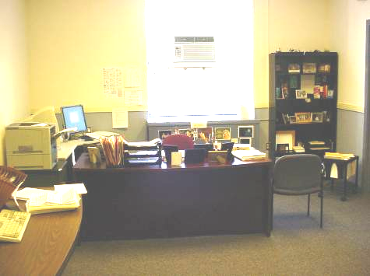

Desk and Chair in Front of Univent

Picture 2

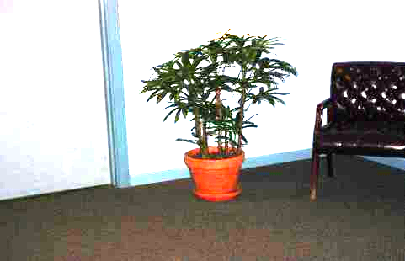

Plant on Carpet
Remarks | Carbon  Dioxide  (*ppm) | TVOC  (*ppm) | Temp.  (°F) | Relative  Humidity  (%) | Occupants  in Room | Windows  Openable | Ventilation |  | Remarks
 |  |  |  |  |  |  | Supply | Exhaust | Remarks
Outside  (Background) | 398 | ND | < 32 | 23
707G | 707 | ND | 70 | 9 | 1 | y | Y | N | Plants
707I | 720 | ND | 70 | 9 | 1 | Y | Y | N | Door open
707H | 714 | ND | 70 | 9 | 0 | Y | Y | N | Water cooler on carpet  Refrigerator
707F | 581 | ND | 71 | 7 | 0 | Y | Y | N | Door open
707D | 606 | ND | 72 | 7 | 1 | Y | Y | Y | Door open
707A | 598 | ND | 72 | 8 | 1 | N | N | N | 2 photocopiers  Personal fan
707E | 609 | ND | 72 | 8 | 0 | N | N | N
707B | 537 | ND | 71 | 6 | 0 | Y | Y | N | Plant of carpet  Door open
707C | 544 | ND | 72 | 7 | 0 | Y | Y | N | Personal fan
707 waiting room | 582 | ND | 72 | 7 | 0 | N | N | N
Interior hallway between 707 and elevator lobby | 645 | ND | 73 | 8 | 0 | N | N | N
7th floor elevator lobby | 674 | ND | 74 | 9 | 6 | N | N | N

