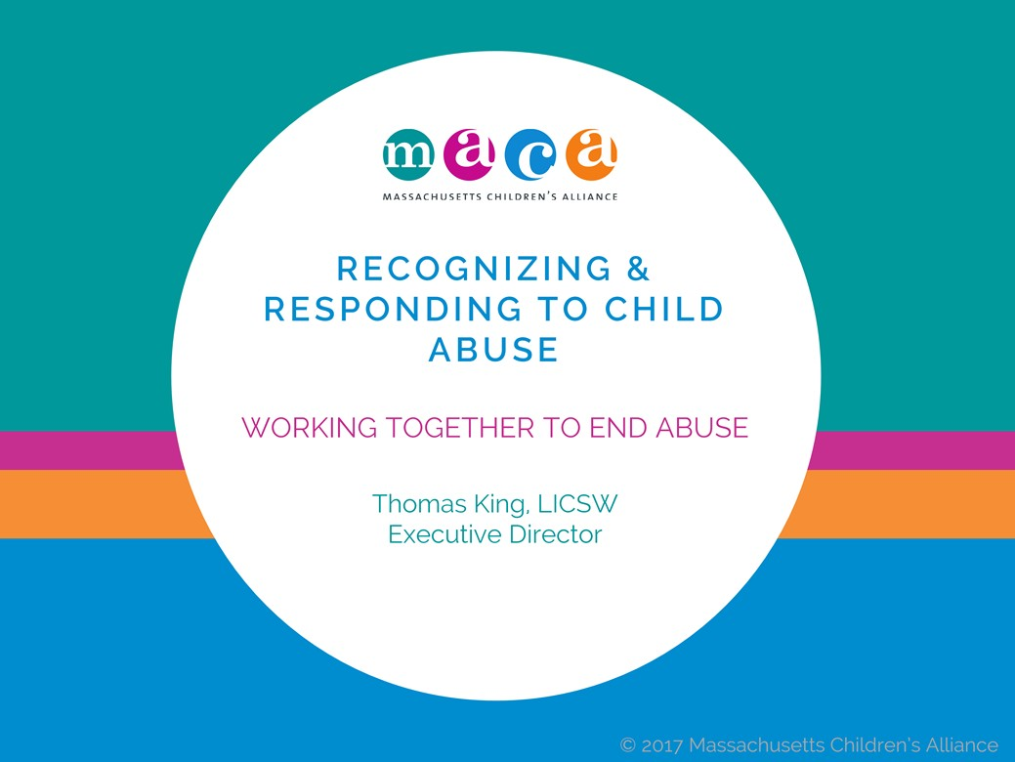

First, we have to thank you for taking the time to be here. Child abuse is something no one wants to think about, much less talk about. But talking about it is one of our best weapons. Today we’ll discuss what, exactly, abuse is, how you can recognize warning signs, and the steps you can take if you suspect a child is being abused.

Unfortunately, child abuse is an every day occurrence. And it’s everyday people – police, teachers, aides—who are the front lines when it comes to being aware of, and stopping it. Listening to, and talking about, these difficult topics is the first step in protecting those who can’t speak up for themselves.

We realize that this is a difficult topic. If you need to take a break at any time during this presentation, feel free to do so. And if you’d like to speak with us privately after this training session, we’ll be available to talk and to provide resources.

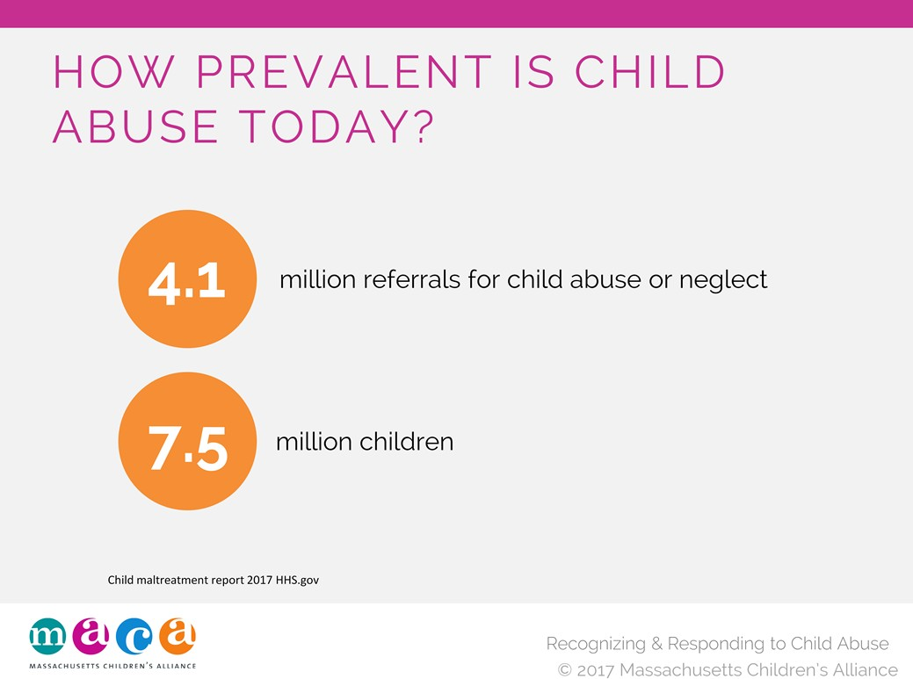

We’d all prefer to think that child abuse is decreasing in our society. The truth is, we still have a lot of work to do. Some recent numbers support this conclusion. In 2010, an estimated 3.3 million referrals for child abuse or neglect were received by public social services or child protective services agencies nationally.
These referrals involved:
- 5.9 million children.
- More than 75 percent (78.3%) suffered neglect.
- More than 15 percent (17.6%) suffered physical abuse.
- Approximately 10 percent (9.2%) suffered sexual abuse.
According to the National Children’s Alliance (2010):
- It is estimated that 1 in 4 girls and 1 in 6 boys are sexually abused before the age of 18.
- 1 in 5 children are sexually solicited while on the internet.
- Nearly 70% of all reported sexual assaults are on children ages 17 and under.
- Boys and girls are equally likely to be targets

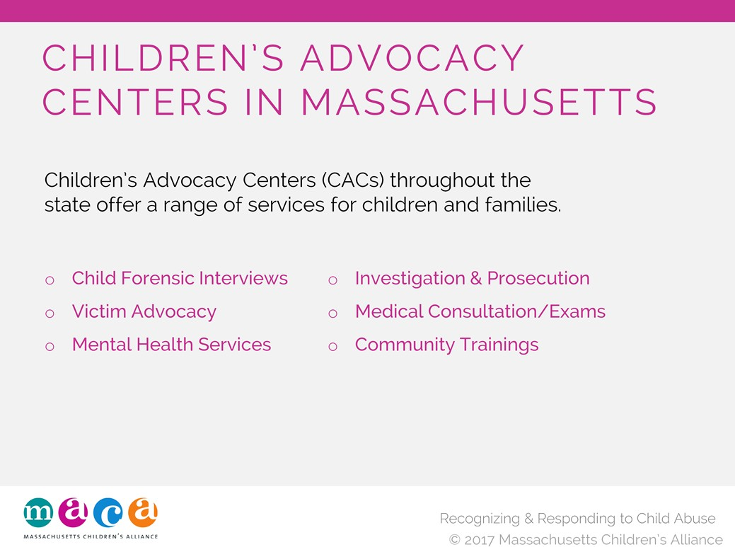

MACA is comprised of Children’s Advocacy Centers throughout the state. Each of these child‐friendly facilities offers a range of services for children and families, easily accessible and in one location. They employ a multidisciplinary team approach in offering culturally sensitive, timely services like:
- Child Forensic Interviews
- Victim advocacy
- Mental health referrals
- Investigation and prosecution
- Medical consultation/exam
- Community trainings

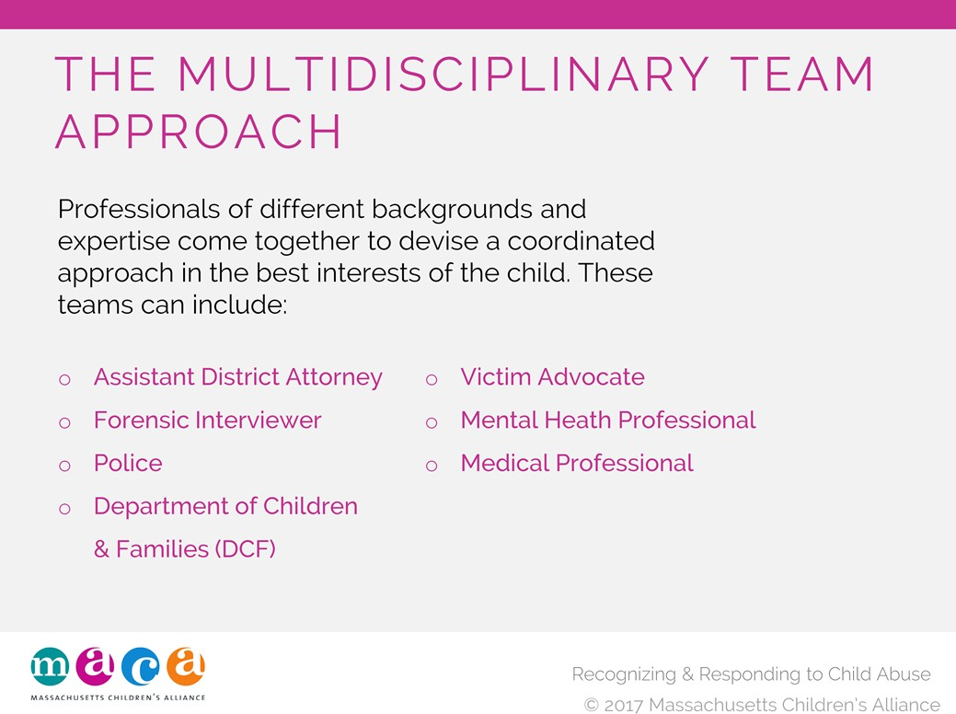

Child abuse touches on many issues. It makes sense to take a multidisciplinary team approach. This approach, also referred to as a SAIN Team approach (Sexual Abuse Intervention Network) incorporates the expertise of professionals from different backgrounds, all working together toward the best outcome.
- Police Protect public safety; determines whether crime been committed; investigates and gathers evidence; takes out initial charges; holds offenders accountable.
- DCF Focus is child protection and strengthening families; participates in overall investigation; determines if abuse/neglect occurred and who is responsible; supports families and works to keep them together when appropriate.
- Forensic interviewer Conducts non‐leading, forensically sound interviews of child victims; coordinates multidisciplinary team response.
- Victim Advocate Role/organization varies across the state; provide support and victim‐centered advocacy; educate those involved about the multidisciplinary team response; maintain up‐to‐ date information; provide guidance throughout the investigation and prosecution process; provide community referrals and resources.
- Mental health professional Role can vary; some CACs have on‐site clinicians, others refer to trauma‐informed clinicians; provide therapeutic intervention and referrals; conduct trainings and community outreach; provide consultation for child abuse professionals.
- District Attorney Determines appropriate criminal charges; aids in the investigation by law enforcement; is responsible for final prosecution of criminal case.
- Medical professional Specialized medical providers as part of MDT; provides medical diagnosis and appropriate treatment of child abuse; conducts photographic documentation of exam; performs evidence collection; follows the “do no harm” approach to care; provides expert testimony.

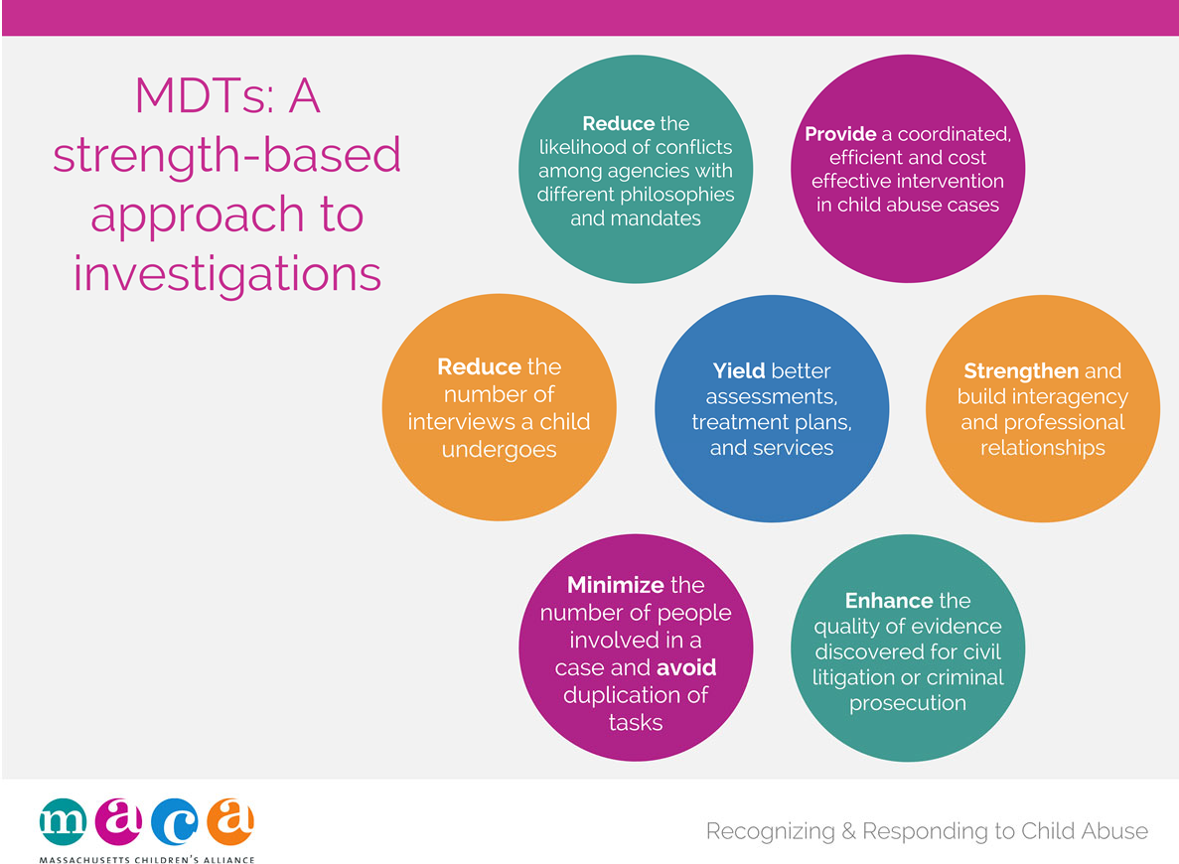

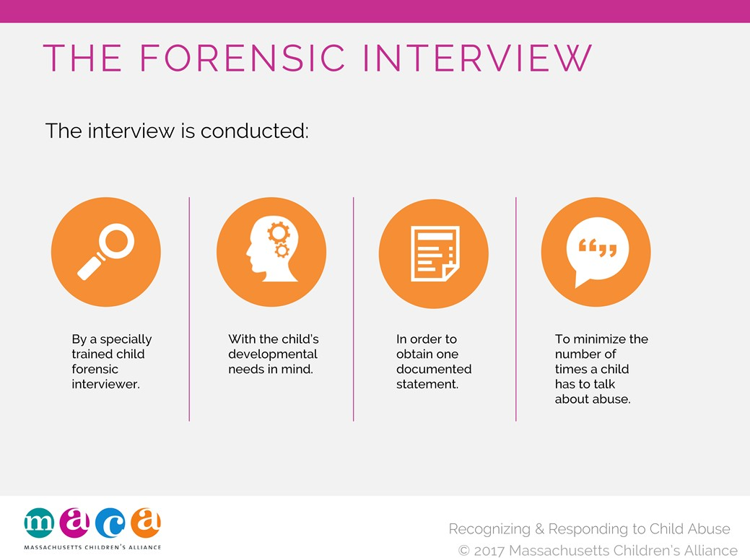

Part of this process is the forensic interview.
- The interview is conducted by a specially trained child forensic interviewer who can tailor the interview to meet the child’s unique developmental needs.
- The investigation is streamlined, resulting in one documented statement from the child. This decreases the likelihood that the child will be re‐traumatized by multiple interviews.
- Recordings may be used to minimize the number of times a child has to testify.
- All interviews are recorded and kept as evidence.

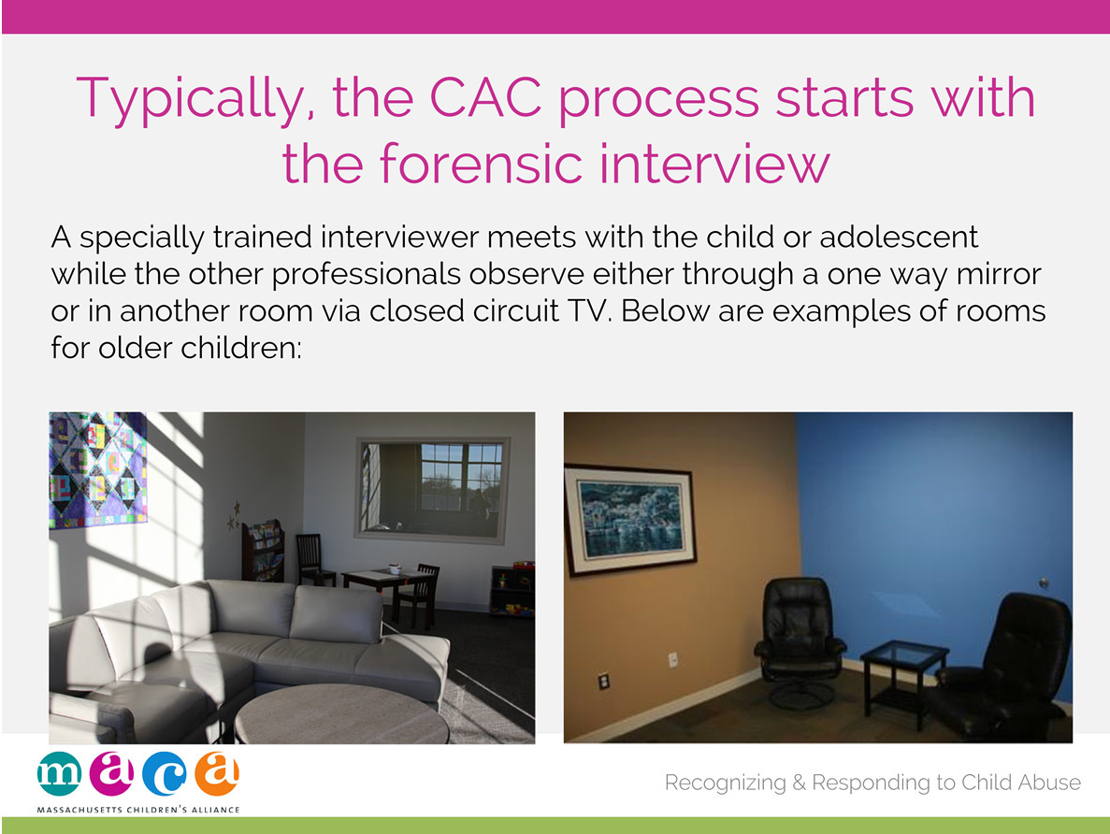

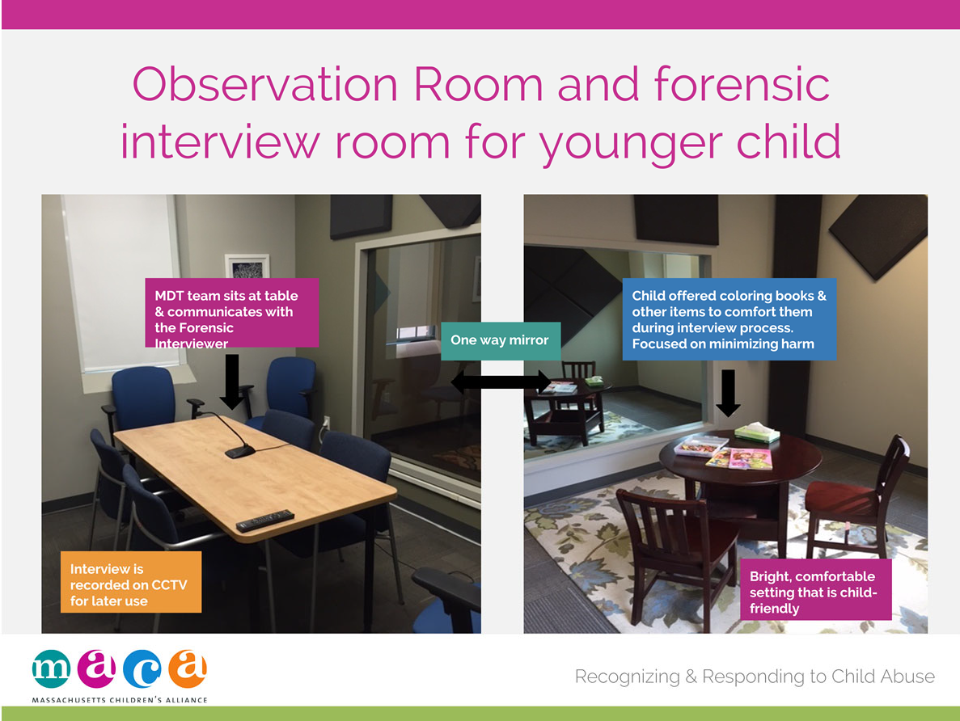

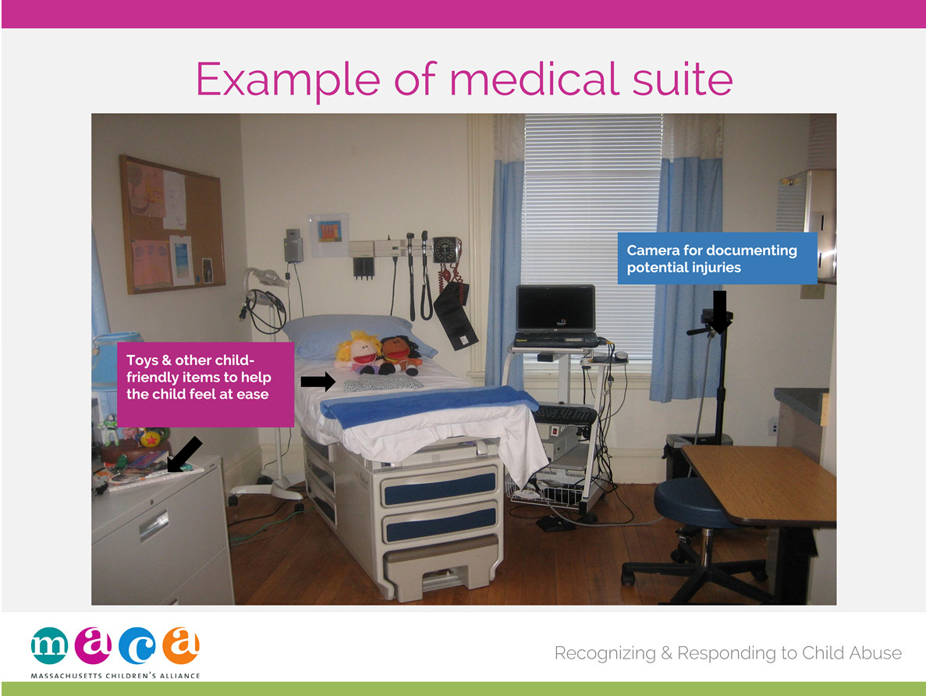

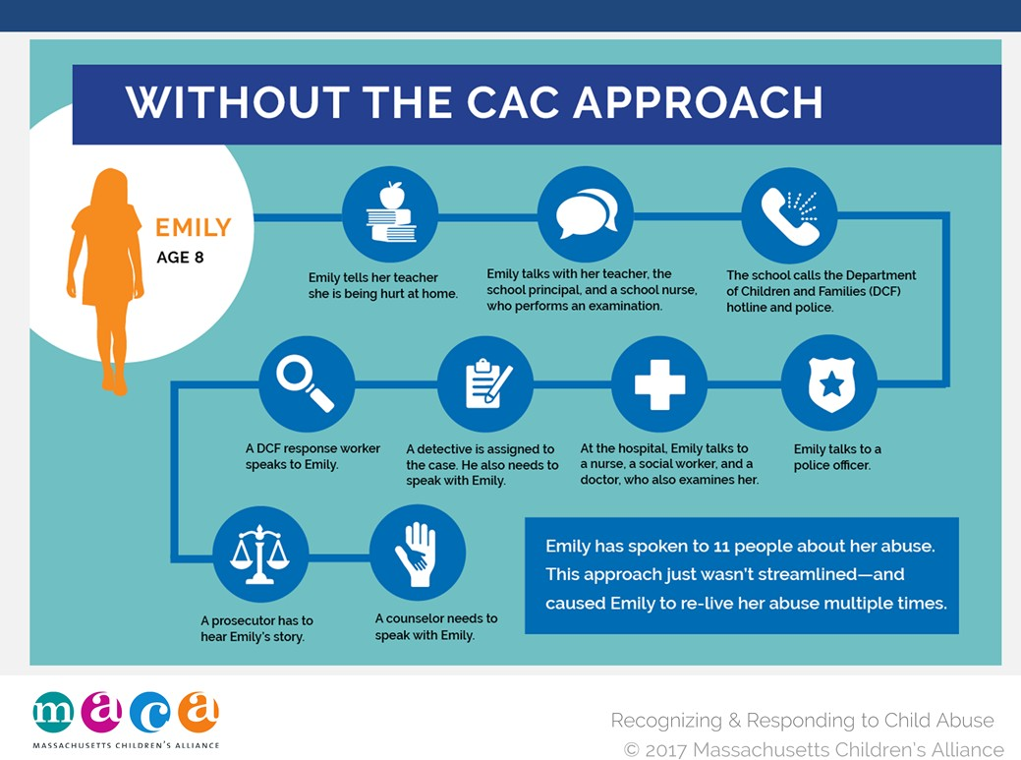

Before the CAC approach, children reporting abuse had to tell their stories again, and again, and again. Well‐meaning professionals conducted these interviews, true, but this approach gave ample opportunities for children to be re‐traumatized.
During the 1980s, there was a nationwide movement toward a more streamlined, child‐friendly approach to child abuse investigations.

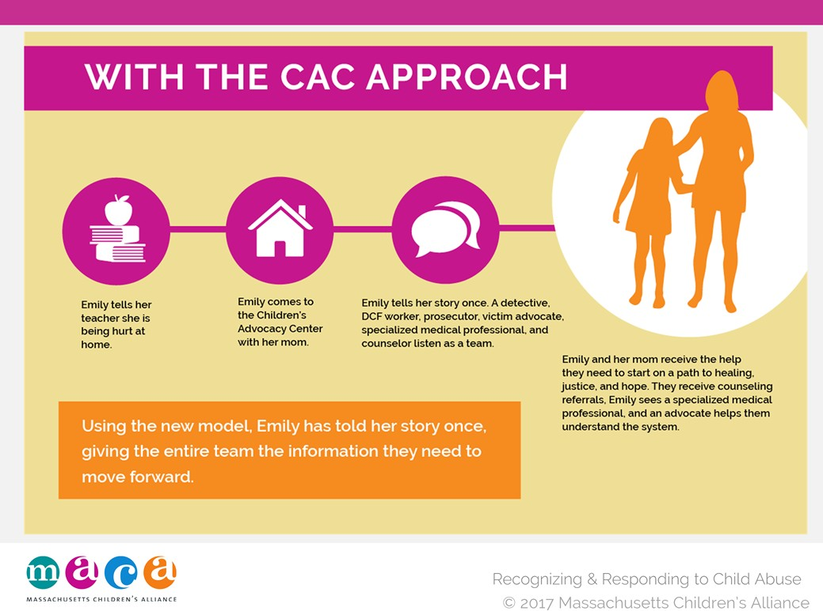

At over 800 CACs nationwide, children receive the streamlined, specialized treatment that gets them to the care they need faster, and with the least amount of trauma possible. Utilizing this model, Emily has to speak to only one person, and her entire multidisciplinary care team listens on to gather the information they need to do their part.1

1National Children’s Advocacy Center, www.nationalcac.org, 2013

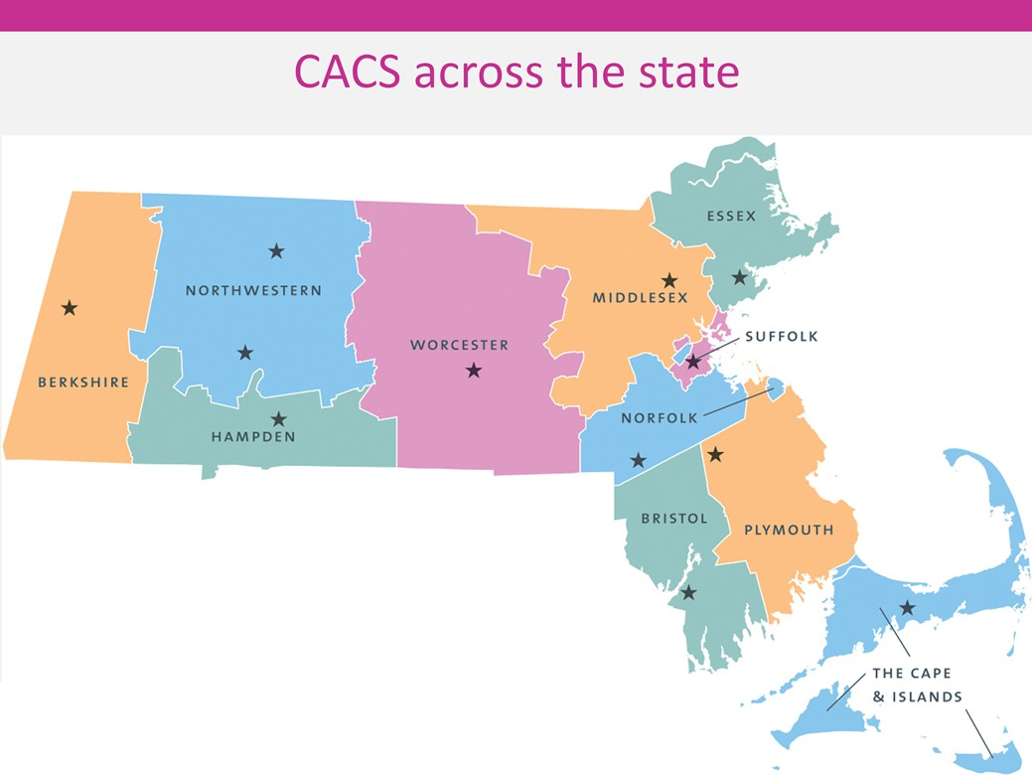

We’d all prefer to think that child abuse is decreasing in our society. The truth is, we still have a lot of work to do. Some recent numbers support this conclusion. In 2010, an estimated 3.3 million referrals for child abuse or neglect were received by public social services or child protective services agencies nationally.
These referrals involved:
- 5.9 million children.
- More than 75 percent (78.3%) suffered neglect.
- More than 15 percent (17.6%) suffered physical abuse.
- Approximately 10 percent (9.2%) suffered sexual abuse.
According to the National Children’s Alliance (2010):
- It is estimated that 1 in 4 girls and 1 in 6 boys are sexually abused before the age of 18.
- 1 in 5 children are sexually solicited while on the internet.
- Nearly 70% of all reported sexual assaults are on children ages 17 and under.
- Boys and girls are equally likely to be targets

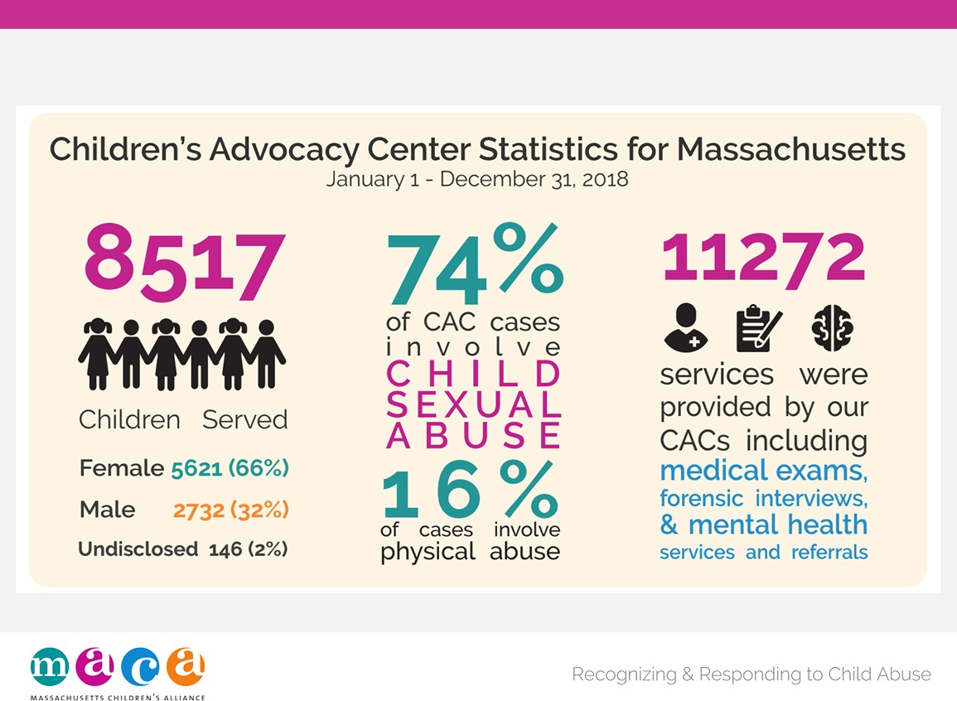

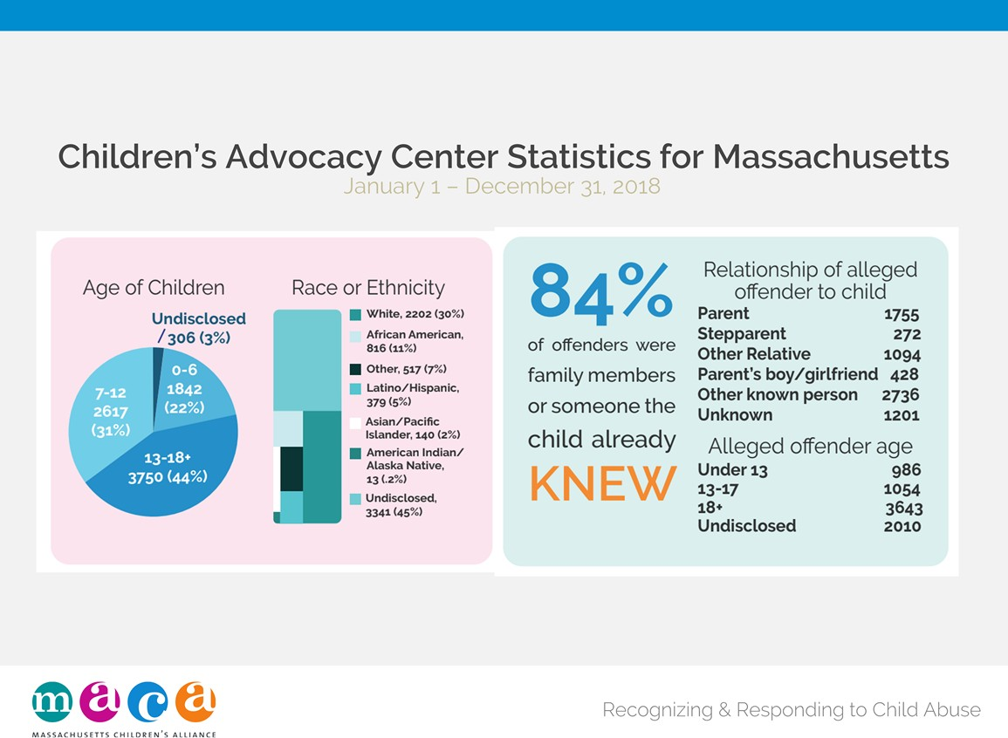

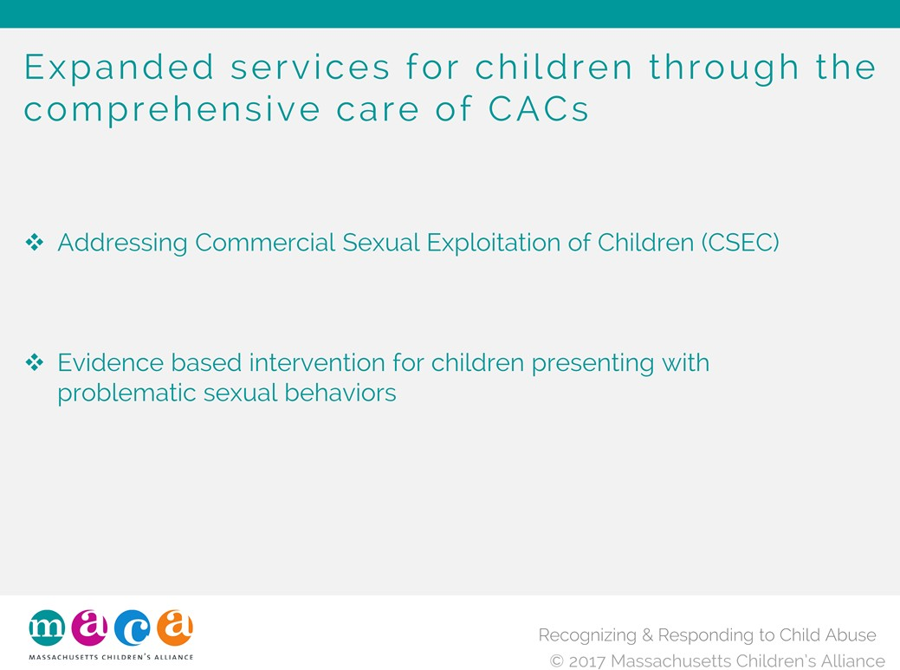

A commercially sexually exploited child is one under the age of 18 who engages, agrees to engage in, or offers to engage in sexual conduct in exchange for money, food, shelter, clothing, education, or care.

Because these victims are children—and therefore, unable to consent to ANY sexual activity, they are victims. Not “child prostitutes.”

Certain children are more vulnerable to CSEC.
Those with a history of emotional, physical or sexual abuse. Children whose parents abuse substances.
Children with school‐related problems (truancy, learning disabilities). Runaways, children in foster homes and other out‐of‐home placements.

People who exploit children in this way often prey on the most vulnerable. Girls, boys, and transgender youths are all victims of exploitation, and 70‐90% of CSEC victims have a history of childhood sexual abuse.1

A significant number of victims are involved with the child welfare or juvenile justice system, yet their exploitation often goes unnoticed. However, early identification provides an opportunity for prevention and intervention.

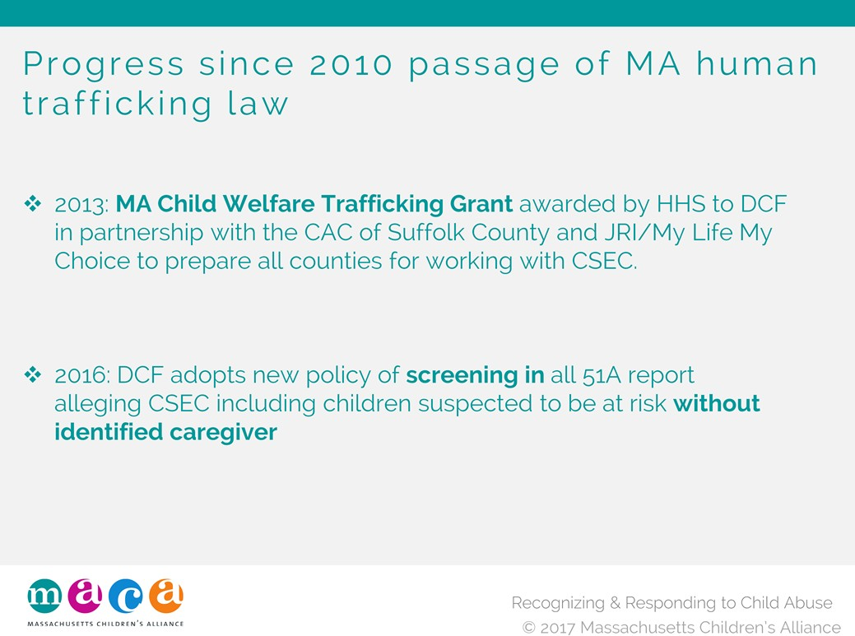

A commercially sexually exploited child is one under the age of 18 who engages, agrees to engage in, or offers to engage in sexual conduct in exchange for money, food, shelter, clothing, education, or care.

Because these victims are children—and therefore, unable to consent to ANY sexual activity, they are victims. Not “child prostitutes.”

Certain children are more vulnerable to CSEC.
Those with a history of emotional, physical or sexual abuse. Children whose parents abuse substances.
Children with school‐related problems (truancy, learning disabilities). Runaways, children in foster homes and other out‐of‐home placements.

People who exploit children in this way often prey on the most vulnerable. Girls, boys, and transgender youths are all victims of exploitation, and 70‐90% of CSEC victims have a history of childhood sexual abuse.1

A significant number of victims are involved with the child welfare or juvenile justice system, yet their exploitation often goes unnoticed. However, early identification provides an opportunity for prevention and intervention.

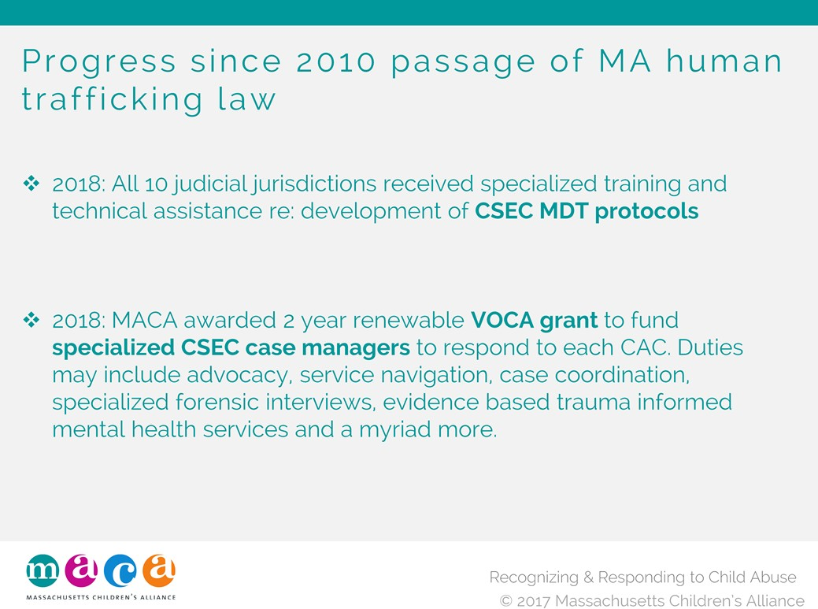

A commercially sexually exploited child is one under the age of 18 who engages, agrees to engage in, or offers to engage in sexual conduct in exchange for money, food, shelter, clothing, education, or care.

Because these victims are children—and therefore, unable to consent to ANY sexual activity, they are victims. Not “child prostitutes.”

Certain children are more vulnerable to CSEC.
Those with a history of emotional, physical or sexual abuse. Children whose parents abuse substances.
Children with school‐related problems (truancy, learning disabilities). Runaways, children in foster homes and other out‐of‐home placements.

People who exploit children in this way often prey on the most vulnerable. Girls, boys, and transgender youths are all victims of exploitation, and 70‐90% of CSEC victims have a history of childhood sexual abuse.1

A significant number of victims are involved with the child welfare or juvenile justice system, yet their exploitation often goes unnoticed. However, early identification provides an opportunity for prevention and intervention.

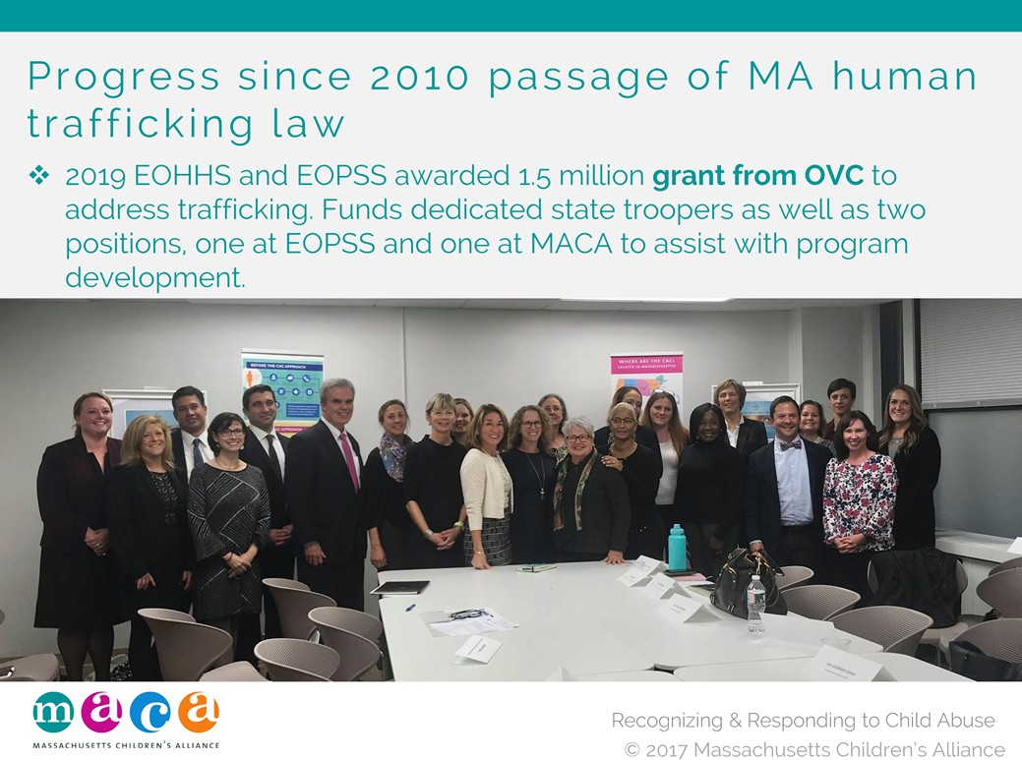

A commercially sexually exploited child is one under the age of 18 who engages, agrees to engage in, or offers to engage in sexual conduct in exchange for money, food, shelter, clothing, education, or care.

Because these victims are children—and therefore, unable to consent to ANY sexual activity, they are victims. Not “child prostitutes.”

Certain children are more vulnerable to CSEC.
Those with a history of emotional, physical or sexual abuse. Children whose parents abuse substances.
Children with school‐related problems (truancy, learning disabilities). Runaways, children in foster homes and other out‐of‐home placements.

People who exploit children in this way often prey on the most vulnerable. Girls, boys, and transgender youths are all victims of exploitation, and 70‐90% of CSEC victims have a history of childhood sexual abuse.1

A significant number of victims are involved with the child welfare or juvenile justice system, yet their exploitation often goes unnoticed. However, early identification provides an opportunity for prevention and intervention.

•