**POST-OCCUPANCY**

**INDOOR AIR QUALITY ASSESSMENT**

**Massachusetts Commission Against Discrimination**

**18 Chestnut Street**

**Worcester, MA**

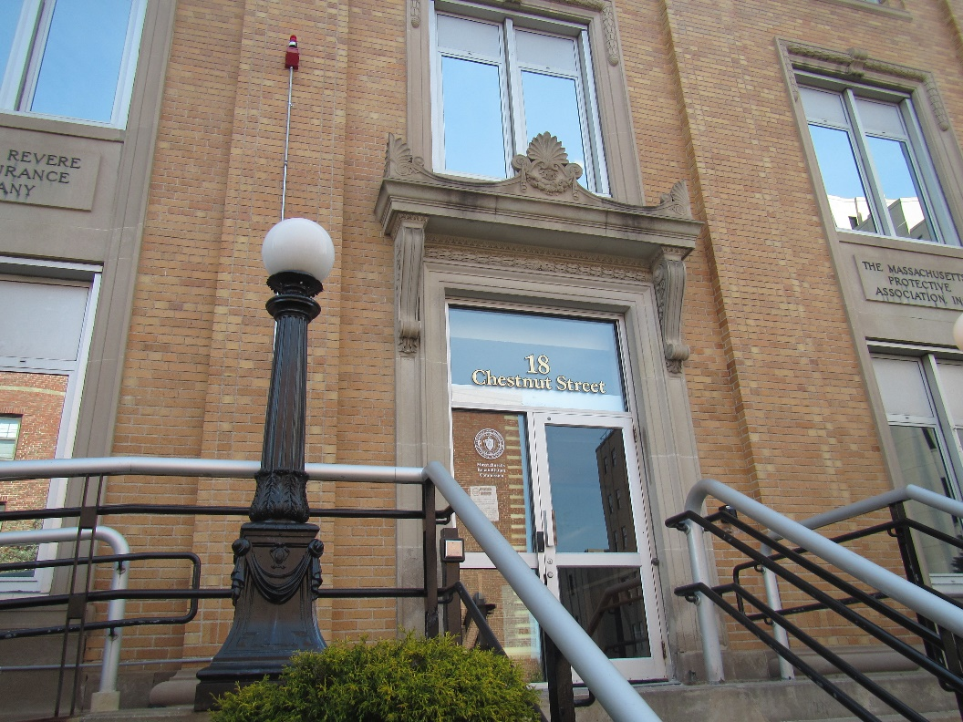

Prepared by:

Massachusetts Department of Public Health

Bureau of Climate and Environmental Health

Indoor Air Quality Program

April 2024

# BACKGROUND

|  |  |
| --- | --- |
| Building: | Massachusetts Commission Against Discrimination (MCAD) office |
| Address: | 18 Chestnut Street, 5th floor |
| Assessment Requested by: | Jamie Merrill Blood, Regional  Planner, Senior Project Manager,  Division of Capital Asset Management & Maintenance (DCAMM), Office of Leasing and State Office Planning |
| Reason for Request: | Post-occupancy visit following pre-occupancy visit in December of 2023 |
| Date of Assessment: | April 10, 2024 |
| Massachusetts Department of Public Health/Bureau of Climate and Environmental Health (MDPH/BCEH) Staff Conducting Assessment: | Ruth Alfasso, Environmental  Engineer/Inspector, and Tom Murphy Environmental Analyst/Inspector IAQ Program |
| Building Description: | The new MCAD office occupies a suite on the 5th floor of a brick and stone building originally built as the Paul Revere Insurance Building in the 1920s. The building has 5 stories plus a basement and is constructed in an “L” shape with an enclosed interior courtyard on one side of the “L” |
| Windows: | Windows do not open in the MCAD suite. |

# METHODS

Please refer to the IAQ Manual for methods, sampling procedures, and interpretation of results (MDPH, 2015).

# RESULTS AND DISCUSSION

The following is a summary of indoor air testing results (Table 1).

* ***Carbon dioxide*** measurements were below the MDPH guideline of 800 parts per million (ppm) indicating adequate fresh air in the space.
* ***Temperature*** was within the recommended range of 70°F to 78°F in all areas tested.
* ***Relative humidity*** was below the recommended range of 40% to 60% in all areas tested, which is typical of the heating season.
* ***Carbon monoxide*** levels were non-detectable (ND) in all areas tested.
* ***Fine particulate matter (PM2.5)*** concentrations were below the National Ambient Air Quality Standard (NAAQS) level of 35 μg/m3 in all areas tested.
* ***Total Volatile Organic Compounds (TVOC)*** were non-detectable (ND).

## Ventilation

A heating, ventilating, and air conditioning (HVAC) system has several functions. First, it provides heating and, if equipped, cooling. Second, it is a source of fresh air. Finally, an HVAC system will dilute and remove normally occurring indoor environmental pollutants by not only introducing fresh air, but also filtering the airstream and ejecting stale air to the outdoors via exhaust ventilation. Even if an HVAC system is operating as designed, point sources of respiratory irritation may exist and affect symptoms in sensitive individuals. The following analysis examines and identifies components of the HVAC system and likely sources of respiratory irritant/allergen exposure due to water damage, aerosolized dust, and/or chemicals found in the indoor environment.

Fresh air is supplied to offices and common areas through ceiling-mounted supply vents (Picture 1). Air is returned to the AHU through ceiling-mounted return vents (Picture 2). As was noted during the pre-occupancy assessment, not all offices have a return vent, which means they are meant to use an undercut in the office door to allow air to be returned to a vent in the central area. Given the very low occupancy of this space (typically 3 people present, rarely more than 5), this method of air return should be sufficient during nearly all periods.

No return or exhaust vent was noted in the kitchen or wellness room, both of which have sinks and refrigerators. Without an exhaust vent, moisture and odors that are generated in these rooms can be distributed to the rest of the space through the action of the return system vents in the central area. Therefore, it is very important that occupants avoid creating smoke, odors, or excess moisture in these rooms. Appliances such as microwaves, refrigerators, and toasters should be kept clean, and any spills cleaned up promptly.

It is recommended that HVAC systems be re-balanced every five years to ensure adequate air systems function (SMACNA, 1994). The system was likely balanced during the remodeling prior to occupancy.

## Microbial/Moisture Concerns

Two water-damaged ceiling tiles were noted in the records storage room (Picture 3). These may be from roof leaks or leaks from the HVAC system. Once leaks are repaired, the water-damaged ceiling tiles should be replaced.

## Other IAQ Concerns

Sampling for total volatile organic compounds (TVOC) was conducted, with all readings being non-detectable (ND). An examination was conducted for products that may be a source of VOCs in indoor air. Products such as hand sanitizers were found in offices and common areas (Table 1). In the absence of adequate fresh air and exhaust ventilation, VOCs from these products can build up and lead to irritation of the mucous membranes or irritating odors.

In a few areas, ceiling tiles were ajar, likely due to pulling of cable for internet or telephone (Picture 1). Ajar ceiling tiles can allow dust and debris from above the ceiling tile system into occupied areas. Cleaning with a method that does not aerosolize dust should be conducted following activities that disturb ceiling tiles.

Personal fans and heaters were noted in a few areas (Table 1). Fans and heaters should be cleaned periodically to remove dust. Boxes were noted on the floor in one room (Table 1). Items should be kept off the floor for ease of cleaning.

Most of this office is carpeted. Carpets should be cleaned regularly in accordance with Institute of Inspection, Cleaning and Restoration Certification (IICRC) recommendations (IICRC, 2012).

It was also noted that a small renovation project was in process near the receptionist’s station, to widen the door into the rest of the suite. Several floor tiles were missing and there was some dust and debris on the floor (Picture 4). The area should be cleaned once the floor tiles have been replaced. If mastics, glues, or paints that may have an odor will be used, this should be done when the office is unoccupied.

Portions of this building, including spaces on the 5th floor near the MCAD suite, have not yet been finished for other tenants. As other areas in the building are being renovated, care should be taken to avoid the impacts of construction on occupants of the MCAD suite. Use the guidance in the document “[Construction and renovation generated pollutants in occupied buildings](https://www.mass.gov/service-details/construction-and-renovation-generated-pollutants-in-occupied-buildings)” to minimize impacts of construction in adjacent areas. This also applies to activities on the exterior of the building, such as roof work, that may impact the fresh air supply or create noise and dust in occupied areas.

# CONCLUSIONS/RECOMMENDATIONS

The following are recommendations made to maintain IAQ:

## Ventilation recommendations

1. Operate supply and exhaust ventilation in all areas during occupied periods.
2. Ensure filters are replaced on HVAC units at least twice a year. Use filters with a minimum efficiency rating value (MERV) of 8 or better.
3. It is recommended that HVAC systems be re-balanced every five years to ensure adequate air systems function (SMACNA, 1994).

## Water damage recommendations

1. Investigate and remediate the source of water damage to the ceiling in the records room.
2. Keep refrigerators and other food-preparation appliances clean and wipe up any spills promptly.

## Other recommendations

1. Use VOC-containing products in areas with good ventilation and keep tightly closed when not in use. Avoid products with strong scents and avoid mixing incompatible products.
2. Reseat ajar ceiling tiles and clean any resulting dust and debris.
3. Replace the floor tiles near the receptionist’s station and clean any dust and debris. Activities that may produce strong odors or fumes should be conducted when the office is unoccupied.
4. Use the guidance in the document “[Construction and renovation generated pollutants in occupied buildings](https://www.mass.gov/service-details/construction-and-renovation-generated-pollutants-in-occupied-buildings)” to minimize impacts of construction in adjacent areas or outside the building.
5. Periodically dust fans and heaters.
6. Keep items in offices neat and off floors for ease of cleaning. Store excess items elsewhere.
7. Clean carpeting in accordance with IICRC recommendations (IICRC, 2012).
8. For buildings in New England, periods of low relative humidity during the winter are often unavoidable. Therefore, scrupulous cleaning practices should be adopted to minimize common indoor air contaminants whose irritant effects can be enhanced when the relative humidity is low. To control dust, a high efficiency particulate arrestance (HEPA) filter equipped vacuum cleaner in conjunction with wet wiping of all surfaces is recommended. Avoid the use of feather dusters. Drinking water during the day can help ease some symptoms associated with a dry environment (throat and sinus irritations).
9. Refer to resource manual and other related IAQ documents located on the MDPH’s website for further building-wide evaluations and advice on maintaining public buildings. These documents are available at: <http://mass.gov/dph/iaq>.

# REFERENCES

ICRC. 2012. Institute of Inspection, Cleaning and Restoration Certification. Carpet Cleaning: FAQ.

MDPH. 2015. Massachusetts Department of Public Health. Indoor Air Quality Manual: Chapters I-III. Available at: <https://www.mass.gov/lists/indoor-air-quality-manual-and-appendices>.

SMACNA. 1994. HVAC Systems Commissioning Manual. 1st ed. Sheet Metal and Air Conditioning Contractors’ National Association, Inc., Chantilly, VA.

**Picture 1**

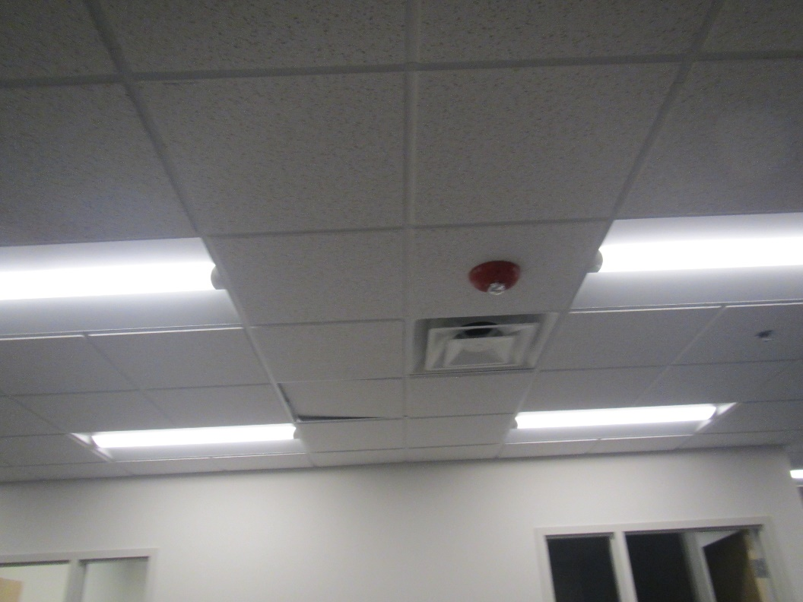

**Supply vent, also note ajar ceiling tile**

**Picture 2**

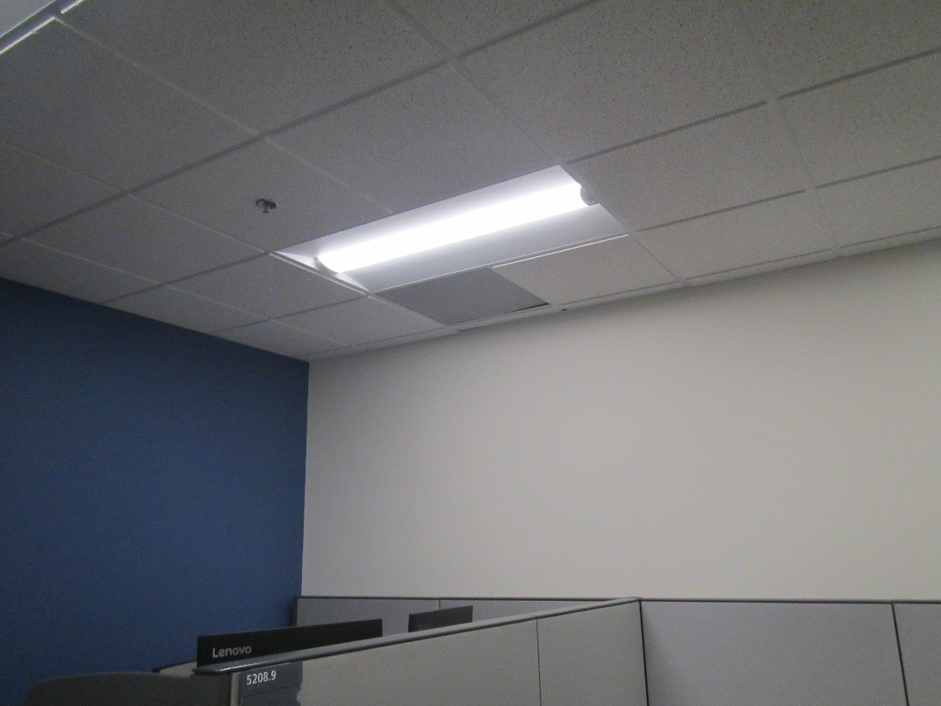

**Return vent in central area**

**Picture 3**

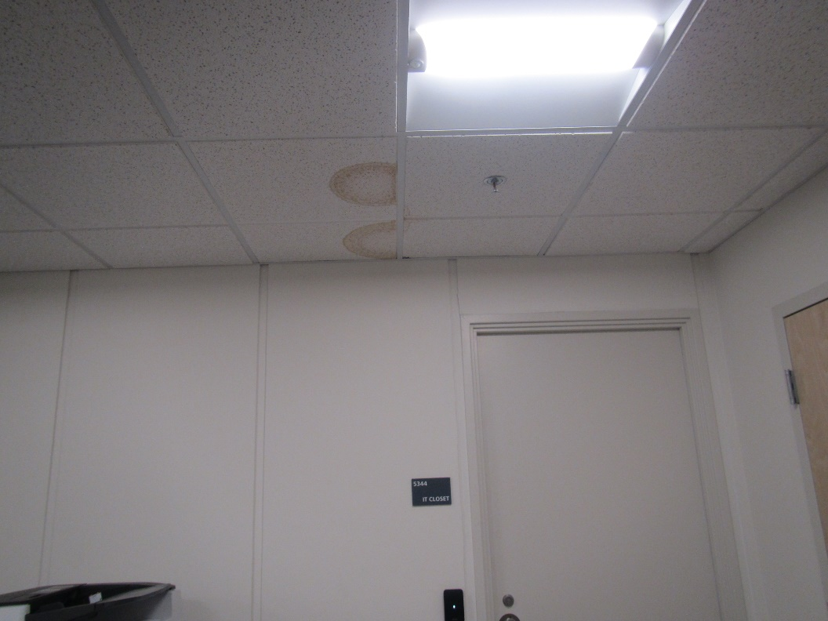

**Water-damaged ceiling tile in records room**

**Picture 4**

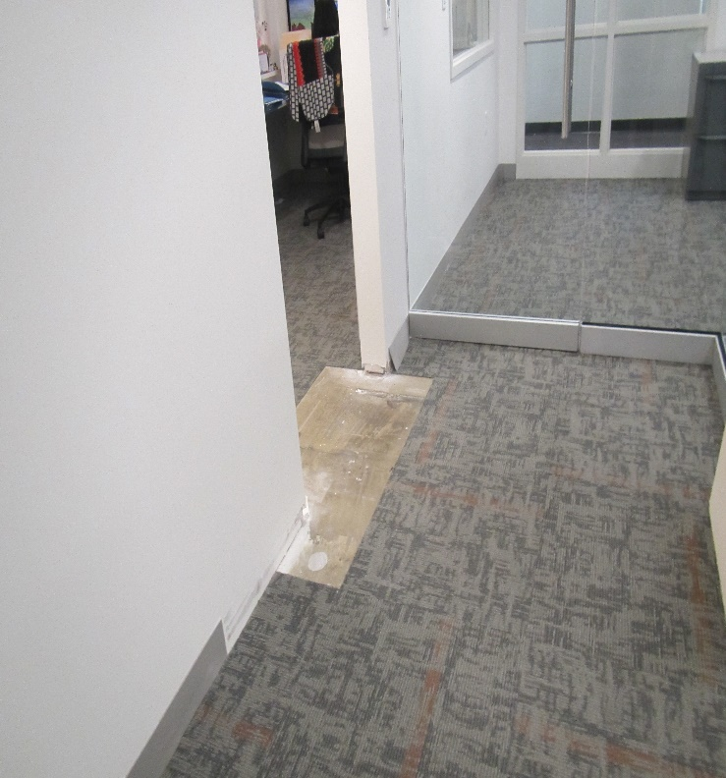

**Missing floor tiles and dust/debris from minor renovations**

| **Location** | **Carbon**  **Dioxide**  **(ppm)** | **Carbon Monoxide**  **(ppm)** | **Temp**  **(°F)** | **Relative**  **Humidity**  **(%)** | **PM2.5**  **(µg/m3)** | **TVOC**  **(ppm)** | **Occupants**  **in Room** | **Windows**  **Openable** | **Ventilation** | | **Remarks** |
| --- | --- | --- | --- | --- | --- | --- | --- | --- | --- | --- | --- |
| **Supply** | **Exhaust** |
| Background | 394 | ND | 55 | 48 | 3 |  |  |  |  |  | Sunny and breezy, idling trucks |
| 5210 | 457 | ND | 72 | 33 | ND | ND | 0 | N | Y | N |  |
| Cube/open area | 465 | ND | 72 | 33 | ND | ND | 0 | N | Y | Y | Ceiling tile ajar (wire pulling) |
| Kitchen | 478 | ND | 72 | 34 | ND | ND | 00 | N | Y | N | NC, sink, fridge, microwave |
| 5214 wellness | 452 | ND | 72 | 32 | ND | ND | 0 | N | Y | N | NC, sink, fridge |
| 5205 records | 502 | ND | 72 | 32 | ND | ND | 0 | N | Y | N | 2 water-damaged ceiling tiles, NC, photocopier, hand sanitizer, records storage |
| 5208 cube area | 482 | ND | 72 | 32 | ND | ND | 0 | N | Y | Y | Ceiling tile ajar, radiator, personal heater, personal fan |
| 5203 | 518 | ND | 71 | 34 | ND | ND | 0 | N | Y | Y |  |
| 5212 | 473 | ND | 72 | 34 | ND | ND | 1 | N | Y | Y | Boxes on floor |
| 5211 | 540 | ND | 72 | 33 | ND | ND | 1 | N | Y | N |  |
| 5210 | 490 | ND | 72 | 33 | ND | ND | 0 | N | Y | N |  |
| Conference | 477 | ND | 72 | 33 | ND | ND | 0 | N | Y | Y | Glass walls |
| Receptionist | 469 | ND | 72 | 33 | ND | ND | 1 | N | Y | N | Fake plants |
| 5206 interview | 506 | ND | 73 | 33 | ND | ND | 0 | N | Y | N |  |
| Waiting area | 480 | ND | 73 | 33 | ND | ND | 0 | N | Y | N | Hallway between waiting area and offices has newly modified doorway, dust, and missing floor tiles |