INDOOR AIR QUALITY ASSESSMENT

Massachusetts Commission for the Blind
436 Dwight Street
Springfield, Massachusetts

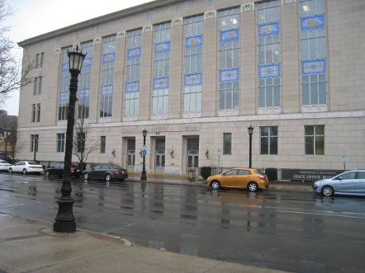

Prepared by:
Massachusetts Department of Public Health
Bureau of Environmental Health
Indoor Air Quality Program
May 2013

Background/Introduction
At the request of Marie Loughran, Director of Human Resources at the Massachusetts Commission for the Blind (MCB), the Massachusetts Department of Public Health (MDPH), Bureau of Environmental Health (BEH) provided assistance and consultation regarding indoor air quality (IAQ) at the MCB, located at 436 Dwight Street, Springfield, MA. The assessment was prompted by concerns of respiratory symptoms and potential association with mold growth in the building. On April 12, 2013, a visit to MCB to conduct an IAQ assessment was made by Mike Feeney, Director of BEH’s IAQ Program, accompanied by Kathleen Gilmore, Environmental Analyst/Regional Inspector for BEH’s IAQ Program.
The MCB is located on the first floor of the Springfield State Office Building which is a four-story, stone and cement building originally constructed in 1937 as a post office. The building was renovated in the 1970s and converted into a multi-agency state office building. Each floor contains various offices for Massachusetts government agencies. Floors are carpeted in most areas. Windows are not openable.

Methods
Air tests for carbon dioxide, carbon monoxide, temperature and relative humidity were taken with the TSI, Q-Trak, IAQ Monitor 7565. Air tests for airborne particle matter with a diameter less than 2.5 micrometers were taken with the TSI, DUSTTRAK™ Aerosol Monitor Model 8520. BEH/IAQ staff also performed visual inspection of building materials for water damage and/or microbial growth.

Results
MCB has an employee population of approximately 16-18 staff. The building can be visited by several members of the public on a daily basis. The tests were taken during normal operations. Test results appear in Table 1.

Discussion

Ventilation
It can be seen from Table 1 that carbon dioxide levels were below 800 parts per million (ppm) in all areas tested, indicating adequate air exchange at the time of assessment. It is important to note that a number of areas were sparsely populated or unoccupied at the time measurements were taken, which may result in reduced carbon dioxide levels. Carbon dioxide levels would be expected to be higher with full occupancy
Heating, ventilation and air-conditioning (HVAC) is provided by rooftop air-handling units (AHUs). Fresh air is drawn into the AHUs and delivered to occupied areas via ceiling-mounted air diffusers. Return air is drawn into the ceiling plenum via ceiling-mounted exhaust grates and directed back into the AHU. BEH/IAQ staff observed that corrugated decking partially obstructed a return vent (Picture 1). This type of blockage can impede the ability of the HVAC system to remove normally-occurring environmental pollutants.
To maximize air exchange, the MDPH recommends that both supply and exhaust ventilation operate continuously during periods of occupancy. In order to have proper ventilation with a mechanical supply and exhaust system, the systems must be balanced to provide an adequate amount of fresh air to the interior of a room while removing stale air from the room. It is recommended that HVAC systems be re-balanced every five years to ensure adequate air systems function (SMACNA, 1994). The date of the last balancing of these systems was not available at the time of the assessment.
Minimum design ventilation rates are mandated by the Massachusetts State Building Code (MSBC). Until 2011, the minimum ventilation rate in Massachusetts was higher for both occupied office spaces and general classrooms, with similar requirements for other occupied spaces (BOCA, 1993). The current version of the MSBC, promulgated in 2011 by the State Board of Building Regulations and Standards (SBBRS), adopted the 2009 International Mechanical Code (IMC) to set minimum ventilation rates. Please note that the MSBC is a minimum standard that is not health-based. At lower rates of cubic feet per minute (cfm) per occupant of fresh air, carbon dioxide levels would be expected to rise significantly. A ventilation rate of 20 cfm per occupant of fresh air provides optimal air exchange resulting in carbon dioxide levels at or below 800 ppm in the indoor environment in each area measured. MDPH recommends that carbon dioxide levels be maintained at 800 ppm or below. This is because most environmental and occupational health scientists involved with research on IAQ and health effects have documented significant increases in indoor air quality complaints and/or health effects when carbon dioxide levels rise above the MDPH guidelines of 800 ppm for schools, office buildings and other occupied spaces (Sundell, J. et al., 2011). The ventilation must be on at all times that the room is occupied. Providing adequate fresh air ventilation with open windows and maintaining the temperature in the comfort range during the cold weather season is impractical. Mechanical ventilation is usually required to provide adequate fresh air ventilation.
Carbon dioxide is not a problem in and of itself. It is used as an indicator of the adequacy of the fresh air ventilation. As carbon dioxide levels rise, it indicates that the ventilating system is malfunctioning or the design occupancy of the room is being exceeded. When this happens, a buildup of common indoor air pollutants can occur, leading to discomfort or health complaints. The Occupational Safety and Health Administration (OSHA) standard for carbon dioxide is 5,000 parts per million parts of air (ppm). Workers may be exposed to this level for 40 hours/week, based on a time-weighted average (OSHA, 1997).
The MDPH uses a guideline of 800 ppm for publicly occupied buildings. A guideline of 600 ppm or less is preferred in schools due to the fact that the majority of occupants are young and considered to be a more sensitive population in the evaluation of environmental health status. Inadequate ventilation and/or elevated temperatures are major causes of complaints such as respiratory, eye, nose and throat irritation, lethargy and headaches. For more information concerning carbon dioxide, consult Appendix A.
Temperature readings in occupied areas ranged from 67º F to 73º F during the assessment, which were within or close to the lower end of the MDPH recommended comfort guideline (Table 1). The MDPH recommends that indoor air temperatures be maintained in a range of 70º F to 78º F in order to provide for the comfort of building occupants. In many cases concerning indoor air quality, fluctuations of temperature in occupied spaces are typically experienced, even in a building with an adequate fresh air supply.
The relative humidity measured during the assessment ranged from 29 to 33 percent (Table 1), which was below the MDPH recommended comfort range in all areas surveyed. The MDPH recommends a comfort range of 40 to 60 percent for indoor air relative humidity. Relative humidity levels in the building would be expected to drop during the winter months due to heating.

Microbial/Moisture Concerns
In order for building materials to support mold growth, a source of water exposure is necessary. No evidence of building leaks, plumbing leaks or water damage were observed in the MCB office space. However, BEH/IAQ staff observed wet carpeting around a water dispenser located in the conference room/lounge (Picture 2). Spills/condensation from these appliances can lead to water damage and mold growth. When possible, water dispensers should be located in tiled areas or placed on a waterproof mat.
The US Environmental Protection Agency (US EPA) and the American Conference of Governmental Industrial Hygienists (ACGIH) recommend that porous materials (e.g., carpeting, gypsum wallboard) be dried with fans and heating within 24 to 48 hours of becoming wet (US EPA, 2001; ACGIH, 1989). If not dried within this time frame, mold growth may occur. Once mold has colonized porous materials, they are difficult to clean and should be removed.

Other IAQ Evaluations
Indoor air quality can be negatively influenced by the presence of respiratory irritants, such as products of combustion. The process of combustion produces a number of pollutants. Common combustion emissions include carbon monoxide, carbon dioxide, water vapor and smoke (fine airborne particle material). Of these materials, exposure to carbon monoxide and particulate matter with a diameter of 2.5 micrometers (μm) or less (PM2.5) can produce immediate, acute health effects upon exposure. To determine whether combustion products were present in the indoor environment, BEH/IAQ staff obtained measurements for carbon monoxide and PM2.5.

Carbon Monoxide
Carbon monoxide is a by-product of incomplete combustion of organic matter (e.g., gasoline, wood and tobacco). Exposure to carbon monoxide can produce immediate and acute health affects. Several air quality standards have been established to address carbon monoxide and prevent symptoms from exposure to these substances. The MDPH established a corrective action level concerning carbon monoxide in ice skating rinks that use fossil-fueled ice resurfacing equipment. If an operator of an indoor ice rink measures a carbon monoxide level over 30 ppm, taken 20 minutes after resurfacing within a rink, that operator must take actions to reduce carbon monoxide levels (MDPH, 1997).
The American Society of Heating Refrigeration and Air-Conditioning Engineers (ASHRAE) has adopted the National Ambient Air Quality Standards (NAAQS) as one set of criteria for assessing indoor air quality and monitoring of fresh air introduced by HVAC systems (ASHRAE, 1989). The NAAQS are standards established by the US EPA to protect the public health from six criteria pollutants, including carbon monoxide and particulate matter (US EPA, 2006). As recommended by ASHRAE, pollutant levels of fresh air introduced to a building should not exceed the NAAQS levels (ASHRAE, 1989). The NAAQS were adopted by reference in the Building Officials & Code Administrators (BOCA) National Mechanical Code of 1993 (BOCA, 1993), which is now an HVAC standard included in the Massachusetts State Building Code (SBBRS, 2011). According to the NAAQS, carbon monoxide levels in outdoor air should not exceed 9 ppm in an eight-hour average (US EPA, 2006).
Carbon monoxide should not be present in a typical, indoor environment. If it is present, indoor carbon monoxide levels should be less than or equal to outdoor levels. On the day of the assessment, outdoor carbon monoxide concentrations were non-detect (ND). Carbon monoxide levels measured in the building were ND during the assessment.

Particulate Matter
The US EPA has established NAAQS limits for exposure to particulate matter. Particulate matter includes airborne solids that can be irritating to the eyes, nose and throat. The NAAQS originally established exposure limits to PM with a diameter of 10 μm or less (PM10). In 1997, US EPA established a more protective standard for fine airborne particulate matter with a diameter of 2.5 μm or less (PM2.5). The NAAQS has subsequently been revised, and PM2.5 levels were reduced. This more stringent PM2.5 standard requires outdoor air particle levels be maintained below 35 μg/m³ over a 24-hour average (US EPA, 2006). Although both the ASHRAE standard and BOCA Code adopted the PM10 standard for evaluating air quality, MDPH uses the more protective PM2.5 standard for evaluating airborne PM concentrations in the indoor environment.
Outdoor PM2.5 concentrations were measured at 5 μg/m³ (Table 1). PM2.5 levels measured in occupied areas ranged from 2 to 13 μg/m³ (Table 1), which were below the NAAQS PM2.5 level of 35 μg/m^{3.}
Frequently, indoor air levels of particulates (including PM2.5) can be at higher levels than those measured outdoors. A number of mechanical devices and/or activities that occur indoors can generate particulate during normal operations. Sources of indoor airborne particulates may include but are not limited to particles generated during the operation of fan belts in the HVAC system, use of stoves and/or microwave ovens in kitchen areas; use of photocopiers, fax machines and computer printing devices; operation of an ordinary vacuum cleaner and heavy foot traffic indoors.

Other Conditions
Other conditions that can affect indoor air quality were observed during the assessment. Offices located on the exterior walls of the MCB were equipped with wall-mounted electric heaters (Picture 3). Vents and fan blades from these units can accumulate dust/debris. Re-activated fans can aerosolize accumulated dust. Fans should be cleaned regularly to prevent aerosolization of dust.
In a number of areas, items were observed on the floors, windowsills, bookcases and desks (Pictures 4 and 5). The large number of items stored provides a source for dusts to accumulate. These items (e.g., papers, folders, boxes) make it difficult for custodial staff to clean. Items should be relocated and/or be cleaned periodically to avoid excessive dust build up.
The offices of the MCB had wall-to-wall carpeting. The Institute of Inspection, Cleaning and Restoration Certification (IICRC), recommends that carpeting be cleaned annually (or semi-annually in soiled high traffic areas) (IICRC, 2005).
Scented candles (Picture 6) were noted in one administrative office. Scented candles contain chemicals that can be irritating to the eyes, nose and throat of sensitive individuals. Furthermore, deodorizing agents do not remove materials causing odors, but rather mask odors that may be present in the area.
MCB staff reported that the office space was infested with fleas during the summer of 2012, which coincided with the addition of a second-hand upholstered couch in one office (Table 1; Picture 7). Used furniture may carry insects as well as allergens and irritants such as pet hair and tobacco smoke. For this reason, the use of second-hand upholstered furniture is not recommended in an office environment. Upholstered furniture can be a vector for the transmission of bedbugs. They can hide in furniture, along walls, in draperies and under loose wallpaper. Although transmission between households through the bugs crawling onto clothing is a less common route, it is possible (MDPH, 2009) so furniture, particularly those with thick upholstery need to be periodically inspected for bedbugs.
In addition, upholstered furniture, pillows and cushions are covered with fabric that comes in contact with human skin. This type of contact can leave oils, perspiration, hair and skin cells. In addition to being a source for fleas, upholstered furniture may accumulate dust mites, which feed upon human skin cells and excrete waste products that contain allergens. In addition, if relative humidity levels increase above 60 percent, dust mites tend to proliferate (US EPA, 1992). In order to remove dust mites and other pollutants, frequent vacuuming of upholstered furniture is recommended (Berry, M.A., 1999). It is also recommended that upholstered furniture be professionally cleaned on an annual basis. If an excessively dusty environment exists due to outdoor conditions or indoor activities (e.g., renovations), cleaning frequency should be increased (every six months) (IICRC, 2000).

Conclusions/Recommendations
In view of the findings at the time of the visit, the following recommendations are made:
- Continue operating all mechanical HVAC systems to provide fresh air during occupied periods. Remove any blockages from supply or exhaust ventilation, such as from the exhaust vent shown in Picture 1.
- Consider adopting a balancing schedule of every 5 years for all mechanical ventilation systems, as recommended by ventilation industry standards (SMACNA, 1994).
- For buildings in New England, periods of low relative humidity during the winter are often unavoidable. Therefore, scrupulous cleaning practices should be adopted to minimize common indoor air contaminants whose irritant effects can be enhanced when the relative humidity is low. To control for dusts, a high efficiency particulate arrestance (HEPA) filter equipped vacuum cleaner in conjunction with wet wiping of all surfaces is recommended. Drinking water during the day can help ease some symptoms associated with a dry environment (throat and sinus irritations).
- Consider moving water dispensing equipment to areas with tiled floors instead of carpeting, or installing waterproof mats to prevent leaks from damaging carpet.
- Clean air diffusers, return vents and electric heater vents/ fans periodically of accumulated dust/debris.
- Relocate or consider reducing the amount of materials stored in offices and common areas to allow for more thorough cleaning. Relocate or consider reducing the amount of materials stored in offices and common areas to allow for more thorough cleaning.
- Clean carpeting annually or semi-annually in soiled high traffic areas as per the recommendations of the Institute of Inspection, Cleaning and Restoration Certification (IICRC)
- Refrain from having scented candles or using air fresheners/deodorizers to prevent exposure to VOCs.
- Vacuum upholstered furniture/pillows/cushions frequently and clean annually. If not feasible, consider removal.
- Refer to resource manuals and other related indoor air quality documents for further building-wide evaluations and advice on maintaining public buildings. Copies of these materials are located on the MDPH’s website: http://mass.gov/dph/iaq.

References
ACGIH. 1989. Guidelines for the Assessment of Bioaerosols in the Indoor Environment. American Conference of Governmental Industrial Hygienists, Cincinnati, OH.
ASHRAE. 1989. Ventilation for Acceptable Indoor Air Quality. American Society of Heating, Refrigeration and Air Conditioning Engineers. ANSI/ASHRAE 62-1989.
Berry, M.A. 1994. Protecting the Built Environment: Cleaning for Health, Michael A. Berry, Chapel Hill, NC.
BOCA. 1993. The BOCA National Mechanical Code/1993. 8th ed. Building Officials and Code Administrators International, Inc., Country Club Hill, IL. Section M-308.1.1.
IICRC. 2000. IICRC S001 Reference Guideline for Professional On-Location Cleaning of Textile Floor Covering Materials Institute of Inspection, Cleaning and Restoration Certification. Institute of Inspection Cleaning and Restoration, Vancouver, WA.
IICRC. 2005. Carpet Cleaning FAQ 4 Institute of Inspection, Cleaning and Restoration Certification. Institute of Inspection Cleaning and Restoration, Vancouver, WA.
MDPH. 1997. Requirements to Maintain Air Quality in Indoor Skating Rinks (State Sanitary Code, Chapter XI). 105 CMR 675.000. Massachusetts Department of Public Health, Boston, MA.
MDPH. 2009. Frequently Asked Questions about Bedbugs. Massachusetts Department of Public Health, Boston, MA
OSHA. 1997. Limits for Air Contaminants. Occupational Safety and Health Administration. Code of Federal Regulations. 29 C.F.R 1910.1000 Table Z-1-A.
SBBRS. 2011. Mechanical Ventilation. State Board of Building Regulations and Standards. Code of Massachusetts Regulations, 8th edition. 780 CMR 1209.0.
SMACNA. 1994. HVAC Systems Commissioning Manual. 1st ed. Sheet Metal and Air Conditioning Contractors’ National Association, Inc., Chantilly, VA.
Sundell. 2011. Sundell, J., H. Levin, W. W. Nazaroff, W. S. Cain, W. J. Fisk, D. T. Grimsrud, F. Gyntelberg, Y. Li, A. K. Persily, A. C. Pickering, J. M. Samet, J. D. Spengler, S. T. Taylor, and C. J. Weschler. Ventilation rates and health: multidisciplinary review of the scientific literature. Indoor Air, Volume 21: pp 191–204.
US EPA. 2001. Mold Remediation in Schools and Commercial Buildings. US Environmental Protection Agency, Office of Air and Radiation, Indoor Environments Division, Washington, DC. EPA 402-K-01-001. March 2001.
US EPA. 2006. National Ambient Air Quality Standards (NAAQS). US Environmental Protection Agency, Office of Air Quality Planning and Standards, Washington, DC. http://www.epa.gov/air/criteria.html.
Picture 1

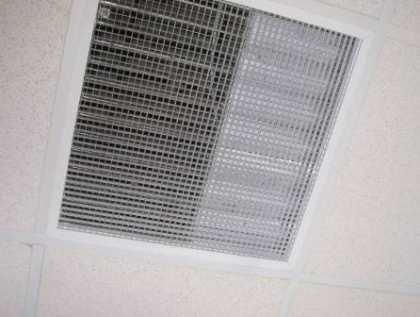

Return vent: note corrugated decking obstruction (arrow)

Picture 2

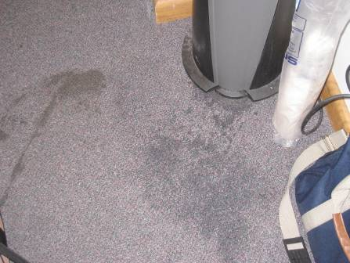

Wet carpeting surounding water dispenser

Picture 3

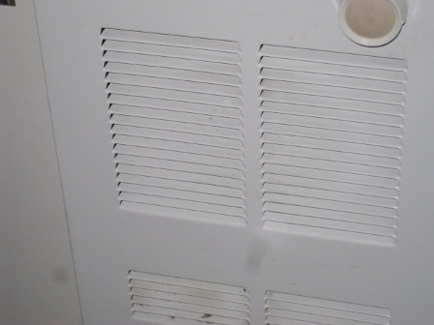

Wall-mounted electric heater vent: note dust on grates

Picture 4

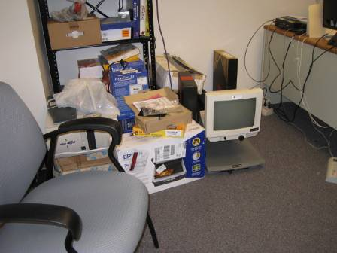

Items stored on floor in office space

Picture 5

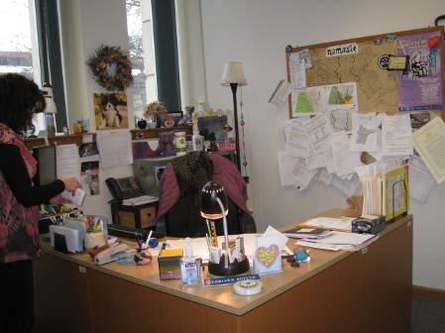

Office space cluttered with items

Picture 6

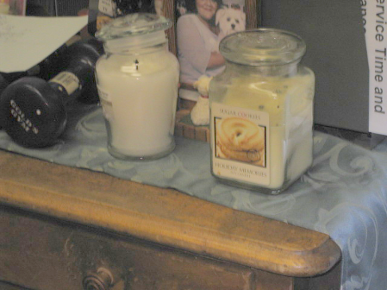

Scented candles in office space

Picture 7

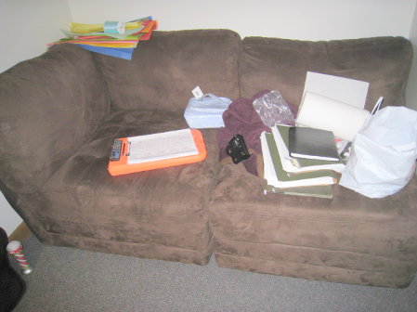

Upholstered couch in office space

Location | Carbon  Dioxide  (ppm) | Carbon Monoxide  (ppm) | Temp  (°F) | Relative  Humidity  (%) | PM2.5  (µg/m³) | Occupants  in Room | Windows  Openable | Ventilation |  |  | Remarks
 |  |  |  |  |  |  |  | Intake | Exhaust |  | Remarks
Background | 398 | ND | 40 | 52 | 5 |  |  |  |  |  | Heavy rain
Administrative area | 591 | ND | 69 | 31 | 3 |  | N | Y |  | Y | PC, boxes on floor
Conference Room/Lounge | 627 | ND | 68 | 33 | 3 | 4 | N | Y |  | Y | Wet carpet around water cooler, refrigerator, microwave, toaster
Electrical Room | 565 | ND | 68 | 32 | 2 | 0 | N | Y |  | Y | DO, computer server, tiled floor, boxes on floor
Hallway | 591 | ND | 67 | 32 | 4 | 0 | N | Y |  | Y | PC, boxes on floor
Molly CT | 724 | ND | 72 | 29 | 5 | 1 | N | Y |  | Y | Upholstered couch, clutter
Ron Gallagher | 634 | ND | 70 | 30 | 6 | 1 | N | Y |  | Y | DO, electric wall heater
400 | 558 | ND | 69 | 31 | 2 | 0 | N | Y |  | Y | DO
401 | 589 | ND | 68 | 32 | 4 | 0 | N | Y |  | Y | DO
404 | 635 | ND | 70 | 31 | 3 | 1 | N | Y |  | Y | DO
405 | 645 | ND | 69 | 32 | 5 | 0 | N | Y |  | Y
408 | 620 | ND | 70 | 31 | 4 | 1 | N | Y |  | Y | DO, electric wall heater
409 | 621 | ND | 70 | 30 | 5 | 1 | N | Y |  | Y | DO, electric wall heater
410 | 633 | ND | 68 | 31 | 3 | 0 | N | Y |  | Y | DO, electric wall heater, clutter
411 | 605 | ND | 73 | 30 | 13 | 1 | N | Y |  | Y | Electric wall heater on and dirty, scented candles
415 | 558 | ND | 69 | 31 | 2 | 0 | N | Y |  | Y

