The Commonwealth of Massachusetts
Executive Office of Health and Human Services
Department of Public Health
Bureau of Infectious Disease and Laboratory Sciences
305 South Street, Jamaica Plain, MA 02130

MARYLOU SUDDERS
Secretary
MONICA BHAREL, MD, MPH Commissioner

Tel: 617-624-6000
www.mass.gov/dph

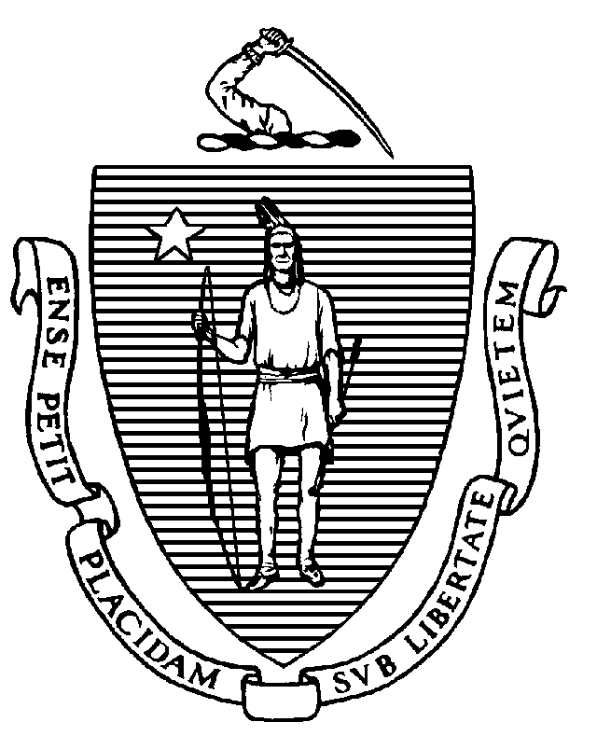

CHARLES D. BAKER
Governor
KARYN E. POLITO
Lieutenant Governor

Massachusetts Department of Public Health (MDPH)
Massachusetts COVID-19 Vaccine Program (MCVP)
Frequently Asked Questions on the MCVP Agreement
Updated December 24, 2020

- Does the MCVP Provider Agreement require that a site agree to be a community distributor to the public?
No, you are not required to be a community provider. You can get vaccine just for your staff and patients if you sign the agreement.

- Are smaller private practices required to complete the MCVP Provider Agreement, or is there an alternate version that we can use?
This is the agreement from the federal government that all health care provider sites that will receive COVID vaccine must sign. States are not allowed to alter it in any way.

- Is there a deadline to complete the Massachusetts COVID-19 Vaccine Program (MCVP) Agreement?
There is no deadline, but COVID-19 vaccine will not be shipped to the site until the agreement is completed.

- Does each site have to complete an MCVP Agreement or can the umbrella organization just complete it? (Clarification made 12/24)
Yes, each site needs to complete an agreement if they want COVID-19 vaccine shipped there for long term storage either directly from the manufacturer/distributor or from another provider site. However, sites can conduct temporary off-site clinics without enrolling those clinic locations individually in the MCVP.

- Why have other sites in my organization not received an email for the Agreement?
The MCVP Agreement will be sent out in phases. Additionally, sites must be registered and submitting immunization data to the Massachusetts Immunization Information System (MIIS) in order to receive the MCVP Agreement.

- What if I am not the appropriate person at my site to complete this form?
You can forward the email with link to the MCVP Agreement to a more appropriate contact.

- Who received the form for my site?
The MDPH Immunization Division leveraged contact information that is stored in the MIIS. Contacts who receive the Agreement for your site are the Primary and Back-up Vaccine Coordinators, Access Administrators, and Clinical Supervisors.

- How do we update our MCVP Agreement?​
Contact the Vaccine Management Unit at DPH-Vaccine-Management@massmail.state.ma.us. Include your PIN and the contact email of who will update the agreement. We will send out a link that will allow you to update your agreement.

- What do we do if the legal name on our organization’s Agreement is incorrect?
You can update the Organization Name in Section A of the MCVP Agreement. If there continues to be a problem and you want to correct your legal name, please contact the MIIS Help Desk at MIIShelpdesk@state.ma.us or (617) 983-4335.

- In the last section of the form, are you looking for employed, credentialed providers or all credentialed providers with prescriptive rights that work out of our site?
CDC requires that every credential provider with prescriptive rights be included.

- Do you want employees, providers, volunteers and contracted personnel included along with patients in our influenza vaccine number when looking at the highest volume administered in one week?
Yes, please include all of these groups in the number.

- Do the CFO and CMO need to sign the Agreement?
They do not need to provide an actual signature. Whoever completes the Agreement should enter their names and ensure the CFO and CMO are aware of the policies and the Agreement.

- How will I know if my Agreement has been submitted?
The Primary and Back-up COVID-19 Vaccine Coordinators will receive an email confirming submission.

- If we complete the Agreement form from MDPH, will this also be pushed to the CDC or do we need to complete the CDC form separately?
Please do not complete the form from CDC or submit anything directly to CDC. In order to receive COVID-19 vaccine you must enroll in the MCVP. We work directly with CDC to share the necessary information needed to process vaccine orders.

- What do I do if the web link to the Agreement is not working?
The MCVP Agreement is best accessed using a more modern browser like Google Chrome or Microsoft Edge. Internet Explorer will not work well.

- Can I fill out a paper form?
No, the Agreement must be completed electronically.

- What if I can't complete the form all at once?
Saving the form will save all data that has already been entered. You can use the original link sent to access the form.

- How do I become designated as my site’s vaccine coordinator, so that I can order vaccine?
Please reach out to the MDPH vaccine unit at DPH-Vaccine-Management@MassMail.State.MA.US or 617-983-6828. They can designate you as
a vaccine coordinator.

- How do I enter a list of additional providers for COVID vaccine?
Go into the section of MIIS that you use for annual enrollment, and then follow the instructions on the training resource document to upload a provider list.

- Can you confirm if Massachusetts will continue to use the MIIS to record COVID vaccine administrations?
Yes, COVID vaccine administrations will be recorded in the MIIS. Sites must be registered and onboarded with the MIIS to receive COVID-19 vaccine. If you are aware of a site that is not registered, please ask them to reach out to the MIIS Help Desk at MIIShelpdesk@state.ma.us or (617) 983-4335.

- Will we be using the same ordering module in MIIS to order the COVID vaccine once it arrives, or will the state be issuing doses to us?
Initially, MDPH will create and process orders for providers. Eventually, sites will be able to order vaccine from MIIS.

- Our sites are enrolled in MIIS. Is there anything else we need to do be approved for vaccine shipment when it becomes available?
If your sites are registered with the MIIS, they will receive the MCVP Agreement. Sites will not be able to receive COVID-19 vaccines until the Agreement is complete.

