INDOOR AIR QUALITY ASSESSMENT

Massachusetts Department of Labor
Department of Industrial Accidents
30 Third Street
Fall River, Massachusetts

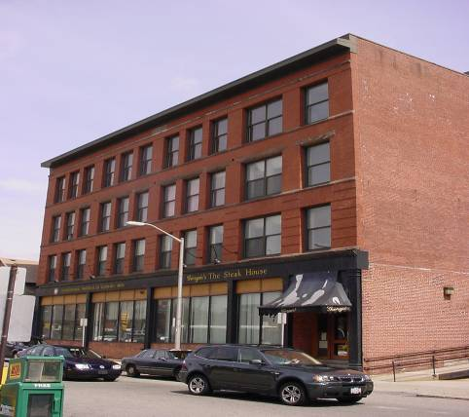

Prepared by:
Massachusetts Department of Public Health
Center for Environmental Health
Emergency Response/Indoor Air Quality Program

May 2007

Background/Introduction

At the request of Martha Goldsmith, Director, Office of Leasing for the Division of Capital Asset Management (DCAM), an indoor air quality (IAQ) assessment was conducted at the Massachusetts Department of Labor, Department of Industrial Accidents (DIA), 30 Third Street, Fall River. The IAQ assessment was conducted by the Massachusetts Department of Public Health (MDPH), Center for Environmental Health (CEH). On April 26, 2007, Michael Feeney, Director of Emergency Response/Indoor Air Quality (ER/IAQ), CEH conducted the assessment. Concerns about water damage to the interior of the building and possible mold contamination prompted the request.
The DIA is located in a four-story building (with basement) that was constructed prior to 1920. It was converted into office space in the early 1990s. DIA offices are located on the first and second floor. The third floor is unoccupied. The fourth floor contains a restaurant. Windows do not appear to be openable in the space occupied by the DIA.
The building was previously evaluated by the Massachusetts Department of Labor and Workforce Development (MDLWD), Division of Occupational Safety (DOS) in 1998. The following recommendations were made in the DOS report:
- Evaluate the heating, ventilating and air-conditioning (HVAC) system;
- Set thermostats to the “on’ position to activate the HVAC system during business hours;
- Provide exhaust ventilation for the basement; and
- Vacuum the carpet nightly (MDLWD, 1998).
At the time of the MDPH evaluation none of the recommendations made by MDLWD appeared to have been implemented.

Methods
Tests for carbon dioxide, temperature and relative humidity were taken with the TSI, Q-Trak, IAQ Monitor, Model 8551. MDPH staff also performed visual inspection of building materials for water damage and/or microbial growth. Moisture content of porous building materials was measured with a Delmhorst, BD-2000 Model, Moisture Detector equipped with a Delmhorst Standard Probe. The tests were taken during normal operations. Test results appear in Table 1.

Results/Discussion
Ventilation
It can be seen from Table 1 that the carbon dioxide levels were over 800 parts per million (ppm) in nearly all areas surveyed on the first floor, indicating inadequate air exchange. All measurements on the second floor were below 600 ppm, indicating adequate air exchange. Ventilation is provided by natural gas fueled air-handling units (AHUs), which are located in two separate mechanical rooms/closets on opposite ends of the first floor. A similar AHU room/closet is located on the second floor that services the judge’s lobbies. All AHUs were found deactivated at the time of the assessment. Each AHU is connected to ductwork located above the ceiling. The ductwork distributes air to ceiling mounted air diffusers throughout the space.
Return air is drawn to the AHUs by a passive vent that is located on the wall of the mechanical rooms (Picture 1). The system is designed to use hallways to draw return air from office areas. To facilitate airflow, office doors are often undercut approximately one-inch to provide a space through which air can be drawn into the hallways. Office doors did not appear to be undercut, thus limiting the amount of transfer air from offices to the hallway when office doors are closed. Some rooms have a plastic grill installed in the suspended ceiling, with a second plastic grill installed in a wall on the opposite side of the room adjacent to the hallway. It appears that air is intended to be drawn through the ceiling plenum and into the hallways. Picture 2 shows the top of the ceiling plenum, which seems to be the original floor boards of the second story offices.
The ventilation system at the DIA does not appear to be designed to provide either mechanical fresh air supply or exhaust ventilation. With a lack of fresh air supply and/or exhaust ventilation, any interior pollutants will remain inside the building and be continuously recirculated. This situation can lead to air quality/comfort complaints.
Restrooms were found to have non-functioning exhaust vents or lacked them. Exhaust fans in restrooms appear to be connected to a duct by a flexible dryer hose (Picture 3). The flexible hose was disconnected in places, which can allow odors and moisture to vent into the ceiling plenum.
The Massachusetts Building Code requires a minimum ventilation rate of 20 cubic feet per minute (cfm) per occupant of fresh outside air or have openable windows in each room (SBBRS, 1997; BOCA, 1993). The ventilation must be on at all times that the room is occupied. Providing adequate fresh air ventilation with open windows and maintaining the temperature in the comfort range during the cold weather season is impractical. Mechanical ventilation is usually required to provide adequate fresh air ventilation.
Carbon dioxide is not a problem in and of itself. It is used as an indicator of the adequacy of the fresh air ventilation. As carbon dioxide levels rise, it indicates that the ventilating system is malfunctioning or the design occupancy of the room is being exceeded. When this happens a buildup of common indoor air pollutants can occur, leading to discomfort or health complaints. The Occupational Safety and Health Administration (OSHA) standard for carbon dioxide is 5,000 parts per million parts of air (ppm). Workers may be exposed to this level for 40 hours/week, based on a time-weighted average (OSHA, 1997).
The Department of Public Health uses a guideline of 800 ppm for publicly occupied buildings. A guideline of 600 ppm or less is preferred in schools due to the fact that the majority of occupants are young and considered to be a more sensitive population in the evaluation of environmental health status. Inadequate ventilation and/or elevated temperatures are major causes of complaints such as respiratory, eye, nose and throat irritation, lethargy and headaches. For more information concerning carbon dioxide, please see Appendix A.
Temperature readings ranged from 65º F to 73 º F, which were below the MDPH recommended comfort guidelines in a number of areas. The MDPH recommends that indoor air temperatures be maintained in a range of 70 º F to 78 º F in order to provide for the comfort of building occupants. In many cases concerning indoor air quality, fluctuations of temperature in occupied spaces are typically experienced, even in a building with an adequate fresh air supply.
The relative humidity readings ranged from 35 to 53 percent, which were within or close to the lower end of the MDPH recommended comfort range. The MDPH recommends a comfort range of 40 to 60 percent for indoor air relative humidity. Relative humidity in the building would be expected to drop during the winter months due to heating. The sensation of dryness and irritation is common in a low relative humidity environment. Low relative humidity is a common problem during the heating season in the northeast part of the United States.

Microbial/Moisture Concerns
In order for building materials to support mold growth, a source of water exposure is necessary. No active leaks were observed, however, water damage was noted on gypsum wallboard (GW) in a hallway (Picture 4). The hallway reportedly had its carpet removed prior to the MDPH assessment due to water damage. GW was found to be wet 12 days after the April 14, 2007 nor’easter (Picture 5). GW was used to form the sills of windows in the building. The location of the water staining indicates that leaks around window frames are the most likely source of moisture penetration. The floors of the AHU rooms also appear to be heavily stained with moisture (Picture 6), likely due to condensation generated from uninsulated components of the condensation drainage system for each AHU.
A number of likely sources for moisture to travel through the building envelope were identified on the exterior of the building
- It appears that the building was originally equipped with heavy shutters, which were held in place by large steel hangers (Picture 7). Over time, spaces have opened around the hangers, resulting in a pathway for wind-driven rain to access the exterior brick face (Picture 8).
- Ivy growing on exterior walls, which can hold moisture against the building (Picture 9).
- Window frames appear to be missing caulking.
- Damage to the front façade of the building was observed (Picture 10).
- A short roof exists on the north wall of the building (Picture 11). It appears that an adjoining pitched-roof building directs water during heavy rainstorms from a northerly direction onto the short roof since no gutter downspout system exists along the edges of the adjacent building.
- Water penetration through the MDIA entrance door threshold has resulted in damage to the floor (Picture 12).
The US Environmental Protection Agency and the American Conference of Governmental Industrial Hygienists (ACGIH) recommends that porous materials (carpeting, ceiling tiles, etc.) be dried with fans and heating within 24 to 48 hours of becoming wet (US EPA, 2001; ACGIH, 1989). If porous materials are not dried within this time frame, mold growth may occur. Water-damaged porous materials cannot be adequately cleaned to remove mold growth. The application of a mildewcide to moldy porous materials is not recommended.
CEH personnel have consulted with Dr. Harriet Burge on a number of previous assessments concerning GW mold growth. Dr. Burge is currently with the University of California, Irvine, but remains an Adjunct Professor of Environmental Microbiology, Department of Environmental Health, Harvard School of Public Health. The reoccurrence of mold growth on GW after the application of bleach is common. Bleach consists of sodium hypochlorite in a 5 percent concentration mixed with water. When applied to moldy GW, the water of the bleach solution penetrates into the moldy GW, but the sodium hypochlorite remains on the surface. The sodium hypochlorite disinfects the surface mold that it comes in contact with on the GW surface, but not the mold beneath the surface. Since mold colonization of GW can penetrate through its entire structure, the addition of water typically fuels growth in subsurface mold. This enhances mold colonization of the GW. As a result, mold colonies appear on the surface of treated GW shortly after application of bleach (personal communication, Burge, 1999).
Several areas of the DIA also contained a number of plants. Plant soil, standing water and drip pans can also be potential sources of mold growth. Drip pans should be inspected periodically for mold growth and over watering should be avoided.

Other IAQ Evaluations
Of note are the AHU type and location, as well as the design of the ventilation system in the DIA. As previously mentioned, ventilation is provided by gas-fueled AHUs that are located in mechanical room/closets that are depressurized when the HVAC system is operating. If AHUs are gas-fired, the combustion of fuel requires an adequate oxygen source. At the time of the MDPH assessment no combustion air vents were identified. Despite the presence of fans to pull products of combustion from the AHU fire box, it is possible for these pollutants to be drawn into the ventilation system. As mentioned previously, air is returned to the AHUs through hallway return vents (Picture 1). As the vents operate, the hallway becomes depressurized, subsequently allowing air from offices to be drawn through spaces around doors. If the draw of air into the return vent is greater than the draw of air into the firebox by the AHU gas vents, products of combustion from the AHUs would migrate into the hallway through spaces around the mechanical room door. These products of combustion can then be distributed into occupied areas via the return system rather than be removed through the chimney/exhaust vent.
The process of combustion produces a number of pollutants. The type of pollutant produced is dependant on the composition of the material combusted. In general, common combustion emissions can include carbon dioxide, carbon monoxide (CO), water vapor and smoke. As previously discussed, carbon dioxide measurements were taken throughout the office space. Indoor carbon dioxide concentrations on the first floor were 205 ppm to 960 ppm greater than the outdoor measurement (396 ppm), even though the offices were occupied by only eleven individuals during the assessment. Carbon dioxide measurements in unoccupied offices also exceeded 800 ppm (Table 1). In CEH’s experience, carbon dioxide levels similar those measured in the DIA offices are more typical in single rooms with a high number of occupants (20+) with an inactive or poorly operating ventilation system. In this instance, the low number of individuals present may indicate that the source of carbon dioxide production is independent of occupancy and may originate from a source within the DIA.
CO is a product of combustion that can produce immediate, acute health effects upon exposure. The MDPH established a corrective action level concerning CO in ice skating rinks that use fossil-fueled ice resurfacing equipment. If an operator of an indoor ice rink measures a CO level over 30 ppm taken 20 minutes after resurfacing within the rink, that operator must take actions to reduce CO levels (MDPH, 1997).
The US Environmental Protection Agency has established National Ambient Air Quality Standards (NAAQS) for exposure to CO in outdoor air. CO levels in outdoor air must be maintained below 9 ppm over an eight hour period in order to meet this standard (US EPA, 2006). ASHRAE uses NAAQS as a guide for assessing indoor air quality in buildings (ASHRAE, 1989); however, the NAAQS is for a range of applications. CO should not be present in a typical office environment. No levels of CO above the NAAQS or MDPH correction action level were measured during the assessment. However, in order to provide efficient combustion for the gas jets in the AHUs (that minimize the production of CO), an adequate supply of combustion air is needed to provide oxygen.
Several other conditions that can affect indoor air quality were noted during the assessment. Of note was the heavy accumulation of mouse droppings inside the rear AHU room on the first floor (Picture 13). Under current Massachusetts law (effective November 1, 2001) the principles of integrated pest management (IPM) must be used to remove pests in state buildings (Mass Act, 2000). Pesticide use indoors can introduce chemicals into the indoor environment that can be sources of eye, nose and throat irritation. The reduction/elimination of pathways/food sources that are attracting these insects should be the first step taken to prevent or eliminate this infestation.
Rodent infestation can result in indoor air quality related symptoms due to materials in their wastes. Mouse urine contains a protein that is a known sensitizer (US EPA, 1992). A sensitizer is a material that can produce symptoms in exposed individuals can cause running nose or skin rashes in sensitive individuals (e.g., running nose or skin rashes). A three-step approach is necessary to eliminate rodent infestation:
- Removal of the rodents;
- Cleaning of waste products from the interior of the building; and
- Reduction/elimination of pathways/food sources that are attracting rodents.
To eliminate exposure to allergens, rodents must be removed from the building. Please note that removal, even after cleaning, may not provide immediate relief since allergens can exist in the interior for several months after rodents are eliminated (Burge, 1995). A combination of cleaning, along with an increase in ventilation and filtration should serve to reduce rodent associated allergens once the infestation is eliminated.
AHUs are normally equipped with filters that strain particulates from airflow. The AHUs for the DIA office have filters duct taped to air intake openings (Picture 14). In this condition, any airborne particles drawn into the hallway, the floor, wall cavities or other locations can be distributed via the ventilation system. Particle sources can include the AHUs, photocopiers and materials stored in the mechanical rooms. In order to decrease aerosolized particulates, filters should be properly installed. The amount of airborne particles prevented from entering the air stream is determined by the dust spot efficiency. Dust spot efficiency is the ability of a filter to remove particulates of a certain diameter from air passing through the filter. Filters that have been determined by ASHRAE to meet its standard for a dust spot efficiency of a minimum of 40 percent would be sufficient to reduce airborne particulates (Thornburg, 2000; MEHRC, 1997; ASHRAE, 1992). Note that increased filtration can reduce airflow produced by the AHUs by increased resistance (called pressure drop). Prior to any increase of filtration, the AHUs should be evaluated by a ventilation engineer to ascertain whether they can maintain function with more efficient filters installed.
Finally, a pipe in an office appears to have an opening in the floor that allows for basement air to migrate into this office (Picture 15). This condition can allow for moisture and basement odors to enter this office space.

Conclusions/Recommendations
The conditions found within the DIA building raise a number of indoor air quality issues. The configuration of the AHU rooms (and associated equipment), minimal filtration and water penetration damaging the building interior each provide conditions that can degrade indoor air quality. It is also important to reiterate that the mechanical ventilation system does not appear to dilute or remove environmental pollutants from the building. This can result in a buildup of dust, dirt, and other pollutants in the indoor environment, which can lead to indoor air quality/comfort complaints.
While some problems can be addressed immediately, others will require planning and resources. To remedy building problems, remedial efforts consisting of short-term measures to improve air quality and long-term measures to adequately address the overall indoor air quality concerns should be implemented. In addition, several other additional measures to repair/renovate water damaged sections of the building are recommended.

Short-Term Recommendations
- Install a wall-mounted CO alarm with digital readout near the gas-fired AHU. CO levels should be checked daily after the AHU is fired up during the heating season.
- Improve the amount of combustion air provided to the AHU. A mechanical fan to introduce more fresh air may be necessary. Consult with the local fire prevention officer/building code officials to determine an appropriate method to provide combustion air for the AHU. If not feasible, consider replacing current AHU with an electric model.
- Clean mouse droppings in the AHU rooms in a proper manner to prevent the aerosolization of rodent-related allergens. Thoroughly clean and disinfect floors of the AHU rooms to reduce mouse-related allergens.
- Install appropriate filter racks on the AHUs to provide proper filtration.
- Install return vents to draw air from hearing rooms directly to the appropriate AHU room.
- Undercut all interior doors to create at least a 1-inch wide space to provide a pathway for air to return to the AHUs. Once done, remove plastic grates from the suspended ceiling to enhance air flow.
- Consider rendering the mechanical room as airtight as possible to eliminate the draw of combustion air to the occupied areas of the floor. These measures would include:
  - installing a boiler room style, fire rated door in the mechanical room portal;
  - installing weather-stripping along the doorframe of the mechanical room door;
  - installing a door sweep at the bottom of the door of the mechanical room door;
  - sealing all ceiling and wall spaces within the mechanical room; and
  - sealing the doorframe of the mechanical room door.
- Seal breaches in brick façade as well as any other routes of water penetration into the building.
- Seal all window frames and seams in a proper manner.
- Remove ivy from the building exterior.
- Examine the short roof along the north wall to ensure that rubber membrane is intact, properly flashed and draining appropriately.
- Provide appropriate restroom exhaust ventilation and operate during business hours.
- Insulate the components of the AHU condensation drainage system.
- Seal the threshold of the exterior door entrance to the DIA offices to prevent water penetration. Repair tile in the front entrance lobby.
- Consider reducing the number of plants in work areas. Avoid over-watering and examine drip pans periodically for mold growth. Disinfect with an appropriate antimicrobial where necessary.
- Adopt scrupulous cleaning practices. For buildings in New England, periods of low relative humidity during the winter are often unavoidable. Therefore, scrupulous cleaning practices should be adopted to minimize common indoor air contaminants whose irritant effects can be enhanced when the relative humidity is low. Drinking water during the day can help ease some symptoms associated with a dry environment (throat and sinus irritations). Consider obtaining a vacuum cleaner equipped with a high efficiency particulate arrestance (HEPA) filter to trap respirable dusts.
- Seal all pipe penetrations through the floor of the first story to prevent basement air migration into office space.

Long-Term Recommendations
- Consult an HVAC engineering firm to determine if existing AHUs can be retrofitted with fresh air supply and exhaust ventilation.
- Consult a ventilation engineering firm for balance fresh air supply and exhaust ventilation every five years to ensure adequate systems function (SMACNA, 1994), if systems are installed.

Renovations/GW Removal
The following recommendations should be implemented in order to reduce contaminant migration into occupied areas during mold remediation. We suggest that these steps be taken on any remediation project within a public building:
- Remove and replace any mold contaminated/water damaged GW and insulation along exterior walls and around affected windowsills. This measure will remove actively growing mold colonies that may be present. Remove mold contaminated materials in a manner consistent with recommendations found in “Mold Remediation in Schools and Commercial Buildings” published by the US Environmental Protection Agency (US EPA, 2001). This document can be downloaded from the following EPA website: http://www.epa.gov/iaq/molds/mold_remediation.html
- Establish communications between all parties involved with remediation efforts (including building occupants) to prevent potential IAQ problems. Develop a forum for occupants to express concerns about remediation efforts as well as a program to resolve IAQ issues.
- Develop a notification system for building occupants to report remediation/construction/ renovation related odors and/or dusts problems to the building administrator. Have these concerns relayed to the contractor in a manner that allows for a timely remediation of the problem.
- Schedule projects which produce large amounts of dusts, odors and emissions during unoccupied periods or periods of low occupancy, when possible.
- Disseminate scheduling itinerary to all affected parties. This can be done in the form of meetings, newsletters or weekly bulletins.
- Obtain Material Safety Data Sheets (MSDS) for all remediation/decontamination materials used during renovations and keep MSDSs in an area that is accessible to all individuals during periods of building operations, as required by the Massachusetts Right-To-Know Act (MGL, 1983).
- Consult MSDSs for any material applied to the effected area during renovation(s), including any sealant, carpet adhesive, tile mastic, flooring and/or roofing materials. Provide proper ventilation and allow sufficient curing time as per the manufacturer's instructions.
- Use local exhaust ventilation and isolation techniques to control remediation pollutants. Precautions should be taken to avoid the re-entrainment of these materials into the building's HVAC system. The design of each system must be assessed to determine how it may be impacted by renovation activities. Specific HVAC protection requirements pertain to the return, central filtration and supply components of the ventilation system. This may entail shutting down systems (when possible) during periods of heavy construction and demolition, ensuring systems are isolated from contaminated environments, sealing ventilation openings with plastic and utilizing filters with a higher dust spot efficiency (where needed) (SMACNA, 1995).
- Seal utility holes, spaces in roof decking and temporary walls to eliminate pollutant paths of migration. Seal holes created by missing tiles in the ceiling temporarily to prevent renovation pollutant migration.
- Seal construction doors with polyethylene plastic and duct tape. Consider creating an air lock of a second door inside the remediation spaces to reduce migration.
- Relocate susceptible persons and those with pre-existing medical conditions (e.g. hypersensitivity, asthma) away from the general areas of remediation until completion, if possible.
- Implement prudent housekeeping and work site practices to minimize exposure to particles and spores. This may include constructing barriers, sealing off areas, and temporarily relocating furniture and supplies. To control for dusts, a high efficiency particulate air filter (HEPA) equipped vacuum cleaner is recommended. Non-porous surfaces (e.g. linoleum, cement) should be disinfected with an appropriate antimicrobial agent. Disinfection should be followed with a soap and water cleaning.

References
ACGIH. 1989. Guidelines for the Assessment of Bioaerosols in the Indoor Environment. American Conference of Governmental Industrial Hygienists, Cincinnati, OH.
ASHRAE. 1989. Ventilation for Acceptable Indoor Air Quality. American Society of Heating, Refrigeration and Air Conditioning Engineers. ANSI/ASHRAE 62-1989
ASHRAE. 1992. Gravimetric and Dust-Spot Procedures for Testing Air-Cleaning Devices Used in General Ventilation for Removing Particulate Matter. American Society of Heating, Refrigeration and Air Conditioning Engineers. ANSI/ASHRAE 52.1-1992.
BOCA. 1993. The BOCA National Mechanical Code-1993. 8th ed. Building Officials & Code Administrators International, Inc., Country Club Hills, IL.
Burge, H.A. 1995. Bioaerosols. Lewis Publishing Company, Boca Raton, FL.
Burge, H.A. 1999. Personal Conversation with Dr. Harriet Burge, Harvard School of Public Health. December 13th, 1999.
Mass. Act. 2000. An Act Protecting Children and families from Harmful Pesticides. 2000 Mass Acts c. 85 sec. 6E.

MDLWD. 1998. Indoor Air Quality (IAQ) Survey at Fall River, Division of Industrial Accidents Office, DIA), dated June 5, 1998. Massachusetts Department of Labor and Workforce Development, Division of Occupational Safety, West Newton, MA. 98S-0260.
MDPH. 1997. Requirements to Maintain Air Quality in Indoor Skating Rinks (State Sanitary Code, Chapter XI). 105 CMR 675.000. Massachusetts Department of Public Health, Boston, MA.
MEHRC. 1997. Indoor Air Quality for HVAC Operators & Contractors Workbook. MidAtlantic Environmental Hygiene Resource Center, Philadelphia, PA.
MGL. 1983. Hazardous Substances Disclosure by Employers. Massachusetts General Laws. M.G.L. c. 111F.
OSHA. 1997. Limits for Air Contaminants. Occupational Safety and Health Administration. Code of Federal Regulations. 29 C.F.R 1910.1000 Table Z-1-A.
SBBRS. 1997. Mechanical Ventilation. State Board of Building Regulations and Standards. Code of Massachusetts Regulations. 780 CMR 1209.0
SMACNA. 1994. HVAC Systems Commissioning Manual. 1st ed. Sheet Metal and Air Conditioning Contractors’ National Association, Inc., Chantilly, VA
SMACNA. 1995. IAQ Guidelines for Occupied Buildings Under Construction. 1st ed. Sheet Metal and Air Conditioning Contractors’ National Association, Inc., Chantilly, VA.
Thornburg, D. 2000. Filter Selection: a Standard Solution. Engineering Systems 17:6 pp. 74-80.
US EPA. 1992. Indoor Biological Pollutants. US Environmental Protection Agency, Environmental Criteria and Assessment Office, Office of Health and Environmental Assessment, Research Triangle Park, NC. ECAO-R-0315. January 1992.

US EPA. 2001. Mold Remediation in Schools and Commercial Buildings. US Environmental Protection Agency, Office of Air and Radiation, Indoor Environments Division, Washington, D.C. EPA 402-K-01-001. March 2001. http://www.epa.gov/iaq/molds/mold_remediation.html

US EPA. 2006. National Ambient Air Quality Standards (NAAQS). US Environmental Protection Agency, Office of Air Quality Planning and Standards, Washington, DC. http://www.epa.gov/air/criteria.html.
Picture 1

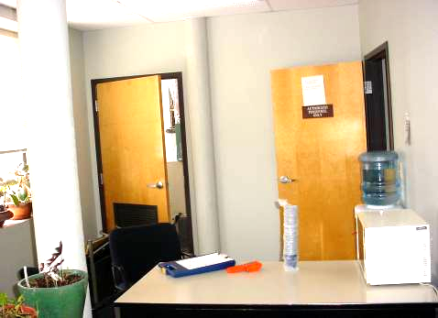

Return Air is Drawn to the AHU Return Vent

Picture 2

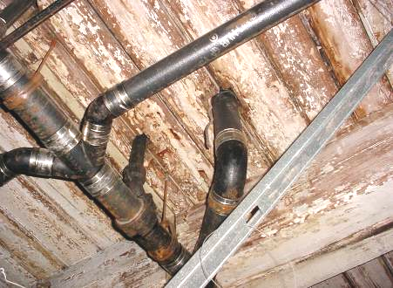

Underside of Floor the Serves as the Top of the Ceiling Plenum,
Note Heavy Water Staining
Picture 3

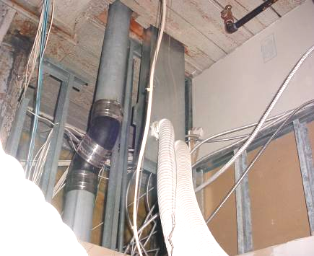

Restroom exhaust vents connected to duct with flexible dryer hose

Picture 4

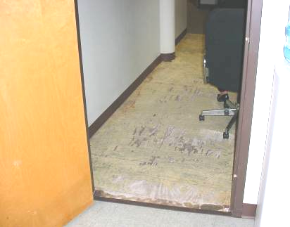

Water Damaged GW and Floor

Picture 5

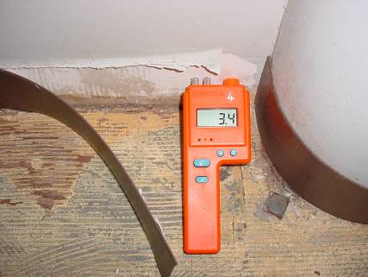

Moisture Meter Measure Moisture in Water Damaged GW 10 Days after Rainstorm

Picture 6

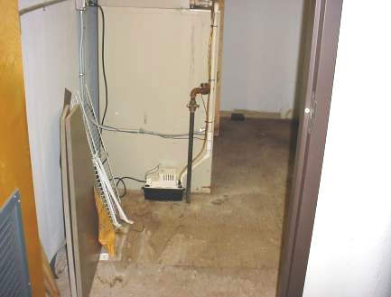

AHU Rooms Appear to be Heavily Stained with Moisture

Picture 7

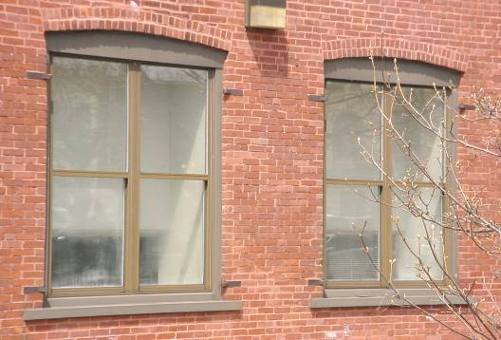

Steel Shutter Hanger

Picture 8

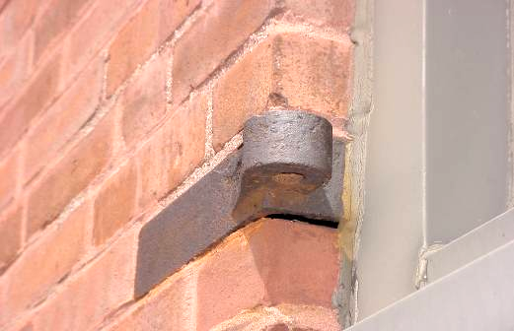

Space under Hanger
Picture 9

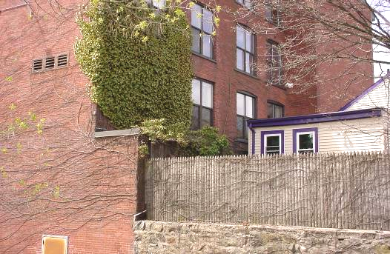

Ivy on Exterior of Building

Picture 10

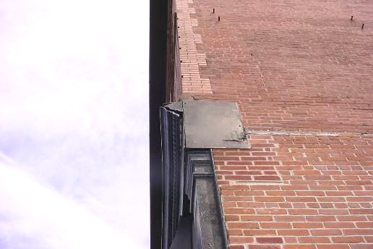

Damage to the Building Façade
Picture 11

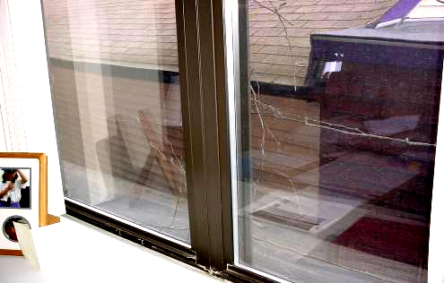

Short Roof, North Side of Building, Note Location of Roof Edge of Adjacent Building Which Lacks a Gutter/Downspout System

Picture 12

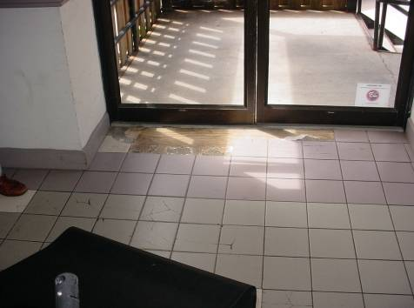

Damage to Tile at Door Threshold
Picture 13

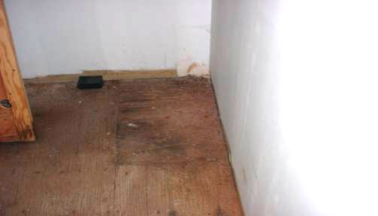

Mouse Droppings on AHU Floor, Note Bait Trap

Picture 14

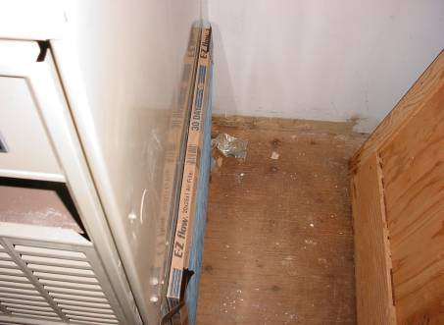

AHU Air Filter Held in Place by Tape, Note Spaces between Filter and Cabinet

Picture 15

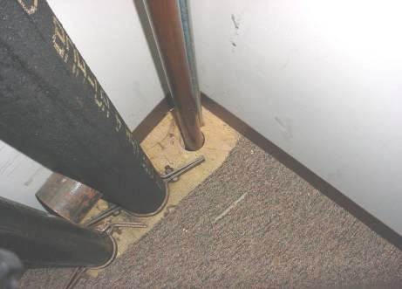

Pipe Hole in Floor of Office, Cold Air Was Found Flowing
upwards Through This Space
Location | Carbon  Dioxide  (ppm) | Temp  (°F) | Relative  Humidity  (%) | Carbon Monoxide  (ppm) | Occupants  in Room | Windows  Openable | Ventilation |  | Remarks
 |  |  |  |  |  |  | Supply | Exhaust | Remarks
Outside  (Background) | 396 | 67 | 30 | ND
Hearing room 2 | 1182 | 65 | 60 | ND | 0 | N | Y | N
Hearing room 1 | 1024 | 67 | 53 | ND | 7 | N | Y | N
Hearing room 3 | 849 | 68 | 48 | ND | 0 | N | Y | N
Administrative assistant | 941 | 69 | 49 | ND | 1 | N | Y | N | Door open
Hearing room 4 | 680 | 68 | 41 | ND | 0 | N | Y | N | Door open
Towney office | 1351 | 69 | 47 | ND | 1 | N | Y | N | Hole in floor (Picture 14)  Door open
Gonsalves office | 967 | 71 | 45 | ND | 2 | N | Y | N
Cox office | 950 | 71 | 44 | ND | 0 | N | Y | N | Condensation in windows  Water damage GW  1 water damaged ceiling tile  Door open
Extra room | 823 | 72 | 41 | ND | 0 | N | Y | Y | 1 water damaged ceiling tile  Plants
OEVR 1 | 839 | 71 | 41 | ND | 0 | N | Y | N | Door open
Reception | 880 | 71 | 41 | ND | 0 | N | Y | N | Photocopier  Door open
1st floor women’s restroom |  |  |  |  |  |  | Y | Y
1st floor men’s restroom |  |  |  |  |  |  | Y | N | No exhaust vent installed
Waiting room | 957 | 69 | 45 | ND | 0 | N | Y | N
Attorney/client conference room | 940 | 69 | 45 | ND | 0 | N | Y | N | Door open
2nd floor women’s restroom |  |  |  |  |  |  | N | N | 6 water damaged ceiling tiles
2nd floor Matse office | 601 | 72 | 39 | ND | 0 | N | Y | N | Plant  Door open
2nd floor Judge’s reception | 607 | 73 | 35 | ND | 3 | N | Y | N | 3 water damaged ceiling tile
2nd floor kitchen | 672 | 73 | 36 | ND | 0 | N | Y | Y | 1 water damaged ceiling tile
2nd floor Stenographer’s office | 600 | 73 | 36 | ND | 1 | N | Y | N | Door open
2nd floor McManus office | 633 | 72 | 37 | ND | 0 | N | Y | N | Door open
2nd floor Conference room | 670 | 72 | 37 | ND | 1 | N | Y | N | Door open
2nd floor Sullivan office | 662 | 72 | 37 | ND | 0 | N | Y | N | Door open
2nd floor Chadinha office | 609 | 72 | 37 | ND | 0 | N | Y | N | Door open
2nd floor Brendenuehl office | 640 | 72 | 38 | ND | 0 | N | Y | N | Door open

