INDOOR AIR QUALITY ASSESSMENT

Massachusetts Department of Revenue
Fall River Office, Center Place
218 South Main Street
Fall River, Massachusetts

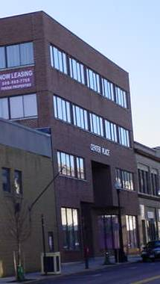

Prepared by:
Massachusetts Department of Public Health
Center for Environmental Health
Emergency Response/Indoor Air Quality Program
January 2007

Background/Introduction
At the request of Donald Trudell of the Massachusetts Department of Revenue (DOR), an indoor air quality assessment was conducted at the Fall River DOR office, 218 South Main Street. This assessment was conducted by the Massachusetts Department of Public Health (MDPH), Center for Environmental Health (CEH). The request was prompted by concerns regarding odors resulting from materials used during demolition of the South Main Place Mall (SMPM), a property adjacent to the DOR office.
The SMPM was constructed in the 1970s (Picture 1) and is scheduled for demolition as part of the Fall River District Court construction project. Asbestos tile abatement at the SMPM was reportedly completed on Wednesday, January 3, 2007. According to Mr. Trudell, the DOR office was closed on Friday January 5, 2007 and Monday, January 8, 2007 due to an unidentified chemical odor that was attributed to the SMPM demolition work.
On January 8, 2007 a visit was made to this building by Michael Feeney, Director of Emergency Response/Indoor Air Quality (ER/IAQ Program. As previously indicated, the DOR offices were unoccupied on this date. Mr. Feeney returned to the Fall River DOR office on January 9, 2007 to conduct further air monitoring while the offices were occupied. DOR staff reported that the odor was strongest on the first floor at the front of the building, along the wall shared with the SMPM.

Methods
Air tests for carbon dioxide, carbon monoxide, temperature and relative humidity were conducted with the TSI, Q-TRAK™ IAQ Monitor, Model 8551. Screening for total volatile organic compounds (TVOCs) was conducted with a HNu, Model 102 Snap-on Photo Ionization Detector (PID).

Results
The DOR offices have a population of approximately 10 to 20 employees. TVOC measurements taken at the offices on January 8 2007 appear in Table 1. General indoor air quality tests and screening for TVOCs were conducted on the January 9, 2007 assessment; these results appear in Table 2.

Discussion
Ventilation
The carbon dioxide levels measured in all DOR offices were below 800 ppm (parts per million), which is indicative of adequate ventilation. Ventilation in this building is provided by a heating, ventilation and air conditioning (HVAC) system. Ducted air diffusers distribute fresh air to the office space. Air diffusers are designed to create airflow by directing air to move along the ceiling and down walls, which allows for fresh air to mix and circulate. Mechanical exhaust ventilation is provided by ceiling-mounted vents.
To maximize air exchange, the MDPH recommends that both supply and exhaust ventilation operate continuously during periods of occupancy. In order to have proper ventilation with a mechanical supply and exhaust system, the systems must be balanced to provide an adequate amount of fresh air to the interior of a room while removing stale air from the room. It is recommended that HVAC systems be re-balanced every five years to ensure adequate air systems function (SMACNA, 1994). The date of the last balancing was unknown at the time of the assessment.
The Massachusetts Building Code requires that each area have a minimum ventilation rate of 20 cubic feet per minute (cfm) per occupant of fresh outside air or openable windows (SBBRS, 1997; BOCA, 1993). The ventilation must be on at all times that the room is occupied. Providing adequate fresh air ventilation with open windows and maintaining the temperature in the comfort range during the cold weather season is impractical. Mechanical ventilation is usually required to provide adequate fresh air ventilation.
Carbon dioxide is not a problem in and of itself. It is used as an indicator of the adequacy of the fresh air ventilation. As carbon dioxide levels rise, it indicates that the ventilating system is malfunctioning or the design occupancy of the room is being exceeded. When this happens, a buildup of common indoor air pollutants can occur, leading to discomfort or health complaints. The Occupational Safety and Health Administration (OSHA) standard for carbon dioxide is 5,000 parts per million parts of air (ppm). Workers may be exposed to this level for 40 hours/week, based on a time-weighted average (OSHA, 1997).
The MDPH uses a guideline of 800 ppm for publicly occupied buildings. A guideline of 600 ppm or less is preferred in schools due to the fact that the majority of occupants are young and considered to be a more sensitive population in the evaluation of environmental health status. Inadequate ventilation and/or elevated temperatures are major causes of complaints such as respiratory, eye, nose and throat irritation, lethargy and headaches. For more information concerning carbon dioxide, please see Appendix A.
Temperature was measured within a range of 69º F to 72º F, which was close to the MDPH recommended range for comfort. The MDPH recommends that indoor air temperatures be maintained in a range between 70º F to 78º F in order to provide for the comfort of building occupants. In many cases concerning indoor air quality, fluctuations of temperature in occupied spaces are typically experienced, even in a building with an adequate fresh air supply.
Relative humidity measured on the third floor ranged from 24 to 39 percent, slightly below the MDPH recommended comfort range of 40 to 60 percent. The sensation of dryness and irritation is common in a low relative humidity environment. Low relative humidity is a very common problem during the heating season in the northeast part of the United States.

TVOCs
CEH staff arrived at the DOR office at approximately 1:00 PM on January 8, 2007. A background level of 0.2 ppm TVOCs was measured outside the building prior to entering the DOR office. At this time, vehicle traffic was moderate and construction activity was light. TVOC levels measured on the first floor of the DOR office ranged from 0.2 ppm in the front lobby to 0.7 ppm detected at the electrical socket and in seams of the plastic coving along the DOR wall shared with the SMPM.
CEH staff examined the SMPM area where the tiles were removed on January 3, 2007. The area is located in an unventilated hallway that runs the length of the wall shared with the DOR office. This area has no means for either mechanical or natural ventilation (Picture 2). TVOC levels measured in this hallway on January 8, 2007 were 4.2 ppm. The product used in the tile removal process is reportedly Chemsafe 100 (Aramsco, 2006; Appendix B), a product containing a hydrocarbon mixture (CAS. No. 64742-88-7, Stoddard solvent IIc) and ethylene glycol monobutyl ether (CAS No. 111-76-2), both of which are volatile organic compounds. The OSHA permissible exposure limit (PEL) for a Stoddard solvent (roughly equivalent to Stoddard solvent IIc) is 500 ppm and ethylene glycol monobutyl ether is 50 ppm. Workers may be exposed to this level, based on a time-weighted average for 40 hours/week (OSHA, 2006). At no time during the air sampling on January 8-9, 2007 did levels exceed OSHA PELs. Each chemical is also heavier than air, and removal of chemical vapors from the hallway would require mechanical ventilation.
During close examination of the wall between DOR and SMPM, CEH staff discovered that a space approximately 2 feet wide separates the two buildings (Picture 3). Air sampling within the wall space on January 8, 2007, produced a TVOC measurement of 1.5 ppm, indicating that the TVOCs where migrating from hallway where the tile was removed into the wall cavity. Examination of the brick wall on the DOR side of the wall cavity revealed window frames sealed with brick and mortar (Picture 4). Breaches were observed around these window frames. These breaches, the presence of chemical odors in the DOR offices (as reported by DOR staff and Fall River Health Department officials on Friday, January 5, 2007), and measurable levels of VOCs indicate that a pathway for airflow exists in the wall cavity space between the DOR and SMPM.
A cold draft was detected from a crack in the gypsum wallboard (GW) in the front corner of the DOR first floor office (Picture 5). CEH staff temporarily sealed the crack with duct tape (Picture 6). The cold air infiltrating the DOR office provides additional evidence of a pathway between the two buildings. Cold outdoor air appears to be entering the wall cavity space, which in turn pressurizes this space to force TVOCs into areas occupied by DOR through openings in the GW, such as electrical outlets and seams between the wall coving and carpet.
Based on these observations, CEH staff recommended depressurizing the shared wall cavity with a portable fan (Picture 7). Holes cut in the GW on the SMPM side of the wall were sealed with polyethylene plastic and duct tape (Picture 8) to maximize the draw of air from the wall cavity.
During the January 9, 2007 visit, workers reported a lingering odor in the DOR offices on the first floor. Screening for TVOCs on the first floor ranged from 0.2 ppm in the front lobby to 0.5 ppm detected at the electrical socket and in seams of the plastic coving along the DOR wall shared with the SMPM. These levels would be expected to drop towards background level as the exhaust fan continues to draw air from the shared wall cavity.

Conclusions/Recommendations
It is important to note that TVOC screening with a PID does not identify specific contaminants; it is used as a screening tool only. While none of the OSHA PELs for hazardous ingredients listed on the MSDS were exceeded during these visits, odors in the building were reportedly noticeable enough to cause a variety of acute symptoms in DOR staff. In consideration of these conditions, the following recommendations were made to minimize occupant exposure to construction materials during renovations:
- Use exhaust fans to draw air from the shared wall cavity. To the knowledge of CEH staff, the SMPM contractor shift begins at 6:30AM. It recommended that this fan be activated at the start of the SMPM contractor shift and operate until the end of the DOR work day.
- Mop the floor of the SMPM hallway where the tile was removed to remove excess residue left from the Chemsafe 100 product.
- Identify the source of cold air pressurizing the DOR wall cavity. The two likely sources are the expansion joint between the two buildings (Picture 9) and/or a hole through the SMPM exterior wall (Picture 10).
- Seal electrical sockets, cracks in GW, seams in wall coving, the seam between the wall coving and carpet and other means of egress in the affected area, which can serve as pathways for materials to enter occupied spaces from the wall cavity.
- Use floor fans to pressure the offices along the shared wall with the SMPM.
- As a safety measure, install a carbon monoxide (CO) detector in the SMPM near the front of the building to detect any build up of products of combustion from gasoline, diesel, propane, acetylene or other flammable materials used for fuel during demolition activities. If the CO alarm activates, cease activities and ventilate the area with exhaust fans.

References
Aramsco. 2006. Material Safety Data Sheet. Chemsafe 100. Aramsco, Thorofare, NY. https://secure.aramsco.com/msds/00003058.pdf
BOCA. 1993. The BOCA National Mechanical Code/1993. 8th ed. Building Officials and Code Administrators International, Inc., Country Club Hill, IL. Section M-308.1.1.
OSHA. 1997. Limits for Air Contaminants. Occupational Safety and Health Administration. Code of Federal Regulations. 29 C.F.R. 1910.1000 Table Z-1-A.
SBBRS. 1997. Mechanical Ventilation. State Board of Building Regulations and Standards. Code of Massachusetts Regulations. 780 CMR 1209.0
SMACNA. 1994. HVAC Systems Commissioning Manual. 1st ed. Sheet Metal and Air Conditioning Contractors’ National Association, Inc., Chantilly, VA.

Picture 1

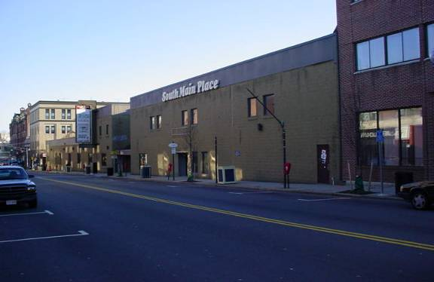

The South Main Place Mall (SMPM)

Picture 2

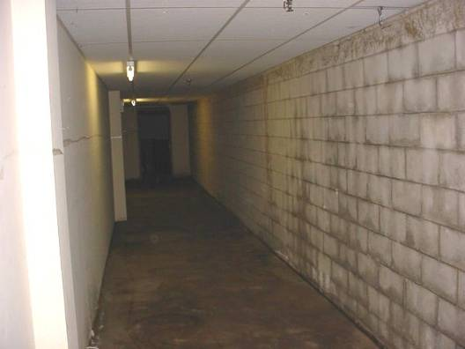

SMPM Hallway Where Tiles Were Removed

Picture 3

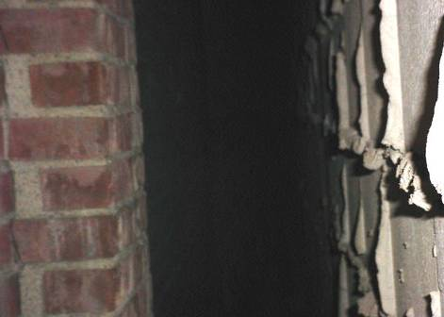

Wall Cavity Between DOR And SMPM

Picture 4

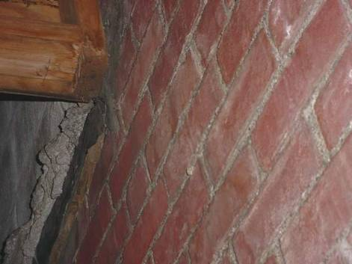

Bricked filled Window Of DOR Building

Picture5

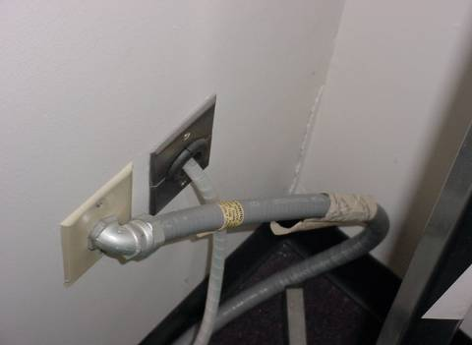

Crack In GW Of DOR Office, First Floor

Picture 6

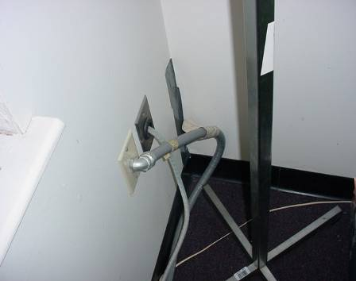

Crack In Picture 4 Sealed With Duct Tape

Picture 7

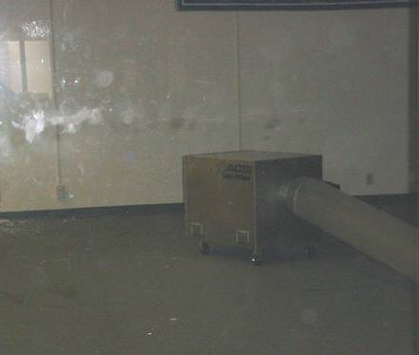

Portable Fan Used To Depressurize Shared Cavity

Picture 8

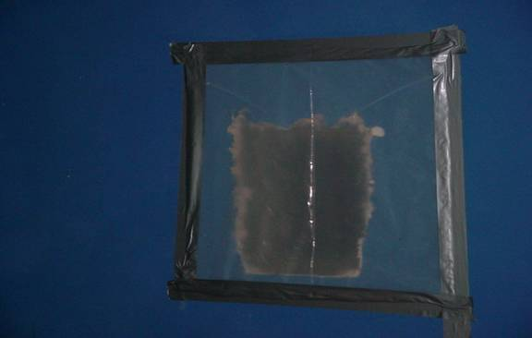

Hole In SMPM GW Sealed With Polyethylene Plastic And Duct Tape To Maximize Wall Space Depressurization

Picture 9

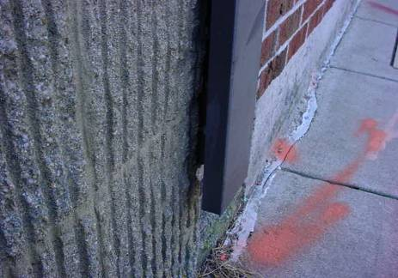

Expansion Joint Between SMPM And DOR Building

Picture 10

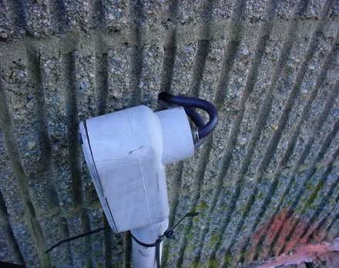

Wall Penetration For Utility In SMPM Wall Near DOR Building
Locations |  | Total Volatile Organic Compounds (TVOCs)  *ppm |  | Remarks
Outside  (Background) | 0.2
3rd floor DOR office | 0.2
2nd floor private office, middle of room | 0.2
2nd floor private office, at electrical socket | 0.5
1st floor DOR office, middle of room | 0.2
1st floor DOR office, at seam of GW wall coving | 0.5
SMPM inside wall cavity, first floor | 1.5 |  | Holes opened in GW to inspect wall cavity
SMPM hallway where Chemsafe 100 was used to remove floor tile | 4.2

Remarks | Carbon  Dioxide  (*ppm) | TVOC | Temp.  (°F) | Relative  Humidity  (%) | Occupants  in Room | Windows  Openable | Ventilation |  | Remarks
 |  |  |  |  |  |  | Supply | Exhaust | Remarks
Outside  (Background) | 377 | 0.2 | 36 | 52
309 meeting room | 484 | 0.2 | 69 | 39 | 0 | N | Y | N | Door open
308 | 442 | 0.2 | 69 | 34 | 0 | N | Y | N | Door open
310 | 455 | 0.2 | 69 | 31 | 2 | N | Y | N | Water damaged carpet  Door open
3rd floor northwest corner | 502 | 0.2 | 71 | 28 | 1 | N | Y | N | Water cooler on carpet  Water damaged carpet  plants
Sylvia office | 480 | 0.2 | 72 | 26 | 1 | N | Y | N | Door open
Cubicles west | 511 | 0.2 | 72 | 27 | 4 | N | Y | N
Cubicles southwest | 512 | 0.2 | 72 | 24 | 2 | N | Y | Y
Ganet office | 492 | 0.2 | 72 | 24 | 0 | N | Y | N | Door open
Byar Office | 555 | 0.2 | 72 | 24 | 1 | N | Y | N | Door open
Cubicle south | 634 | 0.2 | 72 | 28 | 5 | N | Y | N
Cubicle southeast | 754 | 0.2 | 72 | 28 | 6 | N | Y | Y
Breakroom | 544 | 0.2 | 72 | 27 | 0 | N | Y | Y
307 | 508 | 0.2 | 72 | 27 | 0 | N | Y | Y
1st floor lobby | 450 | 0.2 | 71 | 25 | 0 | N | Y | Y
101 front desk | 556 | 0.2 | 69 | 27 | 1 | N | Y | Y
101 behind desk center of room | 442 | 0.2 | 70 | 26 | 2 | N | Y | Y
101 behind desk at seam between wall coving |  | 0.7
102 cubicles center of room | 430 | 0.2 | 71 | 25 | 1 | N | Y | Y
102 cubicles center of room at seam between wall coving

