INDOOR AIR QUALITY ASSESSMENT

Department of Social Services
Dowling Building
22 Pleasant Street
Malden, Massachusetts

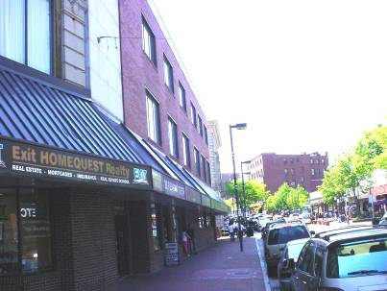

Prepared by:
Massachusetts Department of Public Health
Bureau of Environmental Health
Emergency Response/Indoor Air Quality Program
August, 2007

Background/Introduction
At the request of Rosemary Sammarco, Director, Office of Facilities Management of the Massachusetts Department of Social Services (DSS) and a building occupant, an indoor air quality assessment was done at the DSS Tri-City Area Offices on the second floor of the Dowling Building, 22 Pleasant Street, Malden, Massachusetts. This assessment was conducted by the Massachusetts Department of Public Health (MDPH), Bureau of Environmental Health (BEH). Complaints of upper respiratory symptoms and poor temperature control prompted the request. On May 24, 2007, a visit was made to this building by Michael Feeney, Director of BEH’s Emergency Response/Indoor Air Quality (ER/IAQ), Program.
The DSS is located on the second floor of an early 1900’s office building that appears to have an addition that was built in the mid-1900’s (Picture 1).

Methods
Air tests for carbon dioxide, temperature and relative humidity were taken with the TSI, Q-Trak, IAQ Monitor, Model 8551. BEH staff also performed a visual inspection of building materials for water damage and/or microbial growth.

Results
The building has a population of approximately 115 employees and an estimated 25 individuals who visit on a daily basis. The tests were taken under normal operating conditions. Test results appear in Table 1. Air sampling results are listed in the Table by location that the air sample was taken. Each location was assigned a number as listed on the floor plan provided to BEH staff by DSS personnel (Figure 1).

Discussion
Ventilation
It can be seen from Table 1 that carbon dioxide levels were below 800 parts per million (ppm) in all but one of fifty-two areas sampled, indicating adequate air exchange throughout the building. The DSS space is divided into private offices and an open work area that was subdivided by floor dividers. Each work area contains supply diffusers and exhaust vents that are connected to rooftop air handling units (AHUs), which provide fresh air (Picture 2). Heating in the building is divided into zones controlled by thermostats. The thermostat in each zone controls a damper within the supply duct. Restroom ventilation is provided by ceiling-mounted exhaust vents, which are activated by a light switch. While functioning, these vents deactivate when lights are turned off, preventing the continuous removal of moisture and restroom odors.
To maximize air exchange, the MDPH recommends that both supply and exhaust ventilation operate continuously during periods of occupancy. In order to have proper ventilation with a mechanical supply and exhaust system, the systems must be balanced to provide an adequate amount of fresh air to the interior of a room while removing stale air from the room. It is recommended that HVAC systems be re-balanced every five years to ensure adequate air systems function (SMACNA, 1994). The date of the last balancing was not available at the time of the assessment.
The Massachusetts Building Code requires a minimum ventilation rate of 20 cubic feet per minute (cfm) per occupant of fresh outside air or have openable windows in each room (SBBRS, 1997; BOCA, 1993). The ventilation must be on at all times that the room is occupied. Providing adequate fresh air ventilation with open windows and maintaining the temperature in the comfort range during the cold weather season is impractical. Mechanical ventilation is usually required to provide adequate fresh air ventilation.
Carbon dioxide is not a problem in and of itself. It is used as an indicator of the adequacy of the fresh air ventilation. As carbon dioxide levels rise, it indicates that the ventilating system is malfunctioning or the design occupancy of the room is being exceeded. When this happens a buildup of common indoor air pollutants can occur, leading to discomfort or health complaints. The Occupational Safety and Health Administration (OSHA) standard for carbon dioxide is 5,000 parts per million parts of air (ppm). Workers may be exposed to this level for 40 hours/week based on a time weighted average (OSHA, 1997).
The MDPH uses a guideline of 800 ppm for publicly occupied buildings. A guideline of 600 ppm or less is preferred in schools due to the fact that the majority of occupants are young and considered to be a more sensitive population in the evaluation of environmental health status. Inadequate ventilation and/or elevated temperatures are major causes of complaints such as respiratory, eye, nose and throat irritation, lethargy and headaches. For more information concerning carbon dioxide, please see Appendix A.
Temperature readings ranged from 71º F to 78 º F, which were within the MDPH recommended comfort guidelines in all areas surveyed during the assessment. The MDPH recommends that indoor air temperatures be maintained in a range of 70 º F to 78 º F in order to provide for the comfort of building occupants. In many cases concerning indoor air quality, fluctuations of temperature in occupied spaces are typically experienced, even in a building with an adequate fresh air supply.
The relative humidity in the building during the assessment ranged from 38 to 46 percent, which was within or close to the lower end of the MDPH recommended comfort range. The MDPH recommends a comfort range of 40 to 60 percent for indoor air relative humidity. Relative humidity levels in the building would be expected to drop during the winter months due to heating. The sensation of dryness and irritation is common in a low relative humidity environment. Low relative humidity is a very common problem during the heating season in the northeast part of the United States.

Microbial/Moisture Concerns
Water damaged ceiling plaster (above the ceiling plenum) and stained ceiling tiles were observed (Picture 3) at the time of assessment, which are evidence of roof leaks. In one location, the source of water wetting ceiling tiles appeared to be a duct connected to a rooftop AHU (Picture 4). The AHU cabinet had a space along a corner, through which rainwater could leak under certain weather conditions (Picture 5).
The US Environmental Protection Agency (US EPA) and the American Conference of Governmental Industrial Hygienists (ACGIH) recommend that porous materials be dried with fans and heating within 24 to 48 hours of becoming wet (US EPA, 2001; ACGIH, 1989). If not dried within this time frame, mold growth may occur. Once mold has colonized porous materials, they are difficult to clean and should be removed.
Plants were noted in several areas. Plants can be a source of pollen and mold, which can be respiratory irritants to some individuals. Plants should be properly maintained and be equipped with drip pans. Plants should also be located away from the air stream of mechanical ventilation to prevent aerosolization of dirt, pollen or mold.

Other Concerns
The ceiling plenum was created by installing a suspended ceiling tile system below the original plaster ceiling. It appears that large holes were made in the plaster ceiling in order to install chains from which the suspended ceiling would hang (Picture 6). These holes create breaches through which unconditioned air above the original plaster ceiling can be drawn.
A number of conditions that may attract rodents were observed in work areas. A large collection of soda cans in plastic bags was found in a storeroom (Picture 7). Stored food containers were noted in some rooms. Food preparation equipment (e.g., toasters, microwave ovens and refrigerators) were also found in a number of offices (Picture 8). Food preparation equipment did not appear to be cleaned of food residues, which can serve as a rodent attractant. Numerous means for pests to enter the DSS were identified in the ceiling plenum as well as the electrical closet (Pictures 6 and 9). Under current Massachusetts law (effective November 1, 2001) the principles of integrated pest management (IPM) must be used to remove pests in state buildings (Mass Act, 2000). Pesticide use indoors can introduce chemicals into the indoor environment that can be sources of eye, nose and throat irritation. The reduction/elimination of pathways/food sources that are attracting these insects should be the first step taken to prevent or eliminate infestation.
Rodent infestation can result in indoor air quality related symptoms due to materials in their wastes. Mouse urine is known to contain a protein that is a known sensitizer (US EPA, 1992). A sensitizer is a material that can produce symptoms in exposed individuals can cause running nose or skin rashes in sensitive individuals (e.g., running nose or skin rashes). A three-step approach is necessary to eliminate rodent infestation:
- Removal of the rodents;
- Cleaning of waste products from the interior of the building; and
- Reduction/elimination of pathways/food sources that are attracting rodents.
To eliminate exposure to allergens, rodents must be removed from the building. Please note that removal, even after cleaning, may not provide immediate relief since allergens can exist in the interior for several months after rodents are eliminated (Burge, 1995). A combination of cleaning, along with an increase in ventilation and filtration should serve to reduce rodent associated allergens once the infestation is eliminated.
Several photocopiers were noted in the building. Photocopiers can emit heat and odors. Photocopiers can also produce VOCs and ozone, particularly if the equipment is older and in frequent use. Ozone is a respiratory irritant (Schmidt Etkin, D., 1992). Photocopiers should be located in an area with adequate local exhaust ventilation to help reduce odors, pollutants and excess heat.
A number of areas contained upholstered furniture. Upholstered furniture is covered with fabric that comes in contact with human skin. This type of contact can leave oils, perspiration, hair and skin cells. Dust mites feed upon human skin cells and excrete waste products that contain allergens. In addition, if relative humidity levels increase above 60 percent, dust mites tend to proliferate (US EPA, 1992). In order to remove dust mites and other pollutants, frequent vacuuming of upholstered furniture is recommended (Berry, M.A., 1994).

Conclusions/Recommendations
In view of the findings at the time of the visit, the following recommendations are made:
- Seal the seam in the rooftop AHU shown in Picture 5 with an appropriate caulking material. Inspect rooftop AHUs for similar spaces and repair as needed.
- Remove accumulated soda cans from storage closet.
- Remove furniture and discarded boxes that can serve a pest harborages.
- Reduce/remove toaster ovens, microwave ovens and refrigerators from all areas with the exception of the kitchen.
- It highly recommended that the principles of integrated pest management (IPM) be used to rid the building of pest. A copy of the IPM recommendations can be obtained from the Massachusetts Department of Food and Agriculture (MDFA) website at the following website: http://www.state.ma.us/dfa/pesticides/publications/IPM_kit_for_bldg_mgrs.pdf. Activities that can be used to eliminate pest infestation may include the following:
  - Avoid having food preparation or storage equipment in offices.
  - Rinse out recycled food containers. Seal recycled containers in a tight-fitting lid to prevent rodent access.
  - Remove non-food items that rodents are consuming.
  - Stored foods in tight fitting containers.
  - To the extent possible, avoid eating at workstations. In areas were food is consumed, periodic vacuuming to remove crumbs are recommended.
  - Regularly clean crumbs and other food residues from ovens, toasters, toaster ovens, microwave ovens coffee pots and other food preparation equipment;
  - Holes as small as ¼” are enough space for rodents to enter an area. Examine each room and the exterior walls of the DSS office for means of rodent egress and seal. If doors do not seal at the bottom, install a weather strip as a barrier to rodents. Reduce harborages (e.g. discarded equipment and cardboard boxes) where rodents may reside (MDFA, 1996).
- Install timers on restroom light switches to operate exhaust vents continuously during business hours.
- For buildings in New England, periods of low relative humidity during the winter are often unavoidable. Therefore, scrupulous cleaning practices should be adopted to minimize common indoor air contaminants whose irritant effects can be enhanced when the relative humidity is low. To control for dusts, a HEPA filter equipped vacuum cleaner in conjunction with wet wiping of all surfaces is recommended. Drinking water during the day can help ease some symptoms associated with a dry environment (throat and sinus irritations).
- Repair water leaks and replace any remaining water-stained ceiling tiles. Examine the areas above these tiles for mold growth. Disinfect areas of water leaks with an appropriate antimicrobial as needed.
- Report any roof leaks or other signs of water penetration to the building owner/manager for prompt remediation.
- Ensure all plants are equipped with drip pans. Examine drip pans periodically for mold growth and disinfect with an appropriate antimicrobial where necessary.
- Clean/vacuum upholstered furniture regularly to prevent dust build-up. If not possible/practical, remove upholstered furniture from building.
- Ensure photocopiers are located in a well-ventilated area.
- For further building-wide evaluations, advice on maintaining public buildings and other related indoor air quality documents see the MDPH’s website at http://www.state.ma.us/dph/MDPH/iaq/iaqhome.htm.

References
ACGIH. 1989. Guidelines for the Assessment of Bioaerosols in the Indoor Environment. American Conference of Governmental Industrial Hygienists, Cincinnati, OH.

Berry, M.A. 1994. Protecting the Built Environment: Cleaning for Health, Michael A. Berry, Chapel Hill, NC.

BOCA. 1993. The BOCA National Mechanical Code-1993. 8th ed. Building Officials & Code Administrators International, Inc., Country Club Hills, IL. M-308.1
Philadelphia, PA.

Burge, H.A. 1995. Bioaerosols. Lewis Publishing Company, Boca Raton, FL.
Mass. Act. 2000. An Act Protecting Children and families from Harmful Pesticides. 2000 Mass Acts c. 85 sec. 6E.
MDFA. 1996. Integrated Pest Management Kit for Building Managers. Massachusetts Department of Food and Agriculture, Pesticide Bureau, Boston, MA. http://www.mass.gov/agr/pesticides/publications/IPM_kit_for_bldg_mgrs.pdf

OSHA. 1997. Limits for Air Contaminants. Occupational Safety and Health Administration. Code of Federal Regulations. 29 C.F.R. 1910.1000 Table Z-1-A.

SBBRS. 1997. Mechanical Ventilation. State Board of Building Regulations and Standards. Code of Massachusetts Regulations. 780 CMR 1209.0

Schmidt Etkin, D. 1992. Office Furnishings/Equipment & IAQ Health Impacts, Prevention & Mitigation. Cutter Information Corporation, Indoor Air Quality Update, Arlington, MA.
US EPA. 2001. Mold Remediation in Schools and Commercial Buildings. US Environmental Protection Agency, Office of Air and Radiation, Indoor Environments Division, Washington, DC. EPA 402-K-01-001. March 2001.

US EPA. 1992. Indoor Biological Pollutants. US Environmental Protection Agency, Environmental Criteria and Assessment Office, Office of Health and Environmental Assessment, Research Triangle Park, NC. ECAO-R-0315. January 1992.
Picture 1

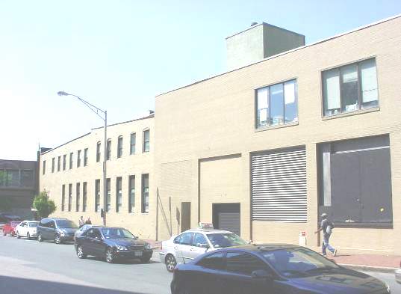

Rear of 22 Pleasant Street, DSS Office is Located on the Second Floor

Picture 2

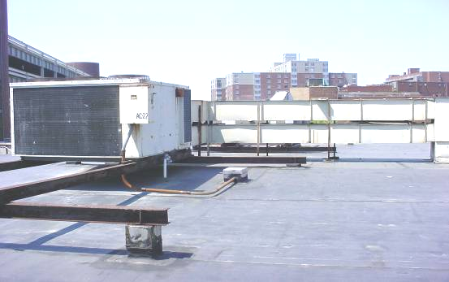

Rooftop AHU
Picture 3

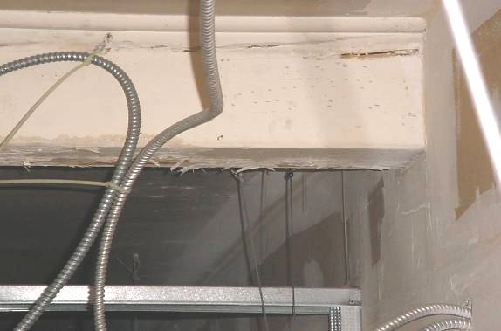

Water Damaged Materials in Ceiling Plenum
Picture 4

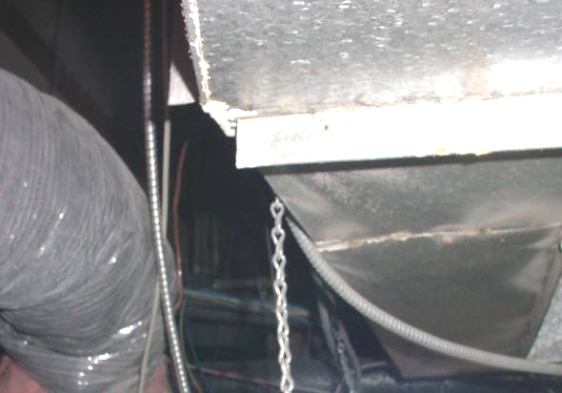
Duct Leaking Water, Note Stain at Seam of Duct (Arrow)
Picture 5

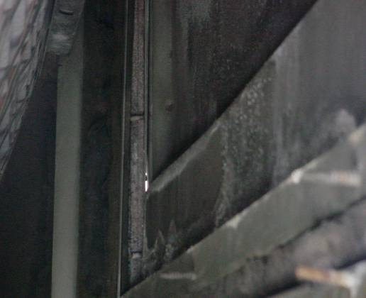

Light at Seam Inside AHU, Indicating Opening (Arrow)
Picture 6

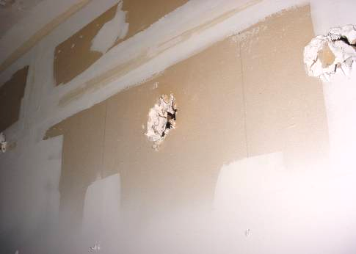

Holes in Wall above Ceiling, Allowing for Rodent Access
Picture 7

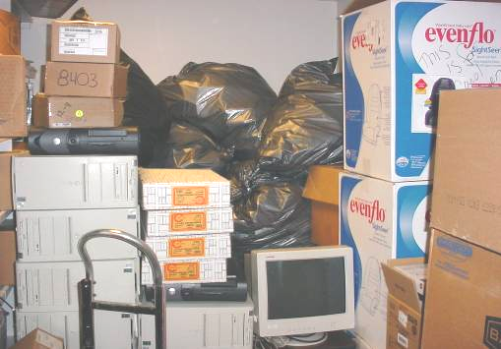

Soda Cans in Plastic Bags
Picture 8

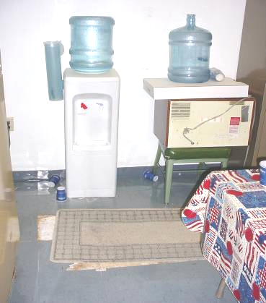

Unused Microwave Oven
Picture 9

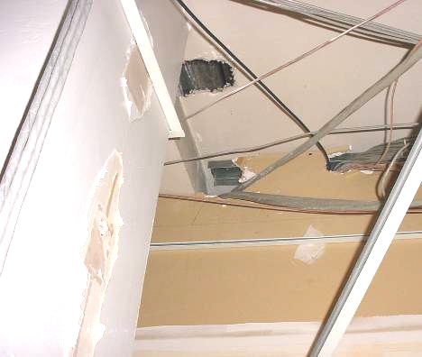

Holes in Wall of Electrical Room
Location | Carbon  Dioxide  (ppm) | Temp  (°F) | Relative  Humidity  (%) | Occupants  in Room | Windows  Openable | Ventilation |  | Remarks
 |  |  |  |  |  | Supply | Exhaust | Remarks
Outside  (Background) | 388 | 75 | 55
Area director | 729 | 75 | 41 | 4 | Y | Y | Y | 1 water damaged ceiling tile  Plants  Dry erase marker  Door open
Waiting room | 688 | 73 | 38 | 4 | N | Y | Y | Door open
Family room | 704 | 75 | 38 | 4 | N | Y | Y | 4 ajar ceiling tiles  Door open
Interview 1 | 711 | 75 | 38 | 0 | N | Y | Y | Door open
Foster care | 790 | 75 | 38 | 2 | N | Y | Y
Interview 2 | 712 | 75 | 39 | 0 | N | Y | Y
Parent resource | 867 | 75 | 40 | 1 | N | Y | Y | 3 water damaged ceiling tiles  Air purifier
Reception | 738 | 73 | 39 | 1 | N | Y | N
Jen unit | 726 | 73 | 40 | 2 | N | Y | Y | Microwave  Door open
Pam unit | 746 | 73 | 41 | 2 | N | Y | Y | Dry erase marker  Microwave
Supply room | 775 | 75 | 41 | 0 | N | Y | Y | Empty soda cans
Admin service coordinator | 737 | 75 | 41 | 1 | N | Y | Y | Clutter  Door open
Area admin manager | 716 | 75 | 41 | 0 | Y | Y | Y | Door open  Damaged window seal
Adolescent supervisor | 687 | 75 | 40 | 0 | N | Y | Y | Door open
Area program manager | 764 | 75 | 39 | 0 | Y | Y | Y | Door open
Area program manager Pam | 762 | 75 | 41 | 0 | Y | Y | Y
Area program manager Marian | 759 | 75 | 41 | 2 | Y | Y | Y | Plants  Door open
SRTU | 700 | 75 | 40 | 1 | n | y | y | Food storage  Insects
Ongoing unit Carol | 707 | 75 | 39 | 0 | N | Y | Y | Refrigerator  Door open
Telephone room | 765 | 73 | 44 | 0 | N | Y | Y
Men’s restroom |  |  |  |  |  | N | Y | Exhaust fan activated by light switch
Women’s restroom |  |  |  |  |  | N | Y | Exhaust off
Storeroom |  |  |  |  |  | Y | N | 1 water damage ceiling tiles
Conference room 1B | 701 | 71 | 44 | 0 | N | Y | N | Door open
Conference room 1A | 702 | 72 | 44 | 0 | N | Y | Y | Door open
Wayside | 749 | 73 | 45 | 2 | N | Y | Y | Door open
Corn | 750 | 73 | 44 | 1 | Y | Y | Y | Plants  Door open
Admin Secretary 1 | 784 | 73 | 45 | 0 | Y | Y | Y | Plants
Ongoing room | 722 | 73 | 43 | 2 | N | Y | Y | 1 water damaged ceiling tile  Upholstered furniture  Door open
Secretary pool | 734 | 73 | 44 | 0 | N | Y | Y | Photocopier
Kitchen | 730 | 73 | 44 | 0 | N | Y | Y
Intake Jody | 745 | 73 | 46 | 1 | N | Y | Y | Personal fan  Refrigerator
Supervisor 9 | 629 | 74 | 46 | 0 | N | Y | Y | Door open
222-10 | 611 | 75 | 45 | 0 | N | Y | Y | Upholstered furniture  Plants
10-219 | 657 | 75 | 45 | 1 | N | Y | Y | Water damage window  Microwave
Open record room | 631 | 75 | 43 | 0 | N | Y | Y
215-7 | 736 | 76 | 44 | 2 | N | Y | Y | Door open
0-212 | 716 | 75 | 44 | 2 | N | Y | Y | Microwave  Refrigerator
Forms | 684 | 76 | 44 | 0 | N | Y | Y | Door open
0-214 | 665 | 76 | 45 | 1 | N | Y | Y | Clutter
217-9 | 668 | 75 | 44 | 0 | N | Y | Y | Upholstered furniture  Door open
218-8 | 674 | 76 | 44 | 0 | N | Y | Y
212-5 | 680 | 76 | 44 | 0 | N | Y | Y | Door open
7-210 | 703 | 76 | 44 | 0 | N | Y | Y | Water damaged light lens
211-4 | 684 | 76 | 44 | 0 | N | Y | Y
6-207 | 708 | 76 | 44 | 1 | N | Y | Y
5-208 | 759 | 76 | 44 | 2 | N | Y | Y
201-1 | 675 | 76 | 44 | 0 | N | Y | Y | 2 water damaged ceiling tiles
1-202 | 707 | 76 | 44 | 4 | N | Y | Y | Microwave
3-203 | 732 | 78 | 44 | 2 | N | Y | Y | Water damaged window frame  Food storage
4-207 | 658 | 77 | 43 | 2 | N | Y | Y | Food storage
5-204 | 792 | 77 | 44 | 5 | N | Y | N | Dry erase marker
205-2 | 741 | 77 | 43 | 0 | N | Y | Y | Door open
206-3 | 672 | 77 | 42 | 0 | N | Y | Y | Door open
214-6 | 671 | 76 | 41 | 0 | N | Y | Y | Door open

