INDOOR AIR QUALITY ASSESSMENT
FIRE/WATER DAMAGE INVESTIGATION

Massachusetts Department of Social Services
67 Mechanic Street
Attleboro, Massachusetts

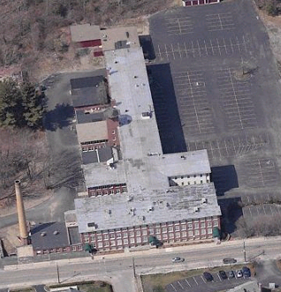

Prepared by:
Massachusetts Department of Public Health
Bureau of Environmental Health
Indoor Air Quality Program
April 2008

Background/Introduction
At the request of Mr. Marty Kenney, Area Manager for the Massachusetts Department of Social Services (DSS), the Massachusetts Department of Public Health (MDPH), Bureau of Environmental Health (BEH) provided assistance and consultation regarding indoor air quality concerns at the DSS office located at 67 Mechanic Street, Attleboro, Massachusetts. The request for assistance was communicated through Doug Shatkin [Human Resources Director, Office of Children, Youth and Families, Executive Office of Health and Human Resources (EOHHS)] and prompted due to employee concerns of smoke odors and water damage associated with a fire that reportedly occurred in an adjacent building.
On April 9, 2008, a visit was made to the DSS by Cory Holmes, Southeast Regional Indoor Air Quality (IAQ) Inspector within BEH’s IAQ Program. Mr. Holmes was accompanied by Mr. Kenney for portions of the assessment. This report focuses on air testing for products of combustion, residual odors and evaluation of water damage and potential mold growth. A report regarding general indoor air quality conditions will follow.
The DSS office is located on the 2nd and 3rd floors of a renovated factory building. The offices consist of open work areas and offices at the perimeter. The building occupied by DSS is attached to another building, forming an H-shape with two semi-enclosed courtyards (Picture 1). Mr. Kenney reported that a fire occurred on the 4th floor of the adjacent building on Saturday April 5, 2008. As a result of excessive heat, the sprinkler system on the 2nd floor file room was activated, causing water damage. Water damage was also evident (to a lesser extent) on the 3rd floor, in the conference room. Building management responded by hiring Service Master, Inc., a professional fire/flooding restoration firm to remove water-damaged building materials (i.e., carpet and ceiling tiles) and conduct drying operations with fans/dehumidifiers. At the time of the assessment, Service Master was still on site conducting drying and restoration.

Methods
Air tests for carbon monoxide were conducted with the TSI, Q-Trak, IAQ Monitor, Model 8554. Air tests for airborne particle matter with a diameter less than 2.5 micrometers were taken with the TSI, DUSTTRAK™ Aerosol Monitor Model 8520. Screening for total volatile organic compounds (TVOCs) was conducted using a Thermo Environmental Instruments Inc., Model 580 Series Photo Ionization Detector (PID). BEH staff also performed visual inspection of building materials for water damage and/or microbial growth. Moisture content of porous building materials (e.g., gypsum wallboard, ceiling tiles, carpet) was measured with Delmhorst, BD-2000 Model, Moisture Detector with a Delmhorst Standard Probe.

Results
The DSS offices have an employee population of approximately 95. The tests were taken under normal operating conditions, however a number of employees were offsite or working in alternate areas due to residual odors. Test results appear in Table 1. Air samples are listed in Table 1 by program function or name of staff.

Discussion

Fire/Smoke Damage
During the course of the assessment, residual smoke/combustion odors were detected in a number of 2nd floor areas, mainly in areas along the semi-enclosed courtyard on the northwest side of the office facing the adjacent building where the fire was located. The main source of odors to the 2nd floor of the DSS was an air intake for the mechanical ventilation system located in the aforementioned courtyard (Picture 2). At the time of the assessment, Service Master was utilizing the courtyard as a staging area for their generators and exhaust motors used to remove smoke from the affected area of the adjacent building (Pictures 2 and 3). Depending on wind and weather conditions, odors and exhaust emissions from this machinery can be “trapped” in the courtyard and subsequently drawn-in by the DSS’s mechanical ventilation system’s 2nd floor fresh air intake, a process known as “entrainment” (Pictures 2 and 3). Once entrained by the ventilation system, these odors and exhaust emissions can be distributed to occupied areas throughout the floor via ducted supply vents (Picture 4). In contrast, no (or very slight) exhaust odors were detected on the 3rd floor of the DSS where the fresh air intakes were located on the roof.
Indoor air quality can be negatively influenced by the presence of respiratory irritants, such as products of combustion. The process of combustion produces a number of pollutants. Common combustion emissions include carbon monoxide, carbon dioxide, water vapor and smoke (fine airborne particle material). Of these materials, exposure to carbon monoxide and particulate matter with a diameter of 2.5 μm or less (PM2.5) can produce immediate, acute health effects upon exposure. To determine whether combustion products or airborne particulate matter related to the adjacent fire were present, BEH staff obtained measurements for carbon monoxide and PM2.5.

Carbon Monoxide
Carbon monoxide is a by-product of incomplete combustion of organic matter (e.g., gasoline, wood and tobacco). Exposure to carbon monoxide can produce immediate and acute health affects. Several air quality standards have been established to address carbon monoxide and prevent symptoms from exposure to these substances. The MDPH established a corrective action level concerning carbon monoxide in ice skating rinks that use fossil-fueled ice resurfacing equipment. If an operator of an indoor ice rink measures a carbon monoxide level over 30 ppm, taken 20 minutes after resurfacing within a rink, that operator must take actions to reduce carbon monoxide levels (MDPH, 1997).
The American Society of Heating Refrigeration and Air-Conditioning Engineers (ASHRAE) has adopted the National Ambient Air Quality Standards (NAAQS) as one set of criteria for assessing indoor air quality and monitoring of fresh air introduced by HVAC systems (ASHRAE, 1989). The NAAQS are standards established by the US EPA to protect the public health from six criteria pollutants, including carbon monoxide and particulate matter (US EPA, 2006). As recommended by ASHRAE, pollutant levels of fresh air introduced to a building should not exceed the NAAQS levels (ASHRAE, 1989). The NAAQS were adopted by reference in the Building Officials & Code Administrators (BOCA) National Mechanical Code of 1993 (BOCA, 1993), which is now an HVAC standard included in the Massachusetts State Building Code (SBBRS, 1997). According to the NAAQS, carbon monoxide levels in outdoor air should not exceed 9 ppm in an eight-hour average (US EPA, 2006).
Carbon monoxide should not be present in a typical, indoor environment. If it is present, indoor carbon monoxide levels should be less than or equal to outdoor levels. Outdoor carbon monoxide concentrations were measured at 1 ppm prior to the assessment (Table 1). Carbon monoxide levels measured indoors ranged from non-detect (ND) to 2 ppm, which were slightly above background but well below the NAAQS of 9 ppm. The source of carbon monoxide was exhaust emissions from equipment operated by Service Master in the semi-enclosed courtyard.

Particulate Matter (PM2.5)
The US EPA has established NAAQS limits for exposure to particulate matter. Particulate matter is airborne solids that can be irritating to the eyes, nose and throat. The NAAQS originally established exposure limits to particulate matter with a diameter of 10 μm or less (PM10). According to the NAAQS, PM10 levels should not exceed 150 microgram per cubic meter (μg/m³) in a 24-hour average (US EPA, 2006). These standards were adopted by both ASHRAE and BOCA. Since the issuance of the ASHRAE standard and BOCA Code, US EPA proposed a more protective standard for fine airborne particles. This more stringent PM2.5 standard requires outdoor air particle levels be maintained below 35 μg/m³ over a 24-hour average (US EPA, 2006). Although both the ASHRAE standard and BOCA Code adopted the PM10 standard for evaluating air quality, MDPH uses the PM2.5 standard for evaluating airborne particulate matter concentrations in the indoor environment to be more conservative.
Outdoor PM2.5 concentrations at the time of the assessment were measured at 26 μg/m³ (Table 1). PM2.5 levels within the DSS ranged from 9 to 33 μg/m³, which were below the NAAQS of 35 μg/m³ (Table 1). However, PM2.5 levels measured on the 2nd floor (21 to 33 μg/m³) were higher than those on the 3rd floor (9 to 20 μg/m³). This suggests that the air intake in the semi-enclosed courtyard is a source of odor and particulate entrainment.
Frequently, indoor air levels of particulates can be at higher levels than those measured outdoors. A number of mechanical devices and/or activities that occur indoors can generate particulates during normal operation. Sources of indoor airborne particulate may include but are not limited to particles generated during the operation of fan belts in the HVAC system, cooking and microwave ovens; use of photocopiers, fax machines and computer printing devices, operating an ordinary vacuum cleaner and heavy foot traffic indoors.

TVOCs
Indoor air quality can also be negatively influenced by the presence of materials containing volatile organic compounds (VOCs). VOCs are carbon-containing substances that have the ability to evaporate at room temperature. Frequently, exposure to low levels of total VOCs (TVOCs) may produce eye, nose, throat and/or respiratory irritation in some sensitive individuals. Typical sources of VOCs from indoor sources include photocopiers, cleaners, health care/beauty products, dry erase materials, permanent markers, combustion sources, fabrics/textiles and paints.
In an effort to determine whether VOCs were present in the building, air monitoring for TVOCs was conducted. Outdoor TVOC concentrations were ND (Table 1). Real-time measurements taken indoors during the assessment were also ND (Table 1).

Mold and Moisture Concerns
As previously mentioned, BEH staff also conducted moisture testing of carpeting and gypsum wallboard (GW) in areas that DSS staff reported had become wet from the activation of the sprinkler system. In order for building materials to support mold growth, a source of water exposure is necessary. Identification and elimination of water moistening building materials is necessary to control mold growth. Materials with increased moisture content over normal concentrations may indicate the possible presence of mold growth. With the exception of GW in the 2nd floor file room directly under the sprinkler pipes (Picture 5), all porous materials tested in these areas were found to have low (i.e., normal) moisture at the time of the assessment.
BEH staff removed vinyl base coving along the 2nd floor to conduct moisture testing (Pictures 5 and 6). At the time of the assessment, the moisture levels in the GW of the 2nd floor file room were found to be elevated. Although the carpet and ceiling tiles had been removed and an industrial model dehumidifier was operating to dry out the area, the GW along the base of the interior wall remained wet. The vinyl coving serves as an impermeable barrier that traps moisture behind it, preventing wet materials from drying.
The US Environmental Protection Agency and the American Conference of Governmental Industrial Hygienists (ACGIH) recommends that porous materials (carpeting, ceiling tiles, etc.) be dried with fans and heating within 24 to 48 hours of becoming wet (US EPA, 2001; ACGIH, 1989). If porous materials are not dried within this time frame, mold growth may occur. Water-damaged porous materials cannot be adequately cleaned to remove mold growth. The application of a mildewcide to moldy porous materials is not recommended.
On previous assessments concerning GW mold growth, BEH personnel have consulted with Dr. Harriet Burge, formerly the Department Chair, but currently an Adjunct Senior Lecturer on Environmental Microbiology of the Department of Environmental Health at the Harvard School of Public Health. The reoccurrence of mold growth on GW after the application of bleach is common. Bleach consists of sodium hypochlorite in a 5 percent concentration mixed with water. Mold colonization of GW can penetrate through its entire structure. When applied to moldy GW, the water of the bleach solution penetrates into the moldy GW, but the sodium hypochlorite remains on the surface. The sodium hypochlorite disinfects the surface mold that it comes in contact with on the GW surface, but not the mold beneath the surface. The additional water added to the subsurface fuels a spurt in mold growth, which increases mold colonization of the GW. As a result, mold colonies reappear on the surface of treated GW shortly after the application of bleach (personal communication, Burge, 1999).

Conclusions/Recommendations
At the time of the assessment no elevated levels of airborne particulates (PM2.5), carbon monoxide or TVOCs were measured. However residual smoke odors as well as transient odors from products of combustion from mechanical equipment used by Service Master were detected within the 2nd floor of the DSS. According to Service Master, restoration activities were tentatively scheduled for completion by Saturday April 12th, 2008. Upon completion of the assessment, BEH staff described the potential for odors to be entrained by the mechanical ventilation system and the relationship to wind/weather conditions and discussed a number of recommendations with Mr. Kenney to help mitigate the odors; these are re-iterated below:
- Continue to monitor odors. If odors persist or become intensified, deactivate the 2nd floor AHU via the wall thermostat (Picture 7) to prevent entrainment.
- Open windows throughout the DSS, with the exception of those along the semi-enclosed courtyard to increase air exchange. Use portable fans if needed to help circulate air.
- Continue to accommodate 2nd floor employees by utilizing space on the 3rd floor.
- Continue with drying operations in the 2nd floor file room.
- Replace water-damaged GW along the base of the 2nd floor file room. This measure will remove any actively growing mold colonies that may be present. Once work is completed, ensure that the area is thoroughly cleaned and disinfected with an appropriate antimicrobial. Dust and particulates generated during remediation should be cleaned using wet wiping methods and/or vacuumed with a high efficiency particulate arrestance (HEPA) filter equipped vacuum cleaner.
- Consult “Mold Remediation in Schools and Commercial Buildings” published by the US Environmental Protection Agency (US EPA, 2001) for recommended practices when conducting mold remediation. This document is available from the US EPA website: http://www.epa.gov/iaq/molds/mold_remediation.html.

References
ACGIH. 1989. Guidelines for the Assessment of Bioaerosols in the Indoor Environment. American Conference of Governmental Industrial Hygienists, Cincinnati, OH.
ASHRAE. 1989. Ventilation for Acceptable Indoor Air Quality. American Society of Heating, Refrigeration and Air Conditioning Engineers. ANSI/ASHRAE 62-1989
Burge, H.A. 1999. Personal Conversation with Dr. Harriet Burge, Harvard School of Public Health. December 13th, 1999.
MDPH. 1997. Requirements to Maintain Air Quality in Indoor Skating Rinks (State Sanitary Code, Chapter XI). 105 CMR 675.000. Massachusetts Department of Public Health, Boston, MA.
SBBRS. 1997. Mechanical Ventilation. State Board of Building Regulations and Standards. Code of Massachusetts Regulations. 780 CMR 1209.0
US EPA. 2001. “Mold Remediation in Schools and Commercial Buildings”. Office of Air and Radiation, Indoor Environments Division, Washington, DC. EPA 402-K-01-001. March 2001. Available at: http://www.epa.gov/iaq/molds/mold_remediation.html.
US EPA. 2006. National Ambient Air Quality Standards (NAAQS). US Environmental Protection Agency, Office of Air Quality Planning and Standards, Washington, DC. http://www.epa.gov/air/criteria.html.
Picture 1

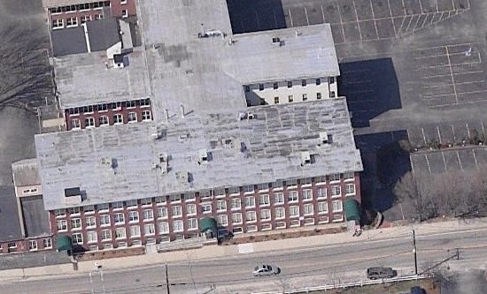
DSS Offices
Area of Fire

Aerial View of 67 Mechanic Street, White Arrow Indicates Semi-Enclosed Courtyard Area
Where Service Master Equipment was Operating, Black Arrow Indicates Location
of Air Intake for DSS 2nd Floor
Picture 2

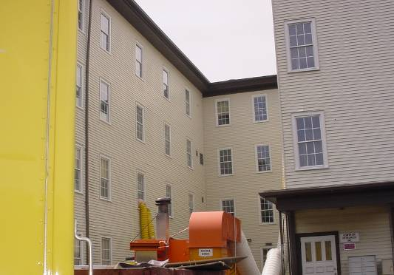

Mechanical Equipment Operating in Semi-Enclosed Courtyard
Picture 3

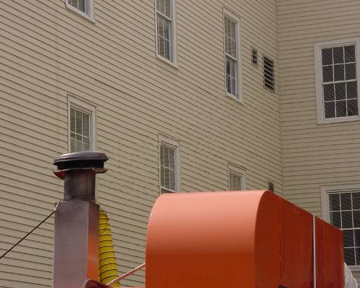

Close-Up of Previous Picture Illustrating the Proximity of the Exhaust Stack
To the Fresh Air Intake for the 2nd Floor AHU

Picture 4

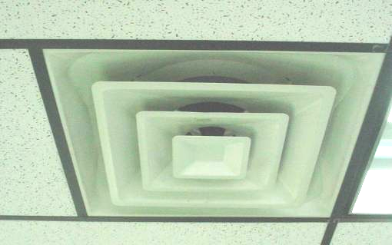

Supply Diffuser for the Mechanical Ventilation System

Picture 5

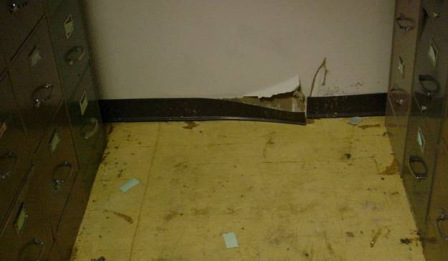

Water Damaged Gypsum Wallboard and Vinyl Base Coving in 2nd Floor File Room
Directly under Sprinkler
Picture 6

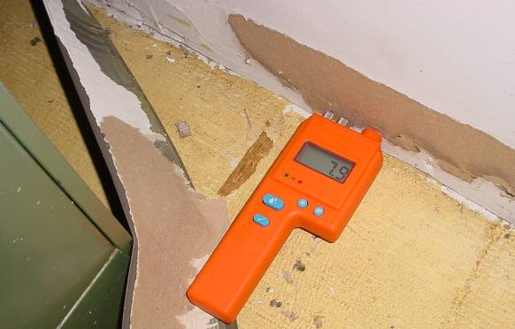

Moisture Testing of Water Damaged Gypsum Wallboard and Vinyl Base Coving in 2nd Floor File Room
Directly under Sprinkler
Picture 7

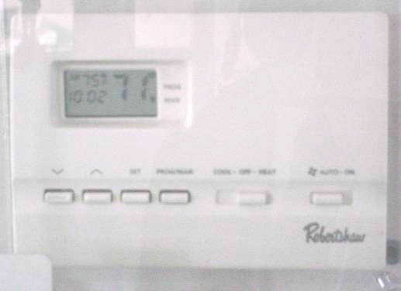

Wall Thermostat for AHU, Arrow Indicates “Off” Switch
Location/ Room | Carbon Monoxide  (ppm) | TVOCs  (ppm) | PM2.5  (µg/m³) | Remarks
Background | 1 | ND | 26 | Cloudy, cool, service master equipment generating exhaust emissions in close proximity to the building
3rd Floor
Andre’s Office | ND | ND | 19
Brennan’s Unit | ND | ND | 20
On-going Unit B | 1 | ND | 16
On-going Unit F | ND | ND | 19
JRI Service Coordinator | ND | ND | 12
Diaz Office | ND | ND | 15
Jackson Office | 1 | ND | 13
Adolescent Unit | ND | ND | 16
Whalen Unit | ND | ND | 15
Family Resource | ND | ND | 13
Adoption Unit | ND | ND | 15
Teaming Unit | ND | ND | 14
Rusty’s Unit | ND | ND | 9
Family Group Conf | ND | ND | 11
File Room | ND | ND | 15
Meeting Room | ND | ND | 13 | Moisture measurements of GW & carpet = low (i.e. normal), water stains on GW, ceiling tiles removed, dehumidifier operating
2nd Floor |  |  |  | Transient exhaust/smoke odors
Reception | 1-2 | ND | 32 | Window open near street
Artie’s Unit | 1 | ND | 23
Anna’s Office | 1 | ND | 22
Screening Unit | ND | ND | 33 | Window open
Evelyn’s Unit | ND | ND | 25
Linda’s Office | ND | ND | 21
Debbie’s Unit | ND | ND | 23
Lawyer’s Unit | ND | ND | 21
Mechanical Room | ND-1 | ND | 21
File Room | 1-1.5 | ND | 21 | Elevated moisture measurements on GW behind and above vinyl base coving, carpet/ceiling tiles removed, dehumidifier operating
Conference Room | 2 | ND | 24

