INDOOR AIR QUALITY ASSESSMENT

Massachusetts Department of Social Services
67 Mechanic Street
Attleboro, Massachusetts 02703

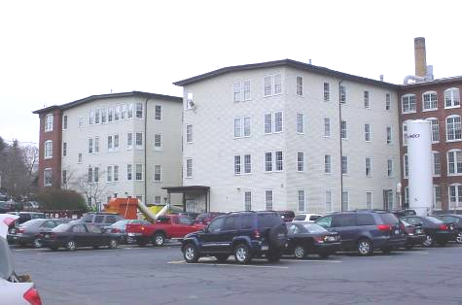

Prepared by:
Massachusetts Department of Public Health
Bureau of Environmental Health
Indoor Air Quality Program
June 2008

Background/Introduction
At the request of Mr. Marty Kenney, Area Manager for the Massachusetts Department of Social Services (DSS), the Massachusetts Department of Public Health (MDPH), Bureau of Environmental Health (BEH) provided assistance and consultation regarding indoor air quality concerns at the DSS office located at 67 Mechanic Street, Attleboro, Massachusetts. The request for assistance was communicated through Doug Shatkin [Human Resources Director, Office of Children, Youth and Families, Executive Office of Health and Human Resources (EOHHS)] and prompted due to employee concerns of smoke odors and water damage associated with a fire that reportedly occurred recently in an adjacent building.
On April 9, 2008, a visit was made to the DSS by Cory Holmes, Southeast Regional Indoor Air Quality (IAQ) Inspector within BEH’s IAQ Program. Mr. Holmes was accompanied by Mr. Kenney for portions of the assessment. A preliminary report was issued regarding fire/flooding restoration (MDPH, 2008). This report focuses on general indoor air quality conditions observed at the time of the assessment.
The DSS offices are located on the 2nd and 3rd floors of a renovated factory building. The offices consist of open work areas and offices around the perimeter. The building occupied by DSS is attached to another building, forming an H-shape with two semi-enclosed courtyards (Picture 1). The DSS occupied space consists of offices and open work areas separated by cloth floor dividers. Floors are covered by wall to wall carpeting. Windows in the DSS space are openable.

Methods
Air tests for carbon monoxide, carbon dioxide, temperature and relative humidity were conducted with the TSI, Q-Trak, IAQ Monitor, Model 8551. Air tests for airborne particle matter with a diameter less than 2.5 micrometers were taken with the TSI, DUSTTRAK™ Aerosol Monitor Model 8520. MDPH staff also performed visual inspection of building materials for water damage and/or microbial growth.

Results
The DSS offices have an employee population of approximately 95. The tests were taken under normal operating conditions, however a number of employees were offsite or working in alternate areas due to residual odors. Test results appear in Table 1. Air samples are listed in Table 1 by program function or name of staff occupying the area.

Discussion
Ventilation
It can be seen from Table 1 that carbon dioxide levels were above 800 ppm (parts per million) in 20 of 27 areas, indicating poor air exchange in the majority of areas surveyed at the time of the assessment. The HVAC system consists of air handling units (AHU), which draw in outside air through outdoor air intakes and distributes it to occupied areas via ceiling-mounted air diffusers (Pictures 1 and 2). The AHU for the 3rd floor is located on the roof (Picture 3); the AHU for the second floor is located in a mechanical room on the second floor (Picture 4). Return air is ducted back to AHUs via ceiling/wall-mounted grills (Picture 5).
Thermostats that control the HVAC system have fan settings of “on” and “automatic”. The “automatic” setting on the thermostat activates the HVAC system at a preset temperature. Once the preset temperature is reached, the HVAC system is deactivated. At the time of the assessment all thermostats in the DSS space were operating in the fan “auto” mode (Picture 6). MDPH recommends that thermostats be set in the fan “on” mode during occupied periods to provide continuous airflow.
To maximize air exchange, the MDPH recommends that both supply and exhaust ventilation operate continuously during periods of occupancy. In order to have proper ventilation with a mechanical ventilation system, the systems must be balanced subsequent to installation to provide an adequate amount of fresh air to the interior of a room while removing stale air from the room. It is recommended that HVAC systems be re-balanced every five years to ensure adequate air systems function (SMACNA, 1994). The date of the last balancing of these systems was not available at the time of the assessment.
The Massachusetts Building Code requires that each room have a minimum ventilation rate of 20 cubic feet per minute (cfm) per occupant of fresh outside air or openable windows (SBBRS, 1997; BOCA, 1993). The ventilation must be on at all times that the room is occupied. Providing adequate fresh air ventilation with open windows and maintaining the temperature in the comfort range during the cold weather season is impractical. Mechanical ventilation is usually required to provide adequate fresh air ventilation.
Carbon dioxide is not a problem in and of itself. It is used as an indicator of the adequacy of the fresh air ventilation. As carbon dioxide levels rise, it indicates that the ventilating system is malfunctioning or the design occupancy of the room is being exceeded. When this happens, a buildup of common indoor air pollutants can occur, leading to discomfort or health complaints. The Occupational Safety and Health Administration (OSHA) standard for carbon dioxide is 5,000 parts per million parts of air (ppm). Workers may be exposed to this level for 40 hours/week, based on a time-weighted average (OSHA, 1997).
The MDPH uses a guideline of 800 ppm for publicly occupied buildings. A guideline of 600 ppm or less is preferred in schools due to the fact that the majority of occupants are young and considered to be a more sensitive population in the evaluation of environmental health status. Inadequate ventilation and/or elevated temperatures are major causes of complaints such as respiratory, eye, nose and throat irritation, lethargy and headaches. For more information concerning carbon dioxide, please see Appendix A.
Temperature readings in DSS occupied space ranged from 70º F to 76 º F, which were within the MDPH recommended comfort guidelines on the day of the assessment. The MDPH recommends that indoor air temperatures be maintained in a range of 70 º F to 78 º F in order to provide for the comfort of building occupants. In many cases concerning indoor air quality, fluctuations of temperature in occupied spaces are typically experienced, even in a building with an adequate fresh air supply.
Although measurements were within MDPH parameters during the assessment, temperature control complaints were expressed by occupants in several areas. In one area the air diffuser was obstructed limiting airflow (Picture 7). Blocking supply diffusers limits the ability of the HVAC system to deliver air and causes air to back up in the duct, forcing more air out of other diffusers without such obstructions. As a result, increased airflow can cause more temperature/comfort complaints as well as an increase in noise produced by the velocity of air forced through the diffusers.
BEH also observed breaches in supply ductwork and a hole in the floor of the 2nd floor mechanical room (Pictures 8 and 9). Compromised integrity of ductwork may reduce the efficiency of the system to heat/cool and distribute air and draw in airborne particulates that can bypass filters. The hole in the floor can serve as a pathway for odors from the floor below to migrate into the mechanical room where they can be entrained into the system via breaches in the ductwork and be distributed to occupied areas.
The relative humidity measurements in the building ranged from 25 to 34 percent, which were below the MDPH comfort range in all areas during the assessment. The MDPH recommends a comfort range of 40 to 60 percent for indoor air relative humidity. Relative humidity levels in the building would be expected to drop during the winter months due to heating. The sensation of dryness and irritation is common in a low relative humidity environment. Low relative humidity is a very common problem during the heating season in the northeast part of the United States.

Other IAQ Evaluations
Finally, a number of supply diffusers and return vents were observed to have accumulated dust/debris (Picture 9). Dust can be irritating to eyes, nose and respiratory tract.

Conclusions/Recommendations
In view of the findings at the time of the visit, the following recommendations are made:
- Continue to implement all applicable recommendations listed in the previous MDPH report (MDPH, 2008).
- Operate the HVAC system continuously in the fan “on” mode during periods of occupancy to maximize air exchange.
- Remove blockage from supply air diffusers. Contact building’s HVAC technician for options to relocate or alter configuration of diffuser to improve thermal comfort of occupants.
- Consult a ventilation engineer concerning re-balancing of the ventilation systems. Ventilation industrial standards recommend that mechanical ventilation systems be balanced every five years (SMACNA, 1994).
- For buildings in New England, periods of low relative humidity during the winter are often unavoidable. Therefore, scrupulous cleaning practices should be adopted to minimize common indoor air contaminants whose irritant effects can be enhanced when the relative humidity is low. To control for dusts, a high efficiency particulate arrestance (HEPA) filter equipped vacuum cleaner in conjunction with wet wiping of all surfaces is recommended. Drinking water during the day can help ease some symptoms associated with a dry environment (e.g., throat and sinus irritations).
- Clean air diffusers, exhaust, return vents and adjacent ceiling tiles periodically of accumulated dust.
- Seal breach in ductwork in 2nd floor mechanical room.
- Seal hole in floor of 2nd floor mechanical room.
- Refer to resource manuals and other related indoor air quality documents located on the MDPH’s website for further building-wide evaluations and advice on maintaining public buildings. These documents are available at: http://www.state.ma.us/dph/MDPH/iaq/iaqhome.htm.
- Clean air diffusers, exhaust, return vents and adjacent ceiling tiles periodically of accumulated dust. If soiled ceiling tiles cannot be cleaned, replace.
- Refer to resource manuals and other related indoor air quality documents located on the MDPH’s website for further building-wide evaluations and advice on maintaining public buildings. These documents are available at: http://www.state.ma.us/dph/MDPH/iaq/iaqhome.htm.

References
BOCA. 1993. The BOCA National Mechanical Code/1993. 8th ed. Building Officials & Code Administrators International, Inc., Country Club Hills, IL.

MDPH. 2008. Indoor Air Quality Assessment, Fire/Water Damage Investigation. Attleboro DSS Office. Massachusetts Department of Public Health, Bureau of Environmental Health. April 2008.

OSHA. 1997. Limits for Air Contaminants. Occupational Safety and Health Administration. Code of Federal Regulations. 29 C.F.R 1910.1000 Table Z-1-A.

SBBRS. 1997. Mechanical Ventilation. State Board of Building Regulations and Standards. Code of Massachusetts Regulations. 780 CMR 1209.0

SMACNA. 1994. HVAC Systems Commissioning Manual. 1st ed. Sheet Metal and Air Conditioning Contractors’ National Association, Inc., Chantilly, VA.
Picture 1

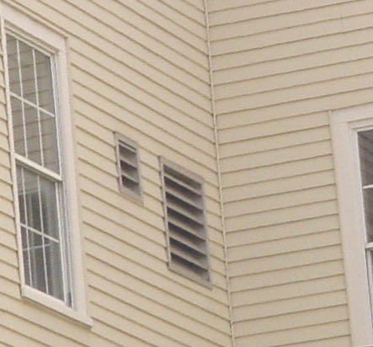

Fresh Air Intake for 2nd Floor AHU

Picture 2

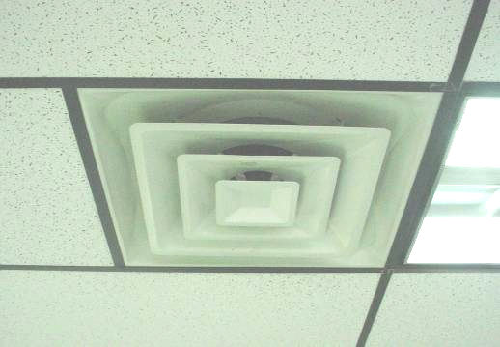

Ceiling-Mounted Supply Diffuser

Picture 3

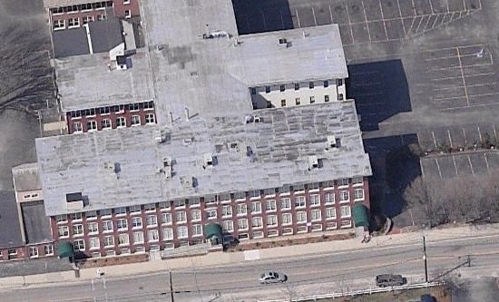
AHUs

Aerial View of 67 Mechanic Street, Arrows Indicate Location
of Air Handling Units/Intakes for DSS 3rd Floor

Picture 4

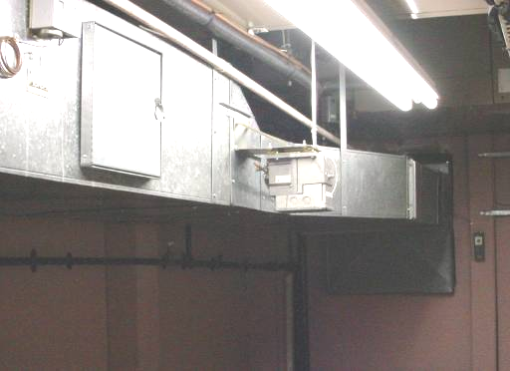

AHU in 2nd Floor Mechanical Room
Picture 5

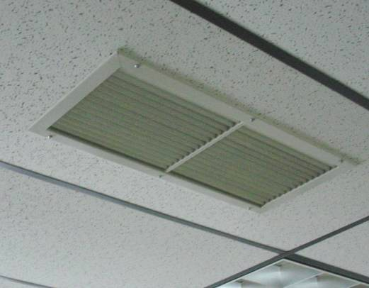

Ceiling-Mounted Return Vent

Picture 6

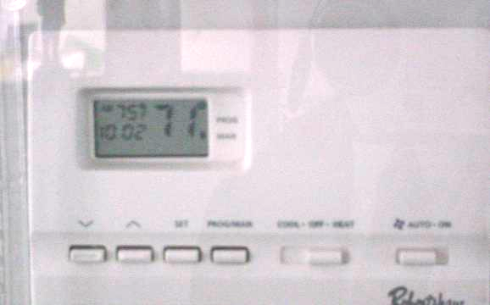

Digital Thermostat, Note Fan in “Auto” Setting
Picture 7

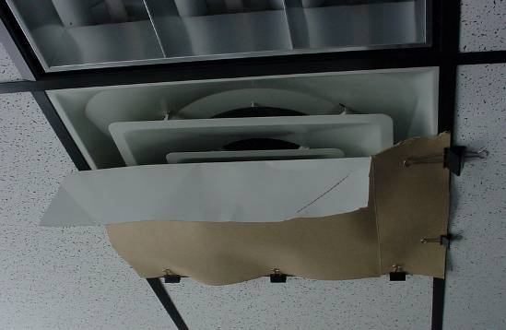

Air Diffuser Partially Obstructed by Cardboard

Picture 8

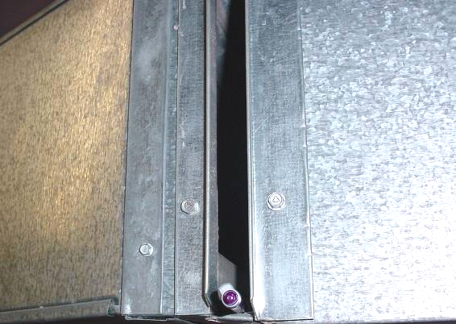

Breach in Ductwork in 2nd Floor Mechanical Room, Pen Inserted by BEH Staff
Picture 9

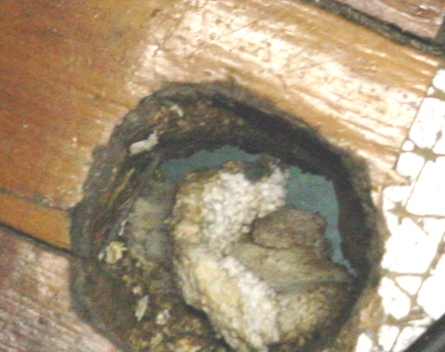

Hole in Floor of 2nd Floor Mechanical

Picture 10

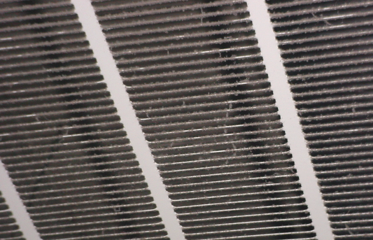

Dust/Debris Accumulated on Return Grate
Location/ Room | Occupants  in Room | Temp  (°F) | Relative  Humidity  (%) | Carbon  Dioxide  (ppm) | Windows  Openable | Ventilation |  | Remarks
 |  |  |  |  |  | Supply | Exhaust
Background |  | 53 | 50 | 383 |  |  |  | Cloudy, cool
3rd Floor
Andre’s Office | 0 | 70 | 34 | 749 | Y | Y | Y | DO
Brennan’s Unit | 5 | 71 | 33 | 858 | N | Y | Y
On-going Unit B | 4 | 72 | 32 | 866 | Y | Y | Y
On-going Unit F | 4 | 73 | 32 | 893 | N | Y | Y | Thermostat Fan “auto”
JRI Service Coordinator | 3 | 74 | 28 | 831 | N | Y | Y
Diaz Office | 0 | 74 | 28 | 830 | Y | Y | Y | DO
Jackson Office | 1 | 73 | 29 | 890 | Y | Y | Y | DO
Adolescent Unit | 3 | 74 | 29 | 921 | Y | Y | Y | Air supply diffuser obstructed by cardboard
Whalen Unit | 2 | 73 | 29 | 921 | N | Y | Y | Thermostat Fan “auto”
Family Resource | 2 | 73 | 28 | 862 | Y | Y | Y
Adoption Unit | 1 | 73 | 28 | 855 | Y | Y | Y | Window open
Teaming Unit | 3 | 74 | 26 | 803 | Y | Y | Y
Rusty’s Unit | 1 | 75 | 26 | 831 | Y | Y | Y
Family Group Conf | 4 | 73 | 27 | 968 | N | Y | Y | Thermostat Fan “auto”, dusty return vent
File Room | 0 | 73 | 27 | 820 | N | Y | Y
Meeting Room | 0 | 73 | 27 | 876 | Y | Y | Y
2nd Floor
Reception | 1 | 74 | 29 | 881 | Y | Y | Y | Window open
Artie’s Unit | 4 | 74 | 28 | 899 | Y | Y | Y
Anna’s Unit | 0 | 74 | 27 | 841 | Y | Y | Y | DO
Screening Unit | 2 | 74 | 27 | 712 | Y | Y | Y | Window open
Evelyn’s Unit | 2 | 74 | 28 | 734 | Y | Y | Y
Linda’s Unit | 0 | 74 | 26 | 743 | Y | Y | Y
Debbie’s Unit | 0 | 73 | 27 | 793 | Y | Y | Y
Lawyer’s Unit | 1 | 74 | 27 | 759 | Y | Y | Y
Mechanical Room | 0 | 76 | 26 | 783 | N | N | N | Breach in ductwork, hole in floor
File Room | 0 | 76 | 26 | 814 | N | Y | Y
Conference Room | 0 | 75 | 25 | 829 | Y | Y | Y | DO

