Mold/Water Damage Investigation

Massachusetts Department of Social Services
Coastal Area Office
541 Main Street
South Weymouth, Massachusetts

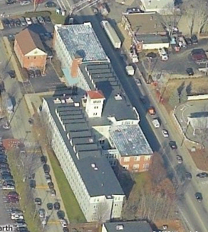

Prepared by:
Massachusetts Department of Public Health
Bureau of Environmental Health
Indoor Air Quality Program
June 2008

Background/Introduction
On February 19, 2008, the Massachusetts Department of Public Health (MDPH) Bureau of Environmental Health (BEH) provided assistance and consultation regarding indoor air quality concerns at the Department of Social Services (DSS) Coastal Area Office, located at 541 Main Street, Weymouth, Massachusetts. The request was prompted by concerns of potential microbial growth due to water-damaged materials on several floors of the DSS facility. The assessment was conducted by Cory Holmes, a Regional Indoor Air Quality Inspector within BEH’s Indoor Air Quality (IAQ) Program. Mr. Holmes was accompanied by J. Madigan, DSS Area Manager and Kevin Carroll, DSS Business Manager, for portions of the assessment.
The DSS occupies the second floor and portions of the third floor of the Stetson Building. The building was constructed in the early-1900s as a shoe factory and subsequently renovated to house office space for a number of businesses. The DSS space consists of offices, open work areas and conference rooms. Windows are openable throughout the building.

Methods
MDPH staff performed a visual inspection of building materials for water damage and/or microbial growth. Moisture content of porous building materials was measured with a Delmhorst, BD-2000 Model, Moisture Detector equipped with a Delmhorst Standard Probe. Temperature and relative humidity were taken with the TSI, Q-Trak, IAQ Monitor. Air tests for airborne particle matter with a diameter less than 2.5 micrometers were taken with the TSI, DUSTTRAK™ Aerosol Monitor Model 8520. Screening for total volatile organic compounds (TVOCs) was conducted using a Thermo Environmental Instruments Inc., Model 580 Series Photo Ionization Detector (PID).

Results
The DSS Coastal Area Office has a staff of approximately 90 and can be visited by up to 50 visitors on a daily basis. At the time of testing, DSS staff whose office areas were located in water damaged areas had been temporarily relocated. Test results appear in Table 1.

Discussion
Microbial/Moisture Concerns
As previously mentioned, the assessment was prompted by concerns over water damage that occurred in DSS space (located on the second and third floors) from a sprinkler release on the fourth floor. Damaged building materials primarily included gypsum wallboard (GW) walls and carpeting. Water-damaged materials appeared to be isolated to portions of the building directly below the sprinkler release.
According to DSS officials the building management responded immediately by contacting a professional flood restoration firm and were reportedly on-scene within hours of the incident. Remediation included removal of sections of GW and vinyl baseboard coving to help dry GW and vent wall cavities (Pictures 1 to 3). In addition, staff were temporarily relocated and a moving company was hired to pack and remove all furniture and personal items in order to conduct drying and cleaning of carpeting.
In order for building materials to support mold growth, a source of water exposure is necessary. Identification and elimination of the source of water and moistened building materials is necessary to control mold growth. In this case, the source of water damage (i.e., the sprinkler release) had been repaired. Materials with increased moisture content over normal concentrations may indicate the possible presence of mold growth. All porous materials tested during the assessment were found to have low (i.e., normal) moisture content (Table 1), indicating that the drying of materials was successful. Please note that moisture content of materials measured is a real-time measurement of the conditions present at the time of the assessment.
BEH staff observed small sections of visible mold growth on the surface of GW in two areas (Michaelle’s office and the third floor hallway) (Pictures 4 and 5). These two areas were pointed out to Mr. Carroll with a recommendation to have the building’s contractor remove these sections of GW. At the time of the assessment, a few areas were still undergoing remediation and were sealed off from occupied areas via plastic polyethylene sheeting (Picture 6).
The US Environmental Protection Agency (US EPA) and the American Conference of Governmental Industrial Hygienists (ACGIH) recommends that porous materials be dried with fans and heating within 24 to 48 hours of becoming wet (US EPA, 2001; ACGIH, 1989). If porous materials are not dried within this time frame, mold growth may occur. Cleaning cannot adequately remove mold growth from water-damaged porous materials. The application of a mildewcide to mold contaminated, porous materials is not recommended.

Temperature and Relative Humidity
Temperature readings ranged from 67º F to 72º F, which were within or slightly below the lower end of the MDPH recommended comfort guidelines in areas surveyed during the assessment. The MDPH recommends that indoor air temperatures be maintained in a range of 70º F to 78º F in order to provide for the comfort of building occupants. Temperature control and poor airflow complaints were expressed in several areas. In many cases concerning indoor air quality, fluctuations of temperature in occupied spaces are typically experienced, even in a building with an adequate fresh air supply.
The relative humidity measured in the building ranged from 25 to 30 percent, which was below the MDPH recommended comfort range the day of the assessment. Relative humidity levels in the building would be expected to drop during the winter months due to heating. The sensation of dryness and irritation is common in a low relative humidity environment. Low relative humidity is common during the heating season in the northeast part of the United States. In addition, these low relative humidity levels (as compared to outdoors 51%) reflect that drying measures taken within the DSS were successful.

Particulate Matter (PM2.5)
Concerns were also raised about airborne dust and potential exposure to particulates related to remediation work. The US EPA has established NAAQS limits for exposure to particulate matter. Particulate matter is airborne solids that can be irritating to the eyes, nose and throat. The NAAQS originally established exposure limits to particulate matter with a diameter of 10 μm or less (PM10). According to the NAAQS, PM10 levels should not exceed 150 microgram per cubic meter (μg/m³) in a 24-hour average (US EPA, 2006). These standards were adopted by both ASHRAE and BOCA. Since the issuance of the ASHRAE standard and BOCA Code, US EPA proposed a more protective standard for fine airborne particles. This more stringent PM2.5 standard requires outdoor air particle levels be maintained below 35 μg/m³ over a 24-hour average (US EPA, 2006). Although both the ASHRAE standard and BOCA Code adopted the PM10 standard for evaluating air quality, MDPH uses the PM2.5 standard for evaluating airborne particulate matter concentrations in the indoor environment to be more conservative.
Outdoor PM2.5 concentrations at the time of the assessment were measured at 13 μg/m³ (Table 1). PM2.5 levels within the DSS ranged from 8 to 19 μg/m³. Indoor and outdoor PM2.5 levels were below the NAAQS of 35 μg/m³ (Table 1). Frequently, indoor air levels of particulates can be at higher levels than those measured outdoors. A number of mechanical devices and/or activities that occur indoors can generate particulates during normal operation. Sources of indoor airborne particulate may include but are not limited to particles generated during the operation of fan belts in the HVAC system, cooking and microwave ovens; use of photocopiers, fax machines and computer printing devices, operating an ordinary vacuum cleaner and heavy foot traffic indoors. While some dust/debris was observed on carpeting and flat surfaces in a few areas, these particles are of a large size and are not likely to become airborne (Pictures 7 and 8).

Volatile Organic Compounds (VOCs)
Indoor air quality can also be impacted by the presence of materials containing volatile organic compounds (VOCs). VOCs are substances that have the ability to evaporate at room temperature. Frequently, exposure to low levels of total VOCs (TVOCs) may produce eye, nose, throat and/or respiratory irritation in some sensitive individuals. For example, chemicals evaporating from a paint can stored at room temperature would most likely contain VOCs. In an effort to determine whether VOCs were present in the building, air monitoring for TVOCs was conducted. Outdoor air samples were taken for comparison. Outdoor TVOC concentrations were non-detect or ND (Table 1). Indoor TVOC measurements in areas surveyed were also ND. Please note, TVOC air measurements are only reflective of the indoor air concentrations present at the time of sampling.

Conclusions/Recommendations
It appears that attempts to repair the source of leaks and the drying of water-damaged materials were successful. In addition, we are including additional MDPH guidance on mold (Appendix A) and renovations (Appendix B). The MDPH has prepared these guidance documents in order to reduce or minimize exposure to mold in buildings and to prevent/reduce the migration of renovation-generated pollutants into occupied areas respectively. The MDPH suggests that the following steps be taken on any renovation project within a public building.
In view of the findings at the time of assessment, the following recommendations are made:
- Continue with plans to complete remediation. Remove sections of GW in 3rd floor hallway and Michaelle’s office with visible mold growth (Pictures 4 and 5). This work should be done while these areas are unoccupied.
- Once work is completed, clean any dust and particulates generated by renovation using a high efficiency particulate air filter (HEPA) equipped vacuum cleaner in conjunction with wet wiping.
- If odorous materials (e.g., adhesives) are used during the reinstallation of vinyl baseboard coving this work should be done during unoccupied periods with sufficient curing time to prevent odor complaints.
- For more information on mold consult “Mold Remediation in Schools and Commercial Buildings” published by the US Environmental Protection Agency (US EPA, 2001). This document can be downloaded from the US EPA website at: http://www.epa.gov/iaq/molds/mold_remediation.html.
- Refer to resource manuals and other related indoor air quality documents for further building-wide evaluations and advice on maintaining public buildings. These materials are located on the MDPH’s website at http://mass.gov/dph/indoor_air.

References
ACGIH. 1989. Guidelines for the Assessment of Bioaerosols in the Indoor Environment. American Conference of Governmental Industrial Hygienists, Cincinnati, OH.
US EPA. 2001. “Mold Remediation in Schools and Commercial Buildings”. Office of Air and Radiation, Indoor Environments Division, Washington, DC. EPA 402-K-01-001. March 2001. Available at: http://www.epa.gov/iaq/molds/mold_remediation.html
US EPA. 2006. National Ambient Air Quality Standards (NAAQS). US Environmental Protection Agency, Office of Air Quality Planning and Standards, Washington, DC. http://www.epa.gov/air/criteria.html.

Picture 1

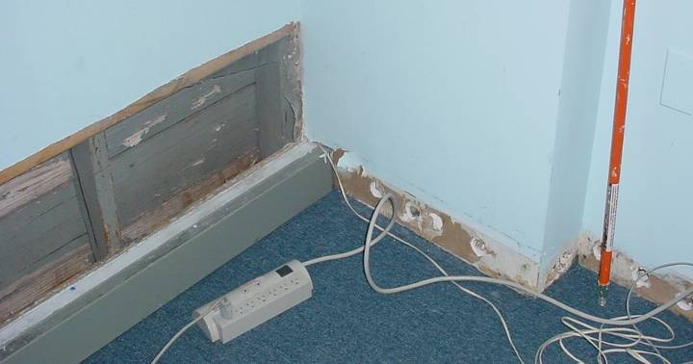

Vinyl Baseboard Coving Removed/Sections of Gypsum Wallboard (GW) Removed and Holes cut into GW (arrows) to Facilitate Drying of Wall Cavities

Picture 2

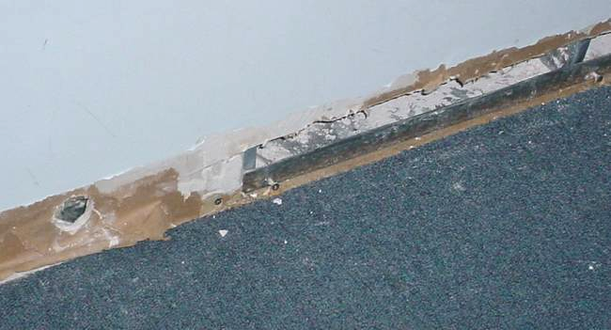

Vinyl Baseboard Coving Removed/Sections of Gypsum Wallboard (GW) Removed and Holes cut into GW to Facilitate Drying of Wall Cavities

Picture 3

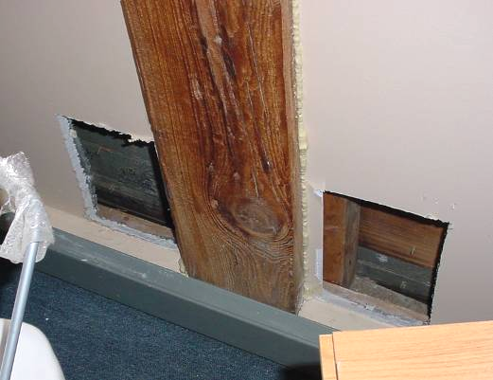

Sections of Gypsum Wallboard (GW) Removed to Facilitate Drying of Wall Cavities

Picture 4

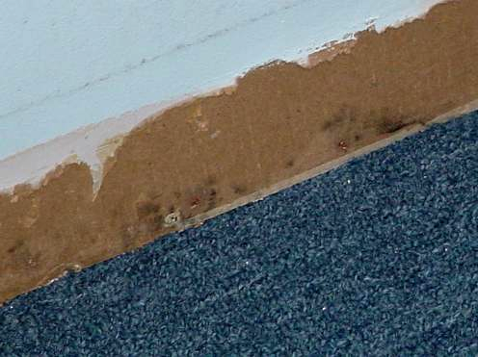

Visible Mold on Surface of GW (as Indicated by Dark Spots) in Office
Picture 5

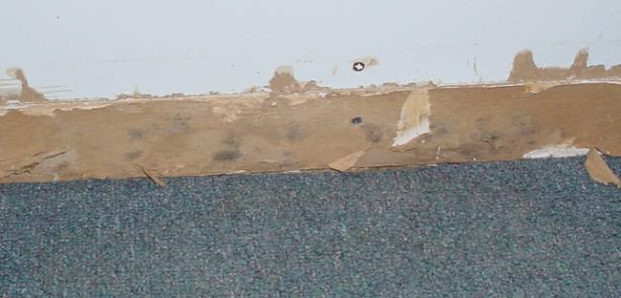

Visible Mold on Surface of GW (as Indicated by Dark Spots) in 3rd Floor Hallway

Picture 6

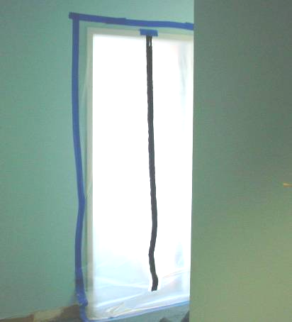

Remediation Area Sealed With Plastic Polyethylene Sheeting
Picture 7

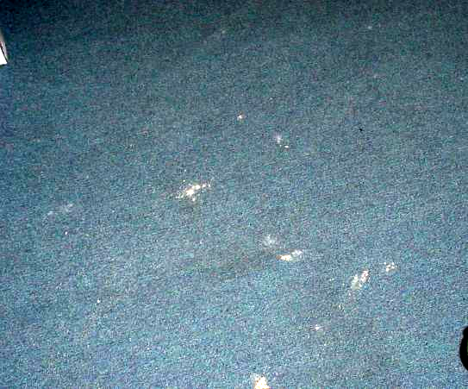

Dirt, Dust and Debris on Carpet

Picture 8

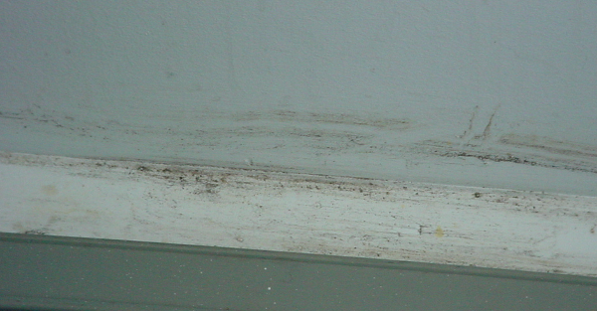

Dirt, Dust and Debris on Wall/Base in Office

Location | TVOCs  (ppm) | PM2.5  (µg/m3) | Temp  (°F) | Relative  Humidity  (%) | Remarks
Outside  (Background) | ND | 13 | 48 | 51 | Partly cloudy, winds: WSW 20-33 mph
3rd Floor  Rear hallway near stairs | ND | 10 | 69 | 31 | Sections of GW/vinyl coving removed, holes in base of GW for drying, GW/carpet-low (i.e., normal) moisture measurements, remediation area-sealed with plastic poly and tape, small area of “light” mold growth on surface of GW near floor-recommended removal, slight odor of carpet cleaner
David/Alyson | ND | 9 | 68 | 29 | GW/carpet-low (i.e., normal) moisture measurements
Family Network | ND | 9 | 68 | 30 | GW/carpet-low (i.e., normal) moisture measurements
Jackie’s Office | ND | 8 | 67 | 27 | GW/carpet-low (i.e., normal) moisture measurements
Unit E | ND | 10 | 68 | 29 | GW/carpet-low (i.e., normal) moisture measurements
Hallway Center | ND | 10 | 70 | 27 | GW/carpet-low (i.e., normal) moisture measurements
Record Room | ND | 10 | 70 | 26 | GW/carpet-low (i.e., normal) moisture measurements, holes in base of GW for drying
Michaelle’s Office | ND | 12 | 70 | 26 | Small area of “light” mold growth on surface of GW (behind desk/near floor)-recommended removal
Ann Marie | ND | 13 | 70 | 25 | GW/carpet-low (i.e., normal) moisture measurements
2nd Floor  Hallway near stairs | ND | 18 | 70 | 28 | GW/carpet-low (i.e., normal) moisture measurements
Goodwin Unit | ND | 9 | 72 | 30 | GW/carpet-low (i.e., normal) moisture measurements
Madigan Office | ND | 18 | 72 | 30 | GW/carpet-low (i.e., normal) moisture measurements
Mary Ellen’s Office | ND | 17 | 72 | 30 | GW/carpet-low (i.e., normal) moisture measurements
Personnel | ND | 11 | 72 | 28 | GW/carpet-low (i.e., normal) moisture measurements
Burke’s Office | ND | 12 | 71 | 26 | GW/carpet-low (i.e., normal) moisture measurements
Maryann’s Office | ND | 16 | 71 | 25 | GW/carpet-low (i.e., normal) moisture measurements
Samantha’s Office | ND | 19 | 71 | 27 | GW/carpet-low (i.e., normal) moisture measurements

