INDOOR AIR QUALITY ASSESSMENT

Department of Transitional Assistance
131 Davidson Street
Lowell, Massachusetts

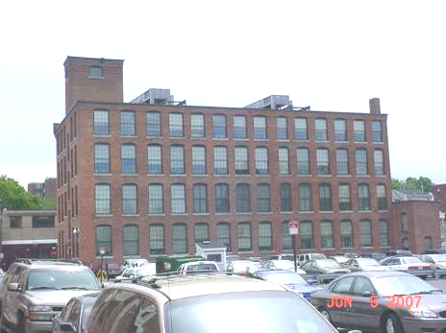

Prepared by:
Massachusetts Department of Public Health
Bureau of Environmental Health
Emergency Response/Indoor Air Quality Program
August 2007

Background/Introduction
In response to a request from Doug Shatkin, Human Resources Director, Office of Children, Youth & Families, Executive Office of Health and Human Resources (EOHHS) and Dan O’Connor, DTA Area Director, the Massachusetts Department of Public Health (MDPH), Bureau of Environmental Health (BEH), provided assistance and consultation regarding indoor air quality concerns at the Massachusetts Department of Transitional Assistance (DTA) located at 131 Davidson Street, Lowell, Massachusetts. The request was prompted by occupant concerns of poor indoor air quality (IAQ) and potential airborne dust created by exposed brick in the building. At the time of the assessment Mr. O’Connor also reported that several employees had voiced concern regarding potential exposure to airborne pollutants in relation to an excavation/soil remediation project behind the building. The project is under the direction of the Massachusetts Department of Environmental Protection and the City of Lowell.
On June 6, 2007, an indoor air quality assessment was conducted at the DTA by Cory Holmes, an Environmental Analyst in BEH’s Emergency Response/Indoor Air Quality (ER/IAQ) Program. Mr. Holmes was accompanied for portions of the assessment by Mr. O’Connor.
The DTA offices are located on the 1st, 2nd and 4th floors of a four-story red brick building (with basement) that was originally constructed as a factory/warehouse in the early 1900s. The building has undergone several interior renovations over the years, most recently in 1996 prior to occupancy by the DTA. The DTA space consists of offices, open work areas and conference rooms. Windows are not openable in the building.
The basement of the building has reportedly flooded twice over the last few years due to record rainfall in the New England area as well as its close proximity to the Merrimac River. Most recently flooding of the basement occurred in April 2007. It was reported that the landlord hired Service Pro, a professional flooding/restoration firm, to dry and disinfect effected areas. This work was completed at the time of the assessment. The basement is unoccupied and is not utilized by DTA staff.

Methods
Tests for carbon monoxide, carbon dioxide, temperature and relative humidity were conducted with a TSI, Q-Trak, IAQ Monitor, Model 8551. Screening for total volatile organic compounds (TVOCs) was conducted using a HNu, Model 102 Snap-on Photo Ionization Detector (PID). Air tests for airborne particle matter with a diameter less than 2.5 micrometers (PM2.5) were taken with the TSI, DUSTTRAK™ Aerosol Monitor Model 8520. BEH staff also performed visual inspection of building materials for water damage and/or microbial growth.

Results
The DTA has an employee population of approximately 50 and is visited by up to 60 individuals daily. Tests were taken during normal operations. Results appear in Table 1.

Discussion
Ventilation
It can be seen from Table 1 that carbon dioxide levels were below 800 parts per million (ppm) in all areas surveyed, indicating adequate air exchange during the assessment. Mechanical ventilation is provided by rooftop air-handling units (AHUs) (Picture 1) equipped with pleated air filters (Picture 2). Fresh air is drawn into the AHUs and delivered to occupied areas via ceiling-mounted air diffusers (Picture 3) and drawn into ceiling-mounted return vents via ductwork to AHUs (Picture 3).
To maximize air exchange, the MDPH recommends that both supply and exhaust ventilation operate continuously during periods of occupancy. In order to have proper ventilation with a mechanical supply and exhaust system, the systems must be balanced to provide an adequate amount of fresh air to the interior of a room while removing stale air from the room. It is recommended that HVAC systems be re-balanced every five years to ensure adequate air systems function (SMACNA, 1994). The date of the last balancing was not available at the time of the assessment.
The Massachusetts Building Code requires a minimum ventilation rate of 20 cubic feet per minute (cfm) per occupant of fresh outside air or have openable windows in each room (SBBRS, 1997; BOCA, 1993). The ventilation must be on at all times that the room is occupied. Providing adequate fresh air ventilation with open windows and maintaining the temperature in the comfort range during the cold weather season is impractical. Mechanical ventilation is usually required to provide adequate fresh air ventilation.
Carbon dioxide is not a problem in and of itself. It is used as an indicator of the adequacy of the fresh air ventilation. As carbon dioxide levels rise, it indicates that the ventilating system is malfunctioning or the design occupancy of the room is being exceeded. When this happens, a buildup of common indoor air pollutants can occur, leading to discomfort or health complaints. The Occupational Safety and Health Administration (OSHA) standard for carbon dioxide is 5,000 parts per million parts of air (ppm). Workers may be exposed to this level for 40 hours/week, based on a time-weighted average (OSHA, 1997).
The MDPH uses a guideline of 800 ppm for publicly occupied buildings. A guideline of 600 ppm or less is preferred in schools due to the fact that the majority of occupants are young and considered to be a more sensitive population in the evaluation of environmental health status. Inadequate ventilation and/or elevated temperatures are major causes of complaints such as respiratory, eye, nose and throat irritation, lethargy and headaches. For more information concerning carbon dioxide, please see Appendix A.
Temperature readings ranged from 72º F to 74 º F, which were within the MDPH recommended comfort guidelines in all areas surveyed during the assessment. The MDPH recommends that indoor air temperatures be maintained in a range of 70 º F to 78 º F in order to provide for the comfort of building occupants. In many cases concerning indoor air quality, fluctuations of temperature in occupied spaces are typically experienced, even in a building with an adequate fresh air supply.
The relative humidity measured in the building ranged from 35 to 37 percent, which was close to the lower end of the MDPH recommended comfort range the day of the assessment. The MDPH recommends a comfort range of 40 to 60 percent for indoor air relative humidity. Relative humidity levels in the building would be expected to drop during the winter months due to heating. The sensation of dryness and irritation is common in a low relative humidity environment. Low relative humidity is a very common problem during the heating season in the northeast part of the United States.

Microbial/Moisture Concerns
As mentioned previously, the basement has flooded over the past few years, most recently in April 2007. At the time of the assessment remediation of the basement was complete; the basement was dry, water-damaged gypsum wallboard had been removed and dehumidifiers that drain directly into sinks had been installed (Pictures 4 and 5).
Plants were observed in several areas. In one case plants were placed on top of a section of carpeting, which is a porous material that can absorb moisture (Picture 6). Plants should be properly maintained and equipped with drip pans. Plants should be located away from ventilation sources to prevent aerosolization of dirt, pollen or mold. Plants should not be placed on porous materials, since water damage to porous materials may lead to microbial growth.
Water coolers and fountains were observed over carpeting (Pictures 7 and 8). Water spillage or overflow of cooler catch basins can result in the wetting of the carpet. In addition, some of the coolers had residue/build-up in the reservoir. These reservoirs are designed to catch excess water during operation and should be emptied/cleaned regularly to prevent microbial and/or bacterial growth.
One water stained ceiling tile was observed on the 4th floor. Mr. O’Conner indicated that the tile had become stained due to a leak that has been repaired. Water-damaged ceiling tiles can provide a source of mold and should be replaced after a leak is discovered and repaired.

Other IAQ Evaluations
As mentioned previously, concerns were raised by occupants about airborne dust from interior brick walls and potential exposure to particulates and fumes from excavation/soil remediation activity outside the facility. Indoor air quality can be negatively influenced by the presence of respiratory irritants, such as products of combustion (from construction vehicles). The process of combustion produces a number of pollutants. Common combustion emissions include carbon monoxide, carbon dioxide, water vapor and smoke (fine airborne particle material). Of these materials, exposure to carbon monoxide and particulate matter with a diameter of 2.5 μm or less (PM2.5) can produce immediate, acute health effects upon exposure. It is important to note that exposure to airborne particulates and products of combustion is unlikely due to the following conditions;
- Windows at the DTA are sealed shut, which prevents both air and pollutants from entering directly into the building.
- The location of AHU fresh air intakes on the roof (i.e., four-stories) would make entrainment of airborne materials generated from the excavation site unlikely (Figures 1 & 2).
- The AHUs are in the center of the roof outside of a direct pathway to the excavation project approximately 100-feet away (Figures 1 & 2).
The combination of distance, building configuration, and efficient AHU filters would be expected to limit the possibility of airborne pollutants generated by the excavation project to be entrained by the HVAC system. However, to determine whether combustion products, airborne particulate matter and/or volatile organic compounds (VOCs) were present within the DTA space, BEH staff conducted measurements for carbon monoxide, PM2.5 and total volatile organic compounds (TVOCs).

Carbon Monoxide
Carbon monoxide is a by-product of incomplete combustion of organic matter (e.g., gasoline, wood and tobacco). Exposure to carbon monoxide can produce immediate and acute health affects. Several air quality standards have been established to address carbon monoxide and prevent symptoms from exposure to these substances. The MDPH established a corrective action level concerning carbon monoxide in ice skating rinks that use fossil-fueled ice resurfacing equipment. If an operator of an indoor ice rink measures a carbon monoxide level over 30 ppm, taken 20 minutes after resurfacing within a rink, that operator must take actions to reduce carbon monoxide levels (MDPH, 1997).
The American Society of Heating Refrigeration and Air-Conditioning Engineers (ASHRAE) has adopted the National Ambient Air Quality Standards (NAAQS) as one set of criteria for assessing indoor air quality and monitoring of fresh air introduced by HVAC systems (ASHRAE, 1989). The NAAQS are standards established by the US EPA to protect the public health from six criteria pollutants, including carbon monoxide and particulate matter (US EPA, 2006). As recommended by ASHRAE, pollutant levels of fresh air introduced to a building should not exceed the NAAQS levels (ASHRAE, 1989). The NAAQS were adopted by reference in the Building Officials & Code Administrators (BOCA) National Mechanical Code of 1993 (BOCA, 1993), which is now an HVAC standard included in the Massachusetts State Building Code (SBBRS, 1997). According to the NAAQS, carbon monoxide levels in outdoor air should not exceed 9 ppm in an eight-hour average (US EPA, 2006).
Carbon monoxide should not be present in a typical, indoor environment. If it is present, indoor carbon monoxide levels should be less than or equal to outdoor levels. Outdoor carbon monoxide concentrations the day of the assessment were non-detect (ND) (Table 1). Carbon monoxide levels measured throughout the DTA were also ND (Table 1).

Particulate Matter (PM2.5)
The US EPA has established NAAQS limits for exposure to particulate matter. Particulate matter is airborne solids that can be irritating to the eyes, nose and throat. The NAAQS originally established exposure limits to particulate matter with a diameter of 10 μm or less (PM10). According to the NAAQS, PM10 levels should not exceed 150 microgram per cubic meter (μg/m³) in a 24-hour average (US EPA, 2006). These standards were adopted by both ASHRAE and BOCA. Since the issuance of the ASHRAE standard and BOCA Code, US EPA proposed a more protective standard for fine airborne particles. This more stringent PM2.5 standard requires outdoor air particle levels be maintained below 35 μg/m³ over a 24-hour average (US EPA, 2006). Although both the ASHRAE standard and BOCA Code adopted the PM10 standard for evaluating air quality, MDPH uses the PM2.5 standard for evaluating airborne particulate matter concentrations in the indoor environment to be more conservative.
Outdoor PM2.5 concentrations at the time of the assessment were measured at 5 μg/m³ (Table 1). PM2.5 levels within the DTA ranged from 1 to 5 μg/m³, which were below the NAAQS of 35 μg/m³ (Table 1). Frequently, indoor air levels of particulates can be at higher levels than those measured outdoors. A number of mechanical devices and/or activities that occur indoors can generate particulates during normal operation. Sources of indoor airborne particulate may include but are not limited to particles generated during the operation of fan belts in the HVAC system, cooking and microwave ovens; use of photocopiers, fax machines and computer printing devices, operating an ordinary vacuum cleaner and heavy foot traffic indoors. While some brick dust was observed on windowsills in a few areas, these particles are of a large size and are not likely to become airborne (Picture 11).

TVOCs
Indoor air quality can also be negatively influenced by the presence of materials containing volatile organic compounds (VOCs). VOCs are carbon-containing substances that have the ability to evaporate at room temperature. Frequently, exposure to low levels of total VOCs (TVOCs) may produce eye, nose, throat and/or respiratory irritation in some sensitive individuals. Typical sources of VOCs from indoor sources include photocopiers, cleaners, health care/beauty products, dry erase materials, permanent markers, combustion sources, fabrics/textiles and paints.
In an effort to determine whether VOCs were present in the building, air monitoring for TVOCs was conducted. Outdoor TVOC concentrations at the time of the assessment were ND (Table 1). Indoor TVOC concentrations were also ND (Table 1). Please note, TVOC air measurements are only reflective of the indoor air concentrations present at the time of sampling.
Indoor air concentrations can be greatly impacted by the use of TVOC-containing products. While no measurable TVOC levels were detected in the indoor environment, VOC-containing materials were noted including office cleaners and spray pesticides (Pictures 12 and 13). These materials contain several VOCs (e.g., isopropyl alcohol and monoethanolamine) that can be irritating to the eyes, nose and throat (3M, 2000). Pesticide applicators should be in full compliance with the federal and state rules and regulations that govern pesticide use including posting and notification requirements (333 CMR 13.10). Under no circumstances should untrained personnel apply this material. This product should not be applied prior or during business hours. Under current Massachusetts law (effective November 1, 2001), the principles of integrated pest management (IPM) must be used to remove pests in state buildings (Mass Act, 2000). Pesticide use indoors can introduce chemicals into the indoor environment that can be sources of eye, nose and throat irritation.
Several conditions that can potentially affect indoor air quality were also identified. The amount of materials stored inside some offices and common areas should be noted. In several areas items were observed on windowsills, tabletops, counters, desks and other flat surfaces. The large number of items stored provides a source for dusts to accumulate. These items, (e.g., papers, folders, boxes) make it difficult for custodial staff to clean. Dust can be irritating to eyes, nose and respiratory tract. Items should be relocated and/or be cleaned periodically to avoid excessive dust build up.
Finally, exposed fiberglass insulation was observed in area 213/214 (Picture 14). Fiberglass insulation can provide a source of skin, eye and respiratory irritation.

Conclusions/Recommendations
Based on air sampling for TVOCs, CO and PM2.5 at the time of the assessment, it does not appear that the indoor environment at the DTA office space was impacted by pollutants generated from the excavation/remediation project. For more information regarding the excavation/soil remediation project contact the MDEP at 617-292-5500 or visit their website at http://db.state.ma.us/dep/cleanup/sites/Site_Info.asp?textfield_RTN=3-0021465
In view of these findings at the time of the visit, the following recommendations are made to improve indoor air quality:
- Consider balancing mechanical ventilation systems every 5 years, as recommended by ventilation industrial standards (SMACNA, 1994).
- For buildings in New England, periods of low relative humidity during the winter are often unavoidable. Therefore, scrupulous cleaning practices should be adopted to minimize common indoor air contaminants whose irritant effects can be enhanced when the relative humidity is low. To control for dusts, a high efficiency particulate arrestance (HEPA) filter equipped vacuum cleaner in conjunction with wet wiping of all surfaces is recommended. Avoid the use of feather dusters. Drinking water during the day can help ease some symptoms associated with a dry environment (throat and sinus irritations).
- Consider increasing cleaning of flat surfaces in close proximity to exposed brick.
- Ensure leak on 4th floor is repaired and replace any remaining water damaged ceiling tiles.
- Ensure all plants are equipped with drip pans. Examine drip pans for mold growth and disinfect areas of water leaks with an appropriate antimicrobial where necessary. Remove carpet from beneath plants (Picture 6).
- Relocate or place tile or rubber matting underneath water coolers and water fountains in carpeted areas. Clean and disinfect reservoirs as needed to prevent microbial growth.
- Relocate or consider reducing the amount of materials stored in offices and common areas to allow for more thorough cleaning. Clean items regularly with a wet cloth or sponge to prevent excessive dust build-up.
- Clean air diffusers, return and exhaust vents periodically of accumulated dust.
- Clean carpeting annually (or semi-annually in soiled high traffic areas) as per the recommendations of the Institute of Inspection, Cleaning and Restoration Certification (IICRC). Copies of the IICRC fact sheet can be downloaded at: http://www.cleancareseminars.com/carpet_cleaning_faq4.htm (IICRC, 2005)
- Discontinue the use of VOC-containing cleaners. Less irritating materials, (soap and water) may suffice to clean in these areas.
- Use the principles of integrated pest management (IPM) to rid the building of pests. A copy of the IPM recommendations can be downloaded from the Internet at http://www.state.ma.us/dfa/pesticides/publications/IPM_kit_for_bldg_mgrs.pdf.
- Seal insulation to prevent exposure to fiberglass (Picture 14).
- For further building-wide evaluations, advice on maintaining public buildings and other related indoor air quality documents, see the MDPH’s website at http://mass.gov/dph/indoor_air.

References
ACGIH. 1989. Guidelines for the Assessment of Bioaerosols in the Indoor Environment. American Conference of Governmental Industrial Hygienists, Cincinnati, OH.

ASHRAE. 1989. Ventilation for Acceptable Indoor Air Quality. American Society of Heating, Refrigeration and Air Conditioning Engineers. ANSI/ASHRAE 62-1989
BOCA. 1993. The BOCA National Mechanical Code/1993. 8th ed. Building Officials and Code Administrators International, Inc., Country Club Hill, IL. Section M-308.1.1.

IICRC. 2005. Carpet Cleaning FAQ 4 Institute of Inspection, Cleaning and Restoration Certification. Institute of Inspection Cleaning and Restoration, Vancouver, WA.

MDPH. 1997. Requirements to Maintain Air Quality in Indoor Skating Rinks (State Sanitary Code, Chapter XI). 105 CMR 675.000. Massachusetts Department of Public Health, Boston, MA.

OSHA. 1997. Limits for Air Contaminants. Occupational Safety and Health Administration. Code of Federal Regulations. 29 C.F.R 1910.1000 Table Z-1-A.

SBBRS. 1997. Mechanical Ventilation. State Board of Building Regulations and Standards. Code of Massachusetts Regulations. 780 CMR 1209.0

SMACNA. 1994. HVAC Systems Commissioning Manual. 1st ed. Sheet Metal and Air Conditioning Contractors’ National Association, Inc., Chantilly, VA.

US EPA. 2001. Mold Remediation in Schools and Commercial Buildings. US Environmental Protection Agency, Office of Air and Radiation, Indoor Environments Division, Washington, DC. EPA 402-K-01-001. March 2001.
US EPA. 2006. National Ambient Air Quality Standards (NAAQS). US Environmental Protection Agency, Office of Air Quality Planning and Standards, Washington, DC. http://www.epa.gov/air/criteria.html.
Picture 1

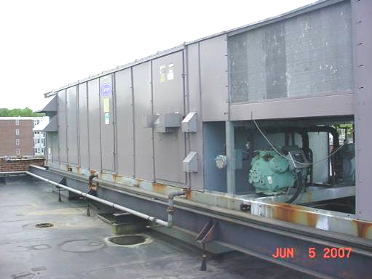

Rooftop AHU

Picture 2

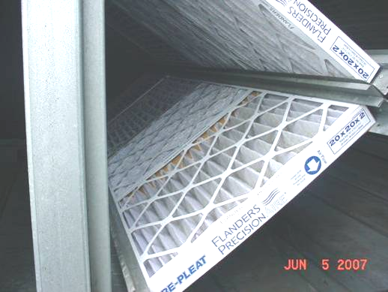

Pleated Air Filters in Rooftop AHUs

Picture 3

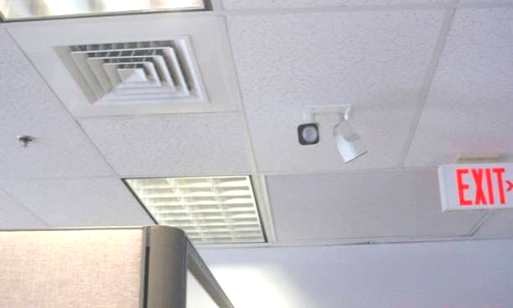

Supply Air Diffuser and Return Vent

Picture 4

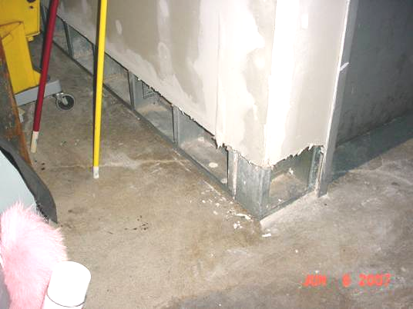

Section of Water Damaged GW Removed in Basement
Picture 5

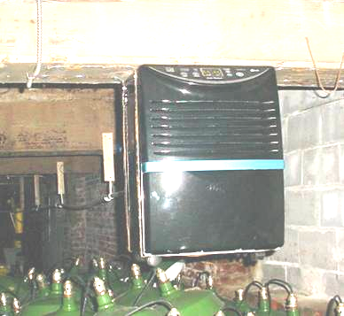

Dehumidifier Installed in Basement, Note Drain Pipe Connected at Rear

Picture 6

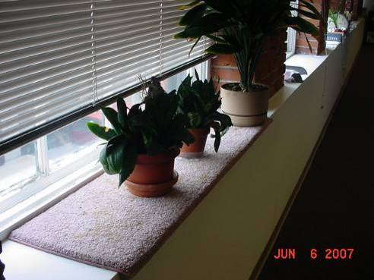

Plants Resting on Sections of Carpeting
Picture 7

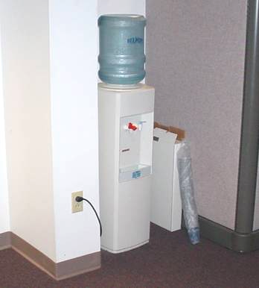

Water Cooler on Carpeting

Picture 8

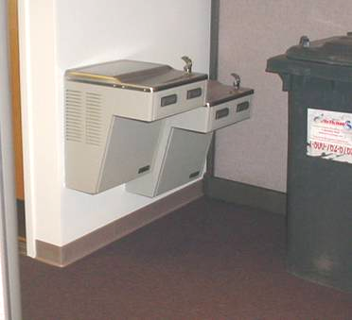

Water Fountain over Carpeting
Picture 9

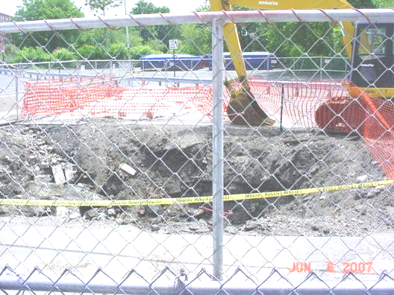

Excavation Site behind DTA

Picture 10

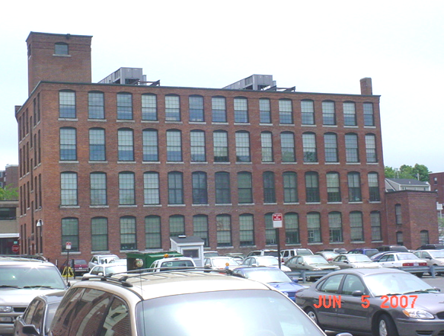
general area of excavation site

Location of Rooftop AHUs in Relation to Excavation Site
Picture 11

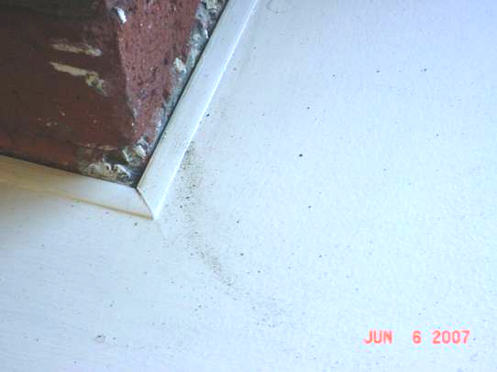

Brick Dust on Windowsill

Picture 12

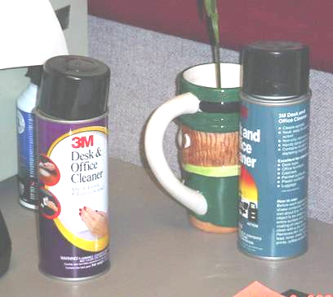

Spray Office Cleaners, Note Label Warning: May Cause Eye Irritation
Picture 13

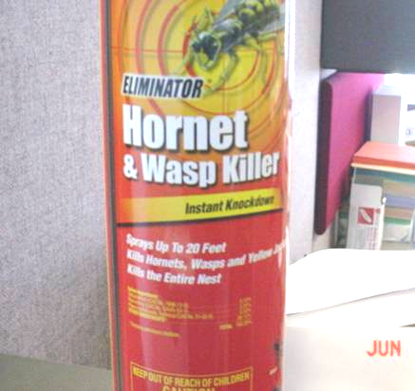

Spray Pesticide in Work Area

Picture 14

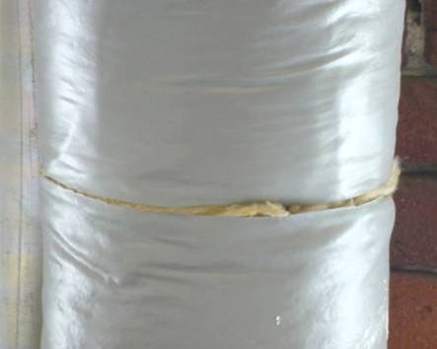

Exposed Fiberglass Insulation in Work Area
Location/ Room | Occupants  in Room | Temp  (°F) | Relative  Humidity  (%) | Carbon  Dioxide  (ppm) | Carbon Monoxide  (ppm) | TVOCs  (ppm) | PM2.5  (µg/m3) | Windows  Openable | Ventilation |  | Remarks
 |  |  |  |  |  |  |  |  | Supply | Exhaust | Remarks
background |  | 73 | 32 | 317 | ND | ND | 5
4th Floor
401 | 0 | 71 | 40 | 375 | ND | ND | 1 | N | Y | Y
404 | 0 | 70 | 39 | 385 | ND | ND | 1 | N | Y | Y | 1 CT
Lunch Room | 0 | 71 | 40 | 365 | ND | ND | 1 | N | Y | Y
DTA QC | 2 | 72 | 39 | 380 | ND | ND | 2 | N | Y | Y
2nd Floor
202/203 | 2 | 73 | 37 | 358 | ND | ND | 1 | N | Y | Y | Plants
236/237 | 2 | 73 | 36 | 358 | ND | ND | 1 | N | Y | Y
234/235 | 1 | 73 | 36 | 366 | ND | ND | 1 | N | Y | Y
232/233 | 0 | 73 | 37 | 365 | ND | ND | 1 | N | Y | Y
217 | 0 | 73 | 36 | 363 | ND | ND | 1 | N | Y | Y
213/214 | 1 | 73 | 36 | 386 | ND | ND | 1 | N | Y | Y | Exposed fiberglass
302/402 | 0 | 73 | 36 | 391 | ND | ND | 1 | N | Y | Y
201 | 0 | 73 | 36 | 364 | ND | ND | 1 | N | Y | Y
210/211 | 1 | 73 | 36 | 410 | ND | ND | 1 | N | Y | Y
207/208 | 0 | 72 | 36 | 380 | ND | ND | 1 | N | Y | Y
204/205 | 2 | 73 | 36 | 426 | ND | ND | 1 | N | Y | Y
202/203 | 1 | 72 | 35 | 374 | ND | ND | 1 | N | Y | Y
225 | 1 | 73 | 36 | 398 | ND | ND | 2 | N | Y | Y
223/228 | 4 | 73 | 36 | 392 | ND | ND | 1 | N | Y | Y
222/231 | 0 | 72 | 36 | 380 | ND | ND | 1 | N | Y | Y
1st Floor
Main Waiting Area | 12 | 72 | 37 | 423 | ND | ND | 5 | N | Y | Y
Reception | 3 | 73 | 37 | 448 | ND | ND | 1 | N | Y | Y
102 | 0 | 73 | 36 | 392 | ND | ND | 1 | N | Y | Y
114/115 | 0 | 73 | 36 | 411 | ND | ND | 1 | N | Y | Y
117/118 | 1 | 74 | 36 | 424 | ND | ND | 1 | N | Y | Y
119/120 | 1 | 73 | 35 | 415 | ND | ND | 1 | N | Y | Y | Plants
121/122 | 0 | 72 | 35 | 382 | ND | ND | 1 | N | Y | Y
128/129 | 0 | 72 | 35 | 388 | ND | ND | 1 | N | Y | Y
122/123 | 1 | 72 | 35 | 392 | ND | ND | 1 | N | Y | Y
124/125 | 0 | 71 | 36 | 399 | ND | ND | 1 | N | Y | Y
127/128 | 2 | 72 | 36 | 376 | ND | ND | 1 | N | Y | Y
130/131 | 4 | 71 | 36 | 398 | ND | ND | 1 | N | Y | Y
132/133 | 0 | 72 | 36 | 394 | ND | ND | 1 | N | Y | Y
105 | 1 | 72 | 37 | 401 | ND | ND | 1 | N | Y | Y
106 | 1 | 72 | 37 | 444 | ND | ND | 1 | N | Y | Y

Figure 1
Proximity of Rooftop HVAC Air Intake Vents to Excavation Site behind
DTA Lowell 131 Davidson Street

Rooftop AHUs/Fresh Air Intakes

~ 104 Feet

~ 40 Feet

Approximate Location of Excavation Site

~ 95 Feet
Figure 2

Proximity of Excavation Site behind DTA Offices at 131 Davidson Street

DTA Office Building on Left, Note 2 Rooftop AHUs (small arrows)
Dashed Line Indicates Approximate Proximity of Excavation Site at the Rear of the Building

