Background/Introduction

INDOOR AIR QUALITY ASSESSMENT

Massachusetts Department of Transitional Assistance
79 North Street
Southbridge, Massachusetts 01550

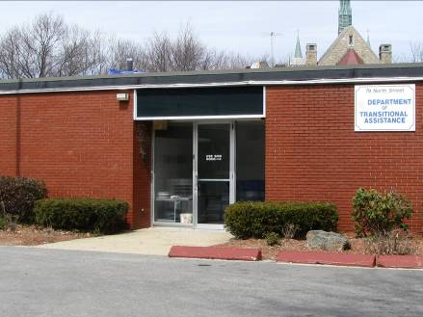

Prepared by:
Massachusetts Department of Public Health
Bureau of Environmental Health
Indoor Air Quality Program
July 2008

In response to a request from Doug Shatkin, Human Resources Director, Office of Children, Youth & Families, Executive Office of Health and Human Resources (EOHHS), the Massachusetts Department of Public Health (MDPH), Bureau of Environmental Health (BEH), provided assistance and consultation regarding indoor air quality concerns at the Massachusetts Department of Transitional Assistance (DTA), 79 North Street, Southbridge, Massachusetts. On March 27, 2008, a visit to conduct an indoor air quality assessment was made to the DTA by Lisa Hébert, an Indoor Air Quality (IAQ) Inspector in BEH’s IAQ Program. The assessment was prompted by concerns about water damaged materials and poor indoor air quality in the building.
The DTA offices are located in a complex of interconnected buildings; namely a one-story brick building built on a slab connected at the rear to a cinderblock building (Picture 1) by an interior ramped corridor. The contrasting building materials and varying roof lines indicate that some sections of the rear building were likely built at different times (Picture 2). The front (brick) building houses administrative personnel for the DTA. The DTA space consists of workstations, offices and common areas. The rear (cinderblock) building contains offices, cubicles and meeting rooms. The second floor of this building is used for storage by the DTA. The Massachusetts Department of Mental Retardation (DMR) also occupies the building.

Methods
Air tests for carbon dioxide, carbon monoxide, temperature and relative humidity were taken with the TSI, Q-Trak™ IAQ Monitor, Model 8551. BEH staff also performed visual inspection of building materials for water damage and/or microbial growth.

Results
The DTA has an employee population of 26 with approximately 120 clients seen on a daily basis. The tests were taken under normal operating conditions and results appear in Table 1.

Discussion

Ventilation
It can be seen from Table 1 that carbon dioxide levels were above 800 parts per million parts (ppm) in 19 of 23 areas, indicating poor air exchange in the majority of areas surveyed at the time of the assessment. The heating, ventilating and air conditioning (HVAC) system consists of a rooftop air-handling unit (AHU) (Picture 3), which draws in fresh air through an outdoor air intake and distributes it to occupied areas via ceiling-mounted air diffusers. Return air is ducted back to the AHU via ceiling/wall-mounted grills. The AHU was deactivated at the time of the assessment; therefore, there was no means of mechanical ventilation being provided during the assessment leading to elevated carbon dioxide levels.
Thermostats that control the HVAC system have fan settings of “on” and “automatic”. The “automatic” setting on the thermostat activates the HVAC system at a preset temperature. Once the preset temperature is reached, the HVAC system is deactivated. At the time of the assessment, thermostats in the DTA space were operating in the fan “auto” mode. MDPH recommends that thermostats be set in the fan “on” mode during occupied periods to provide continuous airflow.
Different types of air diffusers and vents were observed throughout the building (Pictures 4 through 8). Several diffusers and vents appeared to be installed more recently than others. The different configuration of vents lead BEH staff to believe that the HVAC system may be zoned separately or that portions of it may no longer be in operation.
Numerous air diffusers in the offices were closed (Picture 9). Many exhaust vents throughout the building had cobwebs on them, indicating minimal air movement (Picture 10). If exhaust vents are not functioning, backdrafting can occur, which can re-aerosolize accumulated dust particles. Several exhaust vents in the administrative wing were located behind office doors (Picture 11). The location of these return vents can limit exhaust efficiency. When doors are open, these vents are blocked. Further, the vents will tend to draw air from both the hallway and the office. Around the perimeter of the large shared office space were a number of small offices. To create airflow, these offices had passive vents in each door (Picture 12).
To maximize air exchange, the MDPH recommends that both supply and exhaust ventilation operate continuously during periods of occupancy. In order to have proper ventilation with a mechanical ventilation system, the systems must be balanced subsequent to installation to provide an adequate amount of fresh air to the interior of a room while removing stale air from the room. It is recommended that HVAC systems be re-balanced every five years to ensure adequate air systems function (SMACNA, 1994). The date of the last balancing of these systems was not available at the time of the assessment.
The Massachusetts Building Code requires that each room have a minimum ventilation rate of 20 cubic feet per minute (cfm) per occupant of fresh outside air or openable windows (SBBRS, 1997). The ventilation must be on at all times that the room is occupied. Providing adequate fresh air ventilation with open windows and maintaining the temperature in the comfort range during the cold weather season is impractical. Mechanical ventilation is usually required to provide adequate fresh air ventilation.
Carbon dioxide is not a problem in and of itself. It is used as an indicator of the adequacy of the fresh air ventilation. As carbon dioxide levels rise, it indicates that the ventilating system is malfunctioning or the design occupancy of the room is being exceeded. When this happens a buildup of common indoor air pollutants can occur, leading to discomfort or health complaints. The Occupational Safety and Health Administration (OSHA) standard for carbon dioxide is 5,000 parts per million parts of air (ppm). Workers may be exposed to this level for 40 hours/week based on a time-weighted average (OSHA, 1997).
The MDPH uses a guideline of 800 ppm for publicly occupied buildings. A guideline of 600 ppm or less is preferred in schools due to the fact that the majority of occupants are young and considered to be a more sensitive population in the evaluation of environmental health status. Inadequate ventilation and/or elevated temperatures are major causes of complaints such as respiratory, eye, nose and throat irritation, lethargy and headaches. For more information concerning carbon dioxide, see Appendix A.
Temperature measurements in the building ranged from 64° F to 74° F, which were within the MDPH recommended range in all but three of the areas surveyed. The MDPH recommends that indoor air temperatures be maintained in a range of 70° F to 78° F in order to provide for the comfort of building occupants. In many cases concerning indoor air quality, fluctuations of temperature in occupied spaces are typically experienced, even in a building with an adequate fresh air supply.
The relative humidity measured in the building ranged from 22 to 35 percent, which was below the MDPH recommended comfort range at the time of the assessment (Table 1). The MDPH recommends a comfort range of 40 to 60 percent for indoor air relative humidity. Relative humidity levels in the building would be expected to drop during the winter months due to heating. The sensation of dryness and irritation is common in a low relative humidity environment. Low relative humidity is a very common problem during the heating season in the northeast part of the United States.

Microbial/Moisture Concerns
Active roof leaks were reported at the DTA. In an effort to prevent these leaks, two large tarps were secured to the rear portion of the building (Pictures 2 and 13). BEH staff observed water-damaged gypsum wallboard in a second floor storage area. Mold growth was found on an area on the wall (Picture 14).
The ceiling tile system was damaged in several areas throughout the building. BEH staff found ceiling tiles broken, missing or water-damaged (Pictures 15-18). Water damaged ceiling tiles can indicate sources of water penetration and provide a source of mold. Ceiling tiles should be replaced after a water leak is discovered and repaired.
In the administration wing of the building, some of the offices had a wood framed suspended ceiling located approximately one foot below a plywood ceiling (Picture 19). The plywood ceiling in the Program Director’s office exhibited evidence of water damage (Picture 20).
A water cooler and a water fountain were located over carpeted areas (Pictures 21 and 22). Overflow of water coolers/water fountains or spills that often occur around these water sources can moisten carpeting. It is also important that the catch basin of water coolers be cleaned regularly as stagnant water can be a source of odors, and accumulated materials (i.e., dust/debris) can provide a medium for mold growth.
The carpet in cubicle 129 was water damaged (Picture 23). The US Environmental Protection Agency (US EPA) and the American Conference of Governmental Industrial Hygienists (ACGIH) recommends that porous materials be dried with fans and heating within 24 to 48 hours of becoming wet (ACGIH, 1989; US EPA, 2001). If not dried within this timeframe, mold growth may occur. Once mold has colonized porous materials, they are difficult to clean and should be removed/discarded.
It was reported to BEH staff that the two bathrooms in the administration wing had been closed due to a sewer backup. In the bathroom located off the main hallway, evidence of the backup was still visible in the shower, where disintegrated toilet tissue was observed near the shower drain (Picture 24). A vanity in the bathroom was water damaged due to the water/sewage exposure (Picture 25). Biological hazards that may be found in sewage or wastewater include bacteria, fungi, parasites and viruses (CPWR, 2004). In general, it is recommended that absorbent materials (gypsum wallboard, insulation, carpeting, manufactured wood products, fabrics, books, cardboard, etc.) be discarded once in contact with sewage (IICRC, 1999). Flooring and sub flooring (such as wood and tile) should be evaluated, cleaned, disinfected, dried and sealed when appropriate (IICRC, 1999).
Plants were observed in several areas of the building (Picture 26). Plants, soil and drip pans can serve as sources of mold growth and should be properly maintained. Over-watering of plants should be avoided and drip pans should be inspected periodically for mold growth. In addition, flowering plants can be a source of pollen. Therefore, plants should be located away from the air stream of ventilation sources to prevent aerosolization of mold, pollen and particulate matter.
Shrubbery was growing in close proximity to the building (Picture 27). Plants/shrubbery in close contact with brick can hold moisture against the building. Repeated freezing and thawing of water during winter months can create cracks and fissures in the foundation leading to damage and subsequent water penetration. Over time, this process can undermine the integrity of the building envelope and provide a means of water entry into the building via capillary action through exterior walls, foundation concrete and masonry (Lstiburek & Brennan, 2001).

Other IAQ Evaluations
Indoor air quality can be negatively influenced by the presence of respiratory irritants, such as products of combustion. The process of combustion produces a number of pollutants. Common combustion emissions include carbon monoxide, carbon dioxide, water vapor and smoke (fine airborne particle material). Of these materials, exposure to carbon monoxide can produce immediate, acute health effects upon exposure. To determine whether combustion products were present in the indoor environment, BEH staff obtained measurements for carbon monoxide.

Carbon Monoxide
Carbon monoxide is a by-product of incomplete combustion of organic matter (e.g., gasoline, wood and tobacco). Exposure to carbon monoxide can produce immediate and acute health affects. Several air quality standards have been established to address carbon monoxide and prevent symptoms from exposure to these substances. The MDPH established a corrective action level concerning carbon monoxide in ice skating rinks that use fossil-fueled ice resurfacing equipment. If an operator of an indoor ice rink measures a carbon monoxide level over 30 ppm, taken 20 minutes after resurfacing within a rink, that operator must take actions to reduce carbon monoxide levels (MDPH, 1997).
The American Society of Heating Refrigeration and Air-Conditioning Engineers (ASHRAE) has adopted the National Ambient Air Quality Standards (NAAQS) as one set of criteria for assessing indoor air quality and monitoring of fresh air introduced by HVAC systems (ASHRAE, 1989). The NAAQS are standards established by the US EPA to protect the public health from six criteria pollutants, including carbon monoxide and particulate matter (US EPA, 2006). As recommended by ASHRAE, pollutant levels of fresh air introduced to a building should not exceed the NAAQS levels (ASHRAE, 1989). The NAAQS were adopted by reference in the Building Officials & Code Administrators (BOCA) National Mechanical Code of 1993 (BOCA, 1993), which is now an HVAC standard included in the Massachusetts State Building Code (SBBRS, 1997). According to the NAAQS, carbon monoxide levels in outdoor air should not exceed 9 ppm in an eight-hour average (US EPA, 2006).
Carbon monoxide should not be present in a typical, indoor environment. If it is present, indoor carbon monoxide levels should be less than or equal to outdoor levels. On the day of assessment, outdoor carbon monoxide concentrations were non-detect (ND). Carbon monoxide levels measured in the building were also ND.

Volatile Organic Compounds
Indoor air concentrations can be greatly impacted by the use of products containing volatile organic compounds (VOCs). VOCs are carbon-containing substances that have the ability to evaporate at room temperature. Frequently, exposure to low levels of total VOCs (TVOCs) may produce eye, nose, throat and /or respiratory irritation in some sensitive individuals. For example, chemicals evaporating from a paint can stored at room temperature would most likely contain VOCs. In an effort to identify materials that can potentially increase indoor VOC concentrations, BEH staff examined the building for products containing these respiratory irritants.
Dry erase boards and related materials were observed in the administrative wing (Picture 28). Materials such as dry erase markers and dry erase board cleaners may contain VOCs, such as methyl isobutyl ketone, n-butyl acetate and butyl-cellusolve (Sanford, 1999), which can be irritating to the eyes, nose and throat.
Air fresheners and deodorizing materials were observed in several areas (Pictures 29 through 31). Air deodorizers contain chemicals that can be irritating to the eyes, nose and throat of sensitive individuals. Many air fresheners contain 1,4-dichlorobenzene, a VOC which may cause reductions in lung function (NIH, 2006). Furthermore, deodorizing agents do not remove materials causing odors, but rather mask odors that may be present in the area.

Other Conditions
Other conditions that can affect indoor air quality were observed during the assessment.
Empty food/beverage containers were noted in the building (Picture 32). If not properly stored, food can create conditions that attract pests, such as ants. The reduction/elimination of pathways/food sources that may attract these pests should be the first step taken to prevent or eliminate an infestation.
BEH observed floor tiles cracked and in disrepair near the storage room (Picture 33). Given the building’s age, these tiles may contain asbestos. Repeated grinding of small pieces of tile could release asbestos into the indoor environment. Floor tiles should be in tact regardless of the tile composition. Cracked and broken tiles lose their ability to provide a surface that is impervious to water, exposing the subfloor beneath it to water damage. Where asbestos-containing materials are found damaged, these materials should be removed or remediated in a manner consistent with Massachusetts asbestos remediation laws (MDLI, 1993).
Lastly, several floor fans were utilized in the large shared office space. It is recommended that these fans be cleaned prior to use. Re-activated fans can aerosolize dust accumulated on fan blades, which can be irritating to the eyes and respiratory system.

Conclusions/Recommendations
The conditions observed at the DTA raise a number of indoor air quality issues. In view of the findings at the time of the assessment, the following recommendations are made:
- Continue with plans for roof replacement to prevent further leaks into the building. Until roof can be replaced, continue to patch roof leaks as needed.
- Contact an HVAC engineering firm for an assessment of the ventilation system (e.g., controls, air intake louvers, thermostats). Any abandoned heating system components should be removed or properly sealed at both ends.
- Set thermostat controls to fan “on” to operate ventilation system in the building continuously during periods of occupancy.
- Inspect exhaust motors and belts for proper function. Repair and replace as necessary.
- Use openable windows in conjunction with mechanical ventilation to facilitate air exchange. Care should be taken to ensure windows are properly closed at night and weekends to avoid the freezing of pipes and potential flooding.
- Close office doors to maximize air exchange.
- Consider adopting a balancing schedule of every 5 years for all mechanical ventilation systems, as recommended by ventilation industrial standards (SMACNA, 1994).
- Change filters for air-handling equipment (e.g., univents, AHUs and ACs) as per the manufacturer’s instructions or more frequently if needed. Vacuum interior of units prior to activation to prevent the aerosolization of dirt, dust and particulates. Ensure filters fit flush in their racks with no spaces in between allowing bypass of unfiltered air into the unit.
- For buildings in New England, periods of low relative humidity during the winter are often unavoidable. Therefore, scrupulous cleaning practices should be adopted to minimize common indoor air contaminants whose irritant effects can be enhanced when the relative humidity is low. To control for dusts, a high efficiency particulate arrestance (HEPA) filter equipped vacuum cleaner in conjunction with wet wiping of all surfaces is recommended. Avoid the use of feather dusters. Drinking water during the day can help ease some symptoms associated with a dry environment (throat and sinus irritations).
- Remove/replace water-damaged/mold colonized gypsum wallboard and other porous materials.
- Replace water damaged ceiling tiles. Examine the area above and around these areas for mold growth. Disinfect areas of water leaks with an appropriate antimicrobial.
- Remove water damaged carpet within the building, particularly in cubicle 129.
- Provide nonabsorbent mats beneath cooler/bubbler to prevent water damage to carpeted areas.
- Contact a licensed plumber to repair the plumbing system in administrative wing.
- All components of the bathroom (shower, floor and wall tiles) that experienced the sewage backup should be cleaned and properly sanitized once the repairs are made.
- Vanity that exhibited evidence of chronic water damage should be replaced. If water damaged gypsum wallboard is observed behind the vanity, it should be removed three feet above the observed water mark, to ensure that no moisture is retained in the wall.
- Ensure plants have drip pans. Examine drip pans periodically for mold growth and disinfect with an appropriate antimicrobial where necessary.
- Trim shrubbery/plants back approximately 5-feet to prevent water impingement on exterior brick.
- Refrain from using air fresheners and deodorizers to prevent exposure to VOCs.
- Remediate damaged floor tiles in conformance with Massachusetts asbestos remediation and hazardous waste disposal laws.
- Clean fans periodically to prevent excessive dust buildup.
- Refer to resource manual and other related indoor air quality documents located on the MDPH’s website for further building-wide evaluations and advice on maintaining public buildings. These documents are available at: http://mass.gov/dph/indoor_air.

References
ACGIH. 1989. Guidelines for the Assessment of Bioaerosols in the Indoor Environment. American Conference of Governmental Industrial Hygienists, Cincinnati, OH.
ASHRAE. 1989. ASHRAE Standard: Ventilation for Acceptable Indoor Air Quality. Sections 5.11, 5.12. American Society of Heating, Refrigerating and Air-Conditioning Engineers, Inc. Atlanta, GA.
CPWR. 2004. Hazard Alert-Biological Hazards in Sewage and Wastewater Treatment Plants. eLCOSH Website. Center for Construction Research and Training, Silver Spring, MD. http://www.cdc.gov/elcosh/docs/d0200/d000283/d000283.html.
BOCA. 1993. The BOCA National Mechanical Code/1993. 8th ed. Building Officials and Code Administrators International, Inc., Country Club Hill, IL.
IICRC. 1999. IICRC S500. Standard and Reference Guide for Professional Water Damage Restoration, 2nd Edition. Institute of Inspection Cleaning and Restoration, Vancouver, WA.

Lstiburek, J. & Brennan, T. 2001. Read This Before You Design, Build or Renovate. Building Science Corporation, Westford, MA. U.S. Department of Housing and Urban Development, Region I, Boston, MA
MDLI. 1993. Regulation of the Removal, Containment or Encapsulation of Asbestos, Appendix 2. 453 CMR 6,92(I)(i).
MDPH. 1997. Requirements to Maintain Air Quality in Indoor Skating Rinks (State Sanitary Code, Chapter XI). 105 CMR 675.000. Massachusetts Department of Public Health, Boston, MA.
NIH. 2006. Chemical in Many Air Fresheners May Reduce Lung Function. NIH News. National Institute of Health. July 27, 2006. http://www.nih.gov/news/pr/jul2006/niehs-27.htm
OSHA. 1997. Limits for Air Contaminants. Occupational Safety and Health Administration. Code of Federal Regulations. 29 C.F.R 1910.1000 Table Z-1-A.
Sanford. 1999. Material Safety Data Sheet (MSDS No: 198-17). Expo® Dry Erase Markers Bullet, Chisel, and Ultra Fine Tip. Sanford Corporation. Bellwood, IL.

SBBRS. 1997. Mechanical Ventilation. State Board of Building Regulations and Standards. Code of Massachusetts Regulations. 780 CMR 1209.0
SMACNA. 1994. HVAC Systems Commissioning Manual. 1st ed. Sheet Metal and Air Conditioning Contractors’ National Association, Inc., Chantilly, VA
US EPA. 2001. “Mold Remediation in Schools and Commercial Buildings”. Office of Air and Radiation, Indoor Environments Division, Washington, DC. EPA 402-K-01-001. March 2001. Available at: http://www.epa.gov/iaq/molds/mold_remediation.html.
US EPA. 2006. National Ambient Air Quality Standards (NAAQS). US Environmental Protection Agency, Office of Air Quality Planning and Standards, Washington, DC. http://www.epa.gov/air/criteria.html.
Picture 1

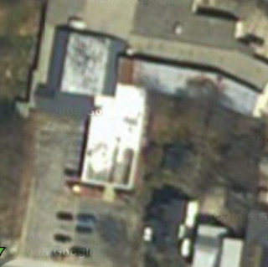

Aerial View of Building and Parking Lot

Picture 2

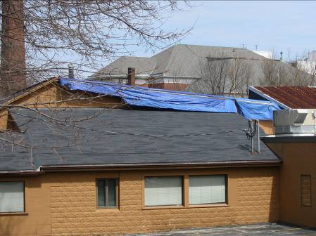

Differing Building Materials and Roof Line, Note Large Tarp on Rear of Building,

Picture 3

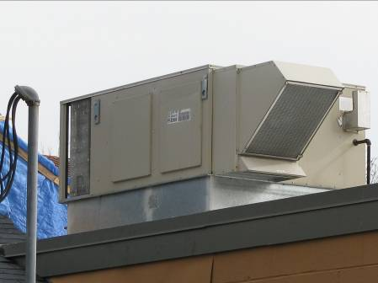

Roof Top Air Handling Unit

Picture 4

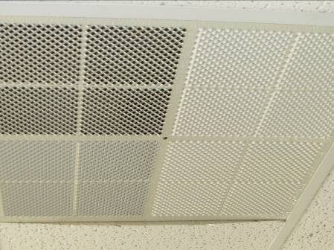

Air Diffuser

Picture 5

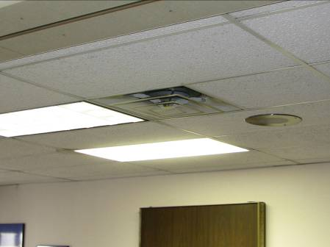

Air Diffuser

Picture 6

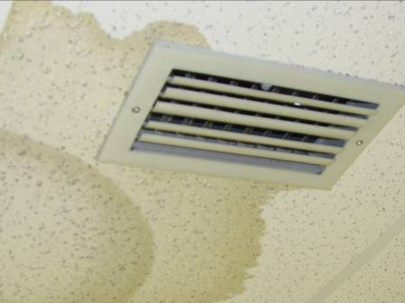

Ceiling Vent, Note Water Damaged Ceiling Tiles

Picture 7

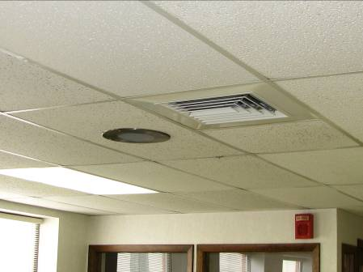

Air Diffuser

Picture 8

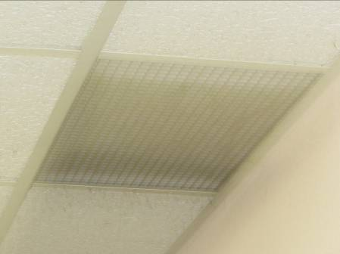

Exhaust Vent

Picture 9

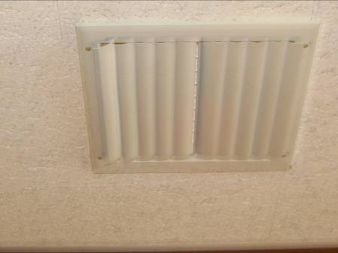

Closed Ceiling Vent

Picture 10

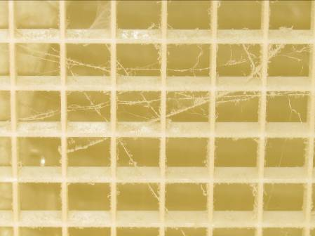

Cobwebs on Exhaust Vent

Picture 11

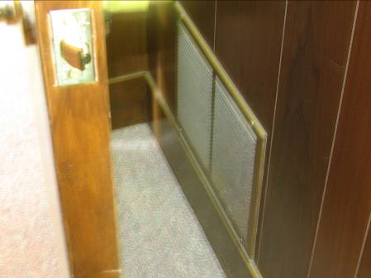

Vent Located Behind Door in Administration Wing

Picture 12

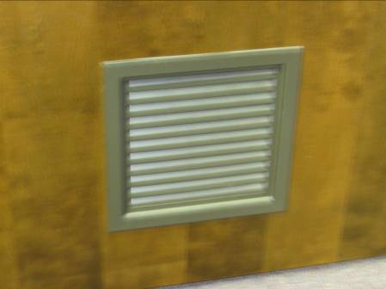

Passive Vent in Office Door

Picture 13

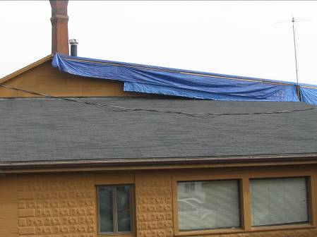

Note Tarp on Rear Roof

Picture 14

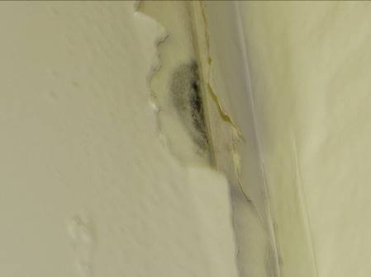

Water Damage and Mold Formation on Wall Of Upstairs Storage Area

Picture 15

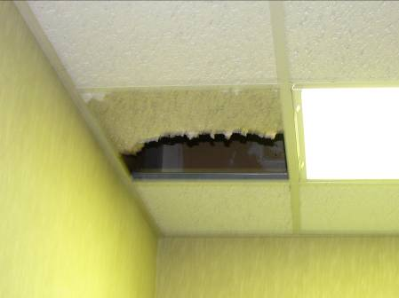

Broken, Water-damaged Ceiling Tile

Picture 16

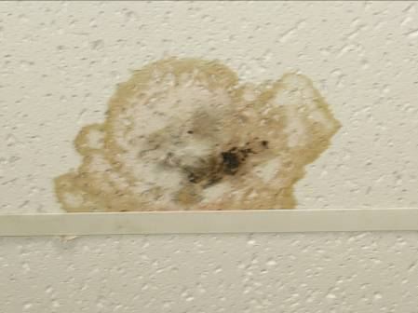

Mold Growth on Ceiling Tile

Picture 17

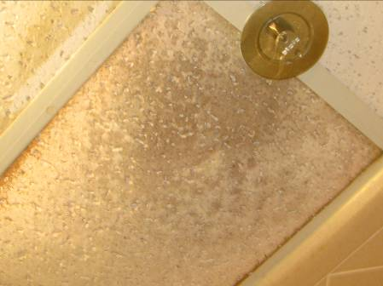

Significant Water-damage on Ceiling Tile

Picture 18

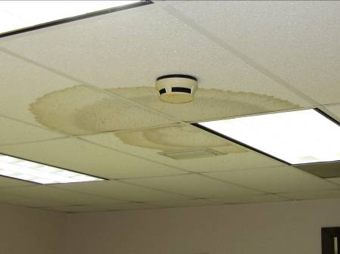

Water-damaged Ceiling Tiles

Picture 19

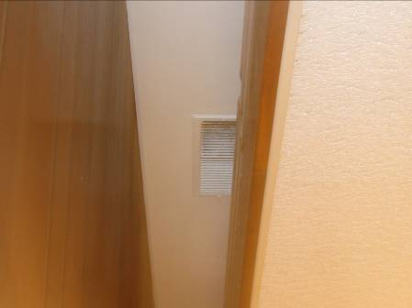

Plywood Ceiling Above Framed Suspended Ceiling

Picture 20

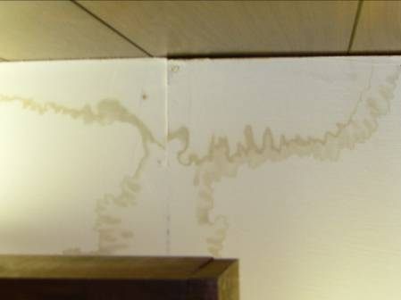

Water Damage to Plywood Ceiling in Program Director’s Office

Picture 21

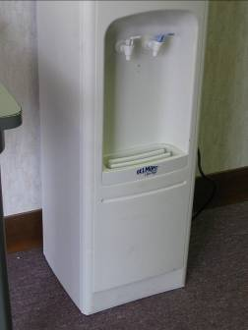

Water Cooler Located On Carpet

Picture 22

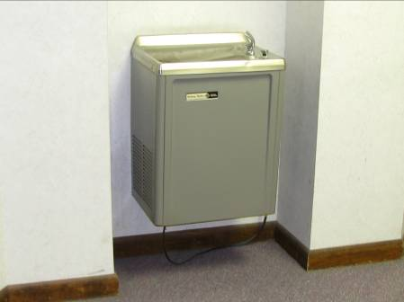

Water Fountain Located Above Carpeting

Picture 23

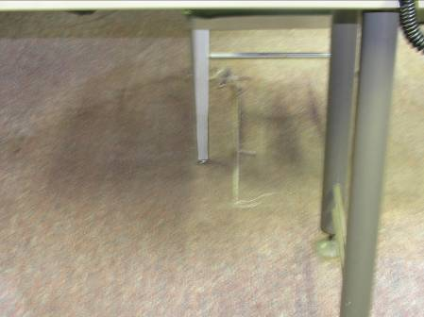

Water Damaged Carpet

Picture 24

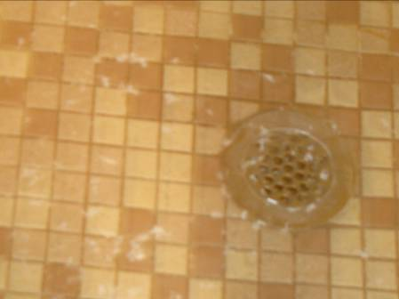

Evidence of Sewer Backup in Shower Area of Bathroom

Picture 25

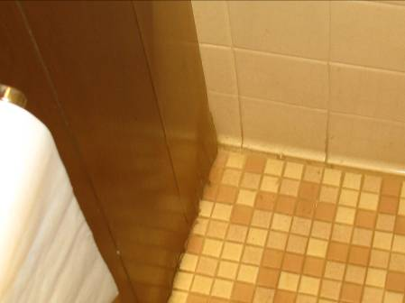

Vanity Exhibits Evidence Of Chronic Moisture Damage.

Picture 26

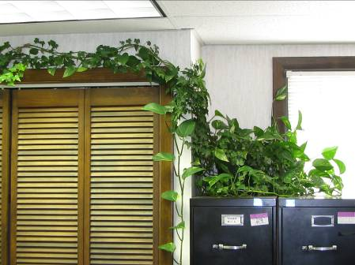

Plants In Office

Picture 27

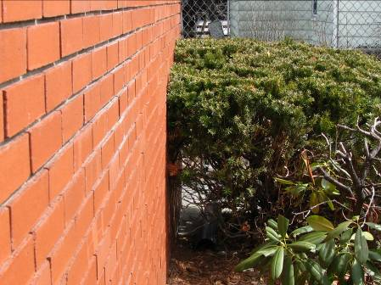

Shrubbery against Building

Picture 28

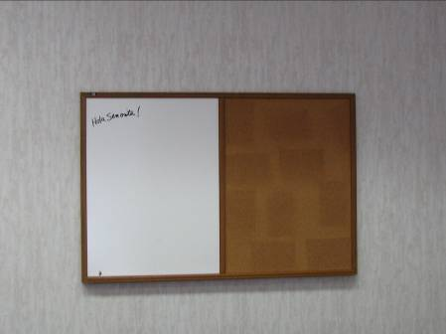

Dry Erase Board

Picture 29

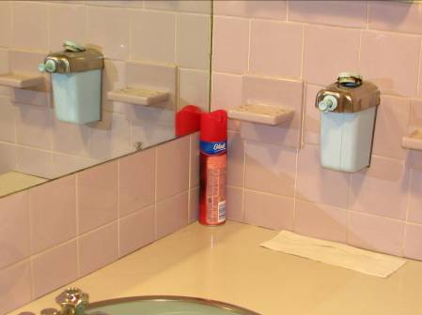

Air Freshener

Picture 30

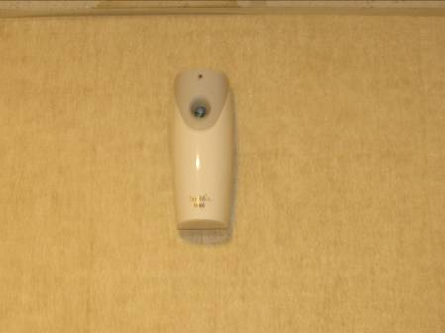

Air Freshener

Picture 31

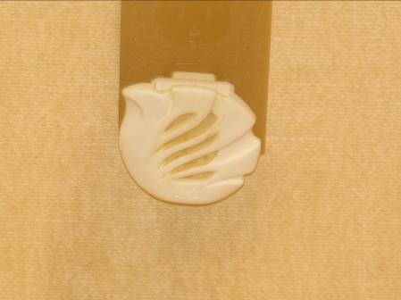

Plug In Air Freshener

Picture 32

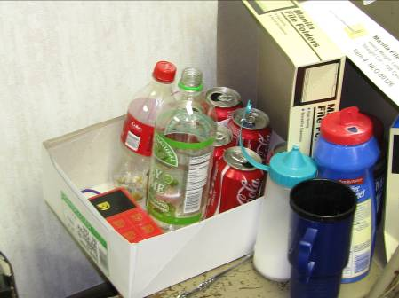

Empty Food and Beverage Containers

Picture 33

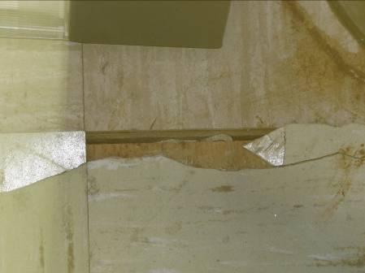

Cracked and Broken Floor Tiles
Location | Occupants  in Room | Carbon  Dioxide  (ppm) | Temp  (°F) | Relative  Humidity  (%) | Carbon Monoxide  (ppm) | Windows  Openable | Ventilation |  | Remarks
 |  |  |  |  |  |  | Supply | Exhaust | Remarks
background |  | 379 | 46 | 14 | ND
Room 1 (Old Entrance) | 0 | 682 | 64 | 35 | ND | NO | YES | YES | DO, WD CT, DEM, Carpet
Personnel | 1 | 828 | 71 | 25 | ND | NO | YES | YES | DO, Carpet
Storage room | 0 | 728 | 69 | 27 | ND | NO | NO | NO | DO, WD CT, Carpet
Office across from Mrs. Clancey | 0 | 734 | 72 | 23 | ND | NO | YES | YES | DO, Plug in air freshener, carpet, plant
Sharron Clancey’s Office | 1 | 833 | 72 | 23 | ND | YES | YES | YES | DO, Carpet
Reception Area | 1 | 1368 | 72 | 26 | ND | NO | NO | NO | DO, Carpet
Room 109 | 0 | 1234 | 72 | 25 | ND | NO | YES | NO | DO, Carpet, Plant
Room 110 | 0 | 1176 | 72 | 24 | ND | NO | YES | NO | DO
Room 111 | 0 | 1034 | 72 | 23 | ND | NO | YES | NO | DO, WD CT
Room 112 | 0 | 1090 | 72 | 24 | ND | NO | YES | NO | DO
Cubes 120/115/124/118 | 1 | 906 | 73 | 23 | ND | NO | YES | YES | WD CT, DO, Plant
Cube 129 | 0 | 904 | 73 | 22 | ND | NO | YES | YES | WD CT, WD Carpet-extensive
Cube 125 | 0 | 887 | 73 | 24 | ND | NO | YES | YES | Carpet
Rear of large office | 0 | 910 | 72 | 23 | ND | NO | YES | YES | Carpet, Numerous large fans in room
Middle of large office | 0 | 1040 | 73 | 23 | ND | NO | YES | YES | Carpet
End of large office | 0 | 1087 | 74 | 23 | ND | NO | YES | YES | Carpet
Room 145 | 1 | 980 | 74 | 23 | ND | NO | YES | YES | DO, Carpet, Vent in door
Room 147 | 1 | 1187 | 74 | 24 | ND | NO | YES | YES | DO, WD CT, Vent in door
Conference Room | 0 | 868 | 73 | 23 | ND | NO | YES | YES | DO, WD CT, Carpet
Kitchen | 0 | 892 | 72 | 23 | ND | NO | YES | NO | DO, WD CT in closet
Room 142 | 0 | 966 | 73 | 24 | ND | NO | YES | NO | DO, WD CTs
Upstairs Storage Room | 0 | 792 | 67 | 22 | ND | NO | NO | NO | WD CTs
Waiting Room | 2 | 1152 | 72 | 24 | ND | NO | YES | YES | WD CT

