INDOOR AIR QUALITY ASSESSMENT
AND
WATER DAMAGE/MOLD INVESTIGATION

Massachusetts Department of Transitional Assistance
75 Fountain Street
Framingham, Massachusetts

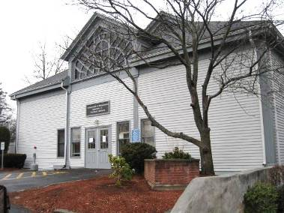

Prepared by:
Massachusetts Department of Public Health
Bureau of Environmental Health
Indoor Air Quality Program
December 2013

Background/Introduction
At the request of Gerald Covino, Project Manager, Office of Leasing, Division of Capital Asset Management and Maintenance (DCAMM), the Massachusetts Department of Public Health (MDPH), Bureau of Environmental Health (BEH) conducted an indoor air quality (IAQ) assessment at the Massachusetts Department of Transitional Assistance (DTA) offices located at 75 Fountain Street, Framingham, Massachusetts. The assessment was conducted in response to water damage related to a sewage backup/flooding event that occurred on Sunday, December 1, 2013. The flooding event was isolated to areas of the 1st floor and resulted in damage/contamination of building materials, furniture and various items throughout the 1st floor space (Pictures 1 through 5).
The U.S. Centers for Disease Control and Prevention (CDC) has developed guidance concerning cleanup following flooding and other incidents resulting in contamination of building materials. According to the CDC Guidance “Clean Up Safely After a Disaster”: drywall, insulation, and carpeting that has been contaminated with sewage or flood waters should be discarded and hard surfaces (e.g. flooring, concrete, wood and metal) should be thoroughly cleaned with hot water and detergent (Appendix A).
On December 3, 2013, an initial site assessment was made by Cory Holmes, Environmental Analyst/Regional Inspector in BEH’s Indoor Air Quality (IAQ) Program. During the assessment, Mr. Holmes was accompanied by Mr. Covino. At the time of assessment, Serv-Pro, a professional remediation/restoration firm was on-site conducting an evaluation and some remedial activities. In addition, Belfor, a property restoration firm was conducting an inventory and removal of documents. Sterling Movers were dissembling and removing workstations and furniture for remediation efforts. It is important to note that the 1st floor, where the contamination occurred, and the 2nd floor, which was unaffected, have separate heating, ventilation and air conditioning (HVAC) systems. The 1st floor air-handling unit (AHU) is located in a mechanical room on the 1st floor. The 2nd floor AHU is located in a rooftop penthouse and draws air from the outside at roof level.
At the time of the December 3, 2013 site visit, BEH/IAQ staff recommended:
- Damaged/contaminated carpeting and gypsum wallboard (GW) be removed while the space is under negative pressure;
- Vents in 1st floor areas be sealed; and
- The two stairwells (front and rear) be sealed with plastic sheeting and tape to reduce/prevent odors and particulates from migrating to unaffected areas of the 2nd floor.
On December 5, 2013, Mr. Holmes and Mr. Covino returned to the site along with Mary Farrell, Office for Leasing and State Owned Properties, Executive Office of Health and Human Services (EOHHS), to conduct IAQ testing of the 2nd floor and to monitor progress of remediation efforts on the 1st floor.

Methods
To determine if remediation efforts were impacting areas of the 2nd floor BEH/IAQ staff conducted a variety of tests to assess IAQ throughout the 2nd floor. Tests were also taken on the 1st floor for comparison. Air tests for carbon monoxide were taken with the TSI, Q-Trak, IAQ Monitor Model 7565. Air tests for airborne particle matter with a diameter less than 2.5 micrometers were taken with the TSI, DUSTTRAK™ Aerosol Monitor Model 8520. Screening for total volatile organic compounds (TVOCs) was conducted using a Thermo Environmental Instruments Inc., Model 580 Series Photo Ionization Detector (PID). Test results are provided in Table 1. Please note, air measurements are only reflective of the indoor air concentrations present at the time of testing.

Results and Discussion
At the time of the December 5th visit, vents were sealed (Picture 6), carpet removal was well underway (Picture 7), high efficiency particulate arrestance (HEPA) air filtration units were in use (Pictures 8 and 9), and stairwells were sealed with plastic and tape. However, musty odors from wet building materials were noted on the 2nd floor upon entering the building, particulary near the front stairwell to the 1st floor. Upon closer examination in the stairwell, spaces were noted around plastic barriers near handrails, which were not removed prior to installation of the plastic sheeting (Picture 10). Similar spaces were noted in the plastic barrier in the rear stairwell. BEH/IAQ staff instructed Serv-Pro personnel to remove handrails, reinstall plastic barriers at the base of stairwells (adjacent to remediation areas), and install a secondary plastic barrier halfway up the stairwell for dual integrity (Pictures 11 and 12). In addition, the elevator, which can act like a piston drawing and/or forcing air between floors, was sealed. This action provides a secondary plastic barrier at the door to the room entering the elevator lobby on the 2nd floor (Pictures 13 and 14). Finally, the return vent located above the front stairwell was sealed to prevent negative pressure from drawing odors up the 1st floor via the stairwell (Pictures 15 and 16).

IAQ Evaluations/Air Testing
The primary purpose of air testing was to identify pathways and reduce/prevent movement of odor/pollutant. Remediation/renovation activities can produce a number of pollutants, including dust, particulate matter, and combustion products such as carbon monoxide (from vehicles, heaters, motors, etc.). Particles generated from remediation/renovation activities can settle on horizontal surfaces. Dusts can be irritating to the eyes, nose and respiratory tract.
Of these materials, exposure to carbon monoxide and particulate matter with a diameter of 2.5 micrometers (μm) or less (PM2.5) can produce immediate, acute health effects upon exposure. To determine whether remediation/combustion products were present in the indoor environment, BEH/IAQ staff obtained measurements for carbon monoxide, PM2.5 and TVOCs.

Particulate Matter
The US EPA has established NAAQS limits for exposure to particulate matter. Particulate matter includes airborne solids, which can result in eye and respiratory irritation if exposure occurs. The NAAQS originally established exposure limits to particulate matter with a diameter of 10 μm or less (PM10). According to the NAAQS, PM10 levels should not exceed 150 micrograms per cubic meter (μg/m³) in a 24-hour average (US EPA, 2006). These standards were adopted by both ASHRAE and BOCA. Since the issuance of the ASHRAE standard and BOCA Code, US EPA established a more protective standard for fine airborne particles. This more stringent PM2.5 standard requires outdoor air particle levels be maintained below 35 μg/m³ over a 24-hour average (US EPA, 2006). Although both the ASHRAE standard and BOCA Code adopted the PM10 standard for evaluating air quality, MDPH uses the more protective PM2.5 standard for evaluating airborne particulate matter concentrations in the indoor environment.
Outdoor PM2.5 concentrations were measured at 44 μg/m³ (Table 1); PM2.5 levels measured in the 1st floor undergoing remediation were 40 μg/m³ (Table 1). Both of these measurements were above the NAAQS PM2.5 level of 35 μg/m³. Outdoor PM2.5 levels can be attributed to vehicle exhaust/traffic. The 1st floor PM2.5 levels were from on-going remediation work. PM2.5 levels measured on the 2nd floor ranged from 18 to 37 μg/m³ (Table 1). All but one measurement was below the NAAQS PM2.5 level of 35 μg/m³. The PM2.5 reading of 37 μg/m³ was taken near the breach in plastic containment in the front stairwell. Once the new barrier was installed as recommended by BEH/IAQ staff, the PM2.5 level dropped to 21 μg/m³, which was well below the NAAQS PM2.5 level of 35 μg/m³.
Frequently, indoor particulate levels, including PM2.5, can be at levels higher than those measured outdoors. A number of mechanical devices and/or activities that occur indoors can generate particulates during normal operations. Sources of indoor airborne particulates may include but are not limited to particles generated during the operation of fan belts in the HVAC system, use of stoves and/or microwave ovens in kitchen areas; use of photocopiers, fax machines and computer printing devices; operation of an ordinary vacuum cleaner and heavy foot traffic indoors.

Carbon Monoxide
Carbon monoxide is a by-product of incomplete combustion of organic matter (e.g., gasoline, wood and tobacco). Exposure to carbon monoxide can produce immediate and acute health effects. Several air quality standards have been established to address carbon monoxide and prevent symptoms from exposure to these substances. The MDPH established a corrective action level concerning carbon monoxide in ice skating rinks that use fossil-fueled ice resurfacing equipment. If an operator of an indoor ice rink measures a carbon monoxide level over 30 ppm, taken 20 minutes after resurfacing within a rink, that operator must take actions to reduce carbon monoxide levels (MDPH, 1997).
The American Society of Heating, Refrigerating and Air-Conditioning Engineers (ASHRAE) has adopted the National Ambient Air Quality Standards (NAAQS) as one set of criteria for assessing indoor air quality and monitoring of fresh air introduced by HVAC systems (ASHRAE, 1989). The NAAQS are standards established by the US EPA to protect the public health from six criteria pollutants, including carbon monoxide and particulate matter (US EPA, 2006). As recommended by ASHRAE, pollutant levels of fresh air introduced to a building should not exceed the NAAQS levels (ASHRAE, 1989). The NAAQS were adopted by reference in the Building Officials & Code Administrators (BOCA) National Mechanical Code of 1993 (BOCA, 1993), which is now an HVAC standard included in the Massachusetts State Building Code (SBBRS, 2011). According to the NAAQS, carbon monoxide levels in outdoor air should not exceed 9 ppm in an eight-hour average (US EPA, 2006).
Carbon monoxide should not be present in a typical, indoor environment. If it is present, indoor carbon monoxide levels should be less than or equal to outdoor levels. On the day of assessment, outdoor carbon monoxide concentrations ranged from 1 to 7 parts per million (ppm), due to idling vehicles and local traffic (Table 1). No measureable levels of carbon monoxide were detected inside the building during the assessment (Table 1).

Volatile Organic Compounds
Indoor air concentrations can be greatly impacted by the use of products containing volatile organic compounds (VOCs). VOCs are carbon-containing substances that have the ability to evaporate at room temperature. Frequently, exposure to low levels of total VOCs (TVOCs) may produce eye, nose, throat and/or respiratory irritation in some sensitive individuals. For example, chemicals used in cleaning/disinfection contain VOCs. In an effort to determine whether VOCs related to remedial activities were migrating into occupied areas of the building, air monitoring for TVOCs was conducted. An outdoor air sample, as well as readings on the 1st floor, were taken for comparison. Outdoor TVOC concentrations were ND. No measurable levels of TVOCs were detected in the building during the assessment (Table 1).

Relative Humidity
Outdoor relative humidity the day of assessment was measured at 88-100 percent (rain conditions/Table 1). Relative humidity on the 1st floor was measured at 83 percent, due to wet building materials. Relative humidity levels on the 2nd floor ranged from 33 to 47.

Conclusions/Recommendations
Air testing at the time of assessment in 2nd floor areas showed that parameters were not unusual. The combined remedial actions (e.g. operation of the 2nd floor HVAC system, which is independent from the 1st floor; isolation using plastic barriers and negative pressure differentials, use of air filtration in the remediation area), to address impacts of the sewage release on the 1st floor are not impacting 2nd floor indoor environmental conditions. Additional activities such as the installation of dual barriers, sealing of the return vent above the front stairwell and most importantly, the continued removal of wet/contaminated/odor-producing building materials (i.e. GW and carpeting) will aid in preventing any impacts to the 2nd floor space.
As discussed previously, the CDC Fact Sheet “Clean Up Safely After a Disaster” is included as Appendix A. In view of the findings at the time of the visit, the following is recommended:

2nd Floor Recommendations:
- Inspect plastic containment barriers several times daily to ensure integrity.
- Develop a communication system to provide building occupants a means to report remediation/renovation related odors and/or dusts problems to the building administrator. Have these concerns relayed to the contractor in a manner to allow for a timely remediation of any issues.
- Operate HVAC system on 2nd floor in fan “on” mode to provide continuous air circulation and filtration.
- Change filters in ceiling mounted return vents and AHU. Ensure the return vent at the front of the building shown in Picture 15 is re-sealed after the filter is changed.
- Ensure windows directly above the exhaust effluence of the HEPA filtration units are closed (Picture 9) to avoid entrainment.
- Disseminate scheduling itinerary to all affected parties through meetings, emails and/or weekly bulletins.
- Ensure Material Safety Data Sheets (MSDS) are available for all materials used during remediation/renovation and keep them in an area that is accessible to all individuals during periods of building operations as required by the Massachusetts Right-To-Know Act (MGL, 1983). Provide proper ventilation and allow sufficient curing time as per the manufacturer’s instructions concerning these materials.

1st Floor Recommendations:
- Continue to remove remaining contaminated/water-damaged materials (carpeting, GW, etc.) using proper isolation and negative ventilation techniques. Place fans in front of plastic barriers inside the remediation zone to draw air/odors away from stairwells toward HEPA filtration units.
- Inspect plastic containment barriers several times daily to ensure integrity.
- Ensure all contaminated hard surfaces (e.g., flooring, metal wall studs, wood) are thoroughly cleaned/disinfected.
- Change HVAC filters prior to re-occupancy.
- Ensure all areas are thoroughly cleaned and vacuumed using a HEPA-filter equipped vacuum cleaner after remediation is complete.

References
ASHRAE. 1989. Ventilation for Acceptable Indoor Air Quality. American Society of Heating, Refrigeration and Air Conditioning Engineers. ANSI/ASHRAE 62-1989.
BOCA. 1993. The BOCA National Mechanical Code/1993. 8th ed. Building Officials and Code Administrators International, Inc., Country Club Hill, IL.
MDPH. 1997. Requirements to Maintain Air Quality in Indoor Skating Rinks (State Sanitary Code, Chapter XI). 105 CMR 675.000. Massachusetts Department of Public Health, Boston, MA.
SBBRS. 2011. Mechanical Ventilation. State Board of Building Regulations and Standards. Code of Massachusetts Regulations, 8th edition. 780 CMR 1209.0
US EPA. 2006. National Ambient Air Quality Standards (NAAQS). US Environmental Protection Agency, Office of Air Quality Planning and Standards, Washington, DC. http://www.epa.gov/air/criteria.html.

Picture 1
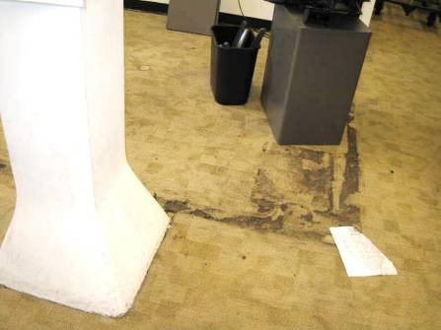
Sewage contamination (brown debris) on 1st floor carpeting and gypsum wallboard
Picture 2
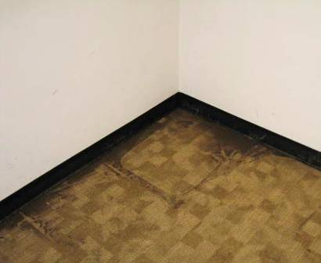
Sewage contamination (brown debris) on 1st floor carpeting and gypsum wallboard

Picture 3
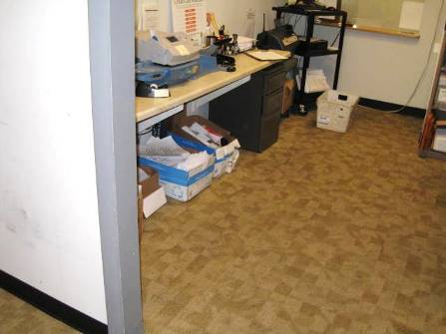
Porous materials on contaminated carpeting

Picture 4
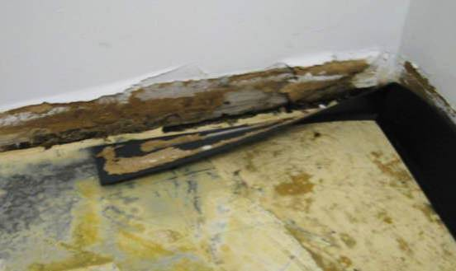
Damaged/contaminated gypsum wallboard
Picture 5
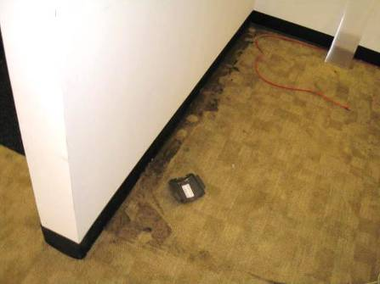
Sewage contamination (brown debris) on 1st floor carpeting and gypsum wallboard
Picture 6
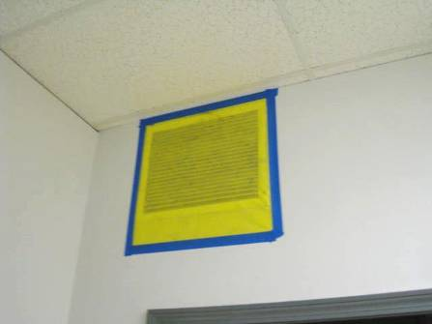
Sealed HVAC vent 1st floor

Picture 7
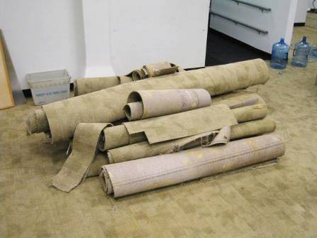
Carpet removal
Picture 8
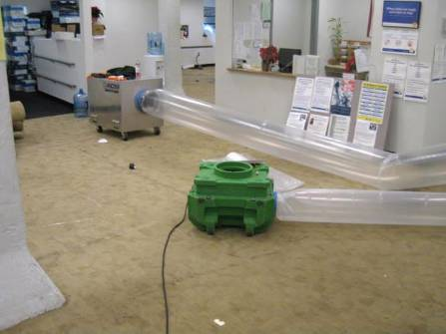
HEPA air filtration units on 1st floor ducted to outside

Picture 9
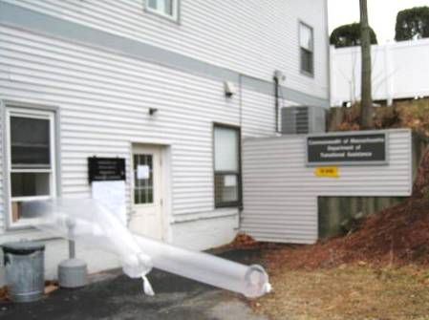
HEPA air filtration units on 1st floor ducted to outside, note proximity of openable windows (arrows)
Picture 10
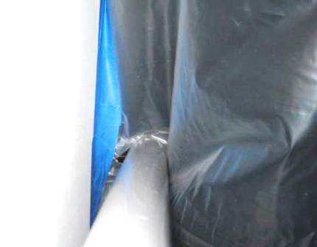
Spaces in plastic barrier around handrail in front stairwell
Picture 11
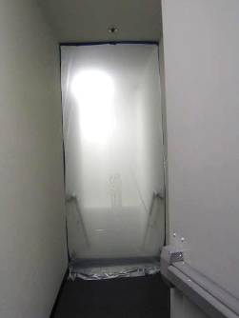
Dual plastic containment barriers in rear stairwell
Picture 12
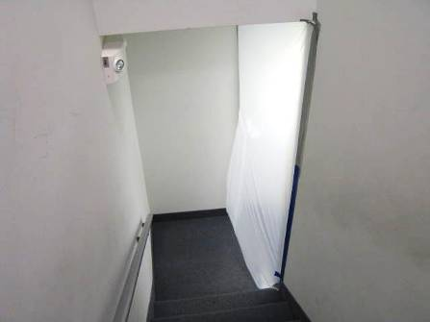
Dual plastic containment barriers in front stairwell

Picture 13
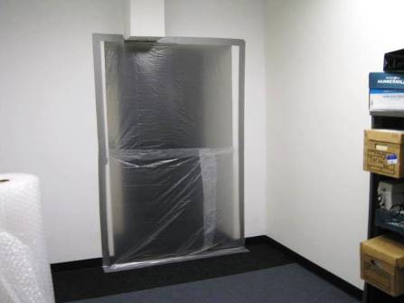
Second floor elevator doors sealed with plastic and tape
Picture 14
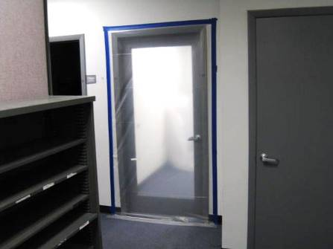
Door to 2nd floor elevator lobby sealed with plastic and tape

Picture 15
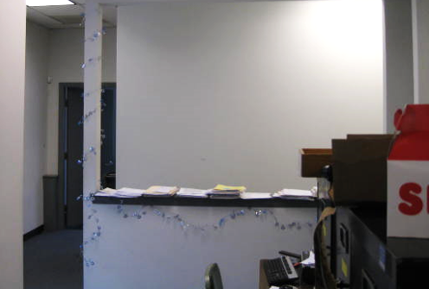
Proximity of return vent (top arrow) to front stairwell, arrows also indicate odor pathway from 1st floor remediation area
Picture 16
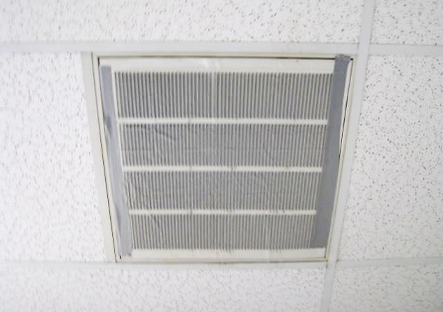
Close-up of sealed return vent above front stairwell

Location | Carbon Monoxide  (*ppm) | Relative  Humidity  (%) | TVOCs  (*ppm) | PM2.5  (µg/m³) | Remarks
Background | 1.0-7.0 | 88-100 | ND | 44 | Overcast, rain later in day, winds WSW 1-12 mph, gusts up to 17 mph, moderate traffic, idling vehicles
2nd Floor |  |  |  |  | Musty/wet odors at front of building near stairwell
60 | ND | 40 | ND | 21
59 | ND | 36 | ND | 21
57 | ND | 34 | ND | 22
Copy Area | ND | 33 | ND | 21
56 | ND | 33 | ND | 20
70 | ND | 33 | ND | 21
49 | ND | 34 | ND | 22
Elevator Area | ND | 40 | ND | 28 | Potential odor pathway-sealed
44 | ND | 36 | ND | 22
Central Area | ND | 37 | ND | 24
Front Stairwell | ND | 47 | ND | 37 | Odor pathway-holes in plastic barrier-sealed
Front Stairwell (after double sealed with plastic) | ND | 37 | ND | 21
Kitchen | ND | 35 | ND | 20
67 | ND | 34 | ND | 20
65 | ND | 34 | ND | 25
64 | ND | 35 | ND | 19
Conference Room | ND | 33 | ND | 19
Rear Stairwell | ND | 43 | ND | 19 | Odor pathway-holes in plastic barrier-sealed
Rear Stairwell (after double sealed with plastic) | ND | 39 | ND | 24
Ramos/Grant Work Area | ND | 38 | ND | 18
1st Floor
1st Floor Remediation Area | ND | 83 | ND | 40 | Carpet removal, cleaning/remediation activities

