INDOOR AIR QUALITY ASSESSMENT

Division of Fisheries and Wildlife
Field Headquarters
1 Rabbit Hill Road
Westborough, MA

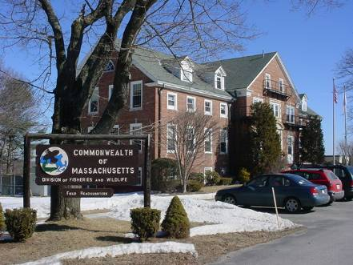

Prepared by:
Massachusetts Department of Public Health
Center for Environmental Health
Emergency Response/Indoor Air Quality Program
May 2007

Background/Introduction
At the request of Mr. Robert Deblinger, Deputy Director of Field Operations for the Massachusetts Division of Fisheries and Wildlife (DFW), the Massachusetts Department of Public Health (MDPH), Center for Environmental Health (CEH) provided assistance and consultation regarding indoor air quality concerns at the DFW field headquarters located at 1 Rabbit Hill Road, Westborough, Massachusetts. The request was prompted by concerns of exacerbation of asthma among staff in the original building and the potential off-gassing of building materials in a new modular office building (Building C). On March 9, 2007, a visit to conduct an IAQ assessment at the DFW field headquarters was made by Cory Holmes, an Environmental Analyst in CEH’s Emergency Response/Indoor Air Quality (ER/IAQ) Program. Mr. Holmes was accompanied during the assessment by Mr. Bruce Walker, Maintenance Supervisor.
The DFW is housed within a series of buildings located on the former campus of the Lyman School. CEH staff were asked to evaluate conditions in buildings A, B and C. The majority of staff are housed in building A, (the main building) which is a three-story, red brick building with an attic that was originally constructed in 1925 (cover photo). The building has undergone interior renovations over the years, most recently in 2006. The building contains storage space, offices and meeting rooms. Windows were reportedly replaced in 2006 and are openable throughout the building. Due to expansion, DFW staff also occupy two modular office buildings located adjacent to the main building (Picture 1). These buildings are identified as “B” and “C”. Modular buildings B and C are approximately 6 years and several months old, respectively.

Methods
Air tests for carbon dioxide, temperature and relative humidity were taken with the TSI, Q-Trak, IAQ Monitor. Screening for total volatile organic compounds (TVOCs) in modular office buildings B and C was conducted using an HNu, Model 102 Snap-on Photo Ionization Detector (PID). CEH staff also performed a visual inspection of building materials for water damage and/or microbial growth. Moisture content of porous building materials were measured with Delmhorst, BD-2000 Model, Moisture Detector with a Delmhorst Standard Probe.

Results
The DFW has an employee population of approximately 30 and can be visited by several members of the public daily. The tests were taken during normal operations and results appear in Table 1.

Discussion
Ventilation
Building A
It can be seen from Table 1 that carbon dioxide levels were above 800 parts per million (ppm) in twenty-one of forty-five areas surveyed, indicating less than optimal air exchange in almost half the areas of the building evaluated. It is important to note that a number of areas were unoccupied or sparsely populated at the time of the assessment, which can contribute to reduced carbon dioxide levels.
Building A is not equipped with a modern mechanical ventilation system, but relies on openable windows for air circulation. The majority of windows were closed at the time of the assessment. Without a means for air exchange via windows or a mechanical supply and exhaust system, normally occurring indoor environmental pollutants can build up, leading to indoor air quality/comfort complaints.
The building was originally designed to use openable windows on opposing exterior walls to create cross-ventilation and provide comfort for building occupants. In addition to openable windows, the building has hinged windows located above hallway doors. These hinged windows or transoms (Picture 2) enable occupants to close hallway doors while maintaining a pathway for airflow into the rooms. This design allows for airflow to enter an open window, pass through a room, pass through the open transom, enter the hallway, pass through the opposing open room transom and exit the building on the leeward side (opposite the windward side) (Figure 1). With all windows and transoms open, airflow can be maintained in a building regardless of the direction of the wind. This system fails if the windows or transoms are closed (Figure 2). Most transoms were found closed and/or permanently sealed at the time of the assessment.

Modular Buildings B and C
It can be seen from Table 1 that carbon dioxide levels were elevated above 800 parts per million (ppm) in all areas surveyed in both B and C Buildings, indicating inadequate air exchange. Mechanical ventilation for buildings B and C is provided by air-handling units (AHUs) mounted on the exterior of the buildings (Picture 3). Fresh air is distributed via ductwork connected to ceiling-mounted air diffusers and drawn back to the AHUs through return grilles. Thermostats control each heating, ventilating and air conditioning (HVAC) system and have fan settings of “on” and “automatic”. Thermostats were set to the “automatic” setting (Picture 4) during the assessment. The automatic setting on the thermostat activates the HVAC system at a preset temperature. Once the preset temperature is reached, the HVAC system is deactivated. Therefore, no mechanical ventilation is provided until the thermostat re-activates the system. It is important to note that the assessment was conducted on an extremely cold day (<32 ºF). During these types of temperature extremes, fresh air drawn into the heating, ventilating and air-conditioning (HVAC) system is often reduced to prevent freezing/damage of HVAC system components. Limiting fresh air intake either by mechanical and/or natural means (e.g., closing of windows) can contribute to an increase in carbon dioxide levels indicating a lack of fresh air to occupied spaces.
The Massachusetts Building Code requires that each room have a minimum ventilation rate of 20 cubic feet per minute (cfm) per occupant of fresh outside air or openable windows (SBBRS, 1997; BOCA, 1993). The ventilation must be on at all times that the room is occupied. Providing adequate fresh air ventilation with open windows and maintaining the temperature in the comfort range during the cold weather season is impractical. Mechanical ventilation is usually required to provide adequate fresh air ventilation.
Carbon dioxide is not a problem in and of itself. It is used as an indicator of the adequacy of the fresh air ventilation. As carbon dioxide levels rise, it indicates that the ventilating system is malfunctioning or the design occupancy of the room is being exceeded. When this happens, a buildup of common indoor air pollutants can occur, leading to discomfort or health complaints. The Occupational Safety and Health Administration (OSHA) standard for carbon dioxide is 5,000 parts per million parts of air (ppm). Workers may be exposed to this level for 40 hours/week, based on a time-weighted average (OSHA, 1997).
The MDPH uses a guideline of 800 ppm for publicly occupied buildings. A guideline of 600 ppm or less is preferred in schools due to the fact that the majority of occupants are young and considered to be a more sensitive population in the evaluation of environmental health status. Inadequate ventilation and/or elevated temperatures are major causes of complaints such as respiratory, eye, nose and throat irritation, lethargy and headaches. For more information concerning carbon dioxide, please see Appendix A.
Temperature readings ranged from 67º F to 73 º F, which were slightly below the MDPH recommended comfort guidelines in some areas. The MDPH recommends that indoor air temperatures be maintained in a range of 70 º F to 78 º F in order to provide for the comfort of building occupants. In many cases concerning indoor air quality, fluctuations of temperature in occupied spaces are typically experienced, even in a building with an adequate fresh air supply.
The relative humidity measured in the building ranged from 13 to 23 percent, which was below the MDPH recommended comfort range in all areas surveyed. The MDPH recommends a comfort range of 40 to 60 percent for indoor air relative humidity. Relative humidity levels in the building would be expected to drop during the winter months due to heating. The sensation of dryness and irritation is common in a low relative humidity environment. Low relative humidity is a very common problem during the heating season in the northeast part of the United States.

Microbial/Moisture Concerns
Building A reportedly has a history of water infiltrating through the building envelope. CEH staff observed water stained ceiling tiles, damaged wall plaster, peeling paint and efflorescence on ceilings and walls in a number of areas (Table 1/Pictures 5 to 9). Repeated water damage to porous building materials can lead to mold growth. Dark staining which appeared to be mold growth was observed on a ceiling tile and gypsum wallboard (GW) in the basement (Pictures 8 and 9). Efflorescence is a characteristic sign of water damage to brick and mortar, but it is not mold growth. As moisture penetrates and works its way through mortar and brick, water-soluble compounds in mortar and brick dissolve, creating a solution. As the solution moves to the surface of the mortar or brick, the water evaporates, leaving behind white, powdery mineral deposits. According to Mr. Deblinger, plans to re-point the building are scheduled for spring of 2007. Re-pointing of the buildings façade should eliminate sources of water penetration through the exterior wall.
CEH staff examined the perimeter of the building to identify breaches in the building envelope that could provide a source for water penetration. A number of exterior sources for moisture penetration were identified:
- Damaged/dislodged gutters and downspouts (Pictures 10 and 11).
- Missing/damaged mortar and cracks in exterior brick (Pictures 12 to14).
- Missing/damaged caulking and spaces around flashing and in masonry around windows (Pictures 15 and 16).
These conditions can undermine the integrity of the building envelope and provide a means of water entry by capillary action into the building through exterior walls, foundation concrete and masonry (Lstiburek & Brennan, 2001). In addition, these breaches in exterior areas can provide a means of drafts and pest entry into the building.
The US Environmental Protection Agency and the American Conference of Governmental Industrial Hygienists (ACGIH) recommends that porous materials (carpeting, ceiling tiles, etc.) be dried with fans and heating within 24 to 48 hours of becoming wet (US EPA, 2001; ACGIH, 1989). If porous materials are not dried within this time frame, mold growth may occur. Water-damaged porous materials cannot be adequately cleaned to remove mold growth. The application of a mildewcide to moldy porous materials is not recommended.

Other Concerns
Several other conditions that can potentially affect indoor air quality were identified during the assessment. As previously mentioned, the assessment was requested in part due to concerns of off-gassing building materials in modular office building C. To determine if measurable levels of volatile organic compounds (VOCs) were present, CEH staff conducted screening for total volatile organic compounds (TVOCs). VOCs are carbon-containing substances that have the ability to evaporate at room temperature. For example, chemicals evaporating from a paint can stored at room temperature would most likely contain VOCs. Frequently, exposure to low levels of VOCs may produce eye, nose, throat and/or respiratory irritation in some sensitive individuals. Outdoor TVOC measurements were taken for comparison to indoor levels. Outdoor TVOC concentrations were non-detect (ND) (Table 1). Indoor TVOC concentrations throughout building C were also ND (Table 1). Please note, TVOC air measurements are only reflective of the indoor air concentrations present at the time of sampling.
Also of note was the amount of materials stored inside offices. In areas throughout the building, items were observed on windowsills, tabletops, counters, bookcases and desks. The large number of items stored provides a source for dusts to accumulate. These items (e.g., papers, folders, boxes) make it difficult for custodial staff to clean. Several areas had cloth curtains that were water damaged, stained or had accumulated dust. Dust can be irritating to eyes, nose and respiratory tract. Items should be relocated and/or be cleaned periodically to avoid excessive dust build up. Occupants pointed out a coating of white dust on the surface of computers in Building C (Picture 17). The dust appears to have originated from the recently refinished plaster ceiling directly above work stations.
CEH staff inspected HVAC filters in the modular office buildings. The filters installed in the AHUs were of a type that provides minimal filtration (Picture 18). In order to decrease aerosolized particulates, higher efficiency, disposable filters can be installed in the AHUs. The dust spot efficiency is the ability of a filter to remove particulates of a certain diameter from air passing through the filter. Filters that have been determined by ASHRAE to meet its standard for a dust spot efficiency of a minimum of 40 percent would be sufficient to reduce airborne particulates (Thornburg, 2000; MEHRC, 1997; ASHRAE, 1992). Note that increased filtration can reduce airflow produced through increased resistance (called pressure drop), which may be occurring due to high efficiency filters installed in the central return vent, as opposed to in the AHUs. Prior to any increase in filtration, AHUs should be evaluated by a ventilation engineer to ascertain whether they can maintain function with more efficient filters.
Finally, CEH staff observed exposed pipe insulation in the basement meeting room closet of Building A, which may be an asbestos containing material (ACM) (Picture 19). This finding was reported to Mr. Deblinger upon discovery. CEH staff recommended that the material be inspected/remediated by a professional remediation firm.

Conclusions/Recommendations
The conditions noted at the DFW Field Headquarters raise a number of indoor air quality issues. Chronic water infiltration through the building envelope in Building A has led to repeated water damage to building materials and mold growth in some areas. At the time of the CEH assessment, plans to re-point the building, which should eliminate sources of water penetration, are scheduled for spring of 2007.
As discussed previously, Building A is not equipped with a modern mechanical ventilation system but relies on openable windows for air exchange. The sealing of the original transom system coupled with renovations of the building over the years (i.e. construction of interior walls) has nearly eliminated the ability to provide cross-ventilation as designed. In addition, the replacement of windows in 2006 has greatly reduced drafts, which in essence “tightened” up the building resulting in less natural infiltration (as evidenced by elevated carbon dioxide levels).
To improve indoor environmental conditions in the building, a two-phase approach is recommended. This approach consists of short-term measures to improve air quality and long-term recommendations that will require planning and resources to adequately address the overall indoor air quality concerns.

The following short-term measures should be considered:
- Continue with plans to have exterior of the building re-pointed to prevent further water penetration and damage to building materials.
- Remove water damaged/mold-colonized building materials (e.g., GW) in areas that are susceptible to water penetration. Mold-colonized materials should be remediated in a manner consistent with recommendations in “Mold Remediation in Schools and Commercial Buildings” published by the US Environmental Protection Agency (US EPA, 2001). This document is available from the US EPA website: http://www.epa.gov/iaq/molds/mold_remediation.html.
- Open windows to temper rooms and provide fresh air in Building A. As discussed, this building was designed to use windows (in combination with radiators) to provide fresh air and heat. Care should be taken to ensure windows are properly closed at night and weekends to avoid the freezing of pipes and potential flooding.
- Consider supplementing fresh air by operating window-mounted air conditioners in the "fan only" “fresh air” mode, which introduces outside air by mechanical means.
- Operate thermostats for modular offices (Buildings B and C) in the fan “on” setting during occupancy to provide continuous air circulation.
- Consider adopting a balancing schedule of every 5 years for mechanical ventilation systems, as recommended by ventilation industrial standards (SMACNA, 1994).
- For buildings in New England, periods of low relative humidity during the winter are often unavoidable. Therefore, scrupulous cleaning practices should be adopted to minimize common indoor air contaminants whose irritant effects can be enhanced when the relative humidity is low. To control for dusts, a high efficiency particulate arrestance (HEPA) filter equipped vacuum cleaner in conjunction with wet wiping of all surfaces is recommended (particularly in modular Building C). Drinking water during the day can help ease some symptoms associated with a dry environment (e.g., throat and sinus irritations).
- Repair/replace missing/damaged sections of gutter/downspout system.
- Consider increasing the dust-spot efficiency of HVAC filters in modular offices (Buildings B and C). Prior to any increase of filtration, each piece of air handling equipment should be evaluated by a ventilation engineer as to whether it can maintain function with more efficient filters.
- Relocate or consider reducing the amount of materials stored in offices and common areas to allow for more thorough cleaning. Clean items regularly with a wet cloth or sponge to prevent excessive dust build-up.
- Remediate exposed pipe insulation in basement meeting room closet in conformance with Massachusetts asbestos remediation and hazardous waste disposal laws.
- Refer to resource manuals and other related indoor air quality documents for further building-wide evaluations and advice on maintaining public buildings. Copies of these materials are located on the MDPH’s website: http://mass.gov/dph/indoor_air.

The following long-term recommendations should be considered:
- Consider consulting with an architect, masonry firm or general contractor regarding the integrity of the building envelope, primarily concerning water penetration through exterior walls. Ensure all leaks are repaired.
- Contact an HVAC engineering firm to examine the feasibility of retro-fitting the building with a modern mechanical ventilation system.

References
ACGIH. 1989. Guidelines for the Assessment of Bioaerosols in the Indoor Environment. American Conference of Governmental Industrial Hygienists, Cincinnati, OH.
ASHRAE. 1992. Gravimetric and Dust-Spot Procedures for Testing Air-Cleaning Devices Used in General Ventilation for Removing Particulate Matter. American Society of Heating, Refrigeration and Air Conditioning Engineers. ANSI/ASHRAE 52.1-1992.

BOCA. 1993. The BOCA National Mechanical Code/1993. 8th ed. Building Officials and Code Administrators International, Inc., Country Club Hill, IL. Section M-308.1.1.
Lstiburek, J. & Brennan, T. 2001. Read This Before You Design, Build or Renovate. Building Science Corporation, Westford, MA. U.S. Department of Housing and Urban Development, Region I, Boston, MA
MEHRC. 1997. Indoor Air Quality for HVAC Operators & Contractors Workbook. MidAtlantic Environmental Hygiene Resource Center, Philadelphia, PA.

OSHA. 1997. Limits for Air Contaminants. Occupational Safety and Health Administration. Code of Federal Regulations. 29 C.F.R 1910.1000 Table Z-1-A.

SBBRS. 1997. Mechanical Ventilation. State Board of Building Regulations and Standards. Code of Massachusetts Regulations. 780 CMR 1209.0
SMACNA. 1994. HVAC Systems Commissioning Manual. 1st ed. Sheet Metal and Air Conditioning Contractors’ National Association, Inc., Chantilly, VA.
Thornburg, D. Filter Selection: a Standard Solution. Engineering Systems 17:6 pp. 74-80.

US EPA. 2001. “Mold Remediation in Schools and Commercial Buildings”. Office of Air and Radiation, Indoor Environments Division, Washington, DC. EPA 402-K-01-001. March 2001. Available at: http://www.epa.gov/iaq/molds/mold_remediation.html
Picture 1

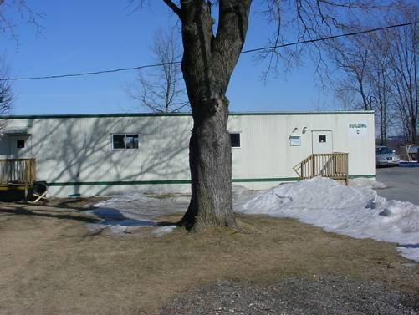

Modular Office Unit Building C

Picture 2

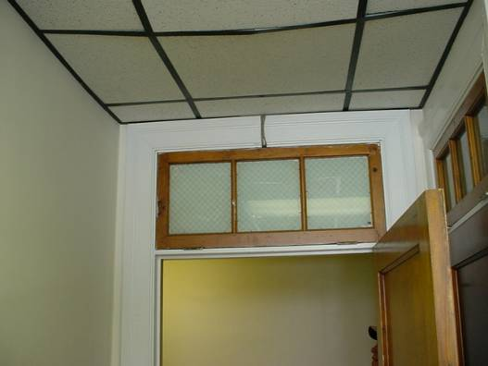

Sealed Transom above Hallway Door
Picture 3

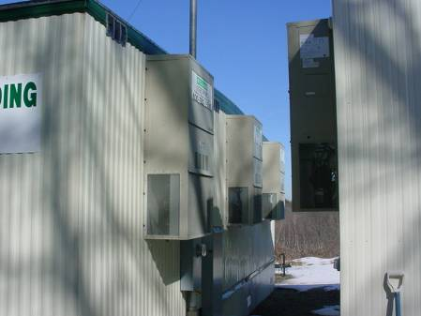

AHUs Mounted on the Exterior of Modular Office Buildings

Picture 4

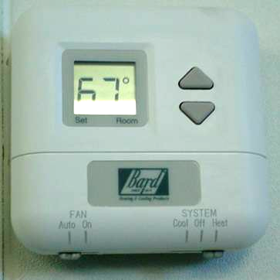

Thermostat in Modular Office Building with Fan Set to “Auto”
Picture 5

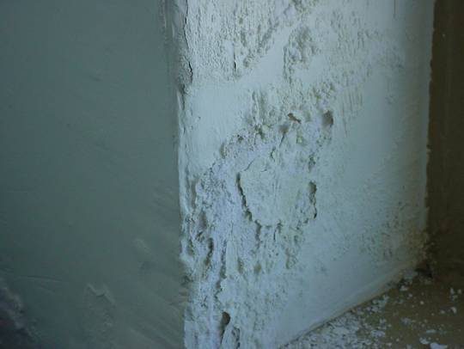

Water Damaged Wall Plaster/Efflorescence and Peeling Paint

Picture 6

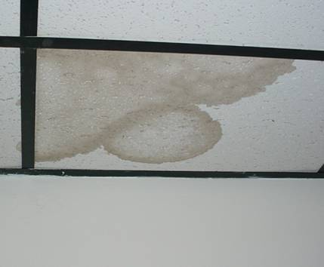

Water Stained Ceiling Tiles
Picture 7

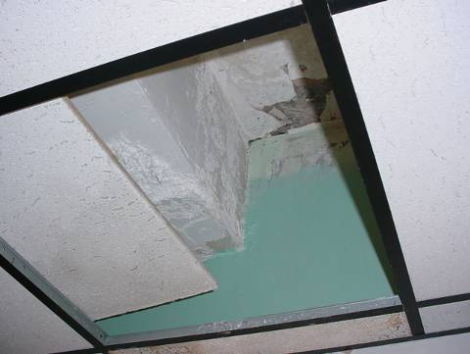

Water Damaged Wall Plaster/Efflorescence and Peeling Paint above Ceiling Tile System

Picture 8

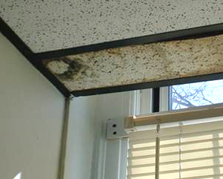

Water Stained Ceiling Tiles, Dark Area on Left Indicates the Presence of Possible Mold Growth
Picture 9

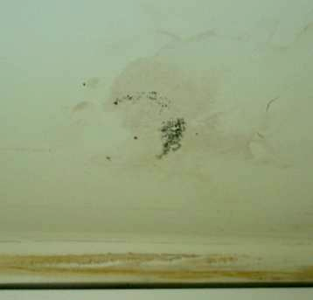

Visible Mold Growth as Indicated by Dark Stains on GW in First Floor Office (Woolsley)

Picture 10

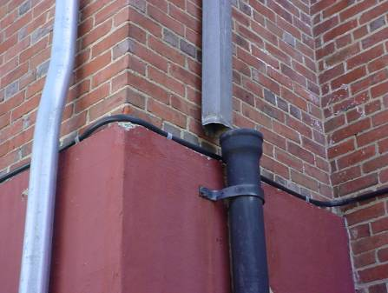

Disconnected Downspout and Drainage Pipe
Picture 11

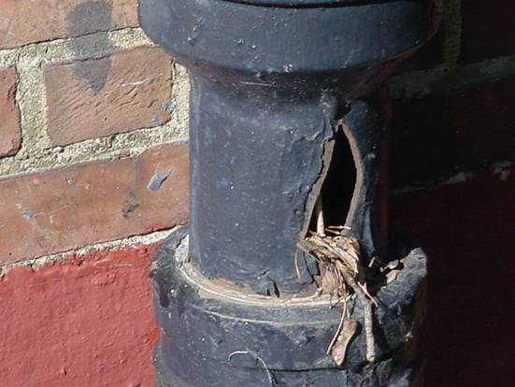

Breach in Drainage Pipe, Note Accumulation of Material/Clog

Picture 12

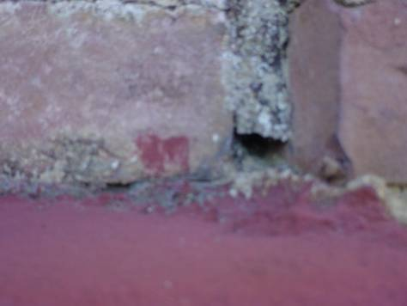

Missing/Damaged Mortar around Exterior Brick
Picture 13

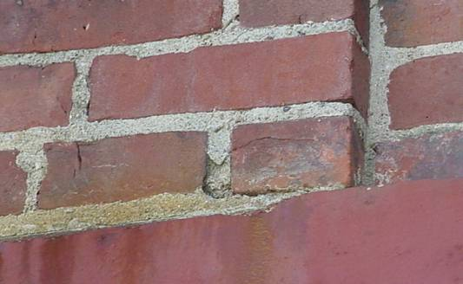

Missing/Damaged Mortar around Exterior Brick

Picture 14

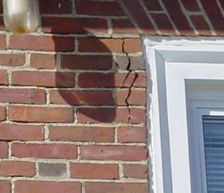

Missing/Damaged Mortar around Exterior Brick, Note Large Fissure, Which Corresponds to Water Damaged Building Materials on the Interior
Picture 15

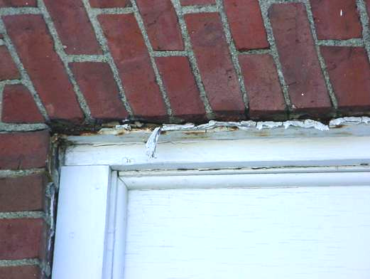

Missing/Damaged Caulking around Window Frames

Picture 16

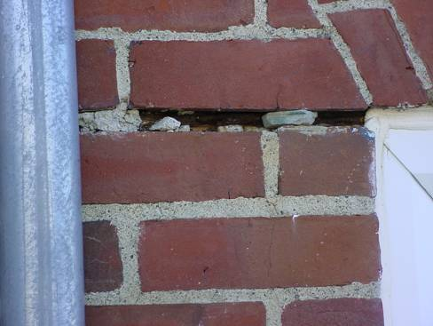

Close-Up of Missing/Damaged Caulking around Window Frames
Picture 17

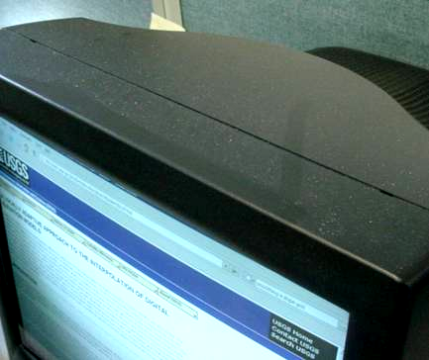

Dust Accumulation on Surface of Computer Monitor

Picture 18

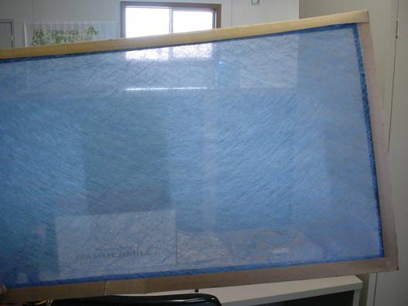

Fibrous Mesh Filter in Modular Office Building AHU
Picture 19

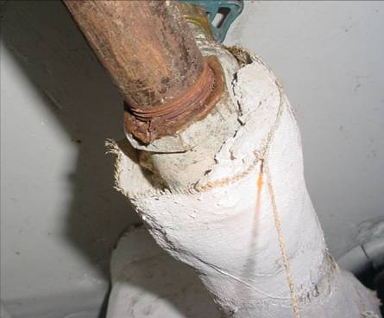

Exposed Pipe Insulation in Basement Meeting Room Closet
Location | Carbon  Dioxide  (*ppm) | Temp  (°F) | Relative  Humidity  (%) | Occupants  in Room | Windows  Openable | Ventilation |  | Remarks
 |  |  |  |  |  | Supply | Exhaust | Remarks
Outside  (Background) | 406 | <32 | 14 |  |  |  |  | Cold, mostly sunny
4th Floor Director’s Office | 830 | 65 | 22 | 0 | Y | N | N
4th Floor Office | 966 | 68 | 23 | 3 | Y | N | N | Fan
Secretary’s Office | 920 | 69 | 22 | 1 | Y | N | N
Computer Office | 522 | 69 | 16 | 0 | Y | N | N | AC computer network equipment
3rd Floor Hallway |  |  |  |  |  |  |  | Efflorescence windows
Cookman/Wooley | 724 | 70 | 18 | 1 | Y | N | N | Historic water damage around windows, fan, plant
Moruzzi | 723 | 72 | 17 | 1 | Y | N | N
Wildlife Office | 922 | 72 | 20 | 0 | Y | N | N | Plant, open utility hole, 2 CT-historic leak
Early | 751 | 72 | 17 | 1 | Y | N | N | 1 CT
Empty Office | 759 | 72 | 18 | 0 | Y | N | N | 4 CT-historic leaks
Woytek | 738 | 71 | 17 | 0 | Y | N | N
Heusmann | 847 | 71 | 17 | 0 | Y | N | N
Cardoza | 754 | 71 | 17 | 0 | Y | N | N | 1 CT-historic leak
Scanlon | 751 | 71 | 17 | 0 | Y | N | N
Fisheries Office | 884 | 70 | 18 | 0 | Y | N | N
Fisheries Director’s Office | 878 | 70 | 18 | 0 | Y | N | N | 2 CT-historic leak
Richards | 858 | 71 | 19 | 0 | Y | N | N | 2 CT-historic leak
Hartley | 906 | 72 | 19 | 0 | Y | N | N
Fontaine | 867 | 72 | 19 | 0 | Y | N | N | 2 CT
Norris | 899 | 72 | 19 | 1 | Y | N | N | 5 CT, fan
Kashiwagi | 930 | 72 | 19 | 1 | Y | N | N | 6 CT
Slater | 941 | 72 | 19 | 1 | Y | N | N
Simmons | 952 | 71 | 19 | 0 | Y | N | N
2nd Floor
Graphics | 916 | 72 | 19 | 1 | Y | N | N | Current leak through building envelope (near ceiling)-5 CT
Larson | 840 | 17 | 19 | 1 | Y | N | N | 1 CT dark stain-possible mold growth
Horwitz | 850 | 18 | 17 | 1 | Y | N | N
Receptionist | 871 | 73 | 18 | 0 | Y | N | N | Plants, air purifier
Zima | 883 | 73 | 17 | 0 | Y | N | N
McGrath | 1271 | 72 | 19 | 0 | Y | N | N
Conference Room | 1370 | 72 | 20 | 0 | Y | N | N | Meeting approx 30 minutes prior to testing
Basement/1st Floor Level  Simmons (old office) | 677 | 71 | 15 | 0 | Y | N | N | 6 CT/MT-building envelope leaks, exposed fiberglass, moisture testing: CT-low/normal, carpet-low/normal, GW-low/normal
Szczebak | 658 | 71 | 14 | 0 | Y | N | N | 2 CT, plant
Swan | 650 | 72 | 14 | 0 | Y | N | N | Plants
Melvin | 647 | 73 | 15 | 0 | Y | N | N | Fan
Culina | 635 | 71 | 13 | 0 | Y | N | N | Fan, peeling paint and efflorescence
Heritage Workroom | 666 | 71 | 15 | 0 | Y | N | N | Moisture testing: ceiling plaster-low/normal, carpet-low/normal, carpet-low/normal
Meeting Room | 617 | 70 | 15 | 0 | N | N | N | Exposed insulation material in closet
Haggerty | 583 | 70 | 15 | 0 | Y | N | N
Corner Office | 636 | 72 | 15 | 0 | Y | N | N | 2 CT-building envelope leak
Marold | 660 | 72 | 15 | 0 | Y | N | N | 2 CT-building envelope leak
Woolsley | 664 | 73 | 14 | 0 | Y | N | N | 6 CT, water damaged GW-visible mold growth, moisture testing: CT-low/normal, carpet-low/normal, GW-low/normal
Regosin | 651 | 74 | 14 | 0 | Y | N | N | 1 CT
Main Area | 733 | 74 | 15 | 0 | Y | N | N | 4 CT/MT
Ausmus | 640 | 68 | 15 | 0 | Y | N | N | 2 plants, moisture testing: GW-low/normal, carpet-low/normal
French | 700 | 69 | 16 | 0 |  | N | N | Plant
Stevens | 703 | 69 | 16 | 1 | Y | N | N
B-Building |  |  |  |  |  |  |  | Thermostat in fan “Auto” position
East | 1044 | 67 | 21 | 2 | Y | Y | Y | Accumulated items, plants
West | 1196 | 68 | 22 | 0 | Y | Y | Y | Accumulated items, plants
Office | 1142 | 69 | 20 | 1 | Y | Y | Y | Wasps nest windows-along exterior
C-Building |  |  |  |  |  |  |  | Thermostat in fan “Auto” position
East | 1138 | 68 | 23 | 3 | Y | Y | Y | Plants, light dust coating surface of computer monitors/equipment-appeared to be from ceiling plaster slough off, filters-minimal filtration
West | 1003 | 70 | 21 | 2 | Y | Y | Y

