Massachusetts Facility Assessment Tool

Massachusetts Department of Public Health
Office on Health and Disability
2009

Introduction to the Massachusetts Facility Assessment Tool

The Massachusetts Facility Assessment Tool compiles standards from the Americans with Disabilities Act of 1990 (ADA), the Massachusetts Architectural Access Board codes, and other Massachusetts Department of Public Health requirements. The Commonwealth of Massachusetts is required to comply with Title II of the ADA, which prohibits state and local governments from discriminating on the basis of disability "directly, or through contractual, licensing, or other arrangements". Thus, agencies doing business with the Commonwealth are also prohibited from discriminating on the basis of disability if they wish to maintain contractual ties with the Commonwealth.

The Massachusetts Facility Assessment Tool provides guidance for state government, surveyors, service providers, licensors, ADA coordinators, and others responsible for meeting the intent of these standards. The Tool serves as a guide to identify and rectify common architectural barriers for people with disabilities. The Tool includes relevant standards necessary to assess facility accessibility with illustrations and simple measurement guidelines to clarify what to assess and how it should be assessed. Those using the Tool should conduct the assessment from the perspective of a person traveling from the parking area into the building, then into the service provision area, and also into other public areas such as rest rooms. The Tool includes graphic depictions, concrete examples, precise measurements, and specific instructions for documenting findings. The standards and the guidance notes in the Tool reflect the ADA standards and Massachusetts Architectural Access Board codes. The Massachusetts Facility Assessment Tool does not encompass the entirety of these codes but covers the following four priority areas:

- Priority 1 - Accessible Approach and Entrance
- Priority 2 - Access to Goods and Services
- Priority 3 - Accessible Rest Room
- Priority 4 - Additional Access

Appendix A of the Tool includes larger versions of diagrams referenced within the assessment. Appendix B provides templates for transition plans for removal of any barriers identified from using the Tool.

While the Massachusetts Facility Assessment Tool can help those responsible for facility accessibility better understand the access requirements, it does not represent total programmatic access for people with disabilities. Please refer to the Massachusetts Department of Public Health Contractor Guidelines for Required ADA Compliance. To find these guidelines on our website, go to http://www.mass.gov and enter “ADA Guide” into the search box. On the results page, click on “ADA Guide for DPH Contracted Providers”. This document provides information on writing accessibility policies and procedures for programmatic access.

Helpful Tools
The United States Department of Justice Title II regulations for state and local governments are located within Title 28, Code of Federal Regulations, Part 35 (abbreviated as 28 CFR pt. 35). The ADA Standards for Accessible Design are located in Appendix A of Title 28, Code of Federal Regulations, Part 36 (abbreviated as 28 CFR pt. 36 app. A). Those regulations, the statute, and many helpful technical assistance documents are located on the ADA Home Page at www.ada.gov and on the ADA technical assistance CD-ROM available without cost from the toll-free ADA Information Line at 1-800-514-0301 (voice) and 1-800-514-0383 (TTY).
Acknowledgments:
The creation of the Massachusetts Facility Assessment Tool involved numerous iterations, pilot studies, revisions, and consensus. The MDPH Office on Health and Disability is grateful for the input and expertise of its staff members, collaborators, and reviewers including:
- Laura Rauscher, M.Ed., Disability Access Consultant
- Massachusetts Department of Public Health, Office on Health and Disability Staff Members
  - Anita Albright
  - Cynthia Boddie-Willis
  - Maureen Foley
  - Monika Mitra
  - Pialee Roy
  - Maxene Spolidoro
  - Rachel Tanenhaus
  - Donna Nadeau
- Massachusetts Health and Disability Advisory Committee
- Northeast Independent Living Program, Inc.
  - Charles Carr
  - James Lyons
  - John Miller
- Stavros Advocates for Independent Living
  - Andrew Bristol

The information provided in this material was supported by Grant/Cooperative Agreement Number U59/CCU103370-17 from the Centers for Disease Control and Prevention (CDC), National Center on Birth Defects and Developmental Disabilities. The contents are solely the responsibility of the authors and do not necessarily represent the official views of CDC.

Note: This Tool provides an overview of ADA compliance issues for state and local governments. While comprehensive, it does not address every possible ADA compliance issue. The Tool should be considered a supplement to – not a replacement for – the regulations and technical assistance materials that provide more extensive discussions of ADA requirements. It also does not replace the professional advice or guidance that an architect or attorney knowledgeable in ADA requirements can provide.

MASSACHUSETTS FACILITY ASSESSMENT TOOL
Cover Page

Assessment Date:
Name of Assessor:
Facility -
Corporate Name:
Facility Name:
Address:
License #:
Facility Host -
Name:
Title:
Email:
Phone:
Fax:
TTY:
Please provide contact information for:
Chief Executive Officer | ADA Coordinator | Site Manager
Name | Name | Name
Email: | Email: | Email:
Phone: | Phone: | Phone:
Fax: | Fax: | Fax:
Address: | Address: | Address:

MASSACHUSETTS FACILITY ASSESSMENT TOOL
General Instructions for Assessors
The Massachusetts Facility Assessment Tool provides guidance to assist health care entities in complying with the ADA which prohibits state and local governments from discriminating on the basis of disability directly or through contractual, licensing, or other arrangements. Assessors using the Tool may be from the facility being surveyed or from an outside entity. For either situation, it is important to prepare before conducting the survey.

Preparing for the Assessment:
- Gather any facility background information such as total number of parking spaces in the lot or copies of floor plans.
- Collect and carry any necessary tools for measurement such as a measuring tape, protractor or smart level, a measuring wheel, and a digital camera.
- Bring a notebook to record measurements of multiple common areas or to note issues.
- External surveyors should carry identification and present it to the facility program manager upon arrival at the site.
- Complete the information on the Cover Page of the Tool.
Understanding and Completing the Assessment Tool:
The Tool has sections: Priority; Item; Element; Standard; and Assessment Objective.

Priority: Each Priority represents an essential function for physical access to services in a facility.
Priority 1 - Accessible Approach and Entrance
Priority 2 - Access to Goods and Services
Priority 3 - Accessible Rest Room
Priority 4 - Additional Access
Item: Below each Priority are Items, critical access components for that Priority.
Priority 1 - Accessible Approach and Entrance
Item 1 – Car-Accessible Parking Space
Item 2 – Van-Accessible Parking Space

Element: The Element spells out the specific standard that is being assessed or measured. There are occasions when the Element applies to multiple situations. For example, there may be multiple doors one must pass through along the route of travel. Each of these doors must meet the standards for doors. Assess each of the doors along the route of travel being addressed and prepare to answer the question on the Tool, “Did all of the doors along the route of travel meet the standards?” The Tool only allows space to record the assessment of one instance of an Element; therefore, make notes on a separate sheet of paper to record findings for each instance.
Priority 2 - Access to Goods and Services
Item 2 – Interior
Element 1 – Halls/Corridors
MASSACHUSETTS FACILITY ASSESSMENT TOOL
General Instructions for Assessors (continued)

Standard: Standard refers to the “ADA Standards,” the requirements necessary to make a facility physically accessible to people with disabilities. The standards in the Tool that may not apply are sometimes preceded by the word “when…” For example, “when there are sidewalks at accessible parking spaces, they must have curb cuts.” In the case where there are no sidewalks at the parking spaces, answer N/A.

Assessment Objective: At the beginning of each new Item, an Assessment Objective spells out the goal for assessing that particular Item. For some Items, additional instructions are provided and should be followed precisely.

- Assessment Objective: Using the table below, determine if the parking area includes the required amount of car-accessible parking spaces...

Answering the Questions on the Tool:

Each Item will have a list of standards to assess and check off YES, NO or N/A. If the standard is met as written, answer YES. If the standard is not met, answer NO. Whenever an answer is NO, make note of the problem area and record the non-conforming measurements. Answer N/A when instructed to do so -OR- when the standard does not apply. Standards that may not apply are sometimes preceded by the word “when…” For example, a standard that reads, “when there are sidewalks at accessible parking spaces, they must have curb cuts.” In the case when there are no sidewalks at the parking spaces, the answer would be N/A.

Often, at the end of a list of Elements is a question as to whether or not all the standards are met. Answer NO, if NO is checked for ANY of the related standards. Indicate YES, if all the standards are met or N/A.

Citations and Diagrams

The MFAT is based on two sets of building codes: the Massachusetts Architectural Access Board (MAAB) regulations and the Americans with Disabilities Act (ADA) Standards for Accessible Design. The MAAB regulations apply to buildings and facilities in Massachusetts, and the ADA codes are national in scope.

Each standard includes a citation of the relevant building code(s). Standards taken from the MAAB regulations are indicated only by their numerical citations, while ADA codes are cited by number and the notation “ADA”. Standards based on MDPH requirements include the notation “DPH”. For example:

Standards | YES | NO | Notes/Measurements (record if checking NO)
is on a well lit accessible route of travel (23.7.1 & DPH) | 1a  | ❑

have raised truncated domes 0.9” in diameter, and 0.2” in height, with a center-to-center spacing of 2.35” (ADA 4.7.7 & 4.29.2) | 4l  | ❑

General Instructions for Assessors (continued)

Citations and Diagrams (continued)

All illustrations and diagrams, including diagram numbers, have been taken directly from the MAAB regulations. Each diagram is inserted into the first MFAT standard in which it is referenced, and future references to a given diagram include citations of the original page on which it appeared. For example:

Standards | YES | NO | Notes/Measurements (record if checking NO)
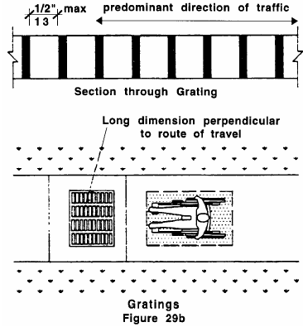  do not have spaces greater than ½” wide in the direction of travel, as per Figure 29b (22.7 & 29.4) | 2a  | ❑

when have elongated openings, they have long dimensions perpendicular to the dominant direction of travel, as per Figure 29b on page 10 (22.7 & 29.4) | 2b  | ❑
 | N/A/ 

Larger versions of all diagrams can be found in Appendix A in the order in which they appear in the MAAB regulations.

References and Codes used in developing the MFAT standards:

Americans with Disabilities Act (ADA) Standards for Accessible Design.
Available online at: http://www.ada.gov/reg3a.html

June Isaacson Kailes and Christie MacDonald "Brief: Importance of Accessible Examination Tables, Chairs and Weight Scales". Part of the Accessible Health Care Series at the Center for Disability Issues and the Health Professions at Western University of the Health Sciences. Edition 3: 4/08/09 Available online at:
http://www.cdihp.org/briefs/1%20%20Brief-Exam%20Tables%20and%20Scales-FINAL%20Edition%204_4%208%2009.doc

Massachusetts Architectural Access Board (MAAB) Rules and Regulations.
Accessible online. Go to http://www.mass.gov/aab.
Click on Architectural Access Board (in the left navigation bar).
Click on Rules and Regulations (towards the bottom of the page).

For more information or assistance on completing this survey, contact:

Massachusetts Department of Public Health
Office on Health and Disability
Health Care Access Project
250 Washington Street, 4th Floor
Boston, MA 02108

Voice: (617) 624-5070
Fax: (617) 624-5075
TTY: (617) 624-5992

MASSACHUSETTS FACILITY ASSESSMENT TOOL
Table of Contents
 |  |  |  | Page
Priority 1 - ACCESSIBLE APPROACH AND ENTRANCE |  |  |  |  | 1
 | Item 1 - Car-Accessible Parking Spaces………………….….………………….. |  |  |  | 2
 |  |  | Element 1 - Design…………………………..…………….……………………... |  | 2
 |  |  | Element 2 - Access Aisles……………………………………………………….. |  | 2
 |  |  | Element 3 - Signage………..…………………………………………………….. |  | 3
 | Item 2 - Van-Accessible Parking Spaces………..……….……………………… |  |  |  | 4
 |  |  | Element 1 - Design…………………………………..…….……………………... |  | 4
 |  |  | Element 2 - Access Aisles……………………………………………………….. |  | 4
 |  |  | Element 3 - Signage……..……………………………………………………….. |  | 5
 | Item 3 - Location of Accessible Parking Spaces.……..………….……………. |  |  |  | 6
 | Item 4 - Passenger Drop-off Area...………………………………………………. |  |  |  | 7
 | Item 5 - Accessible Parking Enforcement………………………………………. |  |  |  | 8
 | Item 6 - Exterior Accessible Route of Travel…..……………………….………. |  |  |  | 9
 |  |  | Element 1 - Pathway……...………………………………………………………. |  | 9
 |  |  | Element 2 - Grates………………………………..………………………………. |  | 10
 |  |  | Element 3 - Protruding Objects………………….………………………………. |  | 11
 |  |  | Element 4 - Curb Cuts……………………………………………………………. |  | 11
 |  |  | Element 5 - Ramps……………...……………………………………………… |  | 13
 | Item 7 - Accessible Entrance.…..…………………………………………………. |  |  |  | 16
 |  |  | Element 1 - Approach……...………………………….………………….………. |  | 16
 |  |  | Element 2 - Door……….………………………………………………………..... |  | 16
 |  |  | Element 3 - Doormats…………………………………………………………… |  | 19
 |  |  | Element 4 - Grates……………………………………………………………….. |  | 20
 |  |  | Element 5 - Protruding Objects..………………………………………………… |  | 20
 |  |  | Element 6 - Carpeting…..………………………………………………………… |  | 20
 |  |  | Element 7 - Directional Signage..……………………………………………….. |  | 21
Priority 2 – ACCESS TO GOODS AND SERVICES |  |  |  |  | 22
 | Item 1 - Directional Signage……….………………………………………………. |  |  |  | 23
 | Item 2 – Interior Accessible Route of Travel.…………………………..………. |  |  |  | 24
 |  |  | Element 1 - Halls/Corridors………………………………………………………. |  | 24
 |  |  | Element 2 - Carpeting…….………………………………………………………. |  | 25
 |  |  | Element 3 - Protruding Objects………….………………………………………. |  | 25
 |  |  | Element 4 - Ramps…….……….………………………………………………… |  | 25
 |  |  | Element 5 - Doors………..……………………………………………………...... |  | 27
 |  |  | Element 6 - Lifts……………………...……………………………………………. |  | 29
 |  |  | Element 7 - Elevators…………..………………………………………………… |  | 33
 |  |  | Element 8 - Exit…..……………………………………………………………….. |  | 37
 |  |  | Element 9 - Emergency Alarm System…………………………………………. |  | 37
 | Item 3 - Area of Rescue Assistance….………………………..…………………. |  |  |  | 38
 |  |  | Element 1 - General…………...………………………………………………….. |  | 38
 |  |  | Element 2 - Two-way Communication System…..……...…………………….. |  | 38
 |  |  | Element 3 - Signage…………..……………………………….…………………. |  | 39
 |  |  | Element 4 - Location and Construction.………………………………………… |  | 40
 | Item 4 - Accessible Stairway……………………...….……………………………. |  |  |  | 41
 |  |  | Element 1 - Steps………….……………………………………………………… |  | 41
 |  |  | Element 2 - Handrails…………………………………………………………….. |  | 41

MASSACHUSETTS FACILITY ASSESSMENT TOOL
Table of Contents continued
 |  |  |  | Page
 | Item 5 - Service Area……….………...……………………………………………... |  |  |  | 43
 |  |  | Element 1 - Reception/Intake Counter…………………..……………………… |  | 43
 |  |  | Element 2 - Waiting Areas……………………………………………………….. |  | 43
 |  |  | Element 3 - Doors.….…………………………………………………………...... |  | 44
 |  |  | Element 4 - Halls/Corridors………………………………………………………. |  | 45
 |  |  | Element 5 - Carpeting…….………………………………………………………. |  | 46
 |  |  | Element 6 - Protruding Objects….………………………………………………. |  | 47
 |  |  | Element 7 - Controls………………..…………………………………………….. |  | 47
 |  |  | Element 8 - Dressing Room………………….………………………………….. |  | 48
 |  |  | Element 9 - Alternative Changing Area………………………………………… |  | 49
 |  |  | Element 10 - Exam Room and Accessible Exam Table………………………  Element 11 - Mammography Machine…………………………………………..  Element 12 - Accessible Weight Scales………………………………………...  Element 13 - Meeting Room……………………………………………………... |  | 50  51  52  53
Priority 3 – USABILITY OF RESTROOMS |  |  |  |  | 55
 | Item 1 - Accessible Restroom……………………………….………………..…… |  |  |  | 56
 |  |  | Element 1 - General………………………………………………………………. |  | 57
 |  |  | Element 2 - Signage…………….………………………………………………... |  | 56
 |  |  | Element 3 - Entrance Door…...………………………………………………...... |  | 58
 |  |  | Element 4 - Urinal………….……………………………………………………… |  | 59
 |  |  | Element 5 - Toilet Stall……………..…………………………………………….. |  | 59
 |  |  | Element 6 - Toilet……..…………………………………………………………... |  | 60
 |  |  | Element 7 - Sink…………………………………………………………………. |  | 62
 |  |  | Element 8 - Dispensers/Devices………………………………………………… |  | 62
 |  |  | Element 9 - Controls & Receptacles…..…..……………………………………. |  | 64
Priority 4 – ADDITIONAL ACCESS |  |  |  |  | 65
 | Item 1 - Accessible Telephone…...………………………………….……………. |  |  |  | 66
 | Item 2 - Text Telephone…………………..………………………………………… |  |  |  | 68
 | Item 3 - Drinking Fountain……..…….…………………………………………….. |  |  |  | 69
 |  |  | Element 1 - Spout….……………………………………………………………... |  | 69
 |  |  | Element 2 - Controls……..……………………………………………………….. |  | 69
 |  |  | Element 3 - Configuration………………….…………………………………….. |  | 69
 |  |  | Element 4 - Cup Dispenser……..……………………………………………….. |  | 71
AppendiCES –  Appendix A – Figures ……………………………………………………………  Appendix B – Transition Plan ….……………………………………………….. |  |  |  |  | 72  80

MASSACHUSETTS FACILITY ASSESSMENT TOOL
Priority ❶
Accessible Approach and Entrance
People with disabilities should be able to arrive on the site, approach the building, and enter as freely as everyone else.
 | In this section, you will be assessing 7 Items related to “Accessible Approach and Entrance.” Some of these have particular Elements that will need assessing while others will not. Below is a list of the Items and Elements that will be assessed in this section.
ITEMS and ELEMENTS to be Assessed:
1 - Car-accessible Parking Spaces
Elements:
1 - Design
2 - Access Aisles
3 - Signage
2 - Van-accessible Parking Spaces
Elements:
1 - Design
2 - Access Aisles
3 - Signage
3 - Location of Accessible Parking Spaces
4 - Passenger Drop-off Area (if applicable)
5 - Accessible Parking Enforcement Procedure
6 - Exterior Route of Travel
Elements:
1 - Pathway
2 - Grates
3 - Protruding Objects
4 - Curb Cuts
5 - Ramps
7 - Accessible Entrance
Elements:
1 - Approach
2 - Door
3 - Doormats
4 - Grates
5 - Protruding Objects
6 - Carpeting
7 - Directional Signage

ITEM 1- CAR-ACCESSIBLE PARKING SPACES ❶
 | Assessment Objective: Use the table below to determine if the parking area includes the required amount of car-accessible parking spaces that meet all of the standards related to the Elements of car-accessible parking spaces: 1-Design, 2-Access Aisles, and 3-Signage. If no parking is available, skip to FINAL question in Car Accessible Parking Spaces and select N/A.
Required Amount of Car-Accessible Spaces
General Public Use (ADA 4.1.2 (5)a) & Residential Facilities* (10.3) |  |  | Medical Facilities (ADA 4.1.2(5)d)
Spaces in Lot |  | Min. # Accessible | Outpatient Units/Facilities:  10% of the total number of spaces provided to serve each outpatient unit or facility.
 | 1-25 | 1
 | 26-50 | 2
 | 51-75 | 3
 | 76-100 | 4 | Units/Facilities specializing in services for or treatment of persons with mobility impairments:  20% of the total number of parking spaces provided to serve each such unit or facility.
 | 100-150 | 5
 | 151-200 | 6
 | 201-300 | 7
 | 301-400 | 8
 | 401-500 | 9
 | 501-1000 | 2% of total
 | 1,001+ | 20 (+1 per/100 over 1000)
*The number of accessible spaces for residential facilities cannot be limited by 23.2.1. A sufficient number should be provided to meet the needs of the dwelling unit occupants.

Element 1 – DESIGN
Standards |  |  | YES | NO | Notes/Measurements (record if checking NO)
are a minimum of 8’ wide not including the access aisles (23.4.1) |  |  | 1a  | ❑
are as long as all other parking spaces (per 780 CMR) (23.4.2) |  |  | 1b  | ❑
have uniform, paved or hard packed smooth surfaces (23.4.4) |  |  | 1c  | ❑
are level & have surface slopes no greater than 1:50 (2%) in all directions (23.4.3) |  |  | 1d  | ❑
are marked by high contrast painted lines or other high contrast delineation (23.4.5) |  |  | 1e  | ❑
Do the required amount of car-accessible parking spaces meet
all of the above DESIGN standards?
1f. YES  NO 
Element 2 - Access aisles
Standards |  |  | YES | NO | Notes/Measurements (record if checking NO)
are part of a well lit accessible route to the building entrance (23.4.6a) |  |  | 2a  | ❑
are level and have surface slopes no greater than 1:50 (2%) in all directions (23.4.6d) |  |  | 2b  | ❑
are a minimum of 5’ wide (23.4.6b) |  |  | 2c  | ❑
CAR-ACCESSIBLE PARKING SPACES CONTINUED ❶
Element 2 - Access aisles continued
Standards |  |  | YES | NO | Notes/Measurements (record if checking NO)
are clearly marked by diagonal stripes (23.4.6e) |  |  | 2d  | ❑
when there are sidewalks at accessible parking spaces, they have curb cuts (23.5) |  |  | 2e  | ❑
 |  |  | N/A 
Note: 2 spaces may share a common access aisle.
Do the required amount of car-accessible parking spaces meet
all of the above ACCESS AISLE standards?
2f. YES  NO 
Element 3 - SIGNAGE
Standards |  |  | YES | NO | Notes/Measurements (record if checking NO)
is posted at the heads of spaces no more than 10’ away (23.6.1) |  |  | 3a  | ❑
is permanently secured in the ground with its top located between 5’ and 8’ above ground (23.6.4) |  |  | 3b  | ❑
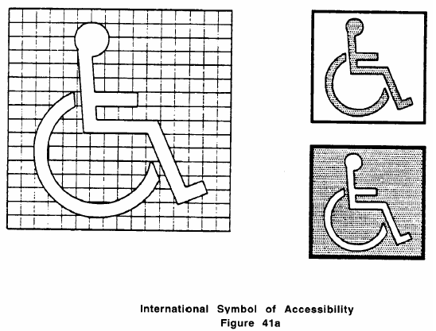  displays the international symbol of accessibility, as per Figure 41a (23.6.2) |  |  | 3c  | ❑
Do the required amount of car-accessible parking spaces meet
all of the above SIGNAGE standards?
3d. YES  NO 
Item 1 - Car-accessible Parking Spaces
Final Question: Does the facility’s parking area include the required amount of car-accessible parking spaces that meet all of the above standards?
YES  NO  N/A 

ITEM 2 - VAN-ACCESSIBLE PARKING SPACES ❶
Assessment Objective: Determine if the facility’s parking area provides at least 1 van accessible parking space (plus 1 for every 8 additional accessible spaces) that meets all of the standards related to the following Elements of van-accessible parking spaces: 1-Design, 2-Access Aisles, and 3-Signage.
If all of the required accessible parking spaces at the facility are at least 11’ wide with 5’ access aisle, van-accessible spaces do not have to be separately provided (23.4.7). In this case, do not assess them and skip down to the FINAL QUESTION on Van-Accessible Parking Spaces and answer N/A. If no parking is available, skip to the FINAL question and select N/A.
Element 1 – DESIGN
Standards |  |  | YES | NO | Notes/Measurements (record if checking NO)
are a minimum of 8’ wide, not including the access aisles (23.4.7d) |  |  | 1a  | ❑
are as long as all other parking spaces (per 780 CMR) (23.4.2) |  |  | 1b  | ❑
are level & have surface slopes no greater than 1:50 (2%) in all directions (23.4.3) |  |  | 1c  | ❑
have minimum vertical clearances of 8’2” at parking spaces and along the vehicle access route to parking from site entrance and exit (23.4.7a) |  |  | 1d  | ❑
have uniform, paved or hard packed smooth surfaces (23.4.4) |  |  | 1e  | ❑
are marked by high contrast painted lines or other high contrast delineation |  |  | 1f  | ❑
Does a minimum of 1 van accessible parking space (plus 1 for every 8 additional
accessible spaces) meet all of the above DESIGN standards?
1g. YES  NO 
Element 2 - Access aisles
Standards |  |  | YES | NO | Notes/Measurements (record if checking NO)
are a minimum of 8’ wide (23.4.7e) |  |  | 2a  | ❑
are level and have no surface slopes greater than 1:50 (2%) in all directions (23.4.6d) |  |  | 2b  | ❑
are clearly marked by diagonal stripes (23.4.6e) |  |  | 2c  | ❑
are part of a well lit accessible route to the building entrance (23.4.6a) |  |  | 2d  | ❑
when there are sidewalks at accessible parking spaces, they have curb cuts (23.5) |  |  | 2e  | ❑
 |  |  | N/A 
Does a minimum of 1 van accessible parking space (plus 1 for every 8 additional
accessible spaces) meet all of the above access aisle standards?
2f. YES  NO 
VAN-ACCESSIBLE PARKING SPACES CONTINUED ❶
Element 3 - SIGNAGE
Standards |  |  | YES | NO | Notes/Measurements (record if checking NO)
includes the words “Van Accessible” (23.4.7 & 23.6.3) |  |  | 3a  | ❑
displays the international symbol of accessibility, as per Figure 41a on page 3 (23.6.2) |  |  | 3b  | ❑
is posted at the heads of spaces no more than 10’ away (23.6.1) |  |  | 3c  | ❑
has its top located between 5’ and 8’ above the ground (23.6.4) |  |  | 3d  | ❑
Does a minimum of 1 van accessible parking space (plus 1 for every 8 additional
accessible spaces) meet all of the above signage standards?
3e. YES  NO 
Item 2 - Van-accessible Parking Spaces
Final Question: Does the facility’s parking area include at least 1 van-accessible parking space (plus 1 for every 8 additional accessible spaces) that meet all of the above standards?
YES  NO  N/A  (Van accessible spaces do not have to be separately provided if all
required accessible parking spaces are 11’ wide with a 5’ access aisle.)

ITEM 3 - LOCATION OF ACCESSIBLE PARKING SPACES ❶
Assessment Objective: Use the table below to determine if the accessible parking is provided in the proper location based on the scenario found at the facility.
All van-accessible spaces may be grouped on one level of a parking structure (23.4.7c).
Scenario | Location
accessible parking spaces serve a particular building | on the shortest accessible route of travel from adjacent parking to an accessible entrance (23.3.1)
accessible parking spaces do not serve a particular building | on the shortest accessible route of travel to an accessible pedestrian entrance of the parking facility (23.3.2)
accessible parking spaces are provided for a building with multiple accessible entrances with adjacent parking | dispersed and located closest to accessible entrances (23.3.3)
accessible parking spaces are provided in a multi-level garage with no elevator | near accessible entrance (23.3.4)

Item 3 - Location of Accessible Parking Spaces
Final (only) Question: Are the accessible parking spaces provided in the proper location according to the scenario found at the facility?
YES  NO 

ITEM 4 - PASSENGER DROP-OFF AREA ❶
Assessment Objective: If the accessible parking spaces cannot be located within 200’ of an accessible entrance, determine if the facility’s parking area has at least 1 passenger drop-off area within 100’ of an accessible entrance that meets all the standards listed below
If the parking spaces can be located within 200’ from an accessible entrance, a person does not have to assess a drop-off area (even if one exists) and can skip down to the FINAL QUESTION on Passenger Drop-off Area and answer N/A.
Standards |  |  | YES | NO | Notes/Measurements (record if checking NO)
is on a well lit accessible route of travel (23.7.1 & DPH) |  |  | 1a  | ❑
has access aisle a minimum of 60” wide & 20' long, adjacent & parallel to the vehicle pull-up space (23.7.2) |  |  | 1b  | ❑
has a vehicle standing space and access aisle that are level and do not have surface slopes greater than 1:50 (2%) in all directions (23.7.4) |  |  | 1c  | ❑
has a vertical clearance that is a minimum of 9’ 6” at the loading zone and along at least one vehicle access route to entrance (23.7.5) |  |  | 1d  | ❑
has a sign that identifies its use and displays the international symbol of accessibility, as per Figure 41a on page 3 (23.6.1 & 26.6.2) |  |  | 1e  | ❑
has its top located between 5’ and 8’ above the ground (23.6.4) |  |  | 1f  | ❑
when there is a curb between the access aisle and the vehicle pull-up space, it has a curb cut (23.7.3) |  |  | 1g  | ❑
 |  |  | N/A 
Item 4 - Passenger Drop-off Area
Final Question: Does the facility’s parking area include at least one passenger drop-off area located within 100’ of an accessible entrance that meet all of the above standards?
YES  NO  N/A  (If the accessible parking spaces can be located within 200’ of an
accessible entrance, a passenger drop-off area is not needed.)

ITEM 5 - ACCESSIBLE PARKING ENFORCEMENT PROCEDURE ❶
Assessment Objective: Determine if the facility has an accessible parking enforcement procedure in place.
Item 5 - Accessible Parking Enforcement Procedure
Final Question: Does the facility have an enforcement procedure in place that ensures accessible parking is used only by those who need it?
YES  NO  N/A 

ITEM 6 - EXTERIOR ACCESSIBLE ROUTE OF TRAVEL ❶
 |  | Assessment Objective: Determine if the facility has at least 1 exterior route of travel - that coincides with the route for the general public - from the accessible parking, passenger drop-off area (if applicable) and public streets or sidewalks to the accessible entrance that meets all of the standards for the following Elements of the exterior accessible route of travel: 1-Pathway, 2-Grates, 3-Protruding Objects, 4-Curb Cuts, and 5-Ramps.
Element 1 – pathway
Standards |  |  |  | YES | NO | Notes/Measurements (record if checking NO)
is continuous and unobstructed (20.1) |  |  |  | 1a  | ❑
is free of parked vehicles that reduce its clear width (36”) by overhanging or by protruding into it (23.4.2) |  |  |  | 1b  | ❑
is free of stairs, steps or escalators even if required to be accessible (20.1) |  |  |  | 1c  | ❑
has adequate lighting along entire route (DPH) |  |  |  | 1d  | ❑
is free of cross slopes greater than 1:50 (2%) (20.9) |  |  |  | 1e  | ❑
is free of slopes greater than 1:20 (5%) (20.9 )  Note: Any slope greater than 1:20 is considered a ramp (20.9) |  |  |  | 1f  | ❑
has a clear width that is a minimum of 36” for entire route of travel (20.3) |  |  |  | 1g  | ❑
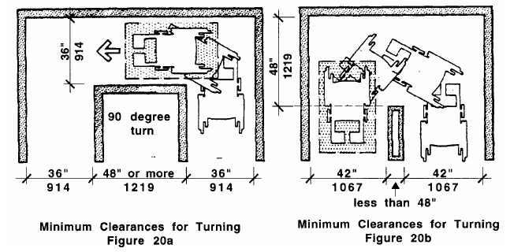  has a minimum clear width for a person using a wheelchair to turn around an obstruction, as per Figures 20a & 20b (20.4) |  |  |  | 1h  | ❑
when less than 60” wide, it has passing spaces a minimum of 60” x 60,” located at intervals no greater than 200’, as per Figure 6b (20.5)  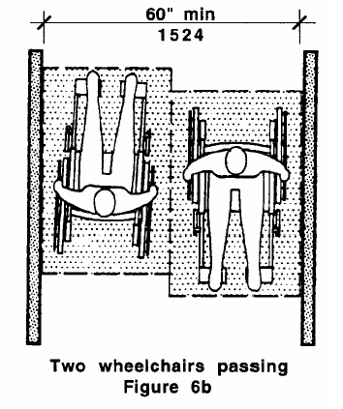  Note: T-intersections are acceptable passing places (20.5) |  |  |  | 1i  | ❑
 |  |  |  | N/A 
has walks that are stable, firm and slip resistant (22.5 & 29.1) |  |  |  | 1j  | ❑
EXTERIOR ACCESSIBLE ROUTE OF TRAVEL CONTINUED ❶
Element 1 - pathway continued
Standards |  |  |  | YES | NO | Notes/Measurements (record if checking NO)
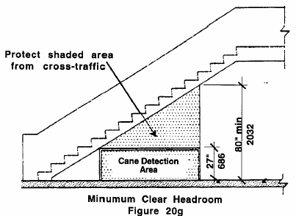  has clear headroom that is a minimum of 80” high for entire route of travel, as per Figure 20g (20.7) |  |  |  | 1k  | ❑
when vertical clearance is reduced to less than 80” at any point along route of travel, a barrier is provided to warn blind or visually-impaired persons (20.7) |  |  |  | 1l  | ❑
 |  |  |  | N/A 
when crosses curb it has a curb cut (21.2) |  |  |  | 1m | ❑
 |  |  |  | N/A 
has walks a minimum of 48” wide with an unobstructed path of travel that is at least 36” clear excluding curb stones (22.2) |  |  |  | 1n  | ❑
has grading and drainage to minimize pooling of water or accumulation of ice or flow of water across walks (22.6) |  |  |  | 1o  | ❑
when there are level changes greater than ½”, ramps or other means of vertical access are provided (29.2.3) |  |  |  | 1p  | ❑
 |  |  |  | N/A/ 
when there are level changes between ¼” and ½,” they have beveled edges with slopes no greater than 1:2 (50%), as per Figure 20h (22.4.1)  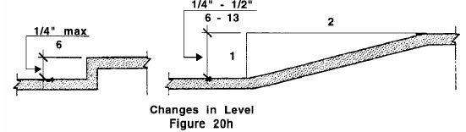 |  |  |  | 1q  | ❑
 |  |  |  | N/A/ 
Does the pathway of the exterior route of travel assessed,
meet all of the above PATHWAY standards?
1r. YES  NO 
Element 2 - grateS
 | If NO grates exist along the route, skip down to the end of the grate standards Element and answer N/A.
Standards |  |  |  | YES | NO | Notes/Measurements (record if checking NO)
do not have spaces greater than ½” wide in the direction of travel, as per Figure 29b (22.7 & 29.4 |  |  |  | 2a  | ❑
EXTERIOR ACCESSIBLE ROUTE OF TRAVEL CONTINUED ❶
Element 2 - grateS CONTINUED
when have elongated openings, they have long dimensions perpendicular to the dominant direction of travel, as per Figure 29b on page 10 (22.7 & 29.4) |  |  |  | 2b  | ❑
 |  |  |  | N/A 
Do all of the grates within the exterior route of travel assessed,
meet all of the above GRATE standards?
2c. YES  NO  N/A 
Element 3 - PROTRUDING OBJECTS
 | If NO protruding objects exist along the route, skip down to the end of the protruding objects standards answer N/A.
Standards |  |  |  | YES | NO | Notes/Measurements (record if checking NO)
are free of sharp or abrupt edges (20.6.1) |  |  |  | 3a  | ❑
do not reduce the clear width (36”) of route of travel or maneuvering spaces (20.6) |  |  |  | 3b  | ❑
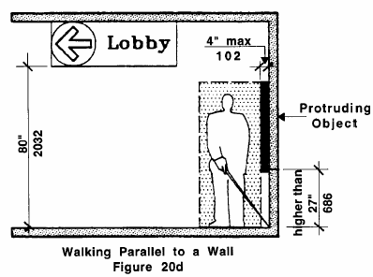  when mounted on a wall between 27” and 80” above ground, do not protrude more than 4” into passageways, walks, etc., as per Figure 20d (20.6.1) |  |  |  | 3c  | ❑
 |  |  |  | N/A 
Do all of the protruding objects within the exterior route of travel you assessed
meet all of the above PROTRUDING OBJECTS standards?
3d. YES  NO  N/A 
Element 4 - curb cuts
 | If NO curb cuts exist along the route, skip down to the end of the curb cut standards below and answer N/A.
Standards |  |  |  | YES | NO | Notes/Measurements (record if checking NO)
GENERAL:
are located or protected to prevent obstruction by parked cars (21.2.5) |  |  |  | 4a  | ❑
are free of slopes greater than 1:12 (8.3%) (21.3) |  |  |  | 4b  | ❑
Note: No tolerances are allowed on any slopes (21.3).
are free of cross slopes greater than 1:50 (2%) (21.3) |  |  |  | 4c  | ❑
have clear widths that are a minimum of 36” exclusive of the flared sides (21.6) |  |  |  | 4d  | ❑
have sides that extend at least 24” at curb (21.7) |  |  |  | 4e  | ❑
EXTERIOR ACCESSIBLE ROUTE OF TRAVEL CONTINUED ❶
Element 4 - curb cuts CONTINUED
Standards |  |  |  | YES | NO | Notes/Measurements (record if checking NO)
GENERAL CONTINUED:
have flares with slopes no greater than 1:10 (10%) (21.7) |  |  |  | 4f  | ❑
have transitions to walks, gutters, or streets that are flush or free of level changes greater than ½” (21.4) |  |  |  | 4g  | ❑
have adjoining gutters and road surfaces (adjacent to curb cuts or route) with slopes no greater than 1:20 (5%) (21.4) |  |  |  | 4h  | ❑
have grading and drainage designed to minimize accumulation of ice, pooling of water, or flow of water across base (21.5) |  |  |  | 4i  | ❑
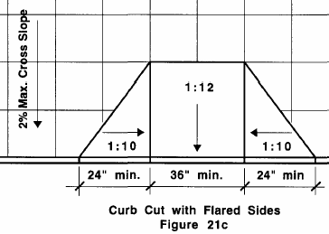  have curbing at the flared sides that blends with the slope of the flared sides, as per Figure 21c (21.7) |  |  |  | 4j  | ❑
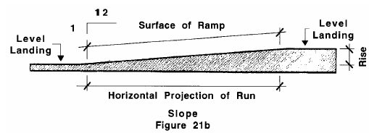  when sidewalks are too narrow for straight-line curb cuts at slopes of 1:12, curb cuts have sides that are no greater than 1:12, as per Figure 21b (21.3) |  |  |  | 4k  | ❑
 |  |  |  | N/A 
Notes: Curb cuts with returned sides are allowed when protected by handrails or when pedestrian travel across a ramp is obstructed by permanently installed street hardware or landscaping (21.8).
Built-up curb cuts are allowed only when they don’t project into vehicle traffic lanes (21.9).
Detectable Warnings:
have raised truncated domes 0.9” in diameter, and 0.2” in height, with a center-to-center spacing of 2.35” (ADA 4.7.7 & 4.29.2) |  |  |  | 4l  | ❑
contrast visually with adjoining surfaces (either light-on-dark, or dark-on-light) (ADA 4.7.7 & 4.29.2) |  |  |  | 4m | ❑
have a contrasting material that is an integral part of the walking surface (ADA 4.7.7 & 4.29.2) |  |  |  | 4n  | ❑
extend the full width and depth of the curb cut (ADA 4.7.7 & 4.29.2) |  |  |  | 4o  | ❑
EXTERIOR ACCESSIBLE ROUTE OF TRAVEL CONTINUED ❶
Element 4 - curb cuts CONTINUED
Standards |  |  |  | YES | NO | Notes/Measurements (record if checking NO)
landings:
are the same widths as curb cuts (21.6.1) |  |  |  | 4p  | ❑
are 48” long (21.6.1) |  |  |  | 4q  | ❑
are located at the tops of curb cuts (21.6.1) |  |  |  | 4r  | ❑
are free of slopes greater than 1:50 (2%) in any direction (21.6.1) |  |  |  | 4s  | ❑
Do all of the curb cuts within the exterior route of travel assessed,
meet all of the above CURB CUT standards?
4t. YES  NO  N/A 
Element 5 – RAMPs
If NO ramps exist along the route, skip down to the end of the ramp standards and answer N/A.
Note: Circular ramps are not permitted, except with approval of the MA Architectural Access Board (24.10).
Standards |  |  |  | YES | NO | Notes/Measurements (record if checking NO)
GENERAL:
have stable, firm, and slip resistant surfaces (24.7) |  |  |  | 5a  | ❑
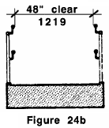  have clear widths a minimum of 48,” measured between railings, as per 24b (24.3) |  |  |  | 5b  | ❑
have run rises a maximum of 30” (24.2.2) |  |  |  | 5c  | ❑
are free of cross slopes greater than 1:50 (2%) (24.6) |  |  |  | 5d  | ❑
are free of slopes greater than 1:12 (8.3%), measured between any two points (24.2)  Note: A slope between 1:10 and 1:12 is allowed for a single rise of 3” maximum (24.2). No tolerance is allowed (24.2.1). |  |  |  | 5e  | ❑
are designed so that water does not accumulate on surfaces (24.9) |  |  |  | 5f  | ❑
have walls, railings, projecting surfaces, or edge curbs that are a minimum of 2” high, that prevent people from slipping off ramps when there are drop offs (24.8) |  |  |  | 5g  | ❑
when gratings exist they are free of spaces greater than ½” in the direction of travel, as per Figure 29b on page 10 (22.7 & 29.4) |  |  |  | 5h  | ❑
 |  |  |  | N/A 
when gratings with elongated openings exist, are placed with their long dimensions perpendicular to dominant direct. of travel, as per Figure 29b on page 10 (22.7 & 29.4) |  |  |  | 5i  | ❑
 |  |  |  | N/A 
EXTERIOR ACCESSIBLE ROUTE OF TRAVEL CONTINUED ❶
Element 5 - RAMPs CONTINUED
Standards |  |  |  | YES | NO | Notes/Measurements (record if checking NO)
Landings:
are located at the tops & bottoms of ramps and ramp runs, and where there are changes in ramp direction (24.4) |  |  |  | 5j  | ❑
are level and unobstructed by projections or door swings (24.4.1) |  |  |  | 5k  | ❑
are at least as wide as the ramp runs leading to them (24.4.2) |  |  |  | 5l  | ❑
are a minimum of 5’ long (24.4.3) |  |  |  | 5m  | ❑
have walls, railings, projecting surfaces, or edge curbs at least 2” high, to prevent people from slipping off when there are drop offs (24.8) |  |  |  | 5n  | ❑
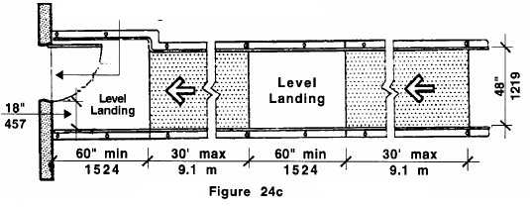  have a maximum of 30’ of ramp run between them, as per Figure 24c (24.4) |  |  |  | 5o  | ❑
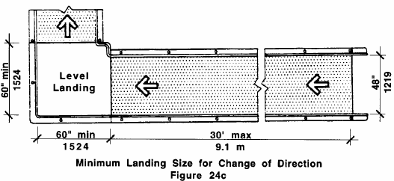  when ramps change direction at landings, landings are a minimum of 60” x 60,” as per Figure 24c (24.4.5) |  |  |  | 5p  | ❑
 |  |  |  | N/A 
when doorways are present, landings have level areas in front of doorways, as per Figures 26d & 26e on page 18 (24.4.6) |  |  |  | 5q  | ❑
 |  |  |  | N/A 
handrails:
are provided at all ramps, on both sides of ramp segments (24.5 & 24.5.1) |  |  |  | 5r  | ❑
are provided in parallel pairs with one between 34” and 38” high, and the other between 18” and 20” high, measured vertically from surface of ramps to tops of handrails (24.5.2) |  |  |  | 5s  | ❑
are continuous without interruption except by doorways and openings, so one can run a hand end to end without interruption (24.5.3) |  |  |  | 5t  | ❑
have ends that are rounded or returned smoothly to ground, wall, or post (24.5.9) |  |  |  | 5u  | ❑
EXTERIOR ACCESSIBLE ROUTE OF TRAVEL CONTINUED ❶
Element 5 - RAMPs CONTINUED
Standards |  |  |  | YES | NO | Notes/Measurements (record if checking NO)
handrails continued:
do not rotate within fittings (24.5.10) |  |  |  | 5v  | ❑
are extended a minimum of 12” beyond tops & bottoms of ramps & are parallel with the ground except when extension would cause a safety hazard, as per Figure 24d (24.5.4) |  |  |  | 5w | ❑
have gripping surfaces that are free of sharp or abrasive elements (24.5.7) |  |  |  | 5x  | ❑
have handgrips that are between 1¼” and 1½” nominal in diameter (24.5.5) |  |  |  | 5y  | ❑
have handgrips that are round or oval in cross-section (24.5.6) |  |  |  | 5z  | ❑
when mounted adjacent to walls, they have clear spaces of 1½” between the handrails and the walls |  |  |  | 5aa | ❑
 |  |  |  | N/A 
Note: Handrails may be located in wall recesses if recesses are no deeper than 3” and extend a minimum of 18” above rail tops (24.5.8).
Do all of the ramps within the exterior route of travel assessed,
meet all of the above RAMP standards?
5bb. YES  NO  N/A 
Item 6 - Exterior Accessible Route of Travel
Final Question: Does the facility have at least one route of travel - coinciding with the route for the general public - that goes from the accessible parking, passenger drop-off area (if applicable) and public streets or sidewalks, to the accessible entrance, that meets all of the above standards?
YES  NO 

ITEM 7 - ACCESSIBLE ENTRANCE ❶
Assessment Objective: Determine if the facility has at least 1 entrance, the main entrance or an alternate entrance, that meets all of the standards related to the following Elements of an accessible entrance: 1-Approach, 2-Door, 3-Doormats, 4-Grates, 5-Protruding Objects, 6-Carpeting, and 7-Directional Signage.
If the only entrance is a service entrance, that entrance has to be accessible and should be assessed (25.1.1).
Element 1 – APPROACH
Standards |  |  |  |  |  | YES |  | NO |  | Notes/Measurements (record if checking NO)
is protected from the weather by a canopy or roof overhang (13.4) |  |  |  |  |  | 1a  |  | ❑
has a slip resistant paved walk or ramp uninterrupted by steps (25.2) |  |  |  |  |  | 1b  |  | ❑
Does the approach of the entrance assessed meet all of the above APPROACH standards?
1c. YES  NO 
Element 2 - door
Standards |  |  |  |  |  | YES |  | NO |  | Notes/Measurements (record if checking NO)
GENERAL:
can be unlocked and opened with one hand (26.11.3) |  |  |  |  |  | 2a  |  | ❑
requires no more than 15 lbs of force to open when hinged, and no more than 5 lbs of force to open when sliding or folding (26.8.1) Note: Power assisted or automatic doors are exempt (26.6). |  |  |  |  |  | 2b  |  | ❑
when the opening force required is more than the maximum allowed, compensating device or automatic opening device is provided (26.8.2) |  |  |  |  |  | 2c  |  | ❑
 |  |  |  |  |  | N/A 
has a handle or control located between 36” and 48” above the ground (26.11.2) |  |  |  |  |  | 2d  |  | ❑
has a handle or control that is operable using a maximum of 5 lbs of force (26.11.3) |  |  |  |  |  | 2e  |  | ❑
has a handle or control that is operable using one hand that does not require tight grasping, tight pinching, or twisting of the wrist (26.11.1) (i.e., operable with a closed fist) Note: This also applies to door pulls, latches and locks. (26.11.1) |  |  |  |  |  | 2f  |  | ❑
when has a closer, door takes at least 6 seconds to close from open position of 90° (26.9) |  |  |  |  |  | 2g  |  | ❑
 |  |  |  |  |  | N/A 
when a sliding door, it has exposed hardware usable from both sides when door is fully open (26.11.1) |  |  |  |  |  | 2h  |  | ❑
 |  |  |  |  |  | N/A 
ACCESSIBLE ENTRANCE CONTINUED ❶
Element 2 - door continued
Standards |  |  |  |  |  | YES |  | NO |  | Notes/Measurements (record if checking NO)
GENERAL CONTINUED:
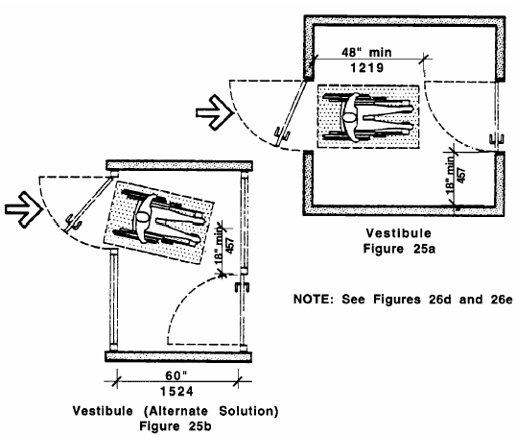  when there are 2 doors in series, they have a minimum of 48” between them, plus the width of door swinging into space, as per Figures 25a & 25b (26.7) |  |  |  |  |  | 2i  |  | ❑
 |  |  |  |  |  | N/A 
when there are 2 doors in series, doors swing in same direction or away from the space between them (26.7) |  |  |  |  |  | 2j  |  | ❑
 |  |  |  |  |  | N/A 
when a revolving door, there is an adjacent accessible door that allows entrance and exit and is unlocked whenever the revolving door is unlocked (26.2.1 & 26.2.2) |  |  |  |  |  | 2k  |  | ❑
doorway:
has a clear opening of at least 32”, measured from the face of the stop on the latch side to the door face when open 90° (26.5)  Note: A bi-fold, accordion, or pocket door opening is measured when door is in a fully open position (26.5). |  |  |  |  |  | 2l  |  | ❑
when a double door, it has at least one leaf that is active and has a minimum clear opening of 32” (26.4) |  |  |  |  |  | 2m |  | ❑
 |  |  |  |  |  | N/A 
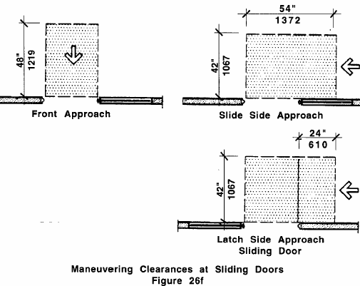  when a sliding door, it has level clear ground and floor spaces, as per Figure 26f (26.6.1 & 26.6.5) |  |  |  |  |  | 2n  |  | ❑
 |  |  |  |  |  | N/A 
ACCESSIBLE ENTRANCE CONTINUED ❶
Element 2 - door continued
Standards |  |  |  |  |  | YES |  | NO |  | Notes/Measurements (record if checking NO)
doorwaY CONTINUED:
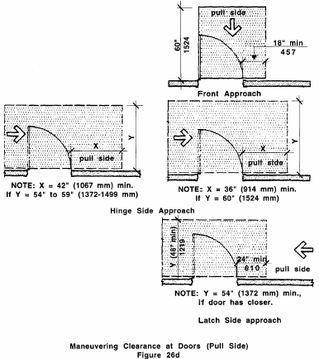  has the minimum level clear ground and floor spaces on the latch, pull side of entrance door, as per Figure 26d (26.6.1 & 26.6.3) |  |  |  |  |  | 2o  |  | ❑
has the minimum level clear ground and floor spaces on the push side of entrance door, as per Figure 26e (26.6.1 & 26.6.4)  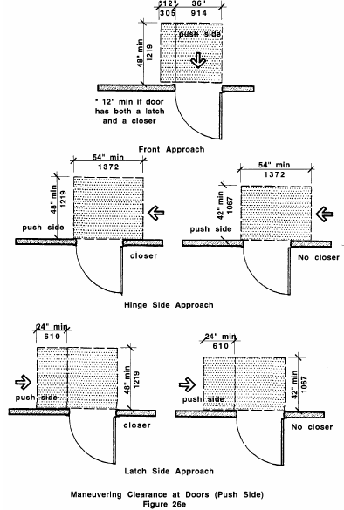 |  |  |  |  |  | 2p  |  | ❑
when a double door, there are minimum level clear ground and floor spaces on the push and pull sides of the door, as per Figures 26d & 26e above (26.4) |  |  |  |  |  | 2q  |  | ❑
 |  |  |  |  |  | N/A 
ACCESSIBLE ENTRANCE CONTINUED ❶
Element 2 - door continued
Standards |  |  |  |  |  | YES |  | NO |  | Notes/Measurements (record if checking NO)
doorwaY CONTINUED:
when a power assisted door, there are minimum level clear ground and floor spaces on the push and pull sides of the door, as per Figures 26d & 26e on page 18 (26.4 & DPH) |  |  |  |  |  | 2r  |  | ❑
 |  |  |  |  |  | N/A 
when entrance door is located in a recess of more than 6”, measured within 6” of door, has minimum level clear ground & floor spaces on push and pull sides of door as per Figures 26d & 26e on pg. 18 (26.4) |  |  |  |  |  | 2s  |  | ❑
 |  |  |  |  |  | N/A 
Note: Automatic doors are exempt from the clear ground and floor space requirements (26.6).
Threshold:
is no higher than ½”, nor ¾” when a sliding door (26.10.1 & 26.10.3) |  |  |  |  |  | 2t  |  | ❑
does not have a slope that is greater than 1:2 (50%) or 1:4 when under a sliding door (26.10.1 & 26.10.3) |  |  |  |  |  | 2u  |  | ❑
has beveled edges on both sides (26.10.1 & 26.10.3) |  |  |  |  |  | 2v  |  | ❑
when floor finish materials change, threshold is beveled at a ratio of 1:2 (50%) or has edge stripping (26.10) |  |  |  |  |  | 2w |  | ❑
 |  |  |  |  |  | N/A 
Does the door to the entrance assessed meet all of the above DOOR standards?
2x. YES  NO 
Element 3 - doormats
 | If NO doormats exist at the entrance, skip down to the end of the doormat standards below and answer N/A.
Standards |  |  |  |  |  | YES |  | NO |  | Notes/Measurements (record if checking NO)
when ½” thick or less, they are securely anchored at all edges (25.4) |  |  |  |  |  | 3a  |  | ❑
 |  |  |  |  |  | N/A 
when between ¼” and ½” thick, they are secured and have beveled edges with slopes no greater than 1:2 (50%) (25.4) |  |  |  |  |  | 3b  |  | ❑
 |  |  |  |  |  | N/A 
when thicker than ½”, they are recessed (25.4) |  |  |  |  |  | 3c  |  | ❑
 |  |  |  |  |  | N/A 
Did all of the doormats within the entrance assessed meet
all of the above DOORMATS standards?
3d. YES  NO  N/A 
ACCESSIBLE ENTRANCE CONTINUED ❶
Element 4 – grates
 | If NO grates exist at the entrance you are assessing, skip down to the end of the grate standards and answer N/A.
Standards |  |  |  |  |  | YES |  | NO |  | Notes/Measurements (record if checking NO)
are free of spaces greater than ½” wide in the direction of travel, as per Figure 29b on page 10 (22.7 & 29.4) |  |  |  |  |  | 4a  |  | ❑
when have elongated openings, are placed with their long dimensions perpendicular to the dominant direction of travel, as per Figure 29b on page 10 (22.7 & 29.4) |  |  |  |  |  | 4b  |  | ❑
 |  |  |  |  |  | N/A 
Do all of the grates within the entrance assessed meet
all of the above GRATES standards?
4c. YES  NO  N/A 
Element 5 - Protruding Objects
 | If NO protruding objects are at the entrance being assessed, skip down to the end of the protruding object standards and answer N/A.
Standards |  |  |  |  |  | YES |  | NO |  | Notes/Measurements (record if checking NO)
are free of sharp or abrupt edges (20.6.1) |  |  |  |  |  | 5a  |  | ❑
do not reduce the clear width of the route of travel or maneuvering spaces (20.6) |  |  |  |  |  | 5b  |  | ❑
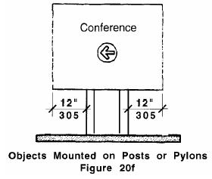  when free-standing & mounted on a post or pylon, are free of overhangs more than 12,” measured between 27” & 80” above ground, as per Figure 20f (20.6.3) |  |  |  |  |  | 5c  |  | ❑
 |  |  |  |  |  | N/A 
when mounted on wall between 27” & 80” above ground, they do not protrude more than 4” into walks, passageways, etc., as per Figure 20d on pg. 11 (24.4.6 & 20.6.1) |  |  |  |  |  | 5d  |  | ❑
 |  |  |  |  |  | N/A 
Do all of the protruding objects within the entrance assessed meet
all of the above PROTRUDING OBJECTS standards?
5e. YES  NO  N/A 
Element 6 - carpeting
 | If NO carpeting exists at the entrance, skip down to the end of the carpeting standards and answer N/A.
Standards |  |  |  |  |  | YES |  | NO |  | Notes/Measurements (record if checking NO)
is adhered directly to the floor -or- is stretched tautly and fastened to floor surfaces at all edges (29.3.2) |  |  |  |  |  | 6a  |  | ❑
is high density and non-absorbent (29.3.1) |  |  |  |  |  | 6b  |  | ❑
has a maximum pile of ½” (29.3.1) |  |  |  |  |  | 6c  |  | ❑
ACCESSIBLE ENTRANCE CONTINUED ❶
Element 6 - carpeting CONTINUED
Standards |  |  |  |  |  | YES |  | NO |  | Notes/Measurements (record if checking NO)
when there is padding, it is not more than ¼” thick and is secured to floor (29.3.4) |  |  |  |  |  | 6d  |  | ❑
 |  |  |  |  |  | N/A 
when edges are exposed to traffic, they have trim along entire length (29.3.3) |  |  |  |  |  | 6e  |  | ❑
 |  |  |  |  |  | N/A 
when edges are perpendicular to the direction of travel, they have beveled edging strips that are no higher than 3/8” above the floor (29.3.3) |  |  |  |  |  | 6f  |  | ❑
 |  |  |  |  |  | N/A 
when edges are perpendicular to direction of travel, they have edging strips with slopes no greater than 1:2 (50%) (29.3.1) |  |  |  |  |  | 6g  |  | ❑
 |  |  |  |  |  | N/A 
Does the carpeting within the entrance assessed meet
all of the above CARPETING standards?
6h. YES  NO  N/A 
Element 7 - directional Signage
If the main entrance of the facility is not the accessible entrance being assessed, determine if there is directional signage at the main entrance that indicates the location of the accessible entrance and meets all of the below standards.
If the main entrance IS the accessible entrance being evaluated, skip down to the end of the signage standards and answer N/A.
Standards |  |  |  |  |  | YES |  | NO |  | Notes/Measurements (record if checking NO)
has characters sized according to distance from which they are to be read (41.4) |  |  |  |  |  | 7a  |  | ❑
has characters and a background that are eggshell, matte, -or- another non-glare finish (41.6) |  |  |  |  |  | 7b  |  | ❑
has characters and symbols that contrast with the background, either light on dark or dark on light (41.6) |  |  |  |  |  | 7c  |  | ❑
when suspended or overhead, characters are at least 3” high, measured with a capital X (41.4.1) Note: Lower case is allowed (41.4.2). |  |  |  |  |  | 7d  |  | ❑
 |  |  |  |  |  | N/A 
Does the directional signage at the main entrance meet all of
the above DIRECTIONAL SIGNAGE standards?
7e. YES  NO  N/A 
Item 7 - Accessible Entrance
Final Question: Does the facility have at least one accessible entrance, the main entrance or an alternate entrance, that meets all of the above standards?
YES  NO 
MASSACHUSETTS FACILITY ASSESSMENT TOOL
Priority ❷
Access To Goods and Services
Ideally, the layout of the interior of the building should allow people with disabilities to obtain
materials or services without assistance.
 | In this section, assess the 5 Items related to “Access to Goods and Services.” Some of these have particular Elements that will need assessing while others will not. Below is a list of the Items and Elements that you will be assessing in this section.
ITEMS and ELEMENTS to be Assessed:
1 - Directional Signage
2 - Interior Accessible Route of Travel
ELEMENTS:
1 - Halls/Corridors
2 - Carpeting
3 - Protruding Objects
4 - Ramps
5 - Doors
6 - Lifts
7 - Elevators
8 - Exit
9 - Emergency Alarm System

3 - Area of Rescue Assistance
ELEMENTS:
1 - General
2 - Two-way Communication System
3 - Signage
4 - Location and Construction
4 - Accessible Stairway
ELEMENTS:
1 - Steps
2 - Handrails
5 - Service Area
ELEMENTS:
1 - Reception/Intake Counter
2 - Waiting Areas
3 - Doors
4 - Halls/Corridors
5 - Carpeting
6 - Protruding Objects
7 - Controls
8 - Dressing Room
9 - Alternative Changing Area
10 - Exam Room and Accessible Exam Table
11 - Mammography Machine
ITEM 1 - directional signage ❷
 |  | Assessment Objective: Determine that upon entering the facility there is directional signage indicating the location of the service area that meets all the standards listed below.
Standards |  |  |  |  | YES |  | NO |  | Notes/Measurements (record if checking NO)
has characters and numbers sized according to the viewing distance from which they are to be read (41.4) |  |  |  |  | 1a  |  | ❑
has characters and symbols that contrast with the background, either light on dark or dark on light (41.6) |  |  |  |  | 1b  |  | ❑
has characters and a background that are eggshell, matte, -or- another non-glare finish (41.6) |  |  |  |  | 1c  |  | ❑
when suspended or overhead, characters are at least 3” high, measured with a capital X (41.4.1)  Note: Lower case characters are permitted (41.4.2). |  |  |  |  | 1d  |  | ❑
Item 1 - Directional Signage
Final Question: Upon entering the facility, is there directional signage indicating the location of the service area that meets all of the above standards?
YES  NO 

ITEM 2 - interior ACcessible route of travel ❷
Assessment Objective: Determine if the facility has at least one route of travel to the service area that coincides with the route for the general public and meets all of the standards related to the following Elements of an interior accessible route of travel: 1-Halls/Corridors, 2-Carpeting, 3-Protruding Objects, 4-Ramps, 5-Doors, 6-Lifts, 7-Elevators, 8-Exit, and 9-Emergency Alarm System.
ONLY assess the Items that are along a DIRECT ROUTE to the service area.
Element 1 - HALLS/CORRIDORS
Standards |  |  |  | YES |  | NO | Notes/Measurements (record if checking NO)
have stable, firm and slip resistant surfaces (29.1) |  |  |  | 1e  |  | ❑
are continuous and unobstructed (20.1) |  |  |  | 1f  |  | ❑
do not include stairs, steps or escalators even if required to be accessible (20.1) |  |  |  | 1g  |  | ❑
are free of cross slopes greater than 1:50 (2%) (20.9) |  |  |  | 1h  |  | ❑
are free of slopes greater than 1:20 (5%) (20.9 ) Note: Any slope greater than 1:20 is considered a ramp (20.9) |  |  |  | 1i  |  | ❑
have minimum clear widths for a person using a wheelchair to turn around an obstruction, as per Figures 20a & 20b on page 9 (20.4) |  |  |  | 1j  |  | ❑
have clear widths of a minimum of 36” for entire route of travel, except at doors or openings less than 24” deep (20.3) |  |  |  | 1k  |  | ❑
when less than 60” wide, have passing spaces of at least 60” x 60,” located at intervals no greater than 200’, as per Fig. 6b on page 9 (20.5) Note: T-intersections are acceptable passing places (20.5). |  |  |  | 1l  |  | ❑
 |  |  |  | N/A 
have clear headroom that is a minimum of 80” high for entire route of travel, as per Figure 20g on page 10 (20.7) |  |  |  | 1m |  | ❑
when vertical clearances are reduced to less than 80”, barriers are provided to warn blind or visually-impaired persons (20.7) |  |  |  | 1n  |  | ❑
 |  |  |  | N/A 
when there are level changes greater than ½,” ramps or other means of vertical access are provided (29.2.3) |  |  |  | 1o  |  | ❑
 |  |  |  | N/A 
when there are level changes between ¼” and ½”, they have beveled edges with slopes no greater than 1:2 (50%), as per Figure 20h on page 10 (22.4.1) |  |  |  | 1p  |  | ❑
 |  |  |  | N/A 
Do all of the halls/corridors within the interior route of travel assessed meet
all of the above HALLS/CORRIDORS standards?
1q. YES  NO 
interior ACcessible route of travel continued ❷
Element 2 – carpeting
 |  | If NO carpeting exists within the route you are assessing, skip down to the end of the carpeting standards and answer N/A.
Standards |  |  |  | YES |  | NO |  |  |  |  | Notes/Measurements (record if checking NO)
is high density and non-absorbent (29.3.1) |  |  |  | 2a  |  | ❑
has a maximum pile of ½” (29.3.1) |  |  |  | 2b  |  | ❑
is adhered directly to the floor -or- is stretched tautly and fastened to floor surfaces at all edges (29.3.2) |  |  |  | 2c  |  | ❑
when padding is installed, it is not more than ¼” thick and is secured taut to floor (29.3.4) |  |  |  | 2d  |  | ❑
 |  |  |  | N/A 
when edges are exposed to traffic, they have trim along entire length (29.3.3) |  |  |  | 2e  |  | ❑
 |  |  |  | N/A 
when edges are perpendicular to direction of travel, they have beveled edging strips no higher than 3/8” above the floor (29.3.3) |  |  |  | 2f  |  | ❑
 |  |  |  | N/A 
when edges are perpendicular to direction of travel, they have edging strips with slopes no greater than 1:2 (50%) (29.3.1) |  |  |  | 2g  |  | ❑
 |  |  |  | N/A 
Does the carpeting within the interior route of travel assessed meet
all of the above CARPETING standards?
2h. YES  NO  N/A 
Element 3 - Protruding Objects
 | If NO protruding objects exist within the route you are assessing, skip down to the end of the protruding objects standards and answer N/A.
Standards |  |  |  | YES |  | NO |  |  |  |  |  |  | Notes/Measurements (record if checking NO)
are free of sharp or abrupt edges (20.6.1) |  |  |  | 3a  |  | ❑
do not reduce clear width (36”) of the route of travel or maneuvering spaces (20.6) |  |  |  | 3b  |  | ❑
when mounted on a wall between 27” and 80” above the floor, they do not protrude more than 4” into walks, passageways, or aisles, as per Figure 20d on pg. 11 (20.6.1) |  |  |  | 3c  |  | ❑
 |  |  |  | N/A 
Do all of the protruding objects within the interior route of travel assessed meet
all of the above PROTRUDING OBJECTS standards?
3d. YES  NO  N/A 
Element 4 – Ramps
ONLY assess those ramps that someone MUST use to get to the service area. If NO ramps exist within the route you are assessing, skip down to the end of the ramp standards and answer N/A.
Note: Circular ramps are not permitted, except with approval of the MA Architectural Access Board (24.10).
interior ACcessible route of travel continued ❷
Element 4 - Ramps continued
Standards |  |  |  | YES |  | NO |  | Notes/Measurements (record if checking NO)
GENERAL:
have stable, firm, and slip resistant surfaces (24.7) |  |  |  | 4a  |  | ❑
have clear widths that are a minimum of 48”, measured between railings, as per Figure 24b on page 13 (24.3) |  |  |  | 4b  |  | ❑
have run rises that are a maximum of 30” (24.2.2) |  |  |  | 4c  |  | ❑
are free of cross slopes greater than 1:50 (2%) (24.6) |  |  |  | 4d  |  | ❑
are free of slopes greater than 1:12 (8.3%), measured between any two points on ramps (24.2)  Notes: A slope between 1:10 & 1:12 is permitted for a single rise of 3” maximum (24.2).  No tolerance is allowed (24.2.1). |  |  |  | 4e  |  | ❑
have walls, railings, projecting surfaces or edge curbs that are a minimum of 2” high, that prevent people from slipping off when they have drop offs (24.8) |  |  |  | 4f  |  | ❑
LANDINGS:
are located (at a min.) at tops & bottoms of ramps and ramp runs, and when there are changes in ramp direction (24.4) |  |  |  | 4g  |  | ❑
are level and unobstructed by projections or door swings (24.4.1) |  |  |  | 4h  |  | ❑
are at least as wide as the ramp runs leading to them (24.4.2) |  |  |  | 4i  |  | ❑
are a minimum of 5’ long (24.4.3) |  |  |  | 4j  |  | ❑
have a maximum of 30’ of ramp run between them, as per Figure 24c on page 14 (24.4) |  |  |  | 4k  |  | ❑
when the ramps change direction at landings, the landings measure a minimum of 60” x 60,” as per Figure 24c on page 14 (24.4.5) |  |  |  | 4l  |  | ❑
 |  |  |  | N/A 
have walls, railings, projecting surfaces, or edge curbs that are a minimum of 2” high, that prevent people from slipping off landings when landings have drop offs (24.8) |  |  |  | 4m | ❑
when doorways are at landings, landings have level areas in front of doorways, as per Figures 26d & 26e on page 18 (24.4.6) |  |  |  | 4n | ❑
 |  |  |  | N/A 
interior ACcessible route of travel continued ❷
Element 4 - Ramps CONTINUED
Standards |  |  |  | YES |  | NO | Notes/Measurements (record if checking NO)
HANDRAILS:
are provided at all ramps, on both sides (24.5 & 24.5.1) |  |  |  | 4o  |  | ❑
are provided in pairs, with one between 34” & 38” high, & the other between 18” & 20” high, measured vertically from the surface of ramps to tops of handrails (24.5.2) |  |  |  | 4p  |  | ❑
do not rotate within fittings (24.5.10) |  |  |  | 4q  |  | ❑
have ends that are rounded or returned smoothly to ground, wall, or post (24.5.9) |  |  |  | 4r  |  | ❑
are continuous without interruption, except by doorways & openings, so a hand can be run end to end without interruption (24.5.3) |  |  |  | 4s  |  | ❑
are extended a min. of 12” beyond tops & bottoms of ramps & are parallel with floor, except when extension causes a safety hazard, as per Fig. 24d on pg. 15 (24.5.4) |  |  |  | 4t  |  | ❑
have handgrips that are between 1¼” and 1½” in diameter (24.5.5) |  |  |  | 4u  |  | ❑
have handgrips that are round or oval in cross-section (24.5.6) |  |  |  | 4v  |  | ❑
have gripping surfaces that are free of sharp or abrasive elements (24.5.7) |  |  |  | 4w |  | ❑
when mounted adjacent to walls, they have 1½” clear space between handrails & walls  Note: Handrails can be in wall recesses if recesses are no deeper than 3” and extend a minimum of 18” above rail tops (24.5.8). |  |  |  | 4x  |  | ❑
 |  |  |  | N/A 
Do all of the ramps along the interior route of travel assessed meet
all of the above RAMP standards?
4y. YES  NO  N/A 
Element 5 – doors
ONLY assess the doors that someone MUST pass through to get to the service area.
If NO doors exist within the route you are assessing, skip down to the end of the door standards and answer N/A.
Standards |  |  |  | YES |  | NO |  |  |  |  | Notes/Measurements (record if checking NO)
GENERAL:
can be unlocked and opened with one hand (26.11.3) |  |  |  | 5a  |  | ❑
require no more than 5 lbs of force to open (26.8.1)  Note: Power assisted or automatic doors are exempt (26.6). |  |  |  | 5b  |  | ❑
interior ACcessible route of travel continued ❷
Element 5 - doors CONTINUED
Standards |  |  |  | YES |  | NO |  |  |  |  | Notes/Measurements (record if checking NO)
GENERAL CONTINUED:
when the opening force required is more than the max. allowed, a compensating or automatic opening device exists (26.8.2) |  |  |  | 5c  |  | ❑
 |  |  |  | N/A 
have handles or controls located between 36” and 48” above the floor (26.11.2) |  |  |  | 5d  |  | ❑
have handles or controls that are operable using a maximum of 5 lbs of force (26.11.3) |  |  |  | 5e  |  | ❑
have handles or controls operable using one hand and do not require tight grasping, pinching or twisting of the wrist (26.11.1) (i.e., operable with a closed fist). Note: Also applies to pulls, latches, and locks (26.11.1) |  |  |  | 5f  |  | ❑
when have closers, doors take a minimum of 6 seconds to close from an open position of 90º (26.9) |  |  |  | 5g  |  | ❑
 |  |  |  | N/A 
when sliding doors, has exposed hardware usable from both sides when door is fully open (26.11.1) |  |  |  | 5h  |  | ❑
 |  |  |  | N/A 
DOORWAYS:
have clear openings of at least 32”, measured from the face of stop on latch side to doors’ face when open 90° (26.5)  Note: A bi-fold, accordion, or pocket door opening is measured when door is in a fully open position (26.5). |  |  |  | 5i  |  | ❑
when double doors, they have at least one active leaf and a clear opening of at least 32” (26.4) |  |  |  | 5j  |  | ❑
 |  |  |  | N/A 
have the minimum level clear floor spaces on the latch, pull side of doors, as per Figure 26d on page 18 (26.6.1 & 26.6.3) |  |  |  | 5k  |  | ❑
have the minimum level clear floor spaces on the push side of doors, as per Figure 26e on page 18 (26.6.1 & 26.6.4) |  |  |  | 5l  |  | ❑
when sliding doors, have the minimum level clear floor spaces, as per Figure 26f on page 17 (26.6.1 & 26.6.5) |  |  |  | 5m |  | ❑
 |  |  |  | N/A 
when double doors, have the min. level clear floor spaces on push & pull sides of doors, per Figs. 26d & 26e on pg. 18 (26.4) |  |  |  | 5n  |  | ❑
 |  |  |  | N/A 
 |  |  |  | N/A 
interior ACcessible route of travel continued ❷
Element 5 - doors continued
Standards |  |  |  | YES |  | NO |  |  |  |  | Notes/Measurements (record if checking NO)
DOORWAYS CONTINUED:
when a power assisted door, there are minimum level clear ground & floor spaces on the push and pull sides of the door, per Figs. 26d & 26e on page 18 (26.4 & DPH) |  |  |  | 5o  |  | ❑
 |  |  |  | N/A 
when doors are located in recesses more than 6” deep, measured within 6” of door, they have the min, level clear floor spaces on the push and pull sides of doors, as per Figures 26d & 26e on page 18 (26.4) |  |  |  | 5p  |  | ❑
 |  |  |  | N/A 
Note: Automatic Doors are exempt from the clear floor space requirements (26.6).
THRESHOLDS:
are no higher than ½”, nor ¾” when a sliding door (26.10.1 & 26.10.3) |  |  |  | 5q  |  | ❑
do not have a slope that is greater than 1:2 (50%) or 1:4 when under a sliding door (26.10.1 & 26.10.3) |  |  |  | 5r  |  | ❑
have beveled edges on both sides (26.10.1 & 26.10.3) |  |  |  | 5s  |  | ❑
when floor finish materials change, threshold is beveled at a ratio of 1:2 (50%) or has edge stripping (26.10) |  |  |  | 5t  |  | ❑
Did all of the doors within the interior route of travel assessed
meet all of the above DOOR standards?
5u. YES  NO  N/A 
Element 6 – lifts
ONLY assess those lifts that someone MUST use to get to the service area.
If NO lifts exist within the route you are assessing, skip down to the end of the lift standards and answer N/A.
Standards |  |  |  | YES |  | NO |  |  |  |  |  | Notes/Measurements (record if checking NO)
GENERAL:
have platforms that are a minimum of 36” wide x 54” deep (28.12.2b) |  |  |  | 6a  |  | ❑
have stable, firm and slip resistant surfaces (29.1) |  |  |  | 6b  |  | ❑
are recessed into floors at all levels, so are flush with floor or have ramps installed when recessing is not possible (28.12.2c) |  |  |  | 6c  |  | ❑
when lifts have grates, grates do not have spaces greater than ½” wide in direction of travel, per Fig. 29b on pg. 10 (22.7 & 29.4) |  |  |  | 6d  |  | ❑
 |  |  |  | N/A 
interior ACcessible route of travel continued ❷
Element 6 - lifts CONTINUED
Standards |  |  |  | YES |  | NO |  | Notes/Measurements (record if checking NO)
GENERAL CONTINUED:
when lifts are key operated, have buzzers & intercom systems connected to a place in the building where key is kept (28.12.2d) |  |  |  | 6e  |  | ❑
 |  |  |  | N/A 
LANDINGS:
are permanently installed and in operating condition (28.12.2f) |  |  |  | 6f  |  | ❑
are located at tops & bottoms of lifts (24.4) |  |  |  | 6g  |  | ❑
are level and unobstructed by projections or door swings (24.4.1) |  |  |  | 6h  |  | ❑
are at least as wide as the lift (24.4.2) |  |  |  | 6i  |  | ❑
are a minimum of 5’ long (24.4.3) |  |  |  | 6j  |  | ❑
have walls, railings, projecting surfaces, or edge curbs at least 2” high to prevent people from slipping off when have drop offs (24.8) |  |  |  | 6k  |  | ❑
when doorways are at landings, there are level areas in front of the landings, as per Figures 26d & 26e on page 18 (24.4.6) |  |  |  | 6l  |  | ❑
 |  |  |  | N/A 
GATES:
can be unlocked and opened with one hand (26.11.3) |  |  |  | 6m |  | ❑
require no more than 5 lbs of force to open (26.8.1) |  |  |  | 6n  |  | ❑
when opening force required is more than max. allowed, gates have compensating or automatic opening device (26.8.2) |  |  |  | 6o  |  | ❑
 |  |  |  | N/A 
have handles located between 36” and 48” above the floor (26.11.2) |  |  |  | 6p  |  | ❑
have handles that are operable using a maximum force of 5 lbs (26.11.3) |  |  |  | 6q  |  | ❑
have handles that are operable using one hand and do not require tight grasping, tight pinching, or twisting of the wrist (26.11.1) (i.e., operable with a closed fist) Note: Also applies to gate pulls, latches, or locks (26.11.1). |  |  |  | 6r  |  | ❑
when in wider side of a platform less than 54” in any dimension gates are a minimum of 42” wide (28.12.2e) |  |  |  | 6s  |  | ❑
 |  |  |  | N/A 
have the minimum level clear floor spaces on gate’s latch, pull side. as per Figure 26d on page 18 (26.6.1 & 26.6.3) |  |  |  | 6t  |  | ❑
interior ACcessible route of travel continued ❷
Element 6 - lifts CONTINUED
Standards |  |  |  | YES |  | NO |  | Notes/Measurements (record if checking NO)
have clear openings, a minimum of 32”, measured from the face of the stop on latch side to the gate face when open 90º (26.5) Note: Measure accordion gates when fully open (26.5). |  |  |  | 6u  |  | ❑
have the minimum level clear floor spaces on gate’s push side as per Figure 26e on page 18 (26.6.1 & 26.6.4) |  |  |  | 6v  |  | ❑
THRESHOLDS:
do not exceed ½” in height (26.10.1) |  |  |  | 6w |  | ❑
are free of slopes greater than 1:2 (50%) (26.10.1) |  |  |  | 6x  |  | ❑
have beveled edges on both sides (26.10.1) |  |  |  | 6y  |  | ❑
when floor finish materials change, threshold is beveled at a ratio of 1:2 (50%) or has edge stripping (26.10) |  |  |  | 6z  |  | ❑
 |  |  |  | N/A 
CARPETING:
is high density and non-absorbent (29.3.1) |  |  |  | 6aa  |  | ❑
is adhered directly to the floor -or- is stretched tautly and fastened to floor surfaces at all edges (29.3.2) |  |  |  | 6bb  |  | ❑
has a maximum pile of ½” (29.3.1) |  |  |  | 6cc  |  | ❑
when edges are exposed to traffic they have trim along length (29.3.3) |  |  |  | 6dd  |  | ❑
 |  |  |  | N/A 
when edges are perpendicular to the direction of travel, they have beveled edging strips that are no higher than 3/8” above the floor (29.3.3) |  |  |  | 6ee  |  | ❑
 |  |  |  | N/A 
when edges are perpendicular to the direction of travel, they have edging strips with slopes no greater than 1:2 (50%) (29.3.1) |  |  |  | 6ff  |  | ❑
 |  |  |  | N/A 
when padding is installed, it is not more ¼” thick and is secured taut to floor (29.3.4) |  |  |  | 6gg  |  | ❑
 |  |  |  | N/A 
CONTROLS:
require no more than 5 lbs of force to operate (39.5) |  |  |  | 6hh  |  | ❑
are operable with one hand and do not require tight grasping, pinching, or twisting of the wrist (39.5) |  |  |  | 6ii  |  | ❑
interior ACcessible route of travel continued ❷
Element 6 - lifts CONTINUED
Standards |  |  |  | YES |  | NO |  | Notes/Measurements (record if checking no)
have level clear floor spaces that are a min. of 30” x 48” for a single, stationary wheelchair & occupant, allowing a forward or parallel approach (39.2 & 6.4.1) |  |  |  | 6jj  |  | ❑
include call buttons used to request assistance when controls cannot be operated independently (DPH) |  |  |  | 6kk  |  | ❑
are located a minimum of 18” from interior corners (39.4) |  |  |  | 6ll |  | ❑
CONTROLS CONTINUED:
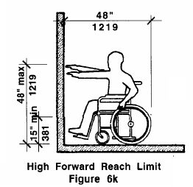  are mounted with highest operable part no higher than 48” nor lower than 15” when a forward approach, as per Figure 6k (6.5) |  |  |  | 6mm |  | ❑
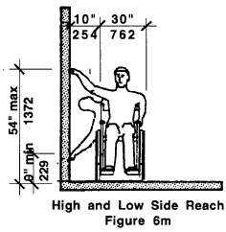  are mounted with highest operable part no higher than 54” nor lower than 9” when a parallel approach, as per Figure 6m (6.6) |  |  |  | 6nn   |  | ❑
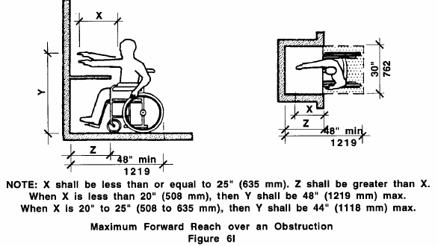  when mounted over obstructions, their high forward reaches conform to measurements in Figure 6l (6.5) |  |  |  | 6oo |  | ❑
 |  |  |  | N/A 
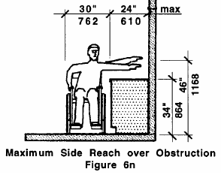  when mounted over an obstruction, their high side reaches conform to the measurements in Figure 6n |  |  |  | 6pp |  | ❑
 |  |  |  | N/A 
Do all of the lifts within the interior route of travel assessed
meet all of the above LIFT standards?
6qq. YES  NO  N/A 

interior ACcessible route of travel continued ❷
element 7 – elevators
ONLY assess those elevators that someone MUST use to get to the service area.
If NO elevators exist within the route you are assessing, skip down to the end of the elevator standards and answer N/A.
Standards |  |  |  | YES |  | NO | Notes/Measurements (record if checking NO)
GENERAL:
are located on an accessible route and are within the space they serve (28.1) |  |  |  | 7a  |  | ❑
have stable, firm and slip resistant floors (29.1) |  |  |  | 7b  |  | ❑
have handrails that are mounted on a minimum of one wall between 32” and 36” above the car floor, with a 1½” clearance from the wall (28.7.2) |  |  |  | 7c  |  | ❑
have clear openings that are a minimum of 32” wide (28.6.1) |  |  |  | 7d  |  | ❑
have horizontal clearances between car platform sills and edges of any hoistway landings that are no greater than 1¼” (28.7.1) |  |  |  | 7e  |  | ❑
have cabs that are a minimum of 54” x 68,” measured wall-to-wall & wall-to-door -or- are a minimum of 60” x 60,” measured wall-to-wall and wall-to-wall, as per Figure 28c (28.7)  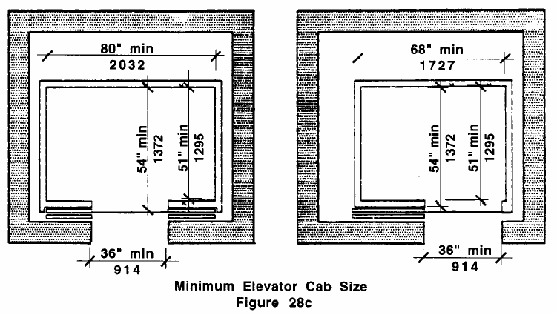  Note: The inside cab area cannot be any smaller than 48” x48”, measured wall-to-wall and wall-to-door (28.7). |  |  |  | 7f  |  | ❑
have doors that open and close automatically (28.6) |  |  |  | 7g  |  | ❑
have doors that close at a maximum speed of approximately 1’ per second (28.6.2) |  |  |  | 7h  |  | ❑
have doors that remain open for a minimum of 3 seconds in response to car call (28.6.5) |  |  |  | 7i  |  | ❑
have car position indicators with numerals that are a minimum of ½” high that illuminate, on a contrasting background, as the car passes or stops at a floor (28.9.2) |  |  |  | 7j  |  | ❑
interior ACcessible route of travel continued ❷
element 7 - elevators CONTINUED
Standards |  |  |  | YES |  | NO | Notes/Measurements (record if checking NO)
GENERAL CONTINUED:
use audible signals that sound as car passes or stops at a floor (28.9.2)  Note: A verbal announcement of floor at which a car stops or passes may be substituted for audible signal (28.9.2 c) |  |  |  | 7k  |  | ❑
have illumination at car controls, platforms, car thresholds and landing sills (28.11) |  |  |  | 7l  |  | ❑
have automatic self-leveling features, independent of operating devices, that bring car to a position level with landings under all loading conditions (28.2.2)  Note: Tolerance of ½” is allowed (28.2.2). |  |  |  | 7m  |  | ❑
CARPETING:
is high density and non-absorbent (29.3.1) |  |  |  | 7n  |  | ❑
has a maximum pile of ½” (29.3.1) |  |  |  | 7o  |  | ❑
is adhered directly to floors -or- is stretched tautly and fastened to floor surfaces at all edges (29.3.2) |  |  |  | 7p  |  | ❑
when padding is installed, it is no more than ¼” thick & is secured taut to floor (29.3.4) |  |  |  | 7q  |  | ❑
 |  |  |  | N/A 
when edges are exposed to traffic, they have trim along entire length (29.3.3) |  |  |  | 7r  |  | ❑
 |  |  |  | N/A 
when edges are perpendicular to the direction of travel, they have beveled edging strips that are no higher than 3/8” above the floor (29.3.3) |  |  |  | 7s  |  | ❑
 |  |  |  | N/A 
when edges are perpendicular to the direction of travel, have edging strips with slopes no greater than 1:2 (50%) (29.3.1) |  |  |  | 7t  |  | ❑
 |  |  |  | N/A 
DOOR REOPENING DEVICES:
remain effective for at least 20 seconds then car doors may close (28.6.3c) |  |  |  | 7u  |  | ❑
can detect possible obstructions passing through the opening at heights of 5” and 29” above finish floor (28.6.3b) |  |  |  | 7v  |  | ❑
will stop & automatically reopen car door if car door becomes obstructed by an object or person while closing without requiring contact with the obstruction (28.6.3) |  |  |  | 7w  |  | ❑
have characters with a centerline of 60” above finish floor (28.5.1) |  |  |  | 7x  |  | ❑
interior ACcessible route of travel continued ❷
element 7 - elevators CONTINUED
Standards |  |  |  | YES |  | NO | Notes/Measurements (record if checking NO)
door jamB markings
Note: Permanently applied plates are acceptable if they are secured to the jambs (28.5.3).
have characters 2” high placed on a background of a contrasting color (28.5.2). |  |  |  | 7y  |  | ❑
include raised & Braille floor designations at both jambs of entrances that are visible from within the car & elevator lobby (28.5) |  |  |  | 7z  |  | ❑
CALL BUTTONS:
are centered 42” above floor (28.3.1) |  |  |  | 7aa  |  | ❑
are raised or flush and are a minimum of ¾” in the smallest dimension (28.3.3) (28.3.3) |  |  |  | 7bb  |  | ❑
have visual signals to indicate when each call is registered and when each call is answered (28.3.2) |  |  |  | 7cc  |  | ❑
have the button designating the up direction at the top (28.3.3) |  |  |  | 7dd  |  | ❑
have no objects mounted beneath them that project into elevator more than 4” (28.3.4) |  |  |  | 7ee  |  | ❑
HALL LANTERNS:
use visible and audible signals to indicate which car is answering a call (28.4) |  |  |  | 7ff  |  | ❑
are mounted so that the lantern’s centerline is at least 72” above the lobby floor (28.4.1) |  |  |  | 7gg  |  | ❑
visual elements are a minimum of 2½” in the smallest dimension (28.4.3a) |  |  |  | 7hh  |  | ❑
signals are visible from the vicinity of the hall call button (28.4.3) |  |  |  | 7ii  |  | ❑
use audible signals that sound once for the up direction and twice for the down direction -or- use verbal annunciators that say “up” and “down” (28.4.2) |  |  |  | 7jj  |  | ❑
Note: In-car lanterns that are visible from the vicinity of the hall call buttons, and conform to the above requirements, are acceptable (28.4.3).
CAR CONTROL BUTTONS:
are raised or flush and are a minimum of ¾” in their smallest dimension (28.8.3) |  |  |  | 7kk  |  | ❑
interior ACcessible route of travel continued ❷
element 7 - elevators CONTINUED
Standards |  |  |  | YES |  | NO | Notes/Measurements (record if checking NO)
CAR CONTROL BUTTONS continued:
have raised designations immediately to left of button to which they apply (28.8.4c) |  |  |  | 7ll  |  | ❑
are designated by Braille and raised standard alphabet characters for letters and Arabic characters for numbers -or- by standard symbols (28.8.4) |  |  |  | 7mm |  | ❑
have floor buttons that use visual indicators to show when each call is registered and that are extinguished when each call is answered (28.8.4) |  |  |  | 7nn  |  | ❑
have floor buttons located at a maximum of 54” above the finished floor for a side approach and at a maximum of 48” for a front approach (28.8.2) |  |  |  | 7oo  |  | ❑
have the call button for the main entry floor designated by a raised star at the left side of the floor designation (28.8.4b)  Note: Applied plates that are permanently attached are allowed for providing raised control designations (28.8.4d) |  |  |  | 7pp  |  | ❑
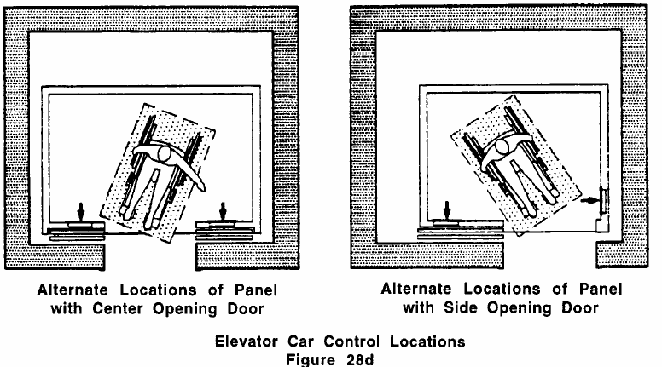  when car has center opening doors, controls are located on the same wall or walls as doors, as per Figure 28d (28.8.1) |  |  |  | 7qq  |  | ❑
 |  |  |  | N/A 
when car has side opening doors, controls are located at side wall or at front wall next to door, as per Figure 28d above (28.8.1) |  |  |  | 7rr  |  | ❑
 |  |  |  | N/A 
emergency controls, including the emergency alarm and emergency stop are grouped at the bottom of the panel and have their centerlines a minimum of 35” above the finish floor (28.8.2) |  |  |  | 7ss  |  | ❑
emergency communication systems:
are identified by adjacent raised symbols and lettering (28.10.2) |  |  |  | 7tt  |  | ❑
have the highest operable part located at a maximum of 48” from floors (28.10.1) |  |  |  | 7uu  |  | ❑
interior ACcessible route of travel continued ❷
element 7 - elevators CONTINUED
Standards |  |  |  | YES |  | NO | Notes/Measurements (record if checking NO)
emergency communication systems continued:
do not require voice communication (28.10.3)  Note: Lights indicating that contact has been made and is being responded to are permitted (28.10.3). |  |  |  | 7vv  |  | ❑
when system requires a handset, it has cords that are at least 20”, that run from the system panels to a hearing amplified handset (28.10.4) |  |  |  | 7ww |  | ❑
 |  |  |  | N/A 
when in a closed compartment, controls can be activated with one hand and do not require tight grasping, pinching, or twisting of the wrist nor do they require more than 5 lbs of force to activate (28.10.5) |  |  |  | 7xx  |  | ❑
 |  |  |  | N/A 
Do all of the elevators within the interior route of travel assessed meet
all of the above ELEVATOR standards?
7yy. YES  NO  N/A 
element 8 – EXIT
Does the interior route of travel assessed also serve as a means of exit for emergencies
-or- does it connect to an accessible area of rescue assistance (20.11)?
8a. YES  NO 
element 9 – Emergency ALARM System
If the facility has an emergency alarm system, does it include both flashing lights and audible signals
in rest rooms, hallways, lobbies, and any other common use area (40.3 )?
9a. YES  NO  N/A 
Item 2 - Interior Accessible Route of Travel
Final Question: Does the facility have at least one route of travel to the service area - that coincides with the route for the general public - that meets all of the above standards?
YES  NO 

ITEM 3 – area of rescue assistance ❷
Assessment Objective: Determine if the facility has at least 1 area of rescue assistance that meets all of the standards related to the following Elements of an area of rescue assistance: 1-Basics, 2-Two-way Communication System, 3-Signage, and 4-Location & Construction.
An area of rescue assistance is an area which has direct access to an exit, where people who are unable to use stairs may remain temporarily in safety to await further instructions or assistance during emergency evacuation. (ADAAG 3.5)
If the facility is undergoing alterations, remodeling, or reconstruction, or has a supervised automatic sprinkler system it does not need to have an area of rescue assistance (20.12). In this case, skip down to the FINAL QUESTION on Area of Rescue Assistance and answer N/A.

element 1 – GENERAL
Standards |  | YES | NO | Notes/Measurements (record if checking NO)
has at least 2 spaces at least 30” x 48" each, but no less than 1 on each story for every 200 persons of calculated occupant load served by the area (20.12.2) |  | 1a  | ❑
does not encroach on required exit width (20.12.2a) |  | 1b  | ❑
has usage instructions posted adjoining the two-way communication system (20.12.5) |  | 1c  | ❑
when there is an adjacent stairway, has a clear width of at least 48”, measured between handrails (20.12.3) |  | 1d  | ❑
 |  | N/A 
Do the general aspects of the area of rescue assistance assessed meet all of the above GENERAL standards?

1e. YES  NO 

Element 2 - TWO-wAY communication system
Standards |  | YES | NO | Notes/Measurements (record if checking NO)
has both visible & audible signals between each area of rescue assistance and the primary entrance to the building (20.12.4)  Note: Fire or appropriate building official may approve a location other than the primary entrance (20.12.4). |  | 2a  | ❑
when system has operable mechanisms, they are located a minimum of 18" from an interior corner (20.12.4 & 39.4) |  | 2b  | ❑
 |  | N/A 
when system has operable mechanisms, they can be used with one hand and do not require tight grasping, pinching, or twisting of the wrist (i.e., operable with a closed fist) using no more than 5 lbs of force (20.12.4 & 39.5) |  | 2c  | ❑
 |  | N/A 
area of rescue assistance continued ❷
Element 2 - TWO-wAY communication system continued
when system has operable mechanisms, they are mounted with highest operable part no higher than 48” nor lower than 15” when a forward approach, and no higher than 54” nor lower than 9” when a parallel approach, per Figs. 6k & 6m on pg. 32 (20.12.4) |  | 2d  | ❑
 |  | N/A 
Does the two-way communication system within the area of rescue assistance assessed
meet all of the above TWO-WAY COMMUNICATION SYSTEM standards?
2e. YES  NO 
element 3 - signage
Standards |  | YES | NO | Notes/Measurements (record if checking NO)
states "area of rescue assistance" (20.12.5) |  | 3a  | ❑
displays the international symbol of accessibility, per Fig. 41a on pg 3 (20.12.5) |  | 3b  | ❑
when exit sign illumination is required, signage is illuminated (20.12.5) |  | 3c  | ❑
 |  | N/A 
is installed at all inaccessible exits and where otherwise necessary to clearly indicate the direction to areas of rescue assistance (20.12.5) |  | 3d  | ❑
Did the signage within the area of rescue assistance you assessed meet
all of the above SIGNAGE standards?

3e. YES  NO 

area of rescue assistance continued ❷
element 4 - location and construction
Does the location and construction of the area of rescue assistance assessed meet
1 of the 7 acceptable configurations in the standards below?
4a. YES  NO 
Configuration (1): a portion of a stairway landing within a smoke-proof enclosure complying with applicable requirements of 780 CMR, as per Figure 20i (20.12.1.a)

Configuration (2): a portion of a stairway landing within an exit enclosure that is vented to exterior and is separated from the interior of the building with not less than 1 hour fire-resistive doors (20.12.1.e)

Configuration (3): a vestibule located immediately adjacent to an exit enclosure and constructed to the
same fire-resistive standards controlling corridors and openings (20.12.1.d)

Configuration (4): portion of exterior exit balcony located immediately adjacent to an exit stairway when balcony complies with requirements of 780 CMR for exterior exit balconies. Openings to building interior located within 20' of area of rescue assistance are protected with fire assemblies that have a ¾ hr fire protection rating (20.12.b)

Configuration (5): a portion of a 1 hr fire-resistive corridor complying with applicable requirements of 780 CMR for fire-resistive construction and for openings located immediately adjacent to an exit enclosure, as per Figure 20j (20.12.1.c)

Configuration (6): an elevator lobby where elevator shafts and adjacent lobbies are pressurized using a system activated by smoke detectors on each floor located in a manner approved by the appropriate
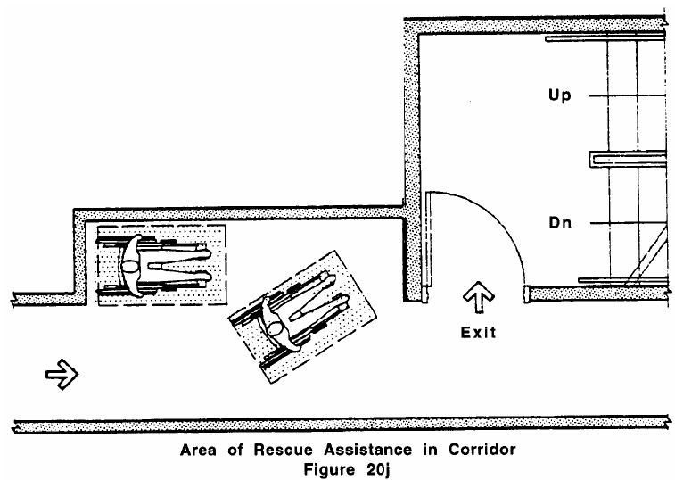
local authority, & has equipment and duct work separated from other portions of building by a minimum 2 hr fire restrictive construction (20.12.1.g)
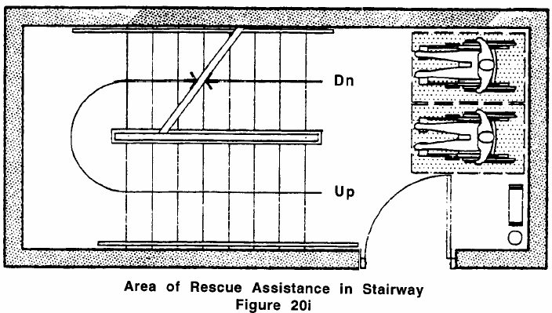
Configuration (7): when approved by the appropriate applicable building official, an area or a room that: is separated from other portions of the building by a smoke barrier with a fire-resistive rating of at least 1 hour and completely encloses the area or room, and has doors that have tight-fitting smoke- and draft-control assemblies with a fire-protection rating of at least 20 minutes and are self- or automatic- closing; has an exit directly to an exit enclosure (where the exit enclosure is required to be of more than 1 hour fire-resistive construction, the room or area has the same fire-resistive construction, including the same opening protection) (20.12.1.f)
Item 3 - Area of Rescue Assistance
Final Question: Does the facility provide at least one area of rescue assistance that meets all of the above standards?
YES  NO  N/A  (Areas of rescue assistance are not required in existing buildings
that are undergoing alterations, remodeling, or reconstruction, or in
facilities that have a supervised automatic sprinkler system.)

ITEM 4 - accessible STAiRWAY ❷
Assessment Objective: If the service area is NOT on the first floor, determine if the facility has at least 1 stairway leading to the service area that meets all of the standards related to the following Elements of an accessible stairway: 1-Steps and 2-Handrails.
If the service area IS on the first floor, skip down to the FINAL QUESTION on Accessible Stairway and answer N/A.

element 1 – steps
Standards |  |  | YES | NO | Notes/Measurements (record if checking NO)
have risers of uniform heights (27.2)  Note: Cannot have open risers (27.2). |  |  | 1a  | ❑
have treads of uniform widths (27.2) |  |  | 1b  | ❑
have non-slip treads on steps (DPH) |  |  | 1c  | ❑
have nosing undersides that are not abrupt (27.3) |  |  | 1d  | ❑
have curvature radiuses at leading edges of treads that are a maximum of ½” (27.3) |  |  | 1e  | ❑
have nosings that project a maximum of 1½”, as per Figure 27b below (27.3) |  |  | 1f  | ❑
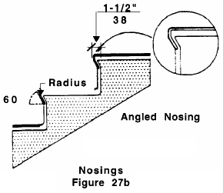  have either risers that are sloped -or- have nosing undersides with angles that are a minimum of 60° from the horizontal, as per Figure 27b (27.3) |  |  | 1g  | ❑
Do all of the steps of the stairway assessed meet
all of the above STEP standards?
1h. YES  NO 
element 2 - Handrails
Standards |  |  | YES | NO | Notes/Measurements (record if checking NO)
are continuous and located on both sides of stairway (27.4.1) |  |  | 2a  | ❑
do not rotate within their fittings (27.4.9) |  |  | 2b  | ❑
have ends that are either rounded or returned smoothly to floor, wall, or  post (27.4.8) |  |  | 2c  | ❑
are mounted between 34" and 38" above stair nosings (27.4.2) |  |  | 2d  | ❑
when a handrail is mounted adjacent to a wall it has a clear space of 1½” between the handrail and the wall (27.4.7) |  |  | 2e  | ❑
 |  |  | N/A 
accessible STAiRWAY continued ❷
element 2 - Handrails continued
Standards |  |  | YES | NO | Notes/Measurements (record if checking NO)
Note: Handrails may be located in a wall recess if the recess is a maximum of 3" deep and extends a minimum of 18” above the top of the rail (27.4.7).
have continuous gripping surfaces so that a hand can move from end to end without interruption by newel posts or other obstructions (27.4.6) |  |  | 2f  | ❑
have gripping surfaces that are free of sharp or abrasive elements (27.4.6) |  |  | 2g  | ❑
have handgrips that are round or oval in cross-section and are between 1¼” and 1½” nominal in diameter (27.4.4 & 27.4.5) |  |  | 2h  | ❑
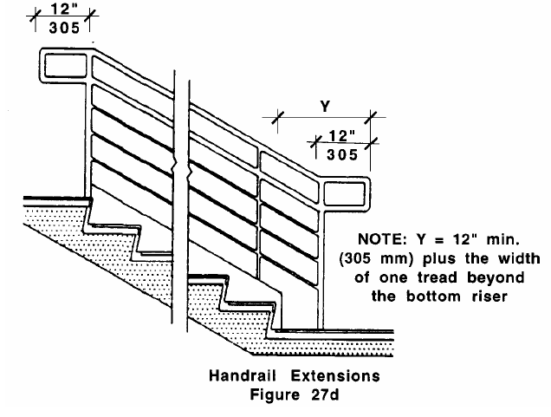  when handrails terminate at the top of a stair run, they have extensions that are a minimum of 12” long beyond the top riser and are parallel with the floor, as per Figure 27d (27.4.3a) |  |  | 2i  | ❑
 |  |  | N/A 
when handrails terminate at the bottom of a stair run, they have extensions that are a minimum of 12” long, plus the width of one tread beyond the bottom riser, as per Figure 27d above (27.4.3b) |  |  | 2j  | ❑
 |  |  | N/A 
have extensions that continue to slope for the width of one tread from the bottom riser with the remainder of the extension horizontal, as per Figure 27d above (27.4.3b) |  |  | 2k  | ❑
when handrails are not attached to walls they have extensions that are returned smoothly to floor or post, as per Figure 27d above (27.4.8) |  |  | 2l  | ❑
 |  |  | N/A 
Note: Extensions need not extend if they would cause a safety hazard or if space does not permit (27.4.3c).
Do all of the handrails of the stairway assessed meet all of the above HANDRAIL standards?
2m. YES  NO 
Item 4 - Accessible Stairway Final Question: Does the facility have at least one stairway leading to the service area that meets all of the above standards? YES  NO  N/A 
(Unless the service area is above the first floor, it is not necessary to have an accessible stairway)

ITEM 5 - SERVICE AREA ❷
 | Assessment Objective: Determine if the facility has a service area that meets all of the standards related to the following Elements of an accessible service area: 1-Reception/Intake Counter; 2-Waiting Areas; 3-Doors; 4-Halls/Corridors; 5-Carpeting; 6-Protruding Objects; 7-Controls; 8-Dressing Room; 9-Alternative Changing Area; 10-Exam Room; and 11-Mammography Machine (as applicable).
element 1 – reception/intake counter
Standards |  | YES | NO | Notes/Measurements (record if checking NO)
is on an accessible route (13.2.2.a) |  | 1a  | ❑
has a portion, or an auxiliary counter, that is a minimum of 36” long and is no higher than 36" above floor (13.2.2.b & 13.2.2.c) |  | 1b  | ❑
has a level clear floor space that is a minimum of 30" x 48" for a single, stationary wheelchair & occupant to allow a forward approach (13.2.2.d) |  | 1c  | ❑
Does the reception/intake counter at the service area meet
all of the above reception/intake counter standards?
1d. YES  NO 
element 2 - waiting areaS
Standards |  | YES | NO | Notes/Measurements (record if checking NO)
are on an accessible route (35.1) |  | 2a  | ❑
when there is built in seating, it includes a minimum of 5% (no less than 1 seat) that is accessible and is distributed by size and location throughout the waiting areas (35.1 & 35.2) |  | 2b  | ❑
 |  | N/A 
have level clear floor spaces that are a minimum of 30" x 48" for a single, stationary wheelchair and occupant (35.4 & 6.4.1)  Note: When only one such space is provided in a waiting room, it should be reserved for a person using a wheelchair (DPH). |  | 2c  | ❑
when coat hooks are provided, at least one is located at a maximum height of 54” above floor (DPH) |  | 2d  | ❑
 |  | N/A 
when informational materials are provided, they are no higher than 48” nor lower than 15” above floor for a forward approach (6.5) and no higher than 54” nor lower than 9” for a parallel approach (DPH, 6.5 & 6.6) |  | 2e  | ❑
 |  | N/A 
Do all of the waiting areas within the service area meet
all of the above WAITING AREA standards?
2f. YES  NO 
SERVICE AREA CONTINUED ❷
element 3 - Doors
ONLY assess the doors that someone MUST pass through in the course of their service visit.
If NO doors must be passed through, skip down to the end of the door standards and answer N/A.

Standards |  | YES | NO | Notes/Measurements (record if checking NO)
GENERAL:
can be unlocked and opened with one hand (26.11.3) |  | 3a  | ❑
require no more than 5 lbs of force to open (26.8.1)  Note: Power assisted or automatic doors are exempt (26.6). |  | 3b  | ❑
when the opening force required is more than the maximum allowed, a compensating device or automatic opening device is provided (26.8.2) |  | 3c  | ❑
 |  | N/A 
have handles or controls located between 36” and 48” above the floor (26.11.2) |  | 3d  | ❑
have handles or controls that are operable using a maximum of 5 lbs of force (26.11.3) |  | 3e  | ❑
have handles or controls operable using one hand that do not require tight grasping, tight pinching, or twisting of the wrist (26.11.1) (i.e., operable with a closed fist).  Note: This also applies to pulls, latches, and locks (26.11.1). |  | 3f  | ❑
when sliding doors, they have exposed hardware usable from both sides when fully open (26.11.1) |  | 3g  | ❑
 |  | N/A 
when doors have closers, it takes a minimum of 6 seconds to close door from an open position of 90° (26.9) |  | 3h  | ❑
 |  | N/A 
DOORWAYS:
have clear openings that are a minimum of 32”, measured from the face of the stop on latch side to the doors’ face when open 90° (26.5)  Note: A bi-fold, accordion, or pocket door opening is measured when door is in a fully open position (26.5). |  | 3i  | ❑
have the minimum level clear floor spaces on the latch, pull side of doors, as per Figure 26d on page 18 (26.6.1 & 26.6.4) |  | 3j  | ❑
have the minimum level clear floor spaces on the push side of doors, as per Figure 26e on page 18 (26.6.1 & 26.6.4) |  | 3k  | ❑
SERVICE AREA CONTINUED ❷
element 3 - Doors CONTINUED
Standards |  | YES | NO | Notes/Measurements (record if checking NO)
DOORWAYS CONTINUED:
when sliding doors, they have the minimum level clear floor spaces, as per Figure 26f on page 17 (26.6.1 & 26.6.5) |  | 3l  | ❑
 |  | N/A 
when doors are located in recesses of more than 6”, measured within 6” of door, they have the minimum level clear floor spaces on push and pull sides of doors, as per Figures 26d & 26e on page 18 (26.4) |  | 3m | ❑
 |  | N/A 
when a power assisted door, there are minimum level clear ground and floor spaces on the push and pull sides of the door, as per Figures 26d & 26e on page 18 (26.4 & DPH) |  | 3n  | ❑
 |  | N/A 
when double doors, they have the minimum level clear floor spaces on the push and pull sides of doors, as per Figures 26d & 26e on page 18 (26.4) |  | 3o  | ❑
 |  | N/A 
when double doors, they have at least one leaf that is active and has a clear opening of at least 32” (26.4) |  | 3p  | ❑
 |  | N/A 
Notes: Automatic doors are exempt from clear floor space requirements (26.6).
THRESHOLDS:
are no higher than ½”, nor ¾” when under a sliding door (26.10.1 & 26.10.3) |  | 3q  | ❑
do not have slope greater than 1:2 (50%) or 1:4 when under a sliding door (26.10.1 & 26.10.3) |  | 3r  | ❑
have beveled edges on both sides (26.10.1 & 26.10.3) |  | 3s  | ❑
when floor finish materials change, threshold is beveled at a ratio of 1:2 (50%) or has edge stripping (26.10) |  | 3t  | ❑
 |  | N/A 
Do all of the doors within the service area meet
all of the above DOOR standards?
3u. YES  NO  N/A 
element 4 – Halls/Corridors
Standards |  | YES | NO | Notes/Measurements (record if checking NO)
have stable, firm and slip resistant floor surfaces (29.1) |  | 4a  | ❑
are continuous & unobstructed (20.1) |  | 4b  | ❑
do not include stairs, steps or escalators even if required to be accessible (20.1) |  | 4c  | ❑
SERVICE AREA CONTINUED ❷
element 4 – Halls/Corridors continued
Standards |  | YES | NO | Notes/Measurements (record if checking NO)
are free of cross slopes greater than 1:50 (2%) (20.9) |  | 4d  | ❑
are free of slopes greater than 1:20 (5%) (20.9)  Note: A slope greater than 1:20 is considered a ramp (20.9) |  | 4e  | ❑
have minimum clear widths for a person using a wheelchair to turn around an obstruction, as per Figures 20a & 20b on page 9 (20.4) |  | 4f  | ❑
when less than 60” wide, they have passing spaces a minimum of 60” x 60,” located at intervals no greater than 200’, per Figure 6b on page 9 (20.5)  Note: T-intersections are acceptable passing places (20.5). |  | 4g  | ❑
 |  | N/A 
have clear widths that are a minimum of 36”, except at doors or openings less than 24” deep (20.3) |  | 4h  | ❑
have clear headroom at least 80” high (20.7) |  | 4i  | ❑
when vertical clearances are reduced to less than 80”, barriers are provided to warn persons with blindness or visual impairments (20.7) |  | 4j  | ❑
 |  | N/A 
Do all of the halls/corridors within the service area meet
all of the above halls/corridors standards?
4k. YES  NO 
element 5 - Carpeting
ONLY assess the carpeting that someone MUST pass over in the course of their service visit.
If NO carpeting must be passed over, skip down to the end of the carpeting standards and answer N/A.
Standards |  | YES | NO | Notes/Measurements (record if checking no)
is high density and non-absorbent (29.3.1) |  | 5a  | ❑
has a maximum pile of ½” (29.3.1) |  | 5b  | ❑
is adhered directly to the floor -or- is stretched tautly and fastened to floor surfaces at all edges (29.3.2) |  | 5c  | ❑
when padding is installed, it is not more than ¼” thick and is secured taut to the floor (29.3.4) |  | 5d  | ❑
 |  | N/A 
when edges are exposed to traffic, they have trim along entire length (29.3.3) |  | 5e  | ❑
 |  | N/A 
SERVICE AREA CONTINUED ❷
element 5 - Carpeting continued
Standards |  | YES | NO | Notes/Measurements (record if checking NO)
when edges are perpendicular to the direction of travel, they have beveled edging strips that are no higher than 3/8” above the floor (29.3.3) |  | 5f  | ❑
 |  | N/A 
when edges are perpendicular to the direction of travel, they have edging strips with slope no greater than 1:2 (50%) (29.3.1) |  | 5g  | ❑
 |  | N/A 
Does the carpeting within the service area meet all of the above CARPETING standards?
5h. YES  NO  N/A 
element 6 - Protruding Objects
ONLY assess the protruding objects that someone MUST pass by in the course of their service visit.
If NO protruding objects must be passed by, skip down to the end of the protruding objects standards and answer N/A.
Standards |  | YES | NO | Notes/Measurements (record if checking NO)
do not reduce the clear width (36”) of route of travel or maneuvering spaces (20.6) |  | 6a  | ❑
are free of sharp or abrupt edges (20.6.1) |  | 6b  | ❑
when mounted on a wall between 27” and 80” above the finished floor, they do not protrude more than 4” into passageways, as per Figure 20d on page 11 (20.6.1) |  | 6c  | ❑
 |  | N/A 
Do all of the protruding objects within the service area meet
all of the above PROTRUDING OBJECTS standards?
6d. YES  NO  N/A 
element 7 - Controls
 | Only assess those controls that members of the general public would operate during the course of a typical service visit (i.e., light switches). Do not assess controls that would be operated only by staff within the facility. If NO such controls exits, skip down to the end of the control standards and answer N/A.
Standards |  | YES | NO | Notes/Measurements (record if checking NO)
require no more than 5 lbs of force to operate (39.5) |  | 7a  | ❑
are operable with one hand and do not require tight grasping, pinching, or twisting of the wrist (39.5) (i.e. operable with a closed fist) |  | 7b  | ❑
have level clear floor spaces a minimum of 30" x 48" for a single, stationary wheelchair and occupant allowing for a forward or a parallel approach (39.2 & 6.4.1) |  | 7c  | ❑
are located at least 18" from an interior corner (39.4) |  | 7d  | ❑
SERVICE AREA CONTINUED ❷
element 7 - Controls continued
Standards |  | YES | NO | Notes/Measurements (record if checking NO)
are mounted with highest operable part no higher than 48” nor lower than 15” when a forward approach, as per Figure 6k on page 32 (6.5) or no higher than 54” nor lower than 9” when a parallel approach, as per Figure 6k on page 32 (6.6) |  | 7e  | ❑
Do all of the controls within the service area meet all of the above CONTROLS standards?
7f. YES  NO  N/A 
element 8 –dressing Room
Determine if there is at least 1 dressing room that meets all of the standards below.
If there is not at least 1 dressing room that meets the standards, you will need to determine if an alternative changing area is provided and complete the assessment below, “Alternative Changing Area.” If dressing rooms or alternative changing areas are not needed to receive comprehensive services, answer N/A.
Standards |  | YES | NO | Notes/Measurements (record if checking NO)
GENERAL:
is located on an accessible route (33.3) |  | 8a  | ❑
is a minimum of 5’ x 6’ (33.4) |  | 8b  | ❑
has a clear floor area that is at least 60” in diameter, measured 12” above the floor (33.4) |  | 8c  | ❑
when has a swinging or sliding door, or curtain, it has a T-shaped clear floor space -or- one that is 60” in  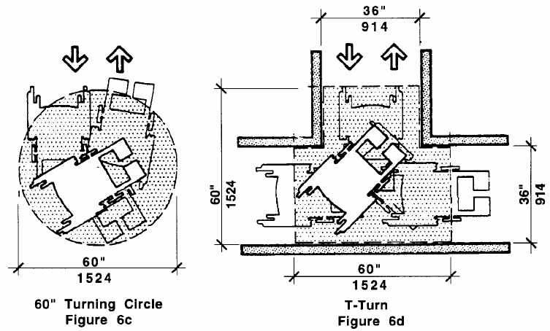  diameter for a wheelchair to make a 180º turn, as per Figs. 6c & 6d (33.3 & 6.3) |  | 8d  | ❑
has no doors that swing into any part of the turning space (33.4.1) |  | 8e  | ❑
when has a mirror, it’s at least 18” wide and 54” high, mounted at least 18” above the floor in a position to afford a view when standing or sitting on the seat/bench (33.7) |  | 8f  | ❑
has a coat hook located a maximum of 54” above the floor (33.4.2) |  | 8g  | ❑
SEAT/BENCH:
meets structural strength codes (30.8) |  | 8h  | ❑
has an adjacent horizontal handrail for self-support during transfer (DPH) |  | 8i  | ❑
is at least 24” x 48” and is fixed to the wall along the shorter dimension (33.6.1) |  | 8j  | ❑
SERVICE AREA CONTINUED ❷
element 8 – dressing Room CONTINUED
SEAT/BENCH CONTINUED:
has a level clear floor space that is at least 30” x 48” alongside bench allowing someone who uses a wheelchair to make a parallel transfer onto the seat (33.6.3 & 6.4.1) |  | 8k  | ❑
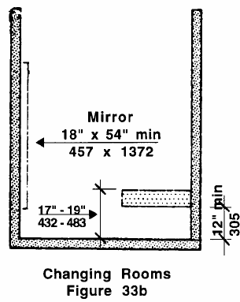  is mounted between 17” and 19” above the floor, with a minimum opening beneath of 12”, measured from floor, as per Figure 33b (33.6.2) |  | 8l  | ❑
has a surface padded with high density foam with a waterproof/washable cover (DPH) |  | 8m | ❑
Does at least one dressing room within the service area meet all of the DRESSING ROOM standards?
8n. YES  NO  N/A 
element 9 - alternative Changing area
If no accessible dressing room is provided, determine if there is at least 1 alternative changing area within the service area that meets all of the standards below,
If there is at least 1 accessible dressing room, skip down to the end of the alternative changing area standards and answer N/A.
Standards |  | YES | NO | Notes/Measurements (record if checking NO)
is a minimum of 5’ x 6’ (33.4) |  | 9a  | ❑
has curtain or privacy screen (DPH) |  | 9b  | ❑
has a T-shaped clear floor space -or- one that is 60” in diameter for a wheelchair to make a 180º turn, per Fig. 6c & 6d on page 47, measured 12” above floor (33.3 & 33.4) |  | 9c  | ❑
has a seat/bench a minimum of 24” x 48” and located at a height between 17” and 19” above the floor (33.6.1 & 33.6.2) |  | 9d  | ❑
has seat/bench padded with high density foam & waterproof/washable cover (DPH) |  | 9e  | ❑
has level clear floor space that is at least 30” x 48” alongside seat/bench so that someone using a wheelchair can make a parallel transfer (33.6.3 & 6.4.1) |  | 9f  | ❑
has a horizontal grab bar next to the seat/bench to support transfer (DPH) |  | 9g  | ❑
has a coat hook located a maximum of 54” above the floor (33.4.2) |  | 9h  | ❑
Does at least one alternative changing area within the service area meet
all of the alternative changing area standards?
9i. YES  NO  N/A 
SERVICE AREA CONTINUED ❷
element 10 – EXAM room
Determine if there is at least 1 accessible exam room within the service area that meets all of the
standards below.
If exam tables are provided, determine that at least one meets all of the accessible exam table standards.

Standards |  | YES | NO | Notes/Measurements (record if checking NO)
GENERAL:
is on an accessible route (DPH) |  | 10a   | ❑
has door handles or controls that are operable using one hand and do not require tight grasping, pinching or twisting of the wrist. (26.11.1) |  | 10b | ❑
if there is a threshold at the doorway it is beveled at a ratio of 1:2 (50%) or has edge stripping. (26.10) |  | 10c | ❑
has a clear door opening of at least 32” measured from the face of stop on latch side to door face when open 90º (26.5) |  | 10d   | ❑
has no doors that swing into any part of the turning space (33.4.1) |  | 10e   | ❑
(exam room) is a minimum of 5’ x 6’ (33.4) |  | 10f   | ❑
has a coat hook located at a maximum of 54” above the floor (33.4.2) |  | 10g   | ❑
has a level clear floor space that is at least 60” x 60” alongside exam table so that someone using a wheelchair can make a 180º turn and make a parallel transfer (DPH) |  | 10h | ❑
has a curtain or privacy screen (DPH) |  | 10i   | ❑
 |  | N/A 
has a visual signal installed if the facility has an emergency alarm system |  | 10j   | ❑
 |  | N/A 
ACCESSIBLE EXAM TABLE:

For outpatient facility:  is adjustable to 17-19" or less above the floor, measured from the floor to the top side of the exam table (DPH) |  | 10k   | ❑
 |  | N/A 
For inpatient facility:  is adjustable to 15” or less above the floor, measured from the floor to the top side of the exam table (13.2.1) |  | 10l   | ❑
 |  | N/A 
SERVICE AREA CONTINUED ❷
element 10 – EXAM room CONTINUED
Standards |  | YES | NO | Notes/Measurements (record if checking NO)
ACCESSIBLE EXAM TABLE CONTINUED
has an articulating backrest controlled by a linear actuator and can be adjusted to any desired position. (DPH) |  | 10m   | ❑
 |  | N/A 
is able to support at least 300 pounds (preferably 600 pounds) (DPH) |  | 10n | ❑
 |  | N/A 
has adjustable hand rails that support at least 250 pounds (DPH) |  | 10o | ❑
 |  | N/A 
has either leg holders or gynecological stirrups as foot attachments (DPH) |  | 10p   | ❑
 |  | N/A 
has foot and leg supports that are adjustable for a variety of range extremities (DPH) |  | 10q   | ❑
 |  | N/A 
foot and leg supports have cushioning and straps (DPH) |  | 10r   | ❑
 |  | N/A 
accommodates different leg lengths (DPH) |  | 10s   | ❑
 |  | N/A 
accommodates different abilities to flex and extend legs (DPH) |  | 10t   | ❑
 |  | N/A 
accommodates different abilities to open and close legs (DPH) |  | 10u   | ❑
 |  | N/A 
Does at least one exam room meet all of the above
EXAM ROOM standards?

10v. YES  NO 

element 11 - Mammography Machine (Note: Complete this section for mammography providers only.)
Determine if there is at least 1 accessible mammography machine within the service area that meets all
of the standards below. If the facility does not provide mammograms, skip to the end of this section and
answer N/A.

Standards | YES | NO | Notes/Measurements (record if checking NO)
is on an accessible route (DPH) | 11a | ❑
SERVICE AREA CONTINUED ❷
element 11 - Mammography Machine continued (Note: Complete for mammography providers only)
Standards | YES | NO | Notes/Measurements (record if checking NO)
has a positioning chair with a braking device and adjustable arms available for ready access (DPH) | 11b | ❑
has a bucky that lowers to a height of 24” above the floor, measured from the floor to the top side of the bucky platform (DPH) | 11c  | ❑
has a T-shaped clear floor space -or- one that is 60” in diameter for a wheelchair to make a 180º turn, per Figs. 6c & 6d on pg. 47 (33.3 & 6.3) on bucky side of machine, measured from bottom center of machine below bucky 5’ to center of room (vertically) then 5’ in center (horizontally) (DPH) | 11d | ❑
Does the mammography machine meet all of the above
MAMMOGRAPHY MACHINE standards?

11e. YES  NO  N/A 

element 12 – ACCESSIBLE WEIGHT SCALES
Determine if there is at least 1 accessible weight scale on an accessible route that meets all of the
standards below. If the facility does not provide an accessible weight scale, select NO at the end of this
section. If the facility does provide an accessible weight scale, select N/A for the weight scale standards
for scales not available at that facility.
Standards | YES | NO | Notes/Measurements (record if checking NO)
General
is on an accessible route (DPH) | 12a   | ❑
if there is a platform, then it is slip resistant (DPH) | 12b   | ❑
if there is a platform, then it is slip resistant (DPH) | N/A 
if there is a display, it is large and easy to read (digital) (DPH) | 12c   | ❑
 | N/A 
if there are handrails, they are sturdy and located at a height of 34”-38” from the top of handrail gripping surface to the top of the scale platform. (DPH) | 12d   | ❑
 | N/A 
Portable Weight Scales
if platform is 34” x 32” , it has a 600lb capacity (DPH) | 12e   | ❑
if platform is 34” x 32” , it has a 600lb capacity (DPH) | N/A 
if platform is 35” x 38”, it has a 800lb capacity (DPH) | 12f   | ❑
if platform is 35” x 38”, it has a 800lb capacity (DPH) | N/A 

SERVICE AREA CONTINUED ❷
element 12 – ACCESSIBLE WEIGHT SCALES continued
Standards |  | YES | NO | Notes/Measurements (record if checking NO)
Stationary Wheelchair Scales |  |  |  | Notes/Measurements (record if checking NO)
if platform is 34” x 32”, it has a 660lb capacity (DPH) |  | 12g   | ❑ | Notes/Measurements (record if checking NO)
 |  | N/A  |  | Notes/Measurements (record if checking NO)
if platform is 30” x 26”, it has a 800lb capacity (DPH) |  | 12h   | ❑ | Notes/Measurements (record if checking NO)
 |  | N/A  |  | Notes/Measurements (record if checking NO)
Platform (portable) Scales |  |  |  | Notes/Measurements (record if checking NO)
if platform is 30” x 32”, it has a 800lb capacity (DPH) |  | 12i   | ❑ | Notes/Measurements (record if checking NO)
 |  | N/A  |  | Notes/Measurements (record if checking NO)
In-floor Medical Scales |  |  |  | Notes/Measurements (record if checking NO)
has 1000lb capacity (DPH) |  | 12j   | ❑ | Notes/Measurements (record if checking NO)
 |  | N/A  |  | Notes/Measurements (record if checking NO)
has a platform that is 36” x 36”, 48” x 36”, or 72” x 48” (DPH) |  | 12k   | ❑ | Notes/Measurements (record if checking NO)
 |  | N/A  |  | Notes/Measurements (record if checking NO)
Electronic In-bed Scale |  |  |  | Notes/Measurements (record if checking NO)
has under bed clearance 4.8” high and has 400lb weight capacity (DPH) |  | 12l   | ❑ | Notes/Measurements (record if checking NO)
 |  | N/A  |  | Notes/Measurements (record if checking NO)
Does the service area have at least one accessible weight scale that meets all of the weight scale standards? 12m. YES  NO  N/A 
element 13 – Meeting room
Determine if there is at least 1 meeting room on an accessible route that meets all of the standards below.
If the facility does not provide a group meeting room, skip to the end of this section and answer N/A.
Standards |  | YES | NO | Notes/Measurements (record if checking NO)
is on an accessible route (DPH) |  | 13a  | ❑
has door handles or controls that are operable using one hand and do not require tight grasping, pinching or twisting of the wrist. (26.11.1) |  | 13b  | ❑
if there is a threshold at the doorway it is beveled at a ratio of 1:2 (50%) or has edge stripping. (26.10) |  | 13c  | ❑
has no doors that swing into any part of the turning space (33.4.1) |  | 13d  | ❑
SERVICE AREA CONTINUED ❷
element 13 – Meeting room continued
Standards |  | YES | NO | Notes/Measurements (record if checking NO)
has a clear door opening of at least 32” measured from the face of stop on latch side to door face when open 90º (26.5) |  | 13e  | ❑
(room) is a minimum of 5’ x 6’ (33.4) |  | 13f  | ❑
has a visual signal installed if the facility has an emergency alarm system |  | 13g  | ❑
has a clear floor area that is at least 60” in diameter, measured 12” above floor (33.4) |  | 13h  | ❑
has level clear floor spaces that are a minimum of 30” x 48” for a single, stationary wheelchair and occupant (35.4 & 6.4.1). |  | 13i  | ❑
when coat hooks are provided, at least one is located at a maximum height of 54” above floor (DPH) |  | 13j  | ❑
when built in seating is provided, it includes a minimum of 5% (no less than 1 seat) that is accessible and is distributed by size and location throughout the room (35.1 & 35.2) |  | 13k  | ❑
when seating spaces for people in wheelchairs are provided at fixed tables or counters, clear floor space are provided. Such clear floor space does not overlap knee space by more than 19”. (35.4) |  | 13l  | ❑
when seating for people in wheelchairs is provided at tables or counters, knee spaces at least 27” high, 30” wide, and 19” deep are provided. (35.5) |  | 13m  | ❑
when seating for people in wheelchairs is provided at tables or counters, the tops of accessible tables and counters are between 28” and 34” above the finish floor or ground. (35.6) |  | 13n   | ❑
when informational materials are provided, they are no higher than 48” nor lower than 15” above floor for a forward approach (6.5) and no higher than 54” nor lower than 9” for a parallel approach (DPH, 6.5 & 6.6) |  | 13o   | ❑
Does the meeting space assessed meet all of the above meeting room standards?
13p. YES  NO  N/A 
 | Item 5 – Service Area - FINAL QUESTION: Does the facility have a service area that meets all of the above standards? YES  NO 

MASSACHUSETTS FACILITY ASSESSMENT TOOL
Priority ❸
Usability of Rest Rooms
When rest rooms are open to the public, they should be accessible to people with disabilities.
 |  | In this Priority, there is only 1 Item related to “Usability of Rest Rooms.” This Item has 9 Elements.
ITEMS and ELEMENTS to be Assessed:
1 - Accessible Rest Room
Elements:
1 - General
2 - Signage
3 - Entrance Door
4 - Urinal
5 - Toilet Stall
6 - Toilet
7 - Sink
8 - Dispensers/Devices
9 - Controls & Receptacles

ITEM 1 - accessible Rest room ❸
Assessment Objective: Determine if the facility has at least 1 public rest room or 1 unisex toilet room (provided in the same area as the public rest room) that meets all of the standards related to the following Elements of an accessible rest room: 1-General; 2-Signage; 3-Entrance Door; 4-Urinal; 5-Toilet Stall; 6-Sink; 7-Dispensers/Devices; and 8-Controls & Receptacles.
NOTE: When there the rest room is in the service area, assess it first. If NOT accessible, determine if there is another rest room elsewhere within the facility does meet the standards.
element 1 – GENERAL
Standards |  |  |  | YES | NO | Notes/Measurements (record if checking NO)
is on an accessible route (30.6) |  |  |  | 1a  | ❑
has a T-shaped clear floor space -or- one that is 60” in diameter for a wheelchair to make a 180º turn, as per Figures 6c & 6d on page 47 (33.3) |  |  |  | 1b  | ❑
when a shelf is provided above a sink, its top is set at a maximum of 40” from the floor (30.11) |  |  |  | 1c  | ❑
 |  |  |  | N/A 
when a mirror is above a sink, the bottom of its reflecting surface is at a maximum of 40” above the floor (30.11) |  |  |  | 1d  | ❑
 |  |  |  | N/A 
Do the general aspects of the rest room assessed meet all of
the above GENERAL standards?
1e. YES  NO 
element 2 – SIGNAGE
Standards |  |  |  | YES | NO | Notes/Measurements (record if checking NO)
uses international symbol of accessibility, as per Figure 41a on page 3 (41.4.3) |  |  |  | 2a  | ❑
is on the wall adjacent to the latch side of the entrance door (41.2) |  |  |  | 2b  | ❑
when no wall space on the latch side of the door exists, signage is placed on the nearest adjacent wall (41.2) |  |  |  | 2c  | ❑
 |  |  |  | N/A 
is mounted 60” above the finished floor to the centerline of the sign (41.2.1) |  |  |  | 2d  | ❑
is mounted so that a person can approach within 3” without encountering any protruding objects or standing within the swing of a door (41.2.1) |  |  |  | 2e  | ❑
uses raised uppercase sans serif or simple serif type characters 1/32”(41.5.1) |  |  |  | 2f  | ❑
has raised characters that are between 5/8” and 2” high (41.5.3) |  |  |  | 2g  | ❑
has letters and/or numerals accompanied by Grade 2 Braille (41.5.2) |  |  |  | 2h  | ❑
accessible Rest room continued ❸
element 2 - SIGNAGE CONTINUED
Standards |  |  |  | YES | NO | Notes/Measurements (record if checking NO)
has characters and backgrounds that are eggshell, matte -or- another non-glare finish (41.6) |  |  |  | 2i  | ❑
has characters and symbols that contrast with the background, either light on dark or dark on light (41.6) |  |  |  | 2j  | ❑
when pictograms are used, signage has the equivalent verbal description placed directly below pictograms (41.5.4) |  |  |  | 2k  | ❑
 |  |  |  | N/A 
Does the signage at the rest room assessed meet all of
the above SIGNAGE standards?
2l. YES  NO 
element 3 - ENTRANCE DOOR
Standards |  |  |  | YES | NO | Notes/Measurements (record if checking NO)
GENERAL:
does not swing into the clear floor space required for any fixture (31.5) |  |  |  | 3a  | ❑
can be unlocked and opened with one hand (26.11.3) |  |  |  | 3b  | ❑
requires no more than 5 lbs of force to open (26.8.1)  Note: Power assisted doors are exempt (26.6). |  |  |  | 3c  | ❑
when opening force required is more than maximum allowed, has a compensating device or automatic opening device (26.8.2) |  |  |  | 3d  | ❑
 |  |  |  | N/A 
has a handle located between 36” and 48” above the floor (26.11.2) |  |  |  | 3e  | ❑
has a handle that is operable using a maximum of 5 lbs of force (26.11.3) |  |  |  | 3f  | ❑
has a handle that is operable using one hand that does not require tight grasping, tight pinching, or twisting of the wrist (26.11.1) (i.e., operable with a closed fist).  Notes: This also applies to pulls, latches, and locks (26.11.1) |  |  |  | 3g  | ❑
when has a closer, it takes at least 6 seconds to close from an open position of 90º (26.9) |  |  |  | 3h  | ❑
 |  |  |  | N/A 
when a sliding door, it has exposed hardware usable from both sides when door is fully open (26.11.1) |  |  |  | 3i  | ❑
 |  |  |  | N/A 
accessible Rest room continued ❸
element 3 - ENTRANCE DOOR CONTINUEd
Standards |  |  |  | YES | NO | Notes/Measurements (record if checking NO)
GENERAL CONTINUED:
when 2 doors in series, they swing either in the same direction or away from the space between the doors (26.7) |  |  |  | 3j  | ❑
 |  |  |  | N/A 
when 2 doors in series, there is at least 48” between them, plus width of door swing, as per Figure 25a & 25b on page 17 (26.7) |  |  |  | 3k  | ❑
 |  |  |  | N/A 
Note: A single unisex toilet room can have doors that swing into the room if the door has a self-closing device, the required maneuvering space, and a minimum clear floor space of 30” x 48” beyond swing of the door (30.4).
DOORWAY:
has a clear opening of at least 32” measured from the face of stop on latch side to the door face when open 90° (26.5)  Note: A bi-fold, accordion, or pocket door opening is measured when door is in a fully open position (26.5). |  |  |  | 3l  | ❑
has the minimum level clear floor spaces on the latch, pull side of door, as per Figure 26d on page 18 (26.6.3) |  |  |  | 3m | ❑
has minimum level clear floor spaces on push side of door, as per Figure 26e on page 18 (26.6.1 & 26.6.4) |  |  |  | 3n  | ❑
when a sliding door, it has the minimum level clear floor spaces, as per Figure 26f on page 17 (26.6.1 & 26.6.5) |  |  |  | 3o  | ❑
 |  |  |  | N/A 
when door is in recess more than 6” deep, measured within 6” of door, has minimum level clear floor spaces on push and pull sides, per Figs 26d & 26e on pg. 18 (26.4) |  |  |  | 3p  | ❑
 |  |  |  | N/A 
when a double door, has minimum level clear floor space on push and pull sides of door, per Figs. 26d & 26e on pg.18 (26.4) |  |  |  | 3q  | ❑
 |  |  |  | N/A 
when a power assisted door, there are minimum level clear ground & floor spaces on push and pull sides of door, as per Figs. 26d & 26e on page 18 (26.4 & DPH) |  |  |  | 3r  | ❑
 |  |  |  | N/A 
when a double door, has at least one active leaf with at least a 32” clear opening (26.4) |  |  |  | 3s  | ❑
THRESHOLD:
does not have a slope more than 1:2 or 1:4 when under a sliding door (26.10) |  |  |  | 3t  | ❑
is no higher than ½”, nor ¾” when under a sliding door (26.10.1 & 26.10.3) |  |  |  | 3u  | ❑
accessible Rest room continued ❸
element 3 - ENTRANCE DOOR CONTINUEd
Standards |  |  |  | YES | NO | Notes/Measurements (record if checking NO)
THRESHOLD CONTINUED:
has beveled edges on both sides (26.10.1) |  |  |  | 3v  | ❑
when floor finish materials change, threshold is beveled at a ratio of 1:2 (50%) or has edge stripping (26.10) |  |  |  | 3w | ❑
 |  |  |  | N/A 
Did the entrance door to the rest room assessed meet all of the above ENTRANCE DOOR standards?
3x. YES  NO 
element 4 – urinal
 |  | If there are urinals in the rest room you are assessing, determine if there is at least 1 that meets all of the standards below. If NO urinals are provided in the rest room assessed, skip down to the end of the urinal standards and answer N/A.
Standards |  |  |  | YES | NO | Notes/Measurements (record if checking NO)
is on an accessible route (30.6) |  |  |  | 4a  | ❑
has a T-shaped clear floor space or one that is 60” in diameter in front of urinal to allow a forward approach, as per Figures 6c & 6d on page 47 (30.10.2) |  |  |  | 4b  | ❑
is stall-type or wall-hung with elongated rim at a maximum of 17" above floor (30.10.1) |  |  |  | 4c  | ❑
has flush control mounted on side of urinal, at least 44” above floor (30.7&30.10 |  |  |  | 4d  | ❑
has flush control that is either automatic or operable with one hand & does not require tight grasping, pinching or twisting of the wrist (30.7.5 & 39.5) (i.e., operable with a closed fist) |  |  |  | 4e  | ❑
has a flush control requiring no more than 5 lbs of force to operate (30.7.5 & 39.5) |  |  |  | 4f  | ❑
Note: Urinal shields that do not extend beyond front edge of urinal rim are allowed with 29" between them (30.10.2)
Does at least one urinal in the rest room assessed meet all of the above URINAL standards?
4g. YES  NO  N/A 
element 5 - toilet stall
 |  | If there are toilet stalls in the rest room you are assessing, determine if there is at least 1 toilet stall that meets all of the standards below. If there are no toilet stalls, as might be the case in a unisex toilet room, skip down to the end of the toilet stall standards below and answer N/A.
Standards |  |  |  | YES | NO | Notes/Measurements (record if checking NO)
GENERAL:
is a minimum of 60”w & 72”d (30.6.1) |  |  |  | 5a  | ❑
has a coat hook no more than 54” above floor (30.6.1.d) |  |  |  | 5b  | ❑
accessible Rest room continued ❸
element 5 - toilet stall continued
DOOR:
is sliding or swinging, with a 32” clear opening (30.6.1a) |  |  |  | 5c  | ❑
has a clear space on the latch pull side that is a minimum of 18” (30.6.1.c) |  |  |  | 5d  | ❑
has on automatic self-closing device (30.6.1) |  |  |  | 5e  | ❑
has a pull device on both sides to assist in closing and opening the door (30.6.1.b) |  |  |  | 5f  | ❑
has a lock located 36” above floor (30.6.1b) |  |  |  | 5g  | ❑
has a lock that does not require tight grasping, pinching or twisting of the wrist to operate (30.6.1b) (i.e., operable with a closed fist) |  |  |  | 5h  | ❑
Does at least one toilet stall in the rest room assessed meet all of the above TOILET STALL standards?
5i. YES  NO  N/A 
element 6 - toilet
 | Determine if there is at least 1 toilet in the rest room assessed that meets all of the standards below.
Standards |  |  |  | YES | NO | Notes/Measurements (record if checking NO)
GENERAL:
is located on the 60” wall (30.6.1) |  |  |  | 6a  | ❑
is between 17” and 19” high, measured to the top of the toilet seat (30.7.3) |  |  |  | 6b  | ❑
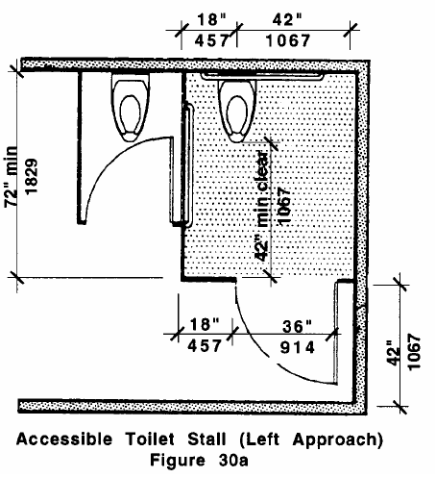  has centerlines 18” from nearest side wall and at least 42” from farthest side wall or closest edge of an adjacent fixture, as per Figure 30a (30.7.2) |  |  |  | 6c  | ❑
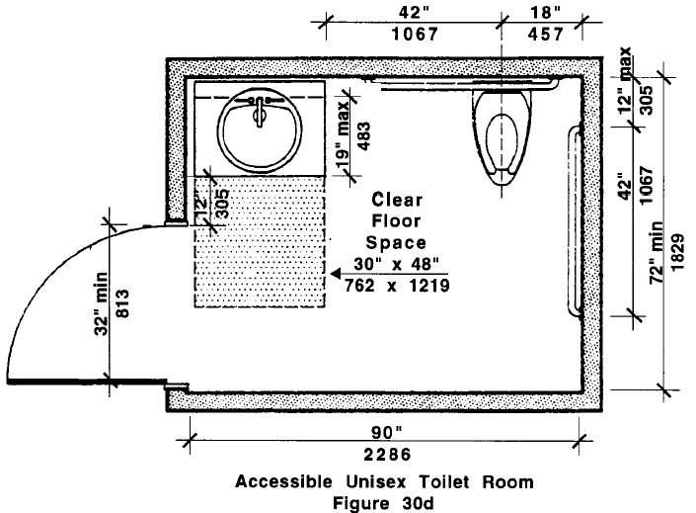when toilet is not inside a stall (as in a unisex toilet room), it has clear floor spaces as per Figure 30d (30.7.1) |  |  |  | 6d  | ❑
 |  |  |  | N/A 
Note: Floor space can allow left or right handed approaches.
has a min. 42” clearance between its front edge and nearest wall fixture (30.7.2) |  |  |  | 6e  | ❑
accessible Rest room continued ❸
element 6 - toilet continued
Standards |  |  |  | YES | NO | Notes/Measurements (record if checking NO)
GENERAL CONTINUED:
has a seat that is not spring mounted to return to a lifted position (30.7.4) |  |  |  | 6f  | ❑
FLUSH CONTROL:
is either automatic or operable with one hand and does not require tight grasping, pinching or twisting of the wrist (30.7.5 & 39.5) (i.e., operable with a closed fist) |  |  |  | 6g  | ❑
requires no more than 5 lbs of force to operate (39.5) |  |  |  | 6h  | ❑
is mounted on wide side of toilet no more than 44” above floor (30.7.5) |  |  |  | 6i  | ❑
TOILET PAPER DISPENSER:
is located on the side wall closest to toilet (30.7.6)  Note: Dispensers that control delivery or do not let paper flow continuously are not allowed (30.7.6). |  |  |  | 6j  | ❑
has the centerline of the roll set at least 24” above the floor (307.6) |  |  |  | 6k  | ❑
GRAB BARS:
are between 1¼” and 1½” in outside diameter and have a 1½” clearance between bar and wall (30.8.3) |  |  |  | 6l  | ❑
are 42" long (30.8) |  |  |  | 6m | ❑
are non-rusting and acid-etched or roughened (30.8.4) |  |  |  | 6n  | ❑
do not rotate within fittings (30.8.4)) |  |  |  | 6o  | ❑
are mounted between 33” and 36” above and parallel to floor (30.8.2)  Note: Where a tank prevents location of the rear grab bar, a bar may be installed 3" above the tank (30.8.2). |  |  |  | 6p  | ❑
are installed so one is on a wall in back of the toilet located a maximum of 6” from the interior corner & another is located on the side wall closest to the toilet located a maximum of 12” from the interior corner (30.8 & 30.8.1) |  |  |  | 6q  | ❑
meet structural strength codes (30.8.4) |  |  |  | 6r  | ❑
when a flushometer prevents having a 42" rear grab bar, a 36” bar is found at side of flushometer, 3" from nearest edge (30.8.2) |  |  |  | 6s  | ❑
 |  |  |  | N/A 
accessible Rest room continued ❸
Does at least one toilet in the rest room assessed meet all of the above TOILET standards?

6t. YES  NO 

element 7 – SINK
 |  | Determine if there is at least 1 sink within the rest room assessed that meets all of the standards below.
Standards |  |  |  | YES | NO | Notes/Measurements (record if checking NO)
general:
is on an accessible route (30.6) |  |  |  | 7a  | ❑
is mounted with its rim at a maximum of 34” above the finish floor (30.9.2) |  |  |  | 7b  | ❑
extends a minimum of 17" from the wall to the front of the sink or counter (30.9.2) |  |  |  | 7c  | ❑
has clear floor space extending at least 19” underneath sink, as per Fig. 30g (30.9.1)  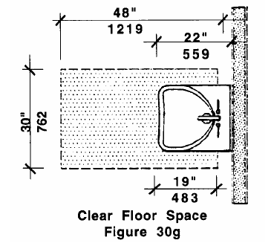  Note: Clear floor space at fixtures, controls, route, & turning space may overlap (30.5). |  |  |  | 7d  | ❑
has a T-shaped clear floor space -or- one that is 60” for a wheelchair to make a 180º turn & allow for a forward approach, as per Figures 6c & 6d on page 47 (30.9.1 & 6.3) |  |  |  | 7e  | ❑
has underneath knee clearance at least 27” from floor to sink underside & extends at least 8”, measured from front edge under sink back towards the wall (30.9.3)  Note: If has a minimum 9" toe clearance, a maximum 6" of the 48” clear floor space at fixture may extend into toe space (30.9.3). |  |  |  | 7f  | ❑
is no deeper than 6 ½” (30.9.4) |  |  |  | 7g  | ❑
is free of sharp or abrasive surfaces under sink (30.9.5) |  |  |  | 7h  | ❑
when hot water & drain pipes are exposed under sink, they are recessed, insulated or guarded (30.9.5) |  |  |  | 7i  | ❑
 |  |  |  | N/A 
has trap and drain located as close to rear wall as possible (30.9.5) |  |  |  | 7j  | ❑
FAUCET:
requires no more than 5 lbs of force to operate (39.5) |  |  |  | 7k  | ❑
accessible Rest room continued ❸
ELEMENT 7 - SiNk Continued
Standards |  |  |  | YES | NO | Notes/Measurements (record if checking NO)
is operable with one hand and does not require tight grasping, pinching, or twisting of the wrist (30.9.6) (i.e. operable with a closed fist)  Note: Lever-operated, push-, touch-type, or electronic faucets are allowed (30.9.6) |  |  |  | 7l  | ❑
when has self-closing valves, faucet stays open for at least 10 seconds (30.9.6) |  |  |  | 7m | ❑
 |  |  |  | N/A 
Does at least one sink in the rest room assessed meet all of
the above SINK standards?
7n. YES  NO 

element 8 – dispensers/devices
If different types of dispensers/devices are provided in the rest room, determine if there is at least 1 of each kind in the rest room assessed that conforms to the standards below?
If there are no dispensers/devices provided, skip down to the end of the dispensers/devices standards and answer N/A.
Standards |  |  |  | YES | NO | Notes/Measurements (record if checking NO)
is on an accessible route (31.6) |  |  |  | 8a  | ❑
requires no more than 5 lbs of force to operate (39.5) |  |  |  | 8b  | ❑
is operable with one hand and does not require tight grasping, pinching, or twisting of the wrist (39.5) |  |  |  | 8c  | ❑
is located within reach of a person using the accessible sink (30.12) |  |  |  | 8d  | ❑
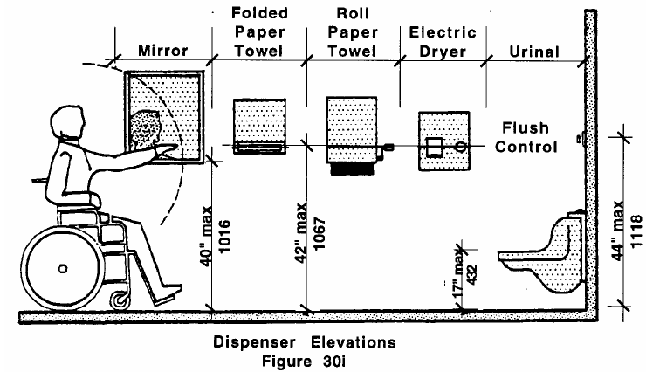  is mounted at a height according to Figure 30i (30.12) |  |  |  | 8e  | ❑
Note: Dispensers or other devices cannot be mounted above grab bars (30.8.5).
Does at least one of each dispenser or device in the rest room assessed meet
all of the above DISPENSERS/DEVICES standards?
8f. YES  NO  N/A 

accessible Rest room continued ❸
element 9 - Controls & Receptacles
If different types of controls and receptacles are provided in the rest room, determine if there is at least 1 of each kind that conforms to the standards below
If there are no controls or receptacles provided, skip down to the end of the controls and receptacle standards and answer N/A.
Standards |  |  |  | YES | NO | Notes/Measurements (record if checking NO)
is on an accessible route (31.6) |  |  |  | 9a  | ❑
has level clear floor space that is at least 30" x 48" for a single, stationary wheelchair and occupant to allow a forward or parallel approach (6.4.1 & 39.2) |  |  |  | 9b  | ❑
is located a minimum of 18" from an interior corner (39.4) |  |  |  | 9c  | ❑
is mounted with highest operable part no higher than 48” nor lower than 15” when forward approach, or no higher than 54” nor lower than 9” when parallel approach, as per Figures 6k & 6m on page 32 (30.13) |  |  |  | 9d  | ❑
requires no more than 5 lbs of force to operate (39.5) |  |  |  | 9e  | ❑
is operable with one hand and does not require tight grasping, pinching, or twisting of the wrist (39.5) |  |  |  | 9f  | ❑
Does at least one of each control and receptacle in the rest room assessed meet
all of the above CONTROLS & RECEPTACLES standards?
9g. YES  NO  N/A 
Item 1 - Accessible Rest Room
Final Question: Does the facility provide at least 1 rest room or 1 unisex toilet room in the same area as the rest room that meets all of the above standards?
YES  NO 

MASSACHUSETTS FACILITY ASSESSMENT TOOL
Priority ❹
Additional Access
This Priority is for Items not required for basic access in the first three Priorities. When amenities such as drinking fountains and public telephones are provided to the general public, they should also be accessible to people with disabilities.
 | In this section, you will be assessing Items related to “Additional Access.” Some of these have particular Elements that will need assessing while others will not.
ITEMS and ELEMENTS to be Assessed:
1 - accessible Telephone
2 - Text Telephone
3 - Drinking Fountains
ELEMENTS:
1 - Spout
2 - Controls
3 - Configuration
4 - Cup Dispenser

ITEM 1 – accessible telephone ❹
Assessment Objective: Determine if the facility has at least 1 public telephone that meets all of the below standards, if public telephones are provided within the facility.
If the facility does not provide public telephones, an accessible telephone does not need to be provided. In this case, skip down to the FINAL QUESTION on Accessible Telephone Item and answer N/A.
Standards |  |  | YES | NO | Notes/Measurements (record if checking NO)
is on an accessible route (37.4) |  |  | 1a  | ❑
has a level clear floor space that is a minimum of 30" x 48" for a single, stationary wheelchair and occupant (6.4.1) and allows for a forward or a parallel approach (37.2) |  |  | 1b  | ❑
when a front approach is required and the clear floor area includes knee space under the telephone, knee space is a minimum of 30" wide and 30” high (37.2.1) |  |  | 1c  | ❑
 |  |  | N/A 
is free of any base, enclosure, or fixed seat that could impede the approach to telephone by people who use wheelchairs (37.2.2) |  |  | 1d  | ❑
is free of protruding objects that reduce the clear width (36”) of the accessible route (37.4 & 20.6) |  |  | 1e  | ❑
is free of protruding objects that have sharp or abrupt edges (37.4 & 20.6.1) |  |  | 1f  | ❑
is hearing aid compatible and equipped with a volume control (37.5) |  |  | 1g  | ❑
is mounted with highest operable part no higher than 48” nor lower than 15” when a forward approach, or no higher than 54” nor lower than 9” when a parallel approach, as per Figures 6k & 6m on page 32 (6.5 & 6.6) |  |  | 1h  | ❑
has push button controls (37.6) |  |  | 1i  | ❑
has instructions for use of volume control attached to or next to phone (37.5.2) |  |  | 1j  | ❑
when telephone books are provided, they are located no higher than 48” nor lower than 15” when a forward approach (6.5) and no higher than 54” nor lower than 9” when a parallel approach (6.6 & 37.7) |  |  | 1k  | ❑
 |  |  | N/A 
when 3 or more telephones are provided in a bank, a minimum of 1 is designed to accommodate a portable TTY (has a shelf that is a minimum of 9” wide by 12” deep and has a 6" minimum vertical clearance, and an electrical outlet within or adjacent to phone enclosure) (37.9) |  |  | 1l  | ❑
 |  |  | N/A 
accessible telephone continued ❹
Standards |  |  | YES | NO | Notes/Measurements (record if checking NO)
when a shelf is provided, phone has a handset capable of being placed flush on surface of the shelf (37.9) |  |  | 1m | ❑
 |  |  | N/A 
when an amplified telephone, it has a depiction of a handset earpiece with radiating sound waves placed on the wall above it or in a location on or near the phone so that it can be easily seen and located (37.10.2) |  |  | 1n  | ❑
 |  |  | N/A 
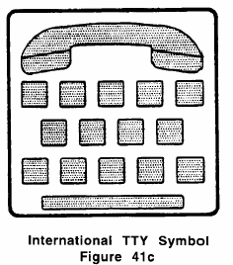  includes directional signage, placed adjacent to all telephone banks that do not contain a TTY, indicating the location of nearest text telephone and includes the international TTY symbol, as per Figure 41c (37.10.1 & 37.10.2) |  |  | 1o  | ❑
Item 1 - Accessible Telephone
Final Question: Does the facility provide at least 1 public telephone that meets all of the above standards?
YES  NO  N/A  (If the facility does not provide public telephones, an accessible
telephone does not need to be provided.)

ITEM 2 - text telephone ❹
Assessment Objective: Determine if the facility provides at least 1 text telephone (TTY) that meets all of the standards below, if 2 or more public telephones are provided in the same location or a single interior public payphone is provided in or adjacent to a hospital emergency room, recovery room, or hospital waiting room.
If neither of the above is true, a text telephone does not need to be provided within the facility. In this case, skip down to the FINAL QUESTION on Text Telephone Item and answer N/A.
Standards |  |  | YES | NO | Notes/Measurements (record if checking NO)
when has an acoustic coupler, the phone cord is at least 29” long to connect the TTY to receiver (37.8) |  |  | 1a  | ❑
 |  |  | N/A 
is permanently affixed within telephone enclosures (37.8) |  |  | 1b  | ❑
is identified by signage that includes the international TTY symbol, as per Figure 41c on page 62 (37.10.1) |  |  | 1c  | ❑
Item 2 - Text Telephone
Final Question: Does the facility provide at least 1 text telephone that meets all of the above standards?
YES  NO  N/A  (If the facility does not have 2 or more public telephones in the
same location or 1 interior public pay phone in or adjacent to a
hospital emergency room, recovery room or waiting room, a text
telephone does not need to be provided.)

ITEM 3 - ACCESSIBLE DRINKING FOUNTAIN ❹
Assessment Objective: Determine if the facility provides at least 1 drinking fountain, on an accessible route, that meets all of the standards related to the following Elements of an accessible drinking fountain: 1-Spout; 2-Controls; 3-Configuration; and 4-Cup Dispenser.
If the facility does not provide drinking fountains, an accessible drinking fountain does not need to be provided. In this case, skip down to the FINAL QUESTION on Accessible Drinking Fountain and answer N/A.
element 1 – spout
Standards |  | YES | NO | Notes/Measurements (record if checking NO)
is located at front of unit and directs water flow in a trajectory parallel or nearly parallel to front of unit (36.3.1) |  | 1a  | ❑
provides a flow of water at least 4" high to allow the insertion of a cup or glass under the flow of water (36.3.2) |  | 1b  | ❑
when fountain has a round or oval bowl, spout is positioned so the flow of water is within 3" of the front edge of the fountain (36.3.3) |  | 1c  | ❑
 |  | N/A 
is a maximum of 36" high, measured from floor to spout outlet (36.4) |  | 1d  | ❑
Does the spout of the drinking fountain assessed meet
all of the above SPOUT standards?
1e. YES  NO  N/A 
element 2 – controls
Standards |  | YES | NO | Notes/Measurements (record if checking NO)
are front-mounted or side-mounted near fountain’s front edge (36.5.1) |  | 2a  | ❑
are operable with one hand and do not require tight grasping, pinching or twisting of the wrist (36.5.2) (i.e., operable with a closed fist) |  | 2b  | ❑
require no more than 5 lbs of force to activate (36.5.2) |  | 2c  | ❑
Notes: Knob-type faucets are not permitted (36.5.2).
Other types of controls may be installed in addition to, but not instead of, hand operated controls (36.5.3)
Do the controls of the drinking fountain assessed meet
all of the above CONTROLS standards?
2d. YES  NO  N/A 
element 3 – CONFIGURATION
 | First, determine which of the following 4 types of drinking fountain units are present: (1) Free-standing Unit; (2) Built-in Unit; (3) Built-in Cantilevered or Wall-mounted Unit; or (4) Wall or Post-mounted Cantilevered Unit. Next, determine if that particular type of unit meets the corresponding Configuration standards below.
accessible drinking fountain continued ❹
element 3 - CONFIGURATION continued
Standards |  | YES | NO | Notes/Measurements (record if checking NO)
Free-standing unit
If no, answer N/A to all the standards in this list.
is mounted with its highest operable part no higher than 54” nor lower than 9” for a person using a wheelchair to make a parallel approach, as per Figure 6m on page 32 (36.2.2 & 6.6) |  | 3a  | ❑
 |  | N/A 
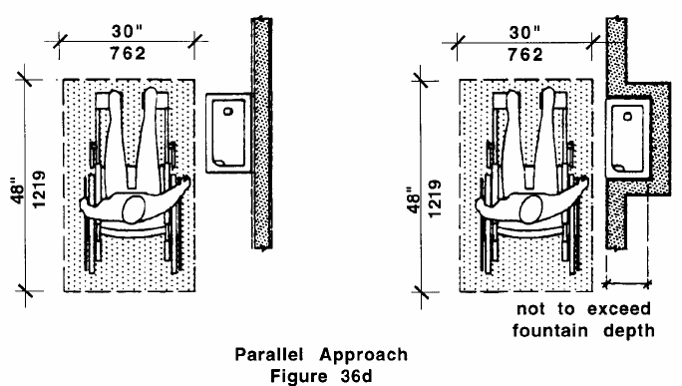  when does not have a knee space under it, the unit has a clear floor space that is a minimum of 30” x 48” that allows a person in a wheelchair to make a parallel approach, as per Figure 36d (36.2.2) |  | 3b  | ❑
 |  | N/A 
built in unit
If no, answer N/A to all the standards in this list.
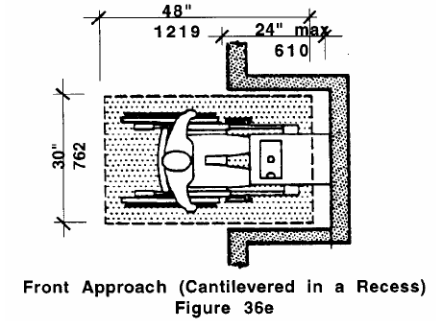  when cantilevered in a recess, the recess is a minimum of 30” wide and complies with Figure 36e (36.2.3b) |  | 3c  | ❑
 |  | N/A 
when located in a recess and has no knee space below it, the recess depth does not exceed fountain depth and fountain has a clear floor space that is at least 30” x 48” to allow a person using a wheelchair to make a parallel approach (36.2.3c) |  | 3d  | ❑
 |  | N/A 
built in cantilevered or wall mounted unit
If no, answer N/A to all the standards in this list.
is free of sharp or abrupt edges (36.2.3a & 20.6.1) |  | 3e  | ❑
 |  | N/A 
does not reduce the clear width (36”) of the route of travel or maneuvering spaces (36.2.3a & 20.6) |  | 3f  | ❑
 |  | N/A 
when mounted between 27” and 80” above floor, does not protrude more than 4” into hallways, as per Figure 20d on page 11 (36.2.3a & 20.6.1) |  | 3g  | ❑
 |  | N/A 

accessible drinking fountain continued ❹
element 3 - CONFIGURATION continued
Standards |  | YES | NO | Notes/Measurements (record if checking NO)
Wall or Post-mounted Cantilevered Unit that only allows a front approach
If no, answer N/A to all the standards in this list.
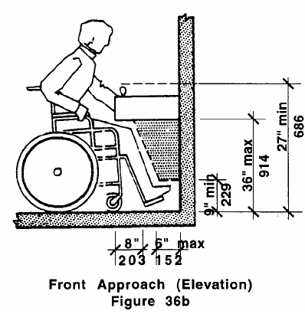  has a clear knee space between the bottom of apron and the floor that is a minimum of 27” high, 30” wide and 19” deep, as per Figure 36b (36.2.1) |  | 3h  | ❑
 |  | N/A 
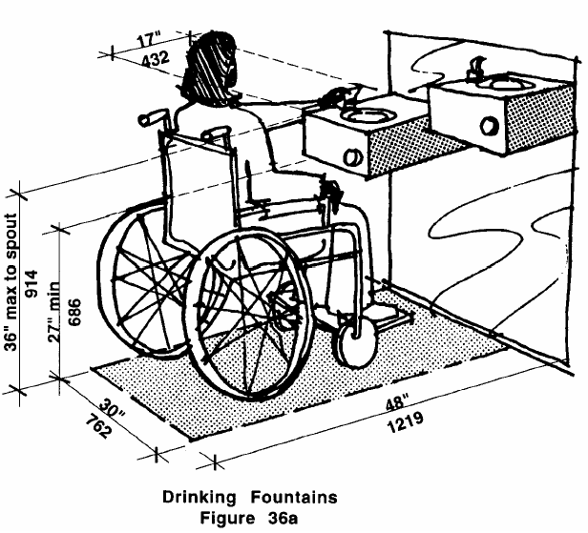  when a “high-low” fountain, it conforms to Figure 36a (36.1.1) |  | 3i  | ❑
 |  | N/A 
has a clear floor space that is a minimum of 30” x 48” to allow a person in a wheelchair to approach the unit facing forward (36.2.1b) |  | 3j  | ❑
Does the configuration of the drinking fountain assessed meet
all of the above CONFIGURATION standards?
3k. YES  NO  N/A 
element 4 - CUP DISPENSER
If no accessible drinking fountain is provided, is there at least one fountain that has a cup dispenser located no higher than 48” nor lower than 15” when a forward approach and no
higher than 54” nor lower than 9” when a parallel approach (6.5, 6.6, 37.7 & DPH)?
4a. YES  NO  N/A 
Item 3 - Accessible Drinking Fountain
Final Question: Does the facility provide at least 1 drinking fountain, on an accessible route, that meet all of the above standards?
YES  NO  N/A  (If the facility does not provide drinking fountains, an accessible
drinking fountain does not need to be provided.)

APPENDIX A

Figures

APPENDIX A - Figures
Figure 6b | Figures 6c & 6d
Figure 6k | Figure 6m
Figure 6l
APPENDIX A - Figures Continued
Figure 6n |  | Figures 20a & 20b
Figure 20d |  | Figure 20f
Figure 20g |  | Figure 20h

APPENDIX A - Figures Continued
Figure 20i | Figure 20j
Figure 21b | Figure 21c
Figure 24b | Figure 24c

APPENDIX A - Figures Continued
Figure 24d  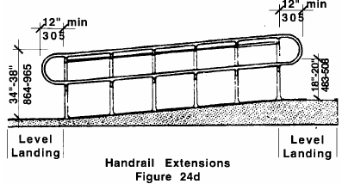 | Figures 25a & 25b
Figure 26d | Figure26f

APPENDIX A - Figures Continued
Figure 26e |  | Figure 27b
 |  | Figure 27d
Figure 28c |  | Figure 28d
APPENDIX A - Figures Continued
Figure 29b |  | Figure 30a
Figure 30d |  | Figure 30i
Figure 33b |  | Figure 36a
APPENDIX A - Figures Continued
Figure 36b | Figure 36d
Figure 36e | Figure 41a
Figure 41c

APPENDIX B

Transition Plan Templates:

1. Transition Plan Cover Page

2. Transition Plan for Readily Achievable Barrier Removal

3. Transition Plan for Non-Readily Achievable Barrier Removal/
Modifications

Directions

After completing the Massachusetts Facility Assessment Tool, make a list of barriers that limit accessibility. Next, identify those barriers whose removal is “readily achievable”. “Readily achievable” is defined under Title III of the ADA as easily accomplishable with little difficulty or expense (42 USC 12181(9)).

Readily achievable barrier removal is an ongoing obligation and can be carried out incrementally over a period of time. Establish an order of priority for the barriers on the list and project cost estimates and a date by which they will be removed using the transition plan templates provided.

Implementing a transition plan requires the collaboration of key individuals at a program site who have the authority to approve the changes outlined. These individuals should review the transition plan and sign the cover page with their approval. Funding should then be allotted in budget plans to adhere to the projected timeline and cost of barrier removal.

Please include this cover page along with each transition plan submitted by your agency’s program sites. Please make sure the transition plans are signed-off by those with the authority to approve the changes outlined. The transition plans are intended to address any facility access barriers you may find after completing the MFAT.

TRANSITION PLAN COVER PAGE

Agency Name: Program Site Name:

Program Site Address:

Plan submitted by (Name): Signature: Date:

Title: Phone #:

ADA Coordinator Name: Signature: Date:

Facility Manager Name: Signature: Date:

Budget Manager Name: Signature: Date:

TRANSITION PLAN FOR READILY ACHIEVABLE BARRIER REMOVAL

Agency Name: Program Site Name:

Program Site Address: Date:

Priority Area, Element, and Item # - Description of Barrier | Planned Action for Structural Changes/ Improvements | Cost  Estimate | Timeline/ Expected Completion Date
 | Total Cost:---------------------------------- →
(use additional rows/sheets as needed)

TRANSITION PLAN FOR
NON-READILY ACHIEVABLE BARRIER REMOVAL/ MODIFICATIONS

Agency Name: Program Site Name:

Program Site Address: Date:

Priority Area, Element, and Item #  - Description of Barrier | Planned Action for Structural Changes/ Improvements | Cost  Estimate | Explanation of why barrier removal is not readily achievable/ modifiable | Steps to be taken with policies and procedures to assure program accessibility in lieu of barrier removal
 | Total Cost-----------------------------------→
(use additional rows/sheets as needed)

ADA, Title II, section 35.103 (b) (1).

