**A worker removing roofing shingles from a roof.

**Massachusetts Fatal Injuries at Work**

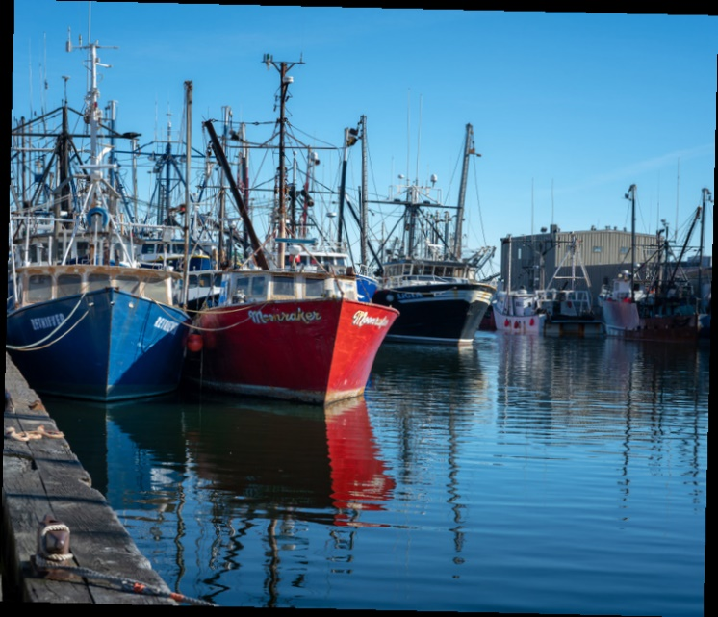**2021–2022**

**Massachusetts Department of Public Health**

Report by the Occupational Health   
Surveillance Program

**Two workers trimming tree branches at the side of a roadway. One worker is using a pole saw and the other worker is putting the debris into a wood chipper machine. **Find this report at: [mass.gov/lists/fatal-work-related-injury-reports-and-publications](https://www.mass.gov/lists/fatal-work-related-injury-reports-and-publications)

Table of Contents

Overview 2

Why do we need statistics about fatal occupational injuries? 2

[Summary of Workplace Deaths in Massachusetts in 2021–2022 2](https://massgov.sharepoint.com/sites/EHS-Teams-DPH_Occupational_Health_Surveillance_Program-FACE/Shared%20Documents/FACE/Fatality%20Update/massachusetts-fatality-update-2021-2022.docx#_Toc168059267)

Projects Behind This Report 3

Fatality Assessment and Control Evaluation Program 3

Census of Fatal Occupational Injuries 3

How did we identify data for this report? 3

The Workers: Demographics 4

Gender 4

Age 5

Race and Hispanic Ethnicity 5

Foreign-Born Status 7

Employment Type 7

Massachusetts Counties Where Injury Took Place 8

Types of Events Causing Worker Deaths 9

Fatal Injuries at Work by Industry, 2021–2022 10

Comparing Massachusetts to the Nation 11

State and Federal Roles in Occupational Health and Safety 12

What agencies enforce workplace safety regulations in Massachusetts? 12

How does OHSP investigate workplace fatalities? 12

Fatal Injury Prevention in Massachusetts: Examples of current activities 13

Workplace Overdose Prevention 13

Suicide Prevention 13

Falls and Struck-By Incident Prevention 14

Landscaping Industry Fatality Prevention 14

Acknowledgements 15

# Overview

This edition of *Massachusetts Fatal Injuries at Work* provides an overview of the fatal occupational injuries that occurred in Massachusetts in 2021–2022 and includes details collected by both the Massachusetts Fatality Assessment and Control Evaluation (FACE) and the Census of Fatal Occupational Injuries (CFOI) projects. Included are deaths traditionally linked to physical and chemical hazards in the work environment such as falls, electrocutions, and exposure to toxic chemicals. Also included are workplace overdoses (from opioids and other substances), homicides and suicides, and motor-vehicle-related fatalities that occur during work or work travel. Workplace and work-related deaths from occupational illnesses, such as health events like heart attacks or asthma attacks, are not systematically counted by the projects and are not included in these analyses.

## Why do we need statistics about fatal occupational injuries?

Fatal occupational injuries are preventable. Information about where and how they occur is essential to develop effective prevention programs. The surveillance findings in this report are intended to guide government, industry, labor, and community organizations in developing and implementing strategies to prevent similar tragedies in the future. Occupational health leaders need to continue efforts to reduce both the human and economic tolls of preventable deaths at work in the Commonwealth. When reporting statistics about fatal occupational injuries, it is important to acknowledge the humanity that these numbers represent.

# Summary of Workplace Deaths in Massachusetts in 2021–2022

In 2021 and 2022, **178 people** died from workplace injuries in Massachusetts.

**The leading causes of fatal occupational injuries were:**

* Workplace overdose (n=47)
* Workplace suicide (n=25)
* Roadway crash (n=21)
* Fall to a lower level (n=19)
* Pedestrian incident (n=14)
* Struck by falling object or equipment (n=12)

**Industries with the highest rates of fatal occupational injuries were:**

* Agriculture, Forestry, Fishing, and Hunting: 36.8 deaths per 100,000 full-time workers
* Landscaping: 14.9 deaths per 100,000 full-time workers
* Transportation and Utilities: 10.9 deaths per 100,000 full-time workers

*See ‘Types of Events Causing Worker Deaths’ on page 9 and ‘Fatal Injuries at Work by Industry, 2021–2022’ on page 9 for more information.*

# Projects Behind This Report

The Massachusetts Department of Public Health (DPH)’s Occupational Health Surveillance Program (OHSP) studies several worker health topics. The work-related fatalities in 2021–2022 described in this report were identified by two projects within the Workplace Fatality Program in OHSP: the Massachusetts Fatality Assessment and Control Evaluation (FACE) and the Census of Fatal Occupational Injuries (CFOI).

## Fatality Assessment and Control Evaluation Program

FACE is funded through a cooperative agreement with the Centers for Disease Control and Prevention’s National Institute for Occupational Safety and Health (NIOSH). The purpose of the [FACE program](https://www.cdc.gov/niosh/face/default.html) is to develop a detailed understanding of how fatal injuries occur, through identifying and documenting workplace deaths and assessing how work procedures, equipment, training, and other factors contributed to the event. FACE develops recommendations that can be shared with relevant industries, labor organizations, equipment manufacturers, and others in positions to take action to prevent work-related injuries. Combining data, case stories, and findings from fatality investigations, MA FACE produces fact sheets and detailed reports that can be used for employee training. Eight states are funded by NIOSH to run a state FACE program.

## Census of Fatal Occupational Injuries

CFOI is funded through a cooperative agreement with the U.S. Department of Labor, Bureau of Labor Statistics (BLS), and a matching DPH contribution. In [CFOI](https://www.bls.gov/iif/overview/cfoi.htm), we complete data coding and entry into a federal system and compile a detailed record of each event. After review by regional and national program staff and data validation, a case is accepted into the official data set. The data is searchable by job (occupation), industry (type of business), event, and many other details. It can be used to inform training for workers on hazards, to understand trends, and to identify gaps in safety practices or standards. CFOI data is available for all 50 states and the District of Columbia, and the project is also conducted in the U.S. territories.

## How did we identify data for this report?

The OHSP Workplace Fatality Program identifies work-related deaths in the Commonwealth by collecting information about each case from death certificates, medical examiner data, obituaries, other various records from the U.S. Department of Labor, Occupational Safety and Health Administration (OSHA), and other enforcement agencies. New stories, police reports, workers’ compensation data, and many other sources are also used to identify and research these deaths.

OHSP uses NIOSH’s [Employed Labor Force](https://wwwn.cdc.gov/Wisards/cps/default.aspx) query system to calculate workforce estimates and this allows us to produce fatality rates based on the number of workers and hours worked, by industry sector and worker demographics. The data presented in this report may not match data published by the BLS because how we obtain this detailed workforce data is different from [how BLS calculates workforce data](https://www.bls.gov/opub/hom/cfoi/calculation.htm) used for state rates.

# The Workers: Demographics

In Massachusetts, 97 and 81 individuals were fatally injured at work in 2021 and 2022, respectively. The fatal occupational injury rate was 2.9 deaths per 100,000 full-time workers in 2021 and 2.4 deaths per 100,000 workers in 2022. While the rate jumped slightly in 2021, the 2022 rate was in line with the rates of previous years.

**FIGURE 1. *Rate of Fatal Occupational Injury by Year, Massachusetts (n=431)***

**Bar graph showing the annual fatality rate, in deaths per 100,000 full-time workers. Year and rate:
2018 2019 2020 2021 2022
2.7 2.4 2.3 2.9 2.4**

**Source:** Occupational Health Surveillance Program, Massachusetts FACE and CFOI, 2021–2022.

Workforce denominator data from the Current Population Survey accessed through the NIOSH Employed Labor Force query system.

**\*Full-Time**

## Gender

The fatally injured included 160 males and 18 females (89.9% and 10.1%, respectively, of the total amount of deaths).Note: These data come from a range of sources (see page 3). Based on our review, there were no workplace fatalities of workers who identified as any other gender.

**FIGURE 2. *Number and Percent of Fatal Occupational Injuries***

***by Gender, Massachusetts, 2021–2022 (n=178)***

**Pie chart showing the distribution of fatal occupational injuries by gender. 
Male Female
160 18
89.9% 10.1%**

**Source**: Occupational Health Surveillance Program, Massachusetts FACE and CFOI, 2021–2022.

Source: Occupational Health Surveillance Program, Massachusetts FACE and CFOI, 2021–2022.

## Age

The fatally injured workers ranged in age from 16 to 86 years, with a mean age of 46 and a median age of 47. The fatalities resulted in a total of 5,301 potential life years lost, based on a life expectancy of 76 years in the United States. That makes an average of 30 potential life years lost per victim.[1]

**FIGURE 3. *Workplace Deaths by Age Group, Massachusetts, 2021-2022***

**Bar graph showing the number of deaths by age group.
Age group Number of workers
16-24 12
25-34 33
35-44 39
45-54 35
55-64 42
65+ 17
**

**Source**: Occupational Health Surveillance Program, Massachusetts FACE and CFOI, 2021–2022.

## Race and Hispanic Ethnicity

A total of 121 (68.0%) of the workers with fatal occupational injuries were White non-Hispanic; 26 (14.6%) were Hispanic; 20 (11.2%) were Black or African American non-Hispanic; three (1.7%) were Asian non-Hispanic; and eight (4.5%) were multi-racial or other specified race. Figure 4 shows these injury distributions compared to the Massachusetts workforce distribution by race and ethnicity. Together they show that Black non-Hispanic and Hispanic workers were overrepresented among those with fatal occupational injuries.

**FIGURE 4. *Fatal Occupation Injuries by Race/Ethnicity Compared to Total Workforce by   
 Race/Ethnicity, Massachusetts, 2021–2022***

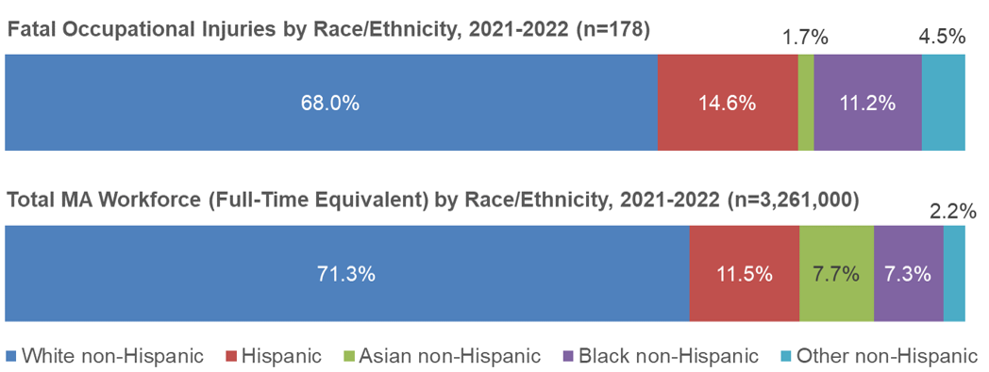

**Sources:** Occupational Health Surveillance Program, Massachusetts FACE and CFOI, 2021–2022.

Current Population Survey accessed through the NIOSH Employed Labor Force query system.

As seen below in Figure 5, while the fatality rate (deaths per 100,000 full-time workers) increased for most groups in 2021–2022 compared to previous years, the fatality rate for Black non-Hispanic workers more than tripled (4.3 per 100,000 workers in 2021–2022, compared to 1.2 in 2020).

**FIGURE 5. *Rate of Fatal Occupational Injury by Race and Hispanic Ethnicity, Massachusetts   
 (n=1,131)***

This line chart shows the change in the fatality rate through the past several analyses. 
  2008-2013 2014-2015 2016-2017 2018-2019 2020 2021-2022
Hispanic  3.2 1.2 3.7 2.9 3.1 3.4
Black non-Hispanic  2.7 1.5 2.8 1.6 1.2 4.1
White non-Hispanic  1.8 2.1 3.3 2.7 2.1 2.5
Asian non-Hispanic  1.3 0.9 1.1  1.2 0.6

**Source**: Occupational Health Surveillance Program, Massachusetts FACE and CFOI, 2021–2022. Workforce denominator data from the Current Population Survey accessed through the NIOSH Employed Labor Force query system.

**Note regarding data not on graph**: Rates are provided where counts or rates in the time period meet publishability standards. As seen in this figure, this results in data we are unable to graph for Asian non-Hispanic in 2018-2019, and for other non-Hispanic for all time points. [2]

[3]

[4]

**Racial and Ethnic Disparities in Massachusetts’ Occupational Fatality Data Reflect National Trends.**

National workforce and injury data over time show us that Hispanic and Black workers disproportionately work in more dangerous jobs and suffer more workplace injuries and deaths.2,3,4 Structural racism and the resultant missed economic opportunity led to this occupational segregation. Factors contributing to the increased risk of work-related injury and illness in these jobs can include economic pressures that deter workers from speaking up about workplace hazards; fear of discrimination in and outside of the workplace; lack of training or supervision; and language, literacy, and cultural barriers in the workplace. In high-risk industries such as construction, Hispanic workers are more likely to be placed in positions where the hazards are less likely to be controlled. OHSP continues to work to reduce these disparities and inequities by providing detailed data to policymakers and advocates and by aiming to improve outreach to workers of color and others who have been affected by persistent systemic racism and related inequities.

## Foreign-Born Status

Forty-five (25.3%) of the 178 workers who died in the workplace were born outside of the United States. The rate of fatal injury among foreign-born workers was 2.8 per 100,000 full-time workers, and the rate among U.S.-born workers was 2.6 per 100,000 full-time workers. These individuals worked in a range of industries: the leading sectors were Other Services (n=10) (of which, seven were in maintenance and repair), Construction (n=9), and Administrative and Support and Waste Management and Remediation Services (n=6).[5]

**FIGURE 6. *Fatal Occupational Injuries by International Region of Origin,   
 Massachusetts, 2021-2022 (n=178)***

Pie chart showing birth region, number and distribution by percentage.
Region %
United States (133) 74.7%
Caribbean (12) 6.7%
Africa (7) 3.9%
Central America (7) 3.9%
South America (7) 3.9%
Asia (6) 3.4%
Europe (5) 2.8%
Other North America (1) 0.6%
 


**Source**: Occupational Health Surveillance Program, Massachusetts FACE and CFOI, 2021–2022.

## Employment Type

Pie chart showing 
Workplace Deaths by Employee Status 
Wage and salary 154 86.5%
Self-employed 23 12.9%
Volunteer 1 0.6%Twenty-three workers were self-employed.[6] The fatal injury rate among self-employed workers was 9.3 per 100,000 full-time workers, compared to 2.7 among wage and salary earners. The self-employed workforce encompasses independent contractors and other independent workers who often [experience worse workplace safety and health outcomes](https://www.bls.gov/opub/btn/volume-8/fatal-occupational-injuries-to-independent-workers.htm). While the self-employed are often not subject to OSHA enforcement, OHSP plays an important role in ensuring that these workers' deaths are counted and by continuing to promote and support workplace policies that will help protect these workers.

**FIGURE 7. *Fatal Occupational Injuries by***

***Employee Status, Massachusetts,   
 2021-2022 (n=178)***

**Source:** Occupational Health Surveillance Program, Massachusetts FACE and CFOI, 2021–2022.

## Massachusetts Counties Where Injury Took Place

The largest number of fatal occupational injuries occurred in Middlesex and Suffolk Counties, followed by Worcester, Essex, Bristol, Norfolk, and Plymouth.

**FIGURE 8. *Number of Fatal Occupational Injuries by County, Massachusetts, 2021–2022***

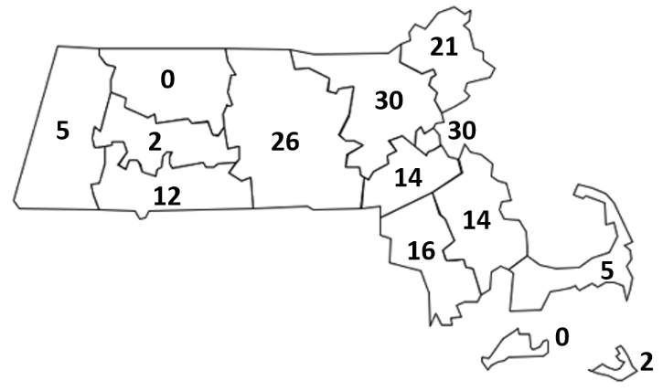

**Source**: Occupational Health Surveillance Program, Massachusetts FACE and CFOI, 2021–2022.

**TABLE 1: *Number of Fatal Occupational Injuries by County, Massachusetts, 2021–2022***

|  |  |
| --- | --- |
| **County** | **Number of Fatalities** |
| Middlesex | 30 |
| Suffolk | 30 |
| Worcester | 26 |
| Essex | 21 |
| Bristol | 16 |
| Norfolk | 14 |
| Plymouth | 14 |
| Hampden | 12 |
| Barnstable | 5 |
| Berkshire | 5 |
| Hampshire | 2 |
| Nantucket | 2 |

**Source**: Occupational Health Surveillance Program, Massachusetts FACE and CFOI, 2021–2022.

# Types of Events Causing Worker Deaths

Highlights on the leading types of events that caused Massachusetts’ 178 worker deaths in 2021–2022:

* **Unintentional overdose** at work was the single leading cause of fatal injury at work in 2021–2022, resulting in 47 deaths. Unintentional overdose at work has been the leading cause of workplace injury death in Massachusetts since 2016. Nationally, as well as statewide, fatal overdoses at work have increased over the years. Further trend analyses, including data by industry and occupation, are described in detail in [other reports](https://www.mass.gov/lists/special-topics-in-occupational-injuries-and-illnesses#opioids-and-work-).
* **Suicide** in the workplace was the second leading event. The 13 deaths in 2021 and 12 deaths in 2022 exceed recent previous years.
* **Roadway motor vehicle collisions** and rollovers contributed to the fatal injuries of 21 workers.
* **Falls to a lower level** resulted in 19 worker deaths. Twelve of these falls involved construction tasks or tools. Half of the falls to a lower level were from heights of 10 feet or less.

**TABLE 2: *Number and Percent of Fatal Occupational Injuries by Event/Exposure,   
 Massachusetts, 2021–2022, n=178***

|  |  |  |
| --- | --- | --- |
| **Event/Exposure** | **Number of Fatalities** | **Percent** |
| **Exposure to harmful substance or environment** | **58** | **33%** |
| * Unintentional overdose, drugs or alcohol | 47 | 26% |
| * Drowning, not vessel related | 4 | 2% |
| * Exposure to electricity | 3 | 2% |
| **Transportation incident** | **42** | **24%** |
| * Roadway collision or non-collision (rollover) | 21 | 12% |
| * Pedestrian struck | 14 | 8% |
| **Violence and other injury by person or animal** | **31** | **17%** |
| * Suicide or self-inflicted injury | 25 | 14% |
| * Homicide | 4 | 2% |
| **Fall, slip, or trip** | **27** | **15%** |
| * Fall to a lower level | 19 | 11% |
| * Fall on same level | 7 | 4% |
| **Contact with object or equipment** | **17** | **10%** |
| * Struck by falling vehicle or part of vehicle | 8 | 4% |
| **Fires and explosions** | **3** | **2%** |
| **Total** | **178** | **100%** |

**Note**: Event/exposure sub-categories with < 3 fatalities are not shown. Sub-categories may not add up to the bolded category totals. Percentages may not add to 100% due to rounding.

**Source**: Occupational Health Surveillance Program, Massachusetts FACE and CFOI, 2021–2022.

**To learn what OHSP is doing to reduce workplace fatalities, see *Fatal Injury Prevention in Massachusetts: Examples of current activities* on page 13.**

# Fatal Injuries at Work by Industry, 2021–2022

Highlights on the industry groups with the highest rates of fatal injuries in Massachusetts in 2021–2022:

* The **Agriculture, Forestry, Fishing and Hunting** industry group had the highest occupational fatality rate with 38.6 deaths per 100,000 full-time workers and a total of 11 deaths.
* The **Landscaping Services Industry** is not seen below in Figure 9 because it is grouped within Professional and Business Services; however, as a standalone industry, it had the second highest occupational fatality rate with 14.9 deaths per 100,000 full-time workers and seven deaths.
* The **Transportation and Utilities** industry group had a fatality rate of 10.9 deaths per 100,000 full-time workers and 21 deaths.
* The **Construction** industry group had a fatality rate of 8.3 deaths per 100,000 full-time workers. It had the highest number of deaths, 39. Twelve of these were owners, managers, or supervisors. The leading fatal event in this sector was falls to a lower level (n=11).
* The **Other Services** industry group had a fatality rate of 8.0 deaths per 100,000 full-time workers and 19 deaths. These included 10 workers in automotive maintenance. In this sector, workplace overdose (n=7) and suicide (n=5) were the leading events, making up 63% of deaths in this sector.

**FIGURE 9: *Number and Rate of Fatal Occupational Injuries by Industry Group,  
 Massachusetts, 2021–2022 (n=178)***

A bar chart that shows the number of deaths and the rate by industry group. Those two measures identify both exposure and risk.
Industry Group Number of Fatalities 2021-2022 Fatality Rate 2021-2022 (per 100,000 full-time workers)
Education and Health Services 6 0.4
Financial Activities 4 0.8
Government* 9 1.2
Professional and Business Services 20 1.7
Manufacturing 11 1.8
Leisure and Hospitality 12 3.0
Wholesale and Retail Trade 24 3.5
Other Services 19 8.0
Construction 39 8.3
Transportation and Utilities      21 10.9
Agriculture, Forestry, Fishing, and Hunting 11 36.8


**Note**: Data not presented for two industry groups which had fewer than three fatalities: Information, and Mining, Quarrying, and Oil and Gas Extraction (n=2 deaths).

**Source**: Occupational Health Surveillance Program, Massachusetts FACE and CFOI, 2021–2022.

*The Government category includes fatalities sustained by public sector workers regardless of industry.

# Comparing Massachusetts to the Nation

* [Nationwide](https://www.bls.gov/iif/oshcfoi1.htm), 5,190 workers and 5,486 workers died from fatal occupational injuries in 2021 and 2022, respectively. This is a rate of 3.6 per 100,000 full-time workers in 2021 and 3.7 in 2022, which are higher than the Massachusetts rates of 2.9 and 2.4.
* Compared to the nation, Massachusetts differs in three important ways.
  1. Massachusetts has proportionately fewer workers in high-risk industries, such as mining, agriculture, logging, or truck transportation, than the United States.
  2. The proportion of work-related injury deaths from roadway transportation incidents was much lower in Massachusetts. These were leading fatal events nationwide, representing 24.6% of all work-related fatal injuries, while in Massachusetts crashes made up just 11.8% of the burden.
  3. Workplace overdoses made up 26.4% of worker deaths in Massachusetts, compared to only 9.3% nationwide. In 2021 the [rate of fatal overdose (not just among workers, but residents overall) in Massachusetts](https://www.mass.gov/doc/opioid-related-overdose-deaths-among-ma-residents-june-2023/download) was 32.7 deaths per 100,000 residents, while it was 32.4 deaths per 100,000 [nationwide](https://www.cdc.gov/nchs/data/databriefs/db457.pdf). This suggests that surveillance of workplace overdoses in Massachusetts may be more robust as the overall rates of fatal overdose are comparable, despite the large gap between national and Massachusetts’ workplace overdose numbers.

# State and Federal Roles in Occupational Health and Safety

As no agency has sole jurisdiction over all workplaces and workers in Massachusetts, OHSP plays an important role in connecting workers and employers with the several agencies that support workplace safety. OHSP refers cases to relevant agencies, serves as an information resource for workers and employers with health and safety questions, and advises on a range of health and safety topics. Our partner agencies include state agencies such as the Department of Labor Standards (DLS, the Department of Industrial Accidents, and the Attorney General’s Office, as well as federal agencies like the Occupational Safety and Health Administration (OSHA) and the Wage and Hour Division in the U.S. Department of Labor.

## What agencies enforce workplace safety regulations in Massachusetts?

OSHA is the main federal agency that is responsible for creating workplace health and safety standards, enforcing these standards, and providing compliance assistance.

* **Private sector employers and workers**: In Massachusetts, OSHA standards apply to private sector employers and employees. OSHA has jurisdiction over private sector employers in Massachusetts and also federal workforces. Other agencies, such as the U.S. Coast Guard or the National Transportation Safety Board, lead the response in investigating worker fatalities in industries like commercial fishing or from certain events like plane crashes.
* **Public sector workers**: The DLS protects state and local public sector workers as a [State Plan](https://www.osha.gov/stateplans/ma) under OSHA.
* **Others:** Self-employed workers, independent contractors, and workers on family farms that employ only immediate family members: These workers are not covered by OSHA or DLS.

OSHA investigated at least 41 (23.0%) of the 178 fatal work-related injuries identified by the OHSP that occurred in 2021–2022.[7] OSHA levied fines for violations of health and safety standards against at least 19 of the employers they investigated in response to these fatal incidents. The lowest fine assessed was $4,096 and the highest was $1,256,092.

Of the remaining incidents, 22 (12.4%) involved workers who fell outside of OSHA jurisdiction, such as public sector employees, sole proprietors, the self-employed, and commercial fishers. Eighty-four (47.2%) additional deaths were events not routinely addressed by OSHA, such as overdoses, suicides, homicides, or roadway motor vehicle collisions. While OHSP does not have an enforcement role, it helps fill an important gap by including these workers in the information it collects, analyzes, and disseminates to the enforcement agencies, workplace safety advocates, and policymakers.

## How does OHSP investigate workplace fatalities?

OHSP conducts in-depth investigations on select workplace fatalities through the FACE program. After conducting these investigations, OHSP publishes detailed reports that document what may have led to the event with recommendations to prevent similar occurrences from happening in the future. A recent investigation is highlighted below. More can be found at [mass.gov/resource/fatality-case-reports](http://www.mass.gov/resource/fatality-case-reports).

# Fatal Injury Prevention in Massachusetts: Examples of current activities

## Workplace Overdose Prevention

Similar to recent years, unintentional overdose at work was the single leading cause of fatal injury at work in 2021–2022, resulting in one quarter of all workplace deaths. These deaths occurred across all industry sectors. The average age of workplace overdose victims was 44 years. Examples of state efforts to address and prevent workplace overdose include:

* **The BeHERE Initiative**. OHSP continues to help support workers and workplaces to understand the connection between opioids, pain, and the workplace. In collaboration with Health Resources in Action on work funded by the State Opioid Response grant, OHSP helped develop new trainings and a comprehensive website for Massachusetts employers. The goals of these products are to increase opioid awareness and provide resources for employers to implement policies and practices that build capacity for ‘upstream’ prevention efforts that follow the principles of Recovery-Supportive Workplaces. Learn more at [behereinitiative.org/workplace/opioids-pain-and-the-workplace](https://behereinitiative.org/workplace/opioids-pain-and-the-workplace/).
* **Data Reports**. In addition, OHSP has [analyzed](https://www.mass.gov/lists/occupational-health-special-topics#opioids-and-work-) opioid overdoses by industry and occupation. Most recently, OHSP released a [report on deaths from 2018-2020](https://www.mass.gov/doc/opioid-related-overdose-deaths-in-massachusetts-by-industry-and-occupation-2018-2020-0/download). These analyses aim to shed light on the work-related factors of opioid overdose and to inform prevention efforts tailored to different industry and occupation groups.

## Suicide Prevention

OHSP continues to work with DPH’s [Suicide Prevention Program](https://www.mass.gov/suicide-prevention-program) to identify [workforces that are at greater risk of suicide](https://www.mass.gov/lists/occupational-health-special-topics#suicides-and-work-). OHSP also helps develop resources for the [MassMen Project](https://www.mass.gov/massmen), a statewide initiative that promotes wellness and empowers working-age men in Massachusetts to take action to feel better emotionally, physically, and spiritually. Examples of resources include:

* 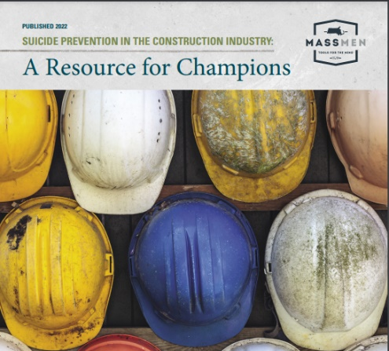**Suicide Prevention in the Construction Industry: A Resource for Champions**. [This resource guide](https://www.mass.gov/doc/suicide-prevention-in-construction-resource-for-champions/download) is for anyone who is working to champion mental health and suicide prevention in the workplace. This resource is not a guide for implementing a specific suicide prevention program, since no one program fits every company, union, or organization. Instead, it provides a starting point for increasing awareness and bringing support and resources to construction workers through existing or new workplace connections. Learn more at [mass.gov/info-details/massmen-resources-for-employers#suicide-prevention-in-the-construction-industry](https://www.mass.gov/info-details/massmen-resources-for-employers#suicide-prevention-in-the-construction-industry).
* **Data Sheet.** DPH’s data sheet, [Suicides Among Workers Age 16 or Older by Industry and Occupation in Massachusetts, 2018-2020](https://www.mass.gov/doc/suicides-by-industry-and-occupation-2018-2020-pdf/download), provides information on suicides among workers in construction and extraction occupation groups. It provides details by work-related factors, as well as data on the connections between mental health conditions, substance use, and deaths by suicide. This data can be used to tailor interventions to specific workplace groups.

*If you or someone you know is thinking about suicide, please contact one of the 24-hour crisis hotline numbers right away:* [*National Suicide Prevention Lifeline*](https://suicidepreventionlifeline.org/)*call or text* ***988*** *|*[*chat*](https://suicidepreventionlifeline.org/chat/)

[*Trevor Lifeline*](https://www.thetrevorproject.org/)*for LGBTQ Youth 1-866-488-7386 | text 678-678 |*[*chat*](https://www.thetrevorproject.org/get-help-now/)

## The fall campaign logo says "Safety Pays. Falls Cost." The image is a triangle framing the silhouette of a construction worker on a roof. They are using a hammer and are using a harness and lanyard system to protect them from falling.Falls and Struck-By Incident Prevention

Falls to a lower level at work claimed 19 lives in 2021–2022. Eleven of these were in the construction industry. The national [Campaign to Prevent Falls in Construction](http://www.stopconstructionfalls.com/) is now in its ninth year, with activities happening across the U.S. as well as in Massachusetts. OHSP actively promotes these campaigns within the state. New safety handouts, videos, and materials for toolbox talks are available. A parallel national initiative strives to prevent [struck-by incidents](https://www.cpwr.com/research/research-to-practice-r2p/r2p-library/other-resources-for-stakeholders/struck-by-hazards/) in the industry.

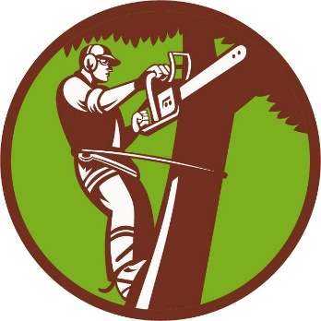

## Landscaping Industry Fatality Prevention

The landscaping services industry had an occupational injury fatality rate of 14.9 deaths per 100,000 full-time workers and seven deaths in the period. This is five times the statewide occupational fatality rate of 2.7. Recently the Massachusetts FACE program developed a [series of Safety Alerts](https://www.mass.gov/lists/fatality-assessment-and-control-evaluation-face-fact-sheets#landscaping-) that address leading hazards in landscape and tree work. The program shared these alerts with employers at a regional industry training and equipment exposition and is working with industry associations to further disseminate the alerts.

# Acknowledgements

The Occupational Health Surveillance Program would like to thank all agencies and people that contribute to our efforts to prevent work-related deaths by reporting fatalities and providing information during our investigations. This project is a joint effort of several state and federal agencies. For their assistance in providing data and advice, we thank: OSHA Region I and area office staff, staff of the Registry of Vital Records and Statistics, local and state police departments, and clerks of cities and towns. We also appreciate the contributions of the Department of Labor Standards and the Department of Industrial Accidents in the Executive Office of Labor and Workforce Development, the Office of the Chief Medical Examiner, the U.S. Coast Guard, the National Transportation Safety Board (NTSB), the Boston Regional Office of the U.S. Bureau of Labor Statistics, and the National Institute for Occupational Safety and Health (NIOSH).

1. cdc.gov/nchs/fastats/deaths.htm life expectancy in 2021.
2. The Washington Center for Economic Growth. Factsheet: U.S. occupational segregation by race, ethnicity, and gender. equitablegrowth.org/factsheet-u-s-occupational-segregation-by-race-ethnicity-and-gender.
3. Seabury SA, Terp S, Boden LI. Racial And Ethnic Differences In The Frequency Of Workplace Injuries And Prevalence Of Work-Related Disability. Health Aff (Millwood). 2017 Feb 1;36(2):266-273. pubmed.ncbi.nlm.nih.gov/28167715.
4. Byler C. Hispanic/Latino fatal occupational injury rates. Bureau of Labor Statistic, Monthly Labor Review, February 2013. bls.gov/opub/mlr/2013/02/art2full.pdf.
5. For information on the makeup of these industry sectors see census.gov/naics/?58967?yearbck=2017.
6. Self-employed workers include persons who own/operate unincorporated businesses and paid and unpaid family workers.
7. OSHA records available to OHSP include several workforces or events that are normally outside of OSHA or DLS jurisdiction. This is partly attributed to robust reporting of any workplace deaths by the Office of the Chief Medical Examiner to the enforcement agencies and to DPH.