Massachusetts Fatal Injuries at Work, Spotlight on Construction, 2023
Occupational Health Surveillance Program, Fall 2025

Introduction
Fatal work injuries are preventable. Information about where and how they occur helps industry, labor, government, and community organizations identify needs for interventions to protect workers. This brief provides the latest data on fatal work injuries in Massachusetts. Also included are details on which workforces may be most at risk, with a focus on construction.

What is a fatal work injury?
This report covers fatal injuries of workers that occur at their workplace or while they are performing a work task. These include deaths linked to physical and chemical hazards in the work environment, such as injuries from falls, electrocutions, and burns from toxic chemicals. Also included are overdoses, suicides, and homicides that occur at work, and motor-vehicle-related fatalities that occur during work or work travel.

How did we generate the data?
The Workplace Fatality Program identifies and documents fatal work injuries in the Commonwealth by collecting information from death certificates, medical examiners, obituaries, records from the Occupational Safety and Health Administration (OSHA) and other agencies, news stories, police reports, workers’ compensation data, and many other sources.

Key takeaways
- Fatal work injuries reached a seven-year high across all industries.
- Construction had the most fatal work injuries of any industry in 2023 and the highest on record since tracking in Massachusetts began in 1991.
- Falls were the leading cause of death in the construction industry, followed by overdoses and motor vehicle incidents. The fatality rate among Hispanic construction workers was more than six times the fatality rate of all workers in all industry sectors.
- These findings demonstrate an urgent need for work injury prevention efforts -- especially in the construction industry. These efforts should be guided by data, so interventions may be tailored to reach those most at risk.

Findings in all industry sectors

Fatal work injuries, 2014–2023

In 2023, Massachusetts saw 111 fatal work injuries — a 37% increase from the previous year and the highest number of deaths since 2016.

Figure 1. Number and rate of fatal work injuries by year, Massachusetts (n=887)
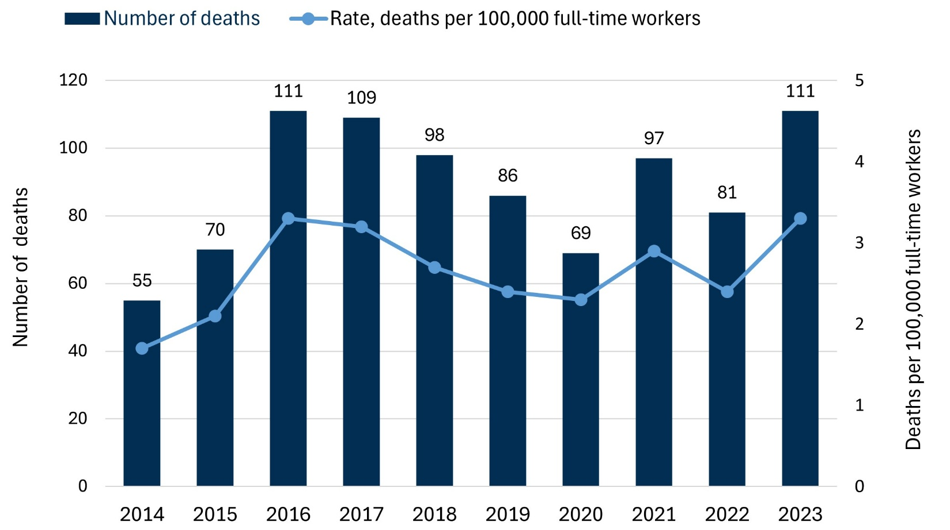

Data source: Occupational Health Surveillance Program, Workplace Fatality Program.
Workforce data used to calculate rates: Current Population Survey, accessed through the National
Institute for Occupational Safety and Health (NIOSH) Employed Labor Force query system.

Fatal work injuries by industry sector, 2023

Among fatal work injuries in 2023, the highest proportion took place in the construction industry sector, at 33% (37). This was followed by Transportation, Warehousing, and Utilities at 11% (12), and Professional and Business Services at 8% (9).

Figure 2. Number of fatal work injuries by industry sector, Massachusetts, 2023 (n=111)
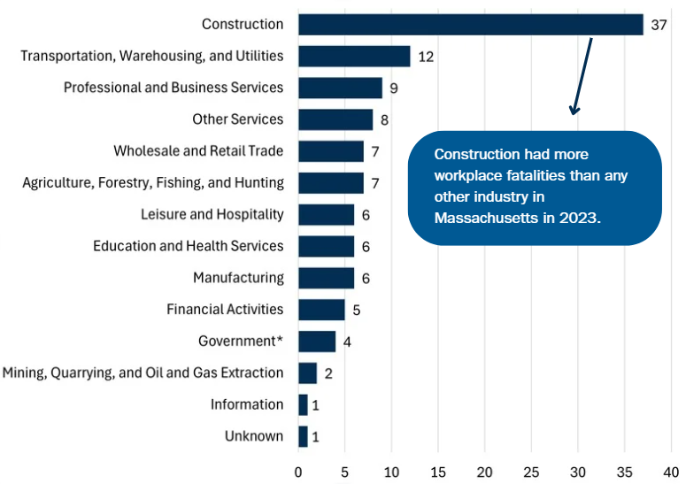

Construction had more workplace fatalities than any other industry in Massachusetts in 2023.

For more information on industry sectors, see the U.S Bureau of Labor Statistics Industries at a Glance resource.]
Data source: Occupational Health Surveillance Program, Workplace Fatality Program.
*Industry sectors shown in this chart are private sector. The Government category includes fatalities sustained by public sector workers in all industry sectors.

For more information on industry sectors, see the U.S Bureau of Labor Statistics Industries at a Glance resource.

Fatal work injuries by industry sector, 2021–2023
Figure 3: Number of fatal work injuries by industry sector, Massachusetts, 2021–2023 (n=289)
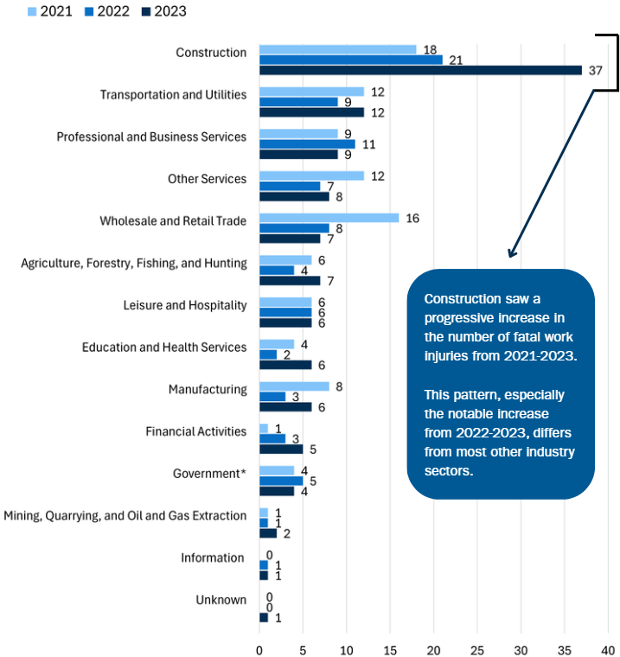

Construction saw a progressive increase in the number of fatal work injuries from 2021-2023. This pattern, especially the notable increase from 2022-2023, differs from most other industry sectors.

Data source: Occupational Health Surveillance Program, Workplace Fatality Program.

*Industry sectors shown in this chart are private sector. The Government category includes fatalities sustained by public sector workers in all industry sectors.

Findings in construction

Fatal work injuries, 2014–2023

With a notable rise in fatal work injuries in construction in 2023 — and a steady increase over the past three years — this industry clearly warrants closer examination.

In 2023, the construction industry sector saw 37 fatal work injuries — the highest number of construction industry deaths in the Workplace Fatality Program’s records, which date back to 1991. This represents a 76% increase in fatal work injuries in Massachusetts’ construction industry compared to 2022.

The fatality rate in the construction industry in 2023, 14.6 deaths per 100,000 full-time workers, was more than four times the statewide rate of 3.3.

Figure 4: Number and rate of fatal work injuries in the construction industry, Massachusetts, 2014–2023 (n=229)

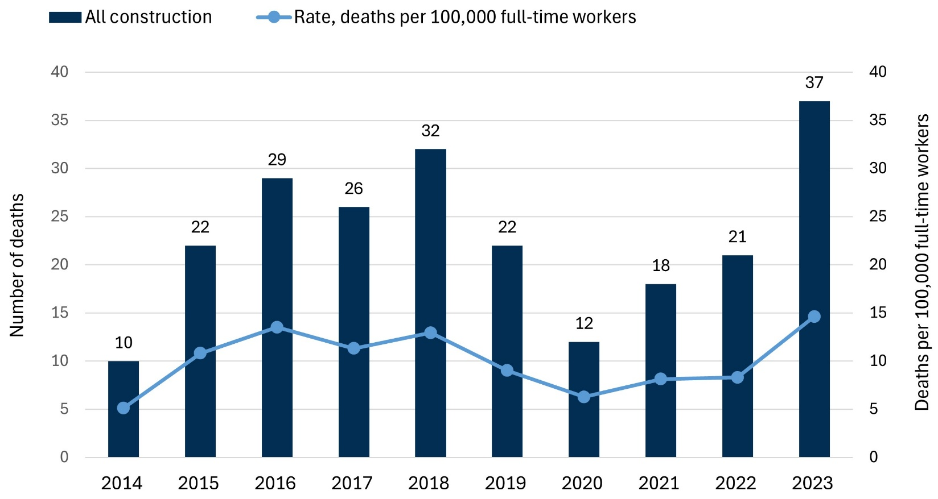

Data source: Occupational Health Surveillance Program, Workplace Fatality Program.
Workforce data used to calculate rates: Private sector construction, Current Population Survey, accessed through the NIOSH Employed Labor Force query system.

Causes of fatal work injuries in construction, 2023

The leading cause of fatal work injuries was falls, at 30% (11), followed by overdoses and motor vehicle crashes — each at 19% (7). The next most common causes were suicides at 16% (6), struck-by incidents involving moving vehicles or equipment at 13% (5), and incidents involving being caught in running powered equipment at 3% (1).

Figure 5: Percent and number of fatal work injuries in the construction industry by event or exposure, Massachusetts, 2023 (n=37)

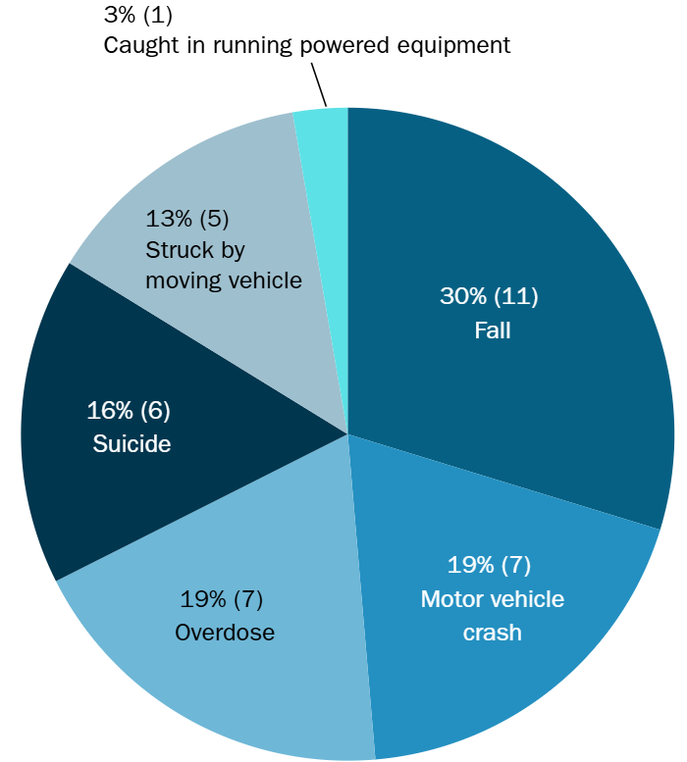

Data source: Occupational Health Surveillance Program, Workplace Fatality Program.

Occupations of workers with fatal work injuries in construction, 2023

In 2023, 27% (10) of all fatal work injuries in the construction industry sector were among construction laborers. This was followed by construction supervisors at 14% (5), and electricians at 8% (3). The remaining 19 fatalities occurred among workers in a variety of other occupations, each with two or fewer deaths, including job titles such as carpenters, brick masons, painters, and more.

Figure 6: Top occupations among construction industry workers with fatal work injuries, Massachusetts, 2023 (n=37)

Content in Figure 6:
Construction laborer: 10
Construction Supervisors: 5
Electricians: 3

Data source: Occupational Health Surveillance Program, Workplace Fatality Program.
*Construction Supervisors include construction foremen and contractors who supervise job sites.

Demographics of workers with fatal work injuries in construction, 2023

Sex and age
In 2023, all workers in the construction industry in Massachusetts who died from work-related injuries were male, ranging in age from 22 to 64, with an average age of 44. Notably, nearly one-quarter of these fatalities occurred among workers aged 55 to 64, highlighting the importance of injury prevention efforts across all stages of working life.

Figure 7: Sex and age of construction workers with fatal work injuries, Massachusetts, 2023 (n=37)

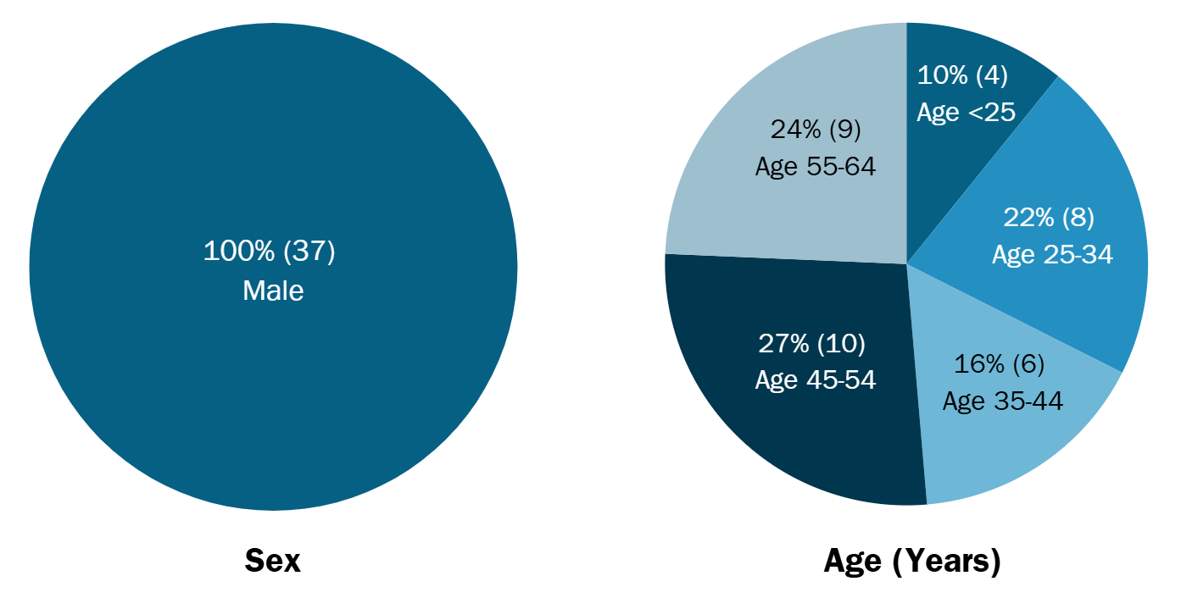

Data source: Occupational Health Surveillance Program, Workplace Fatality Program.

Demographics of workers with fatal work injuries in construction, 2023

Race/ethnicity and region of birth
Of the 37 workers with fatal work injuries, 24 were White non-Hispanic, 7 were Hispanic, 2 were Black non-Hispanic, and 4 were other non-Hispanic. Hispanic workers made up 15.4% of the construction workforce in Massachusetts in 2023, yet they accounted for nearly one in five (19%) of the fatalities. The fatality rate among Hispanic construction workers overall was 1.4 times that of non-Hispanic White construction workers, the next highest group. Roughly one-quarter (10 of 37) of the construction workers who died on the job were born outside the United States. Of these, half were originally from Brazil.

Disparities in Deaths among Hispanic Workers in Construction
These disparities may be due to the overrepresentation of Hispanic workers in high-risk jobs, language barriers, discrimination, and fear of job loss or deportation. These factors may stop some workers from reporting injuries, advocating for their safety, or exercising their legal rights to a safe workplace.

Figure 8: Race/ethnicity and region of birth of construction workers with fatal work injuries, Massachusetts, 2023 (n=37)

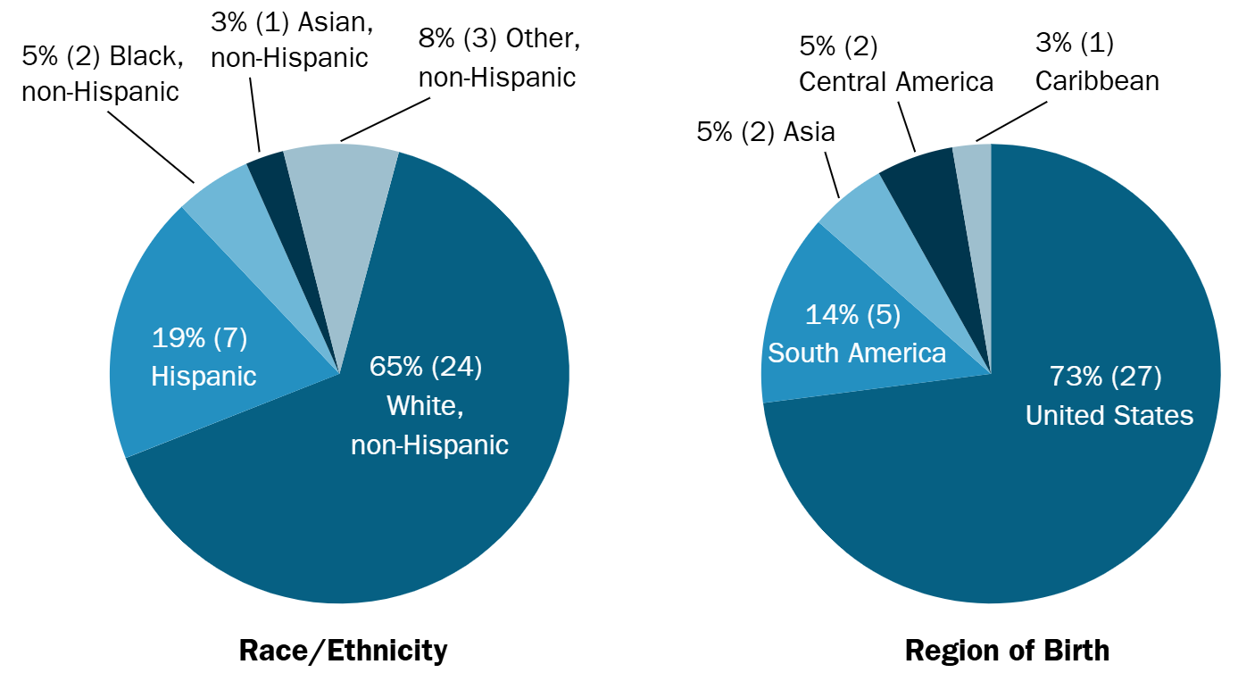

Data source: Occupational Health Surveillance Program, Workplace Fatality Program.

These findings underscore the importance of culturally and linguistically tailored intervention efforts.

Demographics of workers with fatal work injuries in construction, 2023

Workers by their employment type
Among the 37 workers with fatal work injuries, nine of these workers were self-employed. The fatality rate among self-employed construction workers was more than three times the rate of wage and salary workers (39.8 versus 12.1 deaths per 100,000 full-time workers, respectively).

Self-employed workers include independent contractors, individuals who own or operate unincorporated businesses, day laborers, and on-call contractors. This group often experiences worse workplace safety and health outcomes compared to wage and salary employees. Of note, self-employed workers have limited access to benefits like workers’ compensation, earned sick time, and other workplace protections. This may contribute to their worse outcomes.

These data highlight the need for prevention strategies tailored to self-employed workers.

Figure 9: Number and rate of fatal injuries among self-employed construction workers compared to wage-and-salary-earning construction workers, Massachusetts, 2023 (n=37)

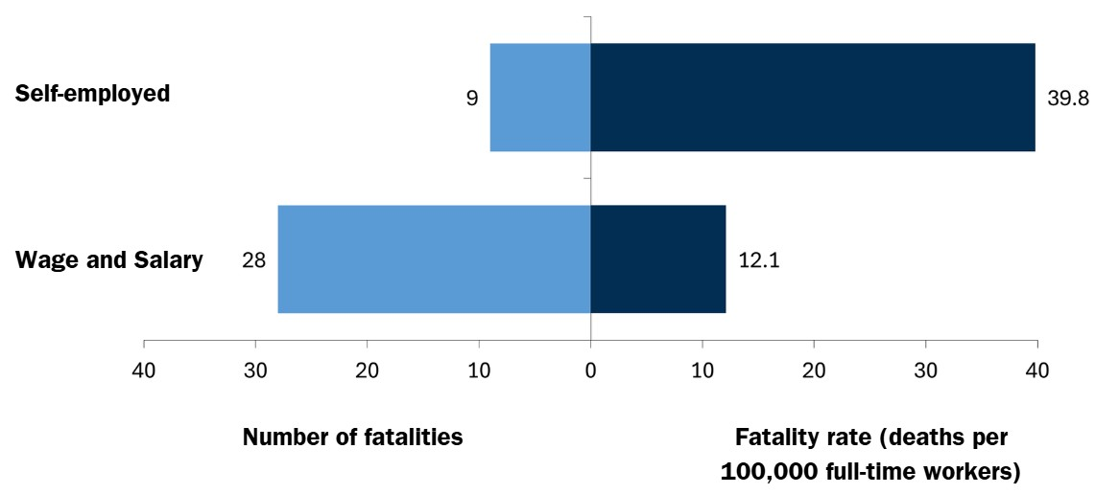

Data source: Occupational Health Surveillance Program, Workplace Fatality Program.
Workforce data used to calculate rates: Private sector construction, Current Population Survey, accessed through the NIOSH Employed Labor Force query system.

Resources

Prevention and support resources

Prevention of falls and struck-by incidents
- Fall prevention for Construction Workers (DPH) - Information available in multiple languages
- Preventing Struck-by Incidents (CPWR)
- Stop Construction Falls: National Campaign to Prevent Falls in Construction (CPWR)

Support for workers with substance addiction
- BeHere: Creating a recovery-supportive workplace through culture, policies, and practices (HRiA)
- Resources to Prevent Opioid Deaths in Construction (CPWR)
- Massachusetts Building Trades Unions Recovery Resources (MBTU)

Support for suicide prevention
- MassMen: Mental Health Resources for the Workplace (DPH)
- Resources to Prevent Suicide Deaths in Construction (CPWR)
- Suicide Prevention in the Construction Industry: A Resource for Champions (DPH)

Helping small businesses
- Helping Small Businesses (OSHA)
- Small Businesses Safety and Health (NIOSH)

Source Guide
- CPWR = The Center for Construction Resource and Training
- DPH = Massachusetts Department of Public Health
- HRiA = Health Resources in Action
- MBTU = Massachusetts Building Trades Unions
- NIOSH = National Institute for Occupational Safety and Health
- OSHA = Occupational Safety and Health Administration

Works cited

- The Census Bureau’s American Community Survey Public Use Microdata Sample was used to look at detailed demographic data within the construction workforce.
- Cunningham TR, Guerin RJ, Keller BM, Flynn MA, Salgado C, Hudson D. Differences in safety training among smaller and larger construction firms with non-native workers: Evidence of overlapping vulnerabilities. Saf Sci. 2018 Mar;103:62-69. doi: 10.1016/j.ssci.2017.11.011.
- Seabury SA, Terp S, Boden LI. Racial And Ethnic Differences In The Frequency Of Workplace Injuries And Prevalence Of Work-Related Disability. Health Aff (Millwood). 2017 Feb 1;36(2):266-273. doi: 10.1377/hlthaff.2016.1185.

