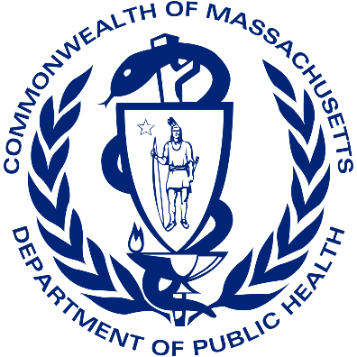

**July 2022**

**FATAL INJURIES**

**AT WORK**

**2020**

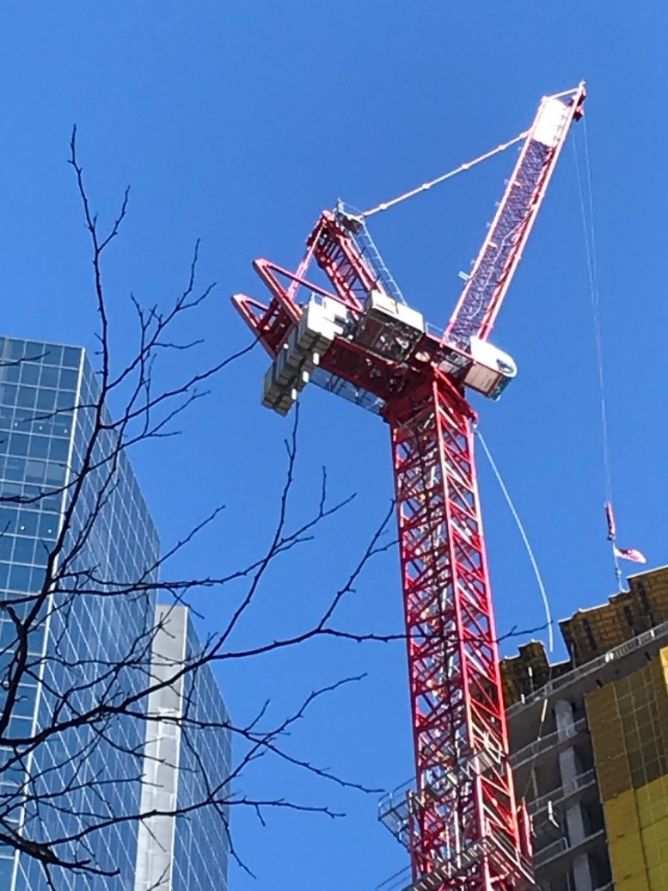**Massachusetts Department of**

**Public Health**

Report by:

Occupational Health Surveillance Program

Census of Fatal Occupational Injuries

Fatality Assessment and Control Evaluation

Find this report at: <https://www.mass.gov/lists/fatal-work-related-injury-reports-and-publications>

[ma.face@mass.gov](mailto:ma.face@mass.gov)

1-800-338-5223

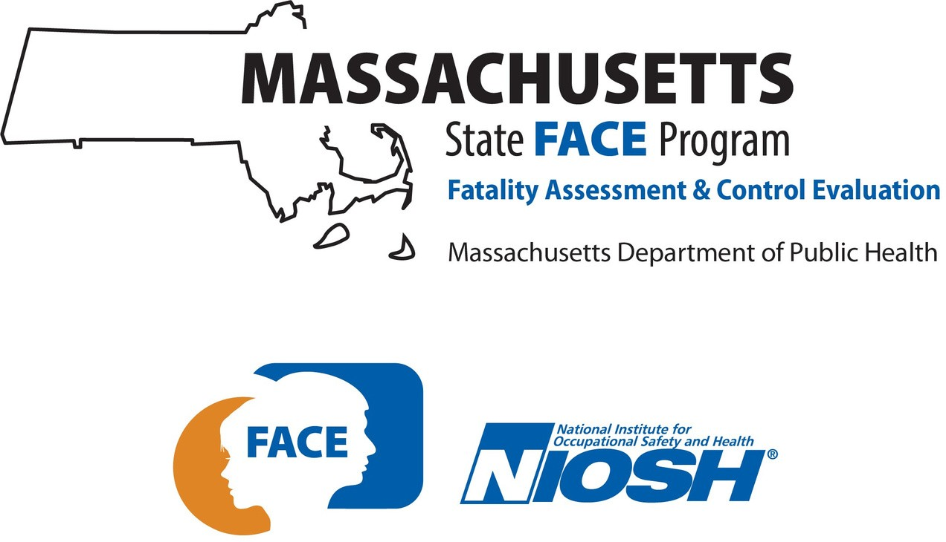

### Foreword

This update provides an overview of fatal injuries at work that occurred in Massachusetts in 2020. There was a marked decline in the number of work-related injury deaths in the Commonwealth compared to previous years. This can be attributed in part to how work changed or halted in some sectors in response to the COVID-19 pandemic and subsequent public health interventions. Figure 1 shows one measure of the impact on workers: the number of full-time equivalent workers by month in 2020. The chart includes those who were able to continue to work in their regular location or in an alternate setting through telework or in a new job. Most apparent is the rapid drop in employment between March and April, when many businesses were ordered to halt in-person operations to help stop the spread. Also reflected in this timeline is the resumption of work as sectors re-opened in phases, starting in May 2020. Fluctuations marking the summer and schooltime are visible, as is the disproportionate employment impact on women. It should be noted the Current Population Survey only reports these workforce data by sex; an additional [national survey](https://www.census.gov/library/stories/2021/11/census-bureau-survey-explores-sexual-orientation-and-gender-identity.html) showed that Lesbian, Gay, Bisexual or Transgender (LGBT) respondents were more likely than non-LGBT respondents to experience economic and mental health hardships during the pandemic.

Figure 1. Massachusetts workforce, full-time equivalent workers, 2020.

Massachusetts workforce, full-time equivalent workers, 2020, by month
Male Female All workers
Jan 1932796.32 1879883.2 3812679.52
Feb 1891501.173 1836515.68 3728016.853
Mar 1847148.587 1802678.453 3649827.04
Apr 1521927.413 1304694.987 2826622.4
May 1514733.12 1375312.32 2890045.44
Jun 1674148.373 1426068.8 3100217.173
Jul 1645846.827 1531974.64 3177821.467
Aug 1669655.093 1557692.107 3227347.2
Sep 1611731.333 1535880.267 3147611.6
Oct 1686094.933 1633901.253 3319996.187
Nov 1745735.2 1644432.267 3390167.467
Dec 1844561.68 1690476.32 3535038


Source: Current Population Survey, 2020.

Work did not change in the same way for all workers in Massachusetts. Over the course of 2020, some workers were required to leave home to do their jobs, placing them at increased risk of exposure to SARS-CoV-2, the virus that causes COVID-19. At the workplace, factors like ability or inability to distance from others further impacted risk of exposure. This risk was not borne equally across groups of workers. A [study](https://doi.org/10.1007/s40615-021-01110-8) conducted by the National Institute for Occupational Safety and Health (NIOSH) demonstrated that Black workers were overrepresented (or more likely to work) in occupations that had higher exposure risk to COVID-19 and higher inability to distance at work. Hispanic workers were also overrepresented in occupations with higher inability to work from home. To better understand the situation in Massachusetts, the Occupational Health Surveillance Program (OHSP) [characterized the workforces](https://www.mass.gov/lists/occupational-health-special-topics#essential-workers-) of three key essential industries – healthcare, food stores and urban transit – and found that workers of color were overrepresented in these high-risk groups. Black and Hispanic workers were overrepresented among healthcare support occupations. Black workers were overrepresented in urban transit. Hispanic and Asian workers were overrepresented in food stores.

[Massachusetts data](https://www.mass.gov/info-details/covid-19-response-reporting#covid-19-chapter-93-data-) shows 12,359 confirmed COVID-19 deaths through 12/31/2020 but identifying *work-related* infections and deaths with the existing systems used by the Fatality Assessment and Control Evaluation (FACE) and Census of Fatal Occupational Injuries (CFOI) projects is not possible at this time. We saw 36 claims for benefits for fatalities attributable to COVID-19 in the workers’ compensation data we normally review to document deaths from injury. We saw a similar number of deaths in Occupational Safety and Health Administration (OSHA) data. Without a way to systematically identify COVID-19-related workplace exposure, we recognize the need to continue collaborations in this area, to strengthen our systems and ensure the element of work is considered and recorded by other programs.

While we don’t have a firm count of work-related COVID-19 deaths, the [COVID-19 Community Impact Survey](https://www.mass.gov/info-details/covid-19-community-impact-survey) is a source of data that helps us understand the broader [impact of the pandemic on Massachusetts workers](https://zoom.us/rec/play/YcrG7wuuK19-iA4ic3d-pw5fZn82ZIFHH-Nw2cI_X_Rz07t65xmbd0oUbJKHWZqlG3dDKWVgHpiYHdjL.TUKm1TBocTX4KWtP?startTime=1622566273000&_x_zm_rtaid=zT5XTNLsQkeWKAs-qrkUTg.1628692288020.152b9beb6e23c1fa15f492b95585a0de&_x_zm_rhtaid=800). Another compelling data source that tells the story of how this illness affected workers is the Survey of Occupational Injuries and Illnesses ([SOII](https://www.bls.gov/iif/soii-data.htm)), run by the U.S. Bureau of Labor Statistics. SOII estimated a more than [forty-fold increase](https://www.bls.gov/news.release/osh.t01.htm) in the number of nonfatal work-related respiratory illness cases in 2020.

Figure 2. Counts of cases of work-related respiratory illnesses and all other illnesses, private industry, 2016-2020, U.S.

Counts of cases of respiratory illnesses and all other illnesses, private industry, 2016-2020, U.S.
Respiratory illnesses Other illnesses
2016 11,000 126,500
2017 10,400 116,000
2018 12,100 114,700
2019 10,800 116,400
2020 428,700 115,900


Source: Bureau of Labor Statistics, Survey of Occupational Injuries and Illnesses, 2020.

Data exclude farms with fewer than 11 employees.

<https://www.bls.gov/news.release/osh.t01.htm>

What has been apparent through the pandemic is the need to continue our efforts to reduce work-related fatalities. For instance, OHSP is undertaking new initiatives to help improve the safety of landscaping and tree workers in the region. Struck-by incidents in construction, like falls, are the focus of efforts nationally, and these initiatives offer lessons that can be shared with other sectors.

### Executive summary

Fatal injuries at work are preventable. Information about where and how they occur is essential to develop effective prevention programs. This update provides an overview of fatal injuries at work that occurred in Massachusetts in 2020 and includes details collected by both the Fatality Assessment and Control Evaluation (FACE) and the Census of Fatal Occupational Injuries (CFOI) projects. Included are deaths traditionally linked to the work environment such as falls, electrocutions, and exposure to toxic chemicals. Also included are workplace opioid overdoses, homicides and suicides, and motor vehicle-related fatalities that occurred during travel on the job. Workplace deaths from occupational illnesses and heart attacks are not systematically counted by the projects and are not included in this report.

When reporting statistics about fatal occupational injuries, it is important to acknowledge the individuals that these numbers represent. Continued efforts are needed to reduce both the human and economic tolls of preventable deaths at work in the Commonwealth. The surveillance findings presented here are intended to guide government, industry, labor, and community organizations in developing and implementing strategies to prevent similar tragedies in the future.

69 people died from workplace injuries in Massachusetts in 2020.

The leading causes of fatal workplace injuries were:

* Workplace overdose (n=18)
* Roadway crash (n=11)
* Fall to a lower level (n=8)
* Water vessel incident (n=6)
* Workplace homicide (n=6)
* Workplace suicide (n=5)
* Struck by falling object or equipment (n=3)

Based on the rate of injury, the following workers had the highest risk of fatal injury:

* Agriculture, Forestry, Fishing, and Hunting: 53.4/100,000 workers[1]
* Landscaping: 28.5/100,000
* Transportation and Utilities and Construction: 6.3/100,000

### Prevention Activities in Massachusetts

### Workplace Overdoses

Similar to recent years, unintentional overdose at work was the single leading cause of fatal injury at work in 2020, resulting in one quarter of all deaths (n=18). These deaths occurred across all industry sectors. The average age of workplace overdose victims was 41 years. The Occupational Health Surveillance Program (OHSP) is currently working with workplace health and safety stakeholders and substance addiction service providers to provide opioid awareness peer training for high-risk worker groups and to identify additional opportunities to implement worker-oriented opioid overdose prevention strategies. In addition, OHSP has [analyzed](https://www.mass.gov/lists/occupational-health-special-topics#opioids-and-work-) opioid overdoses by industry and occupation, and recently released a [report on deaths from 2016-2017](https://www.mass.gov/doc/opioid-related-overdose-deaths-by-industry-and-occupation-2016-2017-0/download) and is in the process of looking at data through 2020.

These findings continue to underscore the need for educational and policy interventions targeting worker populations to prevent opioid-related overdose deaths. Interventions should address workplace hazards that cause injuries for which opioids are prescribed, as well as appropriate pain management following injury, including safer opioid prescribing, access to evidence-based treatment for opioid use disorders, and overdose prevention education.

In Massachusetts, workplace health and safety stakeholders are working with substance addiction service providers and policy makers to provide opioid awareness peer training for high-risk worker groups and to identify additional opportunities to implement worker-oriented opioid overdose prevention strategies.

# Landscaping Industry

The landscaping services industry had a fatality rate of 28.5 deaths per 100,000 workers (4 deaths). This is twelve times the statewide occupational fatality rate. Recognizing the need to prevent future deaths and injuries in this industry, OSHA has an ongoing [Regional Enforcement Program](https://www.osha.gov/sites/default/files/enforcement/directives/CPL-04-00-025.pdf) to increase inspections and outreach to establishments that perform tree work or landscaping. The goal is to reduce injuries from falls, being struck by falling trees, limbs, or moving vehicles or equipment, contact with electrical lines, and noise. OSHA previously developed a topic page for the [tree care industry](http://www.osha.gov/tree-care) that links to resources that address hazards experienced by tree workers. OHSP and MA FACE are working to support these OSHA initiatives.

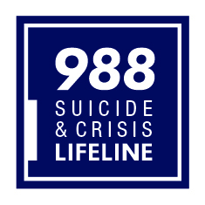Suicide Prevention

# OHSP continues to work with the DPH Suicide Prevention Program to identify [workforces that are at greater risk of suicide](https://www.mass.gov/lists/occupational-health-special-topics#suicides-and-work-) in Massachusetts to help create effective prevention programs. We recognize the pandemic exacerbated the mental health crisis and affected industries such as [construction](https://www.cpwr.com/wp-content/uploads/DataBulletin-January2022.pdf) that are the focus of our interventions.

*If you or someone you know is thinking about suicide, please contact one of the 24-hour crisis hotline numbers right away:*

# [*National Suicide Prevention Lifeline*](https://suicidepreventionlifeline.org/)*call or text* ***988*** *|*[*chat*](https://suicidepreventionlifeline.org/chat/)[*Trevor Lifeline*](https://www.thetrevorproject.org/)*for LGBTQ Youth 1-866-488-7386 | text 678-678 |*[*chat*](https://www.thetrevorproject.org/get-help-now/)

# Falls



Falls to a lower level at work claimed eight lives in 2020. Half of these were in the construction industry. The national [Campaign to Prevent Falls in Construction](http://www.stopconstructionfalls.com/) is now in its ninth year. New safety handouts, videos, and materials for toolbox talks are available. A parallel national initiative strives to prevent [struck-by incidents](https://www.cpwr.com/research/research-to-practice-r2p/r2p-library/other-resources-for-stakeholders/struck-by-hazards/) in the industry.

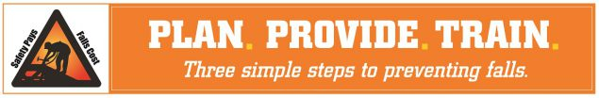

# Motor Vehicle Crashes

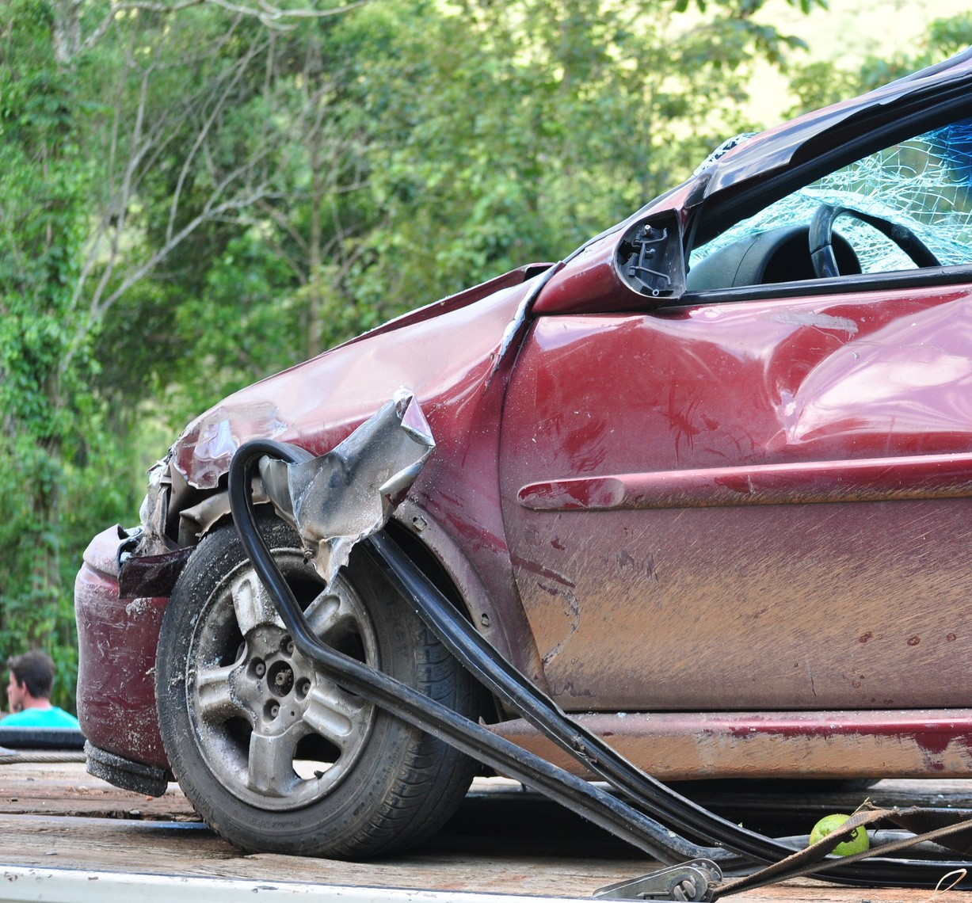

Work-related motor vehicle crashes were the second leading cause of death of workers in Massachusetts in 2020. Many workers need to drive as a core function of their job, whether they work in a transportation industry or perform work for clients. A new [law](https://www.mass.gov/service-details/hands-free-law) took effect in Massachusetts in early 2020 that prohibits the use of hand-held electronic devices while driving. This law improves roadway safety for everyone. Additional resources on motor vehicle safety for workers can be found at: <https://www.cdc.gov/niosh/motorvehicle>.

The workers: Demographics

In Massachusetts, 69 individuals were fatally injured at work in 2020. The fatal occupational injury rate was 2.3 deaths per 100,000 full-time workers. This rate is lower than recent years. This is the result of a changing work landscape due to the pandemic and lower employment, lower exposure to hazards, and fewer fatal injuries. This drop is mostly attributable to a reduction in the number of fatal falls, of which there were half as many in 2020 as there were in each of the prior four years (10 in 2020 compared to an average of 20 each year 2016-2019).

#### Figure 3. Rate of Fatal Occupational Injury by Year

#### Deaths per 100,00 full-time workers

Som

Source: Occupational Health Surveillance Program, Massachusetts FACE and CFOI, 2020.

The fatally injured included 62 men and 7 women (there were no workplace fatalities of workers who identified as any other gender). These workers ranged in age from 23 to 78 years, with a mean age of 48 and a median age of 49 years. The fatalities resulted in a total of 1,845 potential life years lost (difference between the worker’s age and 75 years), an average of 27 potential life years lost per victim.

A total of 47 (68%) of the workers were White non-Hispanic, 10 were Hispanic, three were Asian non-Hispanic, three were Black or African American non-Hispanic, and six were other races including one Native American non-Hispanic individual. The fatality rate (deaths per 100,000 full-time workers) for each of these demographic groups was:

Hispanic: 2.8 White non-Hispanic: 2.0 Black non-Hispanic: 1.2 Asian non-Hispanic: 1.0

Hispanic workers [disproportionately work in more dangerous jobs](https://equitablegrowth.org/factsheet-u-s-occupational-segregation-by-race-ethnicity-and-gender/) and suffer more workplace injuries and deaths. Factors contributing to the increased risk of work-related injury and illness include: lack of training or supervision; language, literacy and cultural barriers in the workplace; fear of discrimination in and outside of the workplace; and economic pressures that deter workers from speaking up about workplace hazards. In high-risk industries such as construction, Hispanic workers are more likely to be placed in positions where the hazards are less likely to be controlled. OHSP continues to work to reduce these disparities by providing detailed data to stakeholders and performing outreach activities to Hispanic workforces.

Nine workers (13%) were born outside of the U.S. and worked in a range of industries. Among these workers, the leading sector for employment was construction (n=4). The rate of fatal injury among foreign-born workers was 1.3 per 100,000 workers and the rate among U.S.-born workers was 2.3 per 100,000 workers.

Four workers were self-employed.[2] This is much lower than the average (18) seen in prior years. The number of self-employed unincorporated workers in the state dropped 24.8% between 2019 and 2020. The fatal injury rate among self-employed workers was 3.0 per 100,000 workers, compared to 2.2 among wage/salary earners. While the self-employed are often not subject to OSHA enforcement, OHSP plays an important role in ensuring that these workers' deaths are counted and continuing to promote and support workplace policies that will help protect these workers.

The largest number of fatal injuries occurred in Barnstable and Norfolk counties, followed by Essex, Middlesex, and Suffolk. A fishing vessel disaster that resulted in four deaths contributed to the increase in Barnstable County during this period.

Deaths by County of Injury, 2020

|  |  |  |  |
| --- | --- | --- | --- |
| Barnstable | 9 | Plymouth | 7 |
| Norfolk | 9 | Worcester | 6 |
| Essex | 8 | Berkshire | 3 |
| Middlesex | 8 | Bristol | 3 |
| Suffolk | 8 | Nantucket | 1 |
| Hampden | 7 |  |  |

* [Nationwide](https://www.bls.gov/iif/oshcfoi1.htm), 4,764 workers died from fatal occupational injuries in 2020. This is a 10.7% decrease from 2019 and translates to a rate of 3.4 per 100,000 workers for the period, which is higher than the Massachusetts rate of 2.3.
* Compared to the nation, Massachusetts differs in three important ways.
  1. Massachusetts has proportionately fewer workers in high-risk industries, such as mining or heavy manufacturing, than the U.S. generally.
  2. The proportion of work-related deaths from roadway transportation incidents was much lower in Massachusetts. These were leading fatal events nationwide, representing 22% of all work- related fatal injuries, while in Massachusetts crashes made up just 16% of the burden.
  3. Workplace overdoses made up 26% of worker deaths in Massachusetts, compared to only 8% nationwide.

## Types of Events Causing Worker Deaths

* Unintentional overdose at work was the single leading cause of fatal injury at work in 2020, resulting in 18 deaths. Exposure to harmful substance or environment is the only event category that saw an increase compared to 2019, resulting in 21 deaths in 2020 compared to 20 in 2019.
* Roadway motor vehicle collisions and rollovers contributed to the fatal injuries of 11 workers.
* Falls to a lower level resulted in eight worker deaths. All but one of these falls were construction workers or involved construction tasks or tools. Half of the falls to a lower level were from heights of six feet or less.
* Four of the five workplace suicides were of owner/operators or managers of small firms.

Table 1. Number and Percent of Fatal Injuries at Work by Event/Exposure, Massachusetts, 2020, N=69  
Event/Exposure Number of Percent
 Fatalities 
Exposure to harmful substance or environment 21 30%
Unintentional overdose, drugs or alcohol 18 26%
Transportation incident 21 30%
Roadway collision or noncollision (rollover) 11 16%
Water vehicle incident 6 9%
Violence and other injury by person or animal 11 16%
Homicide 6 9%
Suicide or self-inflicted injury 5 7%
Fall, slip, or trip 10 14%
Fall to a lower level 8 12%
Contact with object or equipment 6 9%
Struck by falling object or equipment, other than vehicle 3 4%
Fires and explosions 0 0%
Total 69 100%
NOTE: Event/exposure sub-categories with < 3 fatalities are not shown.  Sub-categories may not add up to the bolded category totals. Percentages may not add to 100% due to rounding.  
Source: Occupational Health Surveillance Program, Massachusetts FACE and CFOI, 2020  

#### Fatal Injuries at Work by Industry

* The Agriculture, Forestry, Fishing and Hunting industry group had the highest occupational fatality rate in 2020 (n=8; 53.4 per 100,000 full-time workers). Seven of these were workers on commercial fishing vessels. OHSP works closely with [NIOSH](https://www.cdc.gov/niosh/topics/fishing/default.html), the [Northeast Center for Occupational Health and Safety in Agriculture, Forestry, and Fishing](https://necenter.org/fishing/), and local fishing industry [support organizations](https://fishingpartnership.org/) to ensure findings from investigations of these deaths inform policy and prevention.
* The Transportation and Utilities industry group and the Construction industry group each had a fatality rate of 6.3 deaths per 100,000 full-time workers.
* Construction had the highest number of deaths (n=12). Half of these were construction laborers. Four of the workers in this group were born outside of the U.S., whereas no other sector had more than one foreign-born worker fatally injured at work.
* The Wholesale and Retail Trade industry group had 9 deaths and a fatality rate of 2.6.
* While the Professional and Business Services group had an overall rate below the statewide average, within this group there were four deaths in the Landscaping Services industry, which had a fatality rate of 28.5 deaths per 100,000 workers.

##### Figure 4. Number and Rate of Fatal Injuries at Work by Industry Group, Massachusetts, 2020

##### Number and Rate of Fatal Injuries at Work by Industry Group, Massachusetts, 2020 Industry Group Number of Fatalities Fatality Rate (per 100,000 full-time workers) Education and Health Services 6 0.9 Professional and Business Services 9 1.7 Government* 6 1.9 Leisure and Hospitality 4 2.4 Wholesale and Retail Trade 9 2.6 Other Services 4 3.1 Construction 12 6.3 Transportation and Utilities 6 6.3 Agriculture, Forestry, Fishing, and Hunting 8 53.4

**Number of Fatalities Fatality Rate (per 100,000 full-time workers)**

Note: Data not presented for six industry groups with fewer than three fatalities (N = 2 deaths).

*The Government category includes fatalities sustained by public sector workers regardless of industry. Source: Occupational Health Surveillance Program, Massachusetts FACE and CFOI, 2020.

State and Federal Roles in Occupational Health and Safety

As there is no agency that has sole jurisdiction over all workplaces and workers in Massachusetts, OHSP plays an important role in connecting workers and employers with the various agencies that support workplaces.

The Occupational Safety and Health Administration (OSHA) is the main federal agency that is responsible for creating workplace health and safety standards, providing compliance assistance, and enforcing these standards. In Massachusetts, OSHA standards apply to private sector employers and employees and the Massachusetts Department of Labor Standards uses OSHA standards to protect state and local public sector workers. Self-employed workers or independent contractors are not covered by OSHA, nor are workers on family farms that employ only immediate family members.

OSHA investigated 9 (13%) of the fatal work-related injuries identified by the Massachusetts FACE and CFOI projects that occurred in 2020.[3] OSHA levied fines for violations of health and safety standards against at least six of the employers they investigated in response to these fatal incidents. The lowest fine assessed was $4,048 and the highest was $87,380.

Of the remaining incidents, 17 involved workers who fell outside of OSHA jurisdiction, such as public sector employees, sole proprietors and the self-employed, and commercial fishers. Thirty-six additional deaths were events not routinely addressed by OSHA, such as overdoses, suicides, homicides, or roadway motor vehicle collisions. Thus, OHSP fills an important gap through the information it collects, analyzes, and disseminates.

OHSP conducts in-depth investigations on select workplace fatalities through the FACE program. These investigations lead to detailed reports documenting the contributing factors of the event and providing recommendations that aim to prevent similar occurrences from happening in the future. A recent investigation is highlighted below. More can be found at: <https://www.mass.gov/resource/fatality-case-reports>.

Example Case Report from the Fatality Assessment and Control Evaluation (FACE) Project

Laborer crushed between two large stone slabs at a manufacturing facility –

Massachusetts Report #19MA015

On May 7, 2019, a 49-year-old laborer was killed while assisting in moving a large stone slab to be stored on an A-frame rack. He was positioned between two A-frame racks, trying to disconnect the slab lifter, when he was crushed between two large stone slabs.

Massachusetts FACE Program concluded that, to help prevent similar occurrences, employers should:

* Ensure the use of racks designed with fixed safety posts and individual compartments for each slab
* Ensure that employees are never located in the fall shadow of a stone slab while the slab is being accessed to be moved
* Ensure that only employees with the required OSHA training and state license are permitted to operate forklifts
* Ensure that a job hazard analysis is performed for all routine tasks and updated when needed
* Develop, implement, and enforce standard operating procedures (SOP) for moving, storing, and retrieving stone slabs, which includes ensuring employees are never located in the fall zone

Find the entire report at: <https://www.mass.gov/info-details/laborer-crushed-between-two-large-stone-slabs-at-a-manufacturing-facility-massachusetts>

Surveillance of Work-related Fatalities in Massachusetts

The work-related fatalities in 2020 described in this report were identified by the Massachusetts FACE and CFOI projects. These data may not match data published by the U.S. Bureau of Labor Statistics (BLS). OHSP collects information on all fatal occupational injuries as part of the national CFOI, conducted in cooperation with BLS. Death certificates, records from OSHA, news stories, police reports and other data sources are used to identify these deaths. These source documents are primarily collected by the FACE project, which conducts in-depth investigations of select fatal occupational injuries with support from NIOSH. The purpose of the FACE project is to develop a detailed understanding of how fatal injuries occur and to develop recommendations to prevent similar incidents in the future. These recommendations are disseminated to relevant industries, labor organizations, equipment manufacturers, and others in positions to take action to prevent work-related injuries.

Health and Safety Resources in Massachusetts

For detailed tables of fatal occupational injuries and previous fatality update reports, as well as educational materials, please contact the Massachusetts Department of Public Health, Occupational Health Surveillance Program, 250 Washington Street, 4th Floor, Boston, MA 02108-4619. Reports are available online at <http://www.mass.gov/dph/face> or by calling 1-800-338-5223. Please report work-related fatalities to the MDPH Toll-Free Occupational Fatality Hotline (1-800-338-5223), or to [MA.FACE@mass.gov](mailto:MA.FACE@mass.gov).

Massachusetts Department of Labor Standards (DLS) – Offers free consultation services to help private sector employers improve their safety and health programs and train employees: <http://www.mass.gov/lwd/labor-standards/on-site-consultation-program>.

DLS also has jurisdiction over state and local public sector workforces. Sample safety and health programs and many other resources are available at <https://www.mass.gov/workplace-safety-and-health-program-wshp> and <https://www.mass.gov/service-details/masssafetyworks-resources>.

Massachusetts Department of Industrial Accidents – Has grants available for providing workplace health and safety training to employers and/or employees in companies covered by the Massachusetts Workers’ Compensation Insurance Law: <http://www.mass.gov/the-dias-workplace-safety-training-grant>.

Acknowledgements

The Occupational Health Surveillance Program would like to thank all agencies and people that contribute to our efforts to prevent work-related deaths by reporting fatalities and providing information during our investigations. This project is a joint effort of several state and federal agencies. For their assistance in providing data and advice, we thank: OSHA Region I and area office staff; staff of the Registry of Vital Records and Statistics; local and state police departments; and clerks of cities and towns. We also appreciate the contributions of the Department of Labor Standards and the Department of Industrial Accidents in the Executive Office of Labor and Workforce Development; the Office of the Chief Medical Examiner; the U.S. Coast Guard; the National Transportation Safety Board (NTSB); the Boston Regional Office of the U.S. Bureau of Labor Statistics; and the National Institute for Occupational Safety and Health (NIOSH).

Massachusetts Department of Public Health, Occupational Health Surveillance Program

Census of Fatal Occupational Injuries (CFOI) and Fatality Assessment and Control Evaluation (FACE) projects

<https://www.mass.gov/lists/fatal-work-related-injury-reports-and-publications>

[ma.face@mass.gov](mailto:ma.face@mass.gov)

1-800-338-5223

1. All rates in this report are presented as deaths per 100,000 full-time equivalent workers. This is based on the number of hours worked by residents of the state and is a measure of time exposed to work and work hazards. This employment data comes from the Current Population Survey conducted by the U.S. Bureau of Labor Statistics (BLS). All of the rates described in this report, aside from the overall state and national rates, are based on small numbers of deaths and should be interpreted with caution. Rates generated for this report are not directly comparable to rates published by BLS.
2. Self-employed workers include persons who own/operate unincorporated businesses and paid and unpaid family workers.
3. OSHA investigated two cardiac illness deaths not included in these injury counts and one event in 2020 that resulted in the worker’s death in 2021.